O‘ZBEKISTON RESPUBLIKASI AXBOROT TEXNOLOGIYALARI VA KOMMUNIKATSIYALARINI RIVOJLANTIRISH VAZIRLIGI
MUHAMMAD AL-XORAZMIY NOMIDAGI TOSHKENT AXBOROT TEXNOLOGIYALARI UNIVERSITETI



Informatika asoslari kafedrasi
Dasturlash Fani

4 - AMALIY ISH

Bajardi: Umarov Murodjon

Tekshirdi: Ishniyazov O.O.

Toshkent 2023

1-topshiriq

12.04.2003

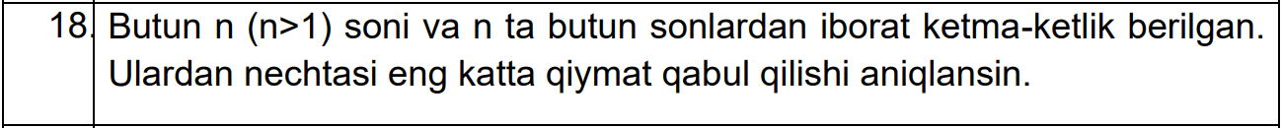

#include <iostream>
#include <cmath>
#include <algorithm>

using namespace std;

int main(){
int n, k = -10000; cin >> n;
int a[n];
for(int i=0; i<n; i++){
cin >> a[i];
k = max(k, a[i]);
}
int s=0;
for(int i=0; i<n; i++)
if(a[i] == k) s++;
cout << k << " sonidan " << s << "ta";
return 0;
}

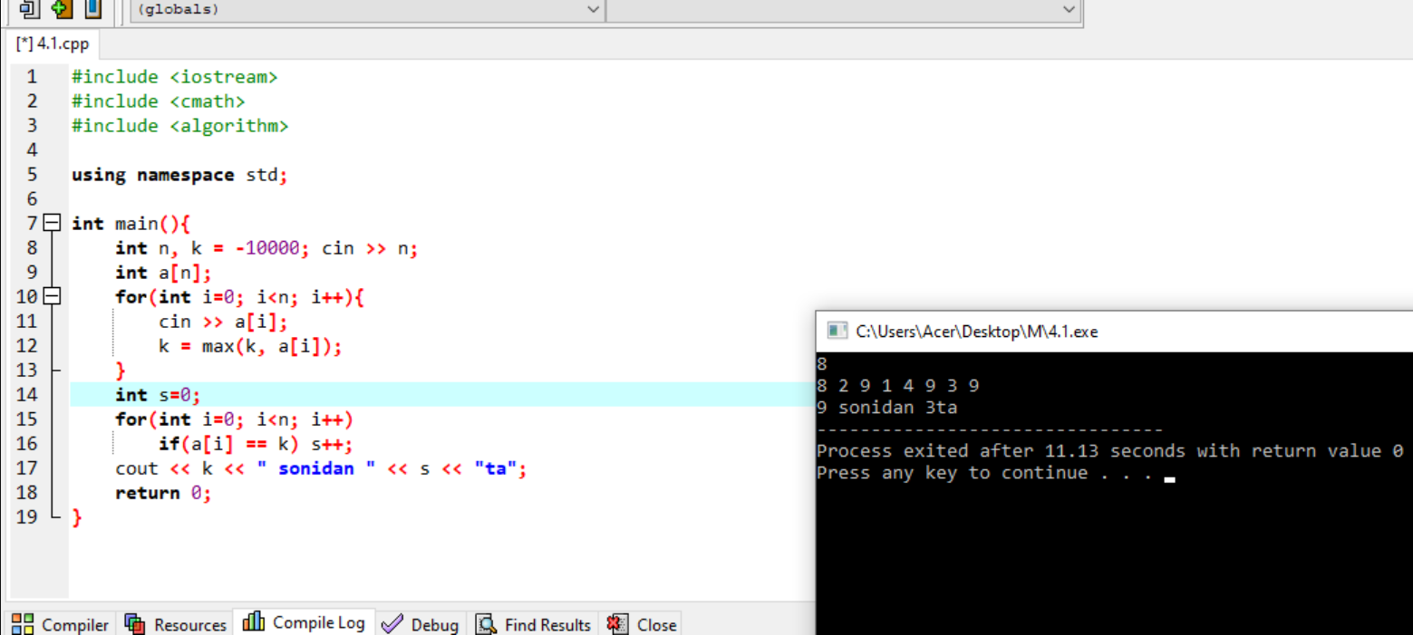

2-topshiriq

12.04.2003

#include<bits/stdc++.h>
using namespace std;

string converter(double num, int k_prec)
{
string binary = "";
int Integral = num;
double fractional = num - Integral;
while (Integral)
{
int rem = Integral % 2;
binary.push_back(rem +'0');

Integral /= 2;
}
reverse(binary.begin(),binary.end());
binary.push_back('.');

while (k_prec--)
{
fractional *= 2;
int fract_bit = fractional;

if (fract_bit == 1)
{
fractional -= fract_bit;
binary.push_back(1 + '0');
}
else
binary.push_back(0 + '0');
}

return binary;
}

int main()
{

double n = 6.4;
int q = 2;
int k = 4;
string s = converter(n, k);
printf("%.1f soni %d sanoq sistemasida, verguldan keyingi %d xona aniqlikda: ", n, q, k); cout << s;
return 0;
}

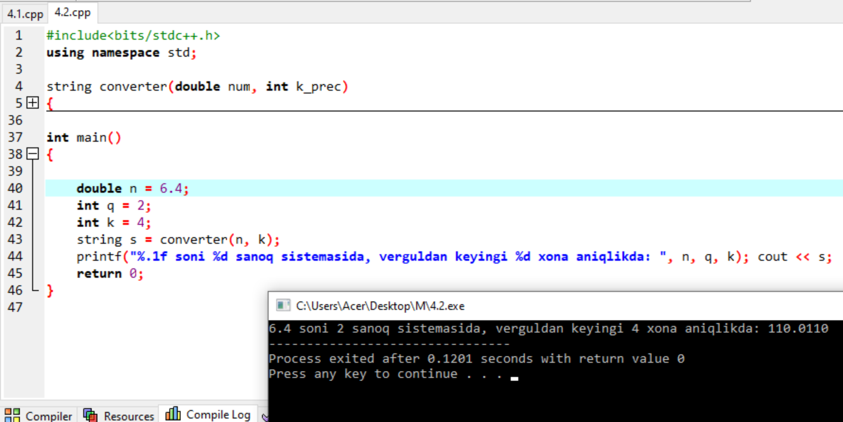

3-topshiriq

12.04.2003

#include <iostream>
using namespace std;

int main(){
int s=0;
for(int i=20; i<=40; i++){
if(i%3==0){
s += (i*i);
}
}

cout << s;
}

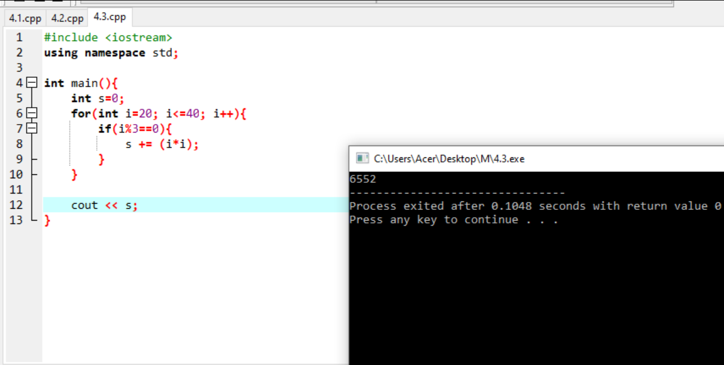

Github: https://github.com/murodjon-umar0v/TUIT-DASTURLASH-MT

