Convolutional Neural Networks

Introduction
This report presents a CNN architecture design, which we implement using PyTorch. We examine the CNN model’s performance on the MNIST dataset. The evaluation metrics we measure are accuracy score, training time, and epoch-to-epoch improvement rate.
Methodology
Datasets:
- The Digits dataset
- number of items in mnist_dataset: 60000
- number of items in mnist_valid_dataset: 10000
- number of items in mnist_train_dataset: 50000
- number of items in mnist_test_dataset: 10000
Model Architecture:

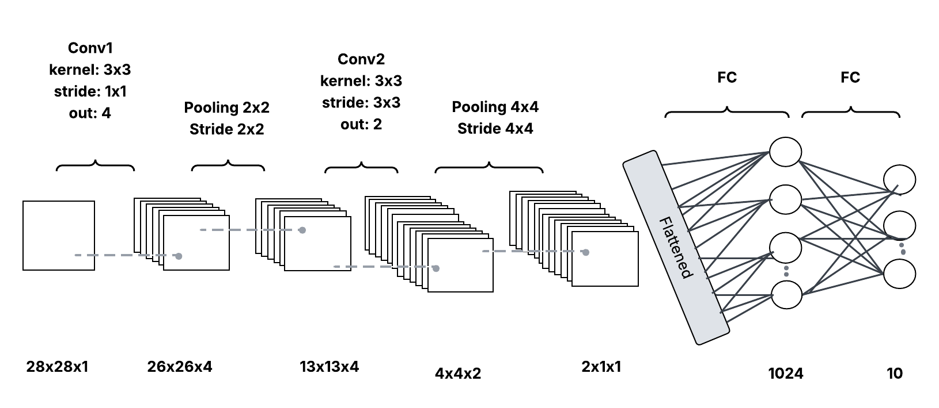
Training Protocol:
- Optimizer: Adam (lr=0.001)
- Batch Size: 64
- Epochs: 10 vs 20 comparison

Evaluation Metrics
- Accuracy Score
- Training Time (seconds)
- Convergence (Epoch-to-epoch improvement rate)

Results and Analysis
Epochs | Features | Last Epoch Accuracy | Last Epoch Time | Last Val Accuracy | Test Accuracy | Total Training Time
10 | 2 | 46.78% | 24.44 seconds | 47.36% | 47.94% | 245 seconds
20 | 2 | 48.34% | 19.78 seconds | 49.04% | 48.54% | 426 seconds

The decreasing training loss and increasing training accuracy show that the model is successfully learning. The validation accuracy is starting to plateau, which indicates that the model is starting to overfit the training data. The low test accuracy also supports the idea that the model's capacity is limited. Increasing the number of epochs did not have a major change to the model performance, it seems to have reached its performance limit.
The required architecture reduces 28×28=784 pixels to just 2 features, losing > 99% of the original information, which explains the around 49% accuracy ceiling despite extended training.
I tried increasing the number of features from 2 to 4, 8, and 32, and I keep getting Runtime Error: mat1 and mat2 shapes cannot be multiplied (64x2 and 8x1024). Changing the number of features did not help the model's performance.

Plots
Below are the plots that will be generated by the program.
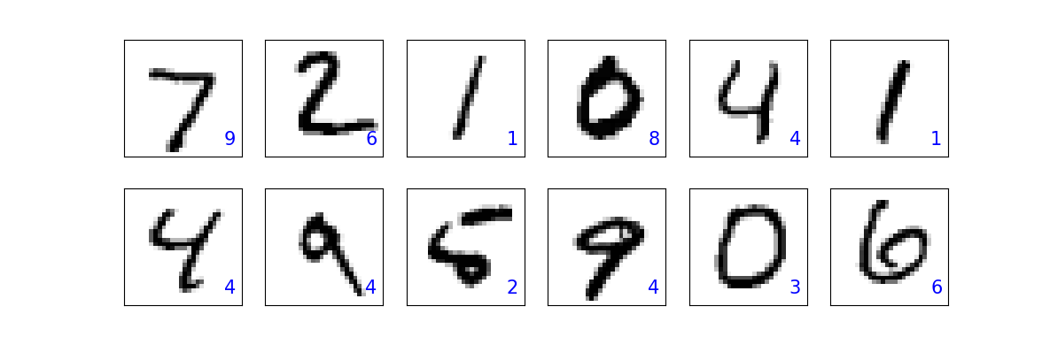
Num_epoch = 10, Features = 2
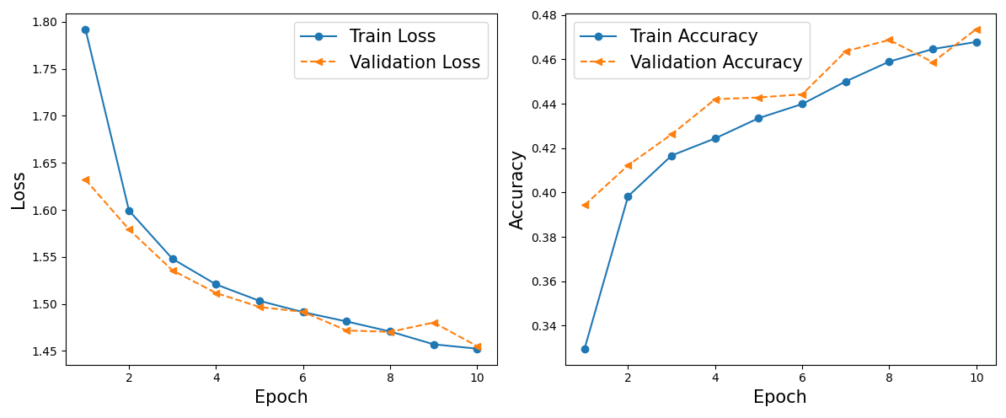

Num_epoch = 20, Features = 2
