Single-layer Linear Neural Networks Report
Introduction
This report analyzes the predictive performance and computational cost of three classification algorithms: Perceptron, Adaline, and Stochastic Gradient Descent (SGD). The evaluation uses the Iris dataset and the Istanbul Stock Exchange dataset, assessing each classifier's accuracy, error/cost trends, and convergence behavior. The influence of learning rate, number of iterations and the importance of feature scaling are also investigated.
Methodology
The classifiers were implemented in Python and evaluated based on the following metrics:
- Accuracy: Percentage of correctly classified instances.
- Error/Cost: Number of misclassifications (Perceptron) and sum-of-squared errors (Adaline, SGD).
- Computational Efficiency: Measured by convergence speed and per-epoch runtime.
- Feature Scaling Impact: Performance comparison with and without feature normalization.
Each classifier is trained for different numbers of iterations (epochs) and learning rates. The error or cost function is plotted against the number of epochs to visualize convergence behavior.
Results and Analysis
The Perceptron quickly achieved 100% accuracy on Iris but had variable on Istanbul, suggesting a linear boundary wasn't ideal. Misclassifications decreased, but high learning rates caused fluctuations. Scaling had little effect, and training time was low. Adaline also got 100% on Iris (high learning rate) but did best on Istanbul (84.51%) with lower rates. Its cost function gradually decreased, and scaling was key for stable, fast convergence. Adaline was more computationally expensive. SGD got 100% on Iris (many iterations) and best on Istanbul (85.97%). Its error fluctuated but generally decreased. Sample-by-sample updates made it faster than Adaline, though convergence was uneven. Scaling was essential, and it was more efficient than Adaline, especially on big datasets.

Plots
Below are a few of the plots that will be generated by the program

Some of the different training rates plottings:
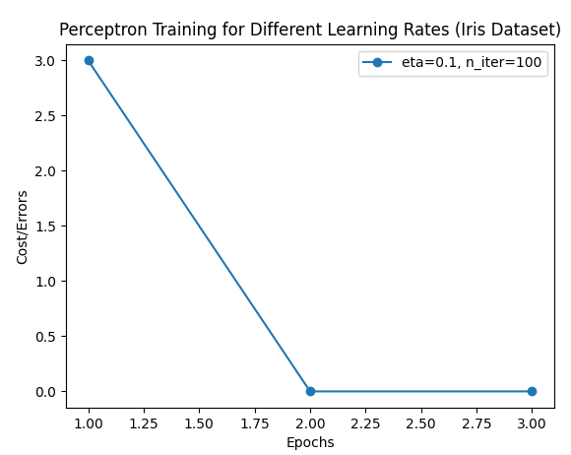
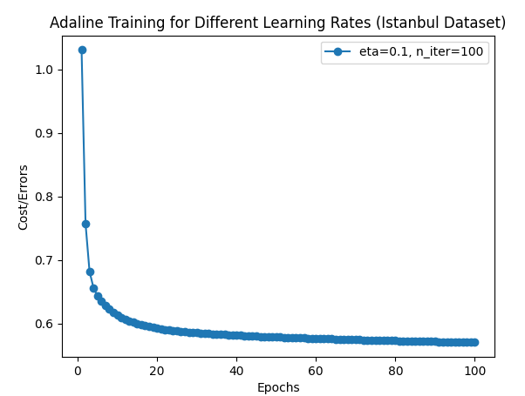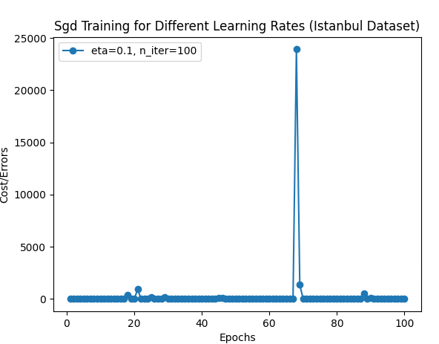

Some of the default plottings:
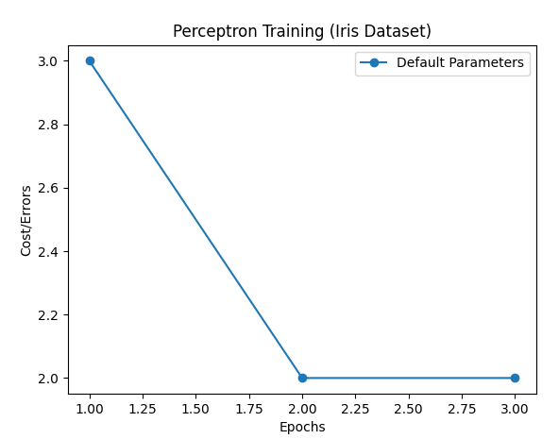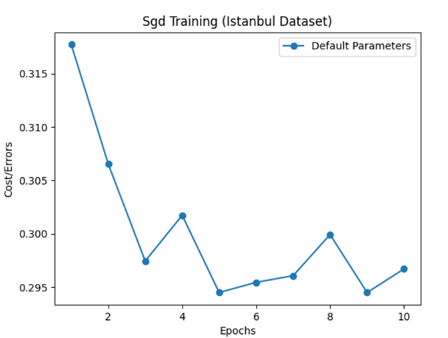
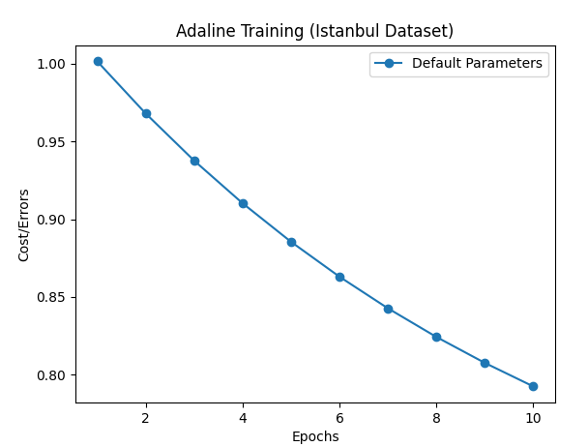
Some of the accuracy plottings:
