3GPP File Writer Design for the Helix™ Architecture∗

Introduction

A File Writer is a component that is used by the Helix™ Media Architecture to lay out media content in a file(s) conforming to a specific file format. Note that the writer does not produce the raw media content, but only organizes it in a file(s) according to a given specification. The file writer is identified by the format of the file it produces. This document describes the design on a 3GPP File Writer that creates a file conforming to the 3GPP file format standard (see document 3GPP TS 26.234 V5.4.0 2003-03). The 3GPP file format is based on the ISO base media file format (see document ISO/IEC 14496-1:2002).

The 3GPP File Format

The 3GPP file format is based on the ISO MP4 file format. The MP4 file format abstracts the media content as a number of elementary streams, where each elementary stream is a consecutive flow of mono-media data. For each such stream, there is an associated meta-data that describes the elementary stream. These meta-data are called traks.

Additionally, we can have what are called hint-streams that contain instructions for packaging the media content so that it can be served using a particular streaming protocol. The hint-stream is specific to a particular protocol (e.g., RTP) and we can have as many hint-streams as possible. Just as for a media stream, we have meta-data associated with the hint-streams. These meta-data are called hint-traks and are similar to the meta-data traks of the normal media data in that they describe the hint-stream. Note that currently, there does not exist a single standard way for specifying the hinting information for a particular protocol. As a result, different standardization bodies have defined their own standards. Thus ISMA has a different hinting specification than some 3GPP. Thus, a hint-trak (or hint-stream) is specified uniquely by a (protocol, flavor) pair, where ‘protocol’ is the streaming protocol for which the hint is written and ‘flavor’ is the hint standard being used. Although, the 3GPP File Writer need not care about other than 3GPP flavor (since it is a 3GPP File Writer, it should always produce hint traks of 3GPP flavor), the input is made general with a view to extending the File Writer to an MP4 File Writer later.

MP4 allows a lot of flexibility in the way the constituent elementary media streams and the associated tracks are arranged. We can have an arrangement where the meta-data can be grouped together and placed in one part of the file while the media data can be placed in the same file preceding or succeeding the meta-data. MP4 also allows other arrangements where we have the elementary streams in different files (even encapsulated in a proprietary protocol packets) and meta-data is in some other file.

MP4 does not restrict the number of constituent streams as well as the way they are physically laid out in the file (e.g., we can have an interleaved physical layout or non-interleaved layout).

The 3GPP file format on the other hand follows the MP4 file format but with certain limitations. To quote 3GPP TS 26.234 V5.4.0 2003-03:

- There shall be no references to external media outside the file, i.e. a 3GP file shall be self-contained;
- The maximum number of tracks shall be one for video, one for audio and one for text;
- The maximum number of sample entries shall be one per track for video and audio (but unrestricted for text);
- Compact sample sizes (‘stz2’) shall not be used;
- Movie fragments shall not be used.

3GPP files end with the .3gp extension. The present design concerns itself with only 3GPP files containing audio and/or video streams only.

The 3GPP file format is object-oriented in that the various media-content and their meta-data are arranged as objects called atoms. Atoms have a type. Different types of atoms are used to store different kinds of data/meta-data. For example the ‘mdat’ type atom is used to store the raw media data, whereas the meta-data are stored using many different types of atoms such as ‘moov’ (the container atom which contains all other meta-data atoms), the ‘trak’ atom (which contain meta-data atoms describing a single stream), etc.

Black-box view of the 3GPP File Writer

We ask the question: How does the user of a file writer use it and what does it produce? The answer to this question is illustrated in the following figure.

The file writer takes as input the media streams, the protocols (along with the flavors) for which hint-traks are required, and the output file name into which the File Writer places the contents according to the 3GPP specifications.
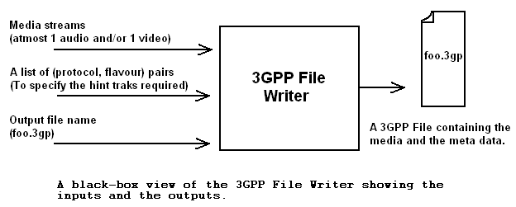

For e.g., the media streams can be AMR (audio), H263 (video), the required hint can be (RTP, 3GPP) and the output file name can be foo.3gp.

Layout of the 3GP File

The ISO/3GPP specifications do not specify how the streams and hint traks could be laid out in the file. They just define their structure. While a wide variety of layouts are possible in MP4, 3GP files are restricted by the fact that the output needs to be in one file only. But, the exact layout in this one file is again not specified.

Consider a 3GP file containing an ARM audio stream, H263 video stream and a RTP hint-stream. The streams and their associated meta-data can be laid out in following distinct ways.

The figure shows two layouts – non-interleaved (or chained) and interleaved. In both cases, the meta-data are laid out at the very end of the file in a non-interleaved fashion. This need not be always followed. Interleaving of the traks is possible as is laying out them in the very beginning of the file.

The proposed design of the Writer should give the user the option of choosing any of the layouts described above.
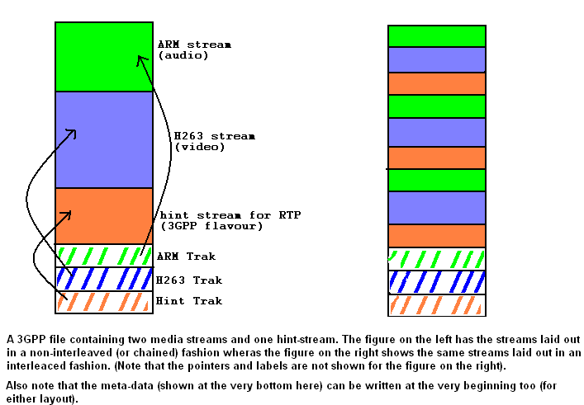

Design of the File Writer

First let’s start with the sequence of operations that are formed on a file writer.

- Initialize the File Writer. Parameters might include the layout of the file, number and type of hint tracks required, etc.
- SetFileHeader: This lets the File Writer to know how many streams are to be expected.
- SetStreamHeader for each of the streams: This gives information about each stream.
- SetPacket: The packet can belong to any of the streams and the packets from the various streams can be interleaved.
- StreamDone for each stream: This tells the Writer than a certain stream has exhausted its packets.

The output at the end must be a 3GPP file with the necessary hint tracks.

We break up the task of handling individual streams and the physical layout of the streams by having separate components for each of these tasks.

The following figure shows the block diagram of the file writer. It shows various functional modules.

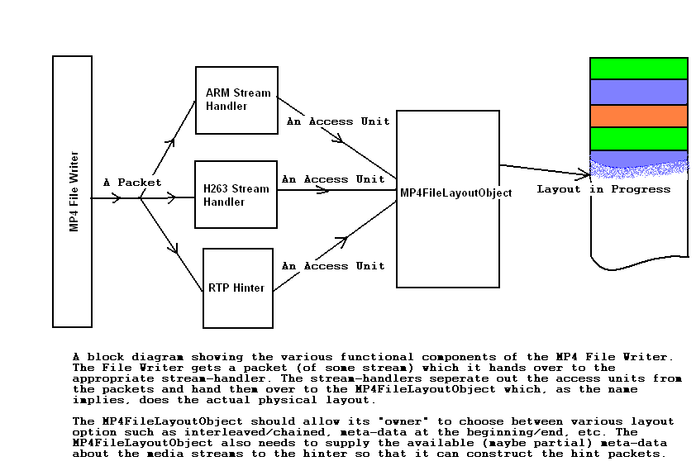

There exists a mime-type specific stream handler for each handler. This is required because the process of separating access units and filling some of the meta-data in the traks requires the knowledge of the particular mime–type. Note that the stream handlers don’t know anything about MP4 file format. Their sole job is to separate access units from packets they receive and to supply some meta-data about the stream (in a generic way, i.e., no need to use atoms or some MP4-specific structure). Finally, we note that these stream handlers can be produced by a StreamHandlerFactory (not shown in the figure) which takes a mime type and produces a StreamHandler for that mime type.

The MP4FileLayoutObject does the actual job of laying out the streams and traks in a way that can be configurable. The MP4FileLayoutObject should also supply some meta-data on the media stream on the fly so as to allow the hinter to form the hint samples. Note that how the MP4FileLayout achieves this is completely hidden from the other components. The MP4FileLayoutObject could write directly in the output file or it could write the streams in separate files and later merge it. Which method it uses is left to it. The only thing required from this component is that it should allow the final layout to be configurable and that it produces an MP4 file according to the specifications and configuration. Note that the MP4FileLayoutObject need not be a separate object, its role could be taken up by the core File Writer object itself.

With, this design in mind, the above sequence of operations on the FileWriter lead to the following actions. The operations have been reproduced for convenience.

- Initialize the File Writer. Parameters might include the layout of the file, number and type of hint tracks required, etc.
  - Create the MP4FileLayoutObject and configure it to produce a layout as specified by the user. Also, specify the chunk size to use.
- SetFileHeader: This lets the File Writer to know how many streams are to be expected.
  - Inform the MP4FileLayoutObject of the number of streams and hint traks it should expect.
- SetStreamHeader for each of the streams: This gives information about each stream.
  - Create a stream handler for each of the streams and initialize them.
    - The stream handler provides the MP4FileLayoutObject with metadata about the stream that the latter can incorporate in the trak associated with the stream.
- SetPacket: The packet can belong to any of the streams and the packets from the various streams can be interleaved.
  - Depending on the stream number of the packet, hand it over to the appropriate stream handler.
    - The stream handler separates access units out of the packets and “dumps” these access units into the MP4FileLayoutObject.
- StreamDone for each stream: This tells the Writer than a certain stream has exhausted its packets.
  - Inform all the stream handlers about the end of the stream packets. The stream handlers in turn inform the MP4FileLayoutObject.
  - The MP4FileLayoutObject wraps up the writing process. It might do some final activities like merging individual stream files, etc.

 This is only a preliminary design. Minor changes are expected during coding phase. For any clarifications on this document, contact the author Pavan Adharapurapu (pavan@cs.ucla.edu).

