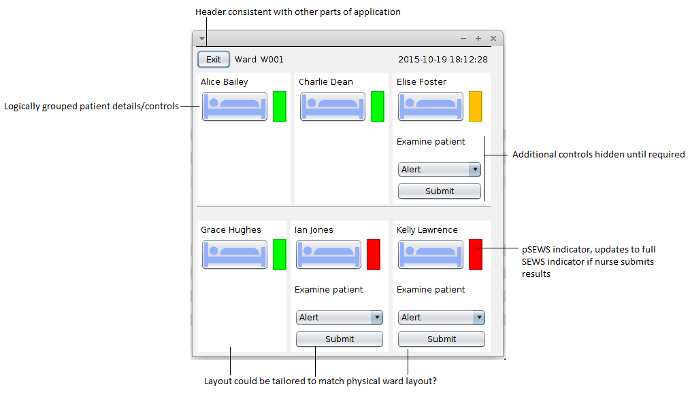
The ward view design is consistent with other parts of the application, having the same header, “click” sound effects, logical grouping of elements and simple/clear layout. Most of this is detailed in the patientview document.

In this windows, however there is more of a focus on interactivity – there are far more buttons and options that can be used. The buttons that allow for the viewing of individual patients are large and easily visible, having an eye-catching image icon to differentiate them from the surrounding controls. The controls allowing the nurse to report on a patient if the pSEWS score is above a threshold are hidden until the pSEWS score breaks that threshold, and will remain there until the nurse examines that patient. Once the nurse enter a response from the patient, and submits it, the pSEWS scores update to full SEWS scores, and the indicators will change colour appropriately. The controls hiding prevents the nurse from accidentally inputting a value when it was not required, and reduces visual clutter. It also prevents any situations where, say, the buttons could be disabled, but still visible, having no effect – an interaction invisible to the user that would cause frustration. An additional benefit is that the appearance of the window changes relatively significantly when a patient needs to be examined, enough to be easily noticeable without requiring a pop-up or other alert which could cause irritation or distraction.

The design is not, however, aesthetically pleasing – an unfortunate consequence of the NetBeans Jframe design interface, which appears to be the antithesis of all HCI design principles. This is (mostly) a cosmetic flaw, however.

