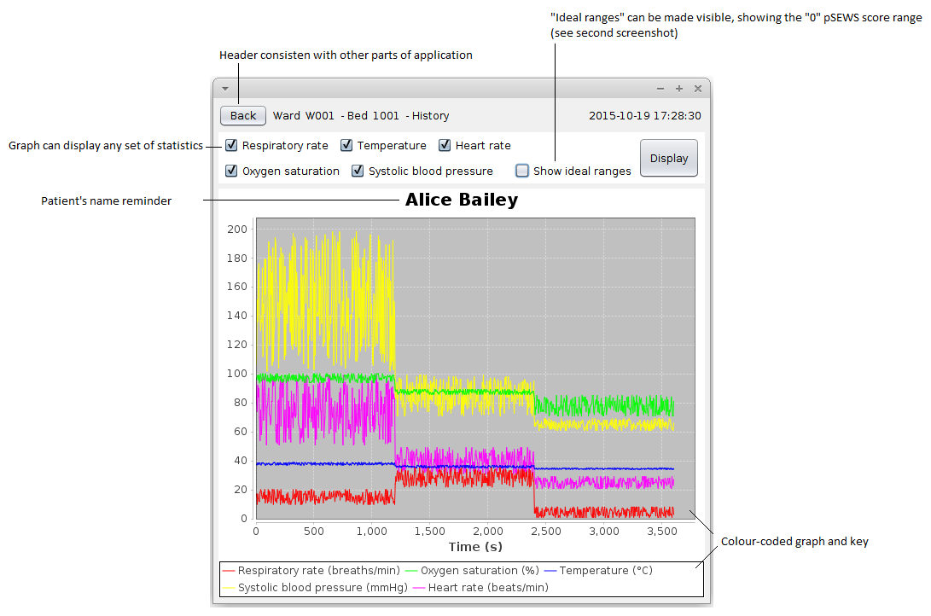
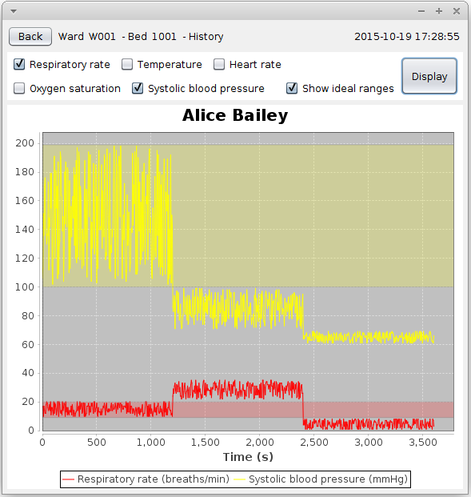
The history view, again, has design consistent with the other parts of the application, described in the patientview document.

The history provides a simple interface to view the progression of the various statistics over the course of the last hour. The graph displayed can be panned, zoomed, and otherwise manipulated to view smaller timeframes and ranges.

The various data sets can be toggled on and off, as well as a set of “ideal range” indicators, which display a semi-transparent overlay on the graph, highlighting the range that the values displayed should ideally occupy. Other than this simple additional functionality, the graph is just a standard graphical view of the data available, which, to a medical practitioner, ought to be sufficient to gain insight into a patients condition.

