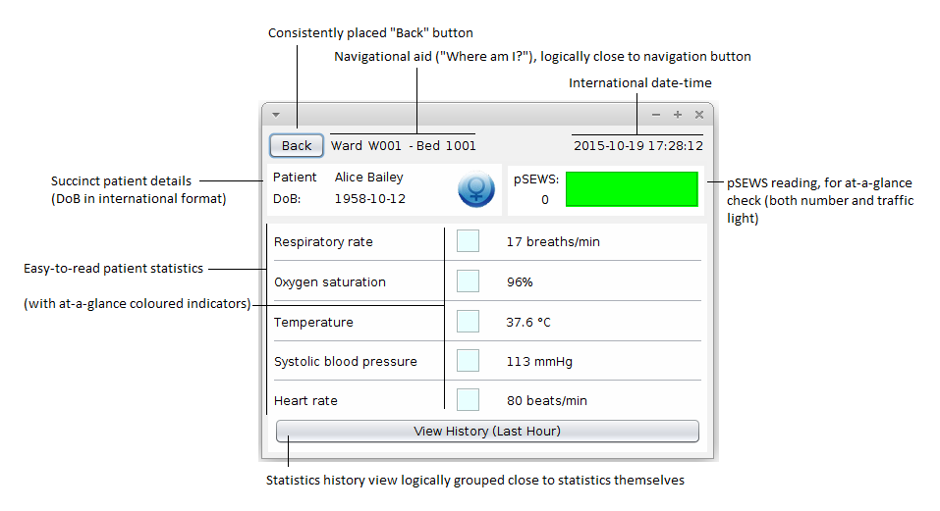
The patient-view interface was designed to be as clean and simple as possible, while still displaying all the information required, and exposing the necessary functionality.

The window shares it's “header” with controls/navigation/time with the other parts of the application, giving a consistent feel where possible.

The controls are simple buttons, their appearance suggesting they can be clicked (or tapped, given the tablet interface) to navigate the application. These buttons provide visual feedback, taking on a depressed look when clicked, and an additional “click” audio clip plays, providing auditory feedback.

The information displayed is all logically grouped. The patient's details are clustered into one area, so assuming the nurse wouldn't need to constantly check the patient's sex/name/DoB, this block can be mentally discounted by the nurse when regularly reading the display. The pSEWS score is visible, along with an easy-to-read traffic-light version – this is the second “logical group.”
The final logical group of information is the live statistics of the patient, where their vital statistics can be read. Coloured indicators, which grow more red, give an at-a-glance version of the information, with the exact readings available. A button to view the last hour of records is part of this group, and gives clear indication of what it does. With these logical groups, the nurse should be able to quickly learn the layout of the information, hopefully easing the learning process of the application.

