

SteamCleaner

Installation



Artifact 1

Curtis Murray

CMPT 395 (AS40)

# Artifact 1: Installation

**Before We Begin**

It is essential that we have all the necessary programs to open and run the project. SteamCleaner is a program built around the Windows OS and was developed and maintained through the use of .sln (solution) files. To open this project, we will need Microsoft Visual Studio which can be downloaded at the following website:

<https://www.visualstudio.com/>

At the time of writing this document, you can also find the GitHub repository for SteamCleaner here:

<https://github.com/Codeusa/SteamCleaner.git>

**Preparing Microsoft Visual Studio**

Once visual studio has been successfully download, go ahead and run the program. You will be greeted with an interface similar to the following:

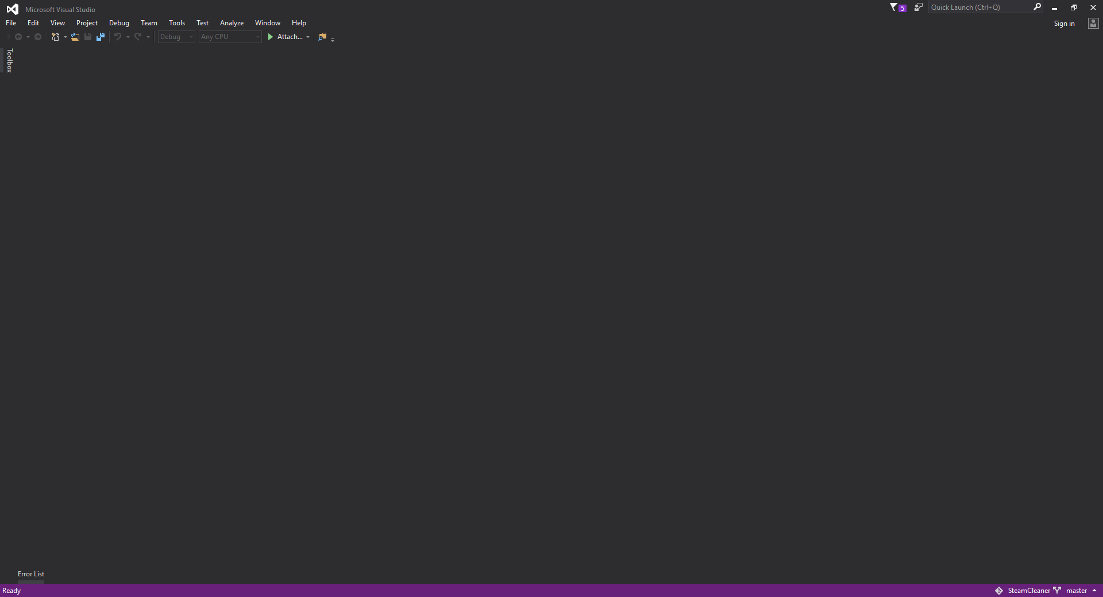

So far so good. Now at this point we could go ahead and open the project solution, but upon attempting to run or debug the program, you may run into credential validation errors telling you that you cannot run the program as an anonymous user. To make sure that we don’t have to deal with these issues, go ahead and click the “Sign in” link at the top-right corner.

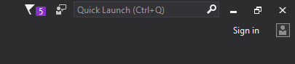

A dialog box will pop up and prompt you to enter in your credentials. Do so now.

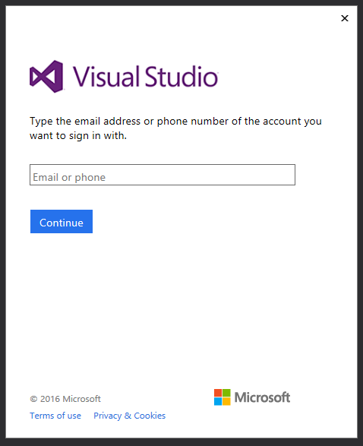

Perfect! Now that we are validated, let’s go ahead and open the .sln. At the top-left corner, go to “File 🡪 Open 🡪 Project/Solution” or press “Ctrl + Shift + O”. Navigate to where you cloned the repository and select the .sln file.

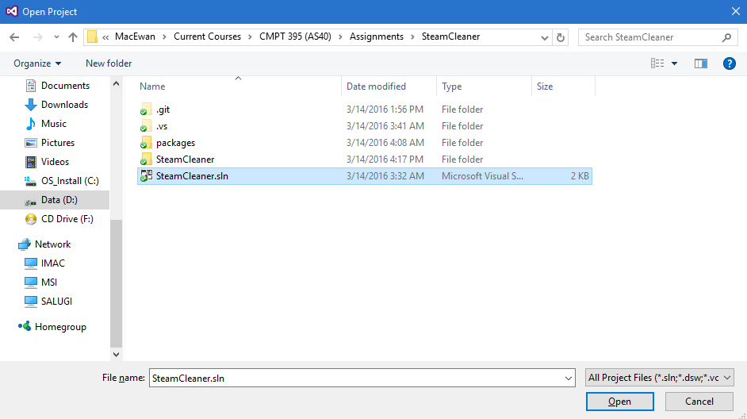

Upon loading the project up, you should now be able to see the entire solution in the Solution Explorer and the Output pane.

*If you do not see the Solution Explorer, you can view it by going to “View 🡪 Solution Explorer” or by pressing “Ctrl + W, S”.*

*If you do not see the Output pane, you can view it by going to “View 🡪 Output” or by pressing “Ctrl + W, O”.*

|  |  |
| --- | --- |
|  |  |

Voila! You can now begin editing and debugging SteamCleaner!