EEE3088F Week 4

Murray Inglis – INGMUR002

Tinashe Timba – TMBTIN004

Ankush Chohan – CHHANK001

Q1 Github [1]

<https://github.com/murrayinglis/EEE3088-group-09>

Q2 Power Subsystem Failure Management [5]

(i)

A duplicate of the 3.3V regulator chip will be included on the board, with test points at the pins of this chip and near the other chip. So if the other 3.3V regulator chip fails, the traces can be scratched or the chip can be removed from the board. The test points can be shorted and the duplicate chip can be used instead.

(ii)

Use thick traces to account for temperature changes and spaced as far possible.

Test points at either side of a trace so that if it’s damaged it can be shorted with a jumper.

(iii)

There are plenty of 3.3V regulator chips available on JLCPCB. One that is also a cheap, basic part and has a similar pinout to our regulator chip is the C14289. As of checking on 13/03/2023 it has 152575 in stock.

(iv)

Test points so components or certain modules in the circuit can be tested or shorted to remove them from the circuit.

Q3 Sensing Subsystem Failure Management [5]

(i)

For the light sensor chip, add a duplicate of the sensor chip with traces to the microcontroller. However, leave out power traces. If the original sensor fails, jumper cables can be used to power this sensor and the traces to the original sensor’s power can be scratched out.

For the battery, the voltage divider resistances may be incorrect or the voltage divider isn’t working as intended. If this occurs, an external resistor voltage divider network can be used and connected using jumper cables. Test points are included at the voltage divider to add this circuit.

Guard traces to prevent interference at the sensor output.

(ii)

Use thick traces to account for temperature changes and spaced as far possible.

Test points at either side of a trace so that if it’s damaged it can be shorted with a jumper.

(iii)

There are plenty of light sensor chips available on JLCPCB. One that has a similar pinout to our light sensor chip is the BH1750FVI. As of checking on 13/03/2023 it has 1202 in stock.

(iv)

Test points so components or certain modules in the circuit can be tested or shorted to remove them from the circuit.

Q4 Microcontroller interfacing Failure Management [5]

(i)

A duplicate of the EEPROM will be included on the board, with test points at the pins of this chip and near the other chip. So if the other 3.3V regulator chip fails, the traces can be scratched or the chip can be removed from the board. The test points can be shorted and the duplicate chip can be used instead.

(ii)

Use thick traces to account for temperature changes and spaced as far possible.

Test points at either side of a trace so that if it’s damaged it can be shorted with a jumper.

(iii)

We have found another EEPROM (C7562) with very similar specifications and the same pinout as the one we designed our circuit around (C6482). This backup component is a cheap, basic part and as of checking on 09/03/2023 it has 32937 in stock.

(iv)

Test points so components or certain modules in the circuit can be tested or shorted to remove them from the circuit.

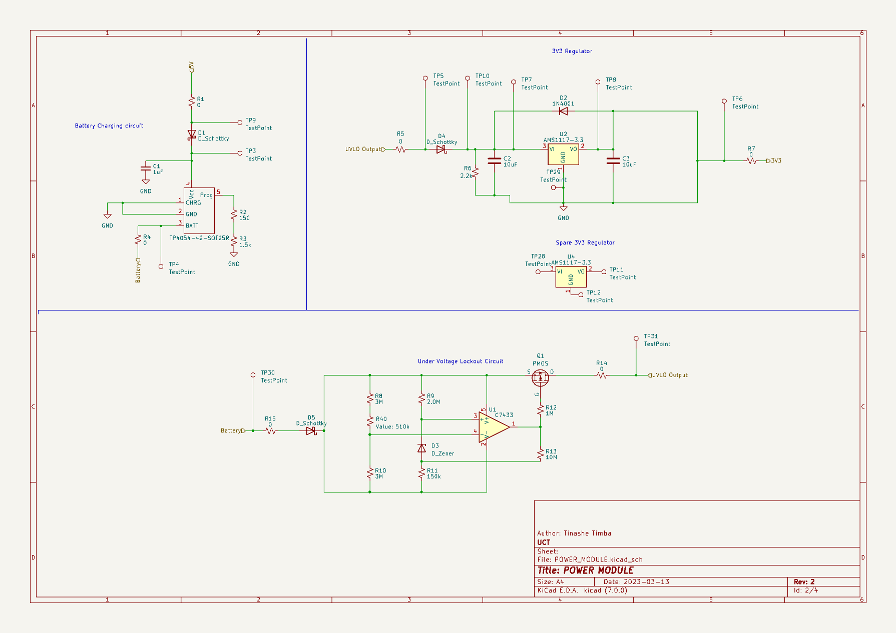Q5 Power Subsystem Schematic [10]

Q6 Sensing Subsystem Schematic [10]

Q7 Microcontroller interfacing Schematic [10]

Q8 Planned ERCs [5]

* Short circuit detection
* Open circuit detection
* Unconnected pin detection
* Clearance checks
* Net list comparison

Q9 Updated BOM [4]

https://github.com/murrayinglis/EEE3088-group-09/blob/main/PCB/SCHEMATICS/BOM.xlsx

|  |  |  |  |  |  |  |
| --- | --- | --- | --- | --- | --- | --- |
| **Reference** | **Value** | **Extended** | **Part** | **Unit price** | **Qty** | **Total** |
| C1, C4, C5 | 1uF |  | C28323 | 0,0058 | 3 | 0,0174 |
| C2, C3 | 10uF |  | C19702 | 0,0066 | 2 | 0,0132 |
| C6 | 3.3nF |  | C1613 | 0,0058 | 1 | 0,0058 |
| D1, D4, D5 | D_Schottky |  | C191023 | 0,0167 | 3 | 0,0501 |
| D2 | 1N4001 |  | C95872 | 0,0069 | 1 | 0,0069 |
| D3 | D_Zener |  | C8056 | 0,0111 | 1 | 0,0111 |
| D6-D8 | LED |  | C2286 | 0,0054 | 3 | 0,0162 |
| MicroXNJ? |  | YES | C404969 | 0,0333 | 1 | 0,0333 |
| Q1 | PMOS |  | C20917 | 0,0864 | 1 | 0,0864 |
| R1, R4, R5, R7, R14-R17, R24, R26, R28-R39 | 0 |  | C4177 | 0,0012 | 22 | 0,0264 |
| R2 | 150 |  | C22808 | 0,001 | 1 | 0,001 |
| R3 | 1.5k |  | C25867 | 0,0005 | 1 | 0,0005 |
| R6, R25, R27 | 2.2k |  | C17520 | 0,0017 | 3 | 0,0051 |
| R8, R10 | 3M |  | C23156 | 0,0013 | 2 | 0,0026 |
| R9 | 2.0M |  | C22976 | 0,0016 | 1 | 0,0016 |
| R11 | 150k |  | C22807 | 0,001 | 1 | 0,001 |
| R12 | 1M |  | C17927 | 0,0031 | 1 | 0,0031 |
| R13 | 10M |  | C26108 | 0,0024 | 1 | 0,0024 |
| R18-R21 | 1k |  | C11702 | 0,0005 | 4 | 0,002 |
| R22, R23 | 100k |  | C17900 | 0,003 | 2 | 0,006 |
| R40 | 510k |  | C11616 | 0,0005 | 1 | 0,0005 |
| TP4054-42-SOT25R? |  |  | C32574 | 0,1433 | 1 | 0,1433 |
| U1 | C7433 |  | C7433 | 0,2804 | 1 | 0,2804 |
| U2, U4 | AMS1117-3.3 | YES | C369933 | 0,0627 | 2 | 0,1254 |
| U3, U5 | LTR-303ALS-01 | YES | C364577 | 0,3887 | 2 | 0,7774 |
| IC1 | CP2102-GMR |  | C6568 | 2,3774 | 1 | 2,3774 |
| U6,U7 | C6482 | YES | C6482 | 0,5172 | 2 | 1,0344 |
| **TOTAL** |  |  |  | **3,9655** | **65** | **5,0309** |