EEE3088F Week 5

Murray Inglis – INGMUR002

Tinashe Timba – TMBTIN004

Ankush Chohan – CHHANK001

Q1 Github [1]

<https://github.com/murrayinglis/EEE3088-group-09>

Branch: main

GERBER Files:

https://github.com/murrayinglis/EEE3088-group-09/tree/main/PCB/SCHEMATICS/GERBERS

Q2 Power Subsystem Failure Management [2]

(i)

A duplicate of the 3.3V regulator chip will be included on the board, with test points at the pins of this chip and near the other chip. So if the other 3.3V regulator chip fails, the traces can be scratched or the chip can be removed from the board. The test points can be shorted and the duplicate chip can be used instead.

(ii)

Use thick traces: We have used 0.5mm traces to account for temperature changes and spaced as far possible.

Test points at either side of a trace so that if it’s damaged it can be shorted with a jumper.

(iii)

There are plenty of 3.3V regulator chips available on JLCPCB. One that is also a cheap, basic part and has a similar pinout to our regulator chip is the C14289. As of checking on 13/03/2023 it has 152575 in stock.

(iv)

Test points so components or certain modules in the circuit can be tested or shorted to remove them from the circuit. The test points are placed at the power input, ground and other inputs and outputs of the circuit in order. This is to account for the component not working or parts of the module circuitry not working.

Q3 Sensing Subsystem Failure Management [2]

(i)

For the light sensor chip, add a duplicate of the sensor chip with traces to the microcontroller. However, leave out power traces. If the original sensor fails, jumper cables can be used to power this sensor and the traces to the original sensor’s power can be scratched out.

For the battery, the voltage divider resistances may be incorrect or the voltage divider isn’t working as intended. If this occurs, an external resistor voltage divider network can be used and connected using jumper cables. Test points are included at the voltage divider to add this circuit.

Guard traces to prevent interference at the sensor output.

(ii)

Use thick traces to account for temperature changes and spaced as far possible.

Test points at either side of a trace so that if it’s damaged it can be shorted with a jumper.

(iii)

There are plenty of light sensor chips available on JLCPCB. One that has a similar pinout to our light sensor chip is the BH1750FVI. As of checking on 13/03/2023 it has 1202 in stock.

(iv)

Test points so components or certain modules in the circuit can be tested or shorted to remove them from the circuit. The test points are placed at the power input, ground and other inputs and outputs of the circuit in order. This is to account for the component not working or parts of the module circuitry not working.

Q4 Microcontroller interfacing Failure Management [2]

(i)

A duplicate of the EEPROM will be included on the board, with test points at the pins of this chip and near the other chip. So if the other 3.3V regulator chip fails, the traces can be scratched or the chip can be removed from the board. The test points can be shorted and the duplicate chip can be used instead.

(ii)

Use thick traces to account for temperature changes and spaced as far possible.

Test points at either side of a trace so that if it’s damaged it can be shorted with a jumper.

(iii)

We have found another EEPROM (C7562) with very similar specifications and the same pinout as the one we designed our circuit around (C6482). This backup component is a cheap, basic part and as of checking on 09/03/2023 it has 32937 in stock.

(iv)

Test points so components or certain modules in the circuit can be tested or shorted to remove them from the circuit. The test points are placed at the power input, ground and other inputs and outputs of the circuit in order. This is to account for the component not working or parts of the module circuitry not working.

Q5 Power Subsystem Schematic [2]

The updated schematic for the power subsystem includes the battery holder (which will be “Do Not Populate” on the board). The battery holder is needed as a power source for the ERCs.

Power flags are also included for labelling GND and power sources for passing the ERCs.

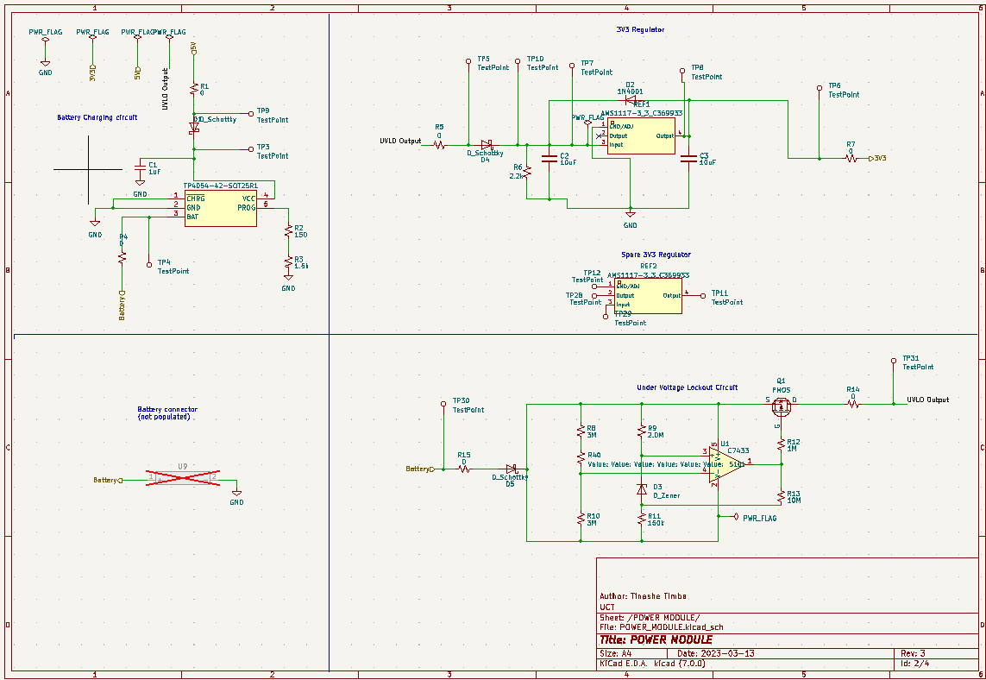The schematic symbol for the 3V3 regulator was changed to match the footprint.

Q6 Sensing Subsystem Schematic [2]

No changes made.

Q7 Microcontroller interfacing Schematic [2]

Added the symbol for the microcontroller and headers. These are both “Do Not Populate”. The symbol is only there so that the footprint is printed onto the PCB.

The 1x24 connectors were added to allow jumper cables to easily be connected to the STM. The connectors themselves are “Do not populate” as we will solder them on ourselves once the board is made.

Q8 Updated ERCs [2]

* Short circuit detection
* Open circuit detection
* Unconnected pin detection
* Clearance checks
* Net list comparison

Note: the exclusions were for the spare components that we included that are only connected to test points.

Q9 DRCs [2]

* Clearance checks
* Minimum track width checks
* Silkscreen checks
* Hole size checks
* Mask-to-pad clearance checks
* Solder mask expansion checks

Q10 Updated BOM [5]

https://github.com/murrayinglis/EEE3088-group-09/blob/main/PCB/SCHEMATICS/BOM.xlsx

|  |  |  |  |  |  |  |
| --- | --- | --- | --- | --- | --- | --- |
| **Reference** | **Value** | **Extended** | **LCSC** | **Unit price** | **Qty** | **Total** |
| C1, C4, C5 | 1uF |  | C28323 | 0,0058 | 3 | 0,0174 |
| C2, C3 | 10uF |  | C19702 | 0,0066 | 2 | 0,0132 |
| C6 | 3.3nF |  | C1613 | 0,0058 | 1 | 0,0058 |
| D1, D4, D5 | D_Schottky |  | C191023 | 0,0167 | 3 | 0,0501 |
| D2 | 1N4001 |  | C64898 | 0,0071 | 1 | 0,0071 |
| D3 | D_Zener |  | C8056 | 0,0111 | 1 | 0,0111 |
| D6-D8 | LED |  | C2286 | 0,0054 | 3 | 0,0162 |
| IC1 | CP2102-GMR |  | C6568 | 2,3774 | 1 | 2,3774 |
| MicroXNJ1 |  | YES | C404969 | 0,0333 | 1 | 0,0333 |
| Q1 | PMOS | YES | C2959854 | 0,0851 | 1 | 0,0851 |
| R1, R4, R5, R7, R14-R17, R24, R26, R28-R34 | 0 |  | C17168 | 0,0005 | 17 | 0,0085 |
| R2 | 150 |  | C22808 | 0,001 | 1 | 0,001 |
| R3 | 1.5k |  | C25867 | 0,0005 | 1 | 0,0005 |
| R6, R25, R27 | 2.2k |  | C17520 | 0,0017 | 3 | 0,0051 |
| R8, R10 | 3M |  | C23156 | 0,0013 | 2 | 0,0026 |
| R9 | 2.0M |  | C22976 | 0,0016 | 1 | 0,0016 |
| R11 | 150k |  | C22807 | 0,001 | 1 | 0,001 |
| R12 | 1M |  | C17927 | 0,0031 | 1 | 0,0031 |
| R13 | 10M |  | C26108 | 0,0024 | 1 | 0,0024 |
| R18-R21 | 1k |  | C11702 | 0,0005 | 4 | 0,002 |
| R22, R23 | 100k |  | C17900 | 0,003 | 2 | 0,006 |
| R40 | 510k |  | C11616 | 0,0005 | 1 | 0,0005 |
| REF1, REF2 | AMS1117-3_3_C369933 | YES | C369933 | 0,0646 | 2 | 0,1292 |
| TP4054-42-SOT25R1 |  |  | C32574 | 0,1433 | 1 | 0,1433 |
| U1 | C7433 |  | C7433 | 0,2804 | 1 | 0,2804 |
| U3, U5 | LTR-303ALS-01 | YES | C364577 | 0,3887 | 2 | 0,7774 |
| U6, U7 | EPROM | YES | C6482 | 0,4906 | 2 | 0,9812 |
| **TOTAL** |  |  |  |  |  | **4,9625** |

Including the cost for 5 boards and for the 5 extended parts:

Total budget:

4.9625*5 + 3*5 = $39.8125

Q11 PCB [15]

Front layout and routing

Back copper routing

SilkScreen

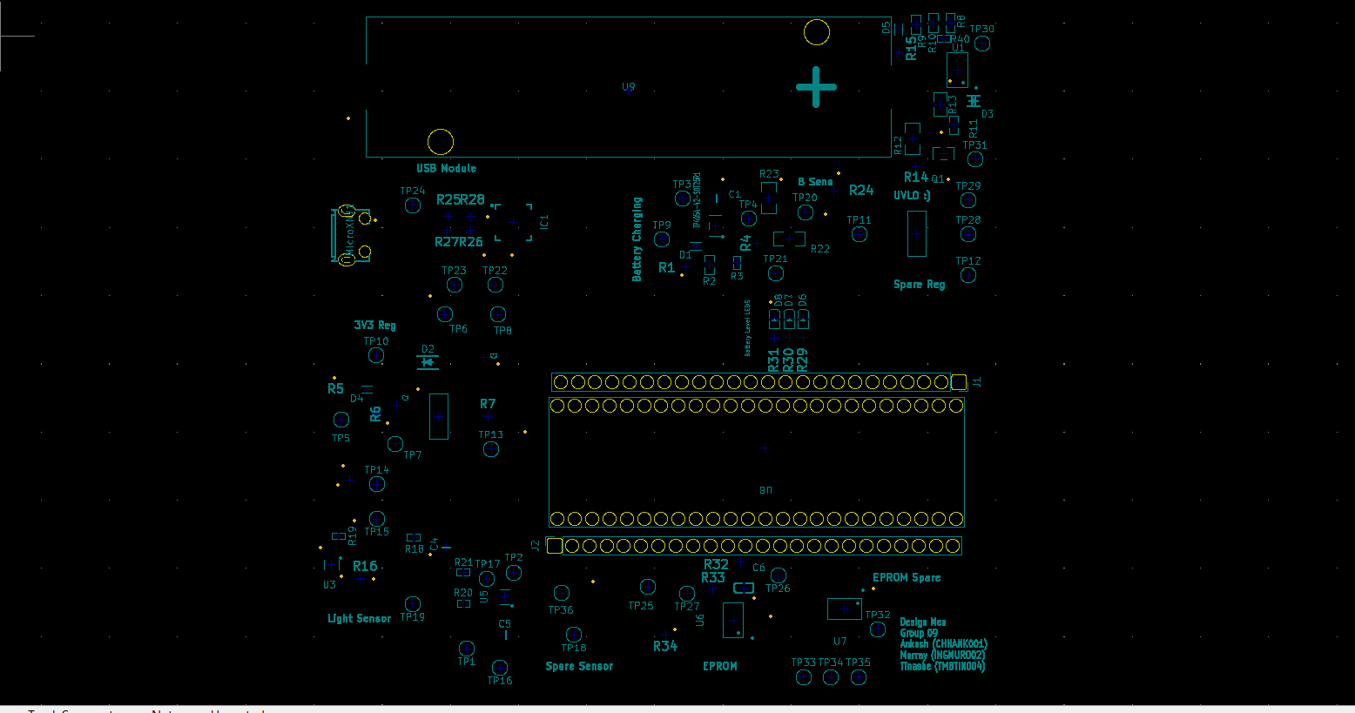

3D image

