Predictors for Growth Mindset and Sense of Belonging in College Students

December 7, 2017

FIGURES

Figure 1: Mindset Responses
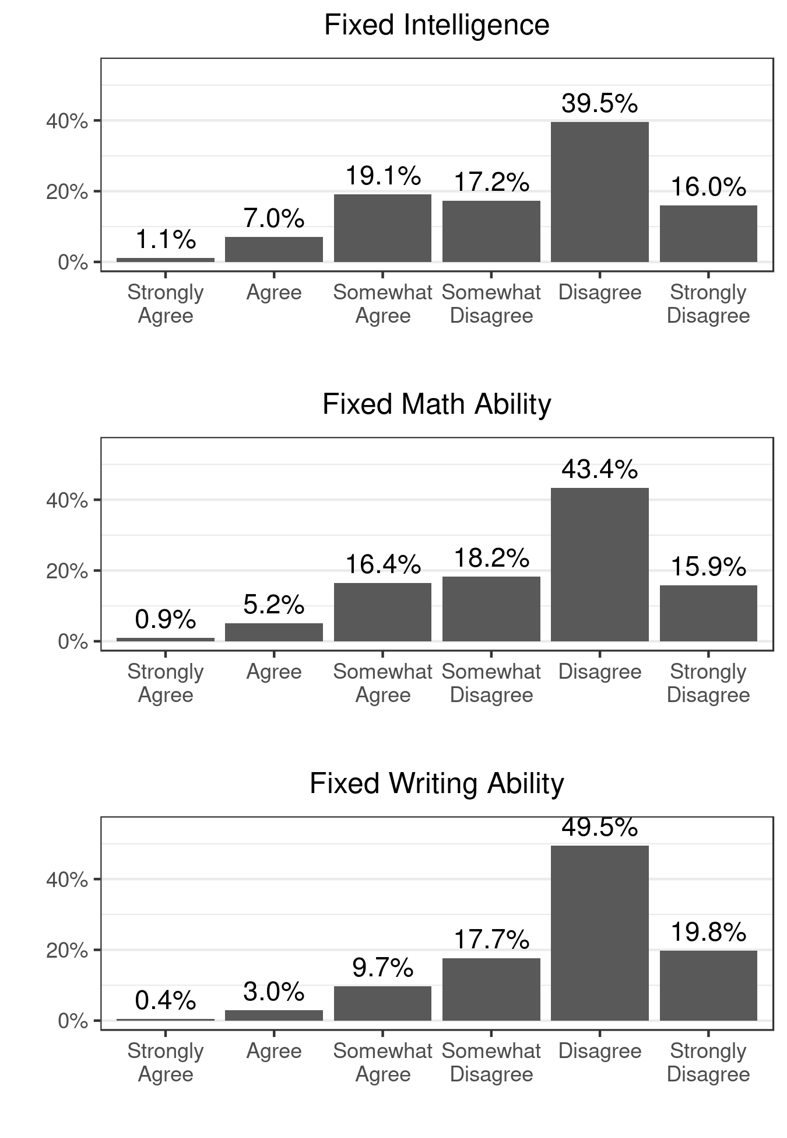
* Sample size: 2,305. The categories of agreement from left-to-right on the horizontal axis correspond to attitudes changing from more fixed intelligence to more growth potential.

Figure 2: Scatterplots of Mindset Variables with Their Common Factor
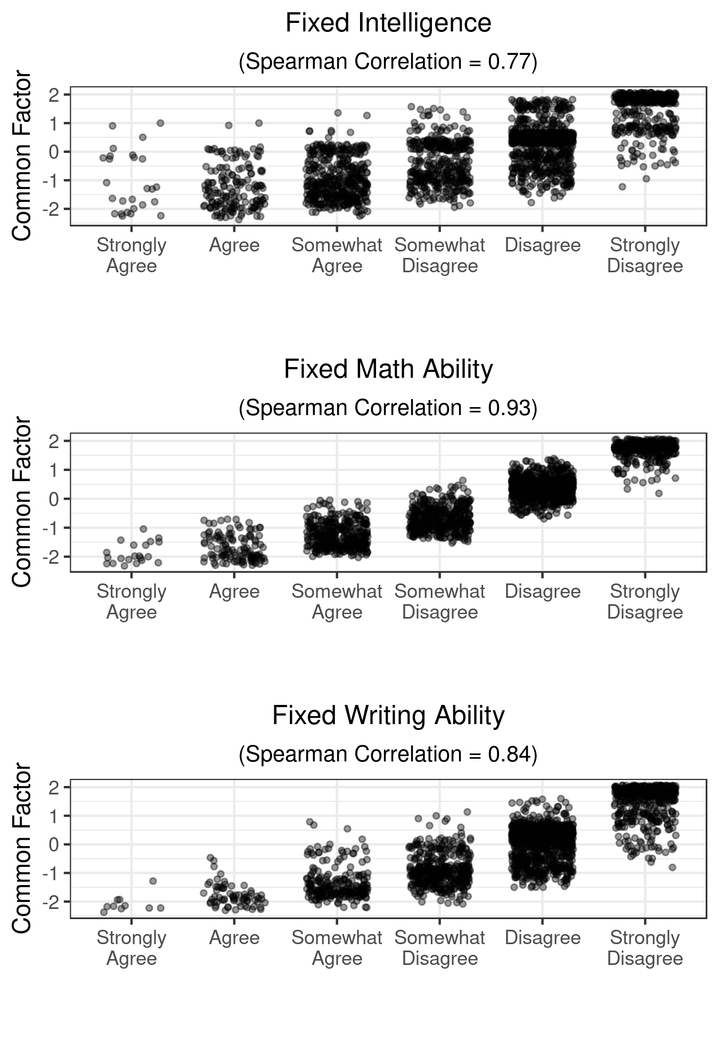
* Sample size is 2,305. To avoid overplotting, the horizontal scale for level of agreement includes jittering on a uniform scale with width equal to 0.3 times the width of the categories.
Figure 3: Belonging Responses
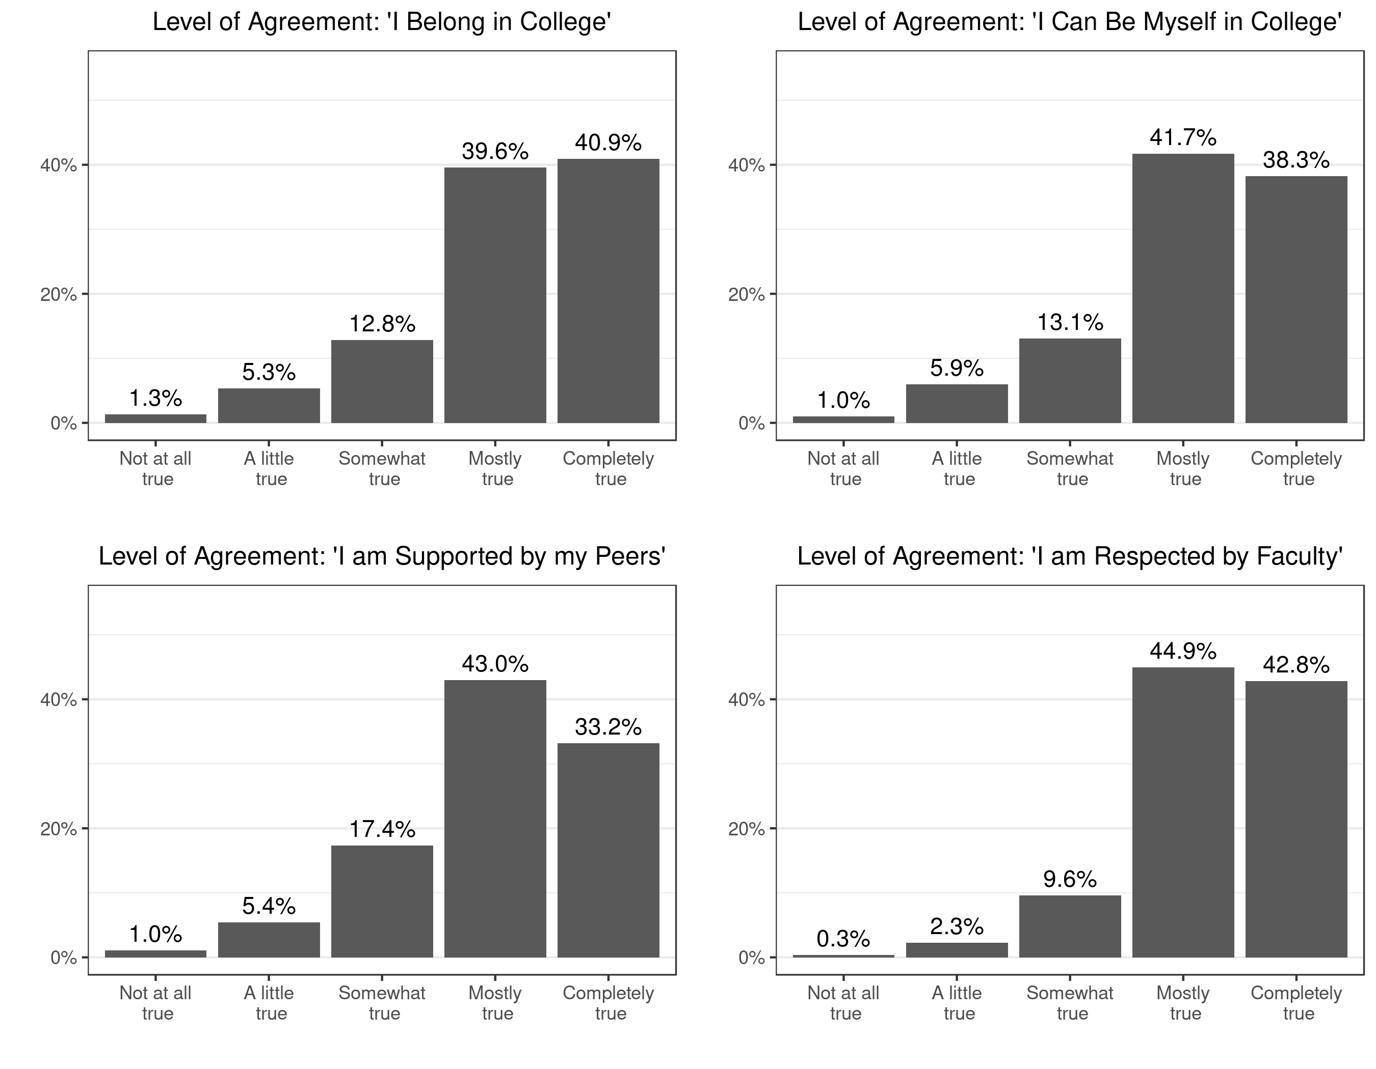
* Sample size: 2,305. Categories from left to right indicate higher levels of belonging.

Figure 4: Scatterplots of Belonging Variables with Their Common Factor
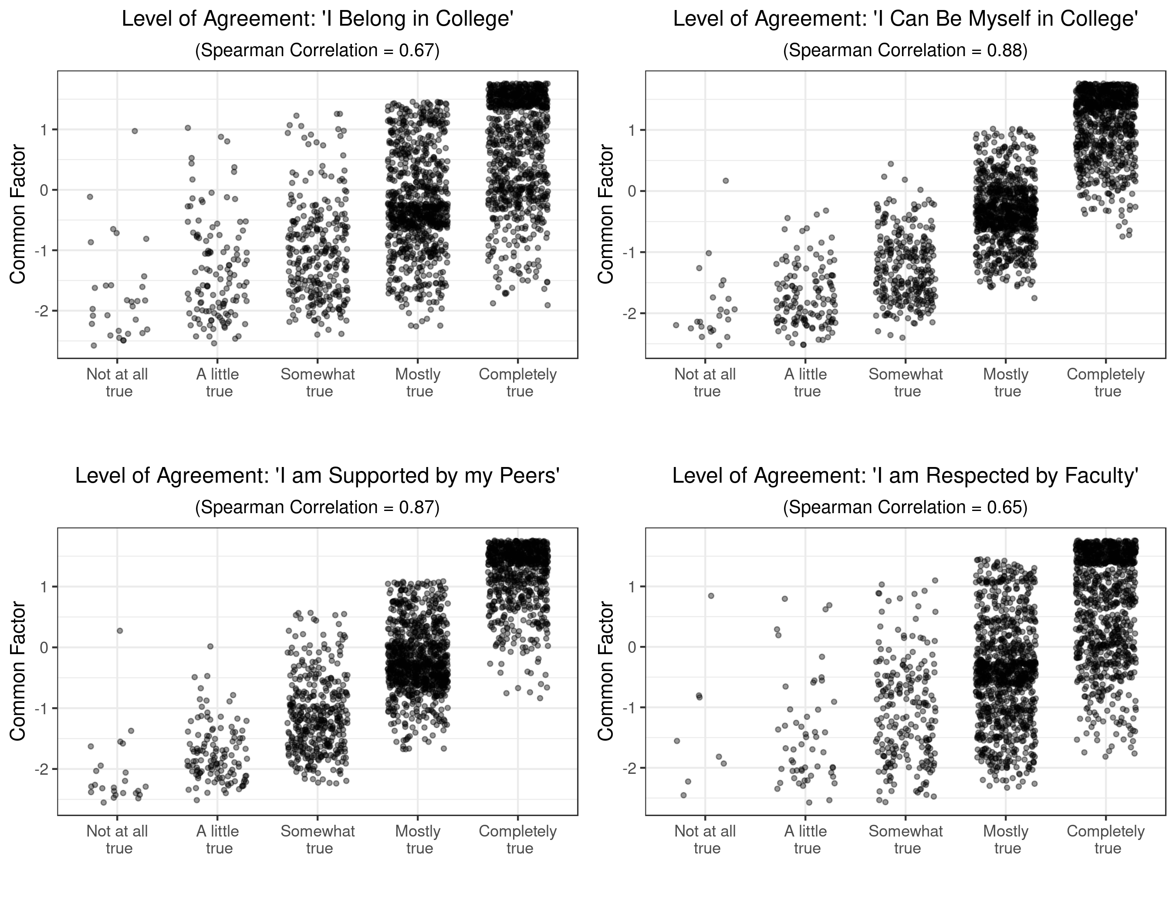
* Sample size is 2,305. To avoid overplotting, the horizontal scale for level of agreement includes jittering on a uniform scale with width equal to 0.3 times the width of the categories.

Figure 5: Distribution of Responses on Confidence and Perseverance
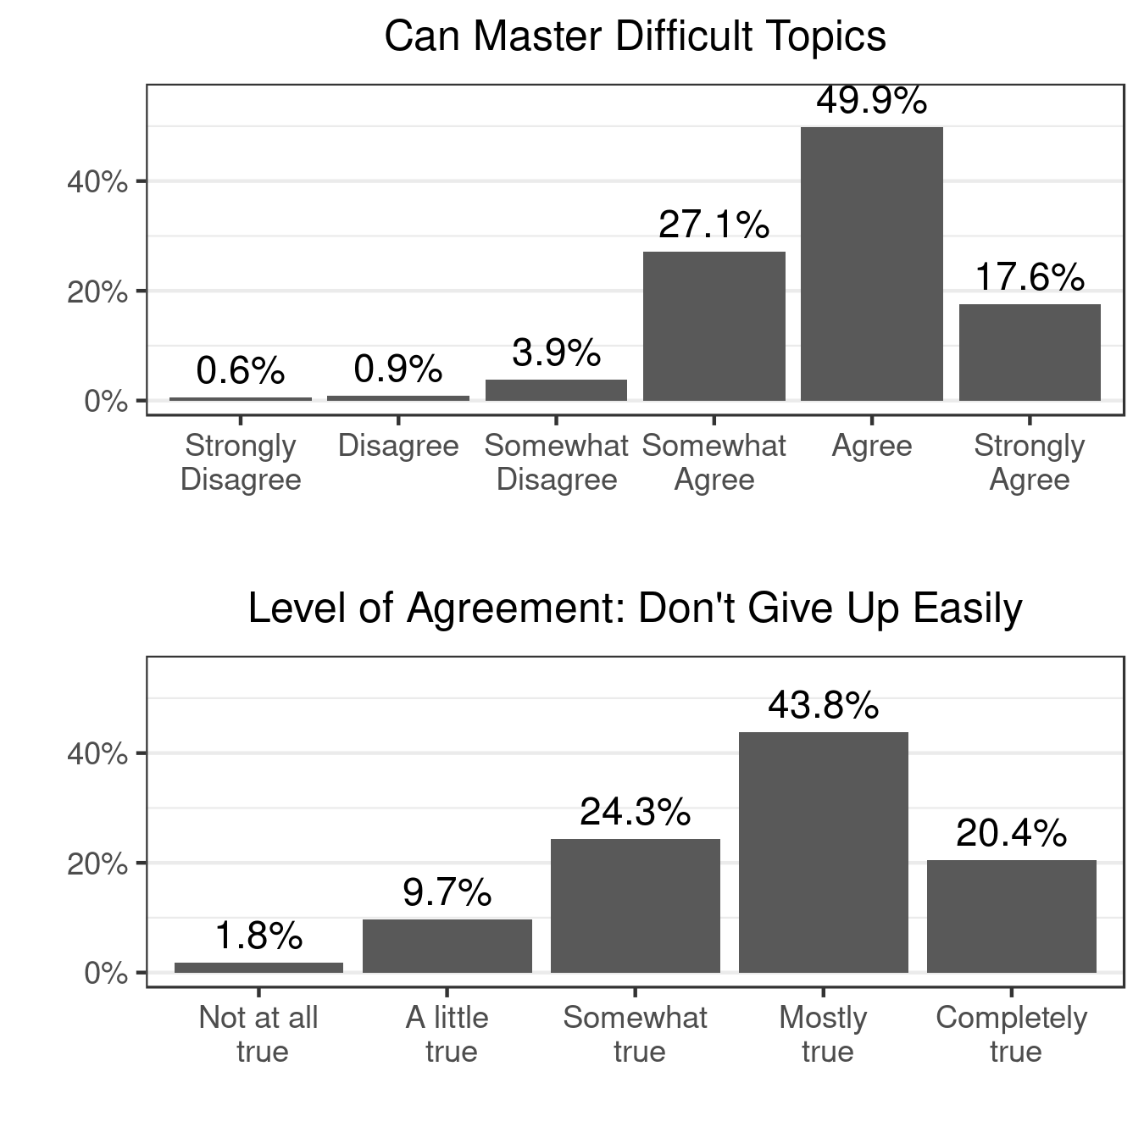
* Sample size: 2,305. Categories from left to right indicate attitudes that
are more conducive to learning.

