Predictors for Growth Mindset and Sense of Belonging in College Students

James M. Murray[1]

College of Business Administration

University of Wisconsin – La Crosse

Sloan Komissarov

Western Technical College

Brenda L. Murray

Department of Economics

University of Wisconsin – La Crosse

Sara L. Cook

College of Education, Science, and Mathematics

Viterbo University

September 16, 2019

**Abstract:**

|  |
| --- |
| Mindset and sense of belonging are important predictors for college student success. This paper describes measures of several dimensions of mindset and belonging and other educational and demographic background information for more than 2,000 students at two four-year universities. We use a factor analysis model to construct overall measures for mindset and belonging and explore explanatory factors. The findings include that formative instructor feedback on writing leads to improvements in mindset and belonging, and feedback on writing even improves students’ mindset regarding mathematics. There is an association between mindset and students’ progress in college, parents' education, race, and major.    Keywords: Mindset, belonging, student writing, feedback, regression |
|  |

**1 Introduction**

In her influential books on mindset, confidence, and motivation, Dweck (1999, 2016) defines mindset as one’s “self-theories” or self-perceptions of how learning works and what it means for their potential. People with a fixed mindset have the attitude that some people are naturally good at some skills and others are not. People with a fixed mindset fail to appreciate the potential that expending effort can have for improving or learning new skills. With a fixed mindset, a success or failure is understood as a validation of one’s ability rather than as an opportunity to improve one’s intelligence or skills (Aditomo (2015).Confronted with challenges, these people are more likely to fall into a trap of self-defeating helplessness. People with a growth mindset view intelligence as malleable. They recognize that putting forth effort in the face of challenges can lead to improvement in their knowledge and skills. Dweck (1999), Blackwell et al. (2007), and Aditomo (2015), and others find that a growth mindset helps prevent drops in motivation and leads to an increase in student effort in the face of setbacks. Aronson et al. (2002) and Dweck (2015) find that classroom interventions designed to encourage a growth mindset results in greater gains in academic achievement, especially among students at risk of lower academic achievement.

A student’s mindset also influences the impact that instructor feedback has on her or his performance. Mangels et al. (2006) measure electrophysiological responses in the brain following corrective instructor feedback and find evidence that individuals with a fixed mindset have less memory-related activity in response to the feedback than individuals with a growth mindset. They also find that people with a fixed mindset have feelings of worry regarding proving themselves relative to their peers. Aditomo (2015) focuses on an undergraduate statistics course and finds that students with a growth mindset are more likely than those with fixed a mindset to succeed and less likely to lose motivation in the event of a setback in their exam grades. These findings are consistent with conclusions by Martin (2006) and (2011), and Martin and Liem (2010) that show that students respond positively to performance goals that are framed as out-performing their own previous efforts.

Sense of belonging can commonly be described as a student’s perception that he or she is accepted, respected, and encouraged by both peers and faculty in the academic setting. As Goodenow (1993) describes it, a student that has a strong sense of belonging likely feels that he or she is a member of a community and feels connected with and supported by others within that community. Strayhorn (2012) describes having a sense of belonging as a basic human need that must be met before higher order goals can be achieved, such as attainment of knowledge in an academic setting.

Hausmann et al. (2007) demonstrate that sense of belonging in first year college students influences a number of academic outcomes including retention, persistence, and achievement. Strayhorn (2012) describes an interdependent relationship between belonging and academic and social involvement, each enhancing the other, or a lack in each having a detrimental effect on the other. Long and Ostrove (2007) show that students lacking a sense of belonging are less likely to participate in class and less willing to seek help from faculty or other resources on campus, which may negatively impact academic outcomes. However, Carter and Hurtado (1997) find that among Latino students, sense of belonging is not related to GPA, even though involvement in academic activities such as discussing course content with others outside of class can improve a student’s sense of belonging.

Multiple demographic factors, including race, gender, and parents’ education, have been shown to influence sense of belonging among college students. Carteer and Hurtado (1997) find that sense of belonging is an especially important factor in academic success among students who may perceive themselves as outside the mainstream student population. For example, students of color at predominantly white institutions, and female students in science, technology, math, and engineering programs may feel a sense of not belonging. Long and Ostrove (2007) find that students from working class backgrounds tend to have a lower sense of belonging than those from higher social class backgrounds where parents have higher levels of both income and education.

Aside from demographic factors, student-faculty interactions can also affect students’ sense of belonging on campus. Andermann et al. (2007) and Hoffman et al. (2002) find that instructor support improves students’ sense of belonging. Open lines of communication between faculty and students increase student motivation and, in turn, enhance sense of belonging. Carter and Hurtado (1997) conclude that frequency of talking with faculty and others about course content and faculty interest in student development have positive effects on sense of belonging.

The purpose of this paper is to identify demographic and educational factors that influence mindset, belonging, and related attitudes on learning including confidence and perseverance. We further identify whether a common form of student-instructor interaction can improve these attitudes. We focus on formative instructor feedback on writing, specifically early drafts of writing before a grade for the work is assigned. This is one type of instructor-student interaction that is highly personalized for students, that occurs throughout the curriculum, and that is present in nearly all disciplines and every level of post-secondary education. The literature above suggests that interactions of this nature should positively influence both mindset and sense of belonging in college students. There is literature that demonstrates feedback on writing positively impacts learning. Anderson et al. (2016) learned from tens of thousands of responses nationwide from the National Survey of Student Engagement that interactive writing practices involving students interacting and receiving feedback on writing from their instructor and peers led to higher perceived integrative and reflective learning experiences and higher gains in acquiring job related skills, including working effectively with others, using computer and information technology, and solving real-world problems. Ekholm et al. (2015) find that students’ perceptions of instructor feedback on writing are positively related to their self-regulation behaviors, such as their ability to set goals and work toward them, behaviors that are also positively associated with a growth mindset (Dweck 1999, 2016).

Using results of a survey from approximately 2,000 students at two Midwestern universities, one public regional comprehensive university and one private liberal-arts university, we find robust evidence that this is true. Giving feedback on early drafts of writing is a practice that nearly all instructors have some experience with and that many instructors can afford to enhance in their classes. We find strong evidence that this simple intervention, even if time consuming, can lead to an improvement in many attitudes related to learning.

The results of the paper are further useful to instructors in identifying sub-populations of students that are associated with better or worse attitudes to learning. We reach much of the same conclusions as the literature on belonging that students of color and first-generation students have a lesser sense of belonging than their peers. While we fail to find evidence for a difference between sense of belonging among students at our public university versus our private university, we do find significant interaction of a positive effect between the private school and first-generation students. That is, while we find that first-generation students have a lesser sense of belonging in college than their peers, the sense of belonging among first-generation students, specifically, is better at the smaller, private university. We find some mixed evidence that race and parents’ education influence mindset, but rather than finding typically at-risk student populations at risk for worse attitudes, we find some evidence that first-generation students and racial minorities mindset that leans more toward growth than their peers.

In the next section of this paper we discuss the survey and sample; the outcome variables related to mindset, belonging, confidence, and perseverance; and the explanatory variables that may influence these. We also use the results from our several survey questions related to mindset and belonging to construct broad measures for underlying factors influencing mindset and belonging. In Section 3 we estimate and discuss a number of regression models to answer how feedback and demographic and educational characteristics influence mindset, belonging, confidence, and perseverance. In Section 4 we conclude.

**2 Survey and Data**

We measured mindset, belonging, and other attitudes important for learning using a survey administered in Spring 2017 to all undergraduate students in traditional programs at the University of Wisconsin – La Crosse (UWL) and Viterbo University. UWL is a public, regional comprehensive university comprised of approximately 10,000 undergraduate students and 800 graduate students. Viterbo University is a smaller, private, Catholic university with a liberal arts tradition with approximately 2,000 undergraduate students and 800 graduate students. Both universities are in La Crosse, Wisconsin and serve the predominately the same geographical area, with a large portion of students at both Universities coming from the state of Wisconsin. In addition to being a smaller university, Viterbo University enjoys a smaller student-faculty ratio (Viterbo is 11:1 vs UW La Crosse is 19:1) and smaller average class size (Viterbo is 16 vs UWL is 28). We expect institutional differences like these may lead to differences in learning and attitudes, and we investigate some of these possibilities below.

The survey included questions on attitudes related to mindset, belonging, confidence, and perseverance; educational and demographic background; and a question relating to instructor feedback on writing. There were 2,305 survey submissions with complete responses to nine questions on attitudes related to mindset, belonging, perseverance, and confidence, which corresponds to an approximately 20% response rate.

**2.1 Mindset**

We measured attitudes on mindset by asking students to rate their level of agreement on the following three statements related to ability to learn and improve math skills, writing skills, and general knowledge:

* You can learn new things, but you can't really change how smart you are.
* You have a certain amount of math ability and you can't do much to change it.
* You have a certain amount of writing ability and you can't really do much to change it.

Students rated each of these statements on the following six-point scale:

|  |  |  |
| --- | --- | --- |
| (6) Strongly disagree | (4) Somewhat disagree | (2) Agree |
| (5) Disagree | (3) Somewhat agree | (1) Strongly agree |

Larger levels of disagreement correspond to an attitude toward learning that emphasizes potential for growth in intelligence rather than fixed a fixed intelligence.

The wording of these survey questions is nearly identical to how others measure mindset in the literature cited above, and the six-point scale is the same. It is common phrase the statements in general terms like the first question, rather than specific to writing or mathematics. Dweck (2008) describes the role of mindset in mathematics and science and uses the mathematics-specific phrasing we do in our second question. She notes an informal finding that students’ mindsets tend to be more fixed regarding math skills than other intellectual skills. Since this paper explores the impact that instructor feedback on writing can have on mindset, we include our last question on mindset regarding writing skills.

Figure 1 illustrates the distribution of students' responses to these three statements on mindset. The categories of agreement from left-to-right on the horizontal axis correspond to attitudes changing from more fixed intelligence to more growth potential.

The distribution of responses is similar for all three statements. A majority of students indicated some level of disagreement for each statement and the modal response for each is "disagree." This implies that a majority of students in the sample have a mindset that leans toward a growth outlook. Still, a large minority that includes hundreds of students revealed opinions consistent with a fixed mindset. On the first statement that read in part, "you can't change how smart you are," 27.2% of the sample, which is 627 respondents, indicated some level of agreement. On the math statement, 22.5% of the sample, or 519 respondents, gave opinions suggesting a fixed mindset. A relatively smaller number of students had a fixed mindset regarding the ability to improve their writing. Only 13.1% of the sample, or 302 respondents, revealed opinions suggesting a fixed mindset on improving writing skills.

We construct an overall measure of mindset by estimating a factor analysis with one factor. Since we have ordinal data, we estimate the factor analysis by decomposing the Spearman correlation matrix and construct the scores using the Bartlett weighted least squares method with the standardized ranks of the data as the dependent variable. We order the categories so that low ranks are associated with a fixed mindset and high ranks are associated with a growth mindset. The common factor is normalized to have zero mean and unit standard deviation.

The results of the factor analysis are presented in Table 1. The factor loadings for all three variables are between 0.7 and 0.87 indicating a high degree of correlation between the three mindset variables and the common factor. The percentage of variability in the three mindset variables that is explained by the single common factor is 62.2%. The uniqueness statistics describe the percentage of the variability in each individual mindset variable that is not explained by the

Figure 1: Mindset Responses

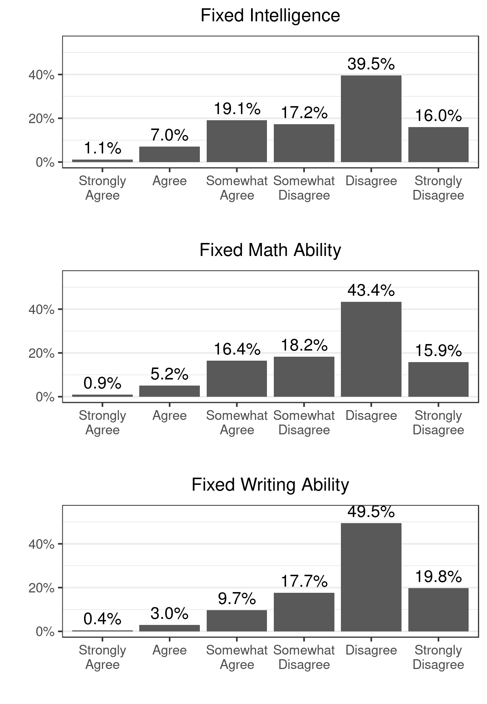

* Sample size: 2,305. The categories of agreement from left-to-right on the horizontal axis correspond to attitudes changing from more fixed intelligence to more growth potential.

Figure 2: Scatterplots of Mindset Variables with Their Common Factor

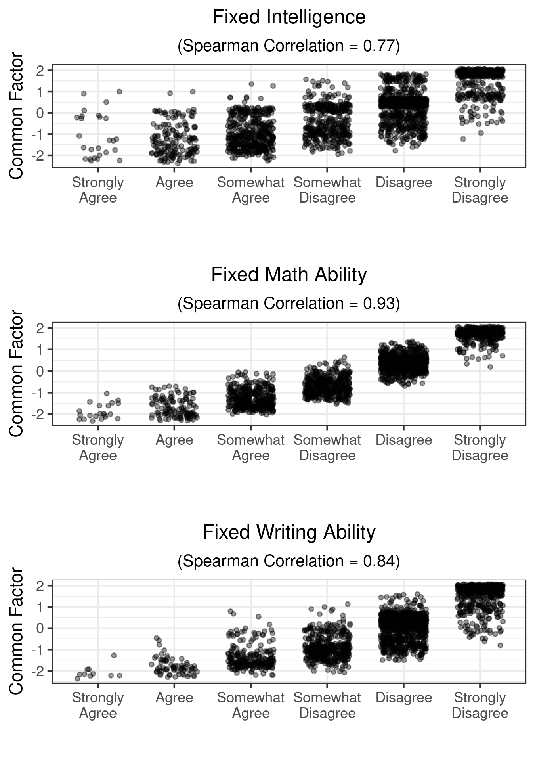

* Sample size is 2,305. To avoid overplotting, the horizontal scale for level of agreement includes jittering on a uniform scale with width equal to 0.3 times the width of the categories.

Table 1: Factor Analysis on Mindset Variables

|  |  |  |
| --- | --- | --- |
| Variable | Factor Loading | Uniqueness |
| Intelligence | 0.700 | 0.511 |
| Math ability | 0.869 | 0.244 |
| Writing ability | 0.787 | 0.380 |
| Sum Sq Loadings | 1.865 |  |
| Percent Var Explained | 62.2% |  |

common factor. With values for uniqueness between 0.24 and 0.51, between 50%-75% of the variability in individual mindset variables is explained by our common measure for mindset.

Figure 2 illustrates the relationship between each of the individual mindset variables and the common factor. The visual confirms that the individual mindset variables are highly correlated with our constructed single measure for growth mindset.

**2.2 Belonging**

We measured attitudes on belonging by asking students to rate their level of agreement on the following four statements:

* I belong in college.
* I can be myself in college.
* I am supported by my peers.
* I am respected by faculty.

Students rated each of these statements on the following five-point scale:

|  |  |  |
| --- | --- | --- |
| (1) Not at all true | (3) Somewhat true | (5) Completely true |
| (2) A little true | (4) Mostly true |  |

Figure 3 illustrates the distribution of responses to these statements of belonging. Regarding every statement, a majority of students indicated a high sense of belonging. Especially high is the feeling that students are respected by faculty. There is the most variability in students' responses to feeling supported by their peers. Still, a sizable minority that includes hundreds of students gave responses that indicate feelings of not belonging. Approximately 23.9% of the sample, or 550 students, responded with one of the lower levels of agreement to the question of being supported by their peers. For the most general statement on whether the student feels they belong in college, 19.4% of the sample, or 447 students, responded with one of the lower levels of agreement.

Like in the previous subsection, we construct a common measure of belonging by estimating a factor analysis allowing for one common factor to explain these four belonging variables. Again, because the variables are measured on an ordinal scale, we use the decomposition of the Spearman correlation matrix and estimate the common factor by Bartlett weighted least squares of the factor loadings on the standardized ranks.

Table 2 shows the results of the factor analysis. Approximately half of the variability in responses to the four belonging questions can be explained by a single common factor. The factor loadings reveal the common factor best explains reactions to the statements on being supported by peers and ability to be oneself. The likelihood ratio goodness of fit test is statistically significant. The null hypothesis is that the one common factor explains all of the variability of all four variables. This implies that while the estimate for common factor is a useful overall metric for sense of belonging, it fails to fully incorporate all of the variability in the various aspects of belonging. In the analysis below, we examine predictors for both the common factor for belonging and the individual belonging variables.

Figure 4 illustrates the relationship between the individual belonging variables and the common factor. The visual confirms that there is a high degree of correlation of the belonging variables to the common factor, and also that there is some variability in the responses to the individual belonging questions which is not completely explained by the one common factor.

**2.3 Confidence and Perseverance**

We also measured attitudes on confidence and perseverance by asking students to rate the following two statements:

* I can master difficult topics.   
  Response choices: Strongly disagree / Disagree / Somewhat disagree / Somewhat agree / Agree / Strongly agree

Figure 3: Belonging Responses

* Sample size: 2,305. Categories from left to right indicate higher levels of belonging.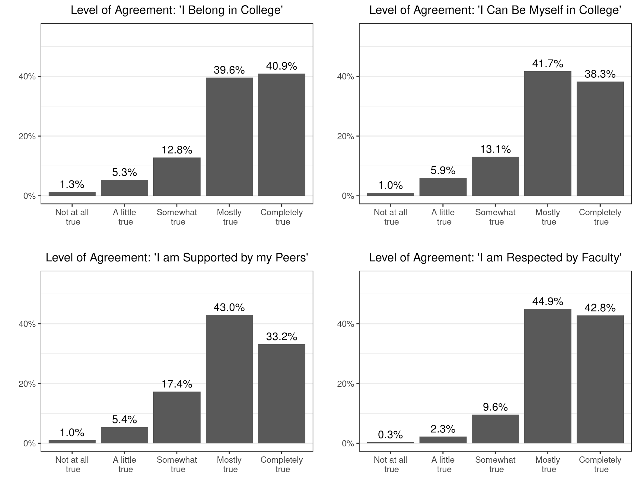

* Setbacks don't discourage me. I don't give up easily.  
  Response choices: Not at all true / A little true / Somewhat true / Mostly true / Completely true

Dweck (1999) and (2016) explain that one’s level of confidence and perseverance can be a consequence of mindset. Following a failure to perform a skill or demonstrate understanding of a difficult concept, those with a fixed mindset are less likely continue their efforts. With a fixed mindset, negative feedback is

Table 2: Factor Analysis on Belonging Variables

|  |  |  |
| --- | --- | --- |
| Variable | Factor Loading | Uniqueness |
| Belong in college | 0.608 | 0.630 |
| Respected by faculty | 0.582 | 0.661 |
| Can be myself | 0.809 | 0.345 |
| Supported by peers | 0.800 | 0.360 |
| Sum Sq Loadings | 2.003 |  |
| Perc Var Explained | 50.1% |  |
| Goodness of fit Chi-Sq (p-value)+ | 0.000 |  |

* Sample size is 2,305.

+ Likelihood ratio test for the null hypothesis that the common factor explains all the four variables. The test statistic is equal to 42.66 and has a Chi-Square distribution with 2 degrees of freedom

interpreted as a signal that one does not have what it takes to succeed. Perceiving a lesser likelihood to succeed, a person with a fixed mindset is more likely to give up. A person with a growth mindset interprets failure not as a reflection of their identity or innate ability, but rather as feedback on what changes can be made to improve upon the skill or understanding and be more likely to succeed the next time.

A person with a fixed mindset may have a high or low degree of confidence. If a person with a fixed mindset has experience of successes in a particular field, they may have confidence that they can master difficult concepts in that field. However, when a person with a fixed mindset experiences failure to perform or understand, confidence can quickly reverse itself. A person with a growth mindset is more likely to experience confidence after failure, as failure is not an indication that one is incapable, but feedback on what to improve for next time.

Figure 5 shows the distribution of responses to the confidence and perseverance questions above. A majority of respondents gave a response consistent with healthy attitudes for learning. Almost all students (94.6%) indicated some level of agreement on their ability to master difficult topics. On perseverance, a majority of students (64.2%) of students gave responses in the highest two categories, but there is still a sizable minority of students who did not feel it was completely true that they do not give up easily.

Figure 4: Scatterplots of Belonging Variables with Their Common Factor

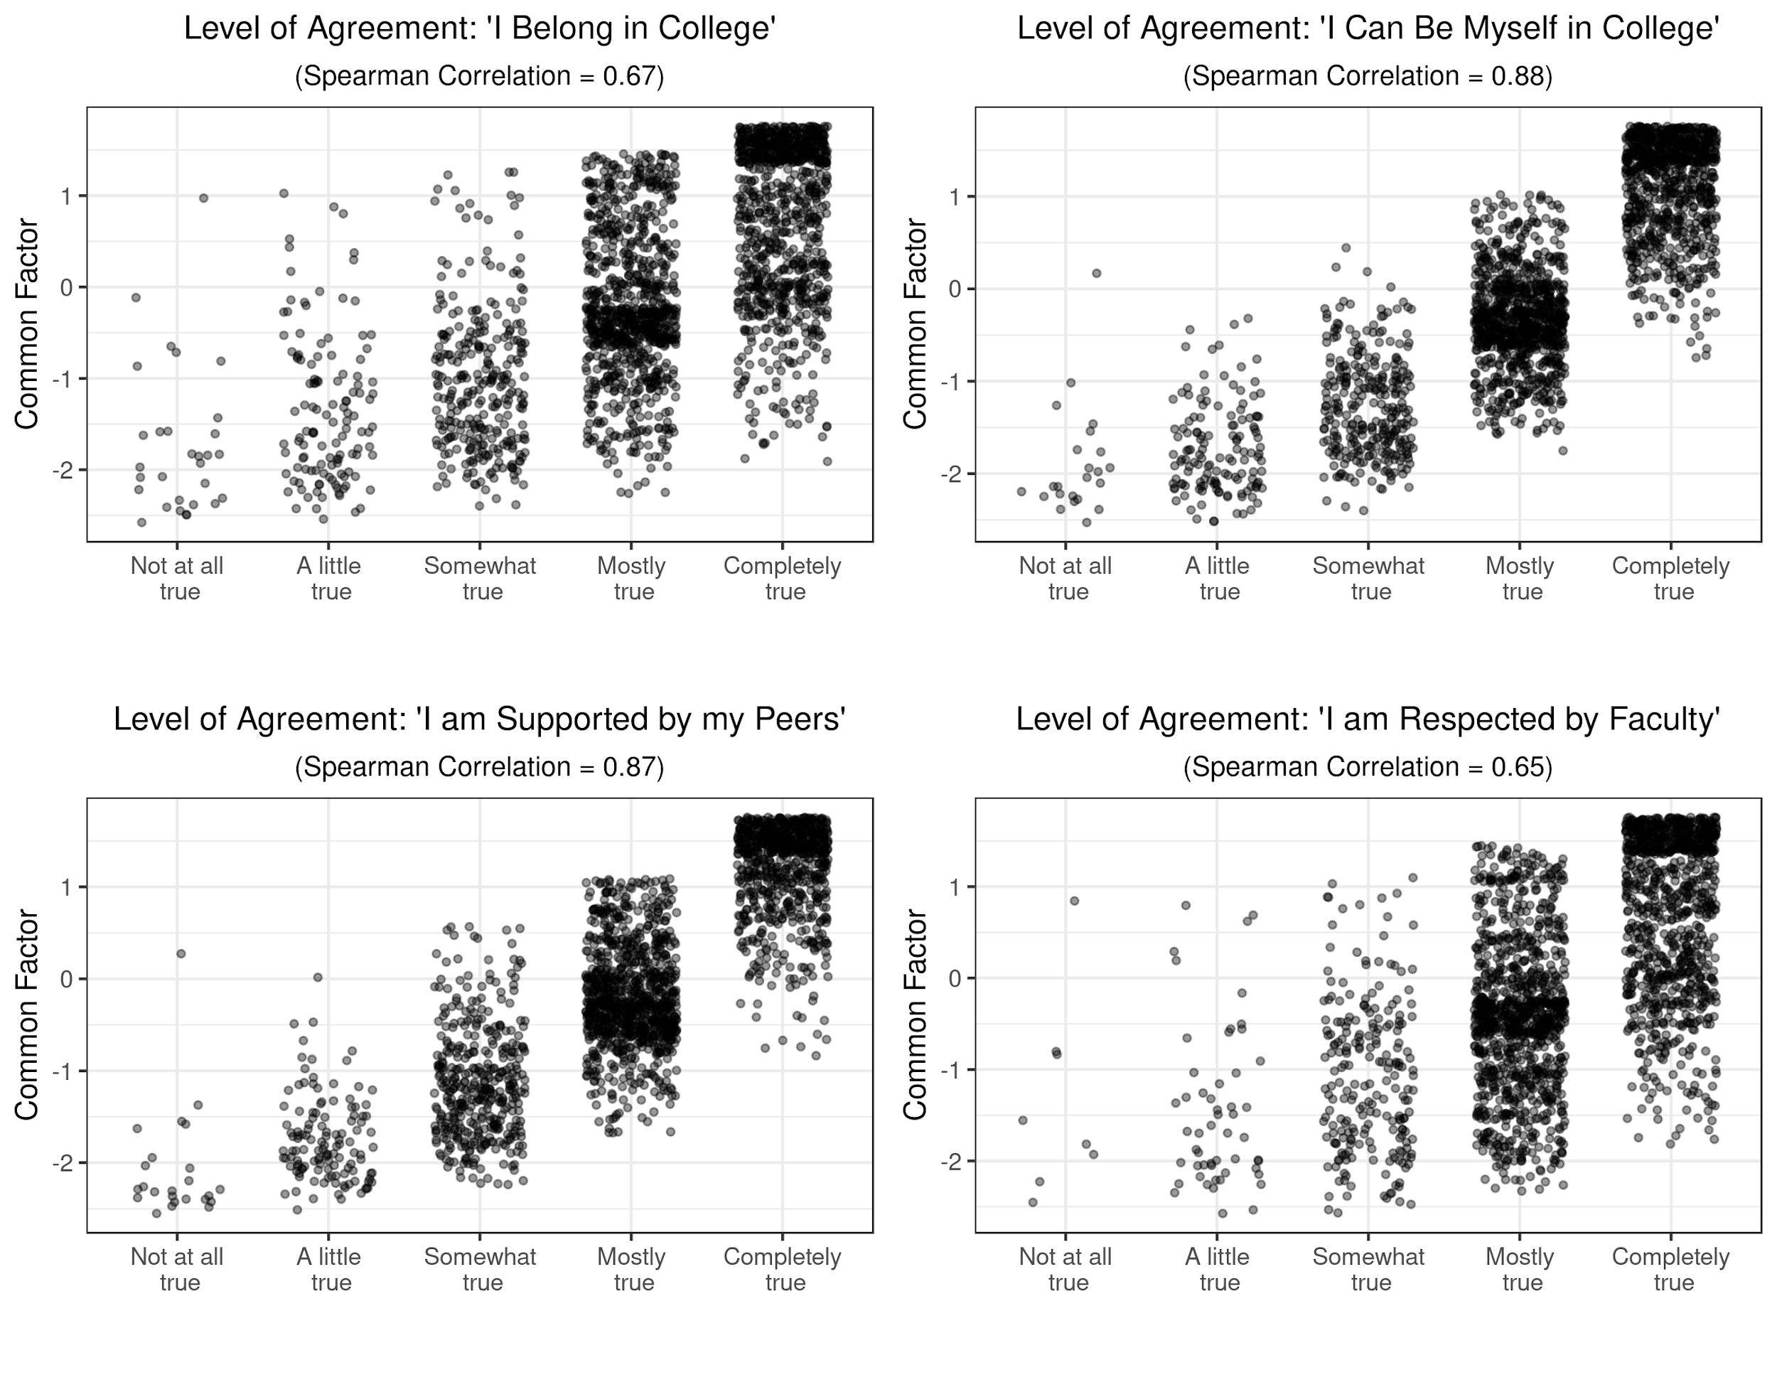

* Sample size is 2,305. To avoid overplotting, the horizontal scale for level of agreement includes jittering on a uniform scale with width equal to 0.3 times the width of the categories.

Figure 5: Distribution of Responses on Confidence and Perseverance

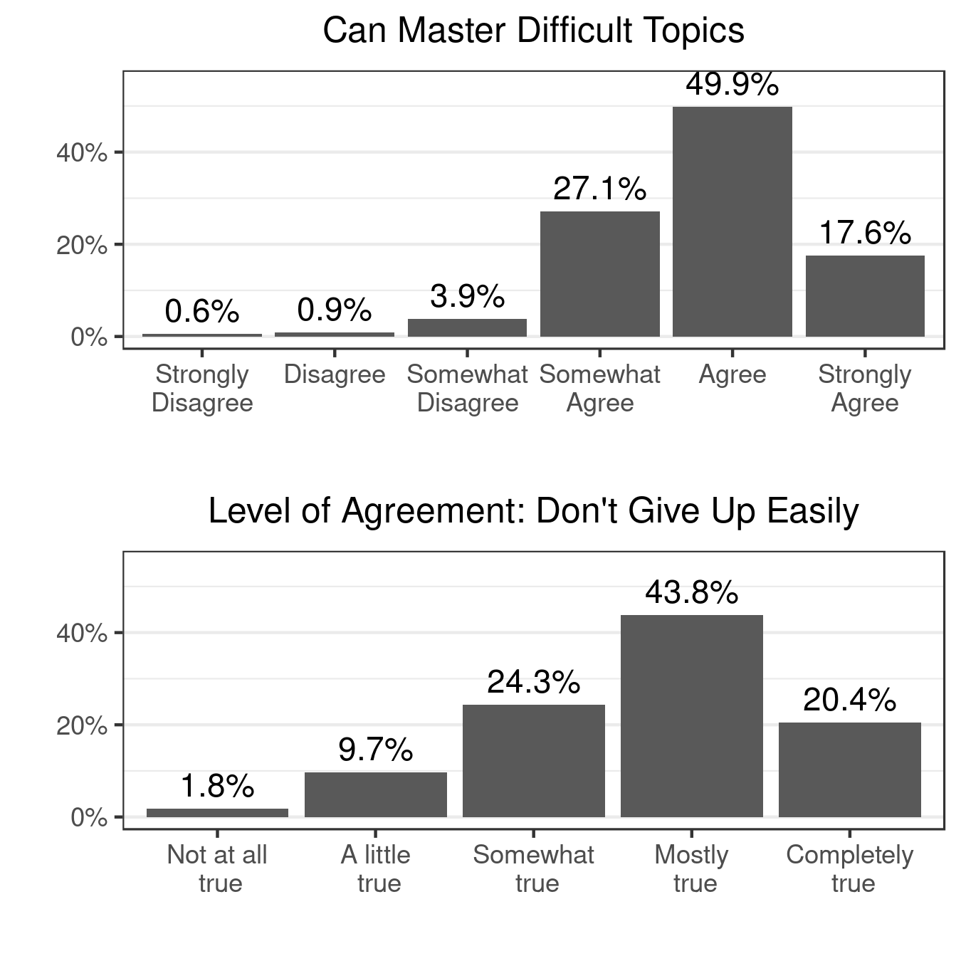

* Sample size: 2,305. Categories from left to right indicate attitudes that  
are more conducive to learning.

**2.4 Predictors for Attitudes on Learning**

We turn now to describing data for possible predictors for the attitudes described so far in this section. We consider the set of explanatory variables in Table 3. The choices for the explanatory variables serves the dual purpose of the paper to estimate the impact formative instructor feedback has on these attitudes and identify sub-populations of students with attitudes more or less conducive to learning.

Regarding instructor influence, we consider whether instructor feedback on early submissions of student work influences attitudes. In particular, we focus on writing assignments as this is a common type of assignment throughout the college curriculum and feedback is often given at the formative stage on draft submissions before a grade is assigned. We asked students the question, “How often do your instructors give you feedback on first drafts of writing assignments before you submit a final draft?” with response choices: Never / Rarely / Sometimes / Most of the time / Always. The binary variable *Feedback* is equal to 1 if the respondent answered with most of the time or always, which corresponds to almost one-third of responses.

We look at a number of educational and demographic characteristics to identify sub-populations of students that may be more or less at risk for negative attitudes on learning. We include racial minority status and parent/guardian education as they are common characteristics associated with students at risk for not continuing or not successfully completing their college education. The binary variable *Nonwhite* is our indicator of racial minority and is equal to 1 if a student self-identified with any race other than white or identified with multiple races, possibly also including white, and 0 otherwise. Both institutions in this study have a large majority white / Caucasian population, with only 7.7% of students identifying with another race.

Parent or guardian education is split into two binary variables, *ParentNoCollege* and *ParentGrad. ParentNoCollege* is equal to 1 if the highest level of education of the any of the student's parents or guardians is at most high school diploma or equivalent and is equal to 0 otherwise. *ParentGrad* is equal to 1 if the same response for parent or guardian education includes a graduate degree (Master degree or above) and is equal to 0 otherwise. The baseline category, when both of these are equal to zero, corresponds to students that have parents or guardians with some college education experience, including those with or without a college degree and may include a two- or four-year degree. About 11% of the sample are first-generation students whose parents or guardians have no college experience. About 24% of the sample are students whose parents or guardians have graduate degrees.

We measure prior educational success with two variables, *ACT* and *HSBelowAvg.* *ACT* is equal to the student's score on the ACT College Readiness

Table 3: Explanatory Variables

|  |  |  |  |
| --- | --- | --- | --- |
| Variable | Scale | Description | Descriptive Statistic |
| *Feedback* | Binary | Equal to 1 if instructors give feedback on writing most of time | Proportion = 29.8% |
| *Nonwhite* | Binary | Equal to 1 is student identified their race as including any race besides white / Caucasian | Proportion = 7.7% |
| *ParentNoCollege* | Binary | Equal to 1 if highest education of any of student's guardians is high school or less | Proportion = 11.3% |
| *ParentGrad* | Binary | Equal to 1 if highest education of any of student's guardian is a graduate degree | Proportion = 24.2% |
| *ACT* | Interval | Student's score on the ACT college readiness exam | Mean = 25.2 |
| *HSBelowAvg* | Binary | Equal to 1 if student had opinion that their high school performance was on average less than peers | Proportion = 1.8% |
| *CreditCat* | Ratio | Number of semesters of college credits accumulated, where 15 credits = 1 semester | Mean = 5.1 |
| *EduMajor* | Binary | Equal to 1 if student major is related to K-12 education | Proportion = 9% |
| *LiberalStudMajor* | Binary | Equal to 1 if student major is in liberal arts or social sciences | Proportion = 22.7% |
| *ScienceMajor* | Binary | Equal to 1 if student major is in science, math, health, or technology | Proportion = 47% |
| *Private* | Binary | Equal to 1 if corresponding to a student at the smaller, private university | Proportion = 18.2% |
| *Age* | Ratio | Age of the student | Mean = 20.5 |
| *Female* | Binary | Equal to 1 if student identified as female, 0 if student identified as male | Proportion = 73.4% |

Exam[2]. The average response for this test score, 25.2, is slightly higher than the populations of the two schools. The average ACT score of all students at Viterbo is 21 and of all students at UWL is 24. *HSBelowAvg* is a binary variable equal to 1 if a student identified themselves as having performed below average in high school compared to their peers.

Other educational characteristics we consider is how much college experience the students had at the point of completing the survey, what field their major or intended major is in, and which institution the student is attending*.* *CreditCat* is equal to the number full-time equivalent semesters (15 credits = 1 semester) the student has already completed. Field of study is measured with three binary variables that identify students with a major in education (*EduMajor);* majors in the related to liberal studies, arts, or social sciences (*LiberalStudMajor)*; and majors related to science, mathematics, or technology (*ScienceMajor)*. The baseline category, when all three of these binary variables are equal to zero, is the major related to business administration. The binary variable *Private* is equal to 1 if the student is attending the private institution, Viterbo University, and is equal to 0 if the student is attending the public institution, UWL. Since Viterbo University has a smaller population of students, it is a smaller proportion of our sample (18.2%).

Finally, we consider two additional demographic characteristics, gender (*Female)* and age (*Age*). While both institutions have larger proportions of females than males (57% at UWL and 75% female at Viterbo), females responded to the survey in higher proportions leading to 73.4% of respondents identifying as female.

**3 Results**

We turn now to estimate the prediction power that the instructional, educational and demographic variables have on students’ attitudes regarding mindset, sense of belonging, perseverance, and confidence.

**3.1 Mindset**

Table 4 presents regression results for the mindset common factor and the individual mindset questions regarding ability to learn new things, improve in math, and improve in writing. The first pair of columns correspond to estimates from ordinary least squares on the common factor, since this dependent variable is constructed as a ratio variable with zero mean and unit standard deviation. The next three pairs of columns are results from ordinal regressions with the ordinal dependent variables that measure level of agreement on statements suggesting a

Table 4: Mindset Results

|  |  |  |  |  |  |  |  |  |
| --- | --- | --- | --- | --- | --- | --- | --- | --- |
|  | Common Factor | | Intelligence | | Math Ability | | Writing Ability | |
| Variable | Coef. | P-val. | Coef. | P-val. | Coef. | P-val. | Coef. | P-val. |
| *Feedback* | 0.144 | 0.010*** | 0.293 | 0.002*** | 0.186 | 0.056* | 0.241 | 0.016** |
| *Nonwhite* | 0.019 | 0.853 | -0.104 | 0.555 | -0.159 | 0.377 | 0.432 | 0.018** |
| *ParentNoCollege* | 0.151 | 0.105 | 0.289 | 0.071* | 0.284 | 0.080* | 0.080 | 0.628 |
| *ParentGrad* | 0.103 | 0.086* | 0.194 | 0.060* | 0.170 | 0.101 | 0.070 | 0.513 |
| *log(ACT)* | 0.083 | 0.002*** | 0.002 | 0.959 | 0.176 | 0.000*** | 0.165 | 0.000*** |
| *HSBelowAvg* | 0.244 | 0.273 | 1.029 | 0.016** | 0.376 | 0.380 | 0.312 | 0.477 |
| *CreditCat* | -0.008 | 0.820 | -0.019 | 0.749 | -0.039 | 0.500 | 0.005 | 0.931 |
| *EduMajor* | 0.300 | 0.003*** | 0.719 | 0.000*** | 0.378 | 0.030** | 0.432 | 0.014** |
| *LiberalStudMajor* | 0.056 | 0.464 | 0.316 | 0.016** | -0.103 | 0.431 | 0.236 | 0.081* |
| *ScienceMajor* | 0.237 | 0.000*** | 0.401 | 0.001*** | 0.417 | 0.000*** | 0.239 | 0.045** |
| *Private* | -0.068 | 0.370 | -0.152 | 0.241 | -0.089 | 0.495 | -0.104 | 0.440 |
| *log(Age)* | 0.098 | 0.019** | 0.039 | 0.614 | 0.223 | 0.003*** | 0.176 | 0.021** |
| *Female* | -0.030 | 0.603 | 0.091 | 0.370 | -0.139 | 0.175 | 0.022 | 0.837 |
| *Private*ParentNoCollege* | 0.208 | 0.269 | -0.057 | 0.858 | 0.398 | 0.224 | 0.539 | 0.112 |

+ Sample size: 1,804. * Statistically significant at the 10% level. ** Statistically significant at the 5% level.

*** Statistically significant at the 1% level.

fixed mindset. For all models, positive coefficients correspond to attitudes that lean more toward a growth mindset.

In all the regressions, we include all the explanatory variables from the previous subsection and consider also the interaction effect of the private institution and the binary variable identifying students whose parents have no college education experience. There are multiple reasons why this interaction could be important. First, Stewart and Ostrove (1993) suggests that students from a less-privileged background may be more likely to suffer from a poor sense of belonging at private institutions, whose student populations may be from primarily middle- to upper-class. It is also possible the interaction effect works in the opposite direction. Viterbo University is a smaller institution with smaller class sizes. There is also a widespread and deliberate effort by instructors and administrators to instill a sense of identity consistent with the Catholic Franciscan values on which the school was founded, which may influence attitudes on learning and sense of belonging.

We also examined several other possibilities for interaction effects among *Feedback*, *Private*, *Nonwhite*, and *ParentNoCollege*, but these other interaction effects were not statistically significant for any of the dependent variables considered in this paper.

The two non-binary explanatory variables, *ACT* and *Age*, are expressed in logs and standardized, so that the coefficients on the regressions on the mindset and belonging common factors can be interpreted as the marginal effect of a one-standard deviation increase in the log transformed variable.

The *Feedback* variable is statistically significant and positive in all models. When instructors give frequent feedback, students’ attitudes improve regarding the potential for growth in learning. It is particularly interesting that the coefficient on *Feedback* is even positive and statistically significant for the ordinal regression on math ability (at the 10% level). When students receive more feedback on their writing, they even develop attitudes towards growth potential regarding their ability to improve their math knowledge and skills. The impact that instructor feedback has on mindset goes beyond their courses or their fields. Simple instructor feedback can instill a healthy belief in students they are capable of learning and improvement in even unrelated courses and fields.

Parents’ level of education has an interesting impact on belonging. The binary variables, *ParentNoCollege* and *ParentGrad* are each equal to 1 if the highest level of education by either parent includes no college and graduate degrees, respectively. The comparison group (when both binary variables are equal to zero) is parents with some college education, including possibly a four-year college degree. The coefficients on both of these variables are positive in all regression models, and statistically significant at the 10% level for the ordinal outcome variables regarding opinions on being able to learn new things (*Intelligence*) and improve math skills (*Math ability).[3]* Relative to students whose parents’ education is limited to undergraduate college experience, students have more of a growth mindset if their parents either have no college experience, or advanced college experience. While there is evidence that first generation students are at risk for lower college performance and lower retention rates (see for example Ishitani (2002) and (2006)), we find that first generation students have on average a mindset that leans more toward growth than many of their peers. It is also true that students whose parents have completed graduate degrees have on average more of a growth mindset than their peers whose parents educational experience is limited to undergraduate school.

The coefficient on *ACT* is positive and statistically significant in three of the four regressions, so students who performed better on the college entrance exam are likely to have attitudes leaning more to a growth mindset. *Age* is also positive and statistically significant in three of the four regressions which implies that as students mature, they are likely to have attitudes leaning more to a growth mindset.

Students’ chosen field is a significant predictor for mindset. We categorized students’ majors into four fields: business (the baseline case), education, liberal studies, and science and health. The coefficients on *EduMajor* and *ScienceMajor* are both positive and statistically significant across all regressions meaning these students have attitudes that lean more toward growth mindset than business majors. The coefficient on *LiberalStudMajor* is positive and statistically significant only in the ordinal regression on writing ability, indicating that relative to business majors, liberal studies majors have a healthier attitude on their ability to improve writing skills, though not necessarily other skills.

We find statistical evidence that race influences mindset only regarding writing. The coefficient on *Nonwhite* in the regression on *Writing Ability* is positive and statistically significant, meaning that nonwhite students lean more toward a growth mindset for the potential to improve their writing than their white peers. In all other regressions on mindset, *Nonwhite* is not statistically significant. While several other studies reveal that minority students are at risk for lower rates of retention (see for example, DeAngelo et al. (2010) and Change et al. (2014)) and another study prescribes educational interventions to improve mindset focusing mostly on minorities (Blackwell et al. (2007)), we do not find that racial minorities are at an advantage in terms of mindset, and at least regarding writing potential, they may be at an advantage.

**3.2 Belonging**

Table 5 presents regression results for the belonging common factor and the individual belonging questions. We estimate the impact of the same set of explanatory variables on our constructed common factor for belonging and on the responses for the individual questions on sense of belonging, including an overall sense (agreement to statement ‘I feel like I belong in college), comfort in being oneself, feeling of supported by peers, and feeling of being respected by faculty. The regression results for the common factor are from ordinary least squares and all other regressions are results ordinal logistic regressions.

*Feedback* is positive and statistically significant in all regressions, which again implies that all instructors have the power to positively influence students’ attitudes and morale by simply enhancing part of their regular job: giving students feedback on early drafts of work. We find that giving students early feedback on writing improves their sense of belonging in college, their sense of being supported by their peers, and not surprisingly, their sense of being respected by faculty.

Table 5: Belonging Results

|  |  |  |  |  |  |  |  |  |  |  |
| --- | --- | --- | --- | --- | --- | --- | --- | --- | --- | --- |
|  | Common Factor | | Belong in College | | Be Myself | | Supported by Peers | | Respected by Faculty | |
| Variable | Coef. | P-val. | Coef. | P-val. | Coef. | P-val. | Coef. | P-val. | Coef. | P-val. |
| *Feedback* | 0.269 | 0.000*** | 0.296 | 0.003*** | 0.389 | 0.000*** | 0.373 | 0.000*** | 0.456 | 0.000*** |
| *Nonwhite* | -0.268 | 0.009*** | -0.366 | 0.038** | -0.500 | 0.006*** | -0.317 | 0.070* | -0.344 | 0.065* |
| *ParentNoCollege* | -0.290 | 0.002*** | -0.442 | 0.008*** | -0.355 | 0.032** | -0.508 | 0.002*** | -0.307 | 0.071* |
| *ParentGrad* | 0.069 | 0.259 | 0.264 | 0.013** | 0.066 | 0.531 | 0.080 | 0.444 | 0.087 | 0.421 |
| *log(ACT)* | -0.011 | 0.697 | 0.162 | 0.001*** | -0.035 | 0.456 | -0.094 | 0.041** | 0.058 | 0.221 |
| *HSBelowAvg* | -0.101 | 0.657 | -0.840 | 0.034** | -0.248 | 0.521 | 0.284 | 0.468 | -0.362 | 0.358 |
| *CreditCat* | 0.098 | 0.004*** | 0.192 | 0.001*** | 0.085 | 0.146 | 0.233 | 0.000*** | -0.010 | 0.874 |
| *EduMajor* | 0.026 | 0.801 | -0.002 | 0.992 | -0.089 | 0.607 | 0.188 | 0.282 | 0.090 | 0.612 |
| *LiberalStudMajor* | -0.086 | 0.274 | -0.210 | 0.119 | -0.129 | 0.336 | -0.203 | 0.126 | 0.138 | 0.124 |
| *ScienceMajor* | 0.071 | 0.306 | 0.171 | 0.154 | 0.070 | 0.557 | 0.091 | 0.435 | 0.176 | 0.149 |
| *Private* | -0.061 | 0.429 | -0.108 | 0.419 | -0.205 | 0.126 | 0.010 | 0.941 | -0.057 | 0.677 |
| *log(Age)* | -0.080 | 0.060* | -0.064 | 0.397 | -0.079 | 0.282 | -0.172 | 0.020** | -0.110 | 0.151 |
| *Female* | 0.071 | 0.237 | 0.117 | 0.261 | 0.158 | 0.127 | 0.010 | 0.923 | 0.186 | 0.079* |
| *Private*ParentNoCollege* | 0.324 | 0.093* | 0.429 | 0.214 | 0.306 | 0.360 | 0.759 | 0.027** | 0.108 | 0.748 |

+ Sample size: 1,804.

* Statistically significant at the 10% level.   
** Statistically significant at the 5% level.

*** Statistically significant at the 1% level.

*Nonwhite* and *ParentNoCollege* are both negative and statistically significant in all regressions, implying that these traditionally at-risk populations for low retention suffer from lower sense of belonging than their peers.

*CreditCat* is positive and statistically significant in three of the five regressions (and not statistically significant in the others) revealing that overall sense of belonging and feeling of support by peers improves as students accumulate more college experience. There is not evidence, though, and students’ comfort in being themselves and feeling that they are respected by faculty change as students progress in their college careers.

Finally, the interaction term between *Private* and *ParentNoCollege* is positive and statistically significant for the regressions on the common factor for belonging and the sense of support from peers. This implies we have some limited evidence that first-generation students have a higher sense of belonging and peer support at the smaller, private, liberal arts university than the relatively larger, public university.

**3.3 Confidence and Perseverance**

Table 6 presents ordinal logistic regression results for the questions on confidence (level of agreement with ‘I can master difficult topics’) and perseverance (level of agreement on ‘I don’t give up easily’). Again, feedback is positive and statistically significant in both regressions, indicating yet more dimensions where instructor feedback positively influences students’ attitudes on learning.

*Female* is negative and statistically significant in both regressions. While we failed to find evidence that gender was related to mindset or sense of belonging, we do find evidence that female college students have on average less confidence than males in their ability to master difficult subjects, and they do not agree as much with the statement that they do not give up easily.

Regarding parent education and confidence the coefficient on *ParentGrad* is positive and statistically significant, which *ParentNoCollege* is not statistically significantly different from zero, which implies that students with parents that have advanced degrees display more confidence than their peers, but there is no difference between students whose parents have no college education and those with some college education (including undergraduate degrees)

*ACT* and *HSBelowAvg* are both positive and statistically significantly explain confidence. *HSBelowAvg* is equal to one when students believe they

Table 6: Confidence and Perseverance Results

|  |  |  |  |  |
| --- | --- | --- | --- | --- |
|  | Confidence | | Perseverance | |
| Variable | Coef. | P-val. | Coef. | P-val. |
| *Feedback* | 0.448 | 0.000*** | 0.401 | 0.000*** |
| *Nonwhite* | -0.186 | 0.315 | 0.261 | 0.145 |
| *ParentNoCollege* | -0.207 | 0.209 | -0.093 | 0.572 |
| *ParentGrad* | 0.208 | 0.055* | 0.107 | 0.301 |
| *log(ACT)* | 0.488 | 0.000*** | 0.051 | 0.261 |
| *HSBelowAvg* | 0.879 | 0.044** | -0.820 | 0.028** |
| *CreditCat* | 0.085 | 0.157 | -0.003 | 0.952 |
| *EduMajor* | 0.221 | 0.214 | 0.213 | 0.22 |
| *LiberalStudMajor* | -0.032 | 0.812 | -0.166 | 0.214 |
| *ScienceMajor* | 0.216 | 0.071* | 0.062 | 0.597 |
| *Private* | 0.098 | 0.475 | 0.124 | 0.346 |
| *log(Age)* | 0.040 | 0.598 | 0.153 | 0.038** |
| *Female* | -0.338 | 0.001*** | -0.630 | 0.000*** |
| *Private*ParentNoCollege* | 0.194 | 0.574 | -0.103 | 0.766 |

+ Sample size: 1,804. * Statistically significant at the 10% level.

** Statistically significant at the 5% level.

*** Statistically significant at the 1% level.

under-performed their peers in high school. Both of these coefficients positive implies that students that performed better on the ACT college readiness exam have relatively higher confidence, but it is also true, that holding ACT scores constant, students that under-performed relative to their peers in high school have greater confidence in college. It is admittedly difficult to understand what explains these relationships or what use this information could have for instructors and administrators to identify students with low confidence.

*HSBelowAvg* is negative and statistically significant for perseverance, which indicates that students who feel like they under-performed relative to their peers are more likely to give up on time consuming or difficult tasks.

**4 Conclusion**Using a survey of more than 2,000 undergraduate students at public and private Midwestern universities, we find robust evidence that instructor feedback on student writing has a positive impact on students’ mindset, sense of belonging, confidence, and perseverance; all which are important attitudes toward learning that others have shown lead to better academic performance and retention. We specifically focus on instructor feedback on early drafts of writing assignments, before grades are assigned, to focus on the impact of formative, rather than summative, feedback. This is also a type of feedback that is used by instructors throughout the college curriculum.

We also find useful evidence for instructors identifying demographic and educational characteristics that are associated with mindset, belonging, confidence, and retention. We confirm much of the results in the belonging literature that first-generation students and racial minorities suffer from a lower sense of belonging. Regarding mindset, we fail to find evidence that racial minorities or first-generation students are at a disadvantage, and actually find cases where these typically at-risk populations have more positive attitudes toward learning than their peers.

The findings of the paper should be immediately useful for instructors to inform them of the benefits that formative feedback on writing can have on student attitudes and help them identify sub-populations that may be in greater need of this kind of intervention.

**References**

Aditomo, A. (2015). Students’ response to academic setback: “Growth mindset” as a buffer against demotivation. *International Journal of Educational Psychology*,*4*(2), 198-222.

Anderman, L.H., Freeman, T.M., Jensen, J.M. (2007) Sense of Belonging in College Freshmen at the Classroom and Campus Levels. *The Journal of Experimental Education 75(3),* 203-220.

Anderson, P., Anson, C.M., Gonyea, R.M., and Paine, C. (2016) How To Create High-Impact Writing Assignments That Enhance Learning and Development and Reinvigorate WAC/WID Programs: What Almost 72,000 Undergraduates Taught Us. *Across the Disciplines: A Journal of Language, Learning and Academic Writing*, 13(4), 1-18.

Carter, F.C., Hurtado, S. (1997). Effects of College Transition and Perceptions of the Campus Racial Climate on Latino College Students’ Sense of Belonging. *Sociology of Education, 70(4),* 324-345.

Blackwell, L., Trzesniewski, K., & Dweck, C. S. (2007). Implicit theories of intelligence predict achievement across an adolescent transition: A longitudinal study and an intervention. *Child Development*, 78, 246–263.

Chang, M. J., Sharkness, J., Hurtado S., and Newman, C. B. (2014). What matters in college for retaining aspiring scientists and engineers from underrepresented racial groups. *Journal of Research in Science Teaching*. 51(5):555-580.

DeAngelo, L., Franke, R., Hurtado, S., Pryor, J. H., and Tran, S. (2011). *Completing college: Assessing graduation rates at four-year institutions*. Los Angeles: Higher Education Research Institute, UCLA.

Dweck, C. S. (1999). *Self-theories: Their role in motivation, personality, and development*. Philadelphia, PA: Taylor & Francis.

Dweck, C.S. (2008). Mindsets and Math/Science Achievement. Prepared for the Canegie Corporation of New York-Institute for Advanced Study Commission on Mathematics and Science Foundation.

Dweck, C.S. (2015). Growth. *British Journal of Educational Psychology*, 85, 242–245.

Dweck, C.S. (2016). *Mindset: The New Psychology of Success.* Updated Edition. New York: Balantine Books.

Ekhold, E., Zumbrunn S., and Conklin S. (2015). The Relation of College Student Self-Efficacy toward Writing and Writing Self-Regulation Aptitude: Writing Feedback Perceptions as a Mediating Variable. *Teaching in Higher Education,* 20(2), 197-207.

Good, C., Aronson, J. A., and Inzlicht, M. (2003). Improving adolescents’ standardized test performance: An intervention to reduce the effects of stereotype threat. *Journal of Applied Developmental Psychology*, 24, 645–662.

Good, C., Rattan, A., & Dweck, C. S. (2012). Why do women opt out? Sense of belonging and women’s representation in mathematics. *Journal of Personality and Social Psychology*, 102, 700–717.

Goodenow, C. (1993). The psychological sense of school membership among adolescents: Scale development and education correlates. *Psychology of Schools 30(1).* 79-90.

Hoffman, M., Morrow, J., Richmond, J., and Salomone, K. (2002). Investigating “sense of belonging” in first-year college students. *Journal of College Student Retention 4(3).* 227-256.

Hausmann, L.R.M., Schofield, J.W., and Woods, R.L. (2007). Sense of belonging as a predictor of intentions to persist among African American and White first-year college students. *Research in Higher Education 48(7),* 803-839.

Ishitani, T. T. (2002). A longitudinal approach to assessing attrition behavior among first-generation students: Time varying effects of pre-college characteristics. *Research in Higher Education.* 44(4): 433-449.

Ishitani, T. T. (2006). Studying attrition rates and degree completion behavior among first-generation college students in the United States. *Journal of Higher Education.* 77(5): 861-885.

Long, S.M. and Ostrove, J.M. (2007). Social class and belonging: Implications for college adjustment. *The Review of Higher Education 30(4),* 363-389.

Mangels, J. A., Butterfield, B., Lamb, J., Good, C., & Dweck, C. S. (2006). Why do beliefs about intelligence influence learning success? A social cognitive neuroscience model. *Social Cognitive and Affective Neuroscience, 1*(2), 75-86.

Martin, A. J. (2006). Personal bests (PBs): A proposed multidimensional model and empirical analysis. *British Journal of Educational Psychology*, 76, 803–825.

Martin, A. J. (2011). Personal best (PB) approaches to academic development: Implications for motivation and assessment. *Educational Practice and Theory*, 33, 93–99.

Martin, A. J., and Liem, G. A. (2010). Academic Personal Bests (PBs), engagement, and achievement: A cross-lagged panel analysis. *Learning and Individual Differences*, 20, 265–270.

Ostrove, J. M. (2003). Belonging and wanting: Meanings of social class background for women’s constructions of their college experience. *Journal of Social Issues*, 59, 771–784.

Stewart, A. J., and Ostrove, J. M. (1993). Social class, social change, and gender. *Psychology of Women Quarterly*, 17, 475–497.

Strayhorn, T.L. (2012) *College students’ sense of belonging: A key to educational success for all students.* New York.

1. Corresponding author: [jmurray@uwlax.edu](mailto:jmurray@uwlax.edu), 1725 State St., La Crosse, WI 54601
2. As is true at many Midwestern universities, most students have taken the ACT exam rather than the College Board's SAT exam. In the present study, 1,904 respondents gave non-empty responses for the ACT question.
3. When the interaction effect of *ParentNoCollege* x *Private* is excluded from the regressions, the coefficient on *ParentNoCollege* is positive and statistically significant at the 5% level for the regressions on *Common Factor*, *Intelligence*, and *Math Ability*.