Dynamics of Monetary Policy Uncertainty and the Impact on the Macroeconomy

Nicholas Herro  Department of Economics  University of Wisconsin - La Crosse | James Murray  Department of Economics  University of Wisconsin - La Crosse

March 21, 2011

Abstract

A large literature lauds the benefits of central bank transparency and credibility, but when a central bank like the U.S. Federal Reserve has a dual mandate, is not specific to the extent it targets employment versus price stability, and is not specific to the magnitude interest rates should change in response to these targets, market participants must depend largely on past data to form expectations about monetary policy. We suppose market participants estimate a Taylor-like regression equation to understand the conduct of monetary policy, which likely guides their short-run and long-run expectations. When the Federal Reserve's recent actions deviate from its historical targets for macroeconomic variables, an environment of greater uncertainty may be the result. We quantify this degree of uncertainty by measuring and aggregating recent deviations of the federal funds rate from econometric forecasts predicted by constant gain learning. We incorporate measures of uncertainty into a VAR model with ARCH shocks to measure the effect monetary policy uncertainty has on inflation, output growth, unemployment, and the volatility of these variables. We find that a higher degree of uncertainty regarding monetary policy is associated with greater volatility of output growth and unemployment.

Keywords: Taylor rule, uncertainty, learning, volatility.
JEL classification: E31, E32, E58.

“The more fully the public understands what the function of the Federal Reserve System is and on what grounds and on what indications its policies and actions are based, the simpler and easier will be the problems of credit administration in the United States.”
– Federal Reserve Board, Annual Report, 1923, p. 38.

1. Background
With each meeting of the Federal Reserve’s Open Market Committee, financial markets wait in anticipation of the final rate decision. Based on statements and actions, economic participants react to the sentiment and adjust consumption and investment planning accordingly. The federal funds rate has a profound effect on economic activity. This commonly used monetary policy tool will be the exclusive focus of this paper.
When the FOMC’s rulings deviate from market expectations, market participants become uncertain of the future. Consecutive quarters of unexpected decisions can result in an environment of increased uncertainty, hindering planning ability for the economic agents. Methods for anticipating monetary policy actions are widely published, the most prominent of which can be credited to J.P. Taylor (1993). After Taylor published his rule, which he concluded the Federal Reserve informally followed, many academics published research on the topic, building supplemental models based on Taylor’s original rule to form expectations. The reverse of this measurement can be seen at the policy level. The Federal Reserve Bank of Cleveland itself extracts public expectations of Fed actions by analyzing options on federal funds futures, traded on the Chicago Board of Trade, through the implied probabilities measurement. This measurement reveals that the Fed monitors market expectations for rate decisions.
Plenty of research has been published on the effects of inflation and output growth uncertainty, such as Grier and Perry (2000), Grier, Olekalns, and Shields (2004), and Fountas, Karanasos, and Kim (2006) inter alia. Grier and Perry (2000) find that increased inflation uncertainty is significantly related to lower real output growth. Fountas (2006) supports this claim, though interestingly concludes that real uncertainty is a positive determinant for output growth. This finding contradicts most OECD countries’ claims of increased stability as a requisite for long-term output growth. Grier, Olekalns, and Shields (2004) find increased growth uncertainty leads to lower average growth. Further, the authors find inflation uncertainty to be negatively correlated to diminished growth as well as lower average levels of inflation.
The above papers conclude uncertainty can be an important factor for macroeconomic performance. The present paper looks specifically at uncertainty caused by unpredicted changes in monetary policy. Taylor (1999) finds that the monetary policy rule has changed dramatically over time as emphasis has shifted as a result of leadership and equally dramatic changes in economic stability.
Given the influential nature of central bank policy actions on market expectations, the ability to isolate the effects unexpected decisions have on aggregate outcomes would be useful information in central bank decision-making. Should uncertainty cause greater volatility of output growth, inflation, and unemployment rates, it would be in the central bankers’ best interests to operate predictably. An appropriate substitute for predictable behavior may be increased transparency to reduce uncertainty and help the market understand the rationale for the unexpected rate decision. Cecchetti and Krause (2002) empirically show increased transparency as effective means to maximize desirable macroeconomic outcomes. This research suggests that markets will react negatively to surprise decisions which will be evident in macroeconomic volatility. Cecchetti and Krause (2001) offer alternative means to macroeconomic stability and increasing the efficacy of monetary policy through a reduction in direct state ownership and deposit insurance. Bulir et al. (2008) find that inflation targets and forecasts were missed frequently and that about one-third of all monetary policy decisions were found to be a surprise (deviated by more than 1 percentage point). The structure of this research is structured similar to Cecchetti and Krause (2002).
Similarly, Bernanke and Mishkin (1997) have argued inflation targeting as a simple method to create optimal central bank decision outcomes. The authors conclude that this policy would increase transparency and credibility, coherent policymaking, and shift focus to long-run planning. In contrast, Cecchetti and Ehrmann (1999) suggest that countries who introduced inflation targeting as a policy, which increased their risk aversion to inflation volatility, likely suffered more increases in inflation volatility as a result.
Krause (2007) estimates actual and optimal policy in the European Union using aggregate supply and demand shocks, though does not measure these departures against macroeconomic performance measures. Krause finds improved macroeconomic performance as countries operate more closely to a given optimal level. Svensson (1997) suggests that target rules are inherently more stable and easier to motivate than instrument rules, such as Taylor’s.
This research focuses on the expectations of federal funds effective rates and the implications of unanticipated decisions, where the expected federal funds rate is predicted from a modified Taylor rule estimated from data on past rate decisions, output growth, inflation, and unemployment.

2. Estimating Monetary Policy
GDP is reported in seasonally adjusted real terms. Seasonally adjusted CPI rates are calculated as the sum of 3 months of percentage changes. Unemployment figures are seasonally adjusted civilian rates calculated quarterly as percentages. The Federal funds rate is the average effective rate during the quarter.
Table 1 shows summary descriptive statistics of relevant variables to be used in subsequent models. We find fluctuations of Fed funds rates between .11% and 19.08% throughout the period, averaging 5.52%. Further, we find the quarterly growth, inflation, and unemployment rates to average .78%, .95%, and 5.86% throughout the population dataset, respectively. The distribution of these rates appear positively skewed.
Table 1. Summary Descriptive Statistics
 | N | Minimum | Maximum | Median | Mean | Std. Deviation
Fed Funds Rate | 222 | .11 | 19.08 | 5.20 | 5.52 | 3.45
Growth | 222 | -2.71 | 3.93 | .77 | .78 | .93
Inflation | 222 | -3.47 | 4.10 | .78 | .95 | .83
Unemployment | 222 | 3.40 | 10.70 | 5.60 | 5.86 | 1.53

2.1 Learning
Agents learn how the Federal Reserve conducts monetary policy by estimating the following policy rule similar to Taylor (1993),
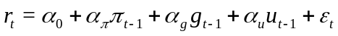 (1)
This policy rule recognizes that the Fed adjusts interest rates to target desired levels for inflation, growth rate of real GDP, and unemployment. At every time agents re-estimate equation (1) using past data up through period 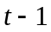. Let 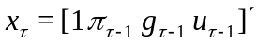 denote the vector of explanatory variables used to predict and 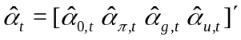 denote the time estimate for the regression coefficients. If agents estimate equation (1) by ordinary least squares, then the estimate for the coefficient at time is given by,
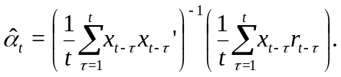 (2)
This can be conveniently re-written in the following recursive form,
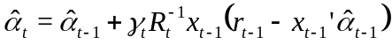 (3)
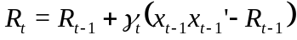 (4)
where 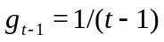 is the learning gain. This recursive representation nicely illustrates the manner in which expectations are adaptive. The term in parentheses on the right hand side of equation (3) is the error that was made forecasting 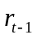 using the previous period's estimate for coefficients. The degree to which the current estimate for 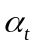 is updated from the previous estimate 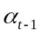 depends on the forecast error and the size of the learning gain, 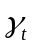. The larger is the error made with the previous estimate, the larger is the update. The larger is the learning gain, the larger is the update. Since the learning gain is the inverse of the sample size, it is large when the sample size is small. Adding a new observation has a relatively large impact on the estimated coefficients. As time approaches infinity, the sample size approaches infinity and the learning gain approaches zero. When there are a large number of observations, a new observation has a negligible effect on the estimates.
As time progresses with ordinary least squares, the learning algorithm converges on a set of coefficients, and uncertainty about how the Fed conducts monetary policy disappears. Also, if market participants always use ordinary least squares, they never suspect that a structural change in monetary policy can occur. If a structural change did occur, market participants would learn about it, but only very slowly. Structural change or not, the weight put on new observations gets smaller and smaller and all observations from the beginning of time are given equal weight.
There is strong evidence that structural changes in Taylor rule occurred at multiple times in U.S. history. For example, Clarida, Gali, and Gertler (2000) find statistical evidence that the Federal Reserve more heavily targeted inflation after Paul Volker's appointment as Fed Chairman in 1979. Constant gain learning is an alternative learning framework where agents can learn about structural changes and learning dynamics do not disappear over time. Constant gain learning simply replaces the learning gain, , with a constant value, . Repeated substitution of equations (3) and (4) shows that constant gain learning is equivalent to the following weighted least squares estimator,
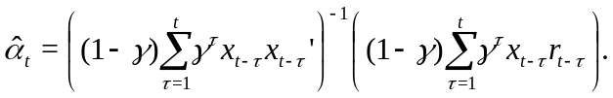 (5)
Equation (5) indicates the weight observations from periods in the past is equal to 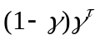. Most recent observations are given the highest weight and the weights decline geometrically with time. One may view this as a learning mechanism for agents that have a constant suspicion of structural change that is not directly observable. Agents do not have a formal understanding of the size of changes that could occur or the probabilities for which they could occur, so they simply put the most weight on the observations which are most likely to reflect the current structure of the economy.
Computing the coefficients for constant gain learning using the recursive algorithm given in equations (3) and (4) requires an initial condition for 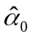 and 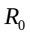. The sample period studied in the this paper runs from 1965:Q1 though 2010:Q2. We use the ten years prior to this sample (1955:Q1 through 1964:Q4) to construct an estimate for the initial conditions for the learning process. We estimate the Taylor rule given in equation (1) with ordinary least squares and use the estimated coefficients to initialize and the average of the outer product, 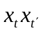, to initialize.
Figures 1 through 5 show the path of the constant gain learning coefficients for a learning gain, using 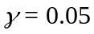. A number of important inferences can be made from these graphs. To begin, we find greater emphasis on inflation and output growth and decreased focus on unemployment during the early 1980s, likely as a result of the tumultuous economic conditions. Further, the early 1980s show decreased persistence in the rate coefficient, as the prior period interest rate falls sharply in size. The unemployment coefficeint has remained relatively consistant post 1980s, whereas the coefficients for output growth and inflation have changed in size. In the past 3 decades, the impact of output growth has increased in size and the impact of inflation has decreased in size potentially showing a shift in emphasis for policy decision-making. Finally, the lagged interest rate has also increased in size in recent decades, likely a result of the period of “great moderation” in the U.S. economy. Taylor (1999) acknowledges the dramatic change of emphasis in the monetary policy rule, in response to similarly dramatic changes in macroeconomic stability.
These figures show that monetary policy has indeed changed over time as suggested by Clarida, Gali, and Gertler (2000), Taylor (1999), and others. We now focus on measuring how changes in monetary policy can lead to an environment of greater uncertainty.

2.2 Uncertainty
An environment of uncertainty results when recent actions of the Federal Reserve deviate from market participants' expectations. Deviations of market expectations are captured by the residuals from agents' estimates of the Taylor rule given in equation (1). The larger are the mean squared residuals from this regression, the larger will be the variance of the forecast for 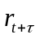, and the larger will be variance for forecasts for any variable that depends on expectations of future interest rates. market participants use weighted least squares to compute their forecasts, so for a given value for , we use the following root weighted mean squared residuals as a measure of the degree of uncertainty caused by recent unpredicted monetary policy actions,
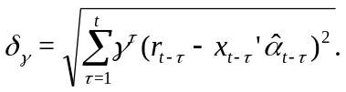 (6)
Figure 6 shows the evolution of uncertainty over the sample period. As with the other figures related to estimating the rate decision, we find a spike in uncertainty during the early 1980s with smaller spikes in the mid-1970s. Since the early 1980s period, we show low uncertainty with relatively larger measures in the early 1990s, early 2000s, and late 2000s.
3. Macroeconomic Impact of Uncertainty
After building a moving average value for uncertainty in each time period, we continue by including these values as independent variables in a one period vector auto-regression model. The purpose of this model is to test the evolution and interdependency of output, inflation, and unemployment as well as the impact of the uncertainty estimator (δ_{γ}) on these variables. We use a VAR(1) model, with ARCH(1) errors, that has been augmented to include the prior rate and a measure of uncertainty to test its impact on macroeconomic performance measures. We estimate the equations for each macroeconomic variable separately. The models are constructed as follows:

g_{t} = β + β₁g_{t-1} + β₂π_{t-1} + β₃u_{t-1} + βδ_{γ} + υ_{g,t} (7)
π_{t} = φ + φ₁g_{t-1} +φ₂π_{t-1} + φ₃u_{t-1} + φδ_{γ} + υ_{π,t} (8)
u_{t} = ψ + ψ₁g_{t-1} +ψ₂π_{t-1} + ψ₃u_{t-1} + ψδ_{γ} + υ_{u,t} (9)
Where: υ_{t} ~ N(0,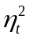), and 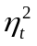 represents time-varying volatility which is described in the next section.
For each of the three dependent measurements, we run separate models substituting the three separate uncertainty estimators in each period. This method creates nine separate OLS regression models with heteroskedastic robust standard errors, as shown in Table 2.
Table 2. One-Period Vector Auto-Regression Models
 | Dependent Variables
 | g_{t} |  |  |  | π_{t} |  |  |  | u_{t}
Ind. Vars | γ = .05 | γ = .02 | γ = .01 |  | γ = .05 | γ = .02 | γ = .01 |  | γ = .05 | γ = .02 | γ = .01
Constant | .306 | .296 | .300 |  | .351 | .339 | .348 |  | .310 | .312 | .302
 | (.262) | (.259) | (.258) |  | (.242) | (.239) | (.241) |  | (.104) | (.103) | (.102)
r _{t-1} | -.034 | -.032 | -.031 |  | .062** | .064*** | .063** |  | .001 | .000 | .001
 | (.026) | (.026) | (.026) |  | (.026) | (.026) | (.027) |  | (.011) | (.011) | (.011)
g _{t-1} | .315*** | .313*** | .312*** |  | .041 | .040 | .041 |  | -.213*** | -.211*** | -.211***
 | (.086) | (.085) | (.085) |  | (.082) | (.082) | (.082) |  | (.034) | (.033) | (.033)
π _{t-1} | -.046 | -.045 | -.045 |  | .433*** | .435*** | .433*** |  | .013 | .013 | .014
 | (.120) | (.119) | (.119) |  | (.118) | (.117) | (.117) |  | (.050) | (.050) | (.050)
u _{t-1} | .083*** | .085*** | .084*** |  | -.026 | -.024 | -.026 |  | .968*** | .967*** | .968***
 | (.034) | (.033) | (.033) |  | (.025) | (.025) | (.024) |  | (.014) | (.013) | (.013)
δ _{γ} | -.240 | -.501 | -.755 |  | -.023 | -.118 | -.098 |  | .262 | .492 | .680
 | (.475) | (.784) | (1.155) |  | (.367) | (.614) | (.900) |  | (.189) | (.320) | (.482)
R² | .173 | .175 | .176 |  | .367 | .367 | .367 |  | .971 | .971 | .971
N | 181 | 181 | 181 |  | 181 | 181 | 181 |  | 181 | 181 | 181

The signs on the coefficients of the uncertainty measurements meet preliminary expectations that increased uncertainty decreases output growth, increases inflation, and increases unemployment within this model, however, we do not find any of these coefficients to be statistically significant different from zero.

4. Model for Evolving Variance
Grier (2000) suggests that constant variance is not evident in output growth and inflation. Accordingly, we construct an autoregressive conditional heteroskedasticity (ARCH) stochastic model, first introduced by Robert F. Engle (1982), to test this assertion. Engle originally used this model to estimate variances of inflation in the United Kingdom as a means to explain the estimated variance escalation during the economically-turbulent 1970s. An ARCH model will allow for the variance of the residual terms of our VAR(1) models to change over time (deviate from constant variance). We further augment the explanatory variables of the ARCH model with the measure of uncertainty to determine if uncertainty leads to greater macroeconomic volatility. Using 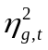, 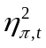, and 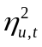 as measures for growth, inflation, and unemployment variance, respectively, we construct the following ARCH(1) models using OLS:

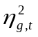= ρ + ρ₁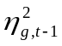+ ρ₂ 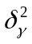 + ν_{t,g} (10)
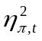= τ + τ₁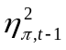+ τ₂ + ν_{t,π} (11)
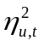= χ + χ₁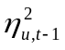+ χ₂ + ν_{t,u} (12)
Where: ν_{t} ~ N(0, 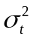)
The results from this model are shown in Table 3. The coefficients from the squared error terms from the VAR(1) equations in the preceding period support time-varying volatility of the error terms. For these measurements, we find strong persistent volatility in the inflation models and no evidence of persistence in the output growth and unemployment models. The uncertainty measurements test the impact central bank uncertainty has on the autocorrelation in the VAR(1) error terms. Interestingly, the coefficients are positive and significant for output growth volatility and unemployment volatility and not for inflation volatility. These positive, statistically significant coefficients shown below suggest that increased uncertainty in the period contributes to increased volatility of output growth and unemployment.
Table 3. ARCH(1) Model
 | Dependent Variables
 | g_{t} |  |  |  | π_{t} |  |  |  | u_{t}
Ind. Vars | γ = .05 | γ = .02 | γ = .01 |  | γ = .05 | γ = .02 | γ = .01 |  | γ = .05 | γ = .02 | γ = .01
Constant | .485 | .487 | .485 |  | .323 | .321 | .318 |  | .057 | .057 | .057
 | (.101) | (.101) | (.101) |  | (.109) | (.109) | (.109) |  | (.013) | (.013) | (.013)
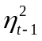 | .115 | .112 | .109 |  | .208*** | .207*** | .207*** |  | .104 | .086 | .074
 | (.074) | (.075) | (.074) |  | (.073) | (.073) | (.073) |  | (.074) | (.074) | (.074)
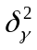 | .585*** | 1.632** | 3.617*** |  | .354 | 1.086 | 2.426 |  | .101*** | .311*** | .743***
 | (.229) | (.672) | (1.433) |  | (.256) | (.742) | (1.584) |  | (.031) | (.091) | (.194)
R² | .058 | .053 | .055 |  | .057 | .058 | .059 |  | .081 | .083 | .096
N | 180 | 180 | 180 |  | 180 | 180 | 180 |  | 180 | 180 | 180

5. Conclusion
The Federal Reserve has a dual mandate to promote stability in employment and inflation and to maintain flexibility, it does not communicate precise targets for each nor the degree to which the federal funds rate will be adjusted in response to each. Market participants decisions often depend on expectations for variables that depend on expectations for monetary policy. We use a Taylor rule regression equation and a constant gain learning model to compute market participants estimates for the conduct of monetary policy, and we develop a measure for the degree of uncertainty caused by unpredicted monetary policy changes by aggregating recent squared residuals. We incorporate our measure of monetary policy uncertainty into a VAR(1) model of output growth, inflation, unemployment, and interest rates with ARCH(1) errors. The VAR(1) results indicate there is insufficient evidence to conclude monetary policy uncertainty affects levels of output growth, inflation, or unemployment, but the ARCH(1) results do show that higher monetary policy uncertainty leads to greater volatility for output growth and unemployment.

Figure 1. WLS Estimate for Constant Coefficient
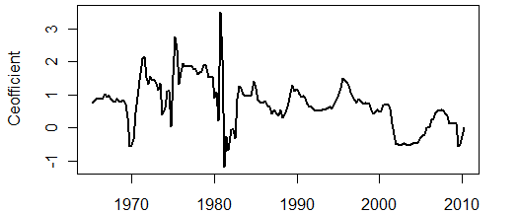

Figure 2. WLS Estimate for Coefficient on Inflation
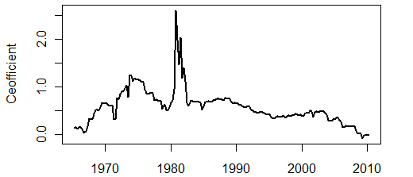

Figure 3. WLS Estimate for Coefficient on Unemployment
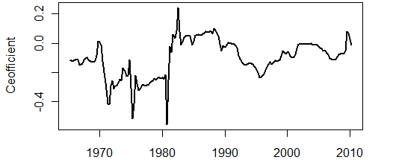

Figure 4. WLS Estimate for Coefficient on Output Growth
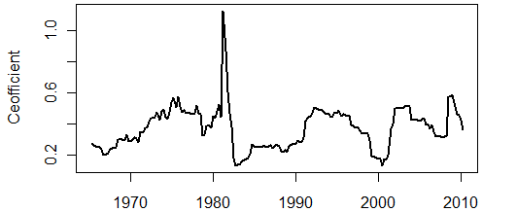

Figure 5. WLS Estimate for Coefficient on Lagged Interest Rate
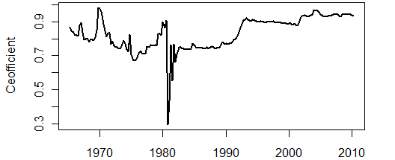

Figure 6. Uncertainty Measurement
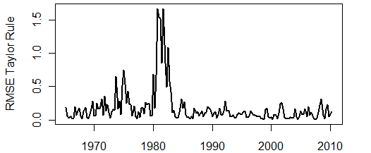

References

Bernanke, B, & Mishkin, F. (1997). Inflation targeting: a new framework for monetary policy?. The Journal of Economic Perspectives, 11(2), 97-116.

Bernanke, B. (2007). Federal reserve communications. Proceedings of the Cato institute 25th annual monetary conference (pp. 1-8). Washington, DC: http://www.federalreserve.gov/newsevents/speech/bernanke20071114a.htm.

Bulir, A, Smidkova, K, Kotlan, Viktor, & Navratil, D. (2008). Inflation targeting and communication: it pays off to read inflation reports. IMF Working Paper No. 08/234, 1-42

Cecchetti, S, & Ehrmann, M. (1999). Does inflation targeting increase output volatility? an international comparison of policymakers' preferences and outcomes. NBER Working Paper No. W7426

Cecchetti, S, & Krause, S. (2001). Financial structure, macroeconomic stability and monetary policy.NBER Working Paper No. W8354

Cecchetti, S, & Krause, S. (2002). Central bank structure, policy efficiency, and macroeconomic performance: exploring empirical relationships. Federal Reserve Bank of St. Louis Review, 84(4), 47-60.

Clarida, R, Gali, J, & Gertler, M. (2000). Monetary policy rules and macroeconomic stability: evidence and some theory. The Quarterly Journal of Economics, 115(1), 147-180.

Engle, R. (1982). Autoregressive conditional heteroskedasticity with estimates of the variance of united kingdom inflation. Econometrica, 50(4), 987-1007.

Fountas, S. (2001). The relationship between inflation and inflation uncertainty in the uk: 1885-1998. Economics Letters, 74(1), 77-83.

Fountas, S, & Karanasos, M. (2007). Inﬂation, output growth, and nominal and real uncertainty: empirical evidence for the g7. Journal of International Money and Finance, 26, 229-250.

Fountas, S, Karanasos, M, & Kim, J. (2006). Inflation uncertainty, output growth uncertainty and macroeconomic performance. Oxford Bulletin of Economics and Statistics, 68(3), 319-343.

Grier, Kevin, & Perry, Mark. (2000). The effects of real and nominal uncertainty on inflation and output growth: some garch-m evidence. Journal of Applied Economics, 15, 45-58.

Grier, K, Henry, O, Olekalns, N, & Shields, K. (2004). The asymmetric effects of uncertainty on inflation and output growth. Journal of Applied Economics, 19, 551-565.

Krause, S. (2007). Measuring monetary policy efficiency in european union countries: the pre-emu years. The IUP Journal of Monetary Economics,5(1), 60-83.

Svensson, L. (1997). Inflation forecast targeting: implementing and monitoring inflation targets. European Economic Review, 41(6), 1111-1146.

Taylor, J. (1993). Discretion versus policy rules in practice. Carnegie-Rochester Conf Ser. Public Policy, 39, 195-214.
Taylor, J. (1999). A historical analysis of monetary policy rules. Monetary Policy Rules, 31, 319-348.

Preliminary and incomplete. All errors are our own.
Mailing address: 1725 State St., La Crosse, WI 54601. Phone: (608)785-8099. E-mail: herro.nich@uwlax.edu.
Mailing address: 1725 State St., La Crosse, WI 54601. Phone: (608)406-4068. E-mail: murray.jame@uwlax.edu.
According to Krause, optimal policy consists of two parts: authorities completely neutralize effects of demand shocks and accommodate supply shocks depending on the structural parameters and preferences of the individual country.
Consumer Price Index for All Urban Consumers: All items; 1Q08 data, for example, would be calculated as the sum of the percentage change for January 2008, February 2008, and March 2008 as reported by the St. Louis Federal Reserve Bank.
All data used in these models was retrieved from the St. Louis Fed’s FRED® interface.
T
Each column of data would be interpreted as a VAR(1) model with robust standard errors and weight γ, where the dependent variable is predicted with an uncertainty measurement with as the added parameter, denoted by δ.

