##### Predictors for Students’ Understanding of Writing: Instructor Actions and Student Mindset

Sara L. Cook  
Viterbo University   
   
Sloan Komissarov  
Western Technical College   
   
Brenda Murray  
University of Wisconsin - La Crosse   
   
James Murray[1]  
University of Wisconsin - La Crosse

June 12, 2018

**Abstract**

College instructors across the curriculum work to develop students’ ability to be purposeful writers, and it can be a significant pedagogical challenge and evolving practice. Whether it is in introductory college writing English course or capstone courses in the sciences, instructors expect students to understand concepts of purpose and audience,and use these ideas to guide decisions in their writing. We surveyed more than 2,000 students at two four-year universities to measure how well students used and understood these writing concepts in the last significant paper they wrote. We measure on ordinal scales students’ depth of application of purpose and audience. We also measure a number of predictors including how often students are assigned writing assignments, students’ use of writing center and library resources, and students’ view on mindset, i.e. their ability to learn new things and develop new skills. We find that most students report shallow-level writing experiences when it comes to purpose and audience. For example, students often describe a limited sense of purpose and audience as writing about a topic for the instructor. We find no progression in depth with academic progression, but we do find statistical evidence for ways instructors can positively influence students’ application of audience and purpose, including nurturing a growth mindset, giving students formative feedback on writing, and sending students to a writing center.

*Keywords*: Student writing, mindset, audience, purpose

## 1 Introduction

Instructors have multiple goals for requiring student writing throughout the curriculum, and these goals may vary between courses or even between assignments in the same course. We can think of three pedagogical goals that encompass most of college writing: (1) demonstrate understanding, (2) foster personal growth for the students, and (3) engage and transform an audience.

The first goal, to assess students’ understanding of course content, could come in the form of exams, papers, or essays that require students to summarize concepts or connect ideas. It may be fair to say in these writing assignments that the *audience* is the instructor.

When instructors have the second goal, the writing assignment is a pedagogical strategy to foster student learning and growth. A writing assignment may ask students to explore new ideas and make new connections. Alternatively, the goal of a writing assignment may be to improve written communication skills or get genre-specific practice (e.g. lab reports or academic discourse). In such cases, the intention may be for the students to be writing to improve themselves. There may not be a formal *audience*. The writing assignment is designed to be a reflective and enriching exercise for the writer, rather than trying to influence an audience.

With the third goal, instructors want students to think of writing as a means to engage and transform an audience. The writing *purpose* is intertwined with the *audience*. The purpose may be to argue or persuade an audience to a point of view or to encourage the audience to make a certain decision. The purpose may be to inform professionals, academics, or popular audiences of research findings. In these cases, as the students write, they need to continually make decisions on style, structure, and content in such a way that appropriately suits their audiences and best achieves the students’ goals for transforming their audiences. The audience is not the instructor and the students should not think of the writing as only for their own sake. Students need to constantly consider the audience’s current position and where they want to take the audience. They need to continually ask themselves questions about the audience. What does the audience already know and not yet know? What are the audience’s values and interests? What will make the audience value and be interested in what I write? What content do I need and how shall I best communicate it to achieve the change I want to see in my audience?

All three goals in the first paragraph are important and have their place in the college curriculum. Any one goal is not necessarily any more or less valuable than another goal and we expect that all students should experience writing assignments with each of these goals throughout their college careers. Still, we may view these three goals as hierarchical. As we move from goal #1 (demonstrating understanding) to goal #2 (writing for personal growth) to goal #3 (engaging and transforming an audience), the writer has to pay greater attention to *purpose*.

This paper estimates how much college students are engaged in each of these writing purposes, how this attention might vary in the curriculum, how students’ characteristics may influence their perceptions of purpose, what instructors can do to improve students’ perception of purpose, and the role that a growth mindset has in determining students’ perceptions.

We also measure students’ understanding of audience. Do students describe their audience as their instructor, fellow students or experts in the field, or authentic audiences (even if fictional), such as grant proposal reviewers, peer reviewers, business decision makers, voters, etc? Again, we investigate how students’ perception of audience varies throught the college curriculum, how it depends on students’ characteristics, how instructors may influence students’ perceptions, and the role that a growth mindset has in determining students perceptions.

Our target audience for this paper is primarily college instructors outside the disciplines of English and communication studies. That is, instructors who require writing assignments in their courses, but who do not have the class time or even necessarily the pedagogical expertise to teach students how to be better writers. Students across all majors will be expected to engage in written communication in their careers, and teaching writing cannot be relegated to only first-year courses. Students must build their written communication skills throughout their college careers, and become more comfortable with discipline-specific audiences and purposes.

## 2 Survey

We measured students’ sense of writing purpose and audience, in addition to factors that may influence either their perceptions or the types of writing assignments they experience. These include instructor actions in the classroom; an aggregate measure of student mindset; demographics including gender, race, parents’ educational attainment, and prior high school performance; and students’ academic characteristics including field of study and credits accumulated toward their degree.

We measured these variables with a survey administered in Spring 2017 to all undergraduate students at the University of Wisconsin - La Crosse (UWL) and Viterbo University, two universities in La Crosse, WI with a large majority of students from Western Wisconsin. Both universities are primarily undergraduate institutions, but both include a limited number of graduate programs and students. UWL is a public, regional, comprehensive university with almost 10,000 undergraduate students. Viterbo University is a smaller private university with approximately 2,000 undergraduate students, a smaller student-to-faculty ratio (Viterbo is 11:1 and UWL is 19:1) and a smaller average class size (Viterbo is 16 and UWL is 28). We received 2,305 responses, for a response rate of approximately 20%.

### 2.1 Students’ Perception of Purpose

We measure students’ sense of purpose with the following open-ended survey prompt:

*Think about the last 3+ page writing assignment you completed. In one sentence,* ***describe the purpose*** *for the writing.* (bold emphasis in survey)

We categorized student responses into the following ordered levels:

1. None / unclear

2. Topic or assignment description, instructor-centered description

3. Writer-centered description (personal growth, to enhance understanding,

improve as a writer, to practice)

4. Reader-centered description (someone other the instructor)

Responses for purpose that were coded as none / unclear included responses like "taking a midterm for the class," "to do the assignment," "for a class grade," etc.

Responses coded as as the second level, topic or assignment description, instructor-centered description, included responses such as "summarize my group’s findings," "show how sociological delinquency theory is applicable in a song," "research an environmental problem," "explain results of mathematics research." These responses reflected *what* the students were writing about, but not *why*. There was no focus on purposefully transforming an audience nor transforming themselves.

Responses coded with the third level, writer-centered description, included descriptions such as "to get me to think about a topic from a different perspective," "to reflect on how the literature is related to Viterbo’s values," "strengthen my writing skills," "better understand myself," etc. All these students understood their writing assignment as having the goal to strengthen themselves.

The final level, reader-centered description, included responses such as "educate others on fracking," "proposal *[sic]* a plan of care for the patient," "write an argumentative essay about the media’s influence," etc. These responses included verbs that imply that writing is taking actions on the reader, such as "to propose," "to educate," "to inform," or "to argue."

We interpret the purpose categories as ordered or hierarchal in the statistical analysis that follows, using the order given above. That is, we look for evidence that explains students preceiving working in a higher-level versus a lower-level. This ranking is not intended to imply that the higher categories are more important, or that they are associated with better assignments or more learning. All the categories above "none" have their place in college curriculum. The ranking reflects greater attention to purpose that students are giving or need to give in making decisions in their writing. The first level shows no attention. The second level reveals only a focus on content. The third level is a focus not only on the content but also how the writing can better the student. The final level, at least when done well, requires the student to understand the point of view, existing knowledge, values, and interests of the reader and to know how to communicate effectively to achieve a transformation in the reader. We consider this as the highest-order recognition of purpose.

Note that we are measuring *students’ perceptions* of writing purpose, and this may or may not correspond to what the students’ instructors would testify is the purpose of the assignments. This is intentional. We want to measure and identify students’ learning and experiences, which may not perfectly correspond to instructors’ intentions. If the instructor gives an assignment with the intention for students to write to an authentic audience, but students still perceive the instructor as the audience, then the student’s experience may not have enhanced their understanding of writing to an audience. In fact, we expect that different students will have different points of view regarding purpose for the same writing assignment, and that it may depend on the attention that the students gave to the assignment, on how much experience students have with writing, on whether they received formative feedback from the instructor or writing center, on their chosen field of study, and even on demographic characteristics. The purpose of this paper is to explain how student-level factors predict students’ perception of purpose.

Figure 1 illustrates students’ descriptions of the purpose of their last writing assignment. A majority described the purpose as the description of the assignment, a description centered on content and/or the instructor, but not one that involved transforming themselves or an audience. Almost 24% of students indicated a purpose around improving themselves, and a small minority (approximately 7%) gave a reader-centered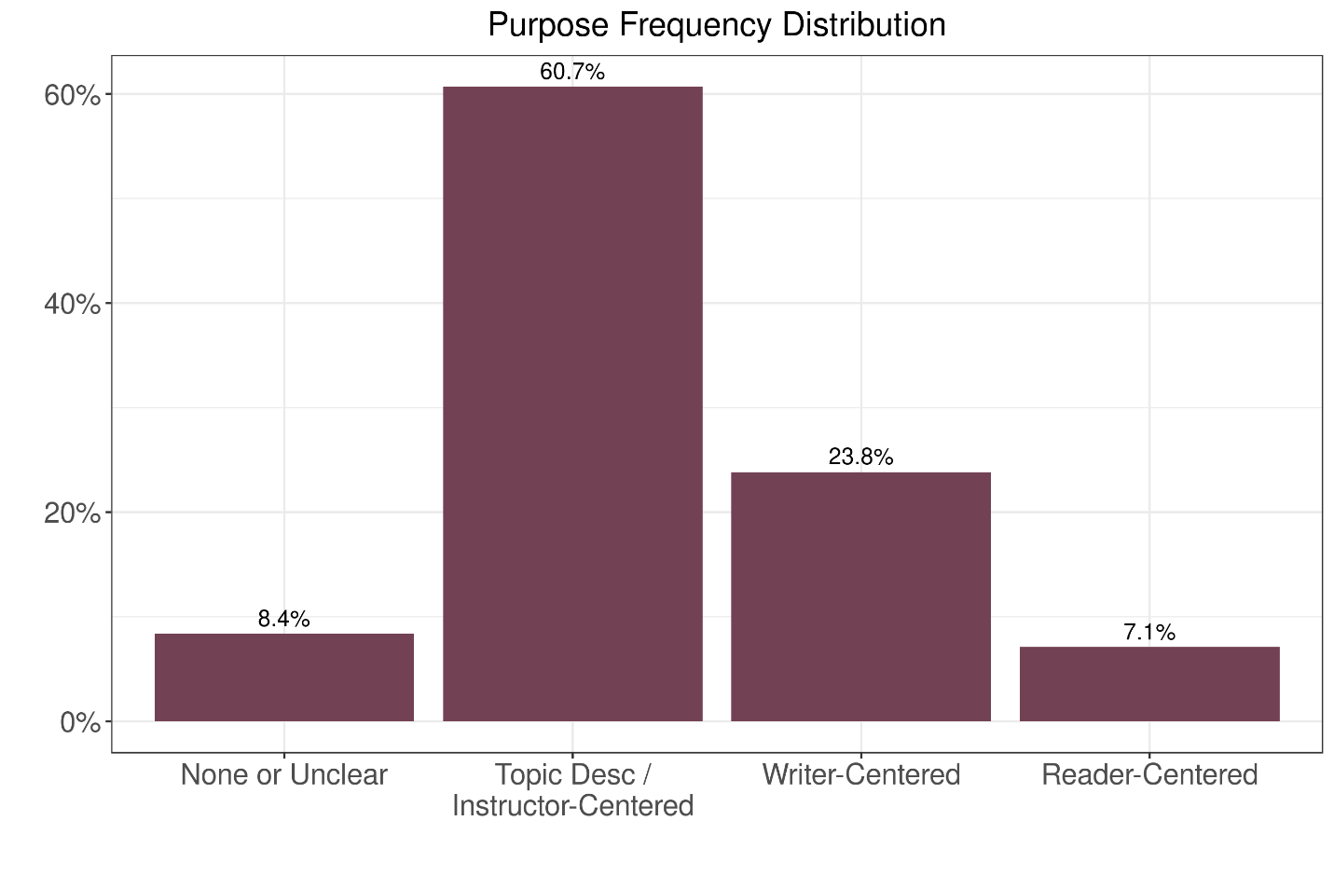

**Figure 1: Students Perception of Purpose Responses**

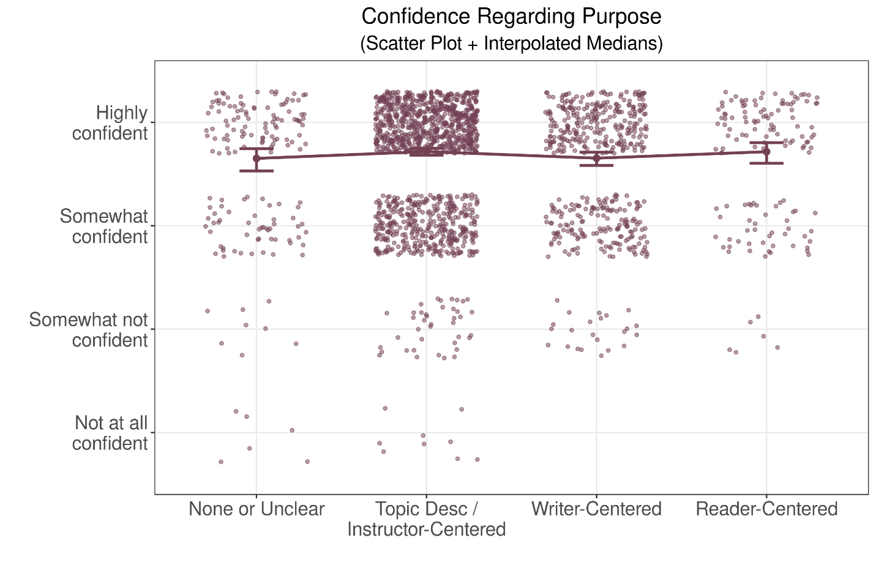

**Figure 2: Student Confidence on Perception of Purpose**

We also asked students how confident they were in their answer, on the four-point ordinal scale, "Not at all confident," "Somewhat not confident," "Somewhat confident," and "Highly confident." Figure 2 shows a scatter plot of students’ perceptions of purpose along with the degree of confidence. The dark line represents the interpolated median for the level of confidence, and the error bars illustrate the 95% bootstrapped confidence interval for interpolated mean for the level of confidence. On average, students report a high level of confidence in their answer, regardless of the depth of purpose in their description.

### 2.2 Students’ Perception of Audience

We similarly measure students’ sense of audience with the following open-ended survey prompt:

*Think about the last 3+ page writing assignment you completed. In one sentence,* ***describe the audience*** *for the writing.* (bold emphasis in survey)

We categorized student responses into the following ordered levels:

• None / unclear

• Instructor-centered

• Subject matter experts or peers

• Authentic descriptions

Responses classified as none / unclear included, "it was for anybody," "no one," "unsure," etc. Responses classified as instructor-centered included responses like "the professor" or "my advisor."

Responses classified as subject matter experts or peers included like "people in my class," "students in my major," and "people interested in this topic," etc. These students’ responses reflected an understanding of audience as people in an academic setting who would already have an interest in the topic. This level of understanding requires students to reflect on the existing knowledge of their audience, but not necessarily their values, interests, or decisions they make.

Finally, responses classified as authentic descriptions included "young adults," "health directors," "students looking to live off campus," "a group of investors," "people unsure if climate change actually exists," etc. These students’ responses reflected an understanding of audience’s knowledge, values, and/or the decisions they make.

In the statistical analysis below, we again assume these categories are ordinal or hierarchal. Higher levels indicate a greater attention, or at least recognition for needing greater attention, to who is reading their work and why the reader is doing so.

Figure 3 shows the distribution of students’ descriptions of their audience. Approximately 43% of students described their audience as their instructor, and almost 39% described the audience as class or subject-matter peers. A minority of students, almost 13%, gave a an authentic audience description.

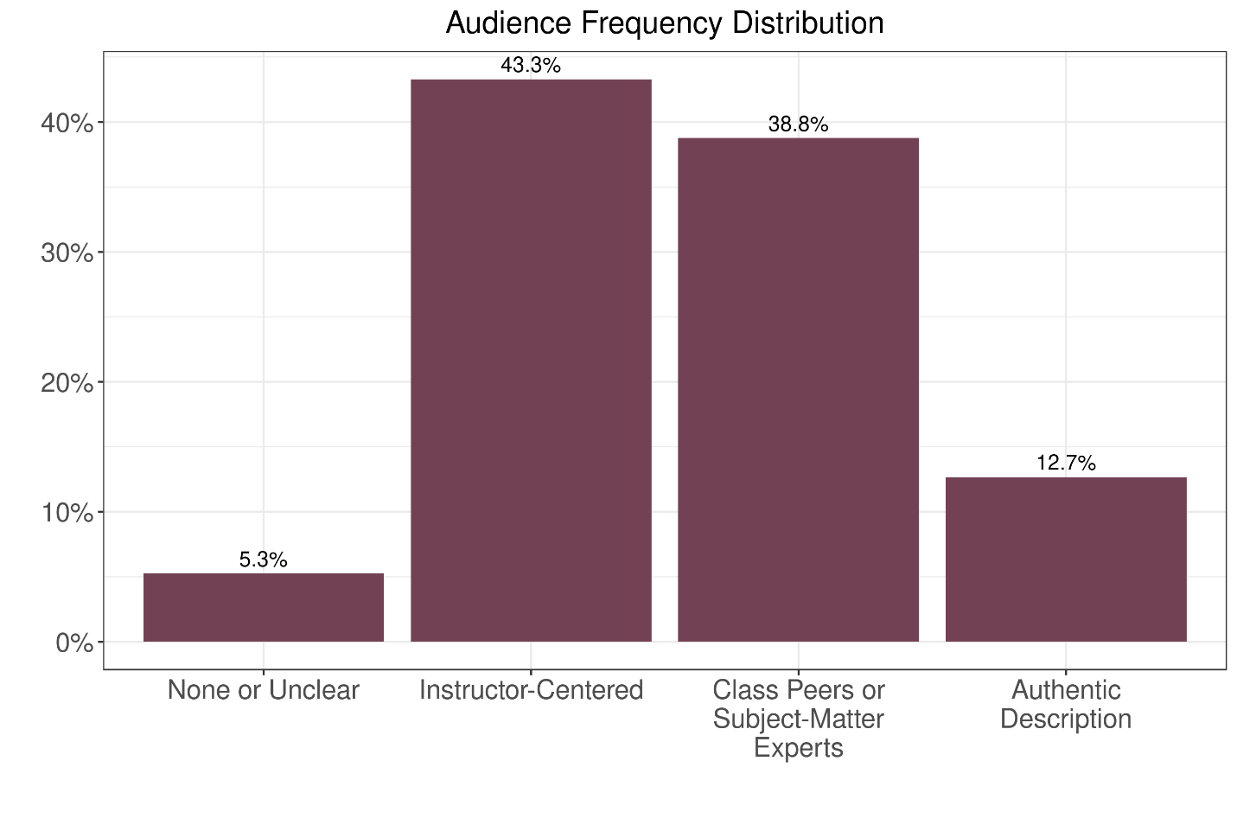

**Figure 3: Students Perception of Audience Responses**

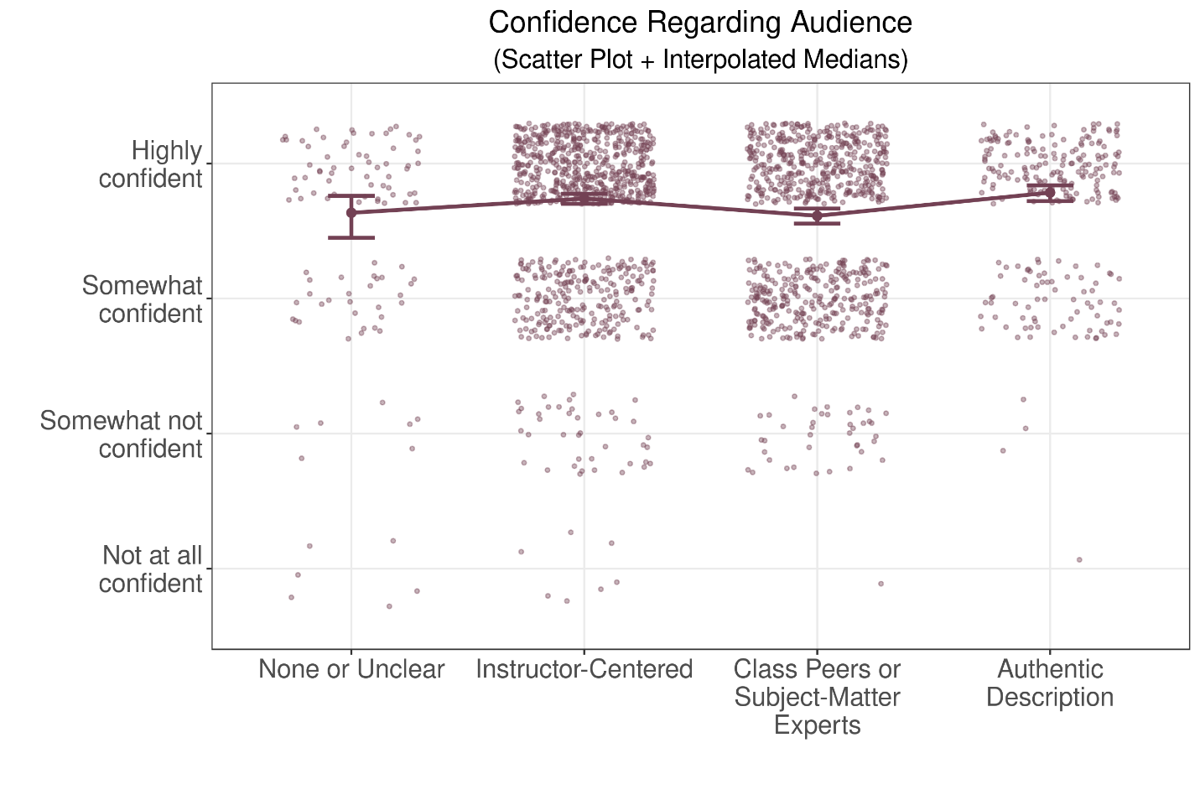

**Figure 4: Student Confidence on Perception of Audience**

As above, we also asked students how confident they were in their answer, on the four-point ordinal scale, "Not at all confident," "Somewhat not confident," "Somewhat confident," and "Highly confident." Figure 4 shows a scatterplot of students’ descriptions of audience with their level of confidence. Again the solid line illustrates the interpolated median for the level of confidence and the error bars illustrate the 95% bootstrapped confidence bounds for the interpolated median. Again, students report a high level of confidence in their audience description, regardless of how they described the audience.

### 2.3 Mindset

We consider mindset as a potential explanatory variable for students’ sense of purpose and audience. Dweck (1999, 2008) defines mindset as a person’s own perceptions of how learning works and what that means for that person’s own potential. A relatively fixed mindset is the view that some people have a talent or skill and others do not. Someone who has a fixed mindset does not perceive a large benefit coming from putting forth time and effort to learning a new task. If someone with a fixed mindset perceives themselves as someone who is naturally good at something, improvement is expected to come with little effort. If someone with a fixed mindset perceives themselves as not one of those people who are naturally good at something, little improvement is expected even if significant effort is applied.

Dweck (1999) demonstrates in much of her work that fixed mindset is damaging to learning. One reason it is so damaging is simply that it is wrong. Despite different people having different experience, academic background, and interests, all people are capable of learning new skills and doing so usually requires effort. Students with a fixed mindset can be dissuaded from applying effort, whether they initially perceived themselves as being someone with the capability or without the capability. Someone without the perceived capability may easily dismiss applying effort to something they have not succeeded in before, with the point of view they are just not one of those people that will succeed at this sort of task. Someone who perceives themselves as capable may get frustrated when success does not come with minimal effort expended. Without the signal of success, they may believe themselves not actually as capable as they thought they were.

The opposite of a fixed mindset is a growth mindset. It is the accurate perception that a person believes themselves capable of improving a skill or learning a new concept and the belief that exerting effort is worthwhile.

We measure mindset with the three statements below which are very similar to how Dweck (1999) reports measuring mindset in many studies. For each statement, we ask respondents to measure their rate of agreement on a six-point scale, (1) Strongly disagree, (2) Disagree, (3) Somewhat disagree, (4) Somewhat agree, (5) Agree, and (6) Strongly agree.

• You can learn new things, but you can’t really change how smart you are.

• You have a certain amount of math ability and you can’t do much to change it.

• You have a certain amount of writing ability and you can’t really do much to

change it.

Each of these statements are phrased in the viewpoint of a fixed mindset, so larger levels of disagreement correspond to more of a growth-oriented mindset and larger levels of agreement correspond to a more of a fixed-oriented mindset.

Figures 5-7 illustrate the responses to these mindset questions. Moving from right to left in these figures indicates more growth-oriented mindset. Each of these measures, taken individually, reveal a majority of students have a growth-oriented mindset. Interestingly, more students tend to have a fixed mindset when it comes to math ability versus writing ability. Also, the more general statement on having a fixed intelligence reveals more students having a fixed-oriented mindset as compared to either the math- or writing-specific statements.

Cook et al. (2017) use these same survey results and estimate a factor analysis with a single factor to generate an overall measure of mindset. The factor analysis generates a common component that explains the responses of all three survey questions on a continuous scale. We refer the reader to this study for the full details. In the present paper, we use this common component as an explanatory variable in the regressions in the next section. We hypothesize that students with a growth-oriented mindset may choose to give greater attention to purpose and audience, and indeed we find evidence of this hypothesis, as we describe in the next section.

|  |
| --- |
| https://raw.githubusercontent.com/murraylax/writingsurvey/4999fc7f425976e6e7aea273c5328384858928e8/mindhist-math.png |
| **Figure 5: Mindset Responses: “You have a certain amount of writing ability and you can’t do much to change it.”** |
| https://raw.githubusercontent.com/murraylax/writingsurvey/4999fc7f425976e6e7aea273c5328384858928e8/mindhist-write.png |
| **Figure 6: Mindset Responses: “You have a certain amount of**  **math ability and you can’t do much to change it.”** |
| https://raw.githubusercontent.com/murraylax/writingsurvey/4999fc7f425976e6e7aea273c5328384858928e8/mindhist-smart.png |
| **Figure 7: Mindset Responses: "You can learn new things,**  **but you can’t really change how smart you are."** |

Figures 8-10 show scatter plots of the estimated common factor for the mindset questions and each of the three survey questions. The vertical scale on each plot is a continuous measure of mindset, measured on a scale with mean zero and unit standard deviation. Larger values indicate a more growth-oriented mindset. The horizontal scale gives the levels of agreement for each of the mindset questions, where movement from left to right indicates more growth-oriented mindset. The figures and the Spearman correlation coefficients are all significantly above zero at the 1% level, which implies that the responses to all three mindset questions are strongly positively related to the overall measure for mindset.

|  |
| --- |
|  |
| “You have a certain amount of writing ability and you  can’t do much to change it.”  **Figure 8: Mindset Common Component vs. Writing Ability** |
|  |
| “You have a certain amount of math ability and you  can’t do much to change it.”  **Figure 9: Mindset Common Component vs. Math Ability** |
|  |
| "You can learn new things, but you  can’t really change how smart you are."  **Figure 10: Common Component vs. Fixed Intelligence Question** |

### 2.4 Other Explanatory Variables

We consider two explanatory variables that are typically within instructors’ control, including giving formative feedback on writing and encouraging students to use the writing center.

We measure how common it is for instructors to give formative feedback on writing with the following question measured on the ordinal scale (1) Never, (2) Rarely, (3) Sometimes, (4) Most of the time, and (5) Always:

*How often do your instructors give you feedback on first drafts of writing assignments before you submit a final draft?*

If students reported "most of the time" or "always" we set a binary variable called feedback equal to 1 and set equal to 0 for the other responses. Almost 30% of students reported with either "most of the time" or "always."

We measure how common it is for instructors to encourage the use of the writing center with the following question:

*Since the beginning of previous semester, have any of your instructors encouraged or required you to use the writing center?*

with possible responses,

• Instructors never encouraged or required students use the writing center.

• At least one instructor encouraged, but did not require, students to use the

writing center.

• At least one instructor required students to use the writing center.

We create a binary variable from these responses equal to 1 if students selected either of the last two levels, meaning the student received encouragement or had a formal requirement in the academic year of the survey; the variable is set equal to 0 if the student responded with the first level, that instructors never encouraged or required students to use the writing center. Approximately 83% of students report being encouraged or required to use the writing center.

We consider demographic explanatory variables of gender, race, parents’ highest level of education, and ACT score. Race is given in the regressions below as the binary variable identifying an individual as non-white. It is equal to one if a student selected any non-white race option for a question that allowed students to check all races that they identify with, and equal to 0 if only white was selected. Students were asked the highest level of education from all of their parent(s) or legal guardian(s). We use a binary variable in the regressions below set equal to 1 if the parents’ highest level of education included no college. The ACT score is the measure of performance on the ACT college entrance exam.[2] The possible range for ACT scores is 1-36. The mean in the sample is 25. UWL reports on its website that the interquartile range of ACT scores for admitted freshman is 23-27.

Finally, we consider academic factors including the number of credits accumulated and chosen field of study. We classify field of study into into four categories: business, education, liberal studies (arts and social sciences), and science / health.

## 3 Results

We estimate two ordered logistic regression models, one for each ordinal dependent variable, (1) students perception of purpose and (2) students perception of audience. The results are given in Table 1. The explanatory variables are grouped into three categories. The first three variables grouped together are related to mindset and instructor influences; the next four variables grouped together are demographic characteristics of the students; and the final four variables grouped together are academic characteristics. The table reports the coefficients and the p-values. The magnitude of the coefficient is not particularly meaningful,[3] but the sign is meaningful. A positive coefficient is an indication that an increase in the explanatory variable, or the presence of the binary variable, leads to an increase in the probability a student perceives a higher-order category for purpose or audience. A negative coefficient is an indication that a the variable makes it less likely the student perceives a higher-order category for purpose or audience.

All of the coefficients in the first grouping are positive and statistically significant. The first variable is the binary variable equal to one when students report that instructors give feedback on writing assignment before submitting a final draft always or most of the time. When students get frequent feedback on writing in their college careers, they are more likely to have higher-order perceptions for purpose and audience for their writing assignments. The second variable is a binary variable equal to one when students report that at least one of their instructor encouraged or required them to use the campus writing center in the academic year when the survey was taken. Again, when students have had this encouragement to seek feedback and/or tutoring on their writing, they were more likely to have a deeper perception of purpose and audience. These findings together suggest a straightforward way for instructors to help students get a deeper understanding for purpose and audience in their writing: provide opportunities for feedback during the writing process.

The statistically signficant positive coefficient on mindset indicates that when students have a more growth-oriented mindset, they are more likely to have a higher-order perception of purpose and audience. A person with a growth mindset has an attitude that expending effort can lead to learning new skills, improving how smart one is, and even becoming a better writer. A person with this kind of attitude is more likely to perceive the audience as someone besides the instructor, and more likely to perceive the purpose of the writing as improving one’s self or transforming an audience.

Some students may come into a class with a more fixed-oriented mindset and others with a more growth-oriented mindset, but just as one’s intelligence is not fixed, neither is mindset. Instructors can apply interventions in class to teach students that intelligence is not fixed. Blackwell et al. (2007) demonstrates that such an intervention led to greater motivation and higher grades for seventh graders in mathematics classes. Aronson et al. (2002) find that an intervention intended to have college students internalize the concept of a growth mindset led to a higher semester GPA by one-quarter of a grade level as compared to a control group.

Most of the next set of coefficients are not statistically significant. These are demographic variables including gender, race, parents’ level of education, and ACT score. Some of these variables may identify populations that are at risk for low academic performance or low retention rates, and others have shown these variables influence academic performance (see, for example, DeBerard et al. (2004) for evidence of of the impact of gender, Lee et al. (2004) for a review of evidence and explanations for the impact of parents’ education, and Shapiro et al. (2017) for the evidence of differences in academic achievement in college students by race and ethnicity). The only coefficient statistically significant in this group is the one on non-white race for the purpose dependent variable, and it is positive. There is statistical evidence that non-white students are more likely perceive deeper levels of purpose in their writing assignments than white students.

**Table 1: Ordered Logistic Regression Results**

|  |  |  |  |  |
| --- | --- | --- | --- | --- |
|  | **Purpose** | | **Audience** | |
| **Explanatory Variable** | **Coefficient** | **P-value** | **Coefficient** | **P-value** |
| Instructor formative feedback | 0.345 | 0.001 | 0.330 | 0.001 |
| Writing center encouragement | 0.215 | 0.098 | 0.274 | 0.024 |
| Mindset common factor | 0.093 | 0.039 | 0.085 | 0.044 |
| Gender: Female | 0.121 | 0.279 | 0.061 | 0.556 |
| Race: Non-white | -0.420 | 0.030 | -0.233 | 0.210 |
| Parent with no college education | -0.160 | 0.302 | 0.077 | 0.593 |
| ACT Score | 0.076 | 0.123 | 0.062 | 0.180 |
| Credits accumulated | -0.200 | 0.000 | 0.046 | 0.317 |
| Field of study: Education | -0.042 | 0.824 | -0.452 | 0.011 |
| Field of study: Liberal studies | -0.045 | 0.757 | -0.245 | 0.077 |
| Field of study: Science / health | 0.130 | 0.314 | -0.189 | 0.126 |
| The omitted category for field of study is business, so the coefficients on the field of studies reflect the difference in the given field as compared to students with a major or intended major in business. | | | | |
| * Significant at 10% level, ** Significant at 5% level, *** Significant at 1% level | | | | |
|  | |

The final set of coefficients are related to academic progression and field of study. The coefficient on the number of credits accumulated toward the degree is negative and statistically significant with regard to purpose. This implies we have evidence that students’ perception of purpose in their writing assignment moves downward as students progress toward their degree. This is a surprising finding as one may expect students’ writing experience to grow throughout college, but one might also expect upper-level undergraduate students to be given more authentic writing assignments in their courses as instructors begin preparing soon-to-be graduates for careers in their field.

The remaining coefficients in this group are binary variables identifying students’ chosen or expected major field of study. The omitted group is business, so each coefficient reflects the difference in perception of purpose and audience of the respective field as compared to business. The coefficients on the education field and the liberal studies field are negative and statistically significant in the regression predicting audience. This indicates students in business majors are more likely to perceive an authentic audience than students majoring in education and liberal studies fields.

## 4 Conclusion

We quantify and measure college students’ understanding of the concepts of purpose and audience in their writing assignments and examine evidence for contributing factors including avenues for instructor influences, student mindset, demographic characteristics, and academic status. Almost all of students have low perceptions of purpose in their writing, describing the content of their writing assignments rather than the piece of writing having an influence on reader or themselves. We also find that most students perceive low levels of audience, a majority identifying their instructor as the target audience of their work. We do not find that students’ sense of purpose or audience deepens as they progress in college. In fact, we find evidence of a lower perception of purpose as students accumulate more credits.

We do find statistical evidence for avenues for instructor influences including creating opportunities for feedback during students’ writing process and encouraging a growth mindset.

College writing assignments do have many purposes and intended audiences, and we expect that college students’ writing exeriences to include all three purposes we identified, demonstrate knowledge to their professor, writing to be self-reflective, and writing with the purpose to transform a target audience. All these purposes and audiences have their place, but we must move students toward the higher levels of purpose and audience, as all careers we prepare students for across disciplines require effective written communication skills and attention to audience and purpose. We have identified that few students experienced these higher levels in their last significant writing assignment, but we find straightforward avenues for instructors to make a difference.

**References**

Aronson, J., Fried, C. B., and Good, C. (2002). Reducing the Effects of Stereotype Threat on African American College Students by Shaping Theories of Intelligence.  *Journal of Experimental Social Psychology*, 38(2):113–125.

Blackwell, L. S., Trzesniewski, K. H., and Dweck, C. S. (2007). Implicit Theories of Intelligence Predict Achievement Across an Adolescent Transition: A Longitudinal Study and an Intervention.  *Child Development*, 78(1):246–263.

Cook, S. L., Komissarov, S., Murray, B., and Murray, J. (2017). Predictors for Growth Mindset and Sense of Belonging in College Students.  *SSRN Electronic Journal*.

DeBerard, M. S., Spielmans, G. I., and Julka, D. L. (2004). Predictors of Academic Achievement and Retention among College Freshmen: A Longitudinal Study.  *College Student Journal*, 38(1):66.

Dweck, C. S. (1999).  *Self-theories: Their role in motivation, personality, and development*. Self-theories: Their role in motivation, personality, and development. Psychology Press, New York, NY, US.

Dweck, C. S. (2008). Mindsets and Math/Science Achievement.  *Prepared for the Canegie Corporation of New York-Institute for Advanced Study Commission on Mathematics and Science Foundation.*, page 17.

Lee, J. J., Sax, L. J., Kim, K. A., and Hagedorn, L. S. (2004). Understanding Students’ Parental Education Beyond First-Generation Status.  *Community College Review*, 32(1):1–20.

Shapiro, D., Dundar, A., Huei, F., Khasiala Wakhungu, P., Yuan, X., Nathan, A., and Hwang, Y. (2017). A National View of Student Attainment Rates by Race and Ethnicity - Fall 2010 Cohort.  *National Student Clearinghouse Research Center*.

Yeager, D. S. and Walton, G. M. (2011). Social-Psychological Interventions in Education: They’re Not Magic.  *Review of Educational Research*, 81(2):267–301.

1. Contact author. *Mailing address*: 1725 State St., La Crosse, WI 54601. *Phone*: (608)406-4068.  
    *E-mail*: jmurray@uwlax.edu.
2. It is far more common for students at UWL and Viterbo (and many colleges and universities in the Midwest) to have completed the ACT rather than the SAT.
3. The coefficient is equal to marginal effect on the log of the odds ratio for being in a higher-order category for purpose or audience.