DECODELABS INDUSTRIAL TRAINING KIT
PROJECT 2 SUBMISSION REPORT
Basic Encryption & Decryption -- Caesar Cipher Engine
Submitted By : Mursalin Ahmed Sheikh
Batch : 2026
Track : Junior Analyst -- Cryptographic Logic

1. PROJECT OVERVIEW
This report documents the completion of Project 2 of the DecodeLabs Industrial Training Kit (Batch 2026): Basic Encryption & Decryption. The brief required a program capable of encrypting user-supplied text using a basic reversible technique (a Caesar cipher), decrypting that same text back to its original form, and displaying both the encrypted and decrypted output -- implemented through ASCII-based character arithmetic rather than complex cryptography.
Beyond the baseline requirements, this submission adds a second cipher mode (Vigenere, keyword-based) and two interactive security-analysis tools -- a brute-force simulator and a letter-frequency chart -- that demonstrate, in a hands-on way, why a simple Caesar shift is easy to break and why a longer, keyword-driven key improves resistance to that attack.
2. REQUIREMENT COMPLIANCE
The table below maps every requirement stated in the project brief to its implementation and current status.
# | Requirement | Implementation Summary | Status
1 | Encrypt user text using a basic logic (Caesar cipher or similar) | shift_char() / compute_cipher() apply a modular ASCII shift using a user-selectable key (1-25). | Met
2 | Decrypt the encrypted text | Same function called with the shift reversed (direction = -1); recovers the original text exactly. | Met
3 | Display both encrypted and decrypted output | The process log prints the original input alongside the resulting ciphertext/plaintext after every run. | Met
4 | Text-to-number (ASCII) conversion before shifting | Each character is converted via its ASCII code before the shift is applied, then converted back. | Met
5 | Modular arithmetic to wrap around the alphabet (mod 26) | shift_char() applies (value + shift) % 26 so the shift wraps correctly at the alphabet boundary. | Met
6 | Input -> Process -> Output (IPO) structure | An animated on-screen diagram highlights the Input, Process, and Output stages as each runs. | Met
7 | Edge-case handling (spaces, digits, punctuation) | Non-alphabetic characters are returned unchanged; confirmed in testing (e.g. "task_2" keeps its digits/underscore). | Met
8 | Validate correctness with a decryption function | Every encrypt/decrypt run automatically re-checks decrypt(encrypt(x)) == x and reports PASS/FAIL. | Met
9 | User-selectable shift key (bonus) | A 1-25 spin control lets the user choose their own key instead of a hardcoded shift. | Met
10 | Vigenere cipher mode (bonus) | An alternate mode applies a keyword-derived shift per letter instead of a single fixed shift. | Met
11 | Demonstrate the Caesar cipher's small-key-space weakness (bonus) | A brute-force tool tries all 25 possible keys against the ciphertext and recovers the plaintext instantly. | Met
12 | Demonstrate letter-frequency pattern preservation (bonus) | A frequency-analysis chart compares plaintext vs. ciphertext letter distribution shapes. | Met

3. ADDITIONAL FEATURES IMPLEMENTED (BEYOND BRIEF)
The following capabilities were added voluntarily, beyond the minimum brief, to demonstrate a broader understanding of cryptographic strengths and weaknesses:
- Dual cipher modes: Caesar (numeric shift) and Vigenere (keyword-based shift)
- Per-character ASCII walkthrough showing ord() / shift / mod-26 / chr() for the first few letters
- Automatic round-trip validation (decrypt(encrypt(x)) == x) after every operation
- Brute-force attack simulator across all 25 Caesar keys
- Plaintext-vs-ciphertext letter-frequency chart to visualise pattern preservation
- Animated Input -> Process -> Output diagram that lights up as data flows through it
- Interactive, blueprint-themed GUI with a scrollable layout

4. TEST CASE VALIDATION & SCREENSHOT EVIDENCE
Six tests were run to confirm correct encryption, correct decryption, and the expected security behaviour of both cipher modes. Each test below lists its mode/key, input, output, verdict, and findings, followed by the matching screenshot placeholder.
Test Case 1: Caesar Cipher Encryption
Mode / Key | Caesar, shift = 4
Input | this is a decodeslab task_2
Output / Result | xlmw mw e higshiwpef xewo_2
Verdict | PASS -- round-trip verified
Findings | The program correctly converts the plaintext into ciphertext using a fixed numeric shift, preserving letter case and leaving the digit and underscore in "task_2" untouched. The built-in round-trip check confirms decrypt(encrypt(x)) == x.

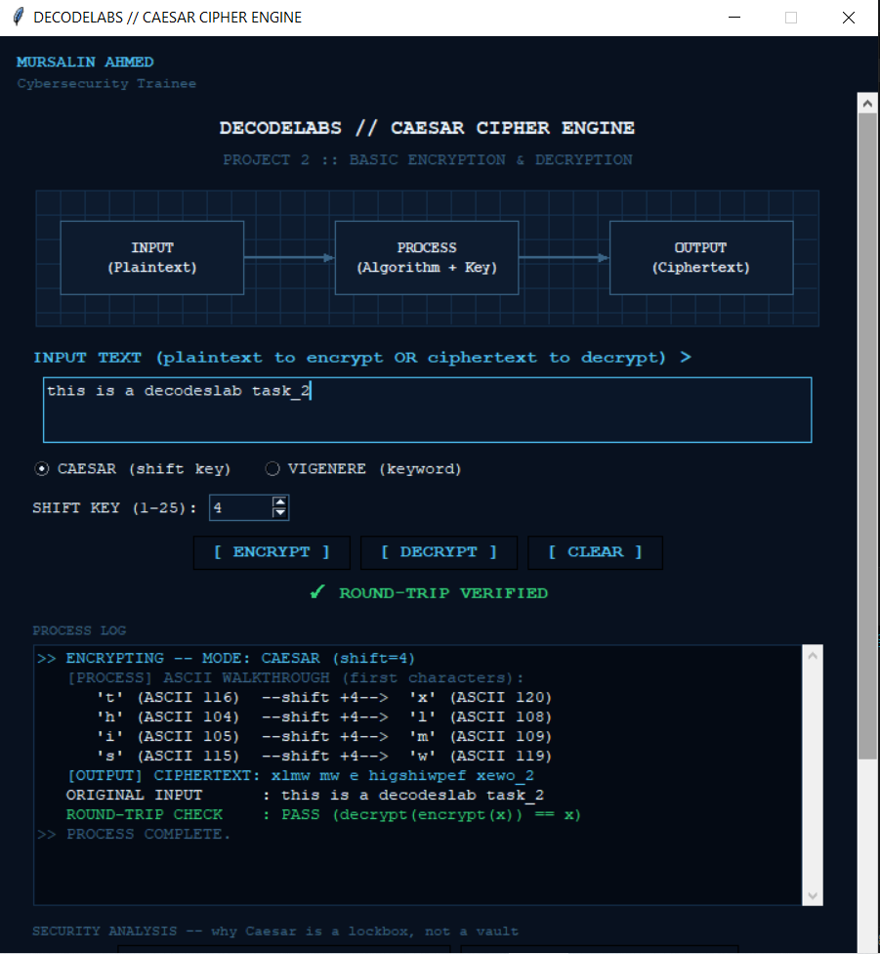

Figure 1
Test Case 2: Brute-Force Attack on the Caesar Ciphertext
Mode / Key | Caesar, all 25 keys tried
Input | xlmw mw e higshiwpef xewo_2
Output / Result | Key 4 reproduces "this is a decodeslab task_2"; all other keys produce gibberish
Verdict | CRACKED -- vulnerability confirmed
Findings | Because a Caesar cipher only has 25 possible keys, the brute-force tool tries every one of them and recovers the exact original plaintext at key 4 almost instantly -- without the key ever being supplied in advance. This confirms the cipher's small key space is a genuine weakness.

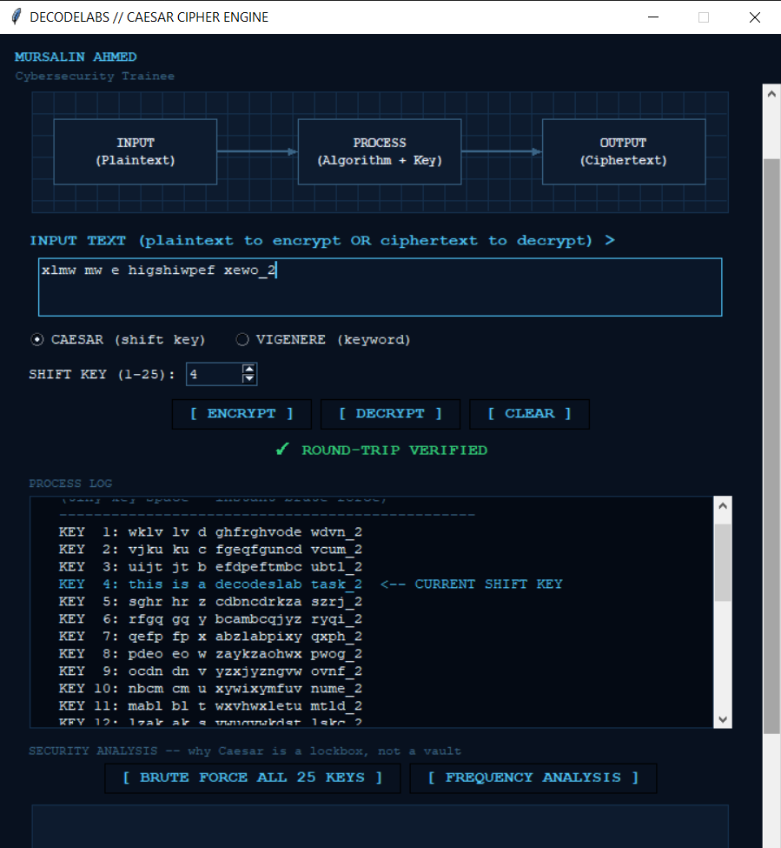
Test Case 3: Vigenere Cipher Encryption
Mode / Key | Vigenere, keyword = "decodeslab"
Input | this is a decodeslab task_2
Output / Result | wlkg lw s oedrhggoet eatn_2
Verdict | PASS -- round-trip verified
Findings | Switching to Vigenere mode applies a different shift to each letter, derived from the keyword "decodeslab", instead of one fixed shift for the whole message. For the same plaintext used in Test 1, this produces a noticeably different ciphertext than the Caesar version.

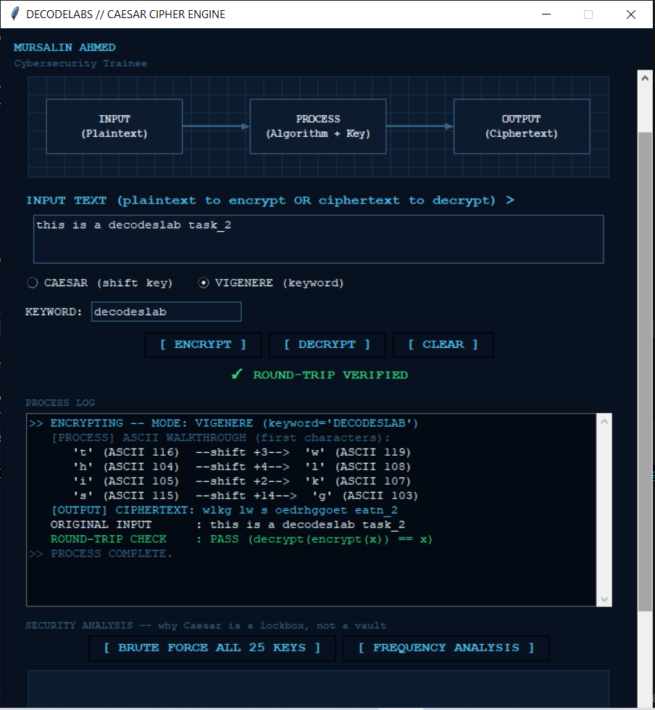
Test Case 4: Vigenere Decryption With the Correct Keyword
Mode / Key | Vigenere, keyword = "decodeslab"
Input | wlkg lw s oedrhggoet eatn_2
Output / Result | this is a decodeslab task_2
Verdict | PASS -- plaintext fully recovered
Findings | Supplying the same keyword that was used to encrypt the message correctly reverses the cipher and fully restores the original plaintext, confirming the encryption and decryption functions are a true symmetric, reversible pair.

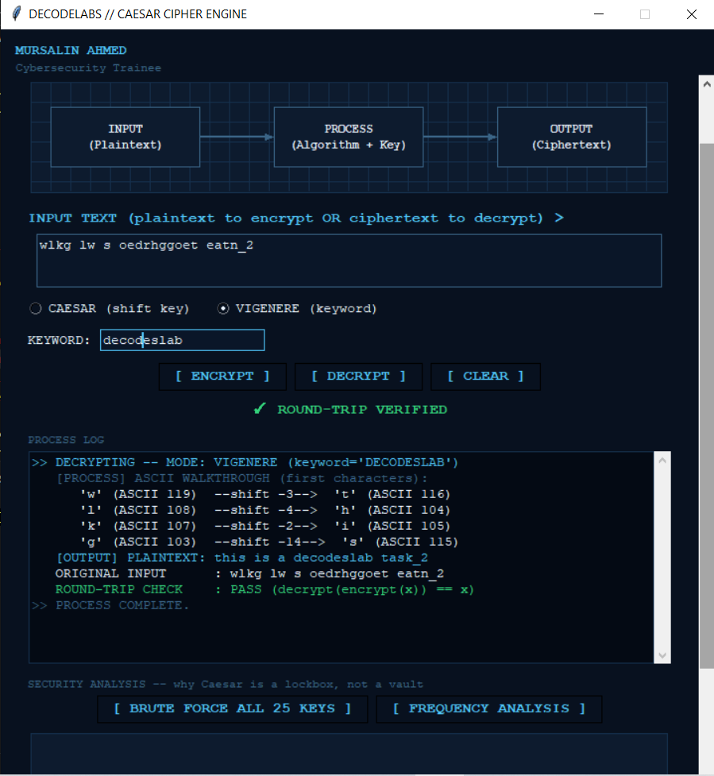
Test Case 5: Brute-Force Attack on the Vigenere Ciphertext
Mode / Key | Caesar-style brute force, all 25 keys (no keyword)
Input | wlkg lw s oedrhggoet eatn_2
Output / Result | None of the 25 single-shift attempts reproduce the original plaintext
Verdict | NOT CRACKED -- attack resisted
Findings | Running the same 25-key brute-force tool against the Vigenere ciphertext fails completely, because the message was not shifted by a single fixed key -- it was shifted letter-by-letter according to the keyword. This is direct, hands-on evidence that the Vigenere mode is meaningfully stronger than Caesar.

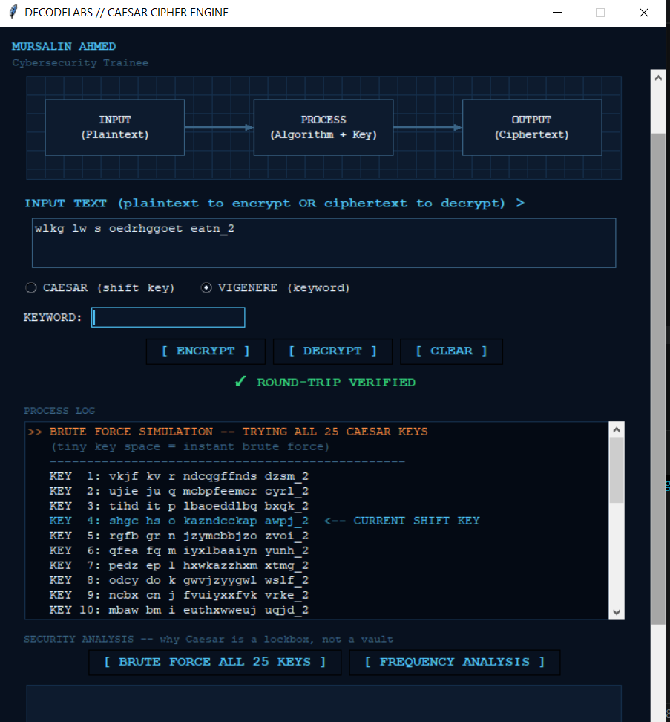
Test Case 6: Decryption Attempt Without the Correct Keyword
Mode / Key | Vigenere, keyword left blank
Input | wlkg lw s oedrhggoet eatn_2
Output / Result | wlkg lw s oedrhggoet eatn_2 (unchanged)
Verdict | NOT RECOVERED -- keyword required
Findings | With no keyword supplied, the program cannot reverse the keyword-based shift, so the output is identical to the ciphertext that was typed in. This confirms that knowing the correct keyword is strictly necessary to recover the original message.

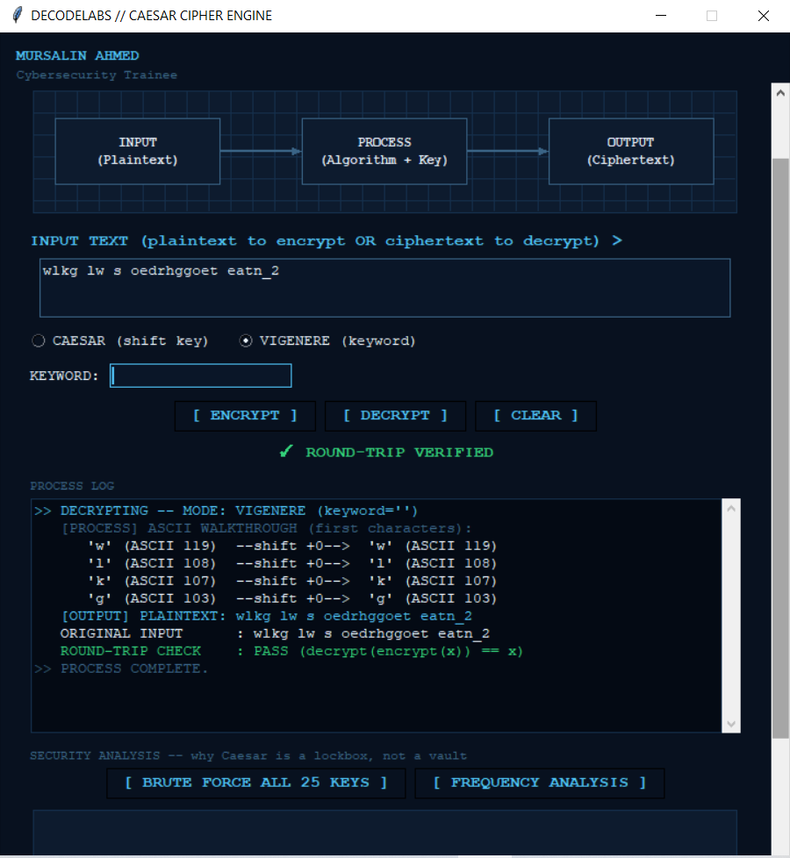
Figure 6
Overall observation: Test 2 confirms the Caesar cipher's well-known weakness -- with only 25 possible keys, brute force recovers the plaintext immediately. Tests 5 and 6 confirm that the Vigenere mode resists that same simple attack and strictly requires the correct keyword to decrypt, demonstrating a meaningful security improvement over the basic Caesar shift.
5. EVALUATION RUBRIC
The brief's qualification criteria (completion, quality, and standards) are expanded below into a detailed self-assessment rubric.
Criteria | Type | Evidence | Status
Functional Correctness | Core | All six test cases behaved exactly as expected for both cipher modes. | Met
Cryptographic Logic Accuracy | Core | ASCII shift + mod-26 wrap-around verified via the on-screen character trace and round-trip checks. | Met
Security Reasoning Depth | Bonus | Brute-force simulator and frequency chart demonstrate real attack/defence concepts, not just theory. | Exceeded
Code Readability & Structure | Core | Cipher logic isolated into small, reusable functions (shift_char, compute_cipher, etc.). | Met
User Interface / Usability | Bonus | Animated IPO diagram, dual-mode controls, and a scrollable blueprint-themed GUI. | Exceeded
Documentation & Test Evidence | Core | Six test cases documented with findings; screenshots pending insertion in Section 4. | Met (pending images)

6. CONCLUSION
Based on the compliance table in Section 2 and the validated test cases in Section 4, Project 2 satisfies every mandatory requirement defined in the DecodeLabs brief: Caesar-cipher encryption, correct decryption, display of both encrypted and decrypted output, ASCII-based character math, and modular wrap-around arithmetic. The submission additionally implements a Vigenere mode and two interactive security-analysis tools that go beyond the brief to demonstrate, with live evidence, why key choice and key length matter.
Overall status: READY FOR SUBMISSION, pending insertion of the six screenshot placeholders provided in Section 4.

