# Profile and group structure

The Hub Power Company Limited (the “Company”) was incorporated in Pakistan on August 1, 1991 as a public limited company under the Companies Ordinance, 1984 (the “Ordinance”). The shares of the Company are listed on the Pakistan Stock Exchange (PSX) and its Global Depository Receipts are listed on the Luxembourg Stock Exchange. The Company owns an oil-fired power station of 1,200 MW (net) in Balochistan (Hub plant) and a 214 MW (net) oil-fired power station in Punjab (Narowal plant).

The Company also holds 75% controlling interest in Laraib Energy Limited which owns and operates a run of the river hydel power plant near the New Bong Escape, 8 km downstream of Mangla Dam in Azad Jammu and Kashmir.

The Company has established wholly owned subsidiaries for its future growth initiatives. Hub Power Holdings Limited (HPHL) has been incorporated to invest in the imported coal based 2x660 MW power project and future expansion initiatives. The Company, with its joint venture partner China Power International Holdings (CPIH), has set up China Power Hub Generation Company (Pvt.) Ltd. (CPHGC), to undertake the aforementioned imported coal-based power project.

A subsidiary, Hub Power Services Limited (HPSL) has been incorporated to manage O&M of its existing power assets and explore other O&M business opportunities onshore and offshore. Another subsidiary, Narowal Energy Limited, has been incorporated to take over the assets and liabilities of Narowal plant post its demerger under the Companies Ordinance, 1984.

The Company also has established Thar Energy Limited to set up a 330 MW mine mouth coal power plant at Thar Coal Block 2, Sindh.

The Company is also investing USD 20 million in Sindh Engro Coal Mining Company Limited (SECMC), a joint venture between Engro Powergen, Thal Limited, HBL, CMEC, Government of Sindh and the Company to develop a coal mine at Thar which has the seventh largest reserves of coal in the world.

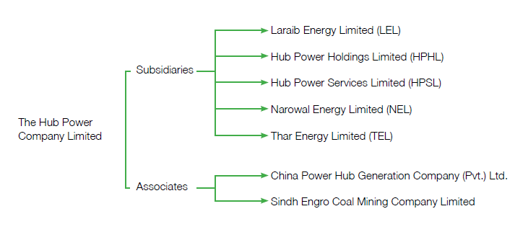Group Structure

# Nature of ownership

## Leadership

Hubco’s leadership comprises of the Board of Directors and the Management Team. The Board is responsible for overall strategic direction of the Company while the Management Team is entrusted with the goal to achieve those strategic objectives leading to a profitable, growth-oriented and sustainable company in the power sector. The leadership structure has evolved in such a manner to create Hubco a more transparent organization.

## BOARD OF DIRECTORS

### ****Charter / Major Terms of Reference****

The Board has ultimate responsibility for managing the Company and is the source of all executive authority within the business. The Board from time to time reviews and approves changes to principal business processes and systems designed to secure appropriate internal control. The Company is run by its Board of Directors and its affairs are managed on a day to day basis by the Chief Executive under the direction and control of the Board.

In performing his task the Chief Executive is required to have a view both to the protection and improvement of shareholders’ value and to the longer term health of the Company. However, there are duties reserved for the Board. The duties reserved to the Board are to consider reports on the conduct of the Company’s affairs and to take strategic and statutory decisions.

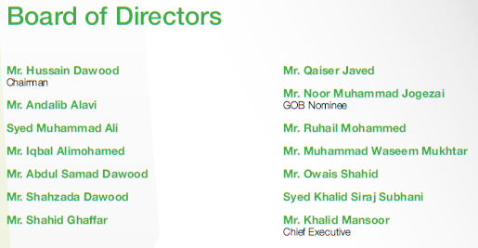

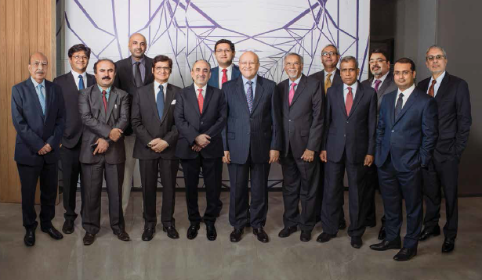

Profile of Board of Directors

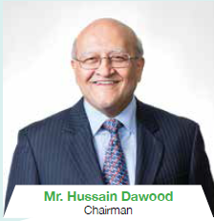Mr. Hussain Dawood is a Pakistani industrialist chairs an array of profit and not-for-profit ventures namely **Dawood Hercules**

The Hub Power Company Ltd., one of the largest Independent Power Producer in Pakistan

Karachi Education Initiative, which funds the graduate management school Karachi School of Business & Leadership, and The Dawood Foundation, with its legacy of establishing various education and health institutions across the country. Mr. Hussain Dawood holds an MBA from the Kellogg School of Management, Northwestern University, USA, and is a graduate in Metallurgy from Sheffield University, UK.

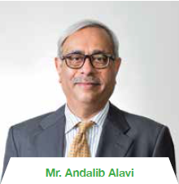Mr. Andalib Alavi is Vice President-Legal and Company Secretary of Engro Corporation Limited and manages the legal affairs of all Engro group companies.

He was a member of the Corporate Governance Committee of the Karachi Stock Exchange.

He is a Bar-at-Law from Lincolns Inn and holds a LLB (Hons.) degree from LSE, University of London. He joined Engro in 1992 as Legal Advisor. Prior to that, he worked with two law firms, being Surridge & Beecheno and Abraham & Sarwana, and practiced law independently thereafter.

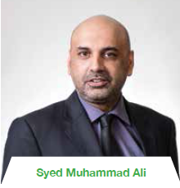Syed Muhammad Ali is the Chief Executive Officer of Engro pak Terminal Limited / Engro Elengy Terminal (Pvt) Limited and Elengy Terminal Pakistan Limited. He is also heading the New Ventures Division at Engro Powergen Limited since September 2015. Prior to this, he was the Chief Executive Officer of Engro Powergen Qadirpur Limited since November 2011.

He joined Engro Fertilizers Limited in the year 2000 and has worked in various technical and managerial capacities.

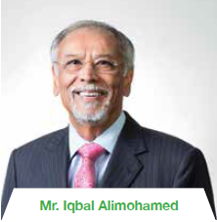Mr. Iqbal Alimohamed is a Fellow of the Institute of Chartered Accountants (England & Wales) and the Institute of Chartered Accountants, Pakistan.

Mr. Alimohamed is on the Board of various companies in the power and textile industries, which include being the Chief Executive Officer and Chairman of Gul

Ahmed Energy Limited and Gul Ahmed Wind Power Limited. He is a Director of Metro Power Company Limited as well as National Foods Limited.

Mr. Alimohamed has also held Chairmanships of the All Pakistan Textile Mills Association (Sindh & Balochistan). Mr. Alimohamed has also been a Director on the Board of Faysal Asset Management LTD.

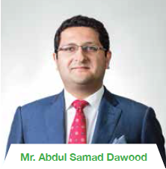Mr. Abdul Samad Dawood is a graduate in Economics from University College London, UK and a Certified Director of Corporate Governance from the Pakistan Institute of Corporate Governance. He is Chairman of Engro Foods Limited and Director on the Boards of Dawood Lawrencepur Limited, The Hub Power Company Limited, Engro Corporation Limited and Engro Fertilizers Limited. He was recently appointed Italian Honorary consul general in Lahore. Samad is a member of Young Presidents’ Organization, Pakistan Chapter.

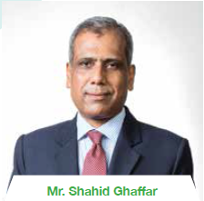 Mr. Shahid Ghaffar is Managing Director, National Investment Trust Limited (NITL). He possesses vast experience of working at top positions in the financial sector.

Prior to joining NIT, he was working as Head of Investor Relations and Corporate Representation as well as member of Management Forum at Habib Bank Limited (HBL). Prior to that he had also served as Chief Executive Officer of HBL Asset Management Limited for over six years (2005-2012) and was instrumental in the establishment and growth of the Company.

While working as Managing Director/CEO Karachi Stock Exchange during his two years’ tenure (1998-2000) he introduced effective risk management measures and was also instrumental in the automation of trading, enhancing capacity building and professionalism at the Stock Exchange.

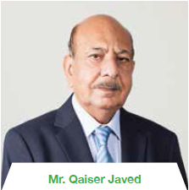 Mr. Qaiser Javed is a Fellow of the Institute of Chartered Accountants, Pakistan. Mr. Javed was first elected on the Company’s Board of Directors in 2006 and has thirty years’ work experience in the power sector. He is presently Director Finance of Fauji Foundation and a nominee Director on the Boards of several Fauji Foundation’s associated companies and is Chairman of various audit committees of Fauji Foundation Group Companies.

He is the Chief Executive Officer of two Wind Power projects being set up by Fauji Foundation and also member on Board of Fauji Daharki Power Company, Fauji Kabirwala Power Company Limited, FFC Energy Limited, Laraib Energy Limited and Chief Executive Officer of an off shore company (Daharki Power Holding Company).

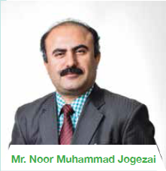 Mr. Noor Muhammad Jogezai was appointed as a Director of the Company on July 12, 2016. Mr. Jogezai did his MBA (HRM) from University of Balochistan.

He started his career as Assistant Commissioner and served as Deputy Commissioner, Commissioner Balochistan Employees Social Security Institution and Director General Provincial Disaster Management Authority Balochistan. Presently, Mr. Jogezai is Secretary Industries & Commerce Department, Government of Balochistan.

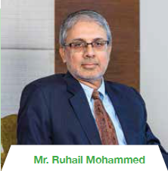 Mr. Ruhail Mohammed is currently the Chief Executive Officer of Engro Fertilizers Limited. Prior to his current position, he was the Chief Financial Officer of Engro Corporation Limited and also the Chief Executive Officer of Engro Powergen Limited (which owns a 217 MW IPP). He holds an MBA degree in Finance from the Institute of Business Administration Karachi, and is also a Chartered Financial Analyst (USA).

Mr. Ruhail has 25 years of Financial & Commercial experience and prior to becoming CEO has worked in areas such as treasury, commodity & currency trading, derivatives, merger & acquisitions, risk management, strategy & financial planning in Pakistan, UAE and Europe. He is on the Board of Engro Corporation Limited and its various subsidiaries. In addition, he is also on the Boards of Pakistan Institute of Corporate Governance and the Sindh Board of Investment.

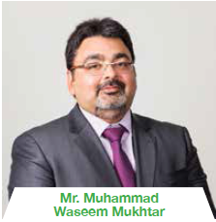 Mr. Muhammad Waseem Mukhtar is an MBA from the University of Chicago Booth School of Business, Illinois, USA. He also holds a Master’s degree in Total Quality Management (TQM) from University of Glamorgan, Wales, U.K. and has diversified 17 years of experience in Finance, IT and Industry. He is a “Certified Director” from Pakistan Institute of Corporate Governance. He has been on the Board of Directors of Allied Bank Limited since 2004 and his strategic guidance played a vital role in technological up-gradation of the Bank.

He is also a Director on the Boards of M/s Ibrahim Fibres Limited, Ibrahim Agencies (Pvt.) Limited, ABL Asset Management Company Limited, Arabian Sea Country Club and Faisalabad Industrial Estate Development Company (FIEDMC).

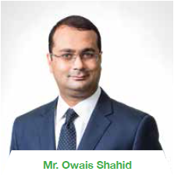 Mr. Owais Shahid is Chief, Corporate & Investment Banking Group in Allied Bank Limited (ABL). He joined ABL in 2005 and has led its investment banking team as Head Syndications and then as Group Head Investment Banking. He established it as a leading investment banking outfit in Pakistan. His Corporate & Investment Banking experience spans over 15 years and includes numerous innovative and unique transactions in syndications, M&A, listings, project financing and capital markets.

With strong credit background and substantial corporate finance & advisory experience, he has led a number of landmark transactions and has executed over 400 investment banking transactions valuing over USD 30 Billion with ABL being in a lead role.

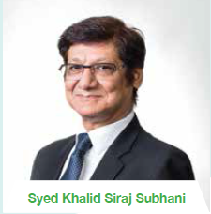 Syed Khalid Siraj Subhani is the **President of Engro Corporation Limited** since 2015.

He is the Chairman of the Board of Engro Fertilizers Limited, Engro Eximp AgriProducts (Private) Limited, Engro Polymer & Chemicals Limited, Engro Polymer Trading (Private) Limited, Engro Powergen Limited, Engro Powergen Qadirpur Limited, Engro Vopak Terminal Limited, Engro Elengy Terminal (Private) Limited, Elengy Terminal Pakistan Limited and Thar Power Company Ltd. He has also served as Chairman of the Board of Avanceon in the past. Mr. Subhani is a Director on the Board of Engro Corporation Limited, Engro Foods Limited, Sindh Engro Coal Mining Company Limited. He is also a Director on the Board of The Hub Power Company Limited and Laraib Energy Limited.

Mr. Subhani began his career in the Manufacturing Division at Exxon Chemical Pakistan Limited in 1983 and has held a variety of leadership roles within the Company, including long term assignment with Esso Chemical Canada. He has served as Manager for New Projects, General Manager for Operations, Vice President for Manufacturing, Senior Vice President for Manufacturing and New Ventures and as President & Chief Executive Officer for Engro Fertilizers Limited and Engro Polymer Chemicals Limited.

He is a member of the Pakistan Engineering Council, Business Advisory Council of the Society for Human Resource, He graduated from NED University of Engineering and Technology, Pakistan with a degree in Chemical Engineering and has completed programs on advance management from MIT and Haas School of Business Management, University of Berkeley, USA.

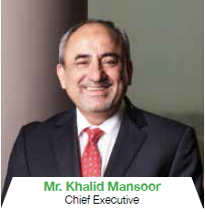Mr. Khalid Mansoor is Graduate in Chemical Engineering with distinction and honors. He has been the Chief Executive Officer of Hubco since May 20, 2013.

Mr. Mansoor is also Chairman of Laraib Energy Limited, Chairman and CEO of Hub Power Services Ltd. and Narowal Energy Ltd., CEO of Hub Power Holdings Ltd. and Thar Energy Limited - the HUBCO subsidiaries. He also represents Hubco on the Board of Sindh Engro Coal Mining Company. In January 2016, he was elected as Vice President of the Overseas Investors Chamber of Commerce & Industry (OICCI) for the term 2016.

He has over 35 years of experience and expertise in Energy & Petrochemical Sectors in leading roles for mega size Projects Development, Execution, Management and Operations. He has previously served as the Chief Executive Officer of Algeria Oman Fertilizer Company (AOA) which has constructed the World biggest Ammonia & Urea fertilizer Complex including around 120MW Captive Power Plant which is located in Industrial Zone of Arzew. In the area of natural gas, he spearheaded the development of a 225 MW power plant at Engro Powergen Limited. As Chairman of Laraib Energy Limited, which is the owner and developer of Pakistan’s first and currently the only Hydel IPP, he is actively promoting the development of Pakistan’s hydropower potential as long term sustainable solution for Pakistan’s energy needs. He is also pursuing the development of a 330 MW mine mouth power plant at Thar.

Prior to AOA, he held the position of the President and Chief Executive Officer of Engro Fertilizers Limited, Engro Powergen Qadirpur Limited (EPQL), Engro Powergen Limited (EPL) and Sindh Engro Coal Mining Company (SECMC).

He also held various key assignments at Engro and with Esso Chemicals Canada including leading the development and execution of various major diversification and expansion Projects for Engro. He had been a Director on the Boards of Engro Corporation, Engro Fertilizers Limited, Engro Polymer & Chemicals Limited, Engro Powergen Qadirpur Limited, Engro Powergen Limited and Sindh Engro Coal Mining Company. He had also served as a Director on the Boards of Engro Foods (Pvt.) Limited, Engro Vopak Terminal Limited, Sui Northern Gas Pipeline Limited and Chairman of the Board of Engro Powergen Limited in the recent past.

## Management Committee

Management Team comprises of nine members. The role of the Committee is to look at annual corporate objectives. Approval and revision of budgets prior to presentation to the Board of Directors, review of strategy, stewarding corporate and departmental objectives.

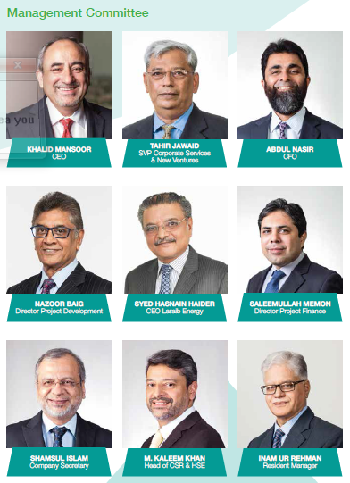

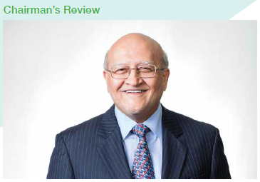

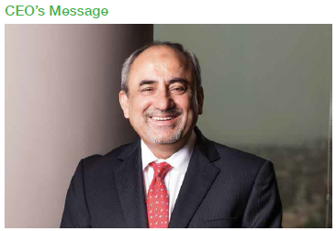

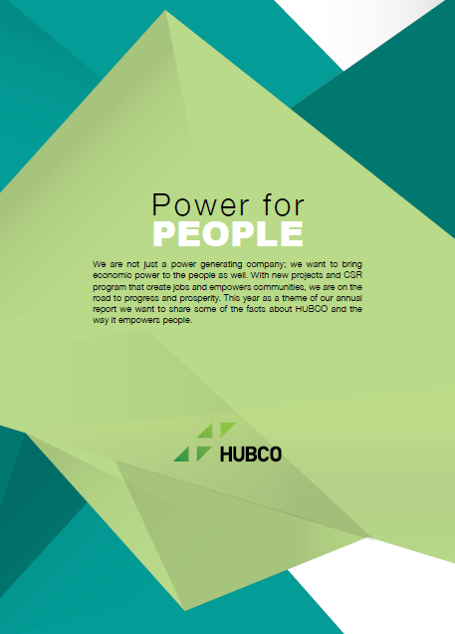

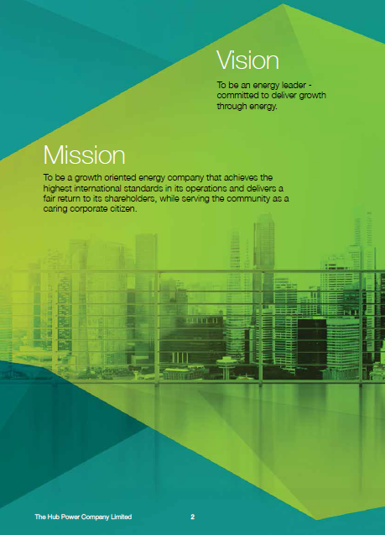

## Objectives

The Company is primarily focused in the following four areas:

* to promote energy efficiency,
* to develop renewable energy,
* to introduce and maintain environmentally efficient technologies,
* to be a major player in the Country's power sector.

The Company's objective is to meet customers' needs with a view to enhance shareholder value. Our strategy is to enhance shareholder's value through efficient operations of our plants whilst maintaining the highest level of safety and environmental performance. We exercise rigorous financial control in our decisions, and invest in the development of our people for the long-term success and sustainability of the Company.

### Company Information

BOARD OF DIRECTORS

Mr. Hussain Dawood Chairman

Mr. Khalid Mansoor Chief Executive

Mr. Andalib Alavi

Syed Muhammad Ali

Mr. Iqbal Alimohamed

Mr. Abdul Samad Dawood

Mr. Shahzada Dawood

Mr. Shahid Ghaffar

Mr. Qaiser Javed

Mr. Noor Muhammad Jogezai GOB Nominee

Mr. Ruhail Mohammed

Mr. Muhammad Waseem Mukhtar

Mr. Owais Shahid

Syed Khalid Siraj Subhani

AUDIT COMMITTEE

Mr. Iqbal Alimohamed (Chairman)

Mr. Andalib Alavi

Mr. Shahid Ghaffar

Mr. Qaiser Javed

Mr. Noor Muhammad Jogezai

Mr. Ruhail Mohammed

Mr. Owais Shahid

COMPANY SECRETARY

Mr. Shamsul Islam

MANAGEMENT

Mr. Khalid Mansoor

Mr. Tahir Jawaid

Mr. Abdul Nasir

Mr. Shamsul Islam

Syed Hasnain Haider

Mr. Saleemullah Memon

Mr. Nazoor Baig

Mr. Mohammad Kaleem Khan

Mr. M. Inam Ur Rehman Siddiqui

REGISTERED & HEAD OFFICE

11th Floor, Ocean Tower

Block-9, Main Clifton Road, Karachi

P.O. Box No. 13841, Karachi-75600

Email: Info@hubpower.com

Website: http://www.hubpower.com

SUBSIDIARIES

Hub Power Holdings Limited

Hub Power Services Limited

Narowal Energy Limited

Thar Energy Limited

Laraib Energy Limited

PRINCIPAL BANKERS

Allied Bank of Pakistan

Askari Bank Limited

Bank Alfalah Limited

Bank Al-Habib Limited

Bank Islami Pakistan Limited

Bank of Punjab

Burj Bank Limited

Citibank N.A. Pakistan

Dubai Islamic Bank Pakistan Limited

Faysal Bank Limited

Habib Bank Limited

Habib Metropolitan Bank Limited

Industrial & Commercial Bank of China

MCB Bank Limited

Meezan Bank Limited

National Bank of Pakistan

NIB Bank Limited

Pak Brunei Investment Company Limited

Pak China Investment Company Limited

Pak Kuwait Investment Company (Pvt) Ltd.

Samba Bank Limited

Standard Chartered Bank (Pakistan) Ltd.

Sumitomo Mitsui Banking Corp. Europe Ltd, London

United Bank Limited

INTER-CREDITOR AGENTS

Habib Bank Limited

Allied Bank Limited

NIB Bank Limited

LEGAL ADVISOR

RIAA Barker Gillette

AUDITORS

EY Ford Rhodes, Chartered Accountants

REGISTRAR

FAMCO Associates (Pvt) Limited

HUB PLANT

Mouza Kund,

Post Office Gaddani,

District Lasbela, Balochistan.

NAROWAL PLANT

Hubco Narowal Project, Mouza Poong,

5 Km from Luban Pulli Point On Mureedkay-Narowal

Road, District Narowal, Punjab

LARAIB ENERGY LTD (SUBSIDIARY)

*Head Office:*

12-B/1, Multi Mansion Plaza, G-8, Markaz,

Islamabad

*Plant:*

New Bong Escape Hydro-Electric Power Complex,

Village Lehri, Tehsil & District Mirpur, Azad Jammu &

Kashmir

### Geographical Representation

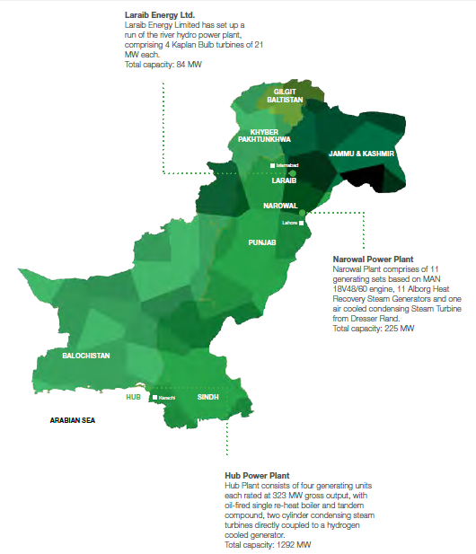

### Company Structure

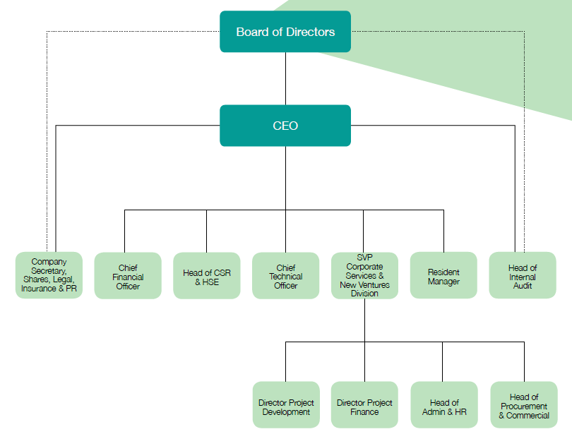

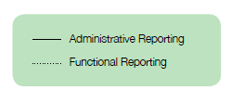

# Corporate Events

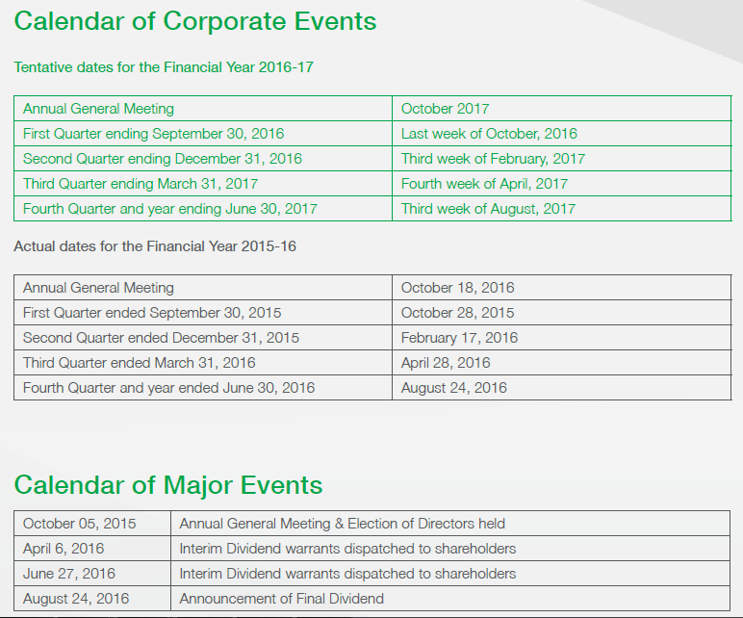

# Celebration

# Company Milestones

HUBCO Host a party for clients. Order a cake to share with employees. Create meaningful anniversary traditions – and then make a point of repeating them every year (or at a set interval).

# Company Picnics

HUBCO Organize Picnic Party in a Year It can be casual or luxurious, indoors or out, but they are always an incredible opportunity for employees to talk, eat and play in a relaxed and vibrant atmosphere with their families.

# Team Meetup

Team Meet is the pinnacle of all performance recognitions. It is a tradition that has rejoiced the achievements of HUBCO family to come together to celebrate the success of the previous year and to get a glimpse into the future plans of HUBCO.

The Team Meet event is a hallmark of meticulous planning, flawless execution and every effort is made to ensure that HUBCO and their guests can enjoy their time spent at the grandest celebration.

Corporate Strategy

## Corporate Governance

Hubco Board has always supported the implementation of the highest standards of Corporate Governance.

The Board initially approved the Company’s own Code of Corporate Governance on June 24, 1994 before the Company issued its shares to the public in October, 1994.

The Company was initially listed only on The Karachi Stock Exchange, however in order to facilitate its shareholders / investors all over Pakistan, the Company is now listed on all Stock Exchanges in Pakistan and the Global Depository Receipts are listed on the Luxembourg Stock Exchange.

Following the Karachi Stock Exchange circular of May 2002 incorporating Securities and Exchange Commission of Pakistan (SECP) Code of Corporate Governance of March 2002 in its Listing Rules the Board at its first meeting in September 2002 amended Hubco’s Code of Corporate Governance to incorporate the SECP code. SECP on April 10, 2012 caused the Stock Exchanges to amend their Listing Regulations to incorporate the revised “Code of Corporate Governance 2012. The revision was approved by the Hubco Board in its meeting on April 25, 2012.

Hubco’s Code of Corporate Governance includes the following:

* Governance Principles
* Hubco’s Code of Business Ethics.
* Dealing by Directors and Employees in Shares of Hubco.
* Hubco’s Code of Corporate Governance.
* SECP’s Revised Code of Corporate Governance 2012.
* Primary and Secondary Delegations.

## Statement Of Compliance With The Code Of Corporate Governance

This statement is being presented in compliance with the Code of Corporate Governance (the “Code”) contained in the regulations of Pakistan Stock Exchange for the purpose of establishing a framework of good governance, whereby a listed Company is managed in compliance with the best practices of corporate governance.

The Company has applied the principles contained in the Code as follows:

1. The Board of Directors of The Hub Power Company Limited (the “Company”) has always supported and re-confirms its commitment to continued support and implementation of the highest standards of Corporate Governance at all times.

2. On June 24, 1994, prior to the issuance of the Company’s shares to the public in October 1994, the then Board of Directors of the Company had approved the implementation of the Company’s own Code of Corporate Governance. The Company’s internal Code of Corporate Governance has been updated in line with the Code from time to time and is implemented in complete letter and spirit.

3. The Company encourages representation of independent non-executive directors and directors representing minority interests on its Board of Directors. At present the Board members are as listed below:

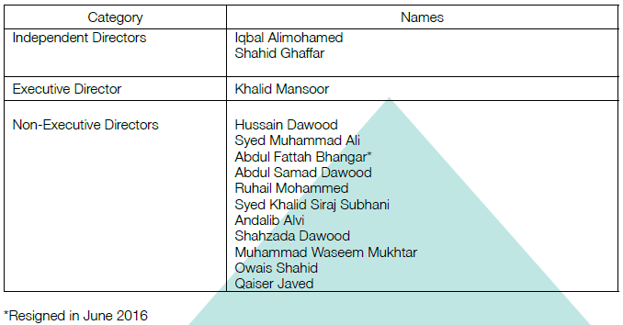

4. The directors have confirmed that none of them is serving as a director on more than seven listed companies, including this Company.

5. All the resident directors of the Company are registered as taxpayers and none of them has defaulted in payment of any loan to a banking company, a DFI or an NBFI or, being a member of a stock exchange, has been declared as a defaulter by that stock exchange.

6. No casual vacancy occurred on the Board during the year ended June 30, 2016.

7. The Company has prepared a “Code of Conduct” and has ensured that appropriate steps have been taken to disseminate it throughout the Company along with its supporting policies and procedures.

8. The Board has developed a “Vision / Mission Statement”, overall corporate strategy and significant policies of the Company. A complete record of particulars of significant policies along with the dates on which they were approved or amended has been maintained.

9. All the powers of the Board have been duly exercised and decisions on material transactions, including appointment and determination of remuneration and terms and conditions of employment of the CEO have been taken by the Board/Shareholders.

10. The meetings of the Board were presided over by the Chairman and, in his absence, by a Director elected by the Board for this purpose and the Board met at least once in every quarter. Written notices of the Board meetings, along with agenda and working papers, were circulated at least seven days before the meetings. The minutes of the meetings were appropriately recorded and circulated.

11. One more Director acquired certification of “Corporate Governance Leadership Skills Programme” conducted by the Pakistan Institute of Corporate Governance (“PICG”).

12. The Board had approved appointment of CFO, Company Secretary and Head of Internal Audit, including their remuneration and terms and conditions of employment as determined by the CEO.

13. The Directors’ Report for this year has been prepared in compliance with the requirements of the Code and fully describes the salient matters required to be disclosed.

14. The financial statements of the Company were duly endorsed by CEO and CFO before approval of the Board.

15. The Directors, CEO and executives do not hold any interest in the shares of the Company other than those disclosed in the pattern of shareholding.

16. The Company has complied with all the corporate and financial reporting requirements of the Code.

17. The Board has formed an Audit Committee. It comprises of seven members. The Chairman of the Committee is an independent director and all other members are non-executive directors including the Chairman.

18. The meetings of the Audit Committee were held at least once every quarter prior to approval of interim and final results of the Company as required by the Code. The terms of reference of the Committee have been formed and advised to the Committee for compliance.

19. The Board has formed Human Resource and Remuneration Committee, called the Board Compensation Committee. It comprises of five members; all of them are non-executive directors including the Chairman.

20. The Board has set-up an effective internal audit function which is suitably qualified and experienced for the purpose and is conversant with the policies and procedures of the Company.

21. The statutory auditors of the Company have confirmed that they have been given a satisfactory rating under the quality control review program of the ICAP, that they or any of the partners of the firm, their spouses and minor children do not hold shares of the Company and that the firm and all its partners are in compliance with International Federation of Accountants (“IFAC”) guidelines on code of ethics as adopted by the ICAP.

22. The statutory auditors or the persons associated with them have not been appointed to provide other services except in accordance with the listing regulations and the auditors have confirmed that they have observed IFAC guidelines in this regard.

23. The ‘closed period’, prior to the announcement of interim/final results, and business decisions, which may materially affect the market price of Company’s securities, were determined and intimated to Directors, employees and Stock Exchange.

24. The related party transactions have been placed before the Audit Committee and have been approved by the Board of Directors.

25. Material/price sensitive information has been disseminated among all market participants at once through stock exchange.

26. We confirm that all principles enshrined in the Code have been complied with.

## Code of Business Ethics

Our Code of Business Ethics applies to all business units and employees of The Hub Power Company Limited and its subsidiaries. The Code outlines the behaviors Hubco expects of its employees and what the employees can expect from the Company.

Compliance with our Code contributes to the long term value creation for our stakeholders and helps us sustain the good reputation of the Company. Unethical practices of any sort are not allowed to find its way into the business.

Employees, at all times, must act in the interests of the Company’s and must abide by the Company’s stated standards of environmental, safety and management practices. We encourage employees to report any matter which causes concern. Any employee who in good faith reports any act of apparent misconduct or unethical behavior will not be victimized or treated adversely.

We believe that the Code of Business Ethics has been fundamental to how we have conducted our business and ourselves with respect to the environment in which we operate.

**Anti-Corruption Measures**

Hubco strictly discourages corrupt business practices and does not give or receive bribes in order to retain or bestow business or financial advantages.

All employees of the Company are directed that any demand for or offer of such bribe must be immediately rejected and reported to the management.

## Business Strategy

With an aggressive growth plan and a focus on increasing the shareholder value, the Company is committed to promote long-term development of the Country. The strategy is not just to aim for growth of the profits but also to ensure that the local communities, our partners and other stakeholders also share our growth and prosperity.

In the years to come, our business strategy will be focused on:

* Increasing reliability and sustainability of our base business
* Increasing power generation and improving the energy mix by utilizing alternative and indigenous sources
* Aligning our HSE systems with the best of the international practices
* Strengthening our team by attracting, hiring and retaining competent and experienced professionals
* Investing 1% of PAT on projects of socio-economic development, with complete involvement and engagement of the local communities to create ownership of the development
* Continuing with our resolve to end the long prevalent energy crisis

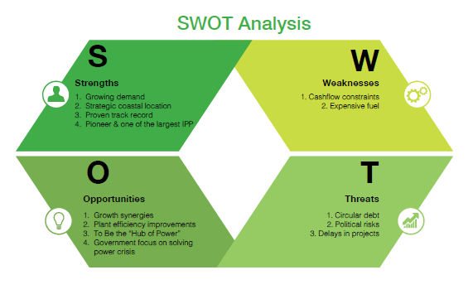

## Functional Strategy

### Board & Functional Committees

To ensure seamless operations of the Board and aid in sound decision making, the Board has established four Committees that are chaired by non-executive directors. The election for the Board of Directors was held on October 5, 2015. These committees are as follows:

BOARD AUDIT COMMITTEE (BAC):

The committee assists the Board in fulfilling its oversight responsibilities, primarily in reviewing and reporting financial and non-financial information to shareholders in compliance with the requisite legislative and regulatory standards, systems of internal control and risk management and the audit process. It has the power to call for information from management and to consult directly with the external auditors or their advisors as considered appropriate.

The committee met 4 times during the year and the attendance was as follows:

Pre-election Meetings attended

Mr. Iqbal Alimohamed 1/1

Mr. Shabbir H. Hashmi 1/1

Mr. Qaiser Javed 1/1

Mr. Ruhail Mohammed 1/1

Mr. Ali Munir 1/1

Post-election Meetings attended

Mr. Iqbal Alimohamed 2/3

Mr. Qaiser Javed 0/3

Mr. Ruhail Mohammed 2/3

Syed Ahmed Iqbal Ashraf 0/3

Mr. Abdul Fattah Bhangar 2/3

Mr. Andalib Alavi 2/3

Mr. Shahid Ghaffar 2/3

Mr. Owais Shahid 3/3

Secretary: Mr. Muhammad Irfan Iqbal

BOARD COMPENSATION COMMITTEE (BCC):

The committee meets to review and recommend all elements of the Compensation, Organization and Employee Development policies relating to the senior executives’ and members of the management committee. The CEO attends Board Compensation Committee meetings by invitation.

The committee met 3 times during the year and the attendance was as follows:

Pre-election Meetings attended

Mr. Hussain Dawood 1/1

Syed Ahmed Iqbal Ashraf 0/1

Mr. Abdul Fattah Bhangar 0/1

Mr. Shahid Hamid Pracha 1/1

Syed Khalid Siraj Subhani 1/1

Mr. Ajaz Ali Khan 1/1

Post-election Meetings attended

Mr. Hussain Dawood 2/2

Syed Khalid Siraj Subhani 2/2

Mr. Shahid Ghaffar 1/2

Mr. Ruhail Mohammed 1/2

Mr. Muhammad Waseem Mukhtar 1/2

Secretary: Mr. Tahir Jawaid

BOARD TECHNICAL COMMITTEE (BTC)

The committee meets to review the internal control system relating to plant operations, approve plant betterments and exceptional expenditures. It also reviews the issues of O&M and measures to safeguard the Company’s assets.

The committee met 9 times during the year and the attendance was as follows:

Pre-election Meetings attended

Syed Khalid Siraj Subhani 2/2

Syed Muhammad Ali 1/2

Mr. Iqbal Alimohamed 2/2

Mr. Shahid Hamid Pracha 2/2

Mr. Inam Ur Rahman 2/2

Post-election Meetings attended

Syed Khalid Siraj Subhani 6/7

Syed Muhammad Ali 7/7

Mr. Andalib Alavi 7/7

Syed Ahmed Iqbal Ashraf 2/7

Mr. Abdul Fattah Bhangar 3/7

Mr. Abdul Samad Dawood 1/7

Secretary: Mr. Abdul Vakil

BOARD INVESTMENT COMMITTEE (BIC):

The committee reviews the investment plans and assists the Board in evaluating investment performances whilst also monitoring various investment opportunities to utilize the Company’s capital and financial resources. The Committee also reviews issues relating to investment, corporate finance, mergers and acquisitions.

The committee met 7 times during the year and the attendance was as follows:

Pre-election Meetings attended

Mr. Abdul Samad Dawood 1/1

Syed Muhammad Ali 1/1

Mr. Iqbal Alimohamed 1/1

Mr. Shabbir H. Hashmi 0/1

Mr. Ruhail Mohammed 0/1

Mr. Inam Ur Rahman 1/1

Post-election Meetings attended

Mr. Abdul Samad Dawood 5/6

Syed Muhammad Ali 3/6

Mr. Iqbal Alimohamed 1/6

Mr. Ruhail Mohammed 4/6

Mr. Shahzada Dawood 3/6

Mr. Qaiser Javed 2/6

Mr. Owais Shahid 5/6

Syed Khalid Siraj Subhani 5/6

Secretary: Mr. Abdul Nasir

During the year, 2 joint BIC and BTC meetings were held. The attendance was as follows:

Pre-election Meetings attended

Syed Khalid Siraj Subhani 2/2

Syed Muhammad Ali 1/2

Mr. Iqbal Alimohamed 1/2

Mr. Shahid Hamid Pracha 2/2

Mr. Inam Ur Rahman 2/2

Mr. Abdul Samad Dawood 1/2

Mr. Shabbir H. Hashmi 2/2

Mr. Ruhail Mohammed 0/2

MANAGEMENT COMMITTEE

The committee is to look at annual corporate objectives, approval and revision of budgets prior to presentation to the Board of Directors, review of strategy, stewarding corporate and departmental objectives. The Committee Members are as follows:

Mr. Khalid Mansoor Chairman

Mr. Tahir Jawaid Member

Mr. Abdul Nasir Member

Mr. Nazoor Baig Member

Syed Hasnain Haider Member

Mr. Saleemullah Memon Member

Mr. Shamsul Islam Member

Mr. Kaleem Khan Member

Mr. Inam ur Rehman Member

Secretary: Mr. Abou Saeed M. Shah

COMMITTEE FOR ORGANIZATION AND

EMPLOYEE DEVELOPMENT (COED)

The committee is to look at employee related policies, compensation, development, trainings, succession planning and to bring necessary focus on HR issues.

The Committee members are as follows:

Mr. Khalid Mansoor Chairman

Mr. Tahir Jawaid Member

Mr. Abdul Nasir Member

Mr. Nazoor Baig Member

Syed Hasnain Haider Member

Mr. Saleemullah Memon Member

Mr. Shamsul Islam Member

Mr. Kaleem Khan Member

Mr. Inam ur Rehman Member

Secretary: Mr. Farrukh Rasheed

CORPORATE HSE COMMITTEE

The committee provides strategic guidance for overall HSE improvement initiatives, sets corporate level HSE targets, reviews company-wide HSE statistics, investigation reports of major accidents, and stewards compliance to HSE management system and relevant national regulations. The Committee members are as follows:

Mr. Khalid Mansoor Chairman

Mr. Tahir Jawaid Member

Mr. Abdul Nasir Member

Mr. Nazoor Baig Member

Syed Hasnain Haider Member

Mr. Shamsul Islam Member

Mr. Inam ur Rehman Member

Mr. Abbas Shahani Member

Mr. Amjad Raja Member

Mr. Abdul Vakil Member

Mr. Muhammad Uneeb Member

Mr. Saleemullah Memon Member

Syed Hassan R. Bukhari Member

Secretary: Mr. Kaleem Khan

### Operational Highlights

### 

Operational Risk

The Company has devised necessary strategies to mitigate the operational risks and substantial investments are constantly made to ensure Plant reliability. The Company is carrying out requisite rehabilitation and refurbishments at the Hub Plant and is carrying out the requisite maintenance required at the Narowal and Laraib Plants.

### 

Hub Plant

Hub Plant completed 10 million man-hours without Lost Time Injury since last accident in December 2013. Hub Plant continued to supply reliable and uninterrupted electricity to the national grid. This year the plant generated 7,547 GWh of electricity (2014-15: 6,810 GWh) with a load factor of 72% (2014-15: 65%) and plant availability of 87% (2014-15: 78%). The electricity generation during the year under review was higher than the last year mainly due to higher availability and utilization by power purchaser.

Laraib Energy Limited

Laraib Plant completed 1.8 Million man-hours without Lost Time Injury since its COD. Laraib Plant – known as the New Bong Escape Hydro Power Plant (NBEHPP) – generated 545 GWh of green energy as compared to 489 GWh last year (11% more than last year’s generation).

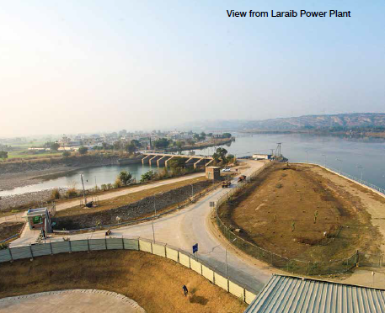

Narowal Plant

Narowal Plant completed 3.1 Million man-hours without Lost Time Injury since COD. Our Narowal Plant supplied 1,162 GWh of electricity to the national grid compared to 1,418 GWh last year. The plant operated at a load factor of 62% compared to 76% in 2015.

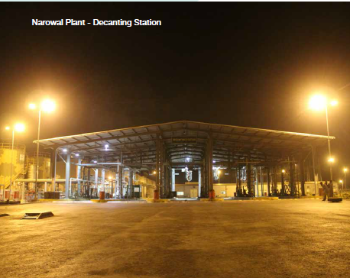

Financial Risk

During the year, the Company was able to operate without any interruption, however, the financial difficulties faced by the Power Purchasers could potentially jeopardize the Company’s ability to continue plant operations and pursue growth initiatives.

Financial Statements

The Company’s Unconsolidated and Consolidated financial statements have been audited without any qualification by the Company’s auditors Messrs EY Ford Rhodes, Chartered Accountants.

Corporate & Financial Reporting Framework

The Directors are pleased to confirm compliance with Corporate and Financial Reporting Framework of the Securities & Exchange Commission Pakistan (SECP) and the Code of Corporate Governance for the following:

1. The financial statements, prepared by the management of the Company, fairly portray its state of affairs, the result of its operations, cash flows and changes in its equity.
2. Proper books of account of the Company have been maintained.
3. Appropriate accounting policies have been consistently applied in preparation of financial statements and accounting estimates are based on reasonable and prudent judgment.
4. IFRS as applicable in Pakistan have been followed in preparation of financial statements and any departure therefrom has been adequately disclosed.
5. The system of internal control is sound in design and has been effectively implemented and is closely monitored; and
6. There are no doubts in the Company’s ability to continue as a going concern.

Key financial data of last six years is as follows:

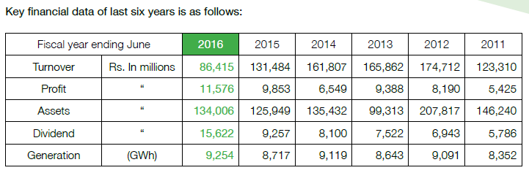

Value of investments of provident fund and gratuity scheme based on their respective audited accounts as at June 30, 2015 are as follow:

Rs. in millions

Provident Fund 92.227

Gratuity Fund 104.706

Financial Performance

Financial highlights of the Group during the year under review are as follows:

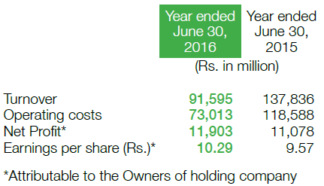

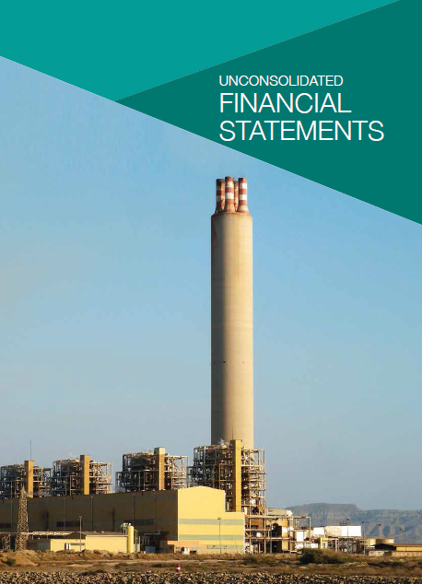

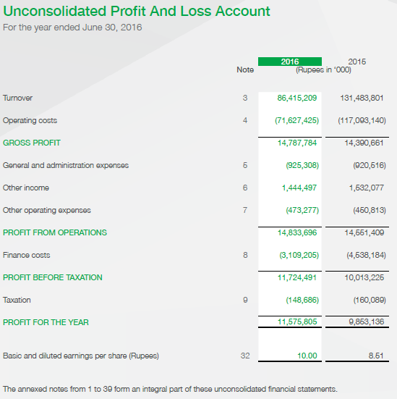

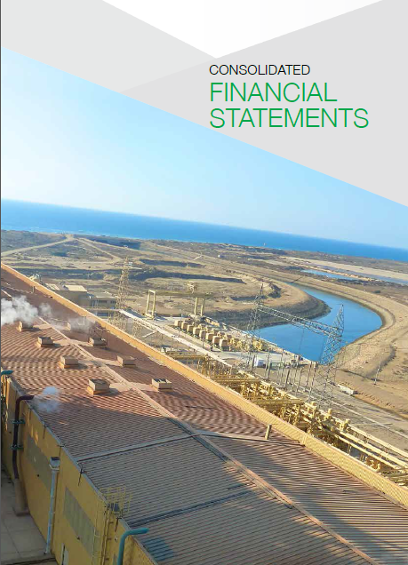

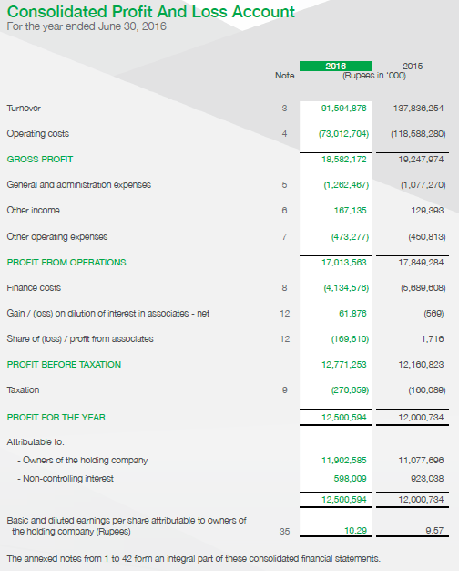

Market share information

Pakistan’s installed power generation capacity is around 24,823 MW of which hydel power is 28.67%, thermal power is 67.73%, wind is 0.43% and nuclear power is 3.17%. Actual power generation varies between 18,000 MW and 24,000 MW, depending mainly on discharge of water in the rivers and watercourses for hydel generation and availability of fuel for thermal Plants.

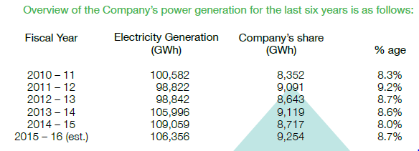

**Market share information**

Pakistan’s installed power generation capacity is around 24,823 MW of which hydel power is 28.67%, thermal power is 67.73%, wind is 0.43% and nuclear power is 3.17%. Actual power generation varies between 18,000 MW and 24,000 MW, depending mainly on discharge of water in the rivers and watercourses for hydel generation and availability of fuel for thermal Plants.



### Human Resources

During the year, the Company focused on timely and successful O&M transition of Hub and Narowal Plants. HR transition on both plants was completed on time. Required HR systems have been put in place at both plants to ensure smooth function of both plants.

522 man days of training was conducted during the year on functional and soft skills covering 100% of the employee population.

Management Trainee Program was further strengthened to ensure the availability of required talent pool for base business and growth projects.

Employer branding activities continued through recruitment drives and participating in other employer branding events.

### Future Outlook

**a. 2x660 MW Coal Project**

Hubco through its wholly owned subsidiary Hub Power Holdings Limited (HPHL) is developing the 2x660MW imported Coal based Power Project with an integrated jetty to be constructed at the existing Hub Site. The project company China Power Hub Generation Company (Pvt.) Ltd. (CPHGC) is a joint venture between HPHL and China Power International (Pakistan) Investment Limited (a Hong Kong based company formed by China Power International Holdings Limited) for the investment in the Project.

**b. Investment in Sindh Engro Coal Mining Company (SECMC)**

Post the Shareholders Agreement between Engro, Thal Limited, HBL, CMEC, Government of Sindh and the Company, SECMC has signed key financing agreements with Chinese and Pakistani lenders for loan amount of USD 634 million. SECMC has achieved its Financial Close in April 2016 and construction activities have been initiated.

**c. Narowal Demerger**

Following the approval of the Board, Narowal Energy Limited (NEL) has been incorporated for the demerger of the Narowal Plant into a separate legal entity. The Board has approved the Scheme of Arrangement for the demerger of the Narowal Plant into NEL which will now be filed in Court after obtaining requisite approvals, for sanctioning the proposed demerger.

**d. 330MW Plant at Thar**

Utilizing the coal supply option that the Company has by virtue of its investment in SECMC, the Company has incorporated Thar Energy Limited to set up a 330MW mine mouth coal power plant at Thar in partnership with other investors. The Company has received the LOI from PPIB to set up the project, has applied for Generation Licence and has submitted the application for the acceptance of the Upfront Tariff.

**e. JV Company for Coal Trading**

The Shareholders Agreement (SHA) with CPIH provides for the Company to establish a coal JV company to venture into coal supply for the project at a later stage.

# Business Feasibility Summary

Soon after Pakistani investor Hussain Dawood bought the controlling stake in Hub Power Company three years ago and put in place his own people to run the country’s largest private electricity producer, it emerged that something was amiss Gradually, it became apparent that the previous foreign sponsors had been delaying a key overhaul of plant and machinery, which had worn out since production started in 1997. Hence, one of the initial actions taken by CEO Khalid Mansoor, soon after taking office in May 2013, was launching a capital intensive refurbishing of generators.But while repairs were being carried out on boilers, which had suffered corrosion due to use of residual fuel oil, power output had to be slashed. This consequently led to drop in profitability in 2014.As most of that work gets done, the company has started to reap the benefit. In the fiscal year, which ended June 2015, Hubco recorded a 50% growth in net profit over the previous year. More importantly, its gross profit margin at 11% was one the highest ever.Its profit clocked in at Rs9.8 billion for the year. The company also announced a cash dividend of Rs5.5 per share, which was in addition to the interim dividend of Rs4 per share paid earlier in April.Hubco has four power units with 325MW capacity each. While boilers of three plants have been worked on, the fourth one will undergo an overhaul later this year. Hubco’s load factor, which reflects utilization of the power plant, was around 65% in 2015, two percentage points less than last year.

The Company owns an oil-fired power station with an installed net capacity of 1,200 MW at Mouza Kund, Hub, in Balochistan and 214 MW net capacity oil-fired PowerStation at Mouza Poong, Narowal in Punjab. The Company also has 75% controlling interest in Laraib Energy Ltd, a subsidiary which owns and operates a 84 MW Hydel power plant near the New Bong Escape, 8 km downstream of Mangla Dam in Azad Kashmir. The project achieved Commercial Operations on 23 March 2013.

The Hub Power Company Limited (Hubco) would develop coal-based projects of up to 660MW at a cost of $800-900 million. The company is working on the project’s feasibility and it would take 12 to 18 months to achieve the financial closure of the project, he said. The board of directors of Hubco in its meeting on June 19 also approved equity investment of $20 million in Sindh Engro Coal Mining Company (SECMC).This investment would be aimed at coal-mining which would revolutionize the power sector. It would also encourage setting up of mine mouth power plants and other coal-based projects.

**SUMMARY**

Established in 1986, the Hub Power Company (HUBCO) was the largest private sector power generation venture in Asia. HUBCO and the rest of Pakistan’s independent power producers (IPPs)—all of them thermal plants—now account for 30 percent of total electricity generated (Government of Pakistan [GoP], 2006). However, this share enjoyed by the IPPs does not exist without a price. Since the advent of the IPPs in the country in 1994, the electricity tariffs have been rising constantly. The liberalization of the power generation sector has drained the Water and Power Development Authority’s (WAPDA) resources

The Hub Power Company Limited (Hubco) was incorporated in Pakistan on August 1, 1991 as a Public Limited Company under the Companies Ordinance, 1984 and commenced commercial operations of its Hub Plant in March 1997. It was the first and largest Independent Power Producer (IPP) in Pakistan to be financed by the private sector in Southern Asia and one of the largest private power projects. The Hub Power Company is listed on the Karachi, Lahore and Islamabad Stock Exchanges and its Global Depository Receipts are listed on the Luxembourg Stock Exchange. The Company’s principal activities are to develop, own, operate and maintain power stations. Hub Plant having a capacity of 1,292 MW is the most efficient steam turbine plant in the country. Hubco is the only IPP to go into expansion and has set up at 225 MW plant at Narowal

The future aim of Hubco is ti increase the productivity and growth with possible least cost. And to hire the experienced and skilled workers. the strength of Hubco is increasing demand of it. Also it has an advantage of its Strategic coastal location.

Despite of that Hubco is working for its new projects and expands its plant size.

The growth has increased and it is good for the country in many ways. Obviously for the electricity shortage will be vanish and also the bigger plant will create more job opportunity.

However it is not working efficiently as its cost is very high. The cost can be minimize by using cheap inputs. It also faces the risky environment and uncertain condition of the country which affects the growth definitely. Some political disturbance also affects its performance.

There is hardly any doubt in the contention that the introduction of IPPs generated more questions than it answered. The experience of the past 15 years has important lessons. Pakistan’s history is full of instances where governments have formulated policies based on exaggerated growth models and misplaced assumptions, ultimately implementing them in a highly non-transparent manner. The long-term consequences are often ignored for short-term political and personal financial gains. The IPPs made, and are still making huge profits on virtually zero-risk investments. Governments since 1994 have accused each other of corruption, disloyalty, and political victimization, and absolved themselves of all responsibility. In the meantime, the public has been paying ever-rising electricity bills. The question remains: who should be blamed for this fiasco? The IPPs, the PPP or PML-N governments, or the World Bank? Whether or not this can be ascertained, one fact that comes out clearly in this investigation is that all power policies have been made in isolation. There was absolutely no effort on the part of the then governments to include independent institutions experienced in policy advisory, and knowledgeable in energy issues. There were no government studies to gauge public willingness to pay such high tariffs. Power sector issues can be resolved by formulating fair and just polices. Looking ahead, taking mistakes of the past into account is the key to formulating such policies. Privatizing the thermal power sector while keeping large-scale hydro generation and the transmission business public, is not a complete solution. Privatization for one reason or the other is seen as a panacea for all ills by international donor organizations, and will invariably be manifested in our policies. However the growth of will be increased if the government take serious and sensible steps and give some incentives to private firms so that they will work more efficiently.

# Organizational Study

Organizational studies is "the examination of how individuals construct organizational structures, processes, and practices and how these, in turn, shape social relations and create institutions that ultimately influence people",[1] that brings together the concepts and research methodology of social psychology, sociology, anthropology, and other social sciences. It focuses on interactions across individuals, groups, organizations, and institutions, as well as organizational processes themselves. [2]

People are multifaceted and complex. They have needs to acquire, the dominant view of economists, but they also have needs to bond with others, to learn and grow, and to defend their self-esteem. While people join organizations with a mix of these needs, organizations are capable of reshaping their relative salience and strengths through selection and socialization.

Organizations are complex open social systems that adapt and cope to survive and prosper. Successful adaptation requires an effective exchange with the environment. The value of the organization’s output (satisfaction of members, customers, shareholders and other stakeholder) must exceed the cost of resources utilized to produce those outputs. By complex is meant that a variety of organizational facets, its design, people, culture, leadership behavior and human resource policies and practices as well its various sub-units – divisions, groups, and geographic entities – are interdependent and are continuously engaged in a process of mutual adaptation to achieve “fit” or congruence. An open system means that the organization is subject to influence by the external environment, largely through the influence of the society on its members.

Over time organizations develop as a distinctive and persistent pattern of behavior or culture. Culture is defined as the assumptions, beliefs and resultant behaviors leaders invent or discover to solve problems in the external and internal environment and which they teach new members as the correct way of perceiving, thinking and acting to solving problems. The tendency of managers to attract and select people based on how similar they are to those already in the organization increases the strength of the culture. Organizations vary in the strength of their culture, however, and subcultures typically exist in their various parts and sub-units.

Organizational behavior is resistant to change due to human cognitive processes and defensive routines. People make sense of past behavior by forming beliefs that rationalize them and by escalating commitment to them. They also avoid embarrassment and threat to self and others. These human characteristics prevent managers from learning that their actual behavior – their theory in action is inconsistent with their stated aspiration – their espoused theory. These human characteristics cause organizational policies and practices to persist in the face of new realities unless skills and norms of inquiry are developed.

Organizational behavior appears to be a product of the confluence of several forces whose interaction and mutual adaptation governs the evolution of the organization over time. It has led to a number of so called “fit” or “congruence” framework and theories.[3]

Working on it

# Addressing Challenges And Opportunities

The following are some of the significant problems:

**Improving People Skills**

**Improving Quality and Productivity**

**Managing Workforce Diversity**

**Responding to Globalization**

**Empowering People**

**Coping with Temporariness**

**Stimulating Innovation and Change**

**Improving Ethical Behavior**

Above challenges resolve through various function of human Resource IN HUBCO.

In Hubco the purpose of Human Resource Division is to look into the following dynamics:

* Attracting manpower (identifying new talent in the market)
* Maintaining manpower(existing employees working at Hubco)
* Sustaining manpower (Hubco believes taking all its employees ahead)
* Engaging manpower (assigning job descriptions and job specifications)
* Motivating manpower (to ensure all employees are happy, satisfied and carrying no grievances )
* Developing manpower (training, workshops,seminars)
* Deploying manpower (to ensure all employees at Hubco are working efficiently and effectively on the tasks assigned which means every individual is contributing something of value to Hubco)

# Human Resources

While focusing on the development of our greatest asset – our employees, HUBCO’s HR department has played an instrumental role in managing strategic initiatives. With our assets in place, it is possible for us to achieve growth through energy.

## Culture & People

A friendly and conducive work environment has enabled us to come together as the backbone of HUBCO. We offer unparalleled learning and development opportunities along with market competitive remuneration to Human Resources by virtue of being in current business growth & transformation phase. We provide a platform where individuals can unleash their potential by becoming part of a committed and devoted group striving to eliminate electricity shortage from our country.

## Adaptability

Employees at Narowal plant who have worked with Malaysian O&M Contractor have readily adapted to the culture brought in by HUBCO after the takeover of Operations and Maintenance of Narowal Plant. As part of joint venture agreement with the Chinese, we are working in a cross cultural environment to achieve a common goal – to light up Pakistan. This is a reflection of cultural adaptability.

Employee Engagement

Throughout the year, we reach out to our extended family by way of identifying their support during this period of growth. This Women’s Day we thanked the women in our lives who keep us going and serve as our support function. Employee Birthdays, New Year and Festivals are celebrated with great zeal and fervor.

## Diversity

Females constitute an essential part of our workforce and occupy important positions in the organization. This enables us to attract top talent and promotes a culture that is equally appealing for both males and females.

## Achievements

HR provided the support that was needed to successfully complete the O&M Takeover of Narowal Plant, by providing the right mix of resources while ensuring smooth transition. Another HR initiative was the launch of HUBCO’s Policy Manual, an interactive interface where employees can easily access the Company’s policies and HR guidelines.

## Talent Acquisition:

HUBCO focuses on developing the right talent pool to support its base business and new projects.



## Working culture at Hubco

The Hub Power Company is an equal opportunity employer that seeks to take on the very best talent available in the country. The Company provides employees with frequent opportunities for training and skills development, both within the country and internationally. Team building workshops and other programmes ensure that all employees in Hubco work closely together for achieving the Company’s Mission. The Company offers market competitive salary and other benefits and an excellent working environment.

## IT Policy

Our IT policy defines the responsibilities of all the users at the Hub Power Company. The policy ensures the security of information when it is stored and transmitted, and protects the data from unauthorized or accidental modification or destruction, and disclosure. The purpose of our IT Governance Policy is to ensure continuity of IT operations and electronic communication, keep the IT infrastructure up to date with relevant updates and system upgrades and to enhance system security to minimize risk of malicious attacks. The policy also provides a framework for effective and efficient data and infrastructure backup system as part of Disaster Recovery Management.

## HR Policy and Succession Planning

A comprehensive HR policy is part of terms of employment and is applicable to all the permanent employees. The key objectives of the HR policy are to develop a high performance culture providing a critical link between an employee’s performance and company’s goals. The policy also supports in maintaining the desired organizational culture. In order to ensure the continued business performance, The Hub Power Company has developed a robust Succession Plan for the positions of CEO, CEO Direct Reports and Business Critical Roles. The Succession Plan is approved & managed by the Board Compensation Committee (BCC) whereby the successors are categorized into the following categories:

* Immediate: Candidates ready to take the leadership positions
* Medium Term: Candidates ready in 1 to 2 Years
* Long Term: Candidates ready in 3 to 5 years

# DIVISION OF HR

The Hubco’s HR division is classified into following four categories namely:

* Recruitment and Selection Team
* Learning and Organizational Development
* Rewards and Performance Management
* HR Technology and Services

(compensation strategy is remaining)

## RECRUITMENT AND SELECTION:

Once managers know their current HR status and their future needs, they can begin to do something about any shortages or excesses. If one or more vacancies exist, they can use the information gathered through job analysis to guide them in recruitment---- that is, locating, identifying, and attracting capable applicants.

How do organizations find employees? At a job fair, a Southwest Airlines recruitment team distributed air sickness bags printed with slogan “Sick of your job?” Although a little more conservative in its recruiting approach, accounting firm Pricewaterhouse Coopers recognized that attracting tomorrow’s accountants, mostly Gen Y, meant using recruitment tools that appealed to them ---- in this case, an interactive Flash-animated Web site. As these examples illustrate, potential job candidates can be found by using several sources, which are explained.

Online recruitment has become a popular choice for organizations and applicants. For instance, Federated Department Stores has Websites called Retail ology that is designed to attract both entry-level and experienced applicants. The site has proved so successful that the company expanded it.

Applicants can now self- select interview times after submitting their resumes and passing the first round of screening.

Although online recruiting allows organizations to identify applicants cheaply and quickly, the quality of those applicants may not be as good as other sources. What recruiting sources do produce superior candidates? The majority of research has found that referred by current employees are prescreened by these employees. Because the recommenders know both the job and the person being recommended they tend to refer applicants who are well qualified. Also, because current employees often feel their reputation is stake, they tend to refer others only when they’re reasonably confident that the person will not make them look bad.

Once the recruitment effort has developed a pool of candidates, the next step in the HRM process is to determine who is best qualified for the job. This step is called selection or screening job applicants to ensure that most appropriate candidates are hired. Selection is an exercise in prediction. It seeks to predict which applicants will be successful if hired. In filling a sales position, for example, the selection process should be able to predict which applicants will generate a high volume of sales; for a position as a network administrator, it should predict which applicants will be able to effectively oversee and manage the organization’s computer network.

A decision is correct when the applicant was predicted to be successful and proved to be successful on the job, or when the applicant was predicted to be unsuccessful and would perform accordingly if hired. In the first case, we have successfully accepted; in the second case, we have successfully rejected.

### TYPES OF SELECTION DEVICES:

Managers can use a number of selection devices to reduce accept and reject errors. The best-known devices include application forms, written and performance-simulation tests, interviews, background investigations, and in some cases, physical exams.

1. **APPLICATION FORMS:**

Almost all organizations require job candidates to fill out an application. The application might be a form on which the person gives his or her name, address and telephone number. Or might be comprehensive personal history profile, detailing the person’s activities, skills, and accomplishments.

1. **WRITTEN TESTS:**

Typical written tests include tests of intelligence, aptitude, ability, and interest. Today personality, behavioral, and aptitude assessment tests are popular among businesses. When properly designed, tests can reduce the likelihood of poor selection decisions. However, mangers need to be careful regarding their use because legal challenges against such tests have been successful when they’re not job related or when they elicit information concerning age, sex, or other areas protected by equal employment opportunity laws.

1. **PERFROMANCE -SIMULATION TESTS:**

What better way is there to find out whether an applicant for a technical writing position a Matsushita can write technical manuals than having him or her do it? Performance-simulation tests are made up of actual than by having him or her do it? Performance-simulation tests are made up of actual job behaviors. The best- known of these are work sampling and assessment centers.

**d) INTERVIEWS:**

The interview, like the application form, is an almost universal selection device. Not many of us have ever gotten a job without one or more interviews. Because there are so many variables that can impact interviewer judgment, the interview may not be the most useful selection device.

Another important factor in interviewing is the legality of certain questions. Employment law attorneys warn managers to be extremely cautious in the types of questions they ask candidates.

Recruitment drives were conducted in educational institutions to bring the brand in spotlight – to attract the right talent and make our presence felt among young, aspiring individuals. Our HR professionals also guide students through career counselling sessions to help them in identifying the right career path. Our interaction with students at various networking events has helped us in identifying the most talented of resources.

At Hubco the manpower is recruited and selected focusing on the philosophy of “HIRING THE RIGHT PERSON FOR THE RIGHT JOB”. The members of recruitment and selection team are specialists at identifying THE RIGHT PERSON using the following methods:

* Manpower testing and shortlisting
* Interviews conducted and finalized
* Joining Formalities

Example: Just recently there was a vacancy for the head of ---------- department so Hubco looked for experienced personnel. Afresh graduate would have never been appropriate for the position of the Head. Similarly for Management Trainees a candidate possessing 15 years of experience will be a misfit. Thereby the Recruitment and selection team knows how to identify talent from a pool.

## LEARNING AND ORGANIZATIONAL DEVELOPMENT:

Employee training is an important HRM activity. As job demands change, employee skills have to change. It’s been estimated that U.S. business firms spend over $51 billion annually on formal employee training. Managers of course, are responsible for deciding what type of training employees need, when they need it, and what form that training should take.

### TRAINING METHODS:

Employee training can be delivered in traditional ways including on-the-job training, job rotation, mentoring and coaching, experimental exercises, workbooks and manuals ,or classroom lectures. But many organizations are relying more on technology-based training methods because of their accessibility, cost, and ability to deliver information.

1. On-the-job:

Employees learn how to do task simply by performing them, usually after an initial introduction to the task.

1. Job rotation:

Employees work at different jobs in particular area, getting exposure to a variety of tasks.

1. Mentoring and Coaching:

Employees work with an experienced worker who provides information, support, and encouragement; also called an apprentice in certain industries.

1. Experiential exercises:

Employees participate in role playing , simulations, or other face-to-face types of training.

1. Workbooks/manuals:

Employees refer to training workbooks and manuals for information.

1. Classroom lectures:

Employees attend lectures designed to convey specific information.

Management Trainee Program:

In early 2014 we kicked off HUBCO’s flagship Management Trainee (MT) program. The program has evolved since then. This year we inducted a batch of 15 MTs who will be part of a disciplined training program, in place, at Hub site. The program offers well planned training sessions and on-job rotation to young professionals who are the future of Pakistan.

Internship Opportunities:

HUBCO encourages students to gain the relevant corporate exposure by offering internship opportunities during their academic program. Each intern is assigned work by a mentor who guides them during the internship period.

Learning and Training:

We focus on polishing technical as well as managerial skills of our valued resources. A total of 522 Man Days of training were logged during the year 2015-16. We have also encouraged our employees to step forth and share their valuable knowledge with the HUBCO family through knowledge sharing sessions.

The learning and OD team is involved in onboarding of new talent trainings sessions for newly hired, organizational development which is further divided into systems, processes and practices, then engagement of employees involves culture at Hubco,Values of Hubco, Leadership ,future planning, employee communication. At Hubco organization development is unified philosophy which is sophisticated and unique in its own way. It is a science of human behavior.

## REWARDS AND PERFORMANCE MANAGEMENT:

Managers need to know whether their employees are performing their jobs efficiently and effectively or whether there is need for improvement. This is what a performance management system does--- establishes performance standards that are used to evaluate employee performance.

The team of Hubco rewards and performance management involved in salaries and benefits, analyzing and interpreting employee performance ( half yearly, annually) and policies development.

## HR TECHNOLOGY AND SERVICES:

The people working under this are using a software called HRIS system ( human resource information system). This system maintains employee data, employee files and the HR technical services team looks into employee relation and the policy implementation (development of policies which were developed by rewards and performance management team).