**CSE 216**

DATABASE MANAGEMENT SYSTEM

# TERM PROJECT



Team Members : Mursheda Tasnim

Umama Akhtar Turna

Student ID’s : 1605092

1605095

Supervisor : Md. Iftekharul Islam Sakib

Level/Term : 2/2

Section : B

**INTRO**

Magoosh is an online test preparation company based in Berkeley, California that teaches students through video lessons, practice test questions, and online email support. It was founded in 2009 and it’s Headquarter is in Berkeley, California, United States. The company is founded by Bhavin Parikh, Vikram Shenoy, Pejman Pour-Moezzi and Hansoo Lee.

Here we have created a Database Management System which acts like the Database Management System of Magoosh. Then we have created a GUI which shows most of the activities of our Database Management System.

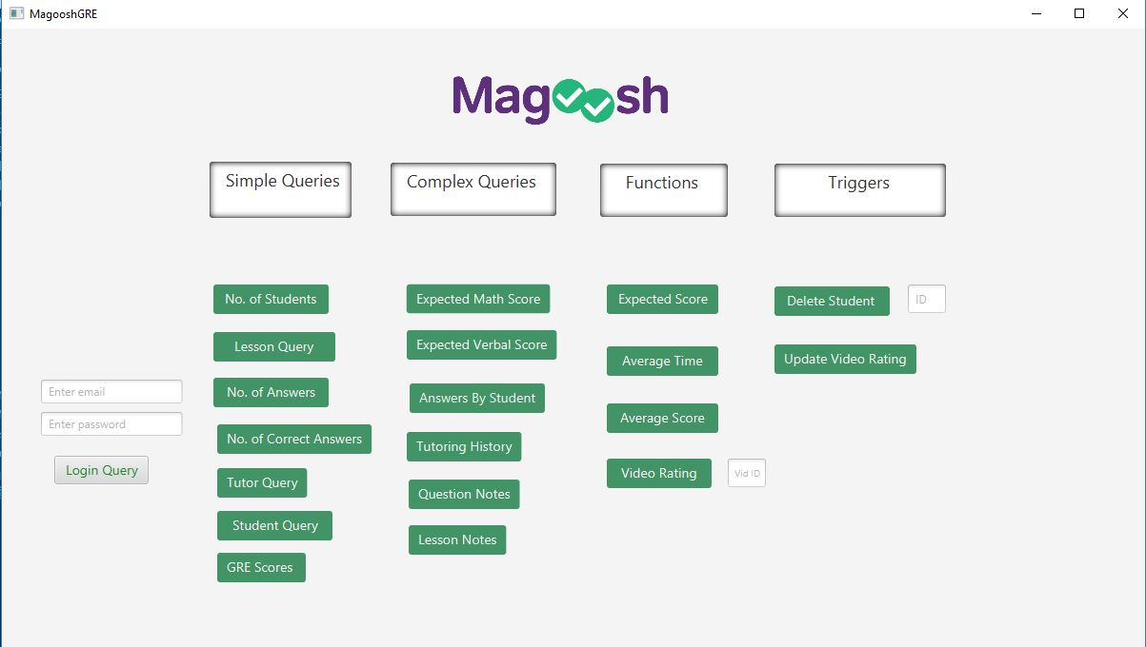

Fig: Front End of Magoosh DBMS

**ERD**

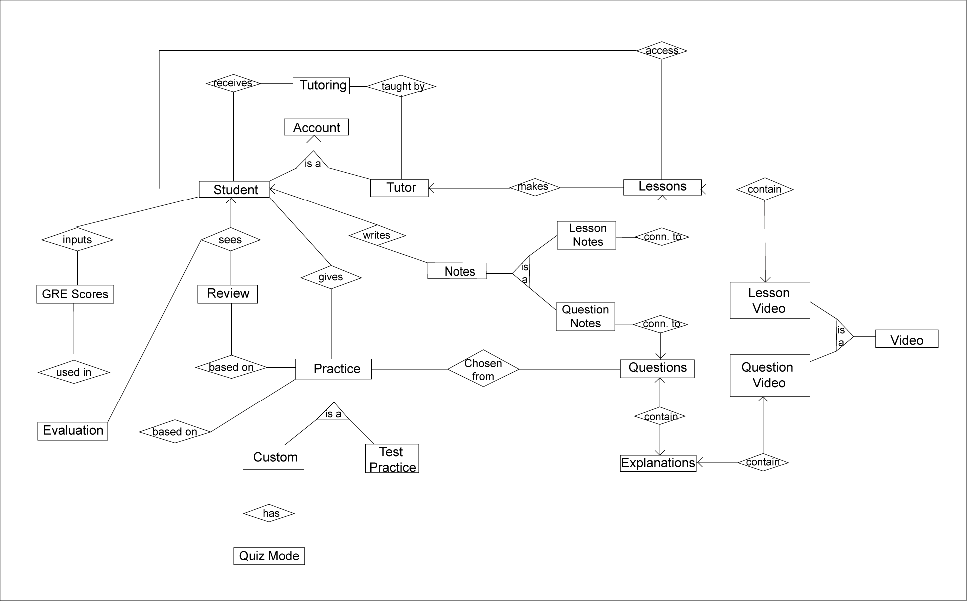

ENTITIES (15):

1. Student

2. Tutor

3. Tutoring

4. Questions

5. Question Videos

6. Question Notes

7. Lessons

8. Lesson Videos

9. Lesson Notes

10. Video Feedback

11. Evaluation

12. GRE Scores

13. Subjects

14. Test Practice

15. Quiz

SIMPLE QUERIES (8):

1. **Student Log In**  
   – Matches email, password from input with “Student” table
2. **No. Of Students**  
   - Counts number of rows in Student Table.  
   This is needed in many other functions, like calculating average time or score.
3. **Lesson Query**– Shows all lessons and their subjects in a Table  
   This is needed when the student wants to choose lessons on a subject or a specific lesson.
4. **No. Of Answers**  
    – Total questions answered by logged in student.  
   This is needed in the Review part of the Magoosh app. Students can see how many questions they answered and how they did.
5. **No. Of Correct answers**   
   – No. of correct answers by logged in student.  
   This is also an important part in the review section of Magoosh.
6. **Tutor information**   
   – All information of signed up tutors in a Table.
7. **Student information**   
   – All information of signed up students in a Table
8. **GRE scores**   
   – Past GRE scores of all students that used Magoosh.  
   This is used to estimate the projected GRE score of a student by comparing his score range with those of the past students and using the trend to estimate his score.

COMPLEX QUERIES (6):

1. **Expected Math Score**   
   – uses student’s correct answers, average score & past students’ GRE scores on Quantitative part.  
   This is used in Dashboard of the Magoosh app.
2. **Expected Verbal Score**   
   – uses student’s correct answers, average score & past students’ GRE scores on Verbal part.  
   This is used in Dashboard of the Magoosh app.
3. **Answer Table** – shows student’s score & time on each question along with question titles and subjects.  
   These information are needed for review section of the app.
4. **Tutoring History of Student**– shows name of tutor and tutoring details of logged in student
5. **Question Notes** – shows notes taken by student on questions along with the question title
6. **Lesson Notes**   
   – shows notes taken by student on lessons along with the lesson title

FUNCTIONS (9):

1. **Expected Score**   
   – Projected total GRE score of student, by matching his average math/verbal score range with scores of past students and their subsequent GRE score
2. **Average Time**   
   – Average time to answer questions (math/verbal)
3. **Average Score**   
   – Average score on all answered questions (math/verbal)
4. **Video Rating**   
   –Rating of people who clicked on Like on a video
5. **Video like percenage**   
   – Percentage of people who clicked on Like on a video
6. **Expected Math Score**  
   – Projected total GRE score of student, by matching his average math/verbal score range with scores of past students and their subsequent GRE score
7. **Expected Verbal Score**  
   – Projected total GRE score of student, by matching his average math/verbal score range with scores of past students and their subsequent GRE score
8. **Average Math Score**  
   – Average score of student only in math part
9. **Average Verbal Score**  
   – Average score of student only in verbal part

TRIGGERS (4):

1. Delete a Student’s Tutoring history if the Student is deleted from Student table
2. Delete Video if Like percentage drops below 20% when feedback table is Update
3. Delete Feedback from feedback table if Video is deleted from Question Video or Lesson Video table *(Not shown in GUI)*
4. Delete a Student’s feedbacks if the Student is deleted from Student table *(Not shown in GUI)*

Here are some samples from our code.

### SIMPLE QUERIES

SELECT password FROM Public.student WHERE email=mail;

select count(*) from videos where vid_id=vid;

select sum(likes) from videos where vid_id=vid;

select count(*) from public.answered where std_id=std;

select avg(time_sec) from answered where std_id=std;

select sum(correct) from answered where std_id=std;

select avg(time_sec) from answered where q_id=q;

### COMPLEX QUERIES

SELECT avg(grescore_math) FROM grescores WHERE math_expected >= ((SELECT avg(scores) FROM answered WHERE std_id=std) - 5) and math_expected <= ((SELECT avg(scores) FROM answered WHERE std_id=std) + 5) ;

select count(*) into crr from public.answered as a, public.stident as b where a.std_id=b.”ID” std_id=std and correct=1;

SELECT sum(grescore) FROM grescores WHERE verbal_expected >= ((SELECT avg(scores) FROM answered WHERE std_id=std) - 5) and verbal_expected <= ((SELECT avg(scores) FROM answered WHERE std_id=std) + 5) ;

select title from public.answered, public.subjects, public.student where std_id=std and subj_name=ans_sub and std_id = student.”ID”;

select sum(likes) from videos inner join public.subjects where vid_id=vid and videos.subject = subjects.subj_name;

**FUNCTIONS**

**1. AVERAGE SCORE**

CREATE OR REPLACE FUNCTION public.avg_score(

std integer,

sub integer)

RETURNS real

LANGUAGE 'plpgsql'

COST 100

VOLATILE

AS $BODY$ DECLARE

tm real;

n real;

av real;

BEGIN

if (sub=0)

then

select howmanyans(std) into n;

select sum(correct) into tm from answered where std_id=std;

end if;

if (sub=1)

then

select count(*) into n from answered where std_id=std and subj='m';

select sum(correct) into tm from answered where std_id=std and subj='m';

end if;

if (sub=2)

then

select count(*) into n from answered where std_id=std and subj='v';

select sum(correct) into tm from answered where std_id=std and subj='v';

end if;

select (tm*170/n) into av;

RETURN av;

END;$BODY$;

ALTER FUNCTION public.avg_score(integer, integer)

OWNER TO postgres;

**2. AVERAGE TIME**

CREATE OR REPLACE FUNCTION public.avg_time(

std integer)

RETURNS numeric

LANGUAGE 'plpgsql'

COST 100

VOLATILE

AS $BODY$ DECLARE

tm INTEGER;

n INTEGER;

mint integer;

sec integer;

str character(20);

BEGIN

select howmanyans(std) into n;

select avg(time_sec) into tm from answered where std_id=std;

mint = tm/60;

sec = tm%60;

select (mint || ' minutes ' || sec || ' seconds') into str;

RETURN tm;

END;$BODY$;

ALTER FUNCTION public.avg_time(integer)

OWNER TO postgres;

**3. VIDEO RATING**

CREATE OR REPLACE FUNCTION public.likepercent(

vid integer)

RETURNS character

LANGUAGE 'plpgsql'

COST 100

VOLATILE

AS $BODY$ DECLARE

perc real;

n real;

summ real;

str character(10);

BEGIN

select count(*) into n from videos where vid_id=vid;

select sum(likes) into summ from videos where vid_id=vid;

select (summ*100/n) into perc;

select (perc||'%') into str;

RETURN str;

END;$BODY$;

ALTER FUNCTION public.likepercent(integer)

OWNER TO postgres;

**5. EXPECTED SCORE**

CREATE OR REPLACE FUNCTION public.expectedscore(

std integer)

RETURNS integer

LANGUAGE 'plpgsql'

COST 100

VOLATILE

AS $BODY$DECLARE

exp_ integer;

n integer;

ownmath real;

y real;

BEGIN

select avg_score(std,1)*100/170 into ownmath;

select avg(grescore_math) from grescores where math_expected>=(ownmath-5) and math_expected<=(ownmath+5) into exp_;

RETURN exp_;

END;

$BODY$;

ALTER FUNCTION public.expectedscore_math(integer)

OWNER TO postgres;

**6. LOGIN**

CREATE OR REPLACE FUNCTION public.login(

mail text,

pass text)

RETURNS integer

LANGUAGE 'plpgsql'

COST 100

VOLATILE

AS $BODY$DECLARE

checkp integer;

passd character varying;

BEGIN

SELECT password into passd

FROM Public.student

where email=mail;

checkp=0;

if passd = pass then

checkp=1;

end if;

RETURN checkp;

END;

$BODY$;

ALTER FUNCTION public.login(text, text)

OWNER TO postgres;

## TRIGGERS

**1. Delete Student -> Delete Tutoring History**

CREATE TRIGGER del_std

BEFORE DELETE

ON public.student

FOR EACH ROW

EXECUTE PROCEDURE public.delstd();

CREATE FUNCTION public.delstd()

RETURNS trigger

LANGUAGE 'plpgsql'

COST 100

VOLATILE NOT LEAKPROOF

AS $BODY$BEGIN

IF TG_OP='DELETE' THEN

DELETE FROM tutoring where "Student id"=OLD."ID";

RETURN OLD;

END IF;

END;$BODY$;

ALTER FUNCTION public.delstd()

OWNER TO postgres;

**2. Delete Video if Feedback < 25%**

CREATE TRIGGER delfeedback

AFTER INSERT OR DELETE OR UPDATE

ON public.videos

FOR EACH ROW

EXECUTE PROCEDURE public.del_if_low_like();

CREATE FUNCTION public.del_if_low_like()

RETURNS trigger

LANGUAGE 'plpgsql'

COST 100

VOLATILE NOT LEAKPROOF

AS $BODY$BEGIN

IF TG_OP='UPDATE' THEN

DELETE FROM public."Question Video" where vid_id=NEW.vid_id AND like_per(NEW.vid_id) < 25;

DELETE FROM lessons where vid_id=NEW.vid_id AND like_per(NEW.vid_id) < 25;

RETURN NEW;

END IF;

END;$BODY$;

ALTER FUNCTION public.del_if_low_like()

OWNER TO postgres;

# **DDLs**

**1.**

CREATE TABLE public.answered

(

sl integer NOT NULL DEFAULT nextval('answered_sl_seq'::regclass),

std_id integer,

q_id integer,

correct integer,

subj character(1) COLLATE pg_catalog."default",

time_sec integer,

CONSTRAINT answered_pkey PRIMARY KEY (sl)

)

WITH (

OIDS = FALSE

)

TABLESPACE pg_default;

ALTER TABLE public.answered

OWNER to postgres;

**2.**

CREATE TABLE public."Lesson Notes"

(

std_id integer,

lesson_id integer,

note text COLLATE pg_catalog."default" NOT NULL,

sl integer NOT NULL DEFAULT nextval('"Lesson Notes_sl_seq"'::regclass),

CONSTRAINT sl PRIMARY KEY (sl),

CONSTRAINT lesson_id FOREIGN KEY (lesson_id)

REFERENCES public.lessons ("ID") MATCH SIMPLE

ON UPDATE NO ACTION

ON DELETE NO ACTION,

CONSTRAINT std_id FOREIGN KEY (std_id)

REFERENCES public.student ("ID") MATCH SIMPLE

ON UPDATE NO ACTION

ON DELETE NO ACTION

)

WITH (

OIDS = FALSE

)

TABLESPACE pg_default;

ALTER TABLE public."Lesson Notes"

OWNER to postgres;

CREATE INDEX fki_lesson_id

ON public."Lesson Notes" USING btree

(lesson_id)

TABLESPACE pg_default;

CREATE INDEX fki_std_id

ON public."Lesson Notes" USING btree

(std_id)

TABLESPACE pg_default;

**3.**

CREATE TABLE public.tutoring

(

"Subject" character(30) COLLATE pg_catalog."default",

"start date" date,

"end date" date,

feedback text COLLATE pg_catalog."default",

"Student id" integer,

"Tutor id" integer,

"tutoring id" integer NOT NULL DEFAULT nextval('"Tutoring_tutoring id_seq"'::regclass),

CONSTRAINT "Tutoring_pkey" PRIMARY KEY ("tutoring id"),

CONSTRAINT "Student id" FOREIGN KEY ("Student id")

REFERENCES public.student ("ID") MATCH SIMPLE

ON UPDATE NO ACTION

ON DELETE NO ACTION,

CONSTRAINT "Tutor id" FOREIGN KEY ("Tutor id")

REFERENCES public.tutor ("ID") MATCH SIMPLE

ON UPDATE NO ACTION

ON DELETE NO ACTION

)

WITH (

OIDS = FALSE

)

TABLESPACE pg_default;

ALTER TABLE public.tutoring

OWNER to postgres;

CREATE INDEX "fki_Student id"

ON public.tutoring USING btree

("Student id")

TABLESPACE pg_default;

CREATE INDEX "fki_Tutor id"

ON public.tutoring USING btree

("Tutor id")

TABLESPACE pg_default;

**4.**

CREATE TABLE public."Question Video"

(

question_id integer,

link text COLLATE pg_catalog."default",

explanation text COLLATE pg_catalog."default",

vid_id integer,

sl integer NOT NULL DEFAULT nextval('"Question Video_sl_seq"'::regclass),

title character(50) COLLATE pg_catalog."default",

CONSTRAINT "Question Video_pkey" PRIMARY KEY (sl),

CONSTRAINT q_id FOREIGN KEY (question_id)

REFERENCES public.questions ("ID") MATCH SIMPLE

ON UPDATE NO ACTION

ON DELETE NO ACTION

)

WITH (

OIDS = FALSE

)

TABLESPACE pg_default;

ALTER TABLE public."Question Video"

OWNER to postgres;

CREATE INDEX fki_vid_id

ON public."Question Video" USING btree

(vid_id)

TABLESPACE pg_default;

CREATE TRIGGER delvid_ques

BEFORE INSERT OR DELETE OR UPDATE

ON public."Question Video"

FOR EACH ROW

EXECUTE PROCEDURE public.delvid_q();

**5.**

CREATE TABLE public.evaluation

(

"time" numeric,

score numeric,

std_id integer,

q_id integer,

sl integer NOT NULL DEFAULT nextval('evaluation_sl_seq'::regclass),

CONSTRAINT evaluation_pkey PRIMARY KEY (sl),

CONSTRAINT std_id FOREIGN KEY (std_id)

REFERENCES public.student ("ID") MATCH SIMPLE

ON UPDATE NO ACTION

ON DELETE NO ACTION

)

WITH (

OIDS = FALSE

)

TABLESPACE pg_default;

ALTER TABLE public.evaluation

OWNER to postgres;

**6.**

CREATE TABLE public.lessons

(

subject character(30) COLLATE pg_catalog."default",

"tutor id" integer,

"ID" integer NOT NULL,

v_link text COLLATE pg_catalog."default",

vid_id integer,

title character(50) COLLATE pg_catalog."default",

CONSTRAINT "Lessons_pkey" PRIMARY KEY ("ID"),

CONSTRAINT subj FOREIGN KEY (subject)

REFERENCES public.subjects (subj_name) MATCH SIMPLE

ON UPDATE NO ACTION

ON DELETE NO ACTION,

CONSTRAINT "tutor id" FOREIGN KEY ("tutor id")

REFERENCES public.tutor ("ID") MATCH SIMPLE

ON UPDATE NO ACTION

ON DELETE NO ACTION,

CONSTRAINT vid_id FOREIGN KEY (vid_id)

REFERENCES public.videos (sl) MATCH SIMPLE

ON UPDATE NO ACTION

ON DELETE NO ACTION

)

WITH (

OIDS = FALSE

)

TABLESPACE pg_default;

ALTER TABLE public.lessons

OWNER to postgres;

CREATE INDEX fki_subj

ON public.lessons USING btree

(subject COLLATE pg_catalog."default")

TABLESPACE pg_default;

CREATE INDEX "fki_tutor id"

ON public.lessons USING btree

("tutor id")

TABLESPACE pg_default;

CREATE TRIGGER delvid_ques

BEFORE INSERT OR DELETE OR UPDATE

ON public.lessons

FOR EACH ROW

EXECUTE PROCEDURE public.delvid_l();