Module 1: Certificate Template Management
1.1 Upload Certificate Template
- Upload an existing certificate design.
- Supported formats: PNG, JPG and JPEG.
- Display the uploaded image in an editor.
- Preserve the original image dimensions and quality.
- Support landscape and portrait certificates.
1.2 Template Management
- Save certificate templates.
- Reuse previously saved templates.
- Edit existing templates.
- Delete templates.
- Assign a template name.

Module 2: Certificate Editor
2.1 Text Box Creation
- Click and drag on the certificate to create a text box.
- Resize text boxes using their corners.
- Move text boxes to different positions.
- Delete existing text boxes.
- Create multiple text boxes.
2.2 Field Identification
Every text box must have a unique field ID assigned by the user.
Examples:
- name
- certificateid
- rank
- eventname
- date
- institution

2.3 Text Formatting
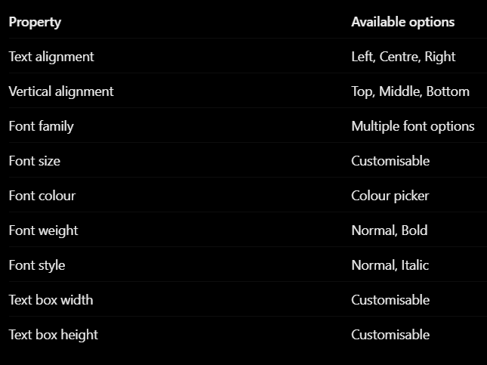
2.4 Additional Text Settings
- Auto-fit text to prevent overflow.
- Change formatting after creating a text box.
- Maintain consistent positioning across generated certificates.

Module 3: Excel/CSV Import
3.1 Upload Spreadsheet
- Upload Excel (.xlsx) files.
- Upload CSV files.
- Read column headers automatically.
- Extract all participant records.
- Identify the total number of participant records.

3.2 Column Mapping
Automatically match Excel column names with certificate field IDs.
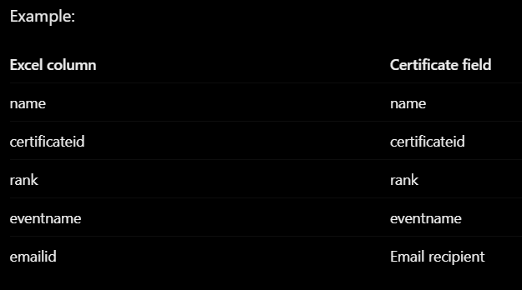
- Automatically map matching column names.
- Allow manual column mapping.
- Allow users to correct incorrect mappings.

Module 4: Bulk Certificate Generation
4.1 Automatic Generation
For every participant record:
- Retrieve the participant's information from the Excel sheet.
- Identify the corresponding certificate fields.
- Insert the information into the configured text boxes.
- Apply the saved formatting and alignment.
- Generate an individual certificate.
4.2 Output Formats
- PDF (primary format).
- PNG (optional format).
4.3 Certificate Naming
Automatically generate meaningful filenames(eg: CERT001_Aliya.pdf)

Module 5: Certificate Preview
- Preview the original certificate template.
- Preview text box positions and formatting.
- Preview individual generated certificates.
- Navigate between generated certificates.
- Check long names and text overflow.
- Return to the editor and modify formatting.
- Regenerate certificates after modifications.

Module 6: Email Distribution
6.1 Email Configuration
Allow the user to configure:
- Email subject.
- Email message/body.
6.2 Email Confirmation
User has to confirm by clicking ‘send’
6.3 Automated Distribution
After confirmation:
- Retrieve the first generated certificate.
- Retrieve the corresponding email address.
- Attach the certificate.
- Send the email.
- Repeat for all valid participant records.
6.4 Email Tracking
Maintain the following statuses:
- Pending
- Sending
- Sent
- Failed

Module 7: Bulk Certificate Download
7.1 ZIP Download
- Generate a ZIP archive containing all individual certificates.
- Maintain meaningful certificate filenames.
- Allow downloading all certificates together.
- Provide an option to download only selected certificates.

