1.INTRODUCTION:

A visaslot management project is system that is used to track and manage the availability of visa slots, which are appoinments that are required for certain visa applications. It might be used by a government agency or a visa processing center to schedule and manage appointments with applicants.

PURPOSE:

Customer relationship management (CRM) is a technology for managing all your company’s relationship and interctions with customers and potential customers. The goal is simple: **IMPROVE BUSINESS RELATIONSHIPS. A CRM system helps companies stay connected to customers, streamline processes, and improve profitability**.

EMPATHY MAP:

A empathy map **is a tool used when collecting data about customers to better understand your target customer base**.They allow you to visualize customer needs, condense customer data into a clear , simplechart, and helps you see what customers want – not what you think they what. 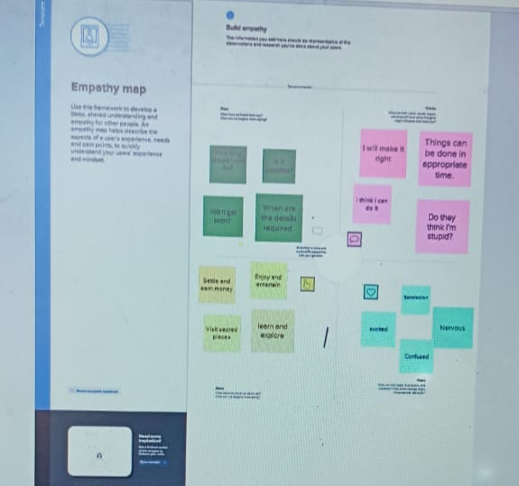

|  |  |  |  |  |
| --- | --- | --- | --- | --- |
| |  | | --- | |  | |  |  | https://mail.google.com/mail/u/0/images/cleardot.gif  https://mail.google.com/mail/u/0/images/cleardot.gif |
| |  | | --- | | BRAINSTORMING: |   C:\Users\admin\Downloads\IMG-20230412-WA0014 (2).jpg | | |

Brainstorming is a group problem-solving method that involves the spontaneous contribution of creative ideas and solutions. This technique requires intensive, freewheeling discussion in which every member of the group is encouraged to think aloud and suggest as many ideas as possible based on their diverse knowledge

5.ADVANTAGE OF CRM:

|  |  |  |
| --- | --- | --- |
| |  | | --- | | https://mail.google.com/mail/u/0/images/cleardot.gif | |  |

Having huge amounts of data on customer interactions enables an organisation to build up a clearer picture of its customers. It allows for deep insights to identify what the company is doing right as well as where it’s weak when it comes to managing its customers. With a CRM system, the most profitable customers can be identified, with the view to more time being spent targeting them. The CRM software also lets a business tailor its marketing communications to achieve more effective results and, hence, a greater return on investment in sales and marketing.

DISADVANTAGE OF CRM:

We’ve looked at the pros—the advantages—of initiating a CRM system, so now it’s time to examine some of the cons—the disadvantages—of a CRM system. Whilst ultimately these are fewer in number than the advantages, for some businesses, the short-term pain of a cultural and technological shift can be a lot to bear and may not generate a return.

3.RESULT:DATA MODEL

|  |  |  |
| --- | --- | --- |
| OBJECT NAME | FIELD LABEL | DATA TYPE |
| PASSPORT | VISASLOT | TEXT |

3.2 ACTIVITY AND SCREENSHOTS

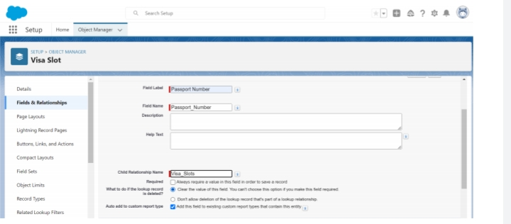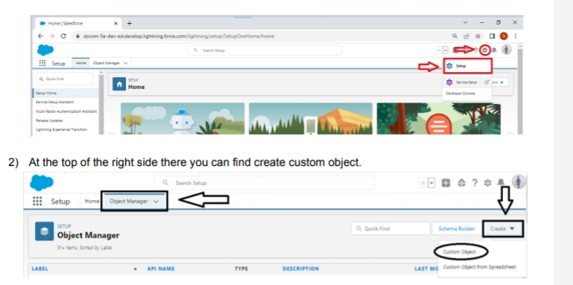

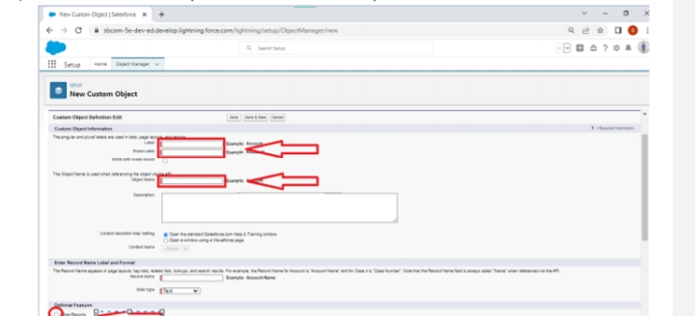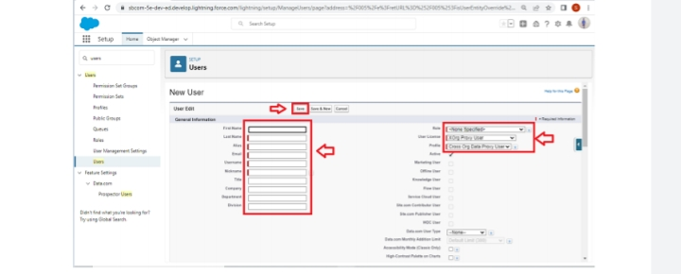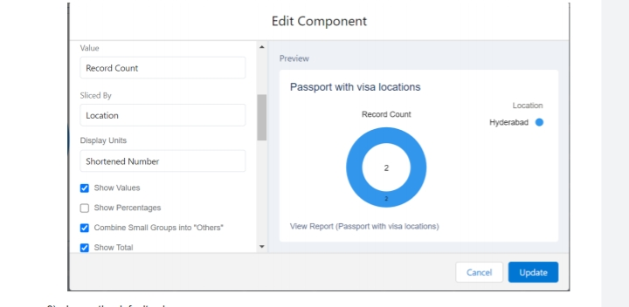

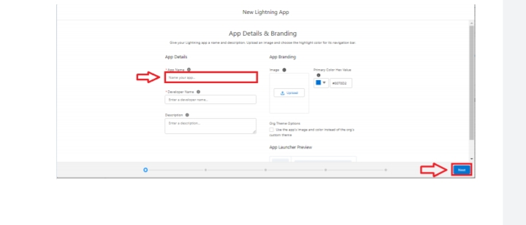

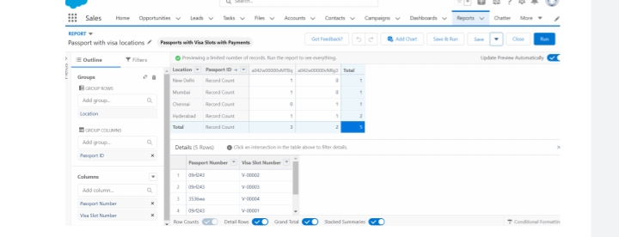ssssss

4.TRAILHEAD PROFILE PUBLIC URL:

TEAM LEADER: <https://trailblazer.me/id/msherin2>

TEAM MEMBER1:<https://trailblazer.me/id/ssabi64>

TEAM MEMBER2:<https://trailblazer.me/id/mmadhu151>

TEAM MEMEBER3: <https://trailblazer.me/id/navya25>

**7.conclusion:**

|  |  |  |  |
| --- | --- | --- | --- |
|  |  |  |  |
| |  | | --- | | https://mail.google.com/mail/u/0/images/cleardot.gif | | | |

Customer Relationship Management enables a company to align its strategy with the needs of the customer in order to best meet those needs and thus ensure long-term customer loyalty. However, in order to be successful in these aims, the different company departments have to work together and use measures in a coordinated fashion. This purpose is achieved via a customer database which is analyzed and updated using CRM software. This approach will be of particular interest to companies operating in highly competitive markets where it is difficult to attract new customers.

|  |  |
| --- | --- |
|  |  |

**8.FUTURE OF CRM**

The best CRM technology today uses cloud-based, mobile-friendly, and AI-optimized software. These features are increasingly the norm, not the future. CRM already gives companies the ability to provide a personalized customer experience. The future of customer relationship management can be seen in a number of ways, including increased adoption of CRM technology across enterprises, deeper insights fueled by expanding artificial intelligence, and more robust customer data integration. Companies that invest in CRM will benefit from having a single source of customer truth, as well as a way to uniformly support the entirety of the customer lifecycle.

**6.APPLICATION**:

CRM store customer and prospect contact information sales oppurtunities record service issues and manage marketing campaigns, all in one central location.

|  |
| --- |
|  |