|  |
| --- |
| **flyway.com**  **Application Screenshots** |

**Version History:**

|  |  |
| --- | --- |
| Author: | Mayur Bharatkumar Solanki |
| Purpose: | Screenshots of the application |
| Date: | 25nd October, 2021 |
| Version: | 1.0 |

**Table of Content:**

Flight Booking: 3

Main Menu Screen Shot: 3

Registration Page 4

Successful Registration 4

Admin Login Page 5

Welcome Admin Page 5

Change Password 6

Selecting Date of Travel: 7

Payment Page 8

Payment Successfully Done 8

Access Denied Page 9

Database 9

# Flight Booking:

## Main Menu Screen Shot:

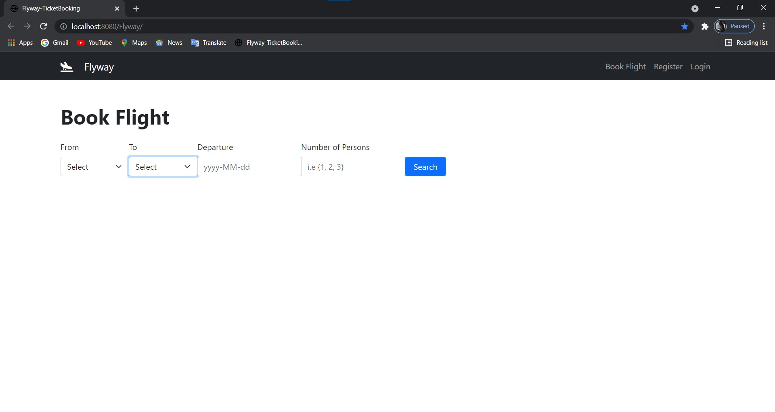

## Registration Page

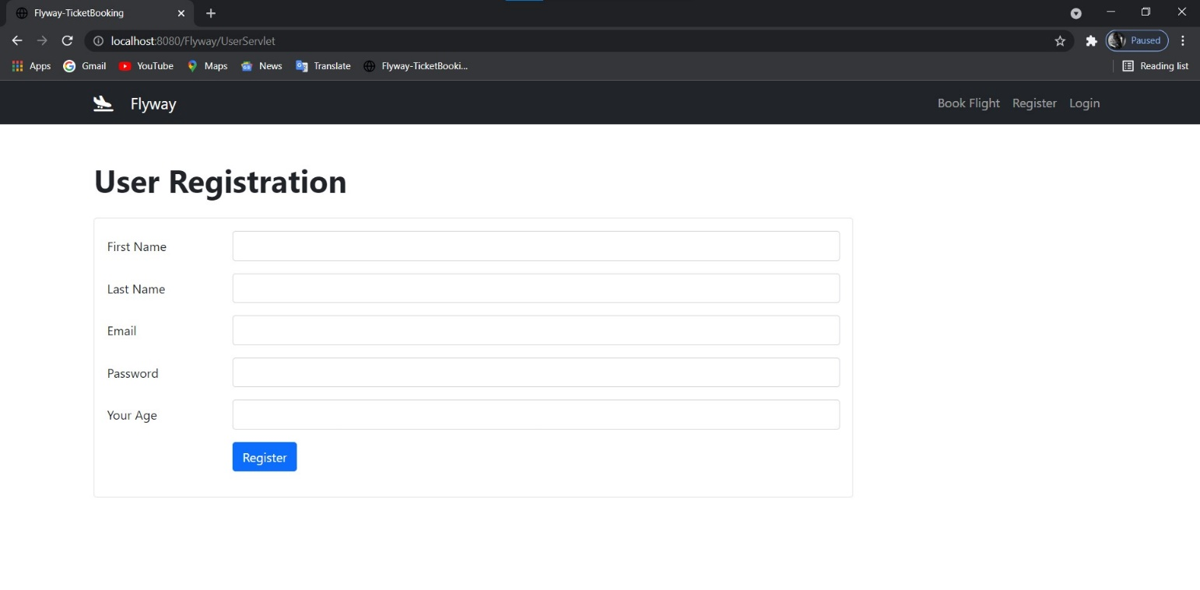

### Successful Registration

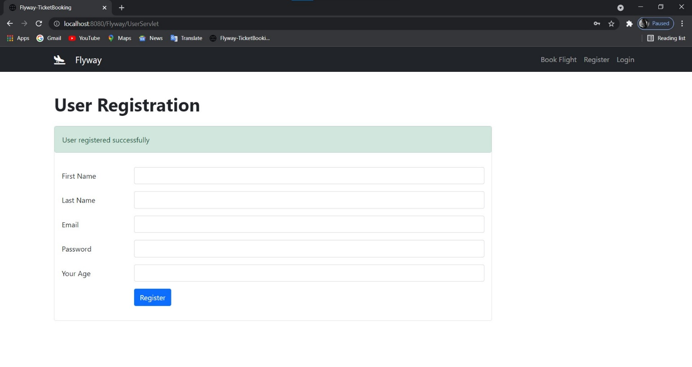

### Admin Login Page

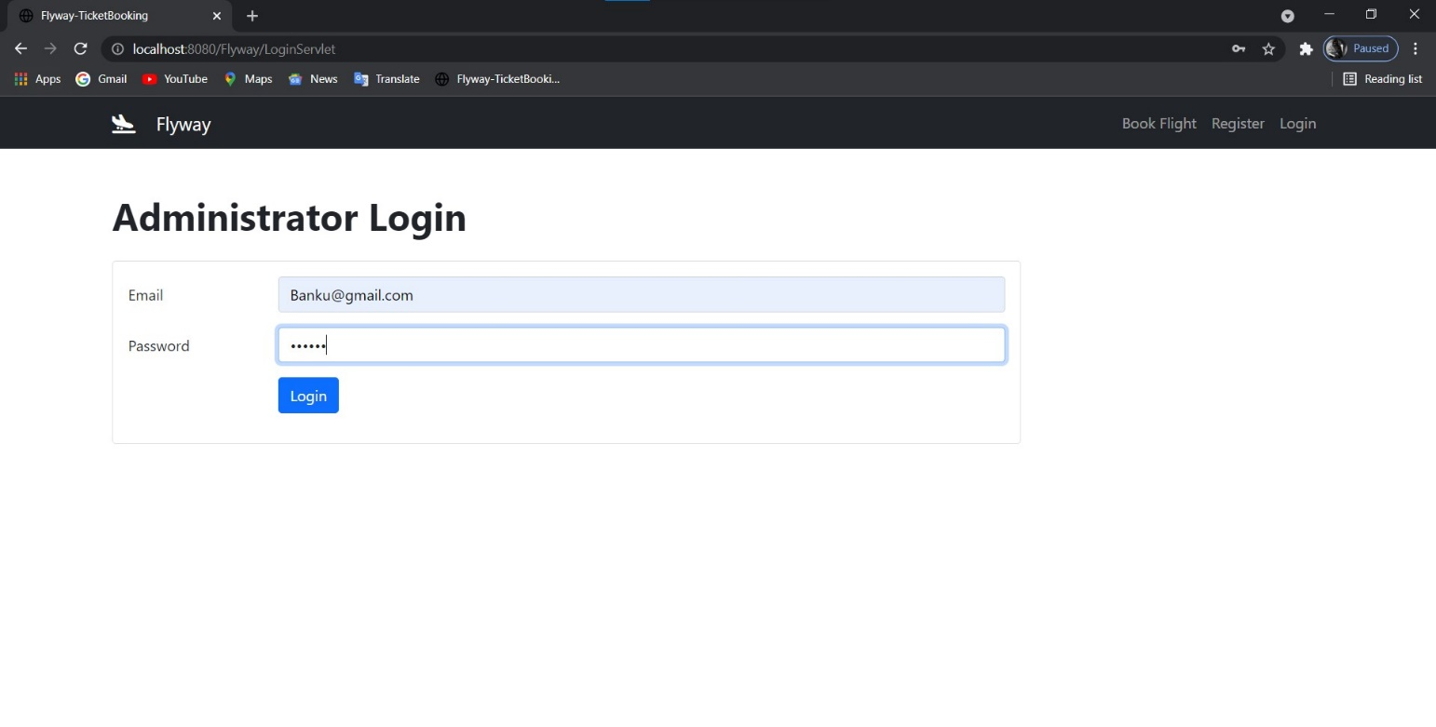

### Welcome Admin Page

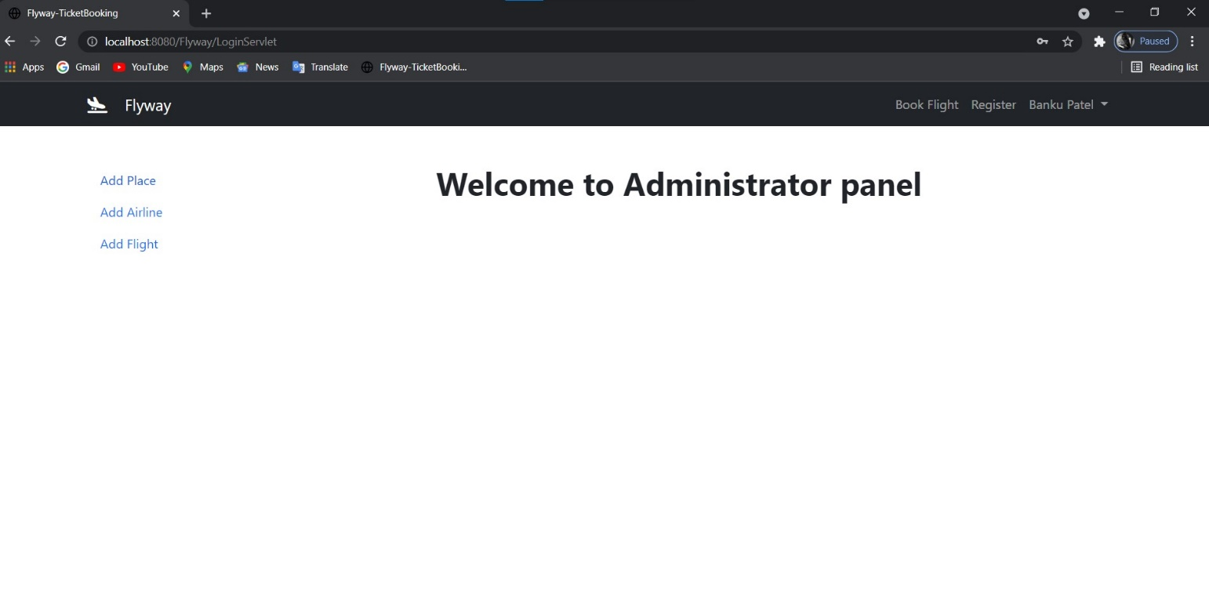

### Change Password

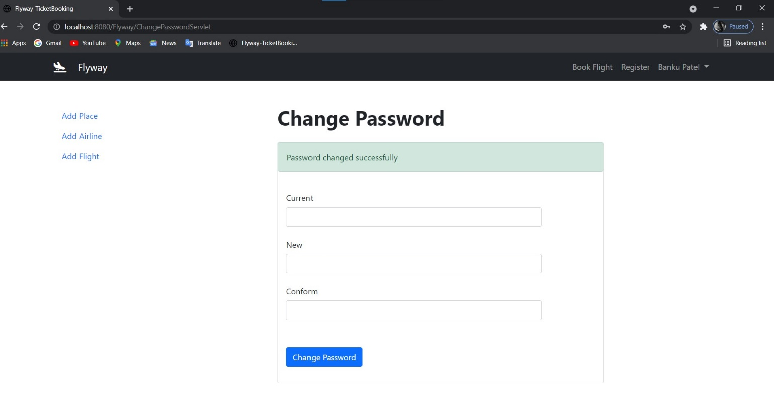

Booking Page

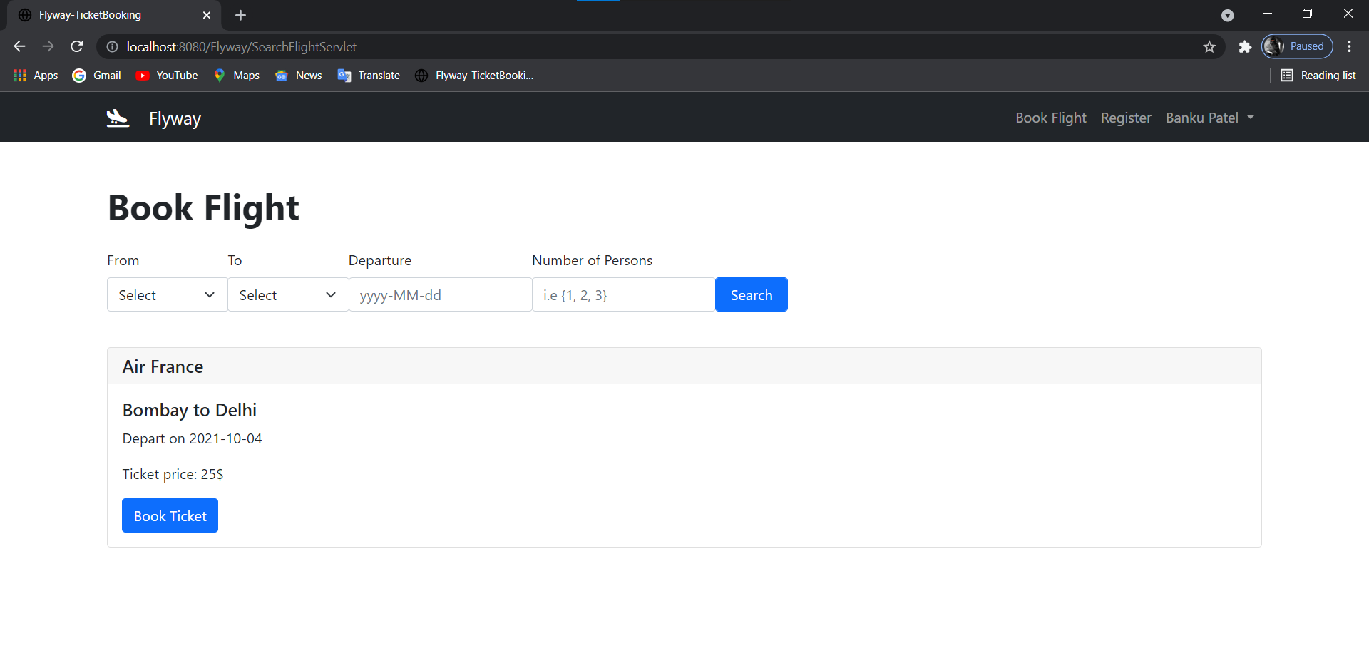

### Selecting Date of Travel:

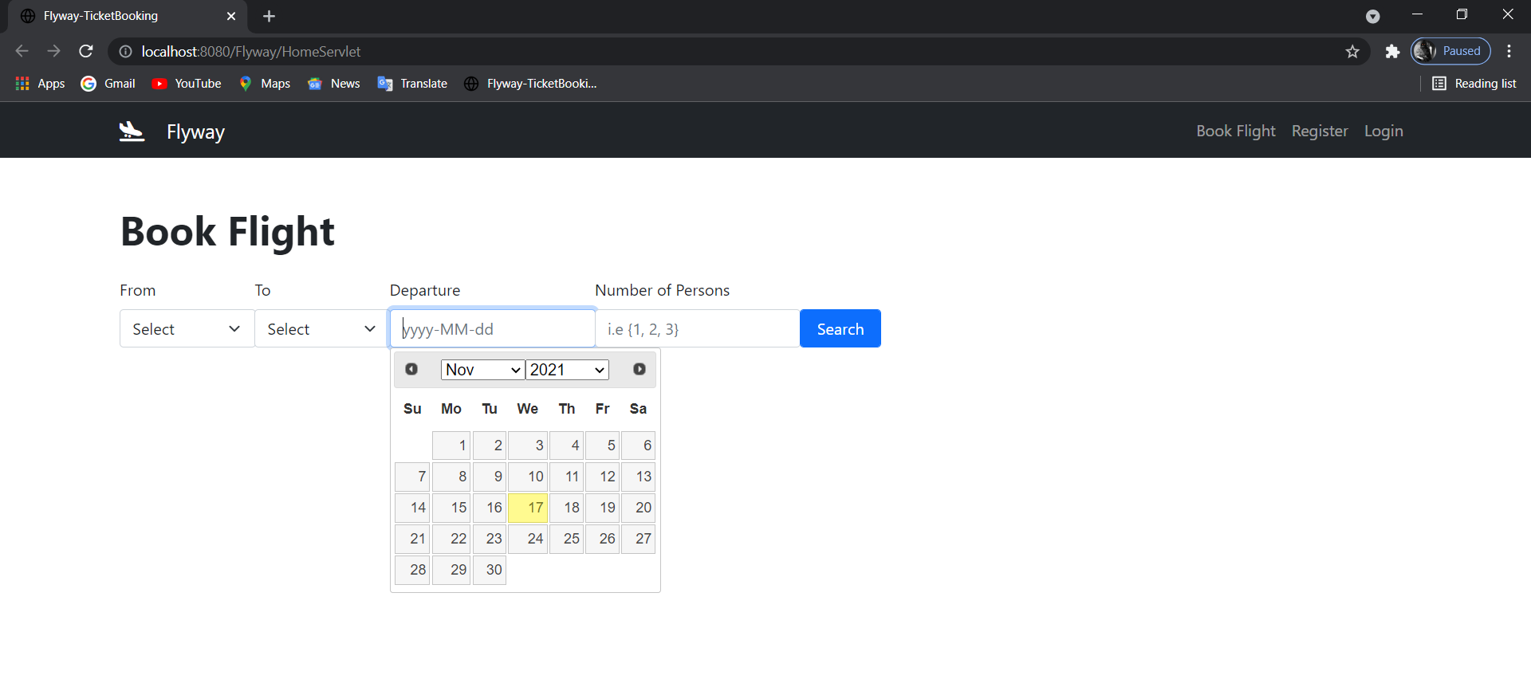

### Payment Page

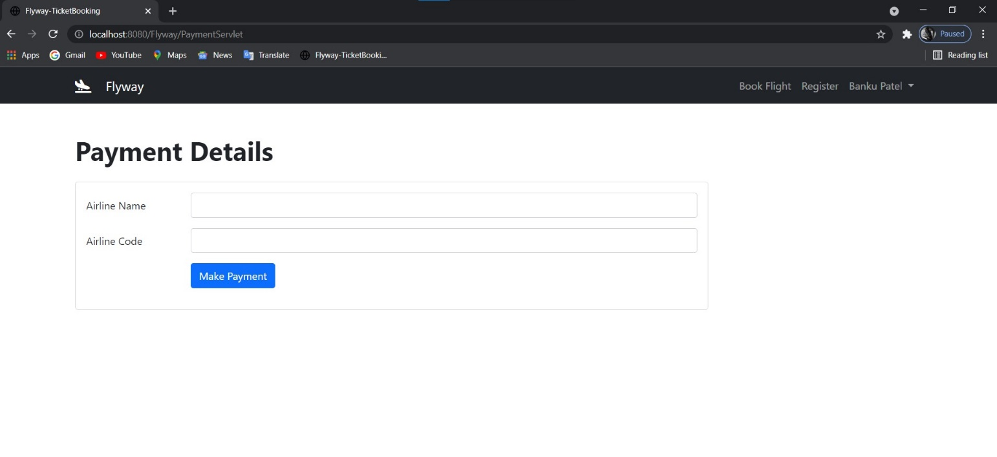

### Payment Successfully Done

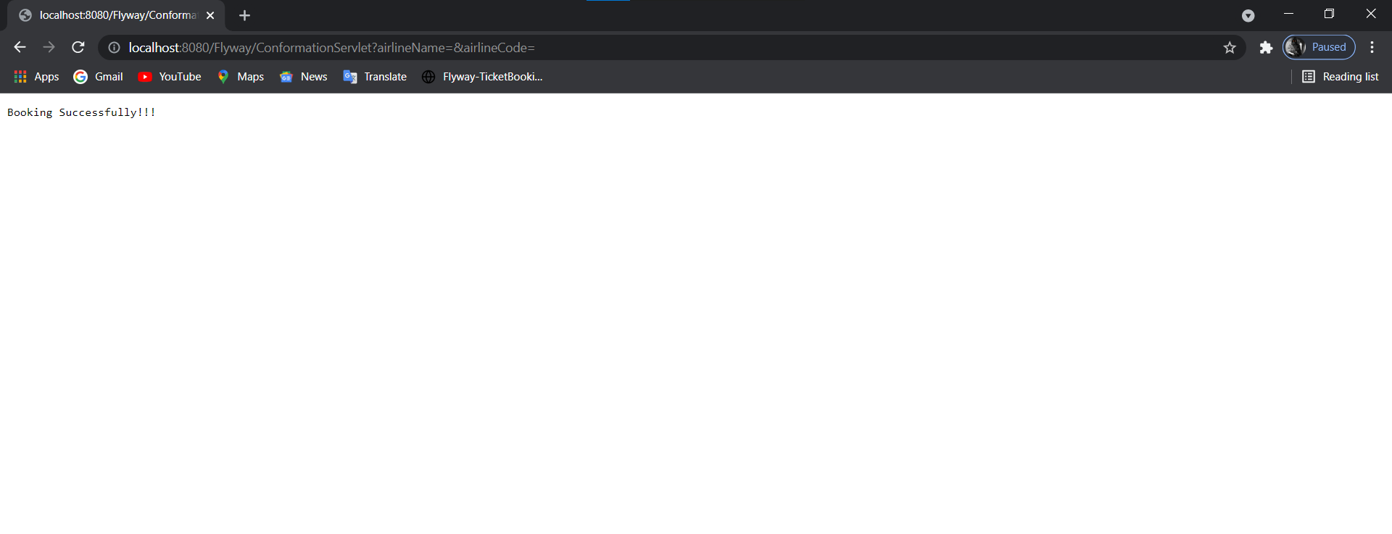

### Access Denied Page

### 

DATABASE

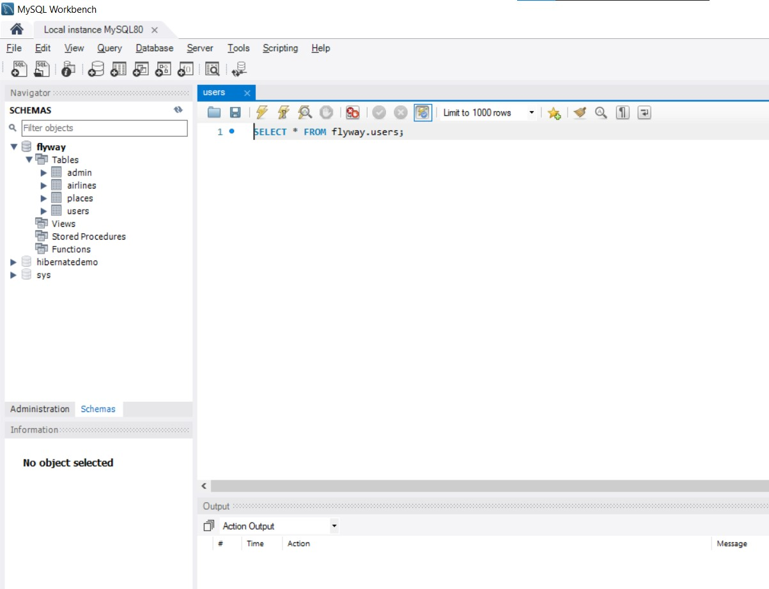

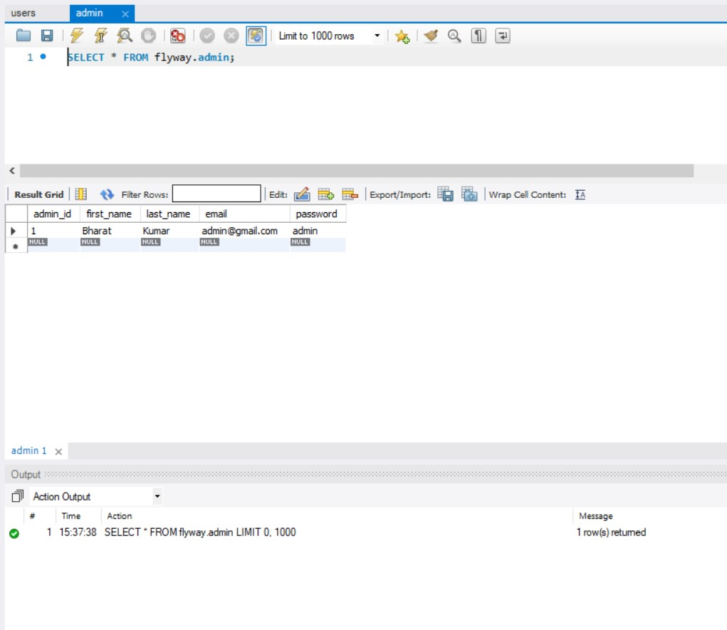

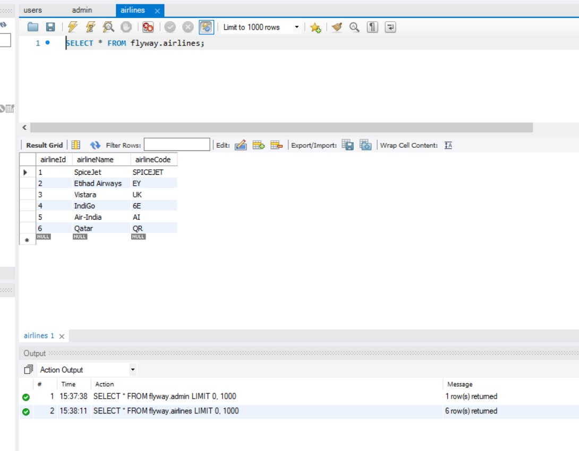

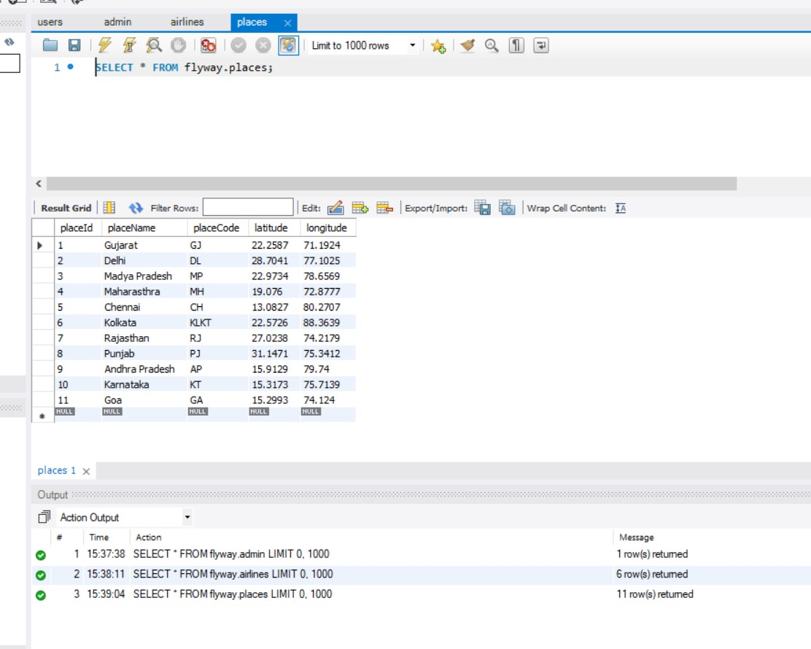

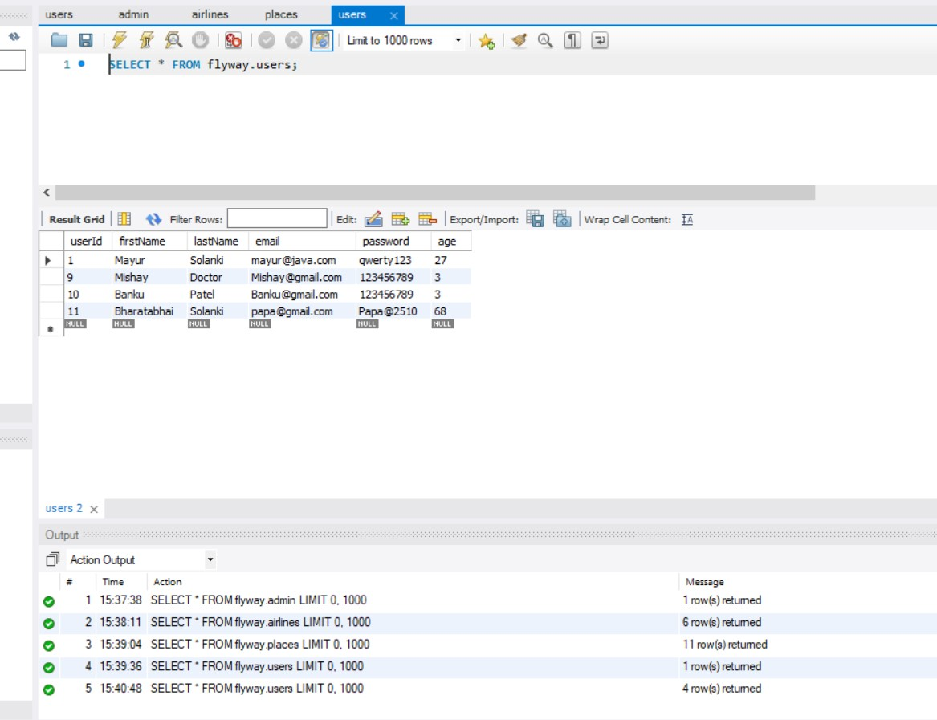

WEBSITE LOOK

