|  |
| --- |
| **flyway.com**  **Project Source Code** |

**Version History:**

|  |  |
| --- | --- |
| Author: | Mayur Bharatkumar Solanki |
| Purpose: | Project Source Code and GITHUB |
| Date: | 25th October, 2021 |
| Version: | 1.0 |

Table of Content:

Project GITHUB Link: 3

Project Code: 4

# Project GITHUB Link:

|  |  |
| --- | --- |
| Repository Name: | SL_FSD_PHASE2_Project |
| Github Link: | <https://github.com/mursky66/SL_FSD_PHASE2_Project> |

# Project Code:

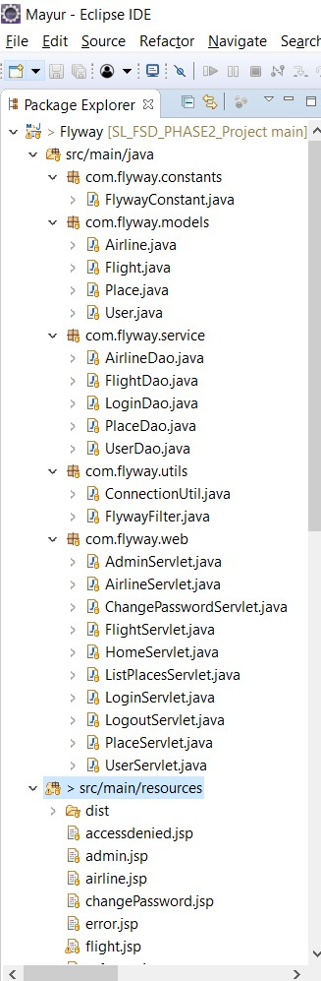

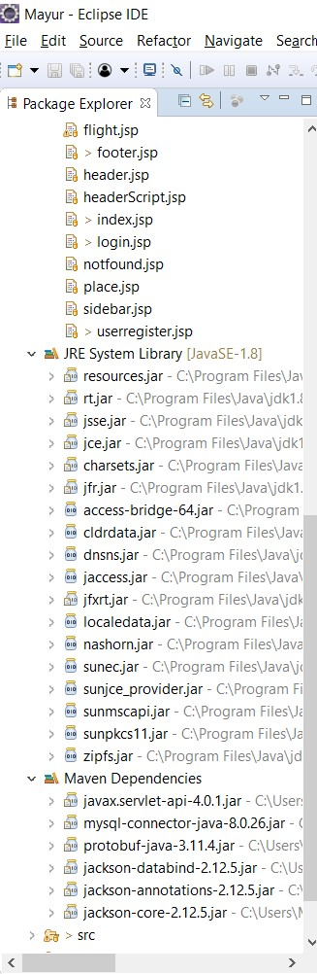

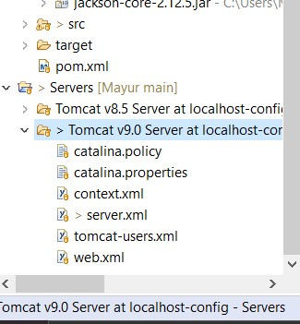

**INDEX**

<!DOCTYPE html>

<html lang=*"en"*>

<head>

<meta charset=*"utf-8"* />

<meta name=*"viewport"*

content=*"width=device-width, initial-scale=1, shrink-to-fit=no"* />

<meta name=*"description"* content=*"Flyway Ticketbooking (Admin panel)"* />

<meta name=*"author"* content=*"Mayur Solanki"* />

<title>Flyway-TicketBooking</title>

<jsp:include page=*"headerScript.jsp"* />

</head>

<body onload="populatePlaces()">

<!-- Responsive navbar-->

<jsp:include page=*"header.jsp"* />

<!-- Page content-->

<div class=*"container mt-5"*>

<div class=*"row"*>

<div class=*"col-lg-12"*>

<!-- Post content-->

<article>

<!-- Post header-->

<header class=*"mb-4"*>

<!-- Post title-->

<h1 class=*"fw-bolder mb-1"*>Book Flight</h1>

</header>

</article>

<form class=*"mb-4 input-group"*>

<div class=*"mb-3"*>

<label for=*"fromPlace"* class=*"form-label"*>From</label> <select

class=*"form-select"* id=*"fromPlace"* name=*"fromPlace"*

aria-label=*"From"*>

</select>

</div>

<div class=*"mb-3"*>

<label for=*"toPlace"* class=*"form-label"*>To</label> <select

class=*"form-select"* id=*"toPlace"* name=*"toPlace"* aria-label=*"To"*>

</select>

</div>

<div class=*"mb-2"*>

<label for=*"departureDate"* class=*"form-label"*>Departure</label> <input

type=*"text"* id=*"departureDate"* name=*"departureDate"*

class=*"form-control"* placeholder=*"yyyy-MM-dd"*>

</div>

<div class=*"mb-2"*>

<label for=*"noOfPerson"* class=*"form-label"*>Number of

Persons</label> <input type=*"text"* id=*"noOfPerson"* class=*"form-control"*

placeholder=*"i.e {1, 2, 3}"*>

</div>

<div class=*"mb-2"*>

<label class=*"form-label"*>&nbsp;</label>

<button class=*"btn btn-primary form-control"* id=*"button-search"*

type=*"button"*>Search</button>

</div>

</form>

</div>

</div>

<div id=*"searchResult"*>

<div class=*"card mb-3"*>

<h5 class=*"card-header"*>Air India</h5>

<div class=*"card-body"*>

<h5 class=*"card-title"*>Bombay to Delhi</h5>

<p class=*"card-text"*>Depart on 2021-10-04</p>

<p class=*"card-text"*>Ticket price: 25$</p>

<a href=*"#"* class=*"btn btn-primary"*>Book Ticket</a>

</div>

</div>

<div class=*"card mb-3"*>

<h5 class=*"card-header"*>Indigo</h5>

<div class=*"card-body"*>

<h5 class=*"card-title"*>Bombay to Delhi</h5>

<p class=*"card-text"*>Depart on 2021-10-04</p>

<p class=*"card-text"*>Ticket price: 68$</p>

<a href=*"#"* class=*"btn btn-primary"*>Book Ticket</a>

</div>

</div>

</div>

</div>

<script type=*"text/javascript"*>

**function** populatePlaces() {

$("#fromPlace").html("");

$("#toPlace").html("");

$("#fromPlace").append('<option value="NA">Select</option>');

$("#toPlace").append('<option value="NA">Select</option>');

$.ajax({

url : "http://localhost:8080/Flyway/ListPlacesServlet",

type : 'GET',

success : **function**(res) {

console.log(res);

**if** (res) {

$.each(res, **function**(key, value) {

$("#fromPlace").append(

'<option value="'+value.placeId+'">'

+ value.placeName + '</option>');

$("#toPlace").append(

'<option value="'+value.placeId+'">'

+ value.placeName + '</option>');

});

}

}

});

}

</script>

<jsp:include page=*"footer.jsp"* />

</body>

</html>

LOGIN

<!DOCTYPE html>

<html lang=*"en"*>

<head>

<meta charset=*"utf-8"* />

<meta name=*"viewport"*

content=*"width=device-width, initial-scale=1, shrink-to-fit=no"* />

<meta name=*"description"* content=*"Flyway Ticketbooking (Admin panel)"* />

<meta name=*"author"* content=*"Mayur Solanki"* />

<title>Flyway-TicketBooking</title>

<jsp:include page=*"headerScript.jsp"* />

</head>

<body>

<!-- Responsive navbar-->

<jsp:include page=*"header.jsp"* />

<!-- Page content-->

<div class=*"container mt-5"*>

<div class=*"row"*>

<div class=*"col-lg-12"*>

<!-- Post content-->

<article>

<!-- Post header-->

<header class=*"mb-4"*>

<!-- Post title-->

<h1 class=*"fw-bolder mb-1"*>Administrator Login</h1>

</header>

</article>

<div class=*"card w-75"*>

<div class=*"card-head"*>

<%

**if** (request.getAttribute("MSG") != **null**) {

%>

<div class=*"alert alert-danger"* role=*"alert"*><%=request.getAttribute("MSG").toString()%></div>

<%

}

%>

</div>

<div class=*"card-body"*>

<form action=*"./LoginServlet"* method=*"POST"*>

<div class=*"mb-3 row"*>

<label for=*"email"* class=*"col-sm-2 col-form-label"*>Email</label>

<div class=*"col-sm-10"*>

<input type=*"text"* class=*"form-control"* id=*"email"* name=*"email"*>

</div>

</div>

<div class=*"mb-3 row"*>

<label for=*"password"* class=*"col-sm-2 col-form-label"*>Password</label>

<div class=*"col-sm-10"*>

<input type=*"password"* class=*"form-control"* id=*"password"*

name=*"password"*>

</div>

</div>

<div class=*"mb-3 row"*>

<label class=*"col-sm-2 col-form-label"*>&nbsp;</label>

<div class=*"col-sm-10"*>

<button type=*"submit"* class=*"btn btn-primary"*>Login</button>

</div>

</div>

</form>

</div>

</div>

<br />

</div>

</div>

</div>

<jsp:include page=*"footer.jsp"* />

</body>

</html>

ADMIN

<!DOCTYPE html>

<%@page import=*"com.flyway.models.User"*%>

<html lang=*"en"*>

<head>

<meta charset=*"utf-8"* />

<meta name=*"viewport"*

content=*"width=device-width, initial-scale=1, shrink-to-fit=no"* />

<meta name=*"description"* content=*"Flyway Ticketbooking (Admin panel)"* />

<meta name=*"author"* content=*"Mayur Solanki"* />

<title>Flyway-TicketBooking</title>

<jsp:include page=*"headerScript.jsp"* />

</head>

<body>

<!-- Responsive navbar-->

<jsp:include page=*"header.jsp"* />

<!-- Page content-->

<div class=*"container mt-5"*>

<div class=*"row"*>

<div class=*"col-lg-4 mb-5"*>

<jsp:include page=*"sidebar.jsp"* />

</div>

<div class=*"col-lg-8"*>

<article>

<!-- Post header-->

<header class=*"mb-4"*>

<h1 class=*"fw-bolder mb-1"*>Welcome to Administrator panel</h1>

</header>

</article>

</div>

</div>

</div>

<jsp:include page=*"footer.jsp"* />

</body>

</html>

CHANGE PASSWORD

<!DOCTYPE html>

<html lang=*"en"*>

<head>

<meta charset=*"utf-8"* />

<meta name=*"viewport"*

content=*"width=device-width, initial-scale=1, shrink-to-fit=no"* />

<meta name=*"description"* content=*"Flyway Ticketbooking (Admin panel)"* />

<meta name=*"author"* content=*"Mayur Solanki"* />

<title>Flyway-TicketBooking</title>

<jsp:include page=*"headerScript.jsp"* />

</head>

<body>

<!-- Responsive navbar-->

<jsp:include page=*"header.jsp"* />

<!-- Page content-->

<div class=*"container mt-5"*>

<div class=*"row"*>

<div class=*"col-lg-4 mb-5"*>

<jsp:include page=*"sidebar.jsp"* />

</div>

<div class=*"col-lg-8"*>

<!-- Post content-->

<article>

<!-- Post header-->

<header class=*"mb-4"*>

<!-- Post title-->

<h1 class=*"fw-bolder mb-1"*>Change Password</h1>

</header>

</article>

<div class=*"card w-75"*>

<div class=*"card-head"*>

<%

**if** (request.getAttribute("MSG") != **null**) {

**if** (request.getAttribute("MSGTYPE") != **null**) {

**final** String MSGTYPE = (String) request.getAttribute("MSGTYPE");

**if** (MSGTYPE.equals("ERROR")) {

%><div class=*"alert alert-danger"* role=*"alert"*><%=request.getAttribute("MSG").toString()%></div>

<%

} **else** {

%><div class=*"alert alert-success"* role=*"alert"*><%=request.getAttribute("MSG").toString()%></div>

<%

}

}

}

%>

</div>

<div class=*"card-body"*>

<form action=*"./ChangePasswordServlet"* method=*"POST"*>

<div class=*"mb-3 row"*>

<label for=*"currentPwd"* class=*"col-sm-2 col-form-label"*>Current

Password</label>

<div class=*"col-sm-10"*>

<input type=*"password"* class=*"form-control"* id=*"currentPwd"*

name=*"currentPwd"*>

</div>

</div>

<div class=*"mb-3 row"*>

<label for=*"newPwd"* class=*"col-sm-2 col-form-label"*>New

Password</label>

<div class=*"col-sm-10"*>

<input type=*"password"* class=*"form-control"* id=*"newPwd"*

name=*"newPwd"*>

</div>

</div>

<div class=*"mb-3 row"*>

<label for=*"confirmPwd"* class=*"col-sm-2 col-form-label"*>Confirm

Password</label>

<div class=*"col-sm-10"*>

<input type=*"password"* class=*"form-control"* id=*"confirmPwd"*

name=*"confirmPwd"*>

</div>

</div>

<div class=*"mb-3 row"*>

<label class=*"col-sm-2 col-form-label"*>&nbsp;</label>

<div class=*"col-sm-10"*>

<button type=*"submit"* class=*"btn btn-primary"*>Change

Password</button>

</div>

</div>

</form>

</div>

</div>

<br />

</div>

</div>

</div>

<jsp:include page=*"footer.jsp"* />

</body>

</html>

ERROR

<%@ page isErrorPage=*"true"*%>

<h3>Sorry an exception occured!</h3>

Exception is:

<%=exception%>

SIDEBAR

<ul class=*"nav flex-column"*>

<li class=*"nav-item"*><a class=*"nav-link active"* href=*"./PlaceServlet"*>Add Place</a></li>

<li class=*"nav-item"*><a class=*"nav-link"* href=*"./AirlineServlet"*>Add Airline</a></li>

<li class=*"nav-item"*><a class=*"nav-link"* href=*"./FlightServlet"*>Add Flight</a></li>

</ul>

HEADER

<%@page import=*"com.flyway.models.User"*%>

<nav class=*"navbar navbar-expand-lg navbar-dark bg-dark"*>

<div class=*"container"*>

<a class=*"navbar-brand"* href=*"./HomeServlet"*> <i

class=*"fa-solid fa-plane-arrival"*></i> &nbsp;&nbsp; Flyway

</a>

<button class=*"navbar-toggler"* type=*"button"* data-bs-toggle=*"collapse"*

data-bs-target=*"#navbarSupportedContent"*

aria-controls=*"navbarSupportedContent"* aria-expanded=*"false"*

aria-label=*"Toggle navigation"*>

<span class=*"navbar-toggler-icon"*></span>

</button>

<div class=*"collapse navbar-collapse"* id=*"navbarSupportedContent"*>

<ul class=*"navbar-nav ms-auto mb-2 mb-lg-0"*>

<li class=*"nav-item"*><a class=*"nav-link"* href=*"./HomeServlet"*>Book

Flight</a></li>

<li class=*"nav-item"*><a class=*"nav-link"* href=*"./UserServlet"*>Register</a></li>

<%

**if** (session.getAttribute("USER") != **null**) {

User user = (User) session.getAttribute("USER");

String displayName = user.getFirstName() + " " + user.getLastName();

%>

<li class=*"nav-item dropdown"*><a

class=*"nav-link dropdown-toggle"* href=*"#"* id=*"navbarDropdown"*

role=*"button"* data-bs-toggle=*"dropdown"* aria-expanded=*"false"*>

<%=displayName%>

</a>

<ul class=*"dropdown-menu"* aria-labelledby=*"navbarDropdown"*>

<li><a class=*"dropdown-item"* href=*"./AdminServlet"*>Admin panel</a></li>

<li><a class=*"dropdown-item"* href=*"./ChangePasswordServlet"*>Change Password</a></li>

<li><a class=*"dropdown-item"* href=*"./LogoutServlet"*>Logout</a></li>

</ul></li>

<%

} **else** {

%>

<li class=*"nav-item"*><a class=*"nav-link"* href=*"./LoginServlet"*>Login</a></li>

<%

}

%>

</ul>

</div>

</div>

</nav>

FOOTER

<!-- Footer-->

<footer class=*"py-5 bg-dark"*

style="position: *fixed*; bottom: *0*; width: *100%*;">

<div class=*"container"*>

<p class=*"m-0 text-center text-white"*>Copyright &copy; Flyway 2021</p>

</div>

</footer>

<!-- Bootstrap core JS-->

<script src=*"./dist/js/bootstrap.bundle.min.js"*></script>

<!-- Core theme JS-->

<script src=*"./dist/js/scripts.js"*></script>

<script src=*"./dist/js/jquery-1.12.4.js"*></script>

<script src=*"./dist/js/jquery-ui.js"*></script>

<script type=*"text/javascript"*>

$(**function**() {

$("#departureDate").datepicker({

dateFormat : "yy-mm-dd",

showAnim : "fold",

changeMonth : **true**,

changeYear : **true**,

});

});

</script>

NOT FOUND

<%@ page language=*"java"* contentType=*"text/html; charset=ISO-8859-1"*

pageEncoding=*"ISO-8859-1"*%>

<!DOCTYPE html>

<html>

<head>

<meta charset=*"ISO-8859-1"*>

<title>Insert title here</title>

</head>

<body>PAGE NOT FOUND

</body>

</html>

USER-RIGISTER

<!DOCTYPE html>

<html lang=*"en"*>

<head>

<meta charset=*"utf-8"* />

<meta name=*"viewport"*

content=*"width=device-width, initial-scale=1, shrink-to-fit=no"* />

<meta name=*"description"* content=*"Flyway Ticketbooking (Admin panel)"* />

<meta name=*"author"* content=*"Mayur Solanki"* />

<title>Flyway-TicketBooking</title>

<jsp:include page=*"headerScript.jsp"* />

</head>

<body>

<!-- Responsive navbar-->

<jsp:include page=*"header.jsp"* />

<!-- Page content-->

<div class=*"container mt-5"*>

<div class=*"row"*>

<div class=*"col-lg-12"*>

<!-- Post content-->

<article>

<!-- Post header-->

<header class=*"mb-4"*>

<!-- Post title-->

<h1 class=*"fw-bolder mb-1"*>User Registration</h1>

</header>

</article>

<div class=*"card w-75"*>

<div class=*"card-head"*>

<%**if** (request.getAttribute("MSG") != **null**) {

**if**(request.getAttribute("MSGTYPE") != **null**){

**final** String MSGTYPE = (String)request.getAttribute("MSGTYPE");

**if**(MSGTYPE.equals("ERROR")){

%><div class=*"alert alert-danger"* role=*"alert"*><%=request.getAttribute("MSG").toString()%></div><%

}**else**{

%><div class=*"alert alert-success"* role=*"alert"*><%=request.getAttribute("MSG").toString()%></div><%

}

}

}

%>

</div>

<div class=*"card-body"*>

<form action=*"./UserServlet"* method=*"POST"*>

<div class=*"mb-3 row"*>

<label for=*"firstName"* class=*"col-sm-2 col-form-label"*>First Name</label>

<div class=*"col-sm-10"*>

<input type=*"text"* class=*"form-control"* id=*"firstName"* name=*"firstName"*>

</div>

</div>

<div class=*"mb-3 row"*>

<label for=*"lastName"* class=*"col-sm-2 col-form-label"*>Last Name</label>

<div class=*"col-sm-10"*>

<input type=*"text"* class=*"form-control"* id=*"lastName"* name=*"lastName"*>

</div>

</div>

<div class=*"mb-3 row"*>

<label for=*"email"* class=*"col-sm-2 col-form-label"*>Email</label>

<div class=*"col-sm-10"*>

<input type=*"text"* class=*"form-control"* id=*"email"* name=*"email"*>

</div>

</div>

<div class=*"mb-3 row"*>

<label for=*"password"* class=*"col-sm-2 col-form-label"*>Password</label>

<div class=*"col-sm-10"*>

<input type=*"password"* class=*"form-control"* id=*"password"* name=*"password"*>

</div>

</div>

<div class=*"mb-3 row"*>

<label for=*"age"* class=*"col-sm-2 col-form-label"*>Your Age</label>

<div class=*"col-sm-10"*>

<input type=*"text"* class=*"form-control"* id=*"age"* name=*"age"*>

</div>

</div>

<div class=*"mb-3 row"*>

<label class=*"col-sm-2 col-form-label"*>&nbsp;</label>

<div class=*"col-sm-10"*>

<button type=*"submit"* class=*"btn btn-primary"*>Register</button>

</div>

</div>

</form>

</div>

</div>

<br />

</div>

</div>

</div>

<jsp:include page=*"footer.jsp"* />

</body>

</html>

HEADER-SCRIPT

<!-- Favicon-->

<link rel=*"icon"* type=*"image/x-icon"* href=*"./dist/assets/favicon.ico"* />

<!-- Core theme CSS (includes Bootstrap)-->

<link href=*"./dist/css/styles.css"* rel=*"stylesheet"* />

<link href=*"./dist/css/jquery-ui.css"* rel=*"stylesheet"* />

<link rel=*"stylesheet"* href=*"./dist/fa/css/all.min.css"*>

ACCESSDENIED

<!DOCTYPE html>

<html lang=*"en"*>

<head>

<meta charset=*"utf-8"* />

<meta name=*"viewport"*

content=*"width=device-width, initial-scale=1, shrink-to-fit=no"* />

<meta name=*"description"* content=*"Flyway Ticketbooking (Admin panel)"* />

<meta name=*"author"* content=*"Mayur Solanki"* />

<title>Flyway-TicketBooking</title>

<jsp:include page=*"headerScript.jsp"* />

</head>

<body>

<!-- Responsive navbar-->

<jsp:include page=*"header.jsp"* />

<!-- Page content-->

<div class=*"container mt-5"*>

<div class=*"row"*>

<div class=*"col-lg-12 mb-5"*>

<h1 class=*"fw-bolder mb-1"*>Access denied:</h1>

<p>You don't have permission to access this resource</p>

</div>

</div>

</div>

<jsp:include page=*"footer.jsp"* />

</body>

</html>

PLACE

<!DOCTYPE html>

<html lang=*"en"*>

<head>

<meta charset=*"utf-8"* />

<meta name=*"viewport"*

content=*"width=device-width, initial-scale=1, shrink-to-fit=no"* />

<meta name=*"description"* content=*"Flyway Ticketbooking (Admin panel)"* />

<meta name=*"author"* content=*"Mayur Solanki"* />

<title>Flyway-TicketBooking</title>

<jsp:include page=*"headerScript.jsp"* />

</head>

<body>

<!-- Responsive navbar-->

<jsp:include page=*"header.jsp"* />

<!-- Page content-->

<div class=*"container mt-5"*>

<div class=*"row"*>

<div class=*"col-lg-4 mb-5"*>

<jsp:include page=*"sidebar.jsp"* />

</div>

<div class=*"col-lg-8"*>

<article>

<header class=*"mb-4"*>

<h1 class=*"fw-bolder mb-1"*>Add Place</h1>

</header>

</article>

<div class=*"card w-75"*>

<div class=*"card-head"*>

<%

**if** (request.getAttribute("MSG") != **null**) {

**if** (request.getAttribute("MSGTYPE") != **null**) {

**final** String MSGTYPE = (String) request.getAttribute("MSGTYPE");

**if** (MSGTYPE.equals("ERROR")) {

%><div class=*"alert alert-danger"* role=*"alert"*><%=request.getAttribute("MSG").toString()%></div>

<%

} **else** {

%><div class=*"alert alert-success"* role=*"alert"*><%=request.getAttribute("MSG").toString()%></div>

<%

}

}

}

%>

</div>

<div class=*"card-body"*>

<form action=*"./PlaceServlet"* method=*"POST"*>

<div class=*"mb-3 row"*>

<label for=*"placeName"* class=*"col-sm-2 col-form-label"*>Name</label>

<div class=*"col-sm-10"*>

<input type=*"text"* class=*"form-control"* id=*"placeName"*

name=*"placeName"*>

</div>

</div>

<div class=*"mb-3 row"*>

<label for=*"placeCode"* class=*"col-sm-2 col-form-label"*>Place

Code</label>

<div class=*"col-sm-10"*>

<input type=*"text"* class=*"form-control"* id=*"placeCode"*

name=*"placeCode"*>

</div>

</div>

<div class=*"mb-3 row"*>

<label for=*"latitude"* class=*"col-sm-2 col-form-label"*>Latitude</label>

<div class=*"col-sm-10"*>

<input type=*"text"* class=*"form-control"* id=*"latitude"*

name=*"latitude"*>

</div>

</div>

<div class=*"mb-3 row"*>

<label for=*"longitude"* class=*"col-sm-2 col-form-label"*>Longitude</label>

<div class=*"col-sm-10"*>

<input type=*"text"* class=*"form-control"* id=*"longitude"*

name=*"longitude"*>

</div>

</div>

<div class=*"mb-3 row"*>

<label class=*"col-sm-2 col-form-label"*>&nbsp;</label>

<div class=*"col-sm-10"*>

<button type=*"submit"* class=*"btn btn-primary"*>Add

Place</button>

</div>

</div>

</form>

</div>

</div>

<br />

</div>

</div>

</div>

<jsp:include page=*"footer.jsp"* />

</body>

</html>

FLIGHT

<!DOCTYPE html>

<%@page import=*"com.flyway.models.Place"*%>

<%@page import=*"com.flyway.models.Airline"*%>

<%@page import=*"java.util.List"*%>

<%@page import=*"com.flyway.constants.FlywayConstant"*%>

<%@page import=*"java.util.Objects"*%>

<html lang=*"en"*>

<head>

<meta charset=*"utf-8"* />

<meta name=*"viewport"*

content=*"width=device-width, initial-scale=1, shrink-to-fit=no"* />

<meta name=*"description"* content=*"Flyway Ticketbooking (Admin panel)"* />

<meta name=*"author"* content=*"Mayur Solanki"* />

<title>Flyway-TicketBooking</title>

<jsp:include page=*"headerScript.jsp"* />

</head>

<body>

<!-- Responsive navbar-->

<jsp:include page=*"header.jsp"* />

<!-- Page content-->

<div class=*"container mt-5"*>

<div class=*"row"*>

<div class=*"col-lg-4 mb-5"*>

<jsp:include page=*"sidebar.jsp"* />

</div>

<div class=*"col-lg-8"*>

<!-- Post content-->

<article>

<!-- Post header-->

<header class=*"mb-4"*>

<!-- Post title-->

<h1 class=*"fw-bolder mb-1"*>Add Flight</h1>

</header>

</article>

<div class=*"card w-75"*>

<div class=*"card-head"*>

<%

**if** (request.getAttribute("MSG") != **null**) {

**if** (request.getAttribute("MSGTYPE") != **null**) {

**final** String MSGTYPE = (String) request.getAttribute("MSGTYPE");

**if** (MSGTYPE.equals("ERROR")) {

%><div class=*"alert alert-danger"* role=*"alert"*><%=request.getAttribute("MSG").toString()%></div>

<%

} **else** {

%><div class=*"alert alert-success"* role=*"alert"*><%=request.getAttribute("MSG").toString()%></div>

<%

}

}

}

%>

</div>

<div class=*"card-body"*>

<form action=*"./FlightServlet"* method=*"POST"*>

<div class=*"mb-3"*>

<label for=*"airlineId"* class=*"form-label"*>Airline Name</label> <select

class=*"form-select"* id=*"airlineId"* name=*"airlineId"*

aria-label=*"airlineId"*>

<%

**if** (Objects.nonNull(request.getAttribute(FlywayConstant.AIRLINES))) {

**final** List<Airline> airlines = (List<Airline>) request

.getAttribute(FlywayConstant.AIRLINES);

**for** (Airline airline : airlines) {

%><option value=*"*<%=airline.getAirlineId()%>*"*><%=airline.getAirlineName()%></option>

<%

}

}

%>

</select>

</div>

<div class=*"mb-3 row"*>

<label for=*"flightCode"* class=*"col-sm-2 col-form-label"*>Flight

Code</label>

<div class=*"col-sm-10"*>

<input type=*"text"* class=*"form-control"* id=*"flightCode"*

name=*"flightCode"*>

</div>

</div>

<div class=*"mb-3"*>

<label for=*"fromPlace"* class=*"form-label"*>From</label> <select

class=*"form-select"* id=*"fromPlaceId"* name=*"fromPlaceId"*

aria-label=*"From"*>

<option value=*"NA"*>Select</option>

<%

**if** (Objects.nonNull(request.getAttribute(FlywayConstant.PLACES))) {

**final** List<Place> places = (List<Place>) request

.getAttribute(FlywayConstant.PLACES);

**for** (Place place : places) {

%><option value=*"*<%=place.getPlaceId()%>*"*>

<%=place.getPlaceName()%>

</option>

<%

}

}

%>

</select>

</div>

<div class=*"mb-3"*>

<label for=*"toPlace"* class=*"form-label"*>To</label> <select

class=*"form-select"* id=*"toPlaceId"* name=*"toPlaceId"*

aria-label=*"To"*>

<option value=*"NA"*>Select</option>

<%

**if** (Objects.nonNull(request.getAttribute(FlywayConstant.PLACES))) {

**final** List<Place> places = (List<Place>) request

.getAttribute(FlywayConstant.PLACES);

**for** (Place place : places) {

%><option value=*"*<%=place.getPlaceId()%>*"*>

<%=place.getPlaceName()%>

</option>

<%

}

}

%>

</select>

</div>

<div class=*"mb-3 row"*>

<label for=*"passengerCapacity"* class=*"col-sm-2 col-form-label"*>Passenger

Capacity</label>

<div class=*"col-sm-10"*>

<input type=*"text"* class=*"form-control"* id=*"passengerCapacity"*

name=*"passengerCapacity"*

placeholder=*"i.e {5, 10, 50, 100, 200}"*>

</div>

</div>

<div class=*"mb-2"*>

<label for=*"departureDate"* class=*"form-label"*>Departure</label>

<input type=*"text"* id=*"departureDate"* name=*"departureDate"*

class=*"form-control"* placeholder=*"yyyy-MM-dd"*>

</div>

<div class=*"mb-3 row"*>

<label class=*"col-sm-2 col-form-label"*>&nbsp;</label>

<div class=*"col-sm-10"*>

<button type=*"submit"* class=*"btn btn-primary"*>Add

Flight</button>

</div>

</div>

</form>

</div>

</div>

<br />

</div>

</div>

</div>

<jsp:include page=*"footer.jsp"* />

</body>

</html>

AIRLINE

<!DOCTYPE html>

<html lang=*"en"*>

<head>

<meta charset=*"utf-8"* />

<meta name=*"viewport"*

content=*"width=device-width, initial-scale=1, shrink-to-fit=no"* />

<meta name=*"description"* content=*"Flyway Ticketbooking (Admin panel)"* />

<meta name=*"author"* content=*"Mayur Solanki"* />

<title>Flyway-TicketBooking</title>

<jsp:include page=*"headerScript.jsp"* />

</head>

<body>

<!-- Responsive navbar-->

<jsp:include page=*"header.jsp"* />

<!-- Page content-->

<div class=*"container mt-5"*>

<div class=*"row"*>

<div class=*"col-lg-4 mb-5"*>

<jsp:include page=*"sidebar.jsp"* />

</div>

<div class=*"col-lg-8"*>

<!-- Post content-->

<article>

<!-- Post header-->

<header class=*"mb-4"*>

<!-- Post title-->

<h1 class=*"fw-bolder mb-1"*>Add Airline</h1>

</header>

</article>

<div class=*"card w-75"*>

<div class=*"card-head"*>

<%

**if** (request.getAttribute("MSG") != **null**) {

**if** (request.getAttribute("MSGTYPE") != **null**) {

**final** String MSGTYPE = (String) request.getAttribute("MSGTYPE");

**if** (MSGTYPE.equals("ERROR")) {

%><div class=*"alert alert-danger"* role=*"alert"*><%=request.getAttribute("MSG").toString()%></div>

<%

} **else** {

%><div class=*"alert alert-success"* role=*"alert"*><%=request.getAttribute("MSG").toString()%></div>

<%

}

}

}

%>

</div>

<div class=*"card-body"*>

<form action=*"./AirlineServlet"* method=*"POST"*>

<div class=*"mb-3 row"*>

<label for=*"airlineName"* class=*"col-sm-2 col-form-label"*>Airline

Name</label>

<div class=*"col-sm-10"*>

<input type=*"text"* class=*"form-control"* id=*"airlineName"*

name=*"airlineName"*>

</div>

</div>

<div class=*"mb-3 row"*>

<label for=*"airlineCode"* class=*"col-sm-2 col-form-label"*>Airline

Code</label>

<div class=*"col-sm-10"*>

<input type=*"text"* class=*"form-control"* id=*"airlineCode"*

name=*"airlineCode"*>

</div>

</div>

<div class=*"mb-3 row"*>

<label class=*"col-sm-2 col-form-label"*>&nbsp;</label>

<div class=*"col-sm-10"*>

<button type=*"submit"* class=*"btn btn-primary"*>Add

Airline</button>

</div>

</div>

</form>

</div>

</div>

<br />

</div>

</div>

</div>

<jsp:include page=*"footer.jsp"* />

</body>

</html>

COM.FLAWAY.WEB

LOGIN SERVLET

package com.flyway.web;

import java.io.IOException;

import java.util.Objects;

import javax.servlet.RequestDispatcher;

import javax.servlet.ServletException;

import javax.servlet.annotation.WebServlet;

import javax.servlet.http.HttpServlet;

import javax.servlet.http.HttpServletRequest;

import javax.servlet.http.HttpServletResponse;

import javax.servlet.http.HttpSession;

import com.flyway.constants.FlywayConstant;

import com.flyway.models.User;

import com.flyway.service.LoginDao;

@WebServlet("/LoginServlet")

public class LoginServlet extends HttpServlet {

private static final long serialVersionUID = 1L;

final LoginDao loginDao = new LoginDao();

@Override

protected void doGet(HttpServletRequest request,

HttpServletResponse response) throws ServletException, IOException {

RequestDispatcher rd = request.getRequestDispatcher("/login.jsp");

rd.forward(request, response);

}

@Override

protected void doPost(final HttpServletRequest request,

final HttpServletResponse response)

throws ServletException, IOException {

final String email = request.getParameter("email");

final String password = request.getParameter("password");

User user = loginDao.doLogin(email, password);

if (Objects.isNull(user)) {

request.setAttribute("MSG", "Login Falied, Invalid credentials");

RequestDispatcher rd = request.getRequestDispatcher("/login.jsp");

rd.forward(request, response);

} else {

HttpSession httpSession = request.getSession();

httpSession.setAttribute(FlywayConstant.USER, user);

RequestDispatcher rd = request.getRequestDispatcher("/admin.jsp");

rd.forward(request, response);

}

}

}

LOGOUT SERVLER

package com.flyway.web;

import java.io.IOException;

import javax.servlet.RequestDispatcher;

import javax.servlet.ServletException;

import javax.servlet.annotation.WebServlet;

import javax.servlet.http.HttpServlet;

import javax.servlet.http.HttpServletRequest;

import javax.servlet.http.HttpServletResponse;

import javax.servlet.http.HttpSession;

@WebServlet("/LogoutServlet")

public class LogoutServlet extends HttpServlet {

private static final long serialVersionUID = 1L;

@Override

protected void doGet(HttpServletRequest request,

HttpServletResponse response) throws ServletException, IOException {

HttpSession httpSession = request.getSession();

httpSession.invalidate();

RequestDispatcher rd = request.getRequestDispatcher("/index.jsp");

rd.forward(request, response);

}

@Override

protected void doPost(HttpServletRequest request,

HttpServletResponse response) throws ServletException, IOException {

doGet(request, response);

}

}

ADMIN SERVLET

package com.flyway.web;

import java.io.IOException;

import javax.servlet.RequestDispatcher;

import javax.servlet.ServletException;

import javax.servlet.annotation.WebServlet;

import javax.servlet.http.HttpServlet;

import javax.servlet.http.HttpServletRequest;

import javax.servlet.http.HttpServletResponse;

@WebServlet("/AdminServlet")

public class AdminServlet extends HttpServlet {

private static final long serialVersionUID = 1L;

@Override

protected void doGet(HttpServletRequest request,

HttpServletResponse response) throws ServletException, IOException {

final RequestDispatcher rd = request.getRequestDispatcher("./admin.jsp");

rd.forward(request, response);

}

}

USER SERVLET

package com.flyway.web;

import java.io.IOException;

import java.util.Objects;

import javax.servlet.RequestDispatcher;

import javax.servlet.ServletException;

import javax.servlet.annotation.WebServlet;

import javax.servlet.http.HttpServlet;

import javax.servlet.http.HttpServletRequest;

import javax.servlet.http.HttpServletResponse;

import com.flyway.models.User;

import com.flyway.service.UserDao;

@WebServlet("/UserServlet")

public class UserServlet extends HttpServlet {

private static final long serialVersionUID = 1L;

private final UserDao userDao = new UserDao();

@Override

protected void doGet(HttpServletRequest request,

HttpServletResponse response) throws ServletException, IOException {

RequestDispatcher rd = request

.getRequestDispatcher("/userregister.jsp");

rd.forward(request, response);

}

@Override

protected void doPost(HttpServletRequest request,

HttpServletResponse response) throws ServletException, IOException {

final String email = request.getParameter("email");

final String password = request.getParameter("password");

final String firstName = request.getParameter("firstName");

final String lastName = request.getParameter("lastName");

final String age = request.getParameter("age");

User user = new User();

user.setEmail(email);

user.setPassword(password);

user.setFirstName(firstName);

user.setLastName(lastName);

if (Objects.nonNull(age) && !age.isEmpty()) {

user.setAge(Integer.valueOf(age));

}

boolean isSaved = userDao.saveUser(user);

if (isSaved) {

request.setAttribute("MSG", "User registered successfully");

request.setAttribute("MSGTYPE", "SUCCESS");

} else {

request.setAttribute("MSG", "User Registration failed");

request.setAttribute("MSGTYPE", "ERROR");

}

RequestDispatcher rd = request

.getRequestDispatcher("/userregister.jsp");

rd.forward(request, response);

}

}

LISTPLACES SERVLET

package com.flyway.web;

import java.io.IOException;

import java.io.PrintWriter;

import java.util.List;

import javax.servlet.ServletException;

import javax.servlet.annotation.WebServlet;

import javax.servlet.http.HttpServlet;

import javax.servlet.http.HttpServletRequest;

import javax.servlet.http.HttpServletResponse;

import com.fasterxml.jackson.databind.ObjectMapper;

import com.flyway.models.Place;

import com.flyway.service.PlaceDao;

@WebServlet("/ListPlacesServlet")

public class ListPlacesServlet extends HttpServlet {

private static final long serialVersionUID = 1L;

private final PlaceDao placeDao = new PlaceDao();

@Override

protected void doGet(HttpServletRequest request,

HttpServletResponse response) throws ServletException, IOException {

final List<Place> places = placeDao.listPlaces();

final ObjectMapper mapper = new ObjectMapper();

final PrintWriter out = response.getWriter();

response.setContentType("application/json");

response.setCharacterEncoding("UTF-8");

out.print(mapper.writeValueAsString(places));

out.flush();

}

}

PLACE SERVLET

package com.flyway.web;

import java.io.IOException;

import java.util.Objects;

import javax.servlet.RequestDispatcher;

import javax.servlet.ServletException;

import javax.servlet.annotation.WebServlet;

import javax.servlet.http.HttpServlet;

import javax.servlet.http.HttpServletRequest;

import javax.servlet.http.HttpServletResponse;

import com.flyway.models.Place;

import com.flyway.service.PlaceDao;

@WebServlet("/PlaceServlet")

public class PlaceServlet extends HttpServlet {

private static final long serialVersionUID = 1L;

private final PlaceDao placeDao = new PlaceDao();

@Override

protected void doGet(HttpServletRequest request,

HttpServletResponse response) throws ServletException, IOException {

RequestDispatcher rd = request.getRequestDispatcher("./place.jsp");

rd.forward(request, response);

}

@Override

protected void doPost(HttpServletRequest request,

HttpServletResponse response) throws ServletException, IOException {

final String placeName = request.getParameter("placeName");

final String placeCode = request.getParameter("placeCode");

final String latitude = request.getParameter("latitude");

final String longitude = request.getParameter("longitude");

Place place = new Place();

place.setPlaceName(placeName);

place.setPlaceCode(placeCode);

if (Objects.nonNull(latitude) && !latitude.isEmpty()) {

place.setLatitude(Double.valueOf(latitude));

}

if (Objects.nonNull(longitude) && !longitude.isEmpty()) {

place.setLongitude(Double.valueOf(longitude));

}

boolean isSaved = placeDao.savePlace(place);

if (isSaved) {

request.setAttribute("MSG", "Place added successfully");

request.setAttribute("MSGTYPE", "SUCCESS");

} else {

request.setAttribute("MSG", "Place adding failed");

request.setAttribute("MSGTYPE", "ERROR");

}

RequestDispatcher rd = request.getRequestDispatcher("./place.jsp");

rd.forward(request, response);

}

}

AIRLINE SERVLET

package com.flyway.web;

import java.io.IOException;

import javax.servlet.RequestDispatcher;

import javax.servlet.ServletException;

import javax.servlet.annotation.WebServlet;

import javax.servlet.http.HttpServlet;

import javax.servlet.http.HttpServletRequest;

import javax.servlet.http.HttpServletResponse;

import com.flyway.models.Airline;

import com.flyway.service.AirlineDao;

@WebServlet("/AirlineServlet")

public class AirlineServlet extends HttpServlet {

private static final long serialVersionUID = 1L;

private final AirlineDao airlineDao = new AirlineDao();

@Override

protected void doGet(HttpServletRequest request,

HttpServletResponse response) throws ServletException, IOException {

RequestDispatcher rd = request.getRequestDispatcher("./airline.jsp");

rd.forward(request, response);

}

@Override

protected void doPost(HttpServletRequest request,

HttpServletResponse response) throws ServletException, IOException {

final String airlineName = request.getParameter("airlineName");

final String airlineCode = request.getParameter("airlineCode");

final Airline airline = new Airline();

airline.setAirlineName(airlineName);

airline.setAirlineCode(airlineCode);

boolean isSaved = airlineDao.saveAirline(airline);

if (isSaved) {

request.setAttribute("MSG", "Airline added successfully");

request.setAttribute("MSGTYPE", "SUCCESS");

} else {

request.setAttribute("MSG", "Airline adding failed");

request.setAttribute("MSGTYPE", "ERROR");

}

RequestDispatcher rd = request.getRequestDispatcher("/airline.jsp");

rd.forward(request, response);

}

}

CHANGE PASSWORD SERVLET

package com.flyway.web;

import java.io.IOException;

import java.util.Objects;

import javax.servlet.RequestDispatcher;

import javax.servlet.ServletException;

import javax.servlet.annotation.WebServlet;

import javax.servlet.http.HttpServlet;

import javax.servlet.http.HttpServletRequest;

import javax.servlet.http.HttpServletResponse;

import javax.servlet.http.HttpSession;

import com.flyway.constants.FlywayConstant;

import com.flyway.models.User;

import com.flyway.service.UserDao;

@WebServlet("/ChangePasswordServlet")

public class ChangePasswordServlet extends HttpServlet {

private static final long serialVersionUID = 1L;

private final UserDao userDao = new UserDao();

@Override

protected void doGet(HttpServletRequest request,

HttpServletResponse response) throws ServletException, IOException {

final RequestDispatcher rd = request.getRequestDispatcher("./changePassword.jsp");

rd.forward(request, response);

}

@Override

protected void doPost(HttpServletRequest request,

HttpServletResponse response) throws ServletException, IOException {

final String currentPwd = request.getParameter("currentPwd");

final String newPwd = request.getParameter("newPwd");

final String confirmPwd = request.getParameter("confirmPwd");

final RequestDispatcher rd = request.getRequestDispatcher("./changePassword.jsp");

if(Objects.isNull(newPwd) || Objects.isNull(confirmPwd) || Objects.isNull(currentPwd)) {

request.setAttribute("MSG", "Password should not be null");

request.setAttribute("MSGTYPE", "ERROR");

rd.forward(request, response);

return;

}else {

if(!newPwd.equals(confirmPwd)) {

request.setAttribute("MSG", "New Password and Confirm password not matched");

request.setAttribute("MSGTYPE", "ERROR");

rd.forward(request, response);

return;

}

}

HttpSession session = request.getSession(false);

if(Objects.nonNull(session)) {

if(Objects.nonNull(session.getAttribute(FlywayConstant.USER))) {

final User user = (User)session.getAttribute(FlywayConstant.USER);

boolean hasUpdate = userDao.changePassword(newPwd, user.getUserId());

if (hasUpdate) {

request.setAttribute("MSG", "Password changed successfully");

request.setAttribute("MSGTYPE", "SUCCESS");

rd.forward(request, response);

return;

}

}

}

request.setAttribute("MSG", "Password not changed");

request.setAttribute("MSGTYPE", "ERROR");

rd.forward(request, response);

}

}

FLIGHT SERVLET

package com.flyway.web;

import java.io.IOException;

import java.text.SimpleDateFormat;

import java.util.Date;

import java.util.Objects;

import javax.servlet.RequestDispatcher;

import javax.servlet.ServletException;

import javax.servlet.annotation.WebServlet;

import javax.servlet.http.HttpServlet;

import javax.servlet.http.HttpServletRequest;

import javax.servlet.http.HttpServletResponse;

import com.flyway.constants.FlywayConstant;

import com.flyway.models.Flight;

import com.flyway.service.AirlineDao;

import com.flyway.service.FlightDao;

import com.flyway.service.PlaceDao;

@WebServlet("/FlightServlet")

public class FlightServlet extends HttpServlet {

private static final long serialVersionUID = 1L;

private final AirlineDao airlineDao = new AirlineDao();

private final PlaceDao placeDao = new PlaceDao();

private final FlightDao flightDao = new FlightDao();

private final SimpleDateFormat fmt = new SimpleDateFormat(

FlywayConstant.DATE_FORMAT);

@Override

protected void doGet(HttpServletRequest request,

HttpServletResponse response) throws ServletException, IOException {

// set Airlines for drop-down

request.setAttribute(FlywayConstant.AIRLINES,

airlineDao.listAirlines());

request.setAttribute(FlywayConstant.PLACES, placeDao.listPlaces());

RequestDispatcher rd = request.getRequestDispatcher("./flight.jsp");

rd.forward(request, response);

}

@Override

protected void doPost(HttpServletRequest request,

HttpServletResponse response) throws ServletException, IOException {

try {

final String airlineId = request.getParameter("airlineId");

final String flightCode = request.getParameter("flightCode");

final String fromPlaceId = request.getParameter("fromPlaceId");

final String toPlaceId = request.getParameter("toPlaceId");

final String passengerCapacity = request

.getParameter("passengerCapacity");

final String departureDate = request.getParameter("departureDate");

final Flight flight = new Flight();

flight.setFlightCode(flightCode);

flight.setToPlaceId(null);

flight.setPassengerCapacity(null);

flight.setDepartureDate(null);

if (Objects.nonNull(airlineId) && !airlineId.isEmpty()) {

flight.setAirlineId(Long.valueOf(airlineId));

}

if (Objects.nonNull(fromPlaceId) && !fromPlaceId.isEmpty()) {

flight.setFromPlaceId(Long.valueOf(fromPlaceId));

}

if (Objects.nonNull(toPlaceId) && !toPlaceId.isEmpty()) {

flight.setToPlaceId(Long.valueOf(toPlaceId));

}

if (Objects.nonNull(passengerCapacity)

&& !passengerCapacity.isEmpty()) {

flight.setPassengerCapacity(Integer.valueOf(passengerCapacity));

}

if (Objects.nonNull(departureDate) && !departureDate.isEmpty()) {

Date date = fmt.parse(departureDate);

flight.setDepartureDate(

new java.sql.Date(date.toInstant().toEpochMilli()));

}

boolean isSaved = flightDao.saveFlight(flight);

if (isSaved) {

request.setAttribute("MSG", "Place added successfully");

request.setAttribute("MSGTYPE", "SUCCESS");

} else {

request.setAttribute("MSG", "Place adding failed");

request.setAttribute("MSGTYPE", "ERROR");

}

RequestDispatcher rd = request.getRequestDispatcher("./flight.jsp");

rd.forward(request, response);

} catch (final Exception ex) {

System.err.print(ex.getMessage());

}

}

}

HOME SERVLET

package com.flyway.web;

import java.io.IOException;

import javax.servlet.RequestDispatcher;

import javax.servlet.ServletException;

import javax.servlet.annotation.WebServlet;

import javax.servlet.http.HttpServlet;

import javax.servlet.http.HttpServletRequest;

import javax.servlet.http.HttpServletResponse;

@WebServlet("/HomeServlet")

public class HomeServlet extends HttpServlet {

private static final long serialVersionUID = 1L;

@Override

protected void doGet(HttpServletRequest request,

HttpServletResponse response) throws ServletException, IOException {

RequestDispatcher rd = request.getRequestDispatcher("/index.jsp");

rd.forward(request, response);

}

@Override

protected void doPost(HttpServletRequest request,

HttpServletResponse response) throws ServletException, IOException {

doGet(request, response);

}

}

COM.FLAYWAY.UTILS

CONNECTION-UTILS.JAVA

package com.flyway.utils;

import java.sql.Connection;

import java.sql.DriverManager;

public class ConnectionUtil {

protected final Connection getCon() {

try {

Class.forName("com.mysql.cj.jdbc.Driver");

return DriverManager.getConnection("jdbc:mysql://localhost:3306/flyway?createDatabaseIfNotExist=true&serverTimezone=UTC", "root", "root");

} catch (Exception ex) {

System.err.println(ex.getMessage());

return null;

}

}

}

FLYWAYFILTER.JAVA

package com.flyway.utils;

import java.io.IOException;

import java.util.ArrayList;

import java.util.List;

import java.util.Objects;

import javax.servlet.DispatcherType;

import javax.servlet.Filter;

import javax.servlet.FilterChain;

import javax.servlet.ServletException;

import javax.servlet.ServletRequest;

import javax.servlet.ServletResponse;

import javax.servlet.annotation.WebFilter;

import javax.servlet.http.HttpServletRequest;

import javax.servlet.http.HttpServletResponse;

import javax.servlet.http.HttpSession;

@WebFilter(dispatcherTypes = {DispatcherType.REQUEST, DispatcherType.FORWARD,

DispatcherType.INCLUDE, DispatcherType.ERROR}, urlPatterns = {"/*"})

public class FlywayFilter implements Filter {

private static final List<String> PRIVATE_URLS = new ArrayList<>();

static {

PRIVATE_URLS.add("/Flyway/AirlineServlet");

PRIVATE_URLS.add("/Flyway/FlightServlet");

PRIVATE_URLS.add("/Flyway/PlaceServlet");

PRIVATE_URLS.add("/Flyway/AdminServlet");

PRIVATE_URLS.add("/ChangePasswordServlet");

}

@Override

public void doFilter(ServletRequest request, ServletResponse response,

FilterChain chain) throws IOException, ServletException {

final HttpServletRequest httpReq = (HttpServletRequest) request;

final HttpServletResponse httpRes = (HttpServletResponse) response;

final String requestURL = httpReq.getRequestURI();

if (PRIVATE_URLS.contains(requestURL)) {

final HttpSession session = httpReq.getSession();

if (Objects.isNull(session.getAttribute("USER"))) {

httpRes.sendRedirect("./accessdenied.jsp");

return;

}

}

chain.doFilter(httpReq, httpRes);

}

}

COM.FLAYWAY.SERVICE

AIRLINE-DAO

package com.flyway.service;

import java.sql.PreparedStatement;

import java.sql.ResultSet;

import java.sql.SQLException;

import java.util.ArrayList;

import java.util.List;

import java.util.Objects;

import com.flyway.models.Airline;

import com.flyway.utils.ConnectionUtil;

public class AirlineDao extends ConnectionUtil {

public boolean saveAirline(final Airline airline) {

final String sql = "INSERT INTO airlines(airlineName, airlineCode) "

+ " VALUES(?, ?)";

try (PreparedStatement stmt = getCon().prepareStatement(sql);) {

stmt.setString(1, airline.getAirlineName());

stmt.setString(2, airline.getAirlineCode());

int insertCnt = stmt.executeUpdate();

if (insertCnt > 0) {

return true;

}

} catch (Exception ex) {

System.err.println(ex.getMessage());

}

return false;

}

public List<Airline> listAirlines() {

final List<Airline> airlines = new ArrayList<>();

ResultSet rs = null;

final String sql = "SELECT airlineId, airlineName, airlineCode "

+ " FROM airlines " + " WHERE airlineName IS NOT NULL"

+ " ORDER BY airlineName";

try (final PreparedStatement stmt = getCon().prepareStatement(sql);) {

rs = stmt.executeQuery();

while (rs.next()) {

Airline airline = new Airline();

airline.setAirlineId(rs.getLong("airlineId"));

airline.setAirlineName(rs.getString("airlineName"));

airline.setAirlineCode(rs.getString("airlineCode"));

airlines.add(airline);

}

} catch (Exception ex) {

System.err.println(ex.getMessage());

} finally {

if (Objects.nonNull(rs)) {

try {

rs.close();

} catch (SQLException ex) {

System.err.println(ex.getMessage());

}

}

}

return airlines;

}

}

FLIGHT-DAO

package com.flyway.service;

import java.sql.PreparedStatement;

import com.flyway.models.Flight;

import com.flyway.utils.ConnectionUtil;

public class FlightDao extends ConnectionUtil {

public boolean saveFlight(final Flight flight) {

final String sql = "INSERT INTO flights (flightCode, airlineId, fromPlaceId, toPlaceId, passengerCapacity,departureDate) "

+ " VALUES(?, ?, ?, ?, ?, ?)";

try (PreparedStatement stmt = getCon().prepareStatement(sql);) {

stmt.setString(1, flight.getFlightCode());

stmt.setLong(2, flight.getAirlineId());

stmt.setLong(3, flight.getFromPlaceId());

stmt.setLong(4, flight.getToPlaceId());

stmt.setInt(5, flight.getPassengerCapacity());

stmt.setDate(6, flight.getDepartureDate());

int insertCnt = stmt.executeUpdate();

if (insertCnt > 0) {

return true;

}

} catch (Exception ex) {

System.err.println(ex.getMessage());

}

return false;

}

}

LOGIN-DAO

package com.flyway.service;

import java.sql.Connection;

import java.sql.PreparedStatement;

import java.sql.ResultSet;

import com.flyway.models.User;

import com.flyway.utils.ConnectionUtil;

public class LoginDao extends ConnectionUtil {

public User doLogin(final String email, final String pwd) {

try {

User user = null;

final String sql = "SELECT userId, firstName, lastName, email, age " + " FROM users"

+ " WHERE email=? AND password=?";

Connection con = getCon();

PreparedStatement stmt = con.prepareStatement(sql);

stmt.setString(1, email);

stmt.setString(2, pwd);

ResultSet rs = stmt.executeQuery();

if (rs.next()) {

Long dbUserId = rs.getLong("userId");

String dbFirstName = rs.getString("firstName");

String dbLastName = rs.getString("lastName");

String dbEmail = rs.getString("email");

int dbAge = rs.getInt("age");

user = new User();

user.setUserId(dbUserId);

user.setEmail(dbEmail);

user.setFirstName(dbFirstName);

user.setLastName(dbLastName);

user.setAge(dbAge);

}

return user;

} catch (Exception ex) {

System.err.println(ex.getMessage());

return null;

}

}

}

PLACE-DAO

package com.flyway.service;

import java.sql.PreparedStatement;

import java.sql.ResultSet;

import java.sql.SQLException;

import java.util.ArrayList;

import java.util.List;

import java.util.Objects;

import com.flyway.models.Place;

import com.flyway.utils.ConnectionUtil;

public class PlaceDao extends ConnectionUtil {

public boolean savePlace(final Place place) {

final String sql = "INSERT INTO places(placeName, placeCode, latitude, longitude) "

+ " VALUES(?, ?, ?, ?)";

try (final PreparedStatement stmt = getCon().prepareStatement(sql);) {

stmt.setString(1, place.getPlaceName());

stmt.setString(2, place.getPlaceCode());

stmt.setDouble(3, place.getLatitude());

stmt.setDouble(4, place.getLongitude());

int insertCnt = stmt.executeUpdate();

if (insertCnt > 0) {

return true;

}

} catch (Exception ex) {

System.err.println(ex.getMessage());

}

return false;

}

public List<Place> listPlaces() {

final List<Place> places = new ArrayList<>();

ResultSet rs = null;

final String sql = "SELECT placeId, placeName, placeCode "

+ " FROM places "

+ " WHERE placeName IS NOT NULL"

+ " ORDER BY placeName";

try (final PreparedStatement stmt = getCon().prepareStatement(sql);) {

rs = stmt.executeQuery();

while (rs.next()) {

Place place = new Place();

place.setPlaceId(rs.getLong("placeId"));

place.setPlaceName(rs.getString("placeName"));

place.setPlaceCode(rs.getString("placeCode"));

places.add(place);

}

} catch (Exception ex) {

System.err.println(ex.getMessage());

} finally {

if (Objects.nonNull(rs)) {

try {

rs.close();

} catch (SQLException ex) {

System.err.println(ex.getMessage());

}

}

}

return places;

}

}

USER-DAO

package com.flyway.service;

import java.sql.PreparedStatement;

import com.flyway.models.User;

import com.flyway.utils.ConnectionUtil;

public class UserDao extends ConnectionUtil {

public boolean saveUser(final User user) {

final String sql = "INSERT INTO users(firstName, lastName, password, email, age) "

+ " VALUES(?, ?, ?, ?, ?)";

try (PreparedStatement stmt = getCon().prepareStatement(sql);) {

stmt.setString(1, user.getFirstName());

stmt.setString(2, user.getLastName());

stmt.setString(3, user.getPassword());

stmt.setString(4, user.getEmail());

stmt.setInt(5, user.getAge());

int insertCnt = stmt.executeUpdate();

if (insertCnt > 0) {

return true;

}

} catch (Exception ex) {

System.err.println(ex.getMessage());

}

return false;

}

public boolean changePassword(final String newPassword, final Long userId) {

final String sql = "UPDATE users SET password = ? WHERE userId = ?";

try (PreparedStatement stmt = getCon().prepareStatement(sql);) {

stmt.setString(1, newPassword);

stmt.setLong(2, userId);

int updateCnt = stmt.executeUpdate();

if (updateCnt > 0) {

return true;

}

} catch (Exception ex) {

System.err.println(ex.getMessage());

}

return false;

}

}

Com.flyway.models

AIRLINE.JAVA

**package** com.flyway.models;

**public** **class** Airline {

**private** Long airlineId;

**private** String airlineName;

**private** String airlineCode;

**public** Long getAirlineId() {

**return** airlineId;

}

**public** **void** setAirlineId(Long airlineId) {

**this**.airlineId = airlineId;

}

**public** String getAirlineName() {

**return** airlineName;

}

**public** **void** setAirlineName(String airlineName) {

**this**.airlineName = airlineName;

}

**public** String getAirlineCode() {

**return** airlineCode;

}

**public** **void** setAirlineCode(String airlineCode) {

**this**.airlineCode = airlineCode;

}

}

USER.JAVA

**package** com.flyway.models;

**public** **class** User {

**private** Long userId;

**private** String firstName;

**private** String lastName;

**private** String email;

**private** String password;

**private** Integer age;

**public** Long getUserId() {

**return** userId;

}

**public** **void** setUserId(Long userId) {

**this**.userId = userId;

}

**public** String getFirstName() {

**return** firstName;

}

**public** **void** setFirstName(String firstName) {

**this**.firstName = firstName;

}

**public** String getLastName() {

**return** lastName;

}

**public** **void** setLastName(String lastName) {

**this**.lastName = lastName;

}

**public** String getEmail() {

**return** email;

}

**public** **void** setEmail(String email) {

**this**.email = email;

}

**public** Integer getAge() {

**return** age;

}

**public** **void** setAge(Integer age) {

**this**.age = age;

}

**public** String getPassword() {

**return** password;

}

**public** **void** setPassword(String password) {

**this**.password = password;

}

}

PLACE.JAVA

**package** com.flyway.models;

**public** **class** Place {

**private** Long placeId;

**private** String placeName;

**private** String placeCode;

**private** Double latitude;

**private** Double longitude;

**public** Long getPlaceId() {

**return** placeId;

}

**public** **void** setPlaceId(Long placeId) {

**this**.placeId = placeId;

}

**public** String getPlaceName() {

**return** placeName;

}

**public** **void** setPlaceName(String placeName) {

**this**.placeName = placeName;

}

**public** String getPlaceCode() {

**return** placeCode;

}

**public** **void** setPlaceCode(String placeCode) {

**this**.placeCode = placeCode;

}

**public** Double getLatitude() {

**return** latitude;

}

**public** **void** setLatitude(Double latitude) {

**this**.latitude = latitude;

}

**public** Double getLongitude() {

**return** longitude;

}

**public** **void** setLongitude(Double longitude) {

**this**.longitude = longitude;

}

}

FLIGTH.JAVA

**package** com.flyway.models;

**import** java.sql.Date;

**public** **class** Flight {

**private** Long flightId;

**private** String flightCode;

**private** Long airlineId;

**private** Long fromPlaceId;

**private** Long toPlaceId;

**private** Integer passengerCapacity;

**private** Date departureDate;

**public** Long getFlightId() {

**return** flightId;

}

**public** **void** setFlightId(Long flightId) {

**this**.flightId = flightId;

}

**public** String getFlightCode() {

**return** flightCode;

}

**public** **void** setFlightCode(String flightCode) {

**this**.flightCode = flightCode;

}

**public** Long getAirlineId() {

**return** airlineId;

}

**public** **void** setAirlineId(Long airlineId) {

**this**.airlineId = airlineId;

}

**public** Long getFromPlaceId() {

**return** fromPlaceId;

}

**public** **void** setFromPlaceId(Long fromPlaceId) {

**this**.fromPlaceId = fromPlaceId;

}

**public** Long getToPlaceId() {

**return** toPlaceId;

}

**public** **void** setToPlaceId(Long toPlaceId) {

**this**.toPlaceId = toPlaceId;

}

**public** Integer getPassengerCapacity() {

**return** passengerCapacity;

}

**public** **void** setPassengerCapacity(Integer passengerCapacity) {

**this**.passengerCapacity = passengerCapacity;

}

**public** Date getDepartureDate() {

**return** departureDate;

}

**public** **void** setDepartureDate(Date departureDate) {

**this**.departureDate = departureDate;

}

}

COM.FLYWAY.CONSTANTS

FLAWAY-CONSTATNTS

**package** com.flyway.models;

**import** java.sql.Date;

**public** **class** Flight {

**private** Long flightId;

**private** String flightCode;

**private** Long airlineId;

**private** Long fromPlaceId;

**private** Long toPlaceId;

**private** Integer passengerCapacity;

**private** Date departureDate;

**public** Long getFlightId() {

**return** flightId;

}

**public** **void** setFlightId(Long flightId) {

**this**.flightId = flightId;

}

**public** String getFlightCode() {

**return** flightCode;

}

**public** **void** setFlightCode(String flightCode) {

**this**.flightCode = flightCode;

}

**public** Long getAirlineId() {

**return** airlineId;

}

**public** **void** setAirlineId(Long airlineId) {

**this**.airlineId = airlineId;

}

**public** Long getFromPlaceId() {

**return** fromPlaceId;

}

**public** **void** setFromPlaceId(Long fromPlaceId) {

**this**.fromPlaceId = fromPlaceId;

}

**public** Long getToPlaceId() {

**return** toPlaceId;

}

**public** **void** setToPlaceId(Long toPlaceId) {

**this**.toPlaceId = toPlaceId;

}

**public** Integer getPassengerCapacity() {

**return** passengerCapacity;

}

**public** **void** setPassengerCapacity(Integer passengerCapacity) {

**this**.passengerCapacity = passengerCapacity;

}

**public** Date getDepartureDate() {

**return** departureDate;

}

**public** **void** setDepartureDate(Date departureDate) {

**this**.departureDate = departureDate;

}

}

POM.XML

<project xmlns=*"http://maven.apache.org/POM/4.0.0"*

xmlns:xsi=*"http://www.w3.org/2001/XMLSchema-instance"*

xsi:schemaLocation=*"http://maven.apache.org/POM/4.0.0 http://maven.apache.org/xsd/maven-4.0.0.xsd"*>

<modelVersion>4.0.0</modelVersion>

<groupId>com.learning</groupId>

<artifactId>Flyway</artifactId>

<version>0.0.1</version>

<packaging>war</packaging>

<properties>

<java.version>1.8</java.version>

<maven.compiler.source>${java.version}</maven.compiler.source>

<maven.compiler.target>${java.version}</maven.compiler.target>

</properties>

<dependencies>

<dependency>

<groupId>javax.servlet</groupId>

<artifactId>javax.servlet-api</artifactId>

<version>4.0.1</version>

<scope>provided</scope>

</dependency>

<dependency>

<groupId>mysql</groupId>

<artifactId>mysql-connector-java</artifactId>

<version>8.0.26</version>

</dependency>

<dependency>

<groupId>com.fasterxml.jackson.core</groupId>

<artifactId>jackson-databind</artifactId>

<version>2.12.5</version>

</dependency>

</dependencies>

<build>

<plugins>

<plugin>

<groupId>org.apache.maven.plugins</groupId>

<artifactId>maven-war-plugin</artifactId>

<version>3.3.2</version>

<configuration>

<webResources>

<resource>

<directory>src/main/resources</directory>

</resource>

</webResources>

<failOnMissingWebXml>false</failOnMissingWebXml>

</configuration>

</plugin>

</plugins>

</build>

</project>

DATABASE

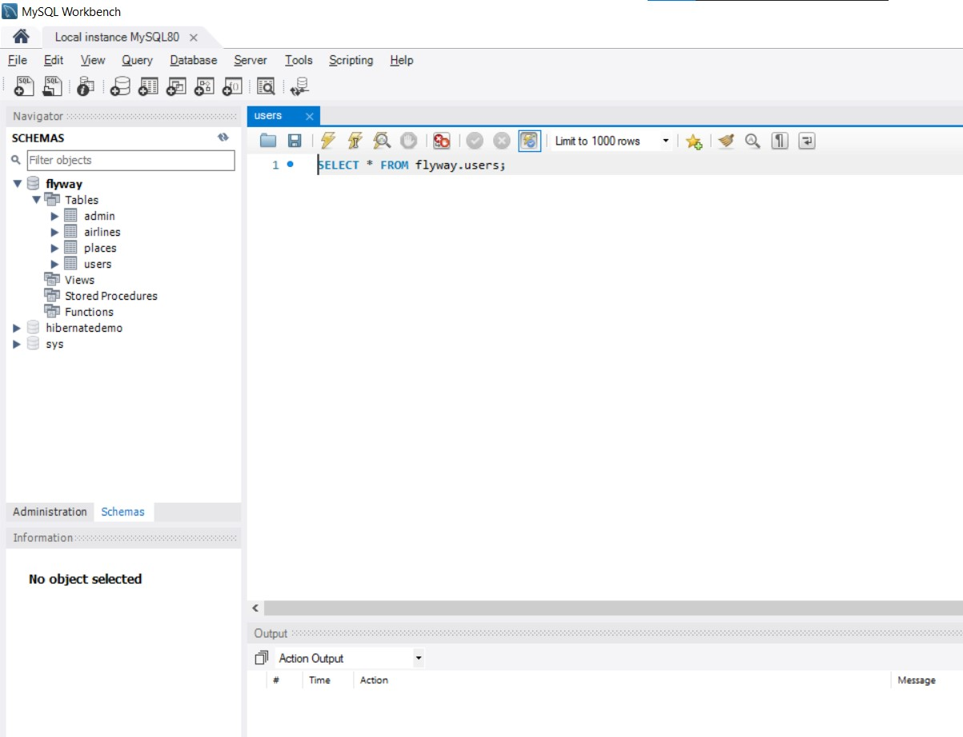

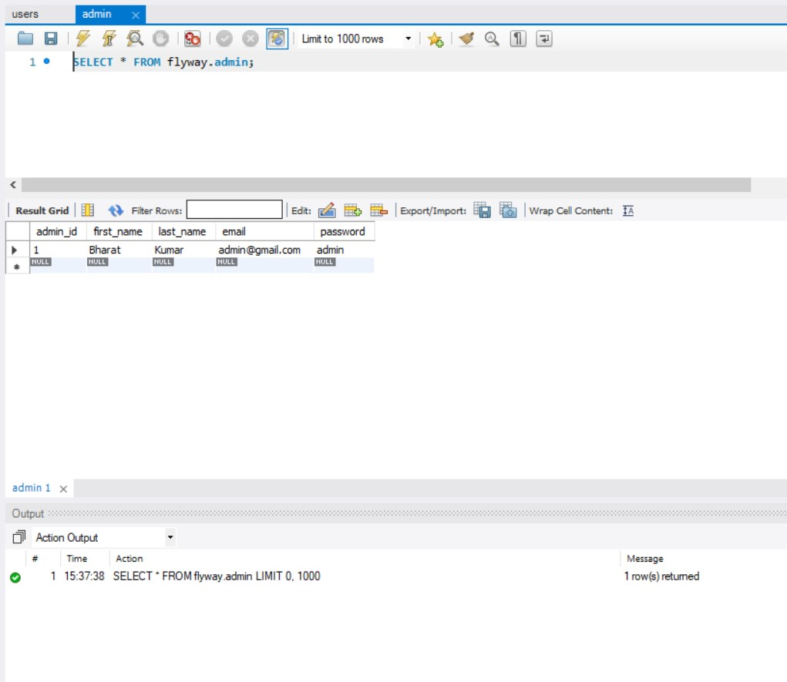

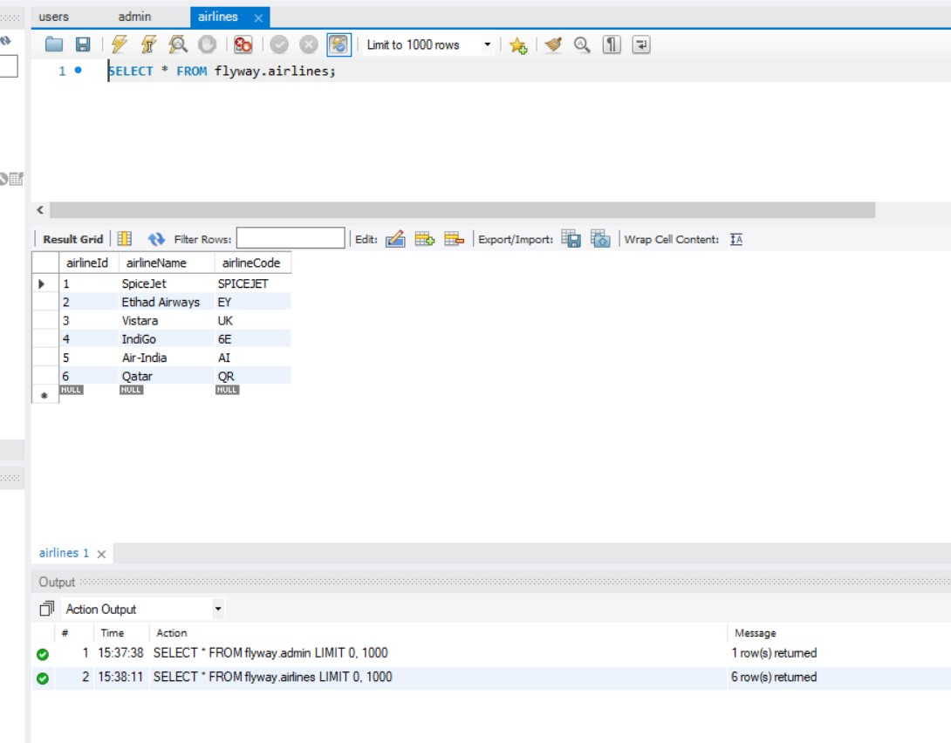

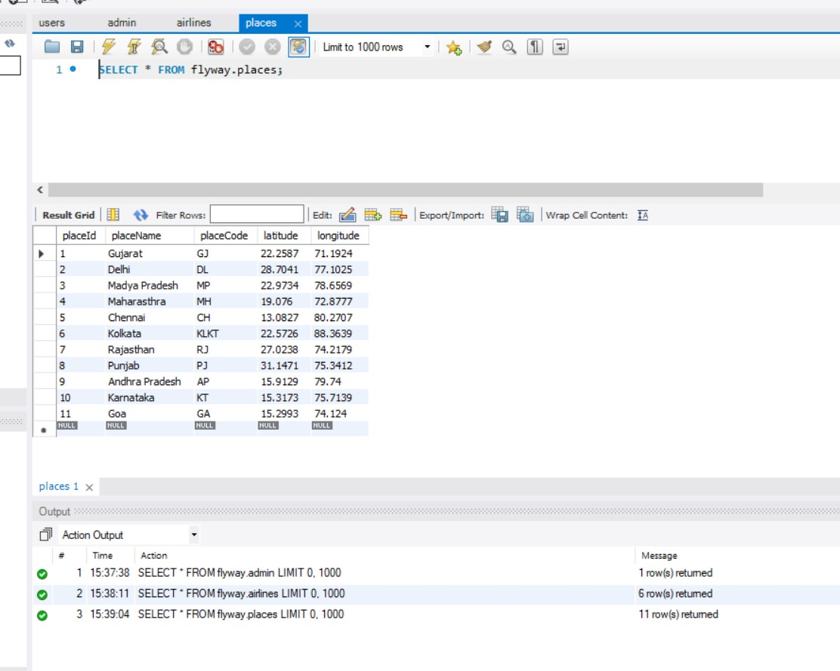

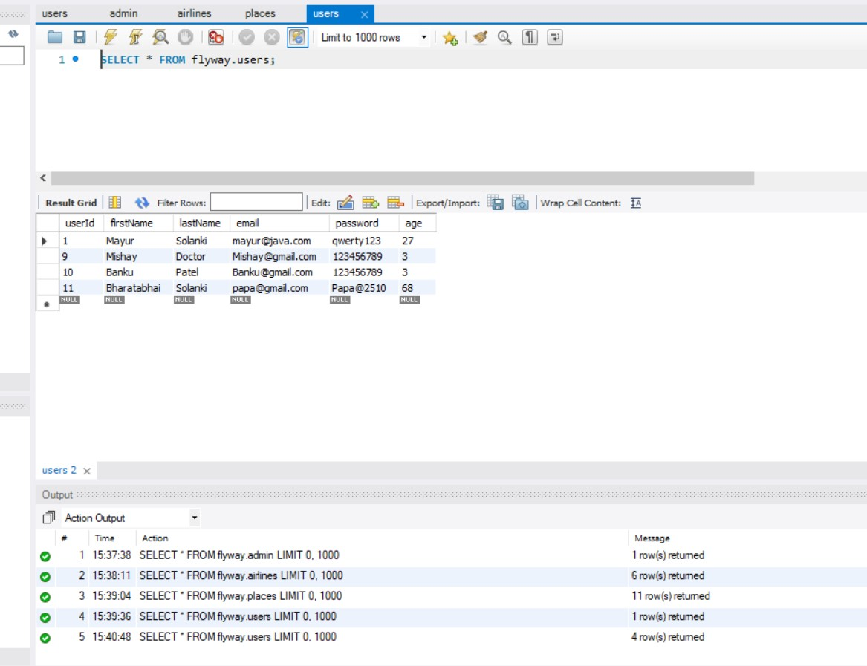

WEBSITE LOOK

