|  |
| --- |
| Sporty Shoes  **Application Screenshots** |

**Version History:**

|  |  |
| --- | --- |
| Author: | Mayur Bharatkumar Solanki |
| Purpose: | Screenshots of the application |
| Date: | 9TH December 2021 |
| Version: | 1.0 |

**Table of Content:**

Shoes Booking: 3

Main Menu Screen Shot: 3

SignUp Page 4

Successful Signup 5

Admin Login Page : 6

Welcome Admin Page 7

Change Password : 8

Add to Cart Page 10

Order place Page 11

# Shoes Booking:

## Main Menu Screen Shot:

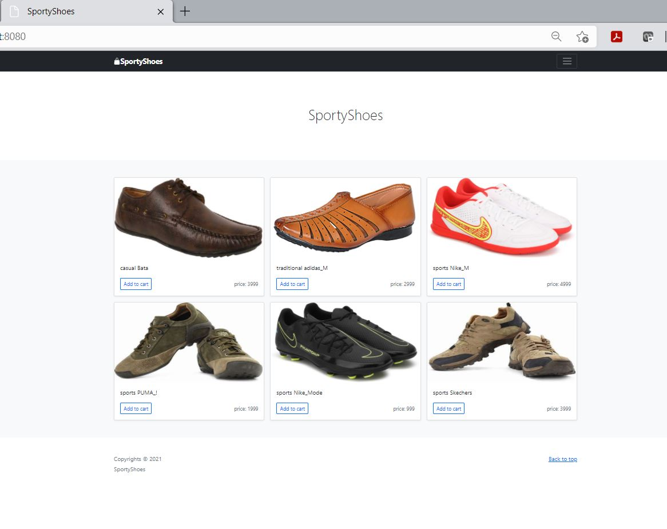

## SignUp Page

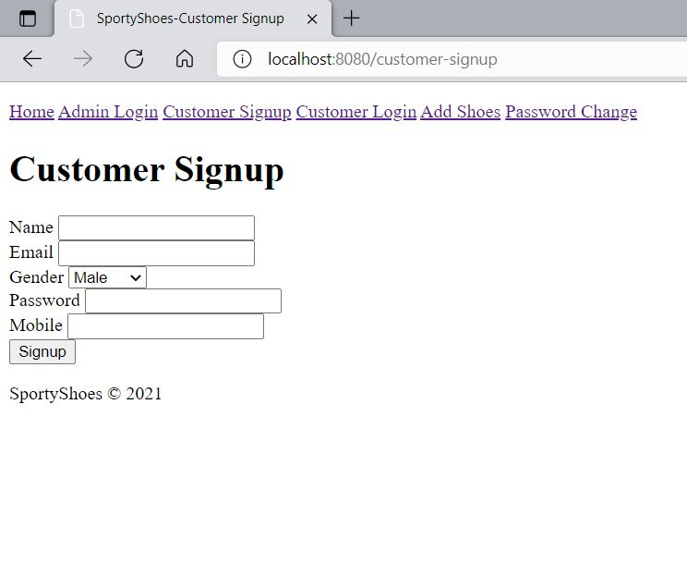

### Successful Signup

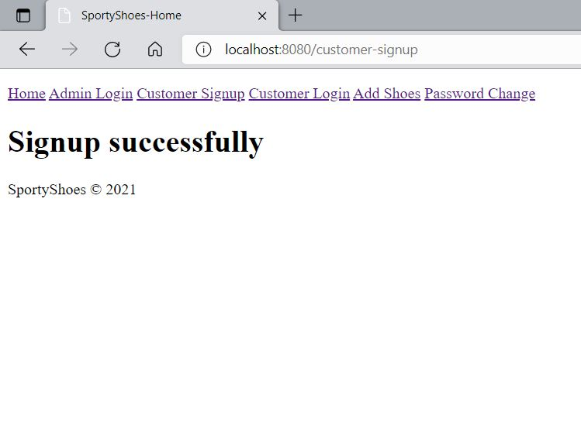

### Admin Login Page :

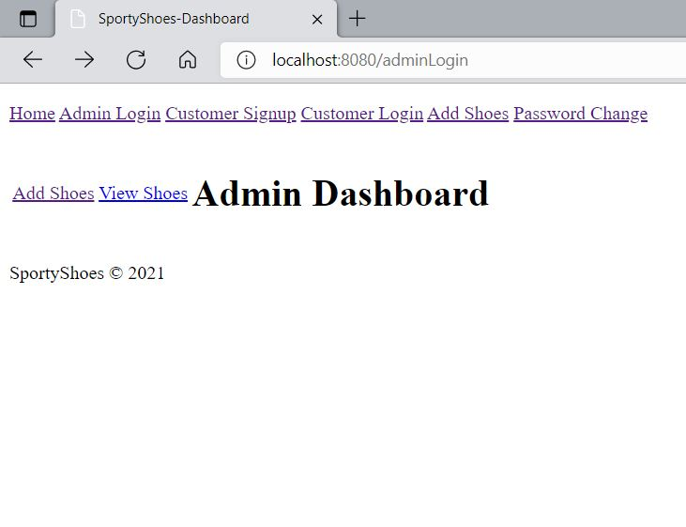

### Welcome Admin Page

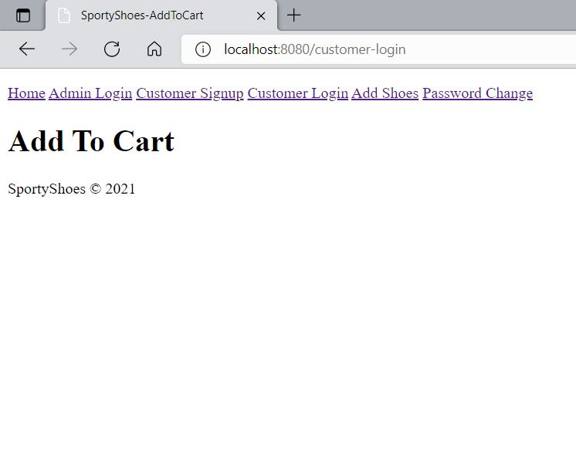

### Change Password :

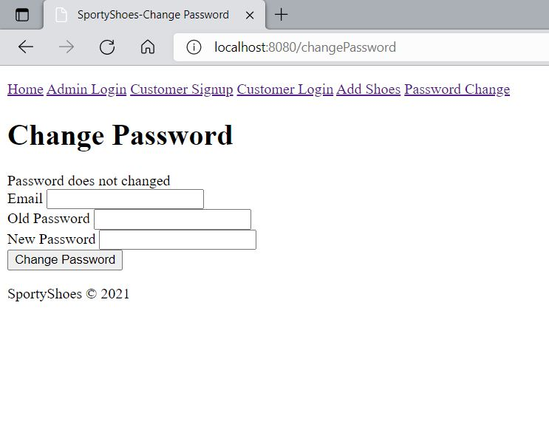

Booking Page

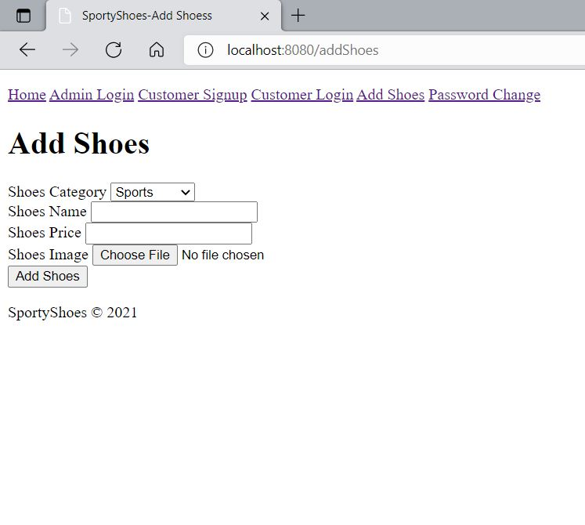

### Add to Cart Page

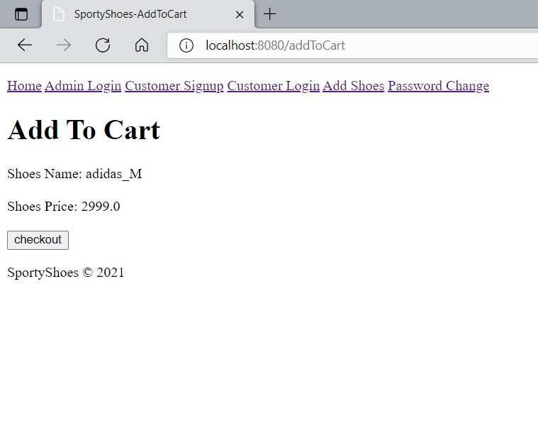

### Order place Page

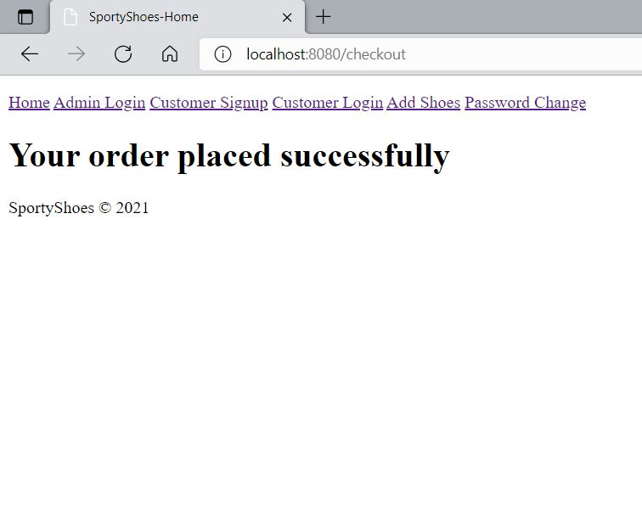

Website Look :

