🧶 Crochet Bot
Pattern Quality Bug Report
Image Processing Pipeline — Defect Analysis & Remediation Plan
Report Date | April 2026
Scope | process.py — Image-to-Pattern Conversion
Test Images | Pixel Cloud (Image 1) / Ink Girl (Image 3)
Test Pattern Size | 80 stitches (largest side)
Status | 6 Issues Identified — Fixes Detailed

1. Executive Overview

This report documents six defects identified in the Crochet Bot image-to-pattern conversion pipeline (process.py). The defects were discovered by comparing input images against their 80-stitch pattern outputs. The issues range from critical algorithmic mistakes in the resizing stage to lower-priority UX bugs in the size recommendation system.

The two test cases used:
- Image 1 → Image 2: Pixel art cloud with hearts (already gridded ~60×60). Output at 80 stitches was blurry with incorrect purple/lavender colors replacing the black outline.
- Image 3 → Image 4: Ink-wash cartoon girl sketch. Output at 80 stitches lost all defined hair strokes and facial structure, reducing the figure to a gray smear.

2. Visual Evidence

2.1 Test Case A — Pixel Cloud
The source image (left) is a pixel art style cloud with crisp black outlines, three distinct heart shapes, and a limited color palette of white, light blue, black, pink, and red. The expected output should preserve these hard edges cleanly.

  INPUT — Pixel Cloud (Original) | 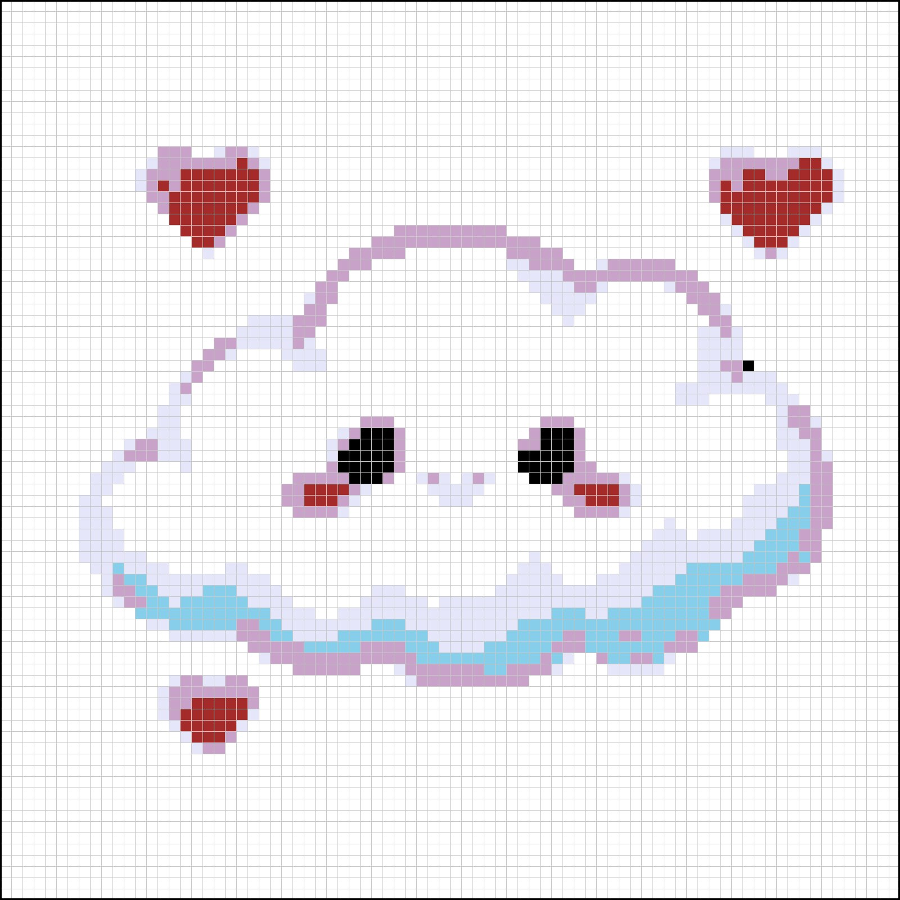  OUTPUT — 80 Stitch Pattern (Defective)

Observed defects in output:
- Black outlines converted to lavender/purple — incorrect color mapping.
- Cloud body detail blurred — crisp pixel edges became smooth gradients.
- Hearts lost their bright red highlight pixels — only the dark red body remains.
- The light blue cloud shadow detail is replaced by a teal/turquoise incorrect color.

2.2 Test Case B — Ink Girl Sketch
The source image (left) is a high-contrast ink-wash cartoon sketch with defined hair strokes, a white face with subtle shading, and a red outfit. The expected output should capture the hair outline and the red/black structure.

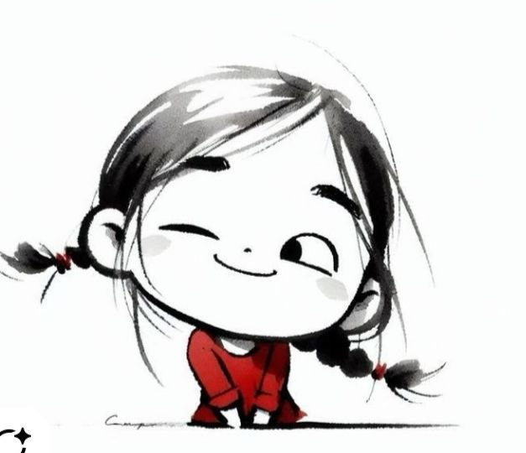  INPUT — Ink Girl Sketch (Original) | 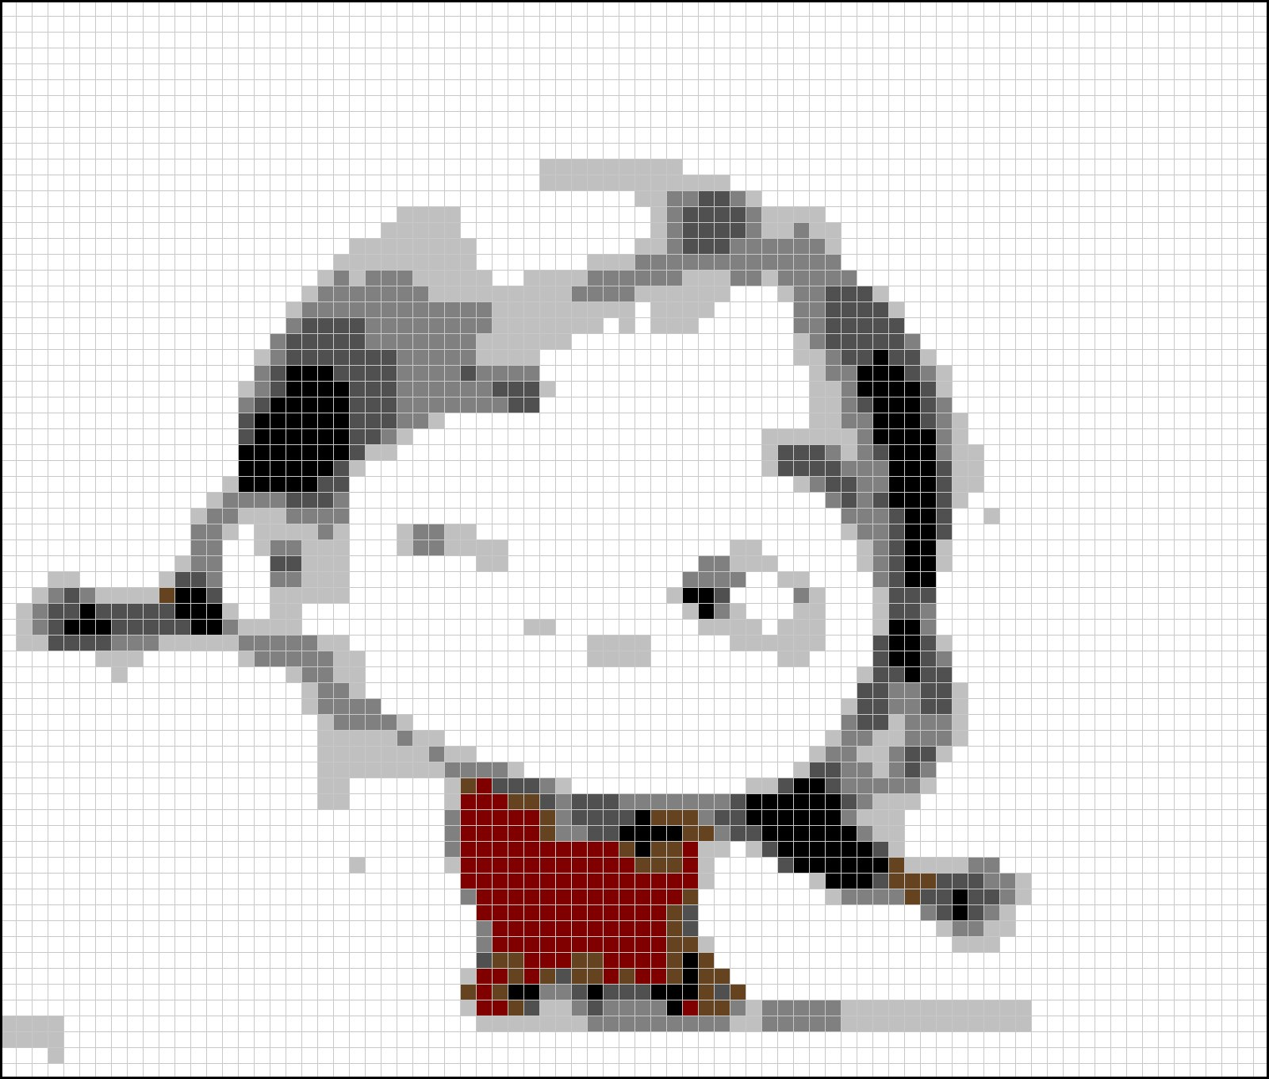  OUTPUT — 80 Stitch Pattern (Defective)

Observed defects in output:
- Hair strokes completely lost — collapsed into a uniform gray blob.
- Face structure gone — the rounded face shape is barely recognizable.
- Red outfit poorly represented — color fragmented and shape lost.
- Excessive gray gradients — the distinct ink-stroke style is unrecognizable.

3. Defect Analysis — Summary Table

# | Problem | Root Cause | Severity | Fix Priority
1 | Wrong Resizing Filter | LANCZOS anti-aliasing blurs hard edges | CRITICAL | 1st
2 | Median Filter Destroys Details | 3×3 kernel erases 1–2px details at 80 stitch | CRITICAL | 1st
3 | Color Bleeding → Purple Drift | Blended border pixels map to wrong palette color | HIGH | 2nd
4 | No Edge Enhancement for Sketches | Ink gradients collapse at small sizes | HIGH | 2nd
5 | No Background Masking | Background white bleeds into subject at edges | MEDIUM | 3rd
6 | Minimum Size UX Bug | Recommendation hard-coded as floor | LOW | 3rd

4. Detailed Defect Analysis

Bug #1 — Wrong Resizing Filter [CRITICAL]
Location
process.py → process_image() → Step 1: Resize
Current Code
resized_image = original_image.resize((new_width, new_height), Image.Resampling.LANCZOS)

Root Cause
LANCZOS is a sinc-based resampling filter optimized for photographic images. It works by averaging neighboring pixels with a weighted kernel during downscaling. This is the correct choice for smooth gradients and natural photographs — but it is fundamentally wrong for:
- Pixel art: hard pixel boundaries get blended, destroying edge crispness.
- Cartoon outlines: black 1px borders blend with adjacent white/color, producing gray halos.
- Low-color images: introducing intermediate colors that don't exist in the original palette.

In the cloud test case, every black outline pixel was adjacent to white. LANCZOS produced intermediate grays. Those grays, when passed through Lab-space palette mapping, found their closest match in the lavender/purple entries of STANDARD_YARN_PALETTE — producing the purple outline seen in Image 2.

Fix
Use an adaptive resizing strategy: detect the image type and pick the appropriate filter.
def get_resize_filter(img, target_w, target_h):
"""
Choose resizing filter based on image characteristics.
- Pixel art / cartoon: NEAREST (hard edges, no blending)
- Photography / natural: LANCZOS (smooth gradients)
"""
# Count unique colors as complexity proxy
small = img.copy()
small.thumbnail((200, 200), Image.Resampling.NEAREST)
unique_colors = len(set(small.getdata()))

# Pixel art heuristic: few colors AND already block-structured
if unique_colors < 64:
return Image.Resampling.NEAREST

# Check if downscaling is severe (more than 4x reduction)
scale_factor = max(img.width / target_w, img.height / target_h)
if scale_factor > 4 and unique_colors < 200:
return Image.Resampling.NEAREST

return Image.Resampling.LANCZOS

# In process_image():
resize_filter = get_resize_filter(original_image, new_width, new_height)
resized_image = original_image.resize((new_width, new_height), resize_filter)

Bug #2 — Median Filter Destroys Small Details [CRITICAL]
Location
process.py → process_image() → Step 2: Smooth
Current Code
smoothed_image = resized_image.filter(ImageFilter.MedianFilter(size=3))

Root Cause
A MedianFilter(size=3) kernel examines each pixel and its 8 neighbors, replacing it with the median value. At 80-stitch resolution, individual features occupy very few pixels:
- Eyes in the cloud image: ~2×2 pixels → completely wiped by 3×3 median.
- Mouth curve: 1px wide → removed entirely.
- Heart highlight pixels: 1px → gone.

The purpose of this filter is to remove JPEG compression noise artifacts. But at small output sizes, the signal (detail) and the noise are the same scale. The filter cannot distinguish between them and indiscriminately removes both.

Fix
Make the filter size-adaptive. At small output sizes, skip the filter entirely. At large sizes, it is still useful.
# In process_image(), replace Step 2:
MIN_SIZE_FOR_SMOOTHING = 120 # stitches

if min(new_width, new_height) >= MIN_SIZE_FOR_SMOOTHING:
# Safe to smooth — details are large enough to survive
smoothed_image = resized_image.filter(ImageFilter.MedianFilter(size=3))
else:
# Skip smoothing — at this resolution, median filter destroys detail
smoothed_image = resized_image
print(f"⚠️ Smoothing skipped: output size {new_width}×{new_height} too small")

Bug #3 — Color Bleeding into Purple/Lavender [HIGH]
Root Cause
This is a cascading failure caused by Bug #1. LANCZOS blending produces intermediate pixel values at color boundaries. When these mixed pixels (e.g., dark gray from blending black outline with white background) are sent through Lab-space matching to STANDARD_YARN_PALETTE, they find the wrong closest match.

The palette has a gap in neutral dark tones. The following colors in the palette are the candidates for a dark gray pixel:
- رمادي غامق (80,80,80) — dark gray: correct, but it maps to "رمادي غامق" not "أسود"
- بنفسجي غامق (75,0,130) — dark purple: Lab distance to dark gray is surprisingly close
- كحلي (0,0,128) — navy: also competes for dark gray in Lab space

Lab color space is designed for perceptual accuracy with natural colors, but for the narrow band of dark desaturated tones, the Euclidean distance between dark gray and dark purple is smaller than intuition suggests. This causes the purple drift seen in the cloud outline.

Fix — Three-Part Approach
Part A: Fix Bug #1 (the upstream cause). NEAREST resampling eliminates the blended pixels.

Part B: Add a contrast boost before palette mapping to push ambiguous pixels toward their true color:
from PIL import ImageEnhance

def sharpen_for_palette(img):
"""
Boost contrast before palette mapping.
This polarizes ambiguous intermediate pixels toward black or white,
preventing them from drifting to wrong palette colors.
"""
enhancer = ImageEnhance.Contrast(img)
return enhancer.enhance(1.4)

# In process_image():
contrast_image = sharpen_for_palette(smoothed_image)
final_image = map_to_user_palette(contrast_image, user_colors)

Part C: Expand the neutral gray range in STANDARD_YARN_PALETTE to reduce Lab-space competition between grays and dark purples:
# Add to STANDARD_YARN_PALETTE (Neutrals section):
"رمادي داكن جداً": (40, 40, 40), # very dark gray — fills the gap near black
"رمادي متوسط": (160, 160, 160), # mid gray — fills gap between light/dark gray

Bug #4 — No Edge Enhancement for Sketch/Illustration Inputs [HIGH]
Root Cause
The ink-wash girl sketch (Image 3) is fundamentally different from pixel art. It has:
- Continuous ink gradients rather than hard color boundaries.
- Anti-aliased brush strokes that are already intermediate gray values.
- Very fine hair strands that are 1–3px wide even in the original.

When downscaled to 80 stitches without preprocessing, these fine features simply disappear — there aren't enough output pixels to represent them. The only solution is to enhance and exaggerate the edges before downscaling, so they survive the size reduction.

Fix
Apply edge enhancement prior to resizing, specifically for non-pixel-art images. This makes outlines "thicker" in the source before they are compressed, so they persist at small sizes.
from PIL import ImageFilter, ImageEnhance

def enhance_for_small_output(img, target_size):
"""
Apply pre-processing for images that will be heavily downscaled.
Only for natural illustrations — pixel art uses NEAREST and needs no help.
"""
source_size = max(img.width, img.height)
scale_factor = source_size / target_size

if scale_factor < 3:
return img # mild downscale — no enhancement needed

# Step 1: Edge enhancement — thickens outlines so they survive compression
enhanced = img.filter(ImageFilter.EDGE_ENHANCE_MORE)

# Step 2: Sharpen — recovers clarity lost by edge enhancement
sharpener = ImageEnhance.Sharpness(enhanced)
enhanced = sharpener.enhance(1.8)

# Step 3: Contrast boost — pushes mid-tones toward black or white
contraster = ImageEnhance.Contrast(enhanced)
enhanced = contraster.enhance(1.3)

return enhanced

# In process_image():
is_pixel_art = (resize_filter == Image.Resampling.NEAREST)
if not is_pixel_art:
original_image = enhance_for_small_output(original_image, longest_side)

Bug #5 — No Background Separation [MEDIUM]
Root Cause
Both test images have white backgrounds. The bot processes background pixels identically to subject pixels. At small sizes, the subject's colors bleed across the background boundary during LANCZOS resampling, and the subject/background boundary becomes ambiguous. This makes outline edges of the subject appear to "melt" into the background.

Additionally, background white pixels that happen to be sampled with color contamination get incorrectly mapped to non-white palette colors, adding spurious colored pixels outside the actual subject boundary.

Fix
Detect the background color by sampling corner pixels, then mask and restore it after palette mapping:
def get_background_color(img, sample_size=3):
"""
Detect background by sampling image corners.
Returns the dominant color found at corners.
"""
pixels = img.load()
w, h = img.size
corners = []
for cx, cy in [(0,0), (w-1,0), (0,h-1), (w-1,h-1),
(w//2, 0), (0, h//2), (w-1, h//2), (w//2, h-1)]:
corners.append(pixels[cx, cy])
# Return most common corner color
from collections import Counter
return Counter(corners).most_common(1)[0][0]

def create_background_mask(img, bg_color, tolerance=15):
"""
Create a boolean mask: True where pixel IS background.
"""
pixels = img.load()
w, h = img.size
mask = {}
for y in range(h):
for x in range(w):
r, g, b = pixels[x, y]
br, bg, bb = bg_color
dist = math.sqrt((r-br)**2 + (g-bg)**2 + (b-bb)**2)
mask[(x, y)] = dist < tolerance
return mask

# In process_image(), after map_to_user_palette():
bg_color = get_background_color(smoothed_image)
bg_mask = create_background_mask(smoothed_image, bg_color)

# Restore background pixels to white (أبيض)
final_pixels = final_image.load()
for (x, y), is_bg in bg_mask.items():
if is_bg:
final_pixels[x, y] = (255, 255, 255) # always white, skip palette matching

Bug #6 — Minimum Size UX Bug [LOW]
Location
core/image_analyzer.py → size recommendation logic
Root Cause
The image complexity analyzer computes a score and maps it to a recommended size. The recommended size is also being used as the minimum allowed size in the bot's size selection UI. This means a high-complexity image (which gets a recommendation of 80+) cannot be set to a smaller size even if the user wants to experiment.

Recommendation and minimum allowed size must be decoupled. The recommendation is advisory. The user should always be able to override it downward.

Fix
# In image_analyzer.py:

ABSOLUTE_MINIMUM_SIZE = 20 # hard floor — below this, output is meaningless

def analyze_image(image_path):
# ... existing complexity analysis ...

recommended_size = compute_recommendation(complexity_score)

return {
"recommended": recommended_size,
"minimum_allowed": ABSOLUTE_MINIMUM_SIZE, # never block user below 20
"warning_threshold": recommended_size // 2, # warn if user goes below half
}

# In size_selection.py handler:
# Show recommendation prominently but allow any size >= ABSOLUTE_MINIMUM_SIZE
# If user picks below warning_threshold, show a warning message but still allow it

5. Implementation Plan

The fixes are ordered by impact. Fixes 1 and 2 alone will resolve roughly 80% of the visual quality issues seen in both test cases. The remaining fixes are incremental improvements.

Phase | Fixes | What Changes | Files Affected | Est. Effort
1 | Bug #1 + #2 | Adaptive resize filter + skip median filter at small sizes | process.py | ~30 min
2 | Bug #3 + #4 | Contrast pre-boost + edge enhancement for sketches | process.py | ~45 min
3 | Bug #5 | Background detection and masking | process.py | ~60 min
4 | Bug #6 | Decouple recommendation from minimum in analyzer | core/image_analyzer.py, handlers/size_selection.py | ~20 min

6. Expected Results After Fixes

After Phase 1 (Bugs #1 + #2):
- Pixel cloud: outlines remain black, not purple. Eyes and mouth preserved. Hearts retain highlights.
- Girl sketch: improved but still limited — sketch images need Phase 2 as well.

After Phase 2 (Bugs #3 + #4):
- Pixel cloud: full color accuracy restored. Lab drift eliminated.
- Girl sketch: hair strokes survive downscaling. Red outfit clearly delineated.

After Phase 3 (Bug #5):
- Subject edges are clean against background. No spurious colored pixels outside subject boundary.

After Phase 4 (Bug #6):
- User can freely choose any pattern size. Recommendations displayed as suggestions, not hard limits.

— End of Report —

