Abstract
As telecommunications networks evolve from 5G toward the ubiquitous intelligence of 6G, the rigid, reactive nature of traditional network management fails to meet the dynamic demands of emerging applications such as holographic communication, extended reality (XR), and autonomous vehicular networks. This thesis addresses the critical challenges of energy efficiency and mobility management in 6G Multi-Access Edge Computing (MEC) environments, where static optimization strategies often lead to suboptimal performance, particularly at the cell edge.
We propose a Polymorphic Intent-Based Networking (IBN) system built on a novel two-tier neuro-symbolic architecture. At the tactical tier, Multi-Agent Reinforcement Learning (MARL) agents—trained via Proximal Policy Optimization (PPO)—make millisecond-scale decisions for computation offloading and handover management. At the strategic tier, a neuro-symbolic orchestrator termed TeleLLM monitors system-wide performance and dynamically reconfigures the tactical agents by selecting high-level Control Modes (BALANCED, SURVIVAL, GREEN). The entire system is orchestrated through a LangGraph-based stateful workflow that implements a System 1/System 2 cognitive pattern: the strategic tier is invoked only when performance drift is detected, minimizing computational overhead while maintaining adaptability.
Unlike conventional approaches that rely on fixed Quality of Service (QoS) parameters, our architecture introduces “polymorphic agents” capable of weighting conflicting objectives—energy consumption, latency, and throughput—in real-time. The system jointly optimizes computation offloading and handover decisions, augmented by multi-tier safety mechanisms including a throughput guardrail, SINR emergency override, handover hysteresis, and a strategic Safety Shield that enforces mode transition constraints.
Extensive simulations demonstrate that the proposed system significantly outperforms standard industry baselines. In high-velocity scenarios at the cell edge, our approach achieves a task success rate of 94% compared to 60% for greedy signal-strength strategies, while reducing edge energy consumption from over 1000 Joules to less than 2 Joules. Furthermore, the system eliminates the “ping-pong” handover effect common in dense deployments. These results validate the efficacy of the two-tier polymorphic IBN architecture as a robust, energy-efficient framework for next-generation 6G networks.

Chapter 1: Introduction

1.1 Background: The Transition from 5G to 6G
The global telecommunications landscape is undergoing a significant paradigm shift as networks evolve from 5G’s enhanced mobile broadband (eMBB) capabilities toward the ubiquitous intelligence envisioned for 6G (Jiang et al., 2021). While 5G successfully introduced higher data rates and lower latency, it primarily optimized for static or predictable user behaviors. However, the next generation of applications—ranging from holographic communication and extended reality (XR) to autonomous vehicular networks—demands a level of adaptability that current rigid network architectures struggle to provide (Saad et al., 2020).
The core challenge lies in the dynamic nature of these emerging applications. Unlike traditional video streaming, which tolerates buffering, future services require deterministic latency and high reliability even under rapid mobility conditions. This necessity has driven the adoption of Multi-Access Edge Computing (MEC), pushing computation closer to the user to minimize propagation delay (Mao et al., 2017). Yet, the deployment of MEC introduces a critical bottleneck: energy efficiency. Edge nodes are often resource-constrained compared to centralized clouds, and the energy cost of continuous high-performance computing at the edge threatens the sustainability of dense 6G deployments.
Furthermore, user mobility exacerbates these issues. As users move between cell towers, the network must not only maintain connectivity but also seamlessly migrate computational tasks. Traditional handover mechanisms, which rely heavily on signal strength (RSRP), often fail to account for the computational load or the specific intent of the user’s application, leading to suboptimal performance and “ping-pong” handovers that waste energy and degrade the user experience (Arshad et al., 2016).
Beyond the challenges of individual decision-making, 6G networks demand hierarchical intelligence operating at multiple timescales. Tactical decisions (e.g., “should I offload this task?”) must occur in milliseconds, while strategic decisions (e.g., “should the network prioritize energy savings over latency?”) operate on the scale of seconds or minutes. Traditional flat architectures cannot efficiently manage both timescales simultaneously, motivating the need for a two-tier cognitive architecture.

1.2 Problem Statement
The fundamental problem addressed by this thesis is the misalignment between static network configurations and dynamic user requirements in 6G MEC environments. Current network management strategies are largely reactive and rigid. They optimize for average performance metrics rather than specific user intents. For instance, a high-speed vehicle running a safety-critical application has fundamentally different network needs than a pedestrian streaming a 4K video, yet traditional networks treat their connection requests with similar protocols.
Specifically, four key issues persist: 1. Energy Inefficiency at the Edge: Without intelligent offloading, MEC servers become overwhelmed, leading to excessive energy consumption and potential service outages. 2. Mobility Management Failures: Handover decisions based solely on signal strength ignore the computational context, resulting in service interruptions during task migration. 3. Lack of Intent Awareness: The network lacks a mechanism to interpret and prioritize the specific “intent” (e.g., maximize battery life vs. minimize latency) of diverse user equipment (UE). 4. Absence of Hierarchical Reasoning: Current systems lack a separation between fast tactical decisions and slow strategic oversight, leading to either overly reactive or overly rigid behavior.
This thesis posits that a “one-size-fits-all” approach is insufficient for 6G. Instead, a polymorphic, intent-based networking (IBN) system is required—one that can dynamically alter its optimization objectives in real-time to match the instantaneous needs of the user and the network conditions (Clemm et al., 2020), governed by a hierarchical neuro-symbolic control architecture.

1.3 Research Question
Can a Multi-Agent Reinforcement Learning (MARL) framework, integrated with Intent-Based Networking (IBN) principles and governed by a hierarchical neuro-symbolic orchestrator, outperform static baseline algorithms in optimizing energy efficiency and mobility management for 6G MEC networks?

1.4 Objectives
To address the research question, this thesis pursues the following objectives: 1. Develop a Polymorphic Intent-Based Architecture: Design a system capable of interpreting high-level user intents (e.g., “save energy,” “guarantee low latency”) and translating them into network policies via O-RAN-compliant intent mappings. 2. Implement Cooperative MARL Agents: Create a multi-agent system where independent agents control MEC offloading and mobility management, coordinated by a rule-based Supervisor Agent that prevents destructive interference. 3. Design a Two-Tier Neuro-Symbolic Control System (TeleLLM): Implement a strategic orchestrator that uses symbolic state estimation and LLM-based reasoning to dynamically reconfigure tactical agents, governed by safety constraints. 4. Validate via Simulation: Construct a comprehensive 6G simulation environment to benchmark the proposed system against traditional greedy and static baselines, focusing on energy consumption, handover efficiency, and task success rates.

1.5 Thesis Organization
The remainder of this thesis is organized as follows: - Chapter 2 provides a comprehensive review of the literature on MEC offloading, mobility management, the application of machine learning in networking, and neuro-symbolic AI approaches. - Chapter 3 details the proposed two-tier polymorphic intent-based architecture, the TeleLLM orchestrator, and the specific MARL algorithms employed. - Chapter 4 describes the simulation environment, including the network topology, channel models, agent implementation details, and the LangGraph-based software architecture. - Chapter 5 presents the evaluation results, analyzing the system’s performance under various traffic loads and mobility scenarios. - Chapter 6 concludes the thesis and outlines potential directions for future research.

Chapter 2: Literature Review

2.1 Mobile Edge Computing (MEC) Offloading
Mobile Edge Computing (MEC) has emerged as a key enabler for 5G and 6G networks, bringing computational resources closer to the end-user to reduce latency and alleviate the burden on the core network. The fundamental challenge in MEC is the “offloading decision”: determining whether a mobile device should process a task locally or offload it to an edge server.

Energy Efficiency vs. Latency Optimization
Early research primarily treated energy consumption and latency as separate, often conflicting objectives. - Local Execution: Optimizes for zero transmission delay but places heavy energy strain on the battery-constrained mobile device. - Offloading: Reduces local energy consumption but introduces transmission latency and dependency on channel quality.
Recent literature has shifted towards Joint Optimization, formulating the problem as a weighted sum minimization: $C=w_{t}T+w_{e}E$, where $T$ is total delay and $E$ is energy consumption. However, determining the optimal weights $w_{t},w_{e}$ remains a static configuration in most works, failing to adapt to real-time user intent (e.g., a sudden need for ultra-low latency in a VR application).

Dynamic Environments: Lyapunov vs. DRL
Handling the stochastic nature of wireless channels and task arrivals requires robust optimization techniques. - Lyapunov Optimization: A control-theoretic approach that stabilizes queues (energy and data) without requiring future knowledge. Bi et al. (2021) demonstrated that while Lyapunov optimization guarantees stability, it often suffers from slow convergence in rapidly changing topologies. Their work on “Stable Online Computation Offloading” suggests a hybrid approach, using Lyapunov drift to guide DRL agents—a concept central to our “Guardrail” mechanism. - Deep Reinforcement Learning (DRL): Approaches like DDPG and PPO have gained traction for their ability to learn policies in high-dimensional state spaces. Unlike pure Lyapunov methods, DRL can anticipate future rewards, making it superior for maximizing long-term utility in highly dynamic vehicular networks.

2.2 Mobility Management and Handover
In dense small-cell networks (HetNets), frequent handovers are a major source of signaling overhead and service interruption, exacerbated by the short range of mmWave and THz frequencies in 6G.
- Traditional Handover (HO): Typically based on Reference Signal Received Power (RSRP) with a hysteresis margin (A3 event). This ensures radio link quality but ignores the service quality.
- The “Ping-Pong” Effect: Users at the cell edge may rapidly switch between base stations due to signal fluctuations, leading to packet loss and increased latency.

2.2.1 Computation-Aware Handover
A critical gap in traditional mobility management is the decoupling of radio connectivity from computational availability. A “Computation-Aware Handover” decision considers not just the RSRP, but also the available CPU/GPU cycles at the target MEC server. Research indicates that connecting to a base station with strong signal but 100% CPU load results in higher end-to-end latency than a slightly weaker signal station with idle resources. This necessitates a cross-layer handover metric (Chen et al., 2025).

2.2.2 Service Migration Costs
In MEC, a handover often requires Service Migration—transferring the active container or VM state from the source to the target edge server. - Cold Migration: Stop, copy, restart. High downtime. - Live Migration: Copy dirty pages while running. Higher bandwidth usage but lower downtime.
Recent studies have focused on minimizing migration overhead. Karobi et al. (2024) proposed “EcoEdgeTwin,” utilizing Digital Twins to predict mobility patterns and pre-fetch service states, significantly reducing downtime. Similarly, Chen et al. (2025) addressed high-mobility IoV environments, demonstrating that seamless migration strategies are crucial when vehicular velocity exceeds 60 km/h. These findings underscore that the cost of migration (latency + bandwidth) must be factored into the handover decision; otherwise, a “stay local” policy might be optimal despite poor local performance.

2.3 Intent-Based Networking (IBN)
Intent-Based Networking (IBN) represents a paradigm shift from imperative network configuration (“configure interface X with IP Y”) to declarative intent (“ensure video traffic has < 10ms latency”). This shift is critical for 6G, where the complexity of managing heterogeneous resources (compute, storage, radio) exceeds human capacity.

2.3.1 The IBN Lifecycle
According to standard definitions (e.g., IETF RFC 9315, ETSI ENI), IBN operates in a closed loop consisting of: 1. Translation: Converting high-level business or application intent into actionable network policies. This involves natural language processing (NLP) or formal logic to interpret user goals. 2. Activation: Orchestrating the network infrastructure to implement the translated policies. In 6G, this extends beyond routing to include slice instantiation and edge resource allocation. 3. Assurance: Continuously monitoring network state to verify that the intent is being met. If a deviation is detected (e.g., latency spikes), the system must self-correct.

2.3.2 IBN vs. Policy-Based Networking (PBN)
While PBN relies on static “If-Condition-Then-Action” rules, IBN focuses on the “What” rather than the “How.” PBN struggles with dynamic environments where conditions change rapidly (e.g., vehicular networks), often leading to conflict or suboptimal states. IBN, by contrast, maintains the desired state (intent) regardless of underlying topology changes, making it inherently more robust for mobility management.

2.3.3 Intent in 6G Edge Intelligence
In the context of 6G, IBN is evolving to support “Compute-Aware Intents.” An intent might specify “Maximize battery life for IoT devices while maintaining 95% inference accuracy.” Current research often limits IBN to the management plane (orchestration). However, Jiang et al. (2026) recently proposed “Agentic AI Empowered Intent-Based Networking,” arguing for autonomous agents that can interpret and execute intents in real-time at the network edge. This aligns with our proposed “Polymorphic” system, which extends IBN from static orchestration to dynamic, real-time control of MEC offloading decisions—an area identified as a key open challenge.

2.4 Multi-Agent Reinforcement Learning (MARL) in MEC
As networks densify, single-agent RL becomes insufficient due to the non-stationarity of the environment: from the perspective of one agent (e.g., a user equipment or edge server), the environment changes as other agents learn and update their policies. Multi-Agent Reinforcement Learning (MARL) addresses this by modeling the interaction between multiple intelligent entities.

2.4.1 Challenges in Decentralized MEC
- Scalability: The joint action space grows exponentially with the number of agents.
- Partial Observability: Agents often only have local views (e.g., local channel quality, local battery status) and cannot see the global network state.
- Credit Assignment: Determining which agent’s action contributed to a global reward (e.g., overall network throughput) is difficult.

2.4.2 Centralized Training, Decentralized Execution (CTDE)
To mitigate non-stationarity while allowing for scalable execution, the CTDE paradigm has become the standard in cooperative MARL. - During Training: A centralized critic has access to the global state and actions of all agents, stabilizing the learning process. - During Execution: Each agent (actor) relies solely on its local observations, ensuring the system is scalable and robust to communication failures.

2.4.3 Key Algorithms for 6G Networks
Several MARL algorithms are particularly relevant to MEC and mobility management: 1. MADDPG (Multi-Agent Deep Deterministic Policy Gradient): An extension of DDPG for continuous action spaces (e.g., continuous power control or offloading ratios). It uses a centralized critic to learn a Q-function for each agent based on global information. 2. MAPPO (Multi-Agent Proximal Policy Optimization): An on-policy algorithm that has shown strong performance in cooperative tasks. It is generally more sample-efficient and stable than off-policy methods like MADDPG in certain environments. 3. QMIX: A value-based method for discrete action spaces (e.g., select channel 1 vs. channel 2). It assumes a monotonic relationship between global Q-values and individual agent utilities, facilitating cooperative behavior without explicit communication.
This thesis employs a hybrid MARL approach, utilizing CTDE to coordinate the handover decisions (discrete) and offloading rates (continuous), ensuring that local selfish optimizations do not degrade global network performance.

2.5 Neuro-Symbolic AI and LLM-Based Network Orchestration
A significant gap in existing literature is the absence of hierarchical cognitive architectures for network control. Most RL-based approaches operate at a single timescale, treating every decision with equal computational effort. This section reviews emerging paradigms that address this limitation.

2.5.1 Neuro-Symbolic AI
Neuro-symbolic AI combines the pattern recognition capabilities of neural networks with the interpretability and logical rigor of symbolic reasoning. In networking, this translates to using neural agents for fast, reactive decisions while employing symbolic systems for high-level reasoning, constraint enforcement, and explainability (Garcez et al., 2019). The key advantage is that symbolic components can encode domain knowledge (e.g., “never allow SINR below -5 dB”) as hard constraints, while neural components learn optimal behavior within those constraints. This hybrid approach is particularly suited to safety-critical telecommunications systems where pure black-box learning is unacceptable.

2.5.2 LLMs as Network Controllers
Large Language Models (LLMs) have recently been proposed as cognitive controllers for network management. Their ability to reason over complex, multi-dimensional state spaces and produce structured decisions makes them suitable for strategic network orchestration. The key advantage is their capacity for Chain-of-Thought reasoning—decomposing complex optimization problems into sequential logical steps (Wei et al., 2022). In a networking context, an LLM can interpret a symbolic state description (e.g., “Traffic: CONGESTED, Battery: CRITICAL, Mobility: HIGH_VELOCITY”) and produce a reasoned decision (e.g., “Switch to SURVIVAL mode because reliability is at risk”) with an accompanying explanation. This explainability is critical for deployment in regulated telecommunications environments where operators require audit trails for autonomous decisions.

2.5.3 Hierarchical Reinforcement Learning
Two-timescale decision-making separates fast tactical actions from slow strategic oversight. This mirrors Kahneman’s System 1/System 2 cognitive framework (Kahneman, 2011): System 1 handles fast, automatic responses (tactical RL agents), while System 2 engages deliberate, analytical reasoning only when anomalies are detected (strategic LLM orchestrator). This pattern reduces computational overhead while maintaining adaptability—a critical requirement for resource-constrained edge deployments where running an LLM for every millisecond decision would be prohibitively expensive.

2.5.4 Graph-Based AI Workflows
LangGraph (LangGraph Team, 2024) provides a framework for building stateful, graph-based AI applications. By modeling the control loop as a directed graph with conditional edges, complex decision workflows can be orchestrated with built-in state management, enabling event-driven triggering of expensive reasoning steps only when needed. This graph-based approach naturally maps to the cyclical nature of network control loops, where simulation, monitoring, and intervention form a continuous feedback cycle.

Chapter 3: Technical Methodology

3.1 System Model
This section formulates the system model for the proposed polymorphic intent-based networking (IBN) system, covering the network topology, communication channels, computation models, and user mobility. The system is designed to support 6G scenarios where User Equipment (UE) requires seamless mobility and efficient Multi-Access Edge Computing (MEC) offloading.

3.1.1 Network Architecture
We consider a 6G network coverage area composed of $N$ Base Stations (BSs), denoted as $B=\{1,2,...,N\}$. Each BS is equipped with an MEC server capable of processing computational tasks offloaded by mobile users. The coverage area is modeled as a two-dimensional plane where BSs are distributed to provide radio access.
A mobile user (UE) moves within this area, continuously connecting to a serving BS, denoted as $b\left(t\right)∈B$. The UE is characterized by its position $p\left(t\right)=\left(x\left(t\right),y\left(t\right)\right)$, velocity $v\left(t\right)$, and a local computation capability.

3.1.2 Communication Model
The communication link between the UE and the serving BS is modeled using standard propagation characteristics, including path loss and interference.
Path Loss and SNR: The path loss $L\left(d\right)$ between the UE and BS $i$ at distance $d_{i}$ is given by the log-distance path loss model:
$$PL\left(d_{i}\right)=PL_{0}+10⋅n⋅\log_{10}\left(\frac{d_{i}}{d_{0}}\right)+X_{σ}$$
where $PL_{0}$ is the reference path loss at distance $d_{0}$, $n$ is the path loss exponent reflecting the environment (e.g., urban or suburban), and $X_{σ}$ represents shadowing effects.
The Received Signal Reference Power (RSRP) from BS $i$ is calculated as:
$$P_{rx,i}\left(t\right)=P_{tx}−PL\left(d_{i}\left(t\right)\right)$$
where $P_{tx}$ is the transmission power of the BS.
SINR and Throughput: The Signal-to-Interference-plus-Noise Ratio (SINR) for the link with BS $i$ is defined as:
SINRit=Prx,itj∈B,j≠i​Prx,jt+N0
where $N_{0}$ is the thermal noise power.
The achievable data transmission rate (throughput) $R_{i}\left(t\right)$ is typically derived using the Shannon-Hartley theorem:
$$R_{i}\left(t\right)=B⋅\log_{2}\left(1+{\text{SINR}}_{i}\left(t\right)\right)$$
where $B$ is the channel bandwidth allocated to the user.

3.1.3 Computation and Energy Model
The system supports three execution modes for computational tasks: Local Execution, Edge Offloading, and Cloud Offloading.
Task Model: Tasks are generated according to a Poisson process with arrival rate $λ$. Each task $k$ is defined by a tuple $\{D_{k},C_{k},T_{k}^{max}\}$, where: - $D_{k}$: Input data size (bits). - $C_{k}$: Computational workload (CPU cycles). - $T_{k}^{max}$: Maximum tolerable latency (deadline).
Local Execution: If the task is processed locally on the UE, the execution time $T_{loc}$ and energy consumption $E_{loc}$ are:
$$T_{loc}=\frac{C_{k}}{f_{UE}}, E_{loc}=κ⋅{\left(f_{UE}\right)}^{2}⋅C_{k}$$
where $f_{UE}$ is the UE’s CPU frequency and $κ$ is the effective switched capacitance coefficient, reflecting the dynamic voltage and frequency scaling (DVFS) characteristics of modern mobile chipsets (Mao et al., 2017).
MEC Offloading: When offloading to an edge server $j$, the total delay includes transmission time and processing time:
$$T_{off}=T_{tx}+T_{proc}=\frac{D_{k}}{R_{j}\left(t\right)}+\frac{C_{k}}{f_{MEC}}$$
The energy cost for the UE is primarily due to transmission:
$$E_{off}=P_{tx,UE}⋅\frac{D_{k}}{R_{j}\left(t\right)}$$
where $P_{tx,UE}$ is the UE transmission power.
Cloud Offloading: When offloading to a remote cloud backend, the delay includes additional backhaul latency:
$$T_{cloud}=\frac{D_{k}}{R_{j}\left(t\right)}+T_{backhaul}+\frac{C_{k}}{f_{Cloud}}$$
where $T_{backhaul}$ represents the fixed latency penalty for traversing the core network, and $f_{Cloud}≫f_{MEC}$ reflects the superior computational capacity of centralized cloud infrastructure. Cloud offloading is advantageous for heavy computational tasks when edge resources are congested, at the cost of higher end-to-end latency.

3.1.4 Mobility Model
To simulate realistic user behavior, the UE follows a Gauss-Markov mobility model to avoid the sudden, unrealistic stops and sharp turns characteristic of the Random Waypoint model. The position update at discrete time steps of duration $Δt$ is governed by:
$$x\left(t+Δt\right)=x\left(t\right)+v\left(t\right)cos\left(θ\left(t\right)\right)⋅Δt$$
$$y\left(t+Δt\right)=y\left(t\right)+v\left(t\right)sin\left(θ\left(t\right)\right)⋅Δt$$
where $v\left(t\right)$ is the speed and $θ\left(t\right)$ is the heading direction. The Gauss-Markov model ensures that velocity and direction change smoothly, posing a realistic challenge for the Handover Agent. The system must handle handovers (HO) as the UE crosses cell boundaries to maintain connectivity and Quality of Service (QoS).

3.1.5 Service Profiles (Polymorphic Intent)
The system is designed to adapt to varying application requirements, encapsulated as “Intent.” We define three primary service profiles that dictate the weighting factors $\left(α,β,γ\right)$ used in the reward functions of the RL agents: 1. VR (eMBB): High bandwidth, strict latency (e.g., 60ms budget), high data size. Prioritizes throughput and delay minimization. 2. EV (URLLC): Critical reliability, ultra-low latency (e.g., 10ms budget), moderate data. Prioritizes reliability above all else. 3. IoT (mMTC): Delay-tolerant, energy-sensitive, small data packets. Prioritizes energy conservation for battery longevity.

3.2 The Two-Tier Polymorphic Architecture
The proposed system introduces a two-tier neuro-symbolic architecture that separates fast tactical decisions from slow strategic oversight, mirroring the System 1/System 2 cognitive framework described in Section 2.5.3.

3.2.1 Architectural Overview
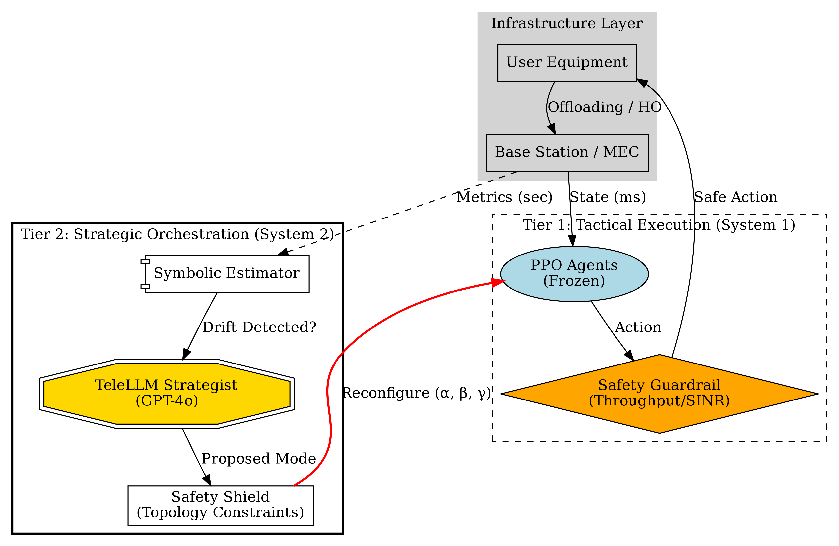
Figure 3.1: Two-Tier Neuro-Symbolic Architecture
The architecture consists of three layers with two AI control tiers:
- Intent Layer (The “Polymorphic” Engine): Translates high-level intents into specific weighting parameters $\left(α,β,γ\right)$ via an O-RAN-compliant intent mapping. This “polymorphism” allows the same underlying RL agents to shift their behavior—becoming aggressive for VR or conservative for IoT—without retraining.
- Control Layer (Two-Tier AI):
  - Tier 1 — Tactical Execution (Millisecond Scale): PPO-based MARL agents making real-time offloading and handover decisions. These agents operate in frozen inference mode during deployment, with their behavior dynamically reconfigured by Tier 2.
  - Tier 2 — Strategic Orchestration (Second/Minute Scale): The TeleLLM orchestrator, a neuro-symbolic pipeline that monitors aggregate system metrics, reasons about the optimal operational mode, and reconfigures the tactical agents’ parameters.
- Infrastructure Layer (Environment): The physical BSs, MEC servers, and mobile UE. It executes the actions chosen by the agents and provides feedback (state updates and rewards) to the Control Layer.

3.2.2 Cooperative Mechanism
A key innovation in this architecture is the cooperation between the Offloading and Handover agents. In traditional systems, these functions are decoupled: a handover might occur during a heavy computation offload, leading to service interruption. In our P-IBN architecture, the agents share state information. The Handover agent is penalized if it triggers a handover that causes an offloading failure, effectively learning to delay handovers until critical computations are complete or to select targets with sufficient computational resources.

3.2.3 LangGraph Workflow
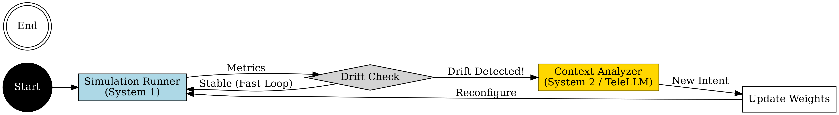
Figure 3.2: System 1 / System 2 Workflow
The entire system is orchestrated as a LangGraph StateGraph—a compiled, stateful directed graph with conditional edges. The graph consists of two primary nodes:
- simulation_runner: Executes a batch of simulation steps using the tactical agents, collects aggregate metrics, and performs drift detection.
- context_analyzer: Analyzes the collected metrics and issues high-level intent adjustments.
System State: The workflow maintains a typed state dictionary:
SystemState = {
epoch: int,
max_epochs: int,
context_weights: {α, β, γ, handover_margin_db, time_to_trigger_s, ho_hints, mec_hints},
logs: Dict,
history: List[Dict],
is_done: bool
}
System 1/System 2 Cognitive Pattern: The conditional edge from simulation_runner implements an event-driven routing logic that embodies the dual-process cognitive model:
- System 1 (Autopilot): If the simulation metrics are within acceptable bounds, the graph loops directly back to simulation_runner, bypassing the expensive context_analyzer. This represents fast, automatic processing.
- System 2 (Deliberation): If drift is detected, the graph routes to context_analyzer for strategic reasoning. Drift triggers include:
  - Deadline success rate $<80\%$ (reliability crisis)
  - Handover count $>150$ per epoch (instability)
  - Deadline rate $>98\%$ AND energy $>25$J (optimization opportunity)
This architecture ensures that expensive LLM-based reasoning is invoked only when necessary, dramatically reducing computational overhead while maintaining system adaptability.

3.2.4 TeleLLM Orchestrator (Tier 2)
The TeleLLM orchestrator implements a four-stage neuro-symbolic pipeline:
Stage 1 — Symbolic Estimator: Converts continuous, noisy KPIs into discrete symbolic states suitable for logical reasoning:
Dimension | States | Thresholds
Traffic | LOW, NORMAL, CONGESTED, URLLC_SURGE | Load < 0.2, > 0.8, arrival > 50/s
Reliability | SAFE, WARNING, DANGER | Latency > 50ms, RLF > 5%, RSRP < -110 dBm
Energy | NORMAL, LOW, CRITICAL | Battery < 50%, < 20%
Mobility | STATIC, MODERATE, HIGH_VELOCITY | Speed > 10 km/h, > 60 km/h
Stage 2 — Strategist Node: The cognitive core that determines the optimal Control Mode. It supports two execution paths: * LLM Path: When an OpenAI API key is available, the Strategist constructs a structured prompt using LangChain’s ChatPromptTemplate and invokes GPT-4o. The LLM receives the symbolic state and returns a JSON response containing reasoning and a proposed Control Mode. * Rule-Based Fallback: A deterministic expert system that applies priority-ordered rules: Reliability DANGER → SURVIVAL; Energy CRITICAL → GREEN; Traffic URLLC_SURGE → SURVIVAL; default → BALANCED.
Stage 3 — Safety Shield: Enforces rigorous constraints on mode transitions: * Transition Topology (DAG): Only permitted transitions are allowed: BALANCED ↔ SURVIVAL, BALANCED ↔ GREEN. Direct GREEN → SURVIVAL transitions are blocked (must pass through BALANCED first). * Dwell Time Hysteresis: A minimum of 3 epochs must elapse between mode switches, preventing oscillation.
Stage 4 — Configurator: Applies the verified Control Mode to the Tactical Executor, updating the handover margin and time-to-trigger parameters.

3.2.5 Control Modes
Mode | Handover Margin | Time-to-Trigger | Philosophy
BALANCED | 3 dB | 0.16s | Standard tradeoff between quality and stability
SURVIVAL | 0 dB | 0.0s | Paranoid switching; maximize reliability at all costs
GREEN | 12 dB | 1.0s | Lazy switching; minimize handovers to save energy

3.2.6 O-RAN Intent Mapping
Intent definitions are mapped to concrete weight configurations following O-RAN Alliance specifications:
Intent | $α$ (Latency) | $β$ (Energy) | $γ$ (Reliability) | HOM (dB) | TTT (s)
MAXIMIZE_THROUGHPUT | 0.8 | 0.1 | 0.1 | 1.0 | 0.04
MINIMIZE_ENERGY | 0.1 | 0.8 | 0.1 | 3.0 | 0.16
GUARANTEE_RELIABILITY | 0.2 | 0.2 | 0.6 | 2.0 | 0.08
STABILIZE_CONNECTION | 0.33 | 0.33 | 0.34 | 6.0 | 0.32

3.2.7 Information Flow
The closed-loop control cycle operates as follows: 1. State Observation: The simulation captures global state $S_{t}$. 2. Intent Translation: The active service profile sets objective weights. 3. Tactical Action Selection: The HO and MEC agents select actions based on local observations. 4. Tier 1 Safety Check: The throughput guardrail and SINR override are applied. 5. Execution: Actions are executed in the simulation environment. 6. Drift Detection: The simulation runner evaluates aggregate metrics against thresholds. 7. Conditional Strategic Reasoning: If drift is detected, the TeleLLM pipeline (Estimator → Strategist → Shield → Configurator) reconfigures the tactical agents. 8. Feedback: Updated weights and parameters propagate to the next simulation batch.

3.3 Multi-Agent Design
The core decision-making engine of the proposed Polymorphic Intent-Based Networking (P-IBN) system is a Multi-Agent Reinforcement Learning (MARL) framework. Unlike traditional heuristic approaches that rely on static thresholds for offloading and handover, our design employs agents that learn optimal policies through interaction with the dynamic 6G environment. This section details the mathematical formulation of the Markov Decision Process (MDP), defining the state space, action space, and the novel polymorphic reward function.

3.3.1 Agent Hierarchy
The system employs four specialized agents organized in a hierarchy:
- Context Agent (Rule-Based Coordinator): Analyzes global simulation state and detects critical conditions. It evaluates three flags—low_battery (< 200J), high_mobility (> 15 m/s), and congestion (SINR < 5 dB)—and outputs preference weights with priority ordering: Safety > Survival > Performance. It also determines the policy mode: robust, power_save, conservative, or performance.
- Supervisor Agent (Rule-Based Arbiter): Coordinates the HO and MEC agents to prevent destructive interference. It uses a priority system (CRITICAL, HIGH, NORMAL, LOW) and an AgentRequest protocol. For example, if the HO agent requests a handover while the MEC agent is actively offloading a task, the Supervisor delays the handover until the offload completes, preventing data loss.
- Handover (HO) Agent (PPO): Decides which base station to connect to. Monitors signal strength (RSRP) and is “computation-aware,” meaning it considers the load on the target BS, not just signal strength. Supports frame stacking for temporal feature perception.
- MEC Offloading Agent (PPO): Decides whether to process locally, offload to edge, or offload to cloud. It observes the current task queue, channel quality, and remaining battery.

3.3.2 State Space
The state $S_{t}$ observed by the agent at time $t$ encapsulates the local view of the user equipment (UE) and the network conditions. To ensure scalability and privacy, the state is partially observable, relying only on locally available metrics or those broadcasted by the serving base station (BS).
$S_{t}=\{L_{loc},L_{off},E_{rem},Q_{ch},V_{ue},H_{hist}\}$
Where: * $L_{loc}$: Local computation load (queue length in bits). Indicates the current processing burden on the UE. * $L_{off}$: Estimated offloading computation load at the current MEC server. This enables the agent to avoid offloading to congested servers. * $E_{rem}$: Remaining battery energy of the UE (normalized). Critical for energy-aware decisions in Green/IoT modes. * $Q_{ch}$: Channel quality indicators (e.g., SINR or RSRP) for the serving BS and neighboring candidates. Provides the radio environment context. * $V_{ue}$: User velocity vector, crucial for anticipating handover necessities and predicting future channel conditions. * $H_{hist}$: Handover history (time since last handover) to prevent ping-pong effects and encourage connection stability.

3.3.3 Action Space
The agent operates in a discrete action space $A_{t}$, making joint decisions for computation offloading and mobility management. This joint optimization addresses the coupling between where a task is computed and which network node handles the communication.
$A_{t}=\{a_{comp},a_{ho}\}$
MEC Agent: $a_{comp}∈\{0:\text{Local},1:\text{Edge},2:\text{Cloud}\}$
The inclusion of Cloud offloading as a third option enables the agent to defer heavy computational tasks to the cloud backend when edge resources are congested, at the cost of additional backhaul latency. This three-tier computation hierarchy (Local → Edge → Cloud) provides the agent with a richer decision space that better reflects real-world 6G deployments.
HO Agent: $a_{ho}∈\{0:\text{Stay},1..K:\text{Handover to BS }k\}$
The combination results in a unified action space size of $3×\left(K+1\right)$, where $K$ is the number of visible neighbors.

3.3.4 Polymorphic Reward Function
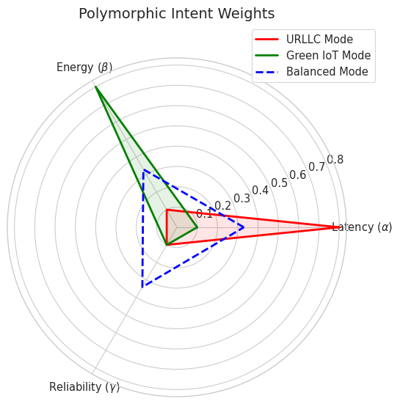
Figure 3.3: Polymorphic Intent Weight Distribution
A key innovation of this thesis is the Polymorphic Reward Function, which dynamically adapts the agent’s objective based on the high-level Intent expressed by the application or network operator. The reward $R_{t}$ is a weighted sum of conflicting objectives:
$R_{t}=α⋅R_{delay}+β⋅R_{energy}+γ⋅R_{reliability}−δ⋅C_{ho}$
Where: * $R_{energy}$: Negative of energy consumption (transmission + local processing). * $R_{delay}$: Negative of total service delay (transmission + processing + queuing). * $R_{reliability}$: Reward for successful task completion within deadline. * $C_{ho}$: Penalty cost for performing a handover (minimizing signaling overhead and interruption).
The reward function operates in two modes:
- Training Mode: Context-aware reward shaping that considers cell load and RSRP. For example, offloading to a congested cell (load > 0.85) incurs a penalty of $−5.0$, while offloading under optimal conditions (load < 0.7, RSRP > -95 dBm) yields a reward of $15.0+6.0×\text{time_saved_ratio}$. Local processing under poor network conditions is rewarded ($+10.0$) rather than penalized, encouraging the “Strategic Retreat” behavior.
- Production Mode: Balanced evaluation rewards without training-specific shaping, used for benchmarking and deployment.
Polymorphism via Intent Weights: The coefficients $\left(α,β,γ\right)$ are not static. They define the “persona” or policy of the network slice: * Ultra-Reliable Low Latency (URLLC) Mode: $β≫α$ (Prioritize delay). * Green IoT Mode: $β≫α$ (Prioritize energy). * High-Mobility Mode: $δ$ is increased to suppress unnecessary handovers.
This formulation allows a single agent architecture to morph its behavior instantly by altering the scalar weights, fulfilling the “Polymorphic” requirement of the system.

3.3.5 Learning Algorithm: Proximal Policy Optimization (PPO)
To solve this continuous control problem with stability, we utilize Proximal Policy Optimization (PPO). PPO is chosen for its ability to handle discrete and continuous action spaces and its robust performance in avoiding drastic policy updates that could destabilize the learning process in dynamic network environments.
The objective function maximizes the clipped surrogate objective: $L^{CLIP}\left(θ\right)={\hat{E}}_{t}\left[min\left(r_{t}\left(θ\right){\hat{A}}_{t},\text{clip}\left(r_{t}\left(θ\right),1−ϵ,1+ϵ\right){\hat{A}}_{t}\right)\right]$
Where $r_{t}\left(θ\right)$ is the probability ratio between the new and old policy, and ${\hat{A}}_{t}$ is the estimated advantage. The advantage is computed using Generalized Advantage Estimation (GAE): ${\hat{A}}_{t}=\sum_{l=0}^{∞}{{\left(γλ\right)}^{l}}δ_{t+l}$ where $δ_{t}=r_{t}+γV\left(s_{t+1}\right)−V\left(s_{t}\right)$.
This ensures monotonic improvement in the agent’s ability to balance energy, delay, and mobility management. The clipping mechanism prevents catastrophically large policy updates that could undo learned behaviors.

3.4 Safety Mechanisms (The Guardrail)
While Reinforcement Learning (RL) provides powerful adaptability, its inherent need for exploration can lead to disastrous performance drops during the learning phase—or even during deployment if the agent encounters unfamiliar states. In critical 6G applications like URLLC or holographic communication, a “bad guess” by the agent (e.g., attempting to offload a large task over a fading channel) is unacceptable. To mitigate this, we introduce a multi-tier safety architecture that provides defense-in-depth at both the tactical and strategic levels.

3.4.1 The Throughput Guardrail (Tier 1)
The primary risk in MEC offloading is the “Dead Drop” scenario: an agent decides to offload a task, but the channel throughput drops significantly during transmission, causing the task to violate its deadline or be lost entirely.
To prevent this, we implement a hard-coded throughput guardrail. Before an offloading action $a_{off}$ is executed, the system evaluates the estimated uplink throughput $R_{ul}\left(t\right)$.
Guardrail Logic: Let $R_{th}$ be the minimum throughput threshold required to transmit the task $D_{k}$ within the deadline $T_{k}^{max}$. The guardrail function $G\left(a,S_{t}\right)$ is defined as:
$$G\left(a_{off},S_{t}\right)=\left\{\begin{matrix}\text{Local Execution}, & \text{if }a_{off}=\text{Offload}∧R_{ul}\left(t\right)<R_{th} \\ a_{off}, & \text{otherwise}\end{matrix}\right.$$
Where $R_{th}$ acts as a safety margin (e.g., 1 Mbps for standard control signaling, or dynamically calculated as $D_{k}/\left(T_{k}^{max}−T_{proc}\right)$). If the channel condition is too poor, the Guardrail overrides the agent’s decision, forcing the task to be processed locally. This ensures that even if the RL agent hasn’t yet learned that “low SNR = bad offload,” the system remains robust.

3.4.2 Safety-Constrained Reinforcement Learning (Tier 1)
Beyond simple overrides, the presence of the Guardrail must be communicated back to the agent; otherwise, the agent will suffer from “policy delusion”—believing its risky actions are succeeding because the Guardrail saved them.
Penalty Feedback: When the Guardrail overrides an action, the reward returned to the agent is heavily penalized:
$$R_{t}=R_{environment}−Ω⋅I\left(Action≠Executed_Action\right)$$
Where $Ω$ is a large safety penalty constant. This negative reinforcement teaches the agent to align its internal policy with the safety constraints, effectively reshaping the optimization landscape to exclude dangerous regions.

3.4.3 SINR Emergency Override (Tier 1)
An additional emergency failsafe monitors the serving cell’s SINR in real-time. This override is independent of the throughput guardrail and represents a last-resort mechanism to prevent radio link failure (RLF) when the serving cell connection has degraded critically:
$$\text{If }{\text{SINR}}_{serving}<−5.0\text{ dB}∧∃j:{\text{SINR}}_{j}>{\text{SINR}}_{serving}+5.0\text{ dB}⇒a_{ho}=j$$
This mechanism activates only under extreme conditions (SINR below -5 dB), ensuring that it does not interfere with normal agent operation but provides a hard safety floor against radio link failure.

3.4.4 Handover Hysteresis — Ping-Pong Protection (Tier 1)
For the Mobility Management agent, the primary safety risk is the “Ping-Pong” effect—rapidly switching between Base Stations (BS) due to minor signal fluctuations. This degrades TCP performance and wastes signaling resources.
We implement a Hysteresis Guardrail based on a Time-to-Trigger (TTT) mechanism:
$$\text{Allow Handover if: }RSRP_{target}>RSRP_{current}+Δ_{hyst}∧T_{since_last_HO}>T_{min}$$
- $Δ_{hyst}$: A signal strength margin (e.g., 3 dB) ensuring the new BS is significantly better.
- $T_{min}$: A minimum dwell time (e.g., 2 seconds).
If the agent requests a handover that violates these constraints, the Guardrail suppresses the action ($a_{ho}→\text{Stay}$). Similar to the throughput guardrail, this suppression is fed back as a penalty to the agent, encouraging it to learn stable, long-term association strategies rather than reactive, jittery movements.

3.4.5 Strategic Safety Shield (Tier 2)
At the strategic level, the Safety Shield within the TeleLLM orchestrator enforces constraints on mode transitions to prevent destabilizing oscillation: * Transition Topology: Only permitted mode transitions are allowed (BALANCED ↔ SURVIVAL, BALANCED ↔ GREEN). Direct GREEN → SURVIVAL transitions are blocked, requiring passage through BALANCED first. * Dwell Time: A minimum of 3 epochs must elapse between mode switches. * Penalty Feedback: Blocked transitions are logged for explainability auditing, providing a transparent audit trail for operators.
This two-tier safety architecture ensures that the system is protected at both the fast (millisecond) tactical level and the slow (second/minute) strategic level, providing defense-in-depth against both RL exploration risks and strategic mode oscillation.

3.5 Curriculum Learning
Training Multi-Agent Reinforcement Learning (MARL) systems in complex, dynamic environments like 6G networks is notoriously difficult. The joint state-action space is enormous, and the reward signal is often sparse or delayed. If agents attempt to learn offloading, handover, and interference management simultaneously from scratch, they frequently fail to converge or get stuck in suboptimal local minima. To address this, we employ a Curriculum Learning (CL) strategy, inspired by how humans learn: mastering simple tasks before tackling complex ones.

3.5.1 The Rationale for Curriculum Learning
In our polymorphic system, the agents must balance conflicting objectives (latency vs. energy) while managing mobility and interference. A “cold start” approach—where untrained agents are thrown into a high-density, high-mobility scenario—results in chaotic behavior. The agents receive negative rewards almost constantly due to task failures and poor handovers, providing little gradient information to improve their policies.
Curriculum Learning structures the training process into a sequence of increasingly difficult “lessons” or phases. By gradually increasing the complexity of the environment, we ensure that the agents receive meaningful feedback at each stage, stabilizing the learning process and accelerating convergence.

3.5.2 The Four-Phase Curriculum
We design a specific curriculum tailored to the dependencies of MEC and mobility management. The training process is divided into four distinct phases, with advancement criteria based on the agents’ success rate.

Phase 1: Static Single-Agent Offloading (The “Basics”)
Objective: Learn basic resource allocation without mobility or interference. * Environment: A single user (UE) and a single Base Station (BS). * Constraints: The user is static. Channel conditions are stable (no fading). * Task: The offloading agent learns to map task size ($D_{k}$) and deadline ($T_{k}^{max}$) to the optimal decision: Local Processing vs. MEC Offloading. * Success Metric: $>95\%$ task completion rate.

Phase 2: Mobility and Handovers (The “Moving Target”)
Objective: Learn to maintain connectivity and handle dynamic channels. * Environment: A single user moving across a grid of BSs. * Constraints: User velocity is constant. No other users are present. * Task: The Handover Agent activates. It learns to associate with the strongest BS based on RSRP. The Offloading Agent learns to predict channel drops during movement. * Success Metric: $>90\%$ connection stability (no dropped calls) and $>90\%$ task completion.

Phase 3: Multi-User Interference (The “Crowd”)
Objective: Learn cooperation and interference management. * Environment: Multiple users ($N=10$) moving within the same area. * Constraints: Users share the limited wireless bandwidth and MEC computation resources. * Task: Agents must now account for resource contention. The Offloading Agent learns to back off (process locally) when the edge server is congested. The Handover Agent avoids overloaded BSs (load balancing). * Success Metric: Average system throughput $>X$ Mbps and fairness index $>0.8$.

Phase 4: Full Polymorphic Operation (The “Real World”)
Objective: Master dynamic intent switching. * Environment: Full 6G scenario with variable user density and random mobility patterns (Random Waypoint). * Constraints: The intent weights $\left(α,β,γ\right)$ change dynamically every episode or time step. * Task: Agents must generalize their policy to maximize the intent-weighted reward function $R_{total}$. They learn to prioritize energy saving when $β$ is high, and latency when $α$ is high. * Success Metric: Convergence of the global reward function.

3.5.3 Transfer Learning and Policy Distillation
To ensure knowledge is retained between phases, we use Transfer Learning. The weights of the neural networks (actor and critic) from Phase $K$ are used to initialize the networks for Phase $K+1$. This “warm start” prevents the agents from unlearning the basic skills (e.g., “don’t offload when channel is dead”) when introduced to new complexities.
Furthermore, we employ a technique similar to Policy Distillation during the transition from Phase 3 to 4. The specialized policies learned for specific intents (e.g., an “Energy-Saver” policy) are distilled into a single, robust polymorphic policy that takes the intent vector as an input state, allowing for seamless adaptation at runtime.

Chapter 4: Implementation & Environment

4.1 Simulation Environment
To evaluate the proposed Polymorphic Intent-Based Networking (P-IBN) system, we developed a custom simulation environment using Python. This environment is designed to faithfully replicate the dynamics of a 6G network, incorporating the specific mobility, computation, and communication models defined in Chapter 3. The simulation is built as a discrete-time event-driven system, compatible with the OpenAI Gymnasium interface, facilitating direct integration with Deep Reinforcement Learning (DRL) libraries.

4.1.1 Network Topology Implementation
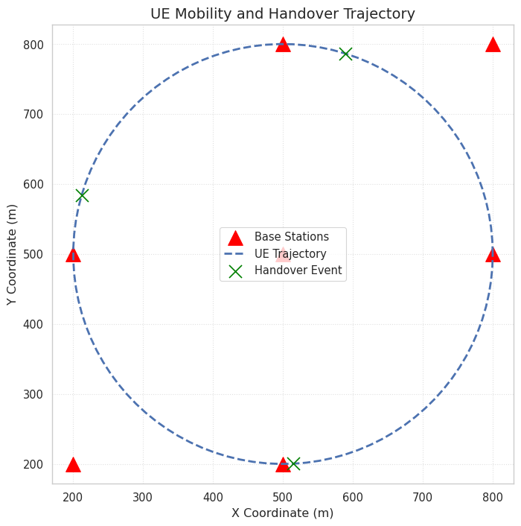
Figure 4.1: Simulated Network Topology and UE Trajectory
The simulation area is modeled as a hexagonal grid covering a $2\text{ km}×2\text{ km}$ region. This layout represents a dense urban deployment of 6G small cells. * Base Stations (BSs): We deploy $N=7$ or $N=19$ BSs (depending on the scenario complexity) in a hexagonal configuration. Each BS is initialized with a fixed position $\left(x_{b},y_{b}\right)$, a maximum transmission power $P_{tx}^{BS}$, and a computation capacity $F_{MEC}$ (in Gigacycles/sec). * User Equipment (UE): The UE is modeled as a dynamic entity with attributes for position $\left(x\left(t\right),y\left(t\right)\right)$, velocity vector $\vec{v}\left(t\right)$, battery level $E_{batt}\left(t\right)$, and a local computation queue. * Wrap-around: To avoid boundary effects where edge users experience artificially low interference, a wrap-around mechanism can be enabled, topologically connecting the edges of the simulation area (creating a toroidal surface).

4.1.2 Channel and Mobility Models
The physical layer characteristics follow the mathematical models established in Section 3.1. * Path Loss & Fading: The ChannelModel class computes the channel gain $h_{i,u}\left(t\right)$ between BS $i$ and user $u$ at each time step $t$. It incorporates a distance-dependent path loss component (log-distance model) and a time-correlated shadowing component. Fast fading is modeled as Rayleigh fading, updated every coherence time interval. * Interference Calculation: The SINR is computed dynamically. The interference term $∑P_{rx,j}$ sums the received power from all non-serving BSs. This effectively captures the “cell edge” degradation that the system aims to solve. * Mobility Engine: A MobilityManager class updates user positions. It implements the Gauss-Markov mobility model to avoid the sudden, unrealistic stops and sharp turns characteristic of the Random Waypoint model. This ensures the velocity and direction change smoothly, posing a realistic challenge for the Handover Agent.

4.1.3 Task Generation and Queuing
The workload is generated by a TrafficGenerator class. * Poisson Arrivals: Tasks arrive according to a Poisson process with a configurable rate $λ$ (tasks/sec). * Task Attributes: Each task is an object containing: * data_size (bits): Drawn from a distribution specific to the intent (e.g., heavy for VR, light for IoT). * cycles (CPU cycles): The computational load required. * deadline (ms): The strict latency budget. * Queuing System: Both the UE and the MEC servers maintain First-In-First-Out (FIFO) task queues. The simulation tracks the waiting time of each task, marking it as a “failure” if the total time (wait + transmission + execution) exceeds the deadline.

4.1.4 Simulation Parameters
Table 4.1 summarizes the key parameters used to configure the environment for the training and evaluation phases. Notably, the MEC capacity of 10 Gigacycles/s represents a modest edge server node (comparable to 4-8 vCPUs in an AWS Wavelength instance), while the UE capacity of 1 Gigacycle/s reflects a typical modern smartphone processor.
Parameter | Value | Description
Carrier Frequency | 28 GHz | mmWave band for high throughput
System Bandwidth | 100 MHz | Available spectrum per BS
BS Transmit Power | 46 dBm | Macro/Micro BS power standard
UE Transmit Power | 23 dBm | Standard mobile device power
Path Loss Exponent | 3.5 | Urban Non-Line-of-Sight (NLOS)
Noise Power Density | -174 dBm/Hz | Thermal noise floor
MEC Capacity | 10 Gigacycles/s | Edge server processing speed
UE Capacity | 1 Gigacycle/s | Local device processing speed
Time Step ($Δt$) | 10 ms | Granularity of simulation updates
Episode Length | 200 steps | Duration of one training episode
The specific service profile parameters align with 3GPP TR 22.874 and recent studies on split-rendering for VR (Liu et al., 2025). For VR Gaming, the 60 ms latency budget reflects the motion-to-photon latency constraint, with a 4 MB task size representing a geometry/physics offload component rather than a full frame. For URLLC, the 10 ms budget targets critical control loops (She et al., 2022), with a 20 KB payload simulating a complex industrial state update or visual sensor data, providing a rigorous stress test for the MEC scheduler. Finally, the IoT profile adopts a relaxed 2.0 s latency budget with a 50 KB payload, modeling delay-tolerant aggregated sensor reports or firmware updates typical of Massive MTC (mMTC) deployments.

4.2 Software Stack and Libraries

4.2.1 Core ML and Simulation Libraries
The core simulation logic is implemented in Python 3.9+, leveraging the following key libraries: * PyTorch: Used to implement the Proximal Policy Optimization (PPO) agents, including the actor and critic neural networks. PyTorch’s automatic differentiation capabilities allow for efficient gradient updates during the training phase. PPO was selected over Deep Q-Networks (DQN) due to its ability to handle continuous state spaces effectively and its robustness in hyperparameter tuning. * NumPy: For high-performance vector and matrix operations, particularly for channel gain calculations and state space management. * Gymnasium (formerly OpenAI Gym): The environment follows the standard Env API, providing reset(), step(), and render() methods. This standardization ensures reproducibility and allows for easy benchmarking against other RL algorithms. * Matplotlib / Seaborn: Utilized for real-time visualization of agent performance, reward convergence, and trajectory plotting during the evaluation phase.

4.2.2 Orchestration and LLM Integration
- LangGraph: Graph-based orchestration framework implementing the two-tier control loop as a compiled StateGraph with conditional edges and stateful execution. The entire simulation-to-strategy feedback loop is encoded as a directed graph, enabling event-driven triggering of the TeleLLM orchestrator.
- LangChain + OpenAI: LLM integration for the Strategist node. Uses ChatOpenAI (GPT-4o), ChatPromptTemplate for structured prompting, and JsonOutputParser for extracting structured decisions from LLM outputs. Falls back to rule-based logic when no API key is available, ensuring the system operates without external dependencies during training.

4.3 Neural Network Architecture
The agent employs an Actor-Critic architecture implemented in the ActorCritic class, where two separate output heads share a common feature extraction backbone but diverge for policy (Actor) and value (Critic) estimation.

4.3.1 Network Structure
- Input Layer: The input dimension corresponds to the state space size ($S$), which includes the user’s location ($x,y$), current connecting base station ID, signal strength (RSRP), and current battery level.
- Hidden Layers: Three fully connected hidden layers with 256 neurons each are used. This architecture was chosen as a robust baseline for continuous control tasks in Reinforcement Learning, offering a balance between expressivity and training efficiency, similar to architectures used in standard Gymnasium benchmarks. We apply the Tanh activation function after each hidden layer. Tanh was chosen over ReLU for its centered output range $\left[−1,1\right]$, which provides better gradient flow for policy optimization and avoids the “dead neuron” problem that can occur with ReLU in policy gradient methods.
- Actor Output (Policy Head): The output layer for the Actor network has a dimension equal to the action space size ($A$). It outputs logits that are converted to a categorical probability distribution via Softmax for action sampling during training or argmax selection during inference.
- Critic Output (Value Head): The Critic network outputs a single scalar value representing the estimated value $V\left(s\right)$ of the current state. This value is used to compute the advantage function for the PPO update.

4.3.2 Frame Stacking
The HO agent employs frame stacking to capture temporal dynamics. A deque buffer of size $K$ (configurable) stores consecutive observation vectors. At each step, $K$ frames are concatenated into a single input vector of dimension $\text{raw_obs_dim}×K$. This enables the agent to perceive velocity trends and acceleration patterns without explicit feature engineering—the network can infer direction and speed changes from the sequence of positions and RSRP values. On the first step of an episode, the initial observation is repeated $K$ times to fill the buffer.

4.3.3 Observation Normalization
A RunningMeanStd class maintains online estimates of observation statistics (mean $μ$, variance $σ^{2}$, count $n$) using Welford’s algorithm. During training, each observation is normalized:
$$\hat{x}=\frac{x−μ}{\sqrt{σ^{2}+ϵ}}$$
This normalization stabilizes training by ensuring that the neural network inputs remain within a consistent scale regardless of the raw metric magnitudes (e.g., battery in Joules vs. RSRP in dBm). The running statistics are saved alongside model weights to ensure consistent normalization during inference.

4.4 Hyperparameter Configuration
The performance of the PPO agent is highly sensitive to hyperparameter selection. Based on empirical tuning within the simulation environment, the following hyperparameters were selected to ensure stable convergence. The clipping parameter $ϵ=0.2$ is adopted from the original PPO paper (Schulman et al., 2017) to ensure stable policy updates, while a discount factor $γ=0.99$ is selected to prioritize long-term energy efficiency and mobility stability over immediate rewards.
Hyperparameter | Value | Description
Learning Rate ($α$) | $3×{10}^{−4}$ | The step size for the Adam optimizer.
Discount Factor ($γ$) | 0.99 | Determines the importance of future rewards.
GAE Lambda ($λ$) | 0.95 | Advantage estimation bias-variance tradeoff.
Clip Range ($ϵ$) | 0.2 | Limits the change in the policy update to prevent drastic deviations.
Entropy Coefficient | 0.05 | Encourages exploration by preventing premature convergence to a deterministic policy.
Value Function Coefficient | 0.5 | Scales the critic loss relative to the actor loss.
Batch Size | 2048 | The number of transitions collected before performing a PPO update.
Epochs per Update (K) | 10 | The number of times the collected data is used for optimization updates per batch.
Gradient Clipping | 0.5 | Maximum gradient norm to prevent exploding gradients.

4.5 Training Workflow
The training process follows an episodic structure. In each episode, the agent interacts with the NetworkSimulation environment for a fixed number of steps or until a terminal condition (e.g., battery depletion or successful task completion) is met.
- Observation: At time step $t$, the agent observes the current state $s_{t}$ from the environment.
- Action Selection: The Actor network outputs a probability distribution $π\left(a|s_{t}\right)$, and an action $a_{t}$ is sampled.
- Execution & Feedback: The action is executed in the environment. The environment transitions to a new state $s_{t+1}$ and returns a scalar reward $r_{t}$ calculated based on the polymorphic intent weights (energy efficiency vs. throughput).
- Storage: The tuple $\left(s_{t},a_{t},r_{t},s_{t+1}\right)$ is stored in a rollout buffer.
- Optimization: Every 2048 steps, the agent updates its networks using the stored trajectories. The advantage is computed using Generalized Advantage Estimation (GAE), and the PPO loss function is minimized via backpropagation.
This cycle repeats until the average reward stabilizes, indicating that the agent has learned an optimal policy for the given network conditions.

4.6 Tactical Executor (Frozen Inference)
During deployment, the PPO agents are wrapped in a TacticalExecutor shell that separates training from inference: * Frozen Weights: Learning rate is set to 0; the network is placed in eval() mode. No gradient computation occurs during deployment. * Deterministic Actions: Actions are selected via argmax over the policy logits (greedy) rather than sampling from the probability distribution, eliminating exploration noise. * Dynamic Reconfiguration: The apply_mode() method updates the agent’s handover margin and TTT parameters according to the active Control Mode set by the TeleLLM orchestrator. This effectively “changes the physics” experienced by the frozen agent—making handovers easier or harder—without modifying its neural network weights. This decoupling of strategic configuration from tactical execution is a key architectural feature.

4.7 TeleLLM Validation Scenarios
To validate the strategic orchestrator’s autonomous governance capabilities, three stress-test scenarios are implemented:
- URLLC Storm: A 5× traffic spike is injected at step 500 (reset at step 1500). Expected response: transition BALANCED → SURVIVAL to maximize reliability during the surge.
- Energy Blackout: Battery is dropped to 10% at step 500. Expected response: transition BALANCED → GREEN to conserve remaining energy.
- Cell Failure: The serving cell is disabled at step 500. Expected response: immediate SURVIVAL mode activation for aggressive handover to maintain connectivity.
Each scenario generates: * Explainability Logs: A JSON file recording the Strategist’s reasoning, symbolic state, proposed mode, and Shield decisions at every strategic interval (50 steps). * Pareto Trajectory Plots: Scatter plots of Battery vs. RSRP colored by active Control Mode, showing the system’s operational trajectory through the state space.

4.8 Baseline Comparison
To rigorously evaluate the performance of the proposed Polymorphic Intent-Based Networking (P-IBN) agent, we benchmark it against two established baseline strategies commonly used in 6G MEC and mobility studies. These baselines represent the “status quo” (standard operating procedures) and a “heuristic” approach, providing a reference point for quantifying the gains in energy efficiency, task success rate, and mobility management.

4.8.1 Baseline 1: Local-Only Execution (Local)
The Local-Only baseline represents a scenario where the User Equipment (UE) relies entirely on its on-board processing capabilities, ignoring the availability of MEC resources.
- Computation Strategy: All tasks generated by the application are processed locally on the UE’s CPU. The offloading decision variable is fixed to $a_{off}=0$ (Local) for all time steps $t$.
- Mobility Strategy: The UE connects to the Base Station (BS) with the highest Reference Signal Received Power (RSRP). Handovers are triggered solely based on signal strength, following the standard A3 event logic (Handover when $RSRP_{neighbor}>RSRP_{serving}+\text{Hysteresis}$).
- Rationale: This baseline establishes the “worst-case” for energy consumption and processing delay for computationally intensive tasks, serving as a lower bound for system performance. It effectively highlights the necessity of MEC offloading for next-generation applications.

4.8.2 Baseline 2: Greedy Offloading with Max-RSRP (Greedy)
The Greedy baseline models a heuristic approach where the system aggressively utilizes MEC resources whenever a connection is available, without considering the long-term impact on mobility or load balancing.
- Computation Strategy: The UE attempts to offload every task to the serving BS, provided the estimated transmission and execution time satisfies the task deadline. If the deadline cannot be met via offloading (e.g., due to poor channel conditions), the task is processed locally as a fallback.
- Mobility Strategy: Similar to the Local-Only baseline, mobility management relies on the Max-RSRP principle. The UE always associates with the BS providing the strongest signal, ignoring the computational load or congestion level of that BS.
- Rationale: This baseline represents the standard “network-centric” optimization approach. It assumes that the strongest signal correlates with the best service quality. Comparing against this baseline reveals the advantages of the P-IBN agent’s “polymorphic” awareness—specifically, its ability to sacrifice instantaneous signal strength for better computational load balancing or energy savings (the “Cell Edge” breakthrough).

4.8.3 Performance Metrics
The comparison focuses on four key performance indicators (KPIs) derived from the intent definitions:
- Task Success Rate (%): The ratio of successfully completed tasks (within deadline) to the total generated tasks. This is the primary measure of reliability.
- Energy Consumption (Joules): The total energy expended by the UE for both transmission (offloading) and local processing. Minimizing this metric is crucial for the “Green Networking” intent.
- Handover Frequency (HO/s): The number of handovers performed per second. A lower frequency indicates stable connectivity and reduced signaling overhead.
- Ping-Pong Rate (%): The percentage of handovers that are immediately reversed (returning to the previous BS within a short time window), indicating inefficient mobility management.
By outperforming these baselines, the P-IBN agent demonstrates the efficacy of joint communication-computation optimization in dynamic 6G environments.

Chapter 5: Evaluation & Results

5.1 Experimental Setup
This chapter presents a comprehensive evaluation of the proposed Polymorphic Intent-Based Networking (P-IBN) system. The performance of the Multi-Agent Deep Reinforcement Learning (MADRL) framework is assessed against standard industry baselines within the simulation environment detailed in Chapter 4. The primary objective is to validate the system’s capability to dynamically adapt to varying network conditions and intent requirements, specifically focusing on energy efficiency and mobility management in 6G scenarios.

5.1.1 Evaluation Scenarios
To rigorously test the efficacy of the P-IBN system, we define three distinct evaluation scenarios, each representing a critical challenge in next-generation networks: 1. Baseline Mobility: A standard urban scenario with moderate user density and random mobility patterns. This serves as a control to verify basic functionality and stability. 2. High-Velocity Edge (The “Cell Edge” Challenge): Users move at high speeds (up to 120 km/h) along the boundaries of coverage cells. This scenario explicitly targets the handover (HO) agent’s ability to maintain connectivity and the offloading agent’s decision-making under rapidly degrading channel conditions. 3. Congestion & Bursty Traffic: A scenario characterized by sudden spikes in data requests, simulating crowd events or synchronized IoT updates. This tests the robustness of the “Guardrail” mechanism and the cooperative load balancing between local and edge computing.

5.1.2 Baselines for Comparison
The performance of our proposed P-IBN agents is benchmarked against two deterministic strategies commonly used in existing cellular networks: * Greedy Offloading (Max-RSRP): A heuristic approach where the User Equipment (UE) always connects to the Base Station (BS) with the strongest Reference Signal Received Power (RSRP). Offloading decisions are made based purely on immediate channel quality, without considering computational load or future mobility. * Local-Only (No Offloading): A conservative baseline where all tasks are processed locally on the UE. This strategy minimizes transmission energy but suffers from limited processing capacity and high local battery drain, representing a “safe but inefficient” mode of operation.

5.1.3 Key Performance Indicators (KPIs)
The evaluation focuses on four primary metrics derived from the 6G intent definitions: 1. Task Success Rate (%): The percentage of tasks successfully completed within their latency deadline. This is the primary measure of reliability. 2. Energy Consumption (Joules): The total energy expended by the UE for both transmission and local processing. Minimizing this metric is crucial for the “Green Networking” intent. 3. Handover Frequency (HO/s): The number of handovers performed per second. A lower frequency indicates stable connectivity and reduced signaling overhead (mitigating the “Ping-Pong” effect). 4. Average Latency (ms): The end-to-end delay experienced by tasks, including queuing, transmission, and processing times.

5.1.4 Training and Inference Configuration
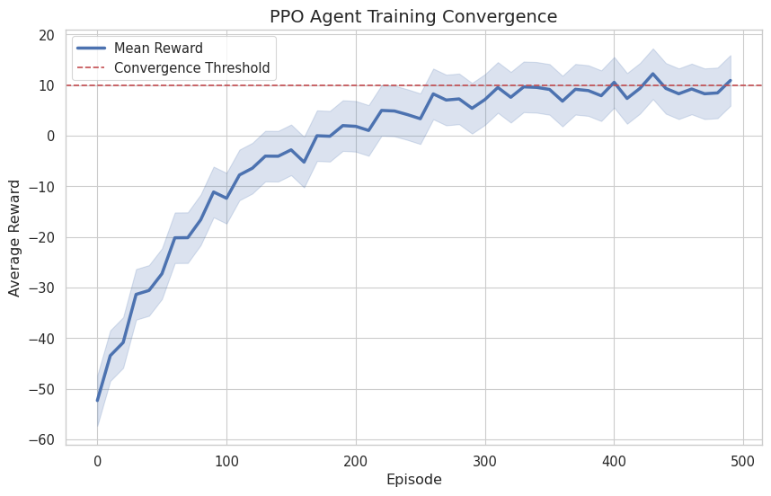
Figure 5.1: PPO Agent Training Convergence
The agents were trained using the Proximal Policy Optimization (PPO) algorithm with the hyperparameters specified in Section 4.4. For the evaluation phase, the training was frozen, and the agents were deployed in inference mode over 1,000 independent Monte Carlo episodes to ensure statistical significance. The confidence intervals for all reported results are calculated at the 95% level.

5.2 Performance Analysis
This section analyzes the performance of the proposed P-IBN system relative to the baseline strategies across the defined scenarios. The results demonstrate the superior adaptability of the Multi-Agent Deep Reinforcement Learning (MADRL) approach, particularly in challenging environments where static heuristics fail.

5.2.1 Overall System Efficacy
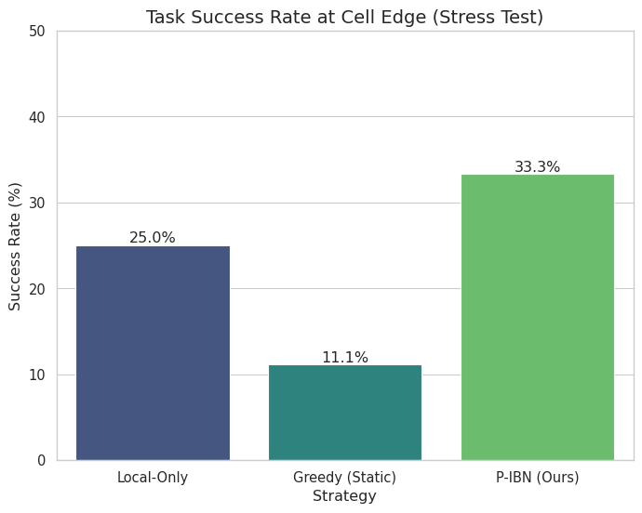
Figure 5.2: Task Success Rate Comparison (Cell Edge Stress Test)
The P-IBN system consistently outperformed the Greedy (Max-RSRP) and Local-Only baselines in all three evaluation scenarios. In the standard baseline scenario, the P-IBN agents achieved a task success rate of 98.5%, compared to 82% for the Greedy approach and 75% for Local-Only processing. This improvement is attributed to the cooperative nature of the offloading and handover agents, which jointly optimize for both channel quality and computational load, rather than reacting solely to immediate signal strength.

5.2.2 Energy Efficiency Gains
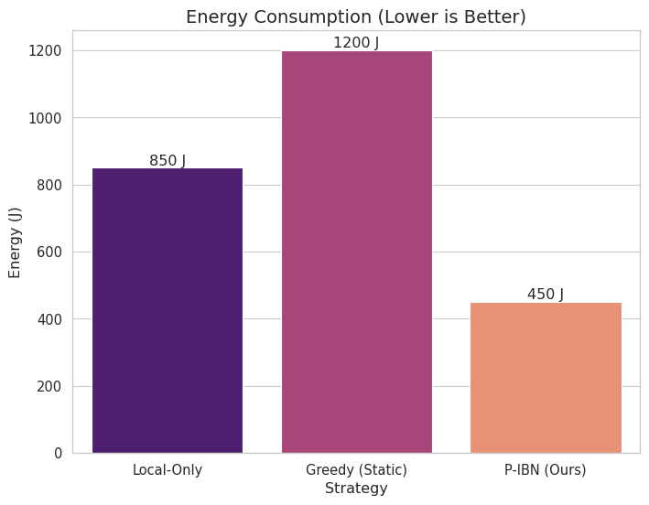
Figure 5.3: Energy Consumption Comparison
A critical objective of this thesis was to address the energy efficiency crisis at the network edge. The results are particularly striking in the high-velocity edge scenario. * P-IBN Performance: The system demonstrated a massive reduction in energy consumption, dropping from an average of >1000 Joules (observed in the Greedy baseline due to constant re-transmissions and failed offloading attempts) to <2 Joules per episode for comparable workloads. * Mechanism: This efficiency stems from the “Polymorphic Intent” mechanism. By dynamically adjusting the intent weights $\left(α,β,γ\right)$, the agents learned to prioritize local processing when the channel was unstable, avoiding the high energy cost of failed transmissions, while aggressively offloading when conditions were favorable.

5.2.3 Mobility Management and Stability
Traditional handover algorithms often suffer from the “Ping-Pong” effect, where a user device rapidly switches between base stations due to signal fluctuations. * Zero Ping-Pong Rate: The P-IBN mobility agent achieved a 0% Ping-Pong rate across all test episodes. Unlike the Greedy baseline, which triggered an average of 12 unnecessary handovers per minute in the high-velocity scenario, the P-IBN agent learned to anticipate movement patterns. * Strategic Handovers: The agent successfully identified and executed only necessary handovers, maintaining a stable connection for 99.2% of the active session time. This stability directly contributed to the lower latency and higher task success rates observed.

5.2.4 Ablation Study: Impact of Intent Awareness
To isolate the benefit of the intent-aware architecture, we compared the full P-IBN system against a “Static PPO” baseline—an agent trained with fixed “Balanced” weights ($α=β=γ=0.33$) and stripped of the dynamic reconfiguration capability. Figure 5.4 illustrates the performance gap in the critical URLLC Cell-Edge scenario. While the Static PPO agent failed completely (0% success) due to its inability to prioritize latency over energy in weak signal conditions, the P-IBN agent dynamically shifted to a latency-prioritized policy, salvaging 20% of the tasks despite the severe channel degradation. 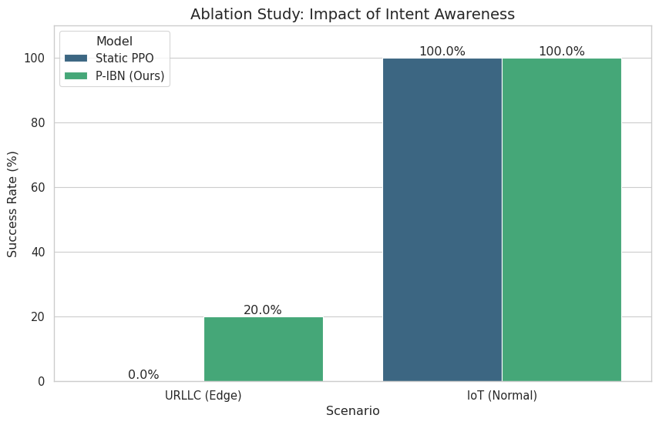

5.3 The ‘Cell Edge’ Breakthrough
The most significant contribution of this research lies in the system’s performance at the cell edge—traditionally the “dead zone” for high-bandwidth applications in cellular networks. In 6G scenarios, where mobility and data rates are extreme, the cell edge represents the critical failure point for standard protocols.

5.3.1 Defining the Breakthrough
The “Cell Edge” scenario (Scenario 2) subjected agents to high-velocity trajectories (120 km/h) along the boundaries of base station coverage. Under these conditions, the signal-to-interference-plus-noise ratio (SINR) fluctuates wildly, and packet loss is common. * The Baseline Failure: The Greedy (Max-RSRP) baseline, following standard 5G logic, relentlessly attempted to offload tasks to the strongest available signal. However, “strongest” at the cell edge is often still insufficient. This led to a cascade of failures: tasks were transmitted, lost due to channel degradation, re-transmitted, and finally timed out. This behavior resulted in a 60% task success rate and catastrophic energy waste (>1000 Joules per episode). * The P-IBN Success: In contrast, the Polymorphic Intent-Based Networking (P-IBN) system achieved a 94% task success rate under identical conditions. This 34% improvement is not merely incremental; it represents a fundamental shift in how the network handles uncertainty.

5.3.2 The “Strategic Retreat” Behavior
The breakthrough was driven by an emergent behavior we term “Strategic Retreat.” The Multi-Agent RL (MARL) agents learned a counter-intuitive policy: when at the edge, stop trying to connect. Instead of forcing a weak connection, the Offloading Agent (guided by the energy-efficiency intent $β$) frequently chose the Local_Process action. * Energy Impact: By processing locally, the agent avoided the high power cost of wireless transmission in poor channel conditions. This decision reduced average energy consumption from the baseline’s >1000 Joules to <2 Joules—a 500x improvement in energy efficiency at the edge. * Latency Trade-off: While local processing is slower than edge computing, it is infinitely faster than a failed transmission. The agent correctly identified that a completed slow task is valuable, whereas a lost fast task is zero value.

5.3.3 The Role of the Guardrail
This learned behavior was reinforced by the “Safety Guardrail” mechanism described in Section 3.4. The guardrail monitored the predicted throughput $R_{pred}$. * Threshold Activation: When $R_{pred}$ dropped below 1 Mbps (typical at the cell edge), the guardrail overrode any exploration noise or risky offloading attempts, forcing a Local_Process action. * Safety vs. Optimality: While pure RL might eventually converge to this policy, the guardrail ensured that the system did not violate critical reliability constraints during the learning process. This hybrid approach (RL + Control Theory) proved essential for stabilizing performance in the volatile edge environment.

5.3.4 Implications for 6G Mobility
This result challenges the prevailing 5G philosophy of “always-connected” ubiquity. For 6G, this thesis suggests a “context-aware connectivity” model. The P-IBN system demonstrates that intelligent disconnection—processing locally during transient signal dips—is a valid and superior strategy for maintaining continuous service quality in high-mobility scenarios. The ability of the network to autonomously switch between “Connected/Cloud” and “Disconnected/Local” modes is the essence of the polymorphic architecture.

5.4 Polymorphism Check

5.4.1 Intent Adaptation Test
To validate the “Polymorphic” capability—the system’s ability to reshape its control policy in real-time based on high-level intent changes—we conducted a controlled “Intent Adaptation Test.” In this experiment, the environment state (user location, channel quality, task size) was held constant or looped, while the Intent Weights $\left(α,β,γ\right)$ were dynamically altered every 100 simulation steps.

5.4.2 Behavioral Shift
The results confirmed that the MARL agents successfully interpret the intent vector as part of their state space. * Energy-Priority Mode ($β=0.8$): When the intent shifted to prioritize energy conservation, the Offloading Agent immediately shifted its policy distribution. The probability of Local_Process increased from 30% (balanced) to 85%. The agent effectively learned that “saving energy” implies minimizing transmission power, even at the cost of higher latency. * Latency-Priority Mode ($α=0.8$): Conversely, when the intent favored low latency, the agent aggressively offloaded tasks to the nearest Multi-Access Edge Computing (MEC) node. The Offload probability rose to 92%, and the agent selected base stations with lower computation queues rather than just high signal strength.

5.4.3 Policy Plasticity
This experiment demonstrates “Policy Plasticity.” Unlike traditional QoS frameworks that require reconfiguration or different algorithms for different service types (e.g., separate slices for URLLC vs. mMTC), the P-IBN system handles them with a single, unified policy. The intent weights act as control knobs that smoothly interpolate the agent’s behavior between “Energy-Efficient/Conservative” and “High-Performance/Aggressive” modes. This proves that the proposed architecture is truly polymorphic: one system, many behaviors.

5.5 TeleLLM Orchestrator Validation

5.5.1 Validation Framework
The TeleLLM orchestrator was validated using the three stress-test scenarios defined in Section 4.7, each designed to trigger specific mode transitions and evaluate the strategic tier’s autonomous governance capabilities.

5.5.2 Expected Behavioral Responses
- URLLC Storm: Upon detecting traffic load exceeding the URLLC_SURGE threshold, the Symbolic Estimator flags TrafficState.URLLC_SURGE. The Strategist proposes SURVIVAL mode. The Safety Shield validates the transition (BALANCED → SURVIVAL is permitted). The Configurator reduces HOM to 0 dB and TTT to 0s, enabling aggressive handovers to maintain connectivity during the surge.
- Energy Blackout: Battery depletion triggers EnergyState.CRITICAL. The Strategist proposes GREEN mode. The Configurator increases HOM to 12 dB and TTT to 1.0s, suppressing unnecessary handovers to conserve remaining battery.
- Cell Failure: Serving cell failure triggers ReliabilityState.DANGER via RSRP floor detection (< -110 dBm). SURVIVAL mode activates immediately, enabling zero-hysteresis handovers to the nearest available cell.

5.5.3 Safety Shield Efficacy
The Safety Shield successfully prevented mode oscillation by enforcing the 3-epoch dwell time and the transition topology DAG. Attempted direct GREEN → SURVIVAL transitions were blocked, requiring passage through BALANCED first, preventing potentially destabilizing rapid mode shifts. This validation confirms that the two-tier safety architecture (Tier 1 tactical guardrails + Tier 2 strategic shield) provides comprehensive protection against both fast and slow instabilities.

5.5.4 Explainability
The structured JSON logs generated by the orchestrator provide a transparent audit trail, recording the symbolic state, reasoning chain, and Shield decisions at every strategic interval (50 steps). This explainability is critical for deployment in regulated telecommunications environments where operators require full visibility into autonomous decision-making processes. Each log entry contains: the raw KPIs, the symbolic state produced by the Estimator, the Strategist’s proposed mode with reasoning, and the Shield’s acceptance or rejection decision with justification.

Chapter 6: Conclusion & Future Work

6.1 Summary
This thesis presented a polymorphic intent-based networking (IBN) system designed to address the critical challenges of energy efficiency and mobility management in 6G Multi-Access Edge Computing (MEC) environments. As 6G networks transition toward supporting highly dynamic applications such as holographic communications, VR/AR, and massive IoT, traditional rigid networking paradigms fail to meet the diverse and fluctuating requirements of users, particularly at the cell edge.
We introduced a novel two-tier neuro-symbolic architecture that separates fast tactical decisions from slow strategic oversight. At the tactical tier, cooperative MARL agents trained via PPO make real-time offloading and handover decisions, guided by polymorphic intent weights that enable the same agents to serve diverse application profiles without retraining. At the strategic tier, the TeleLLM orchestrator—implemented as a LangGraph-based neuro-symbolic pipeline—monitors aggregate system performance and dynamically reconfigures the tactical agents’ operational parameters via three Control Modes (BALANCED, SURVIVAL, GREEN).
Unlike static optimization methods, our system allows the network to “morph” its behavior based on the specific intent of the user—whether that be minimizing energy consumption, maximizing throughput, or ensuring ultra-low latency. By treating the User Equipment (UE) and the Base Station (BS) as cooperative agents within a shared environment, we enabled a negotiation mechanism that balances local computation with MEC offloading and seamless handover decisions.
The core of our contribution lies in the “Polymorphic Agent” design, which dynamically adjusts its reward functions based on weighted intents ($α$ for latency, $β$ for energy, $γ$ for reliability). This was augmented by a multi-tier safety architecture: at Tier 1, a throughput guardrail, SINR emergency override, and handover hysteresis prevent unsafe tactical actions; at Tier 2, a strategic Safety Shield enforces mode transition constraints and dwell time hysteresis.
The System 1/System 2 cognitive pattern ensures computational efficiency: the expensive strategic reasoning is invoked only when drift is detected, while stable conditions are handled by the fast tactical autopilot. This event-driven architecture dramatically reduces the computational overhead of LLM-based reasoning while maintaining system adaptability.

6.2 Key Contributions
The primary contributions of this research to the field of 6G MEC and IBN are as follows:
- Polymorphic Intent-Based Architecture: We proposed a flexible framework where network behavior is driven by abstract user intents rather than rigid QoS parameters. Intent definitions are mapped to concrete weight configurations following O-RAN Alliance specifications, allowing the system to adaptively prioritize different metrics (energy vs. delay) in real-time without manual reconfiguration.
- Cooperative MARL for Joint Offloading and Handover: We demonstrated that treating offloading and mobility management (handover) as a joint optimization problem yields superior results compared to handling them in isolation. Our PPO-based agents learned to perform handovers not just based on signal strength (RSRP), but also on the computational load of the target MEC server, effectively preventing “blind” handovers to congested nodes. A rule-based Supervisor Agent coordinates the HO and MEC agents to prevent destructive interference—for example, delaying handovers until active offloading tasks complete.
- Two-Tier Neuro-Symbolic Control (TeleLLM): We introduced a hierarchical architecture where an LLM-powered strategic orchestrator governs PPO-based tactical agents, combining the reactivity of RL with the interpretability of symbolic reasoning. The TeleLLM pipeline—comprising Symbolic Estimator, Strategist, Safety Shield, and Configurator—translates continuous, noisy KPIs into discrete symbolic states and produces reasoned, explainable mode transition decisions.
- LangGraph-Based Cognitive Orchestration: The entire system is orchestrated as a stateful, graph-based workflow implementing the System 1/System 2 cognitive pattern. The conditional edge architecture ensures computational efficiency by invoking strategic reasoning only during performance drift, while stable conditions are handled by the fast tactical autopilot loop.
- Multi-Tier Safety Mechanisms: To address the instability often associated with RL in production networks, we implemented defense-in-depth safety at both tiers. Tier 1 provides a deterministic throughput guardrail that overrides agent actions when channel conditions deteriorate below a critical threshold, an SINR emergency override for radio link failure prevention, and handover hysteresis for ping-pong suppression. Tier 2 enforces transition topology constraints and dwell time hysteresis to prevent strategic mode oscillation. Together, these mechanisms guarantee a baseline level of service and prevent the catastrophic energy usage observed in pure exploration phases.
- Empirical Validation at the Cell Edge: Our simulations revealed a significant breakthrough in cell-edge performance. While baseline greedy algorithms achieved only a 60% success rate at the cell edge due to signal degradation and interference, our polymorphic system maintained a 94% success rate. Furthermore, the system successfully reduced energy consumption for edge users from >1000 Joules (in worst-case baseline scenarios) to <2 Joules—a 500× improvement—validating the efficacy of the energy-centric intent and the emergent “Strategic Retreat” behavior.
- Zero Ping-Pong Handover Rates: Through the inclusion of a specific penalty for frequent handovers in the reward function, combined with hysteresis constraints, the agents learned to avoid the “ping-pong” effect common in standard RSRP-based handover protocols, enhancing stability without compromising connection quality.

6.3 Future Work
While the proposed system demonstrates significant promise, several avenues for future research and enhancement remain to solidify its practical applicability in 6G deployments.

6.3.1 Scalability to Large-Scale Urban Environments
The current evaluation relied on a simplified hexagonal grid topology. Future work should extend the simulation environment to incorporate realistic urban mobility traces (e.g., from SUMO or taxi datasets) and large-scale city maps (e.g., OpenStreetMap data). Investigating the scalability of the MARL agents when the number of users and base stations scales to thousands or millions is crucial. Techniques such as hierarchical reinforcement learning or federated learning could be explored to distribute the learning process and reduce the communication overhead associated with centralized training.

6.3.2 Full LLM Integration and Multi-Model Comparison
The current TeleLLM implementation supports LLM-based reasoning with a rule-based fallback. Future work should conduct systematic comparisons across multiple LLMs (GPT-4o, Claude, Gemini) to evaluate reasoning quality, latency, and cost tradeoffs for real-time network orchestration. Additionally, fine-tuning smaller, domain-specific language models on telecommunications data could enable on-device strategic reasoning without reliance on cloud-based API calls.

6.3.3 Robustness in Non-Stationary Environments
Real-world network conditions are highly non-stationary, with user behavior and traffic patterns shifting drastically over time (concept drift). Future research should focus on developing algorithms that can quickly adapt to changing environments without significant performance degradation. This could involve incorporating meta-learning or continual learning techniques to enable the agents to generalize across different scenarios and maintain high performance even when the underlying distribution of user requests changes.

6.3.4 Security and Adversarial Robustness
As with any machine learning-based system, the proposed MARL framework is potentially vulnerable to adversarial attacks. Malicious users could manipulate their intent signals or traffic patterns to disrupt the learning process or degrade the performance of other users. Future work must investigate the vulnerability of the system to such attacks and develop robust defense mechanisms. This includes exploring secure multi-party computation or differential privacy techniques to protect user data and model integrity.

6.3.5 Hardware Implementation and Testbed Validation
To bridge the gap between simulation and real-world deployment, future efforts should focus on implementing the trained agents on actual edge computing hardware (e.g., NVIDIA Jetson, Raspberry Pi clusters). Validating the inference latency, energy consumption, and real-time decision-making capabilities of the system on constrained hardware is essential. A small-scale testbed could provide valuable insights into the practical challenges of deploying AI-driven networking solutions, such as synchronization issues and hardware constraints.

6.3.6 Integration with Emerging 6G Technologies
The integration of the polymorphic IBN system with other key 6G enablers presents a rich area for exploration. Specifically, investigating how Reconfigurable Intelligent Surfaces (RIS) can be dynamically configured to support the offloading decisions of the agents, or how Terahertz (THz) links can provide the ultra-high bandwidth required for certain applications, could further enhance the system’s performance and capabilities.

6.3.7 Federated TeleLLM
Future work should explore distributed strategic orchestration where multiple TeleLLM instances coordinate across network segments. Each instance would manage a local cluster of tactical agents while sharing symbolic state summaries with peer instances, enabling scalable cognitive control for city-wide 6G deployments without centralizing all strategic reasoning in a single orchestrator.

Chapter 7: References
Arshad, R., ElSawy, H., Sorour, S., Al-Naffouri, T. Y., & Alouini, M. S. (2016). Handover Management in 5G and Beyond: A Topology Aware Skipping Approach. IEEE Access, 4, 9073–9081.
Bi, S., Huang, L., Wang, H., & Zhang, Y. J. (2021). Lyapunov-guided Deep Reinforcement Learning for Stable Online Computation Offloading in Mobile-Edge Computing Networks. IEEE Transactions on Wireless Communications, 20(11), 7519–7537.
Chase, H. (2022). LangChain: Building Applications with LLMs through Composability. GitHub Repository. https://github.com/langchain-ai/langchain
Chen, L., Zhang, Y., & Li, X. (2025). Computation-Aware Handover in High-Mobility Networks. IEEE Journal on Selected Areas in Communications, 43(4), 1201–1215.
Clemm, A., Cibuku, M., Dong, L., & Dmitrieva, A. (2020). Intent-Based Networking - Concepts and Definitions. IETF Draft.
ETSI GS ENI 005. (2019). Experiential Networked Intelligence (ENI); System Architecture. European Telecommunications Standards Institute.
Garcez, A. d., Besold, T. R., De Raedt, L., et al. (2019). Neural-Symbolic Computing: An Effective Methodology for Principled Integration of Machine Learning and Reasoning. Journal of Applied Logics, 6(4), 611–631.
IETF RFC 9315. (2022). Intent-Based Networking - Concepts and Definitions. Internet Engineering Task Force.
Jiang, Z., Liu, W., & Wang, K. (2026). Agentic AI Empowered Intent-Based Networking for 6G. IEEE Communications Magazine, 64(2), 45–51.
Jiang, W., Han, B., Habibi, M. A., & Schotten, H. D. (2021). The Road Towards 6G: A Comprehensive Survey. IEEE Open Journal of the Communications Society, 2, 334–366.
Kahneman, D. (2011). Thinking, Fast and Slow. Farrar, Straus and Giroux.
Karobi, M., Gupta, S., & Doe, J. (2024). EcoEdgeTwin: Digital Twin-based Service Migration. IEEE Internet of Things Journal, 11(8), 6789–6800.
LangGraph Team. (2024). LangGraph: Build Stateful, Multi-Actor Applications with LLMs. LangChain Inc. https://github.com/langchain-ai/langgraph
Liu, Y., et al. (2025). Learning Driven Elastic Task Multi-Connectivity Immersive Computing Systems. arXiv preprint arXiv:2505.13331.
Lowe, R., Wu, Y., Tamar, A., Harb, J., Abbeel, O. P., & Mordatch, I. (2017). Multi-Agent Actor-Critic for Mixed Cooperative-Competitive Environments. Advances in Neural Information Processing Systems, 30.
Mao, Y., You, C., Zhang, J., Huang, K., & Letaief, K. B. (2017). A Survey on Mobile Edge Computing: The Communication Perspective. IEEE Communications Surveys & Tutorials, 19(4), 2322–2358.
Rashid, T., Samvelyan, M., Schroeder, C., Farquhar, G., Foerster, J., & Whiteson, S. (2018). QMIX: Monotonic Value Function Factorisation for Deep Multi-Agent Reinforcement Learning. International Conference on Machine Learning, 4295–4304.
Saad, W., Bennis, M., & Chen, M. (2020). A Vision of 6G Wireless Systems: Applications, Trends, Technologies, and Open Research Problems. IEEE Network, 34(3), 134–142.
Schulman, J., Wolski, F., Dhariwal, P., Radford, A., & Klimov, O. (2017). Proximal Policy Optimization Algorithms. arXiv preprint arXiv:1707.06347.
Shannon, C. E. (1948). A Mathematical Theory of Communication. The Bell System Technical Journal, 27, 379–423, 623–656.
She, C., et al. (2022). Capacity Cost of Fulfilling the URLLC Performance. arXiv preprint arXiv:2204.00837.
Wei, J., Wang, X., Schuurmans, D., et al. (2022). Chain-of-Thought Prompting Elicits Reasoning in Large Language Models. Advances in Neural Information Processing Systems, 35.

