**Open source lab.**

**Roll No.: - 14bce049**

**Content Management System.**

**ABSTRACT.**

A content management system (CMS) is a software application or set of related programs that are used to create and manage digital content. CMSes are typically used for enterprise content management (ECM) and web content management (WCM). Here, CMS has been used as a part of WCM which has been built using WordPress - one of the CMS platform providers.

**Description:**

Both enterprise content management and web content management systems have two components: a content management application (CMA) and a content delivery application (CDA). The CMA is a graphical user interface (GUI) that allows the user to control the creation, modification and removal of content from a website without needing to know anything about HTML. The CDA component provides the back-end services that support management and delivery of the content once it has been created in the CMA.

**Features of CMSes**

Features can vary amongst the various CMS offerings, but the core functions are often considered to be indexing, search and retrieval, format management, revision control and publishing.

* ● Intuitive indexing, search and retrieval features index all data for easy access through search functions and allow users to search by attributes such as publication dates, keywords or author.
* ● Format management facilitates turn scanned paper documents and legacy electronic documents into HTML or P DF documents.
* ● Revision features allow content to be updated and edited after  initial publication. Revision control also tracks any changes made  to files by individuals.
* ● Publishing functionality allows individuals to use a template or a  set of templates approved by the organization, as well as wizards and other tools to create or modify content.  A CMS may also provide tools for one-to-one marketing. One-to-one marketing is the ability of a website to tailor its content and advertising to a user's specific characteristics using information provided by the user or gathered by the site -- for instance, a particular user's page sequence pattern. For example, if the user visited a search engine and searched for *digital camera*, the advertising banners would feature businesses that sell digital cameras instead of businesses that sell garden products.  Other popular features of CMSes include:  ● SEO- friendly U RLs ● Integrated and online help, including discussion boards ● Full template support and customizable templates ● Easy wizard-based install and versioning procedures ● Admin panel with multiple language support

● Content hierarchy with unlimited depth and size ● Minimal server requirements ● Integrated file managers ● Integrated audit logs.

**Choosing a CMS**

There is almost no limit to the factors that must be considered before an organization decides to invest in a CMS. There are a few basic functionalities to always look for, such as an easy-to-use editor interface and intelligent search capabilities. However, for some organizations, the software they use depends on certain requirements.

**CMS software vendors**

There is a huge number of both free and subscription-based CMS offerings available for personal and enterprise use. The following are just a few examples of CMS platform providers:

SharePoint

Documentum

M-Files

Joomla

WordPress

DNN

Oracle Web Center

Pulse CMS

TERMINALFOUR

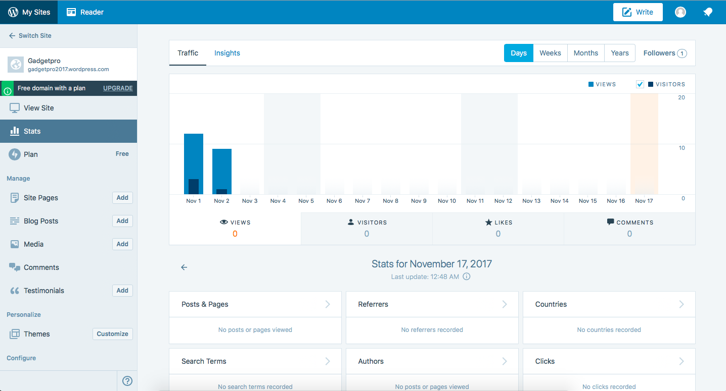

[www.gadgetpro2017.wordpress.com](http://www.gadgetpro2017.wordpress.com)

