**Project Name : Techvanto Academy**( Online Learning Website)

**Overview :**

Techvanto Academy is an Edtech startup company which allows different types of services in an online and offline modes. The services includes Workshops and the Industrial Training programs, Corporate Training, Placement Training, Research, Seminars, Events and provide assistance for their major/minor projects development.

**Home Page :**



**Sign Up Page :**

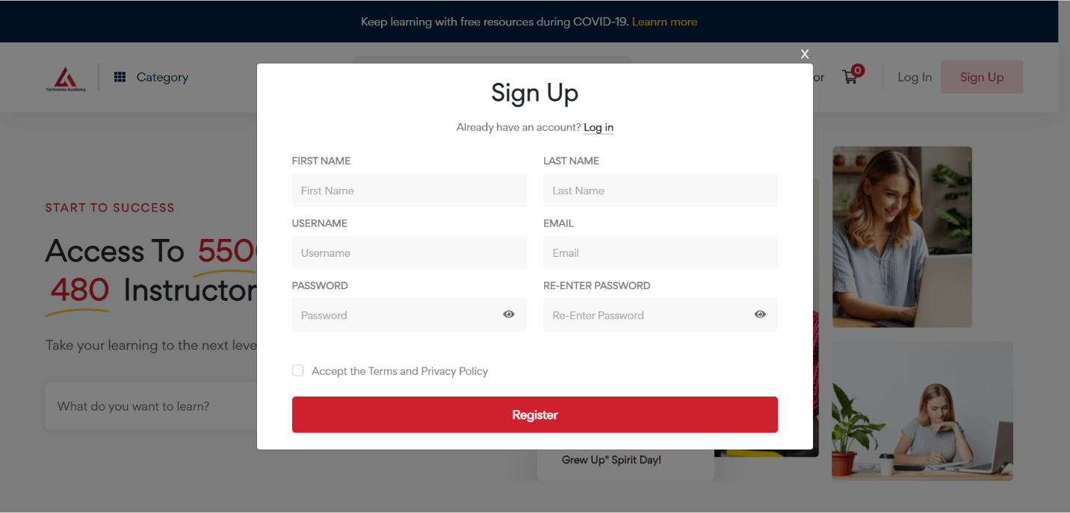

**Technology Used:**

Front-End:

1. Html
2. Css
3. Bootstrap 5
4. React

Dynamic:

1. Javascript
2. Ci/cd with AWS
3. Login and logout(oauth and jwt)

Database:

1. Mongodb
2. Json Data

Code Compiler:

1. Visual studio code
2. Git bash
3. Git hub
4. Node js.

**Goals:**

1. Home Page
2. Sign Up/Log In Pop Up
3. Cart
4. Courses
5. Page
6. Checkout Page
7. Customer Details Page
8. Login and Logout Page