Software Requirements Specification (SRS) | Introduction to Software  Development
Ahmed Abbas (1412102)  Asad Aslam (1412110)  Murtaza Fakhrudin (1412121)  Muhammad Adnan (1412117) |  | Project :  School  Management  System

Software Requirements Specification (SRS) Template

The document in this file is an annotated outline for specifying software requirements, adapted from the IEEE Guide to Software Requirements Specifications (Std 830-1993). It provides the information of Product perspective, Product functions, User characteristics, Constraints, Assumptions and dependencies and specific requirement.

CS3911

(Team Number)

(Team Name)

Ahmed Abbas(1412102)
Asad Aslam (1412110)
Murtaza Fakhrudin(1412121)
Muhammad Adnan(1412117)

Software Requirements Specification

Document

Date: (05/01/2017)

Table of Contents

1. Introduction
1.1 Purpose
1.2 Scope
1.3 Definitions, Acronyms, and Abbreviations
1.4 References
1.5 Overview

2. The Overall Description
2.1 Product Perspective
2.1.1 System Interfaces
2.1.2 Interfaces
2.1.3 Hardware Interfaces
2.1.4 Software Interfaces
2.1.5 Communications Interfaces
2.1.6 Memory Constraints
2.1.7 Operations
2.1.8 Site Adaptation Requirements
2.2 Product Functions
2.3 User Characteristics
2.4 Constraints
2.5 Assumptions and Dependencies
2.6 Apportioning of Requirements

3. Specific Requirements
3.1 External interfaces
3.2 Functions
3.3 Performance Requirements
3.4 Logical Database Requirements
3.5 Design Constraints
3.5.1 Standards Compliance
3.6 Software System Attributes
3.6.1 Reliability
3.6.2 Availability
3.6.3 Security
3.6.4 Maintainability
3.6.5 Portability
3.7 Organizing the Specific Requirements
3.7.1 System Mode
3.7.2 User Class
3.7.3 Objects
3.7.4 Feature
3.7.5 Stimulus
3.7.6 Response
3.7.7 Functional Hierarchy
3.8 Additional Comments

4. Document Approvals

5. Supporting Information

Introduction
This Software Requirement Specification is written accordance with the IEEE
Std 830-1993 model.

Purpose

We are developing this system so that we remove all paper pencil work in
school.Recent years, many systems were developed either by the universities
orthe software companies in order to partially automate many of the processes
carried out by the department. Those developments dramatically reduce the
time take in searching information and should enable the school to maintain
precise and up-to-date information. For example, previously, students would
have to enquire for much of his information from the school student office,
which required more time and effort, particularly from members of staff. The
new system is more efficient and also often presents more accurate
information. However, those systems vary even within the same university.
Some are quite well developed and implemented, some still adopting the
inferior and out of-date technology. This is also one of the project’s aims: to
analysis some sample systems in order to attain the strengths and eliminate the
weaknesses in developing the new potential student information system. In all
these some flaws were found but inour system we will remove these flaws and
make a very sufficient system

1.2 Scope

In this subsection:
- The name of our project is SMART SCHOOL
- Recording information of students, their marks, their fees, their exams schadules and also their marksheets.

1.3 Definitions, Acronyms, and Abbreviations.

SMS Student Management System
Student Info Student Information
GUI Graphical User Interface
HTTPS Hypertext Transfer Protocol Secure
HTTP Hypertext Transfer Protocol
CLI Command line interface
SQL Structured Query Language

1.5 Overview

In this subsection:
- The rest of SRS contain system specification,hardware information
- SRS is organized by a group of 4 students

2. The Overall Description
.

2.1 Product Perspective

Our product is consists on Application (e,g Forms interfaces) and Database. it
controls all the necessary functions of school as well as some office work e.g Fees
collection

2.1.1 System Interfaces

A:Admission Module
B:Exam Schedule Module
C:Fee collection Module
D:Marksheet Module
E:Report Module
F:Login Module

2.1.2 Interfaces

Our user will interact with system by using GUI(Graphcical User Interface) because common computer user can’t directly interact with system through CLI (command line interface) and there is also hardware interface and no need for communication interface because of the Desktop-based Application.

2.1.3 Hardware Interfaces

Minimum Core 2 duo 1.3 Ghz processor

2GB Ram,

250 GB Hard Drive

supported by Windows 7 to 10 OS (Operating Systems)

The SQL Server 2014 is installed in the client PC, used for performing Data
Storage tasks efficentally in the Databases.

2.1.4 Software Interfaces

Client will be interect to the system through GUI (Graphical User Interface) which used Nice theme, Iconed buttons, radio buttons, labels, Icons and other neccessory components for perform desired tasks.
e.g Froms. There are several forms like Student Addmission, Fee Collection,
Reports ,Finance Form,Scheduling etc.

2.1.5 Communications Interfaces
Our software is Desktop-based Application and there is no need to any
communication protocols (e.g HTTPS, HTTP etc) for client to communicate to
the system.

2.1.6 Memory Constraints
Our system can easily run on 1GB Ram. User don’t need to make his system so
dedicate.

2.1.7 Operations

There are two types of users, Admin and Finance user both have a different
interface.
Normal Operations for Both user such as:

- Both could perform add new Record task.(e.g Add New Student, Fee Collection, Marksheet Details etc)
- Both could Print/Print View the Record. .(e.g Student Admission Record, Fee Collection recipt, Result etc)
- Both could Search/View any record. (e.g Student Admission Record, Fee Collection record, Exam Scadule etc)
- Both could Issued the T.C for Student.
- Admin user can make a new user and assign him some credentials.
- Finance receive fee and make salary and send them to the staff. Finance officer can make a monthly report

Special Operations for Admin such as:

- Admin could Edit/Update any record.(e.g Student record, Fee Collection record, Marks etc).
- Admin could Delete any record.
- Reports will be visible only to Admin.(e.g Monthly Fee Report of Students, Monthly Addmission Report etc)
- Only admin is responsiable to manage user Accounts.(e.g Add new user , delete user etc.)

2.1.8 Site Adaptation Requirements

Our sytem is designed environment friendly so it will run a very simple laptop as
well as on a 340 Watt system.

2.3 User Characteristics

We design our GUI so simple and user friendly that it can be use by anyone on
behalf of a simple training.There is no need to be a expert to use our system.

2.5 Assumptions and Dependencies

We assume our system will run fluently on any other system because we are designing this system that can run easily on P4 PC.

3.1 External Interfaces
Our all GUI are connected with Microsoft SQL Server 2014. Our all forms has the
dataflow from GUI to databse and database to GUI

3.2 Functions

We will implement some important functionality such that if a user /Admin wants to delete record of student, Changing of timetable and Adding and delete of user accounts, viewing reports etc.

3.4 Logical Database Requirements

As we mention above we will be using Microsoft SQL Server 2014 for our system. We are mentioning here some of our tables,
User Login
Roles
Student
Marksheet
Fees
Exam Schadule

3.6.1 Reliability

After deploying system on client System,we will make sure that system never turn
Off During and after school and office timings. We ask client to connect a UPS
supply To the system in case of power failure.

3.6.2 Availability

System is designed to be available that it will run whenwever it is open. Now
normally school is not open at night so it is good to turn off the system

3.6.3 Security

- We will implement a feature of user password security to our system but in future we try to deploy biometric system.

3.6.4 Maintainability

We will ensure during development that we design our software in such manner
that it can be extend in future

Some Screen shots of our App
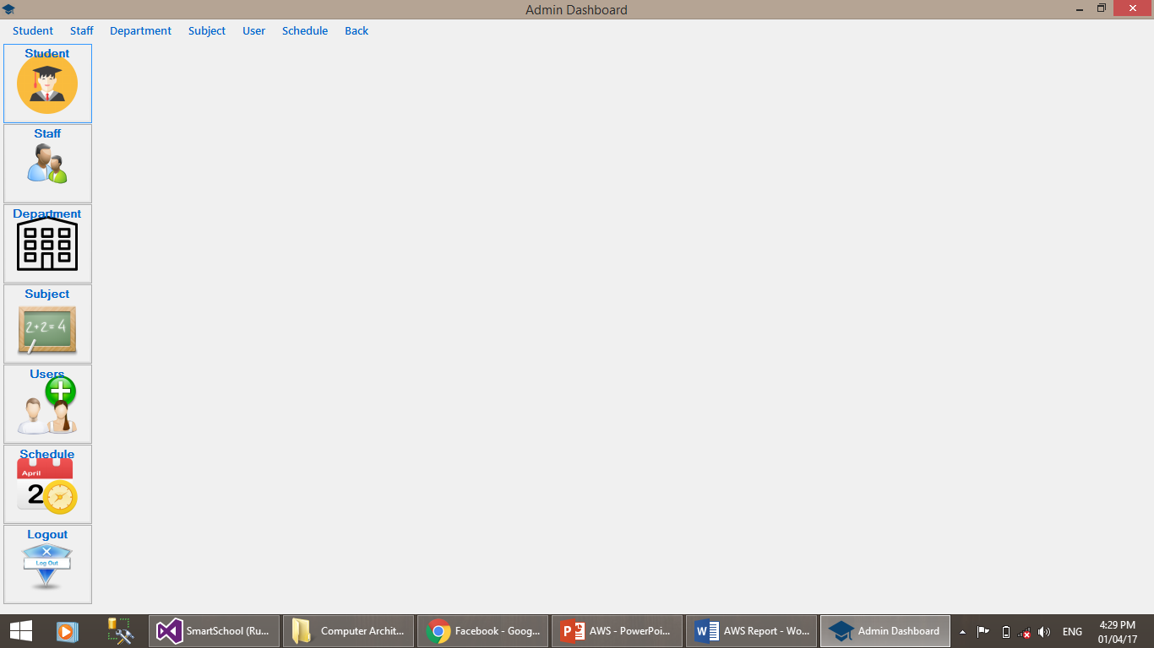

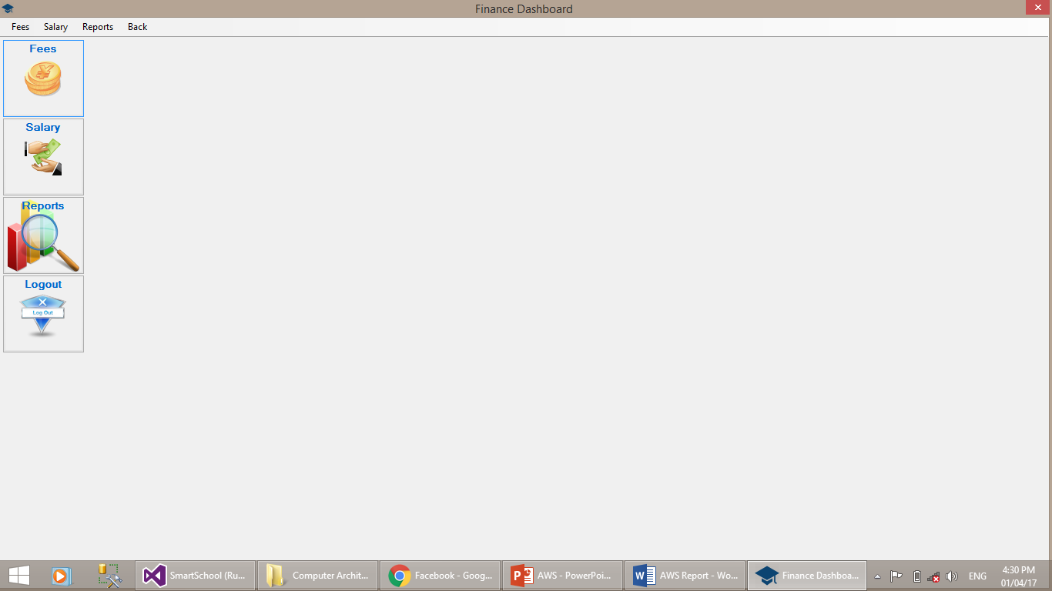

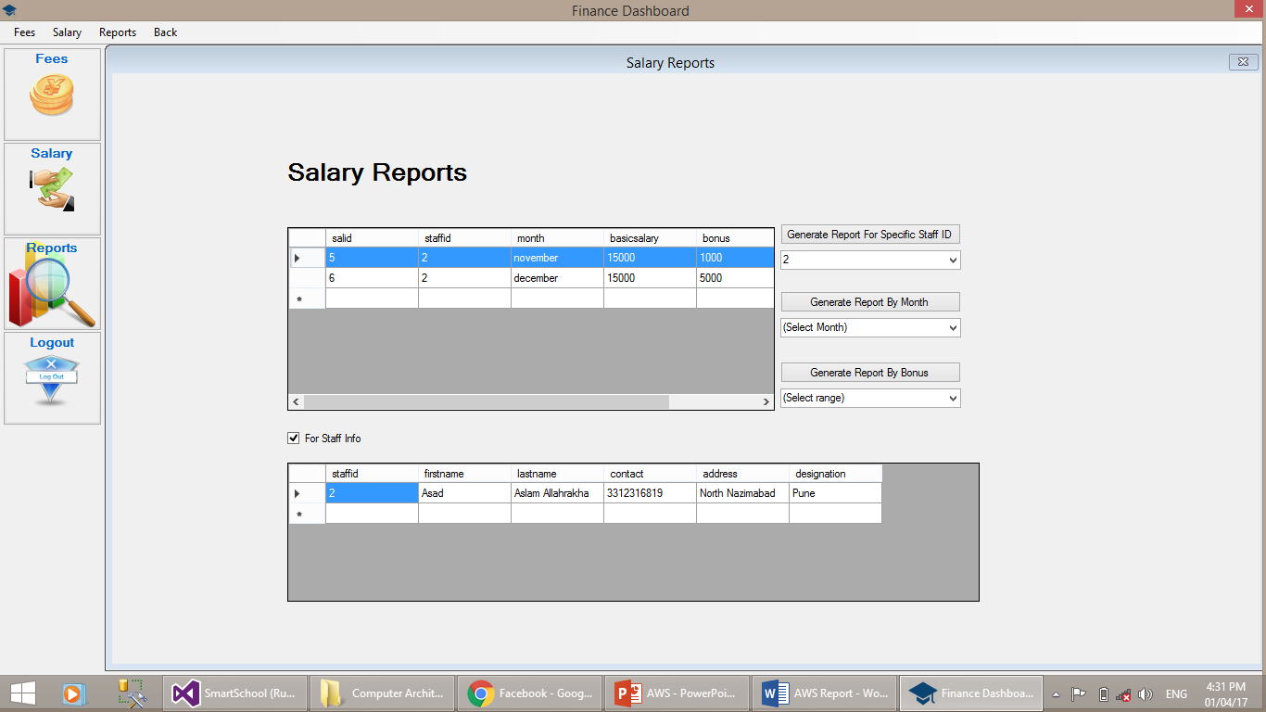

UML DAIGRAMS
Activity 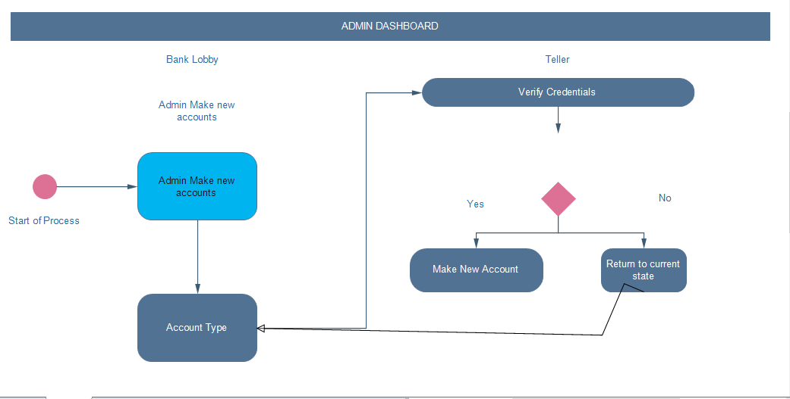:

Finance Daigram:
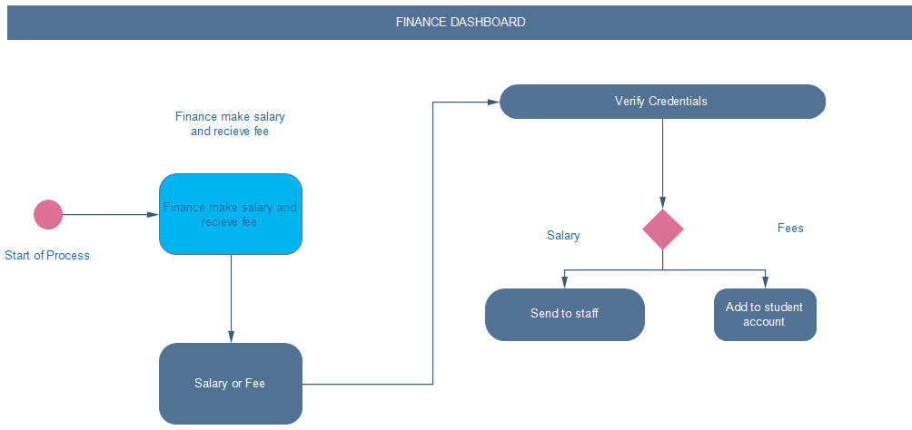

Use case diagram:
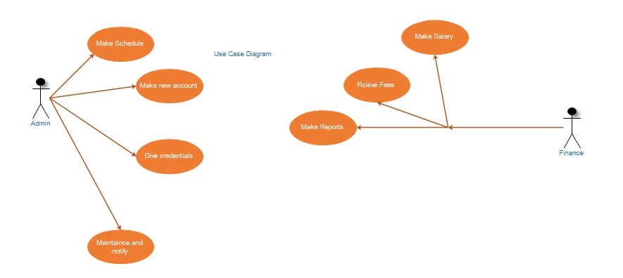

DFD:
