
PAYROLL MANAGEMENT SYSTEM
Operating Manual
Majma al Markazi
Central Education Department
Version 2.0
3 September 2026
Classification: Internal Use

Document Control
Field | Detail
Document Title | Payroll Management System — Operating Manual
Prepared For | Majma al Markazi, Central Education Department
System | Payroll Management System (school payroll module)
Version | 2.0
Date | 3 September 2026
Classification | Internal Use

Revision History
Version | Date | Summary
1.0 | 18 August 2026 | Initial release — covers all five system roles.
2.0 | 3 September 2026 | Redesigned interface throughout; adds the Staff Grading & Compensation Policy tools (Staff Grades, compliance highlighting, single and bulk salary increments), per-school location tiers for HRA/CCA, the dashboard school filter, and the Compensation Compliance report.

Table of Contents

1. Introduction

1.1 Purpose of This Manual
This manual explains how to use the Payroll Management System, organized by the five user roles the system recognizes: Super Admin, HR Manager, Finance Manager, Management, and School Admin. Each role’s chapter walks through exactly what that role can see and do, in the order a typical month’s work would follow, with screenshots of the actual application at each step.

1.2 About the System
The Payroll Management System is a centralized platform for running monthly payroll across every school in the organization. It pulls employee master data from the AIIMS Central ERP, maintains configurable salary structures and statutory rules (Provident Fund, ESI, Professional Tax, TDS, and Labour Welfare Fund) that can be set per school, and computes each employee’s monthly pay automatically — including proration for mid-month joiners and leavers, loss-of-pay, overtime, bonuses, and Full & Final settlements for exiting staff.
Every payroll cycle passes through a two-stage approval workflow — HR review, then Finance approval — before a balanced journal voucher is generated and posted to the organization’s Financial ERP. From there, the system produces payslips, a detailed salary register, statutory reports, a bank payment file for salary disbursement, and a reconciliation report confirming what was posted matches what was computed.
The system also implements the organization’s Staff Grading & Compensation Policy directly: every employee can be assigned a grade with a defined basic-salary band and standard yearly increment, the system highlights anyone whose pay falls outside that band, and annual increments are calculated automatically from a performance rating rather than worked out by hand.

1.3 Roles at a Glance
Role | Typical User | Primary Responsibility
Super Admin | System owner / IT administrator | Full administrative access to every module, including school and GL account setup.
HR Manager | HR / administrative staff | Maintains employee records, salary structures and increments; creates and computes each monthly payroll cycle and submits it for review.
Finance Manager | Accounts / finance staff | Reviews and financially approves payroll; posts the journal voucher to the Financial ERP; manages statutory rates, GL mappings, reconciliation and bank advice.
Management | School / trust leadership | Read-only oversight of payroll cost, trends, status and compensation-policy compliance via the dashboard and reports.
School Admin | School-level administrator | Read-only visibility into employees and payroll (currently the same access tier as Management — see Chapter 5).

2. Getting Started
This section applies to every role. The steps below assume your account has already been created by your Super Admin.

2.1 Signing In
- Open the Payroll Management System in your browser.
- Enter your Login ID. This is a short word (for example HR, Finance, Superadmin, Management or Schooladmin) — not an email address.
- Enter your Password.
- Optionally check “Remember me” to stay signed in on this device.
- Click Sign in.
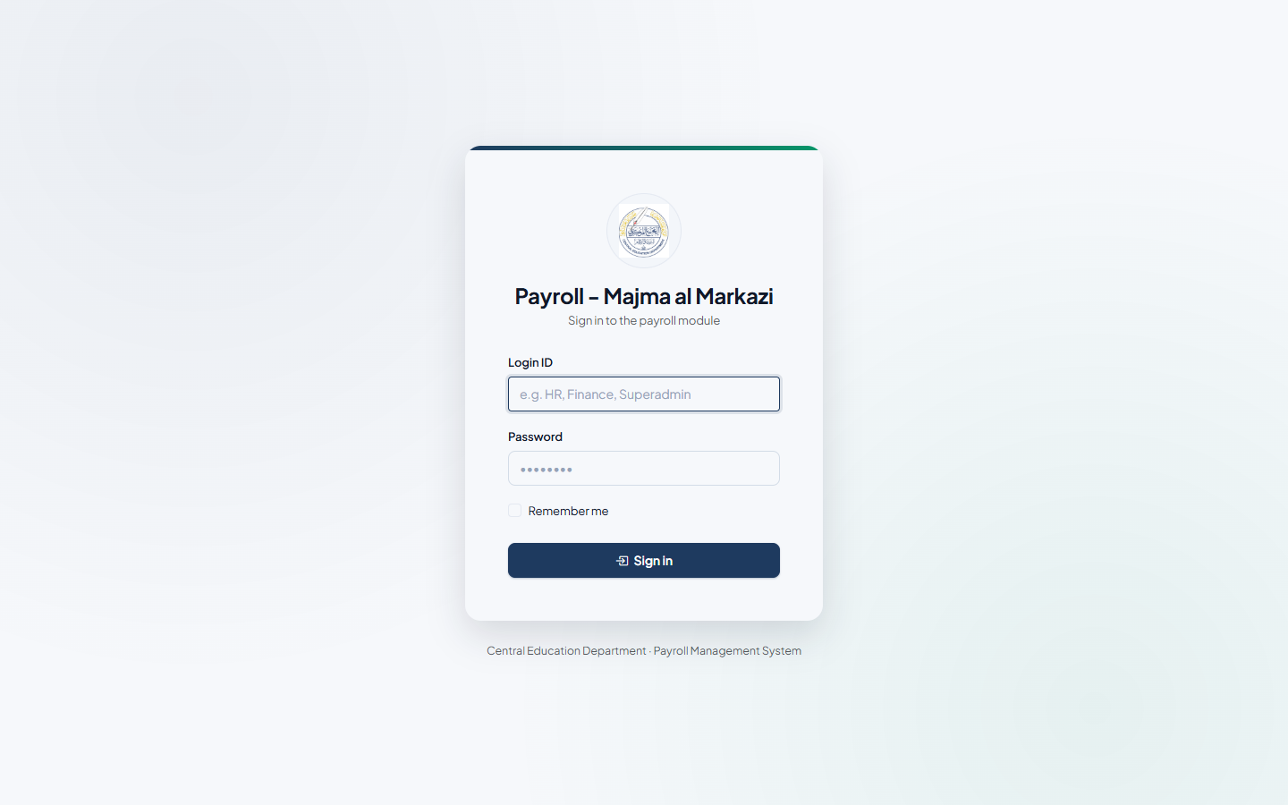
Figure 2.1 — The sign-in screen.
Note: Login IDs and passwords are provisioned individually by your Super Admin. If you’ve forgotten your password or your account has been deactivated, contact your Super Admin — there is currently no self-service password reset.

2.2 The Dashboard
After signing in you land on the Dashboard — a one-screen summary of payroll health across every school. It shows:
- Gross Payroll Cost, Net Disbursement, Pending Approvals, Employees Processed, Month-on-month Cost Variance, Average Approval Turnaround, and AIIMS Sync Health as summary cards.
- A Payroll Cost Trend chart comparing gross vs. net pay over the last 12 months.
- A Department Payroll Cost chart showing which departments cost the most this month.
- A Recent Payroll Runs table listing the latest cycles across all schools with their status.
- A Recent Activity feed showing who did what, and when.
A Filter by School control sits above the summary cards. Open it, tick one or more schools (or use Select all / Clear), and click Apply — every figure on the page, including the trend chart and department breakdown, recalculates for just the schools you picked. Leave nothing selected to see all schools, which is the default.
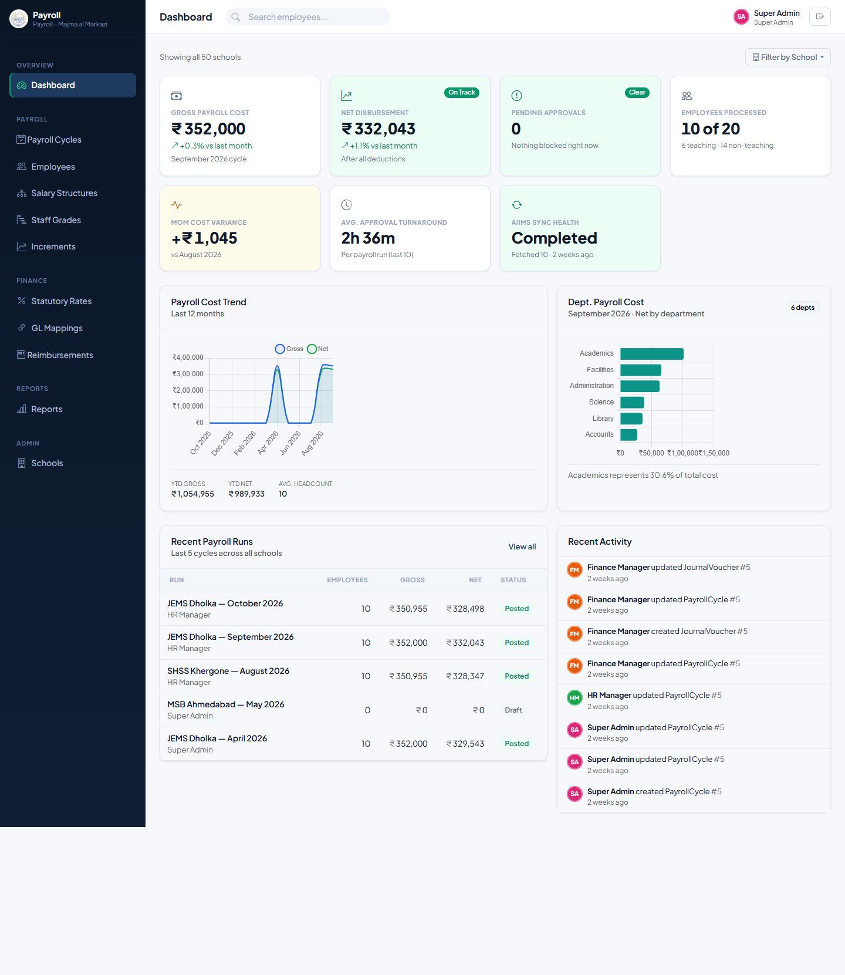
Figure 2.2 — The Dashboard, with the school filter above the summary cards.

2.3 Navigating the Sidebar
The left-hand sidebar is grouped into five sections: Overview (Dashboard), Payroll (Payroll Cycles, Employees, Salary Structures, Staff Grades, Increments), Finance (Statutory Rates, GL Mappings, Reimbursements), Reports, and Admin (Schools). A red badge next to Payroll Cycles or Reimbursements shows how many items are waiting for action. What you can click through to — and which buttons actually appear on a page — depends on your role; the chapters that follow describe those differences in detail.

3. Super Admin
The Super Admin role has unrestricted access to every module in the system. This chapter covers the areas that are Super Admin’s alone — Schools, GL Account Mappings, and Staff Grades — which underpin everything the other roles do.

3.1 Managing Schools
Every employee, payroll cycle and report belongs to a school. Before payroll can run for a new school, it must be registered here.
- From the sidebar, go to Admin → Schools.
- Click + Add School (or Edit an existing one).
- Enter the school’s Name, a short unique Code, its AIIMS School Code (used to match records during AIIMS sync), a default GL Cost Centre Code, and contact details.
- Choose a Location Tier — Tier 1, 2, 3, or leave it Not set. This drives the HRA and CCA percentages HR sees suggested when setting up a salary structure at that school (policy Annexure B-2).
- Save. The school now appears in every school-picker across the system (payroll cycles, employee sync, reports).
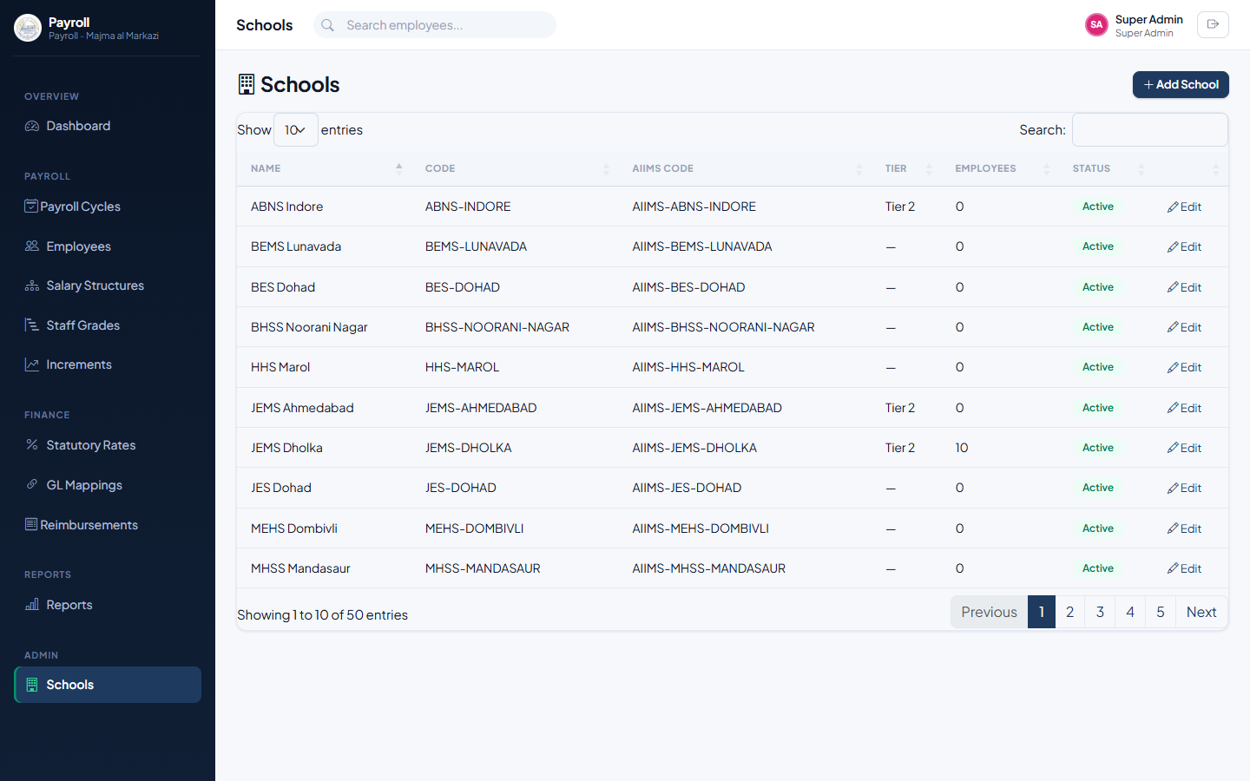
Figure 3.1 — Schools list, showing every registered school, its location tier and employee count.
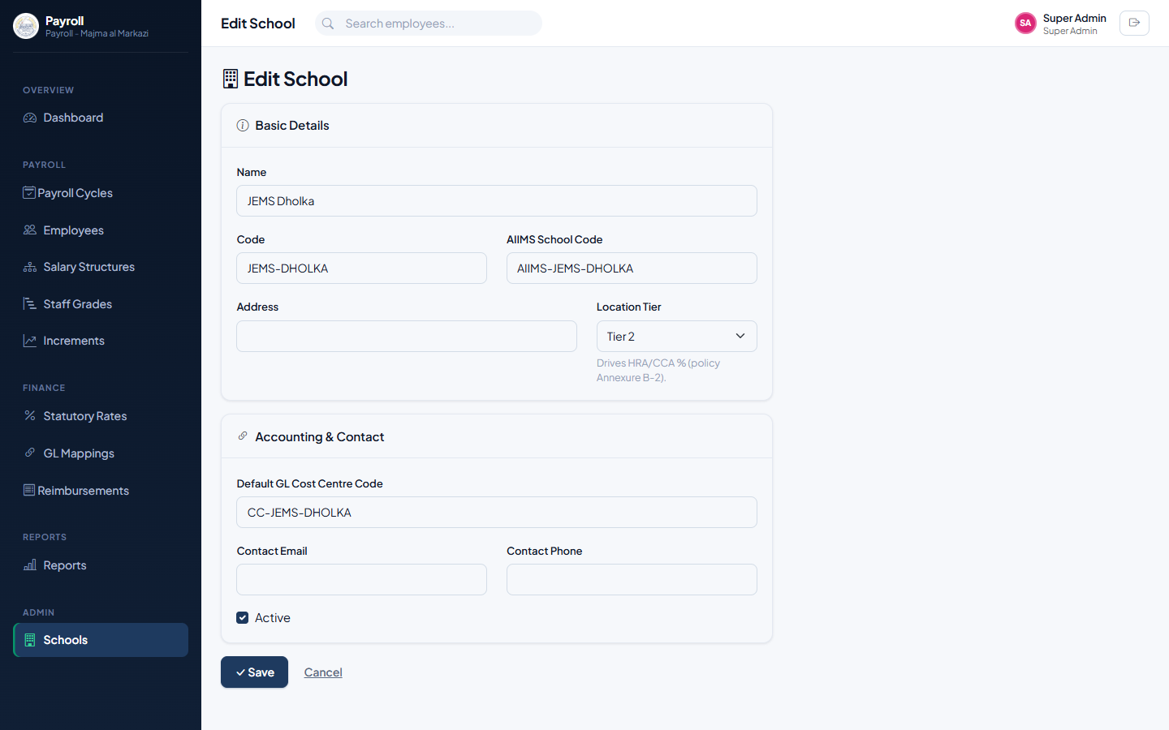
Figure 3.2 — Editing a school, including its Location Tier.

3.2 Configuring GL Account Mappings
Before Finance can post a payroll cycle’s journal voucher to the Financial ERP, every payroll cost and liability category (salary expense, PF liability, net pay payable, and so on) must be mapped to a real GL account code and, optionally, a cost centre. A mapping left without a school selected acts as the organization-wide default; a school-specific mapping overrides it for that school only — useful when a particular school’s finance team uses a different chart of accounts.
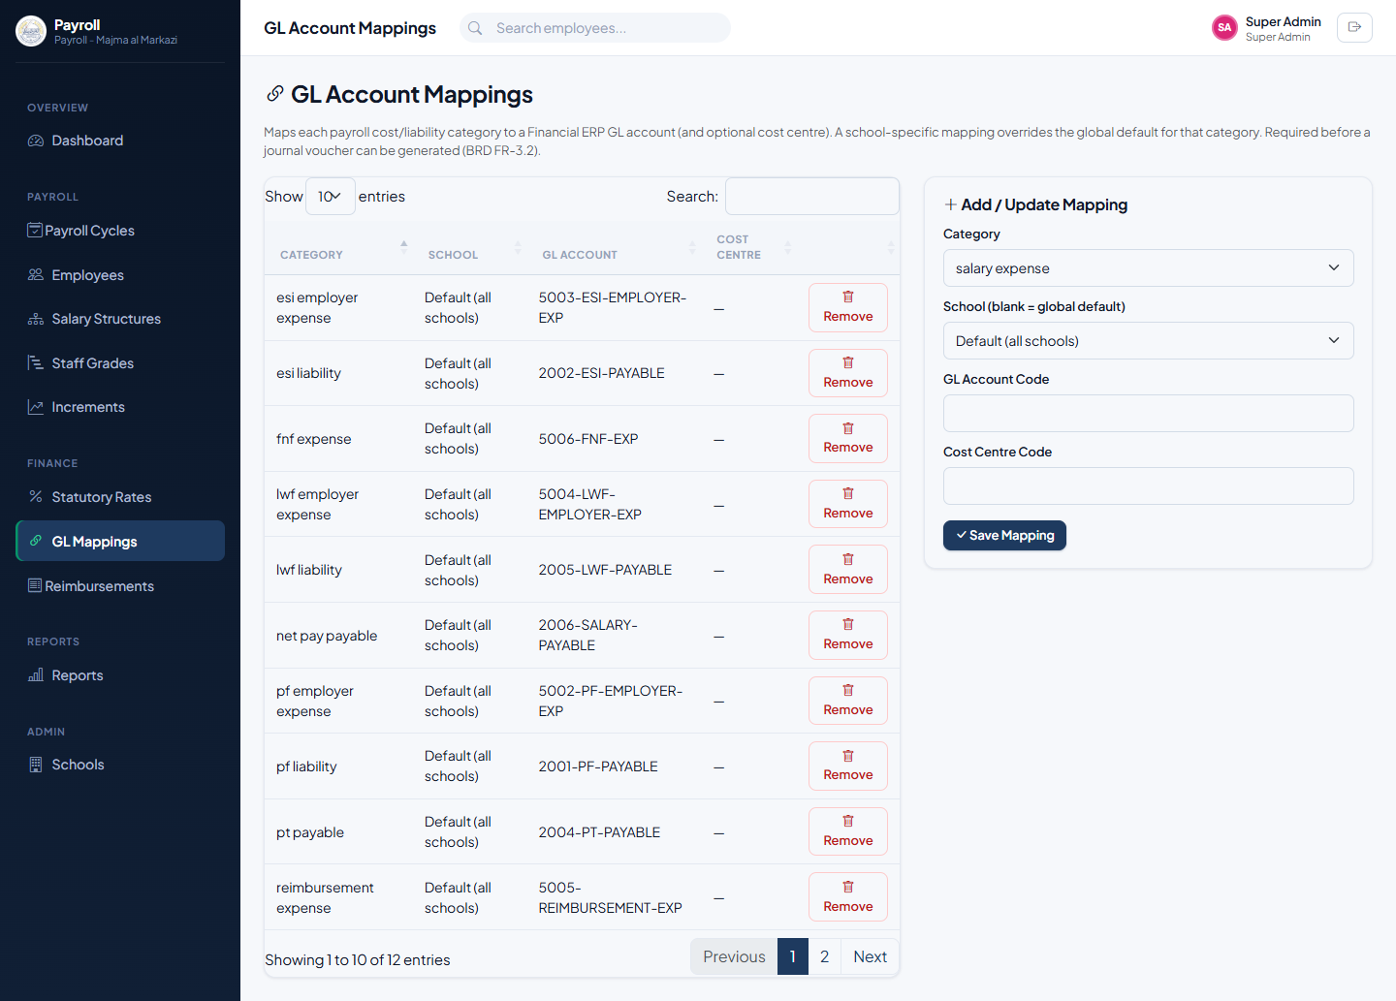
Figure 3.3 — GL Account Mappings: the current mapping table and the add-mapping form.

3.3 Managing Staff Grades
Staff Grades implement the organization’s Staff Grading & Compensation Policy directly in the system. Each grade carries the monthly basic-salary band and the standard yearly increment amount that policy Annexures A-1, A-2 and B-1 define for it — this is what powers the compliance highlighting and increment calculations described in Chapter 4.
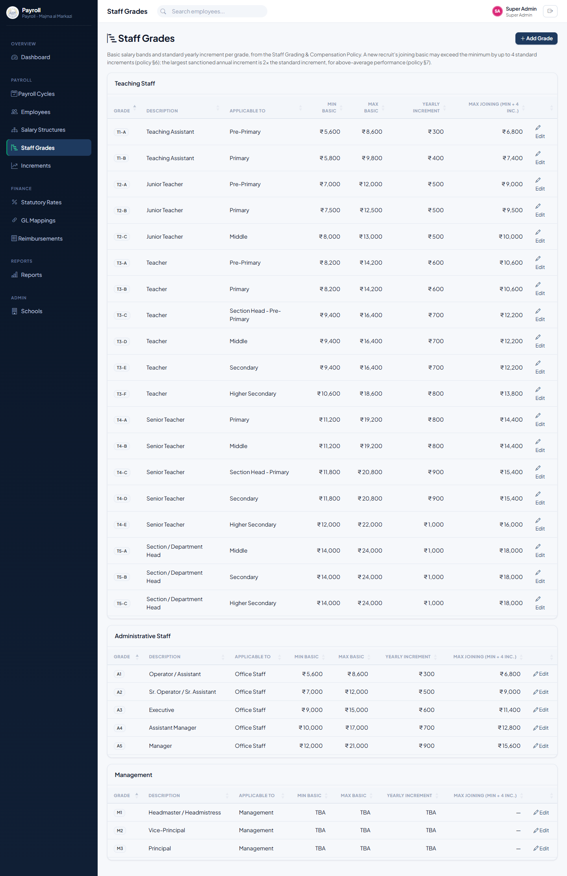
Figure 3.4 — Staff Grades, grouped by Teaching, Administrative and Management staff.
The list is grouped by staff type and shows, for every grade, the minimum and maximum basic, the standard yearly increment, and the maximum permissible joining basic for a new recruit (minimum plus four standard increments, per policy §6). Grades whose pay band hasn’t been finalized yet show as TBA rather than a figure.
- From the sidebar, go to Payroll → Staff Grades.
- Click + Add Grade, or Edit an existing one.
- Enter the Grade Code, Description, Applicable To (e.g. Primary, Office Staff), and Staff Type.
- Enter the Minimum and Maximum monthly basic, and the Yearly Increment — leave these blank if the band isn’t finalized yet.
- Save.
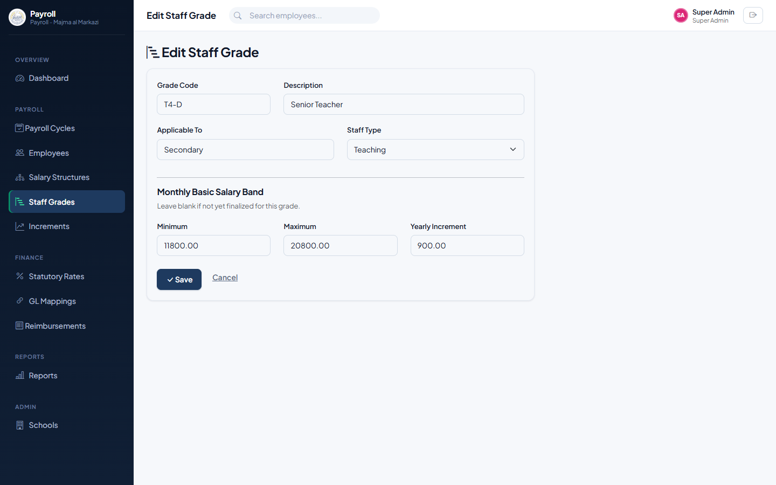
Figure 3.5 — Editing a staff grade.
Note: Pay scale levels are meant to be reviewed periodically to adjust to market dynamics (policy §9) — update the figures here when a revision is approved, rather than tracking it outside the system.

3.4 Scope of the Super Admin Role
Because Super Admin bypasses every role check, this account can also do everything described in Chapter 4 (HR Manager) and Chapter 5 (Finance Manager) — create employees, run payroll, approve cycles, post vouchers, give increments, and so on.
Note: Reserve the Super Admin login for system owners and initial setup. Day-to-day HR and Finance work should go through the dedicated HR and Finance accounts, so the approval workflow’s built-in checks and balances — one person reviewing, a different person approving — stay meaningful.

4. HR Manager
The HR Manager maintains the employee master data, salary structures and increments, and drives each month’s payroll cycle from creation through to HR sign-off.

4.1 Employee Records

4.1.1 Syncing Employees from AIIMS
Employee master data is normally pulled from the AIIMS Central ERP rather than typed in by hand.
- Go to Payroll → Employees.
- Under “Sync from AIIMS Central ERP”, choose the school to sync.
- Leave “Full load” unchecked for a routine incremental sync (new joiners, updates and exits since the last run), or check it to pull every record fresh.
- Click Sync now. A confirmation shows how many records were fetched, created, updated, or failed validation.
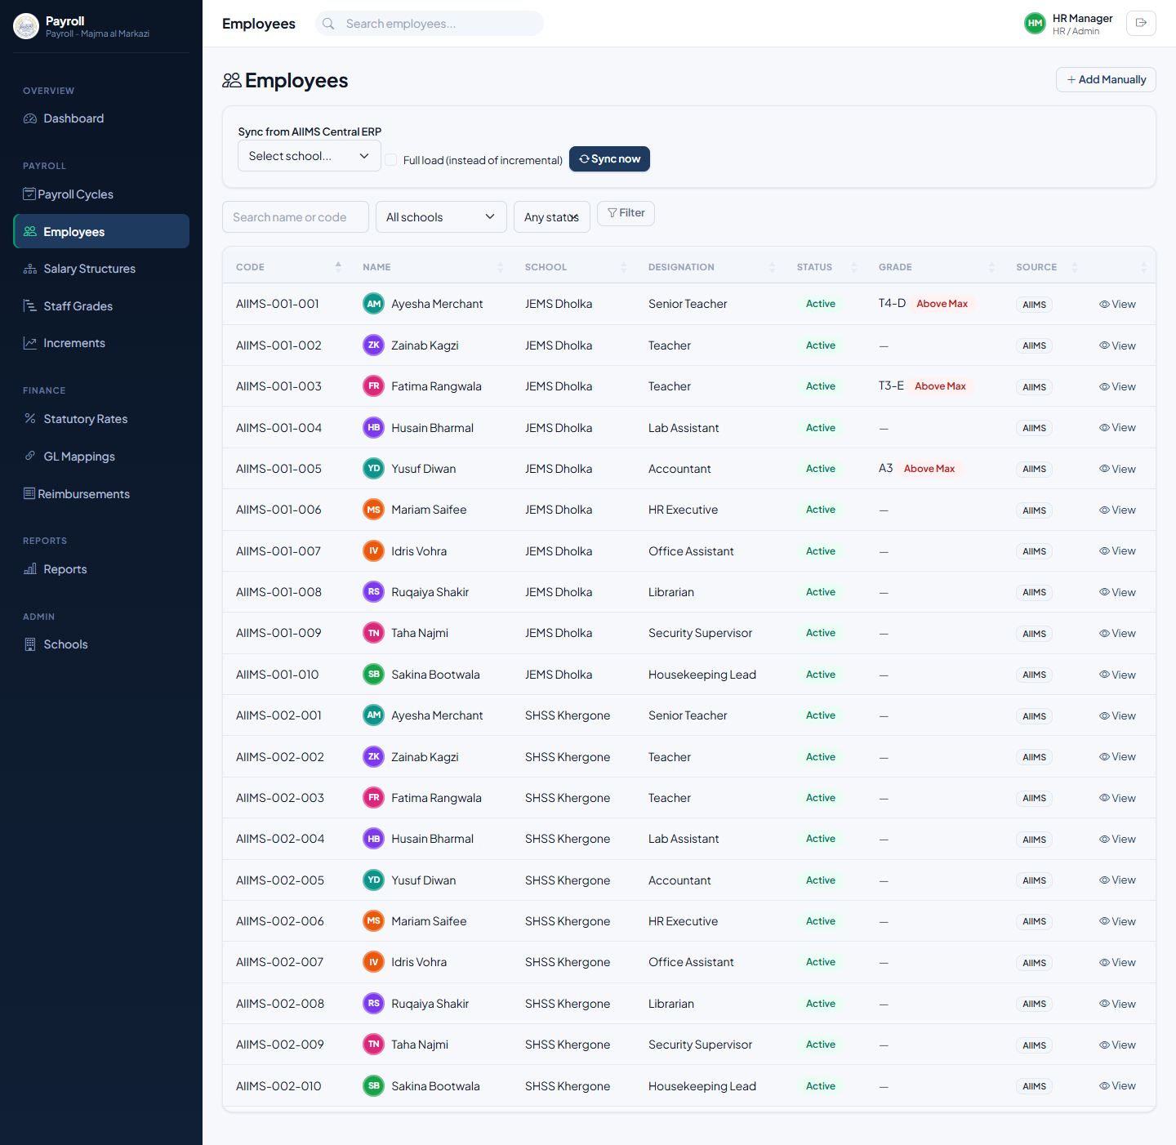
Figure 4.1 — Employees list, with the AIIMS sync panel and a Grade column showing compliance flags.
The Grade column shows each employee’s assigned staff grade and, where their current basic salary falls outside that grade’s policy band, a colored flag — Below Min or Above Max — right in the list, so out-of-band employees are visible at a glance without opening each profile.

4.1.2 Viewing an Employee’s Profile
Click View on any employee to see their full profile: personal and bank details, current salary structure, statutory applicability, grade and compensation-policy compliance, reimbursement history, and past payslips.
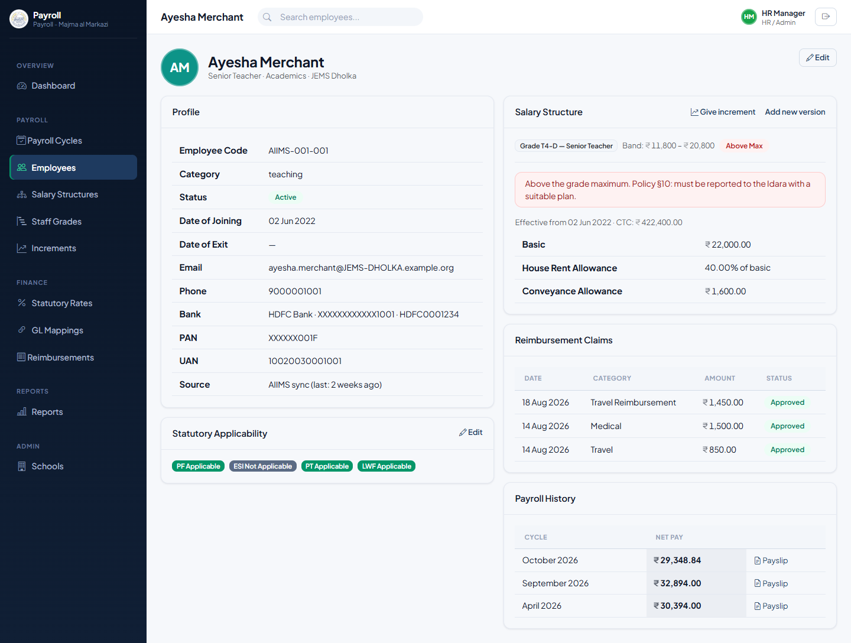
Figure 4.2 — An employee’s profile, showing their grade, policy band and an Above Max compliance flag.
When an employee is outside their grade’s band, the profile explains what that means: below the minimum, the school has up to two years to bring them up to it via suitable increments (policy §10); above the maximum, it must be reported to the Idara with a suitable plan.

4.1.3 Editing an Employee, Statutory Applicability & Staff Grade
Open Edit on an employee to update their details, or to add someone manually who isn’t sourced from AIIMS. The Bank & Statutory section includes four Yes/No toggles — PF, ESI, PT and LWF Applicable — which control whether that employee’s payroll includes each statutory deduction at all. A Staff Grade dropdown, grouped by Teaching / Administrative / Management, lets you assign or change the employee’s grade — this is what drives the compliance highlighting and increment calculations.
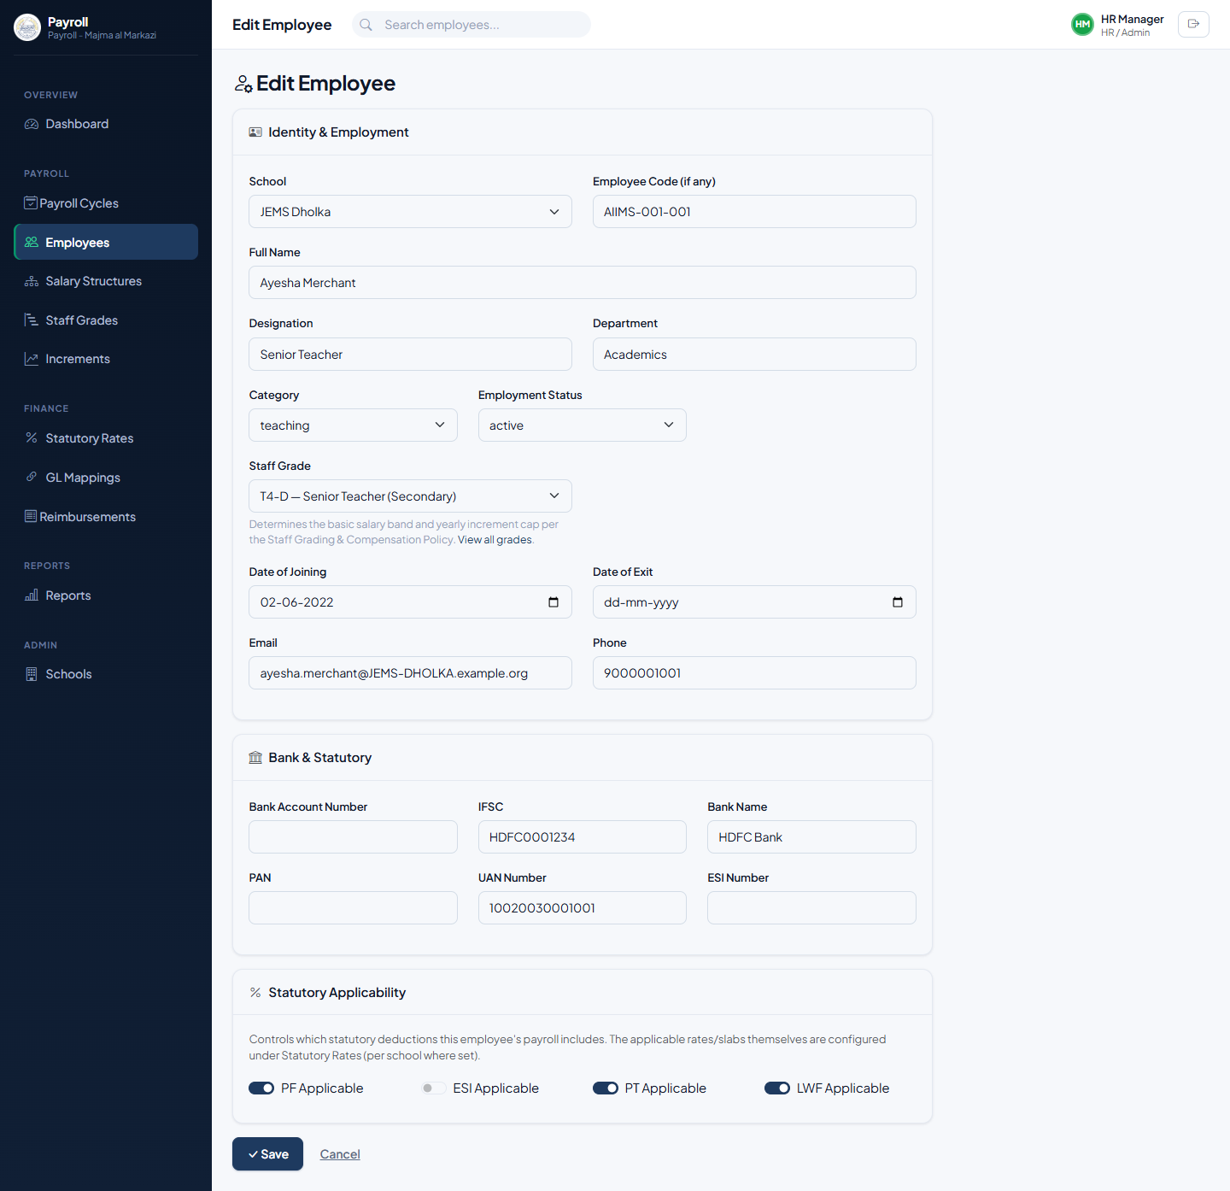
Figure 4.3 — Editing an employee, including the Staff Grade dropdown and statutory applicability toggles.

4.2 Setting Up a Salary Structure
Every employee needs an active salary structure before payroll can be computed for them.
- From the employee’s profile, click Add new version under Salary Structure (or go via Payroll → Salary Structures).
- If the employee has a staff grade assigned, the page shows their grade’s basic band and, for a new recruit, the maximum joining basic allowed (policy §6). If their school has a location tier set, it also shows the policy HRA and CCA percentages for that tier, and pre-fills those percentages into the HRA and CCA fields below.
- Set the Effective From date and the monthly Basic salary.
- Add any allowances that apply — HRA, CCA, Conveyance, Special Allowance and so on — as either a fixed amount or a percentage of basic, adjusting the pre-filled HRA/CCA if needed.
- Save. This becomes the employee’s active structure from that date forward; an older structure is automatically superseded, not deleted. If the figures fall outside what the policy allows, a warning appears on the next screen — explained in §4.3 below.
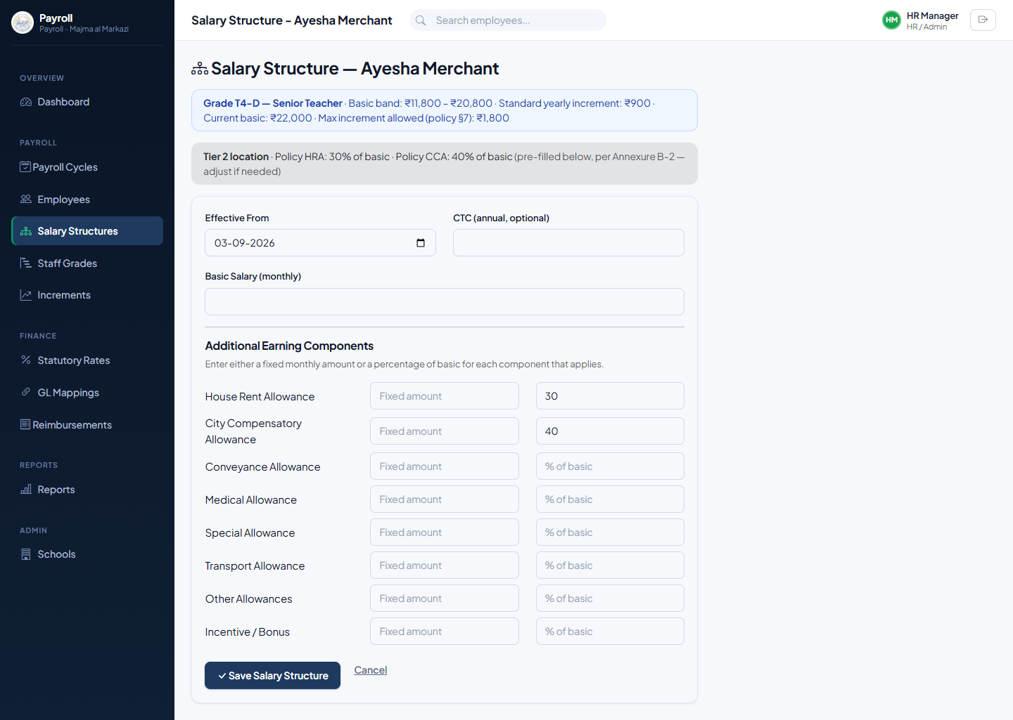
Figure 4.4 — Setting up a salary structure, with the grade band and tier-based HRA/CCA hints shown together.

4.3 Giving Increments
Rather than working out an increment by hand and typing a new basic into the salary structure form, the Increments tool calculates it directly from the employee’s grade and a performance rating, per policy §7: Below Average gives no increment, Average gives the grade’s standard increment, and Above Average gives double the standard increment.

4.3.1 Giving a Single Increment
- From the employee’s profile, click Give increment next to Salary Structure (only shown once the employee has a grade and an existing salary structure).
- Choose a Performance Rating. The New Basic field updates automatically to show current basic plus the resulting increment.
- Set the Effective From date and, optionally, Remarks (e.g. “KRAs met, strong Q3 performance”).
- Click Apply Increment. This creates a new salary structure version at the calculated basic, carrying forward the employee’s existing allowances unchanged, and records the rating on it — including a Below Average outcome, so a review that resulted in no raise still shows as having happened.
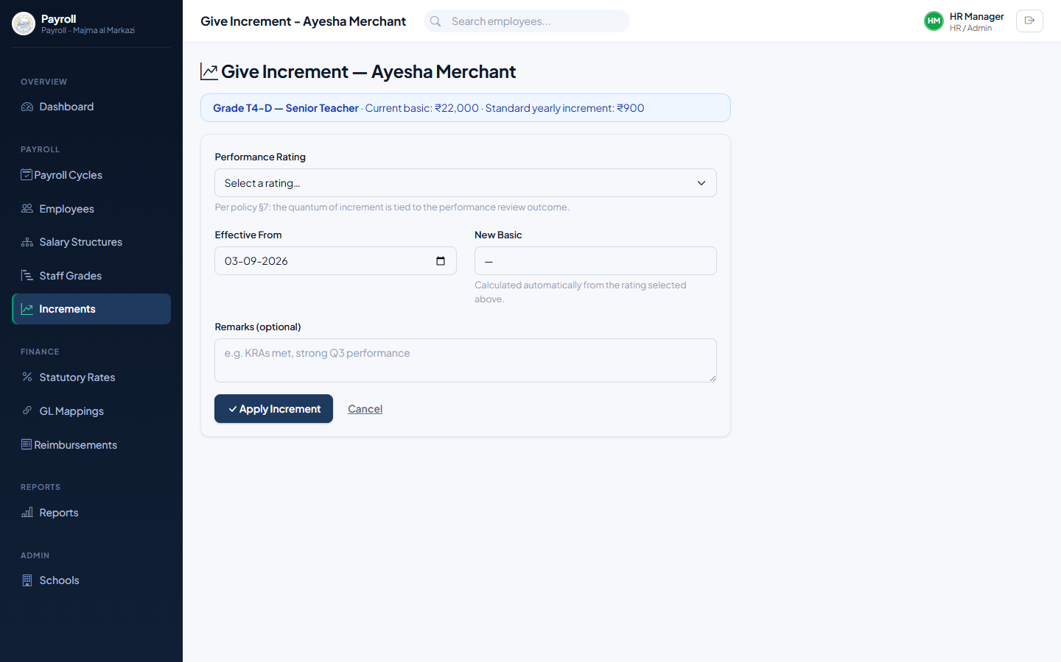
Figure 4.5 — Giving a single increment, with the new basic calculated live from the rating chosen.

4.3.2 Bulk Increments
For an annual increment cycle covering many employees at once, use Payroll → Increments instead of visiting each profile individually.
- Go to Payroll → Increments. The list shows every active employee who has a staff grade with a finalized increment amount, optionally filtered to one school.
- Set the Effective From date that will apply to every increment on this screen.
- For each employee you want to act on, choose a Performance Rating — the New Basic column updates live. Leave a row on No change to skip that employee entirely.
- Click Apply Increments. Every row with a rating selected gets a new salary structure in one action; rows left on No change are untouched.
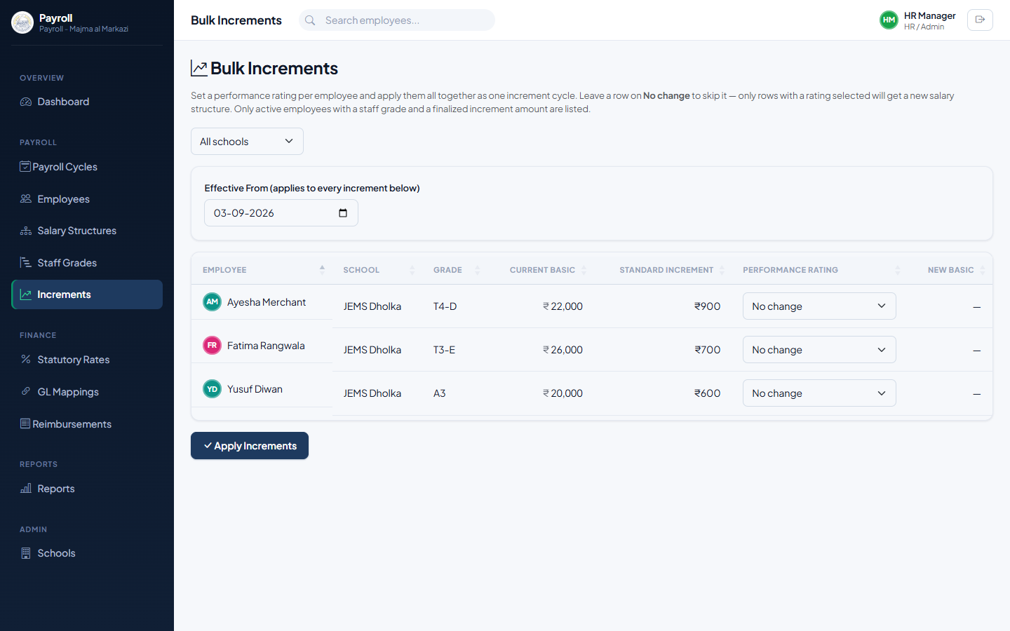
Figure 4.6 — Bulk Increments, applying a performance-based raise to several employees in one action.
Note: These calculations never exceed what policy §6/§7 allow by construction — there’s nothing to override here. The only case where a warning appears is if you instead type a basic directly into the general Salary Structure form (§4.2) and it happens to exceed the policy cap; that warning is advisory, not a block, since the policy allows justified exceptions.

4.4 Creating and Computing a Payroll Cycle
- Go to Payroll → Payroll Cycles and click + New Cycle.
- Choose the School, Month and Year, then Create Cycle. The cycle starts in Draft status.
- On the cycle page, click Run Payroll. The system computes every eligible employee’s pay — basic, allowances, statutory deductions, reimbursements and F&F settlements where applicable — and lists them in the Payroll Items table.
- While still in Draft, you can fine-tune any employee’s loss-of-pay days, overtime, bonus, arrears, or PF/ESI wage override, then click Recompute Payroll to reapply those adjustments.
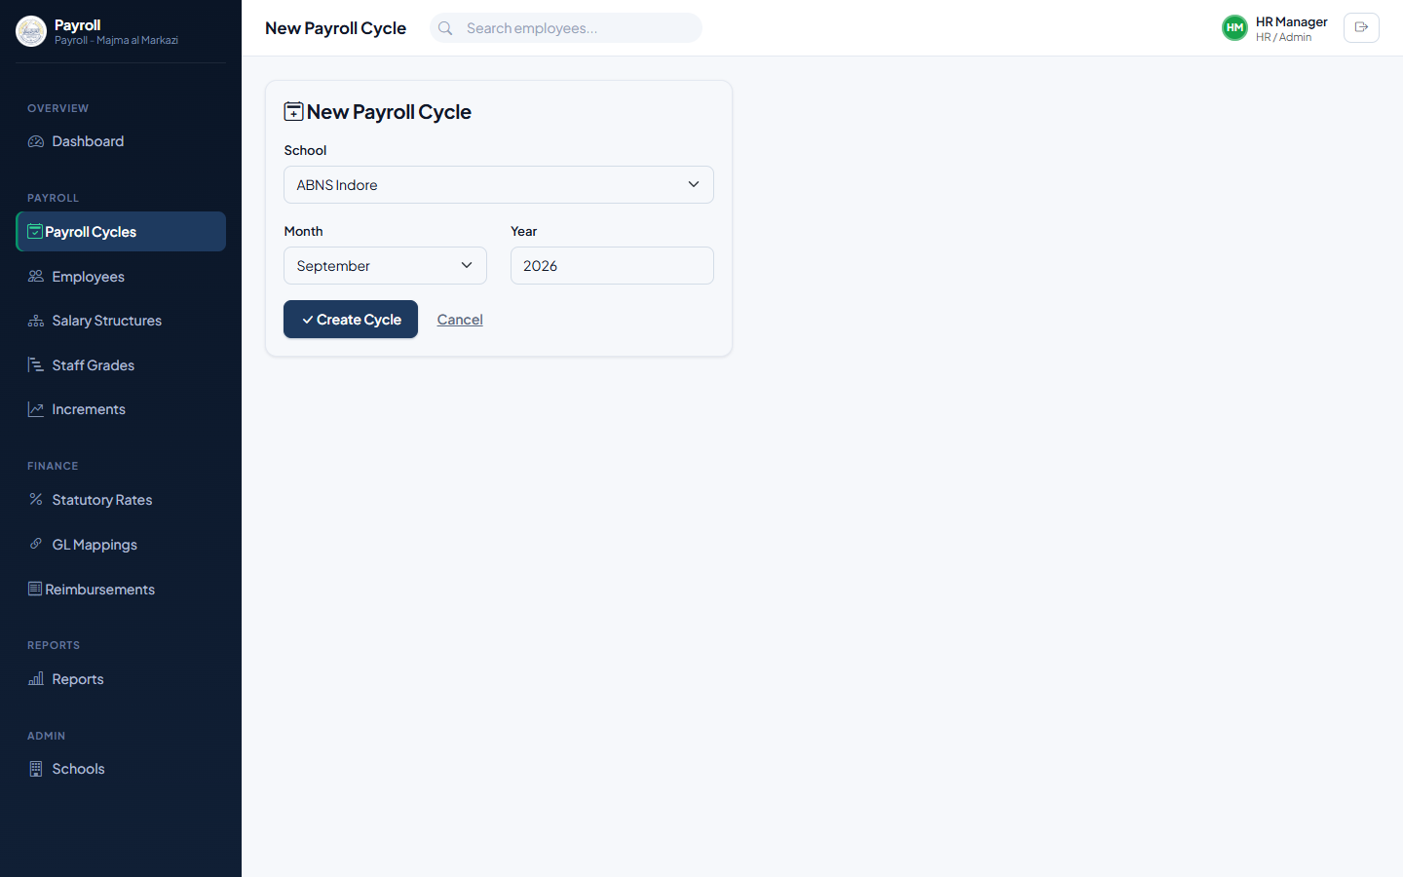
Figure 4.7 — Creating a new payroll cycle.

4.5 Submitting Payroll for Review
Once you’re satisfied with the computed figures, click Submit for HR Review. The Approval Workflow panel at the top of the cycle updates to show the cycle is now waiting on HR sign-off; the HR Approve → Finance button becomes available. Approving here moves the cycle to Finance Review — covered in Chapter 5.
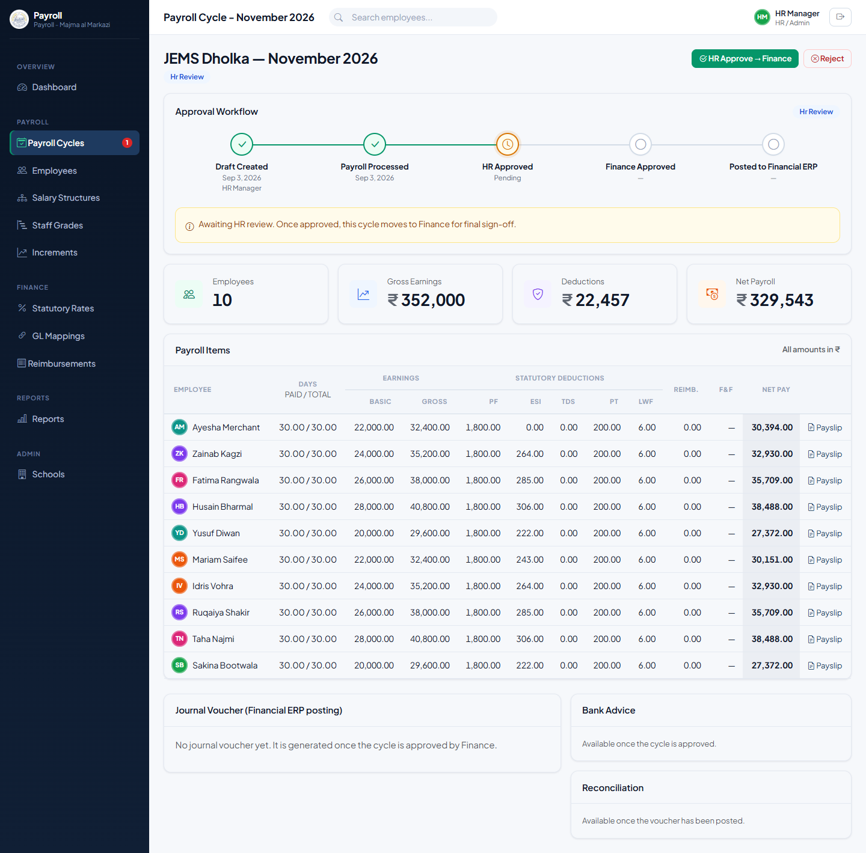
Figure 4.8 — A cycle in HR Review, showing the approval workflow stepper.

4.6 Reimbursement Claims
Employee reimbursement claims (travel, medical, and similar) are submitted and queued here; an approved claim is automatically folded into that employee’s next payroll computation.
- Go to Payroll → Reimbursements (also reachable from Finance) and click + Submit Claim.
- Choose the employee, enter a category, description and amount, and submit.
- From the Reimbursements list, Approve or Reject each pending claim.
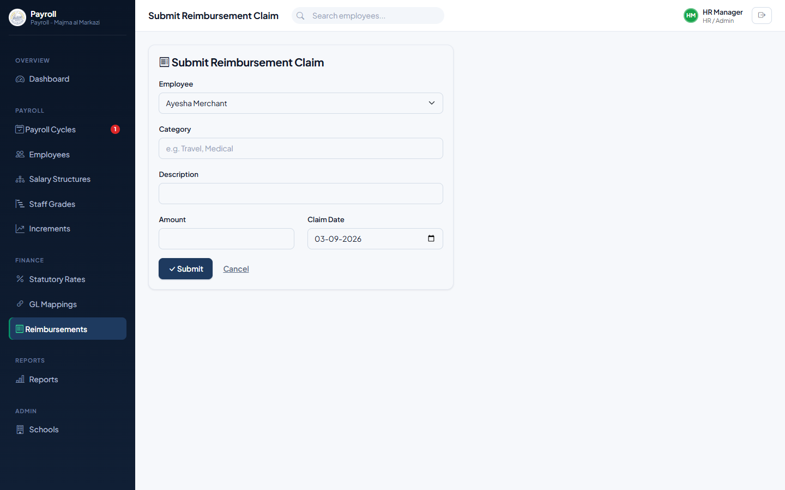
Figure 4.9 — Submitting a reimbursement claim.
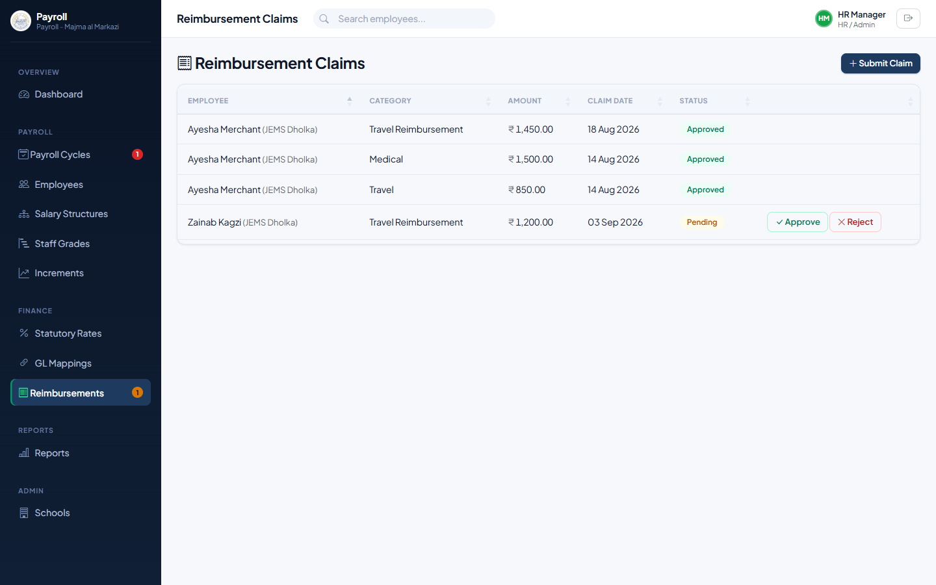
Figure 4.10 — The reimbursements queue, with a claim awaiting approval.

4.7 Monthly Checklist
- Sync employee data from AIIMS for each active school.
- Confirm every employee who needs one has an active salary structure and a staff grade assigned.
- Review the Employees list and the Compensation Compliance report (Chapter 6) for anyone flagged Below Min or Above Max, and act on it per policy §10.
- Run any due increment cycles — single or bulk — before this month’s payroll.
- Approve any pending reimbursement claims so they’re captured in this month’s run.
- Create the payroll cycle for the month and run payroll.
- Review the computed figures; adjust LOP/OT/bonus/overrides and recompute as needed.
- Submit the cycle for HR review, then approve it once satisfied — handing it to Finance.

5. Finance Manager
The Finance Manager gives payroll its final financial sign-off, configures the statutory and GL rules payroll runs against, and takes each approved cycle through to posting and reconciliation.

5.1 Statutory Rate Configuration (Per-School Rules)
PF, ESI, Professional Tax, TDS and LWF rates and slabs are configurable rather than hard-coded, because they can genuinely differ by state and by school. A configuration left without a school selected is the organization-wide default; a school-specific configuration overrides it for that school only, for any date on or after its effective date.
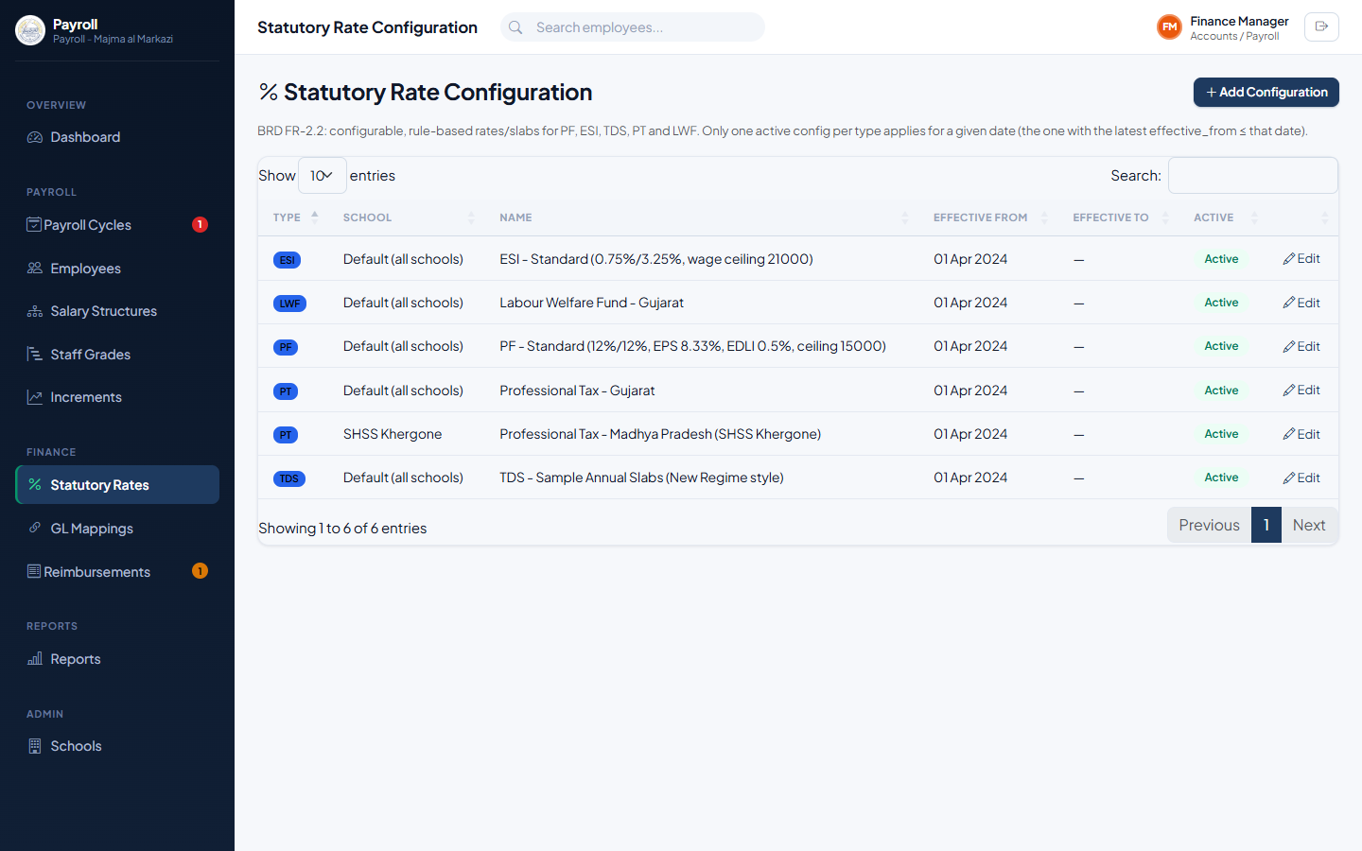
Figure 5.1 — Statutory Rate Configuration list.
- Go to Finance → Statutory Rates and click + Add Configuration.
- Choose the statutory Type (PF, ESI, PT, TDS or LWF), optionally a specific School (leave blank for the global default), a Name, and the rate/slab configuration in the format shown on-screen.
- Set the Effective From date (and an Effective To date if this rate is time-bound).
- Save. The new rate applies to any payroll computed for a date on or after its effective date.
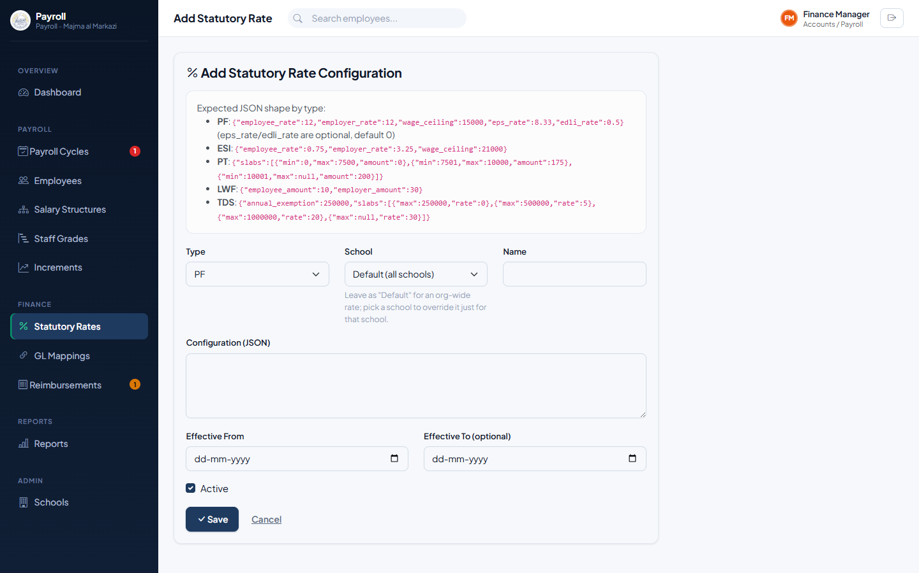
Figure 5.2 — Adding a school-specific statutory rate.

5.2 Reviewing and Approving Payroll
Once HR approves a cycle, it moves to Finance Review. The approval workflow stepper shows it awaiting your sign-off.
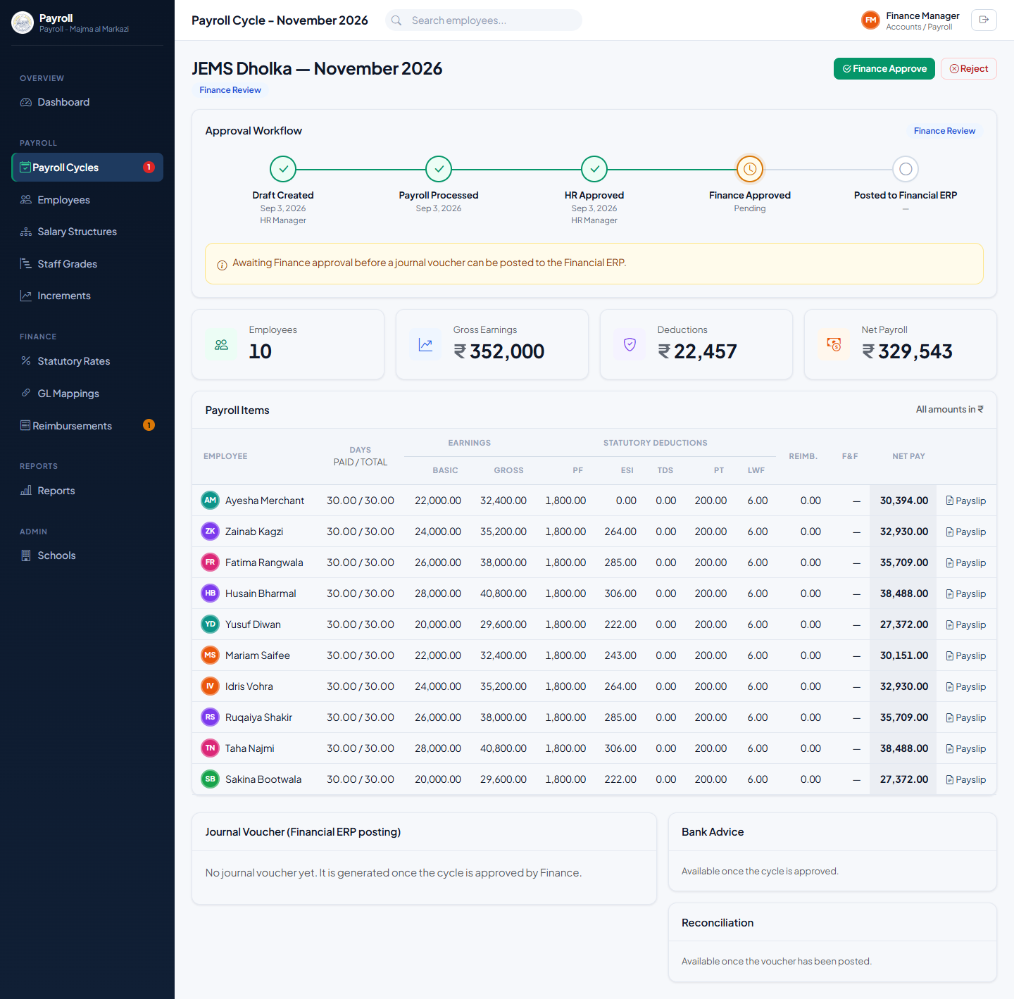
Figure 5.3 — A cycle awaiting Finance approval.
Review the Payroll Items table and the cycle totals, then click Finance Approve. If something needs correcting, click Reject to send the cycle back to Draft with a reason — HR’s and Finance’s sign-offs so far are cleared and the cycle must be resubmitted.

5.3 Generating and Posting the Journal Voucher
Once approved, generate the journal voucher that will post this cycle’s payroll cost to the Financial ERP.
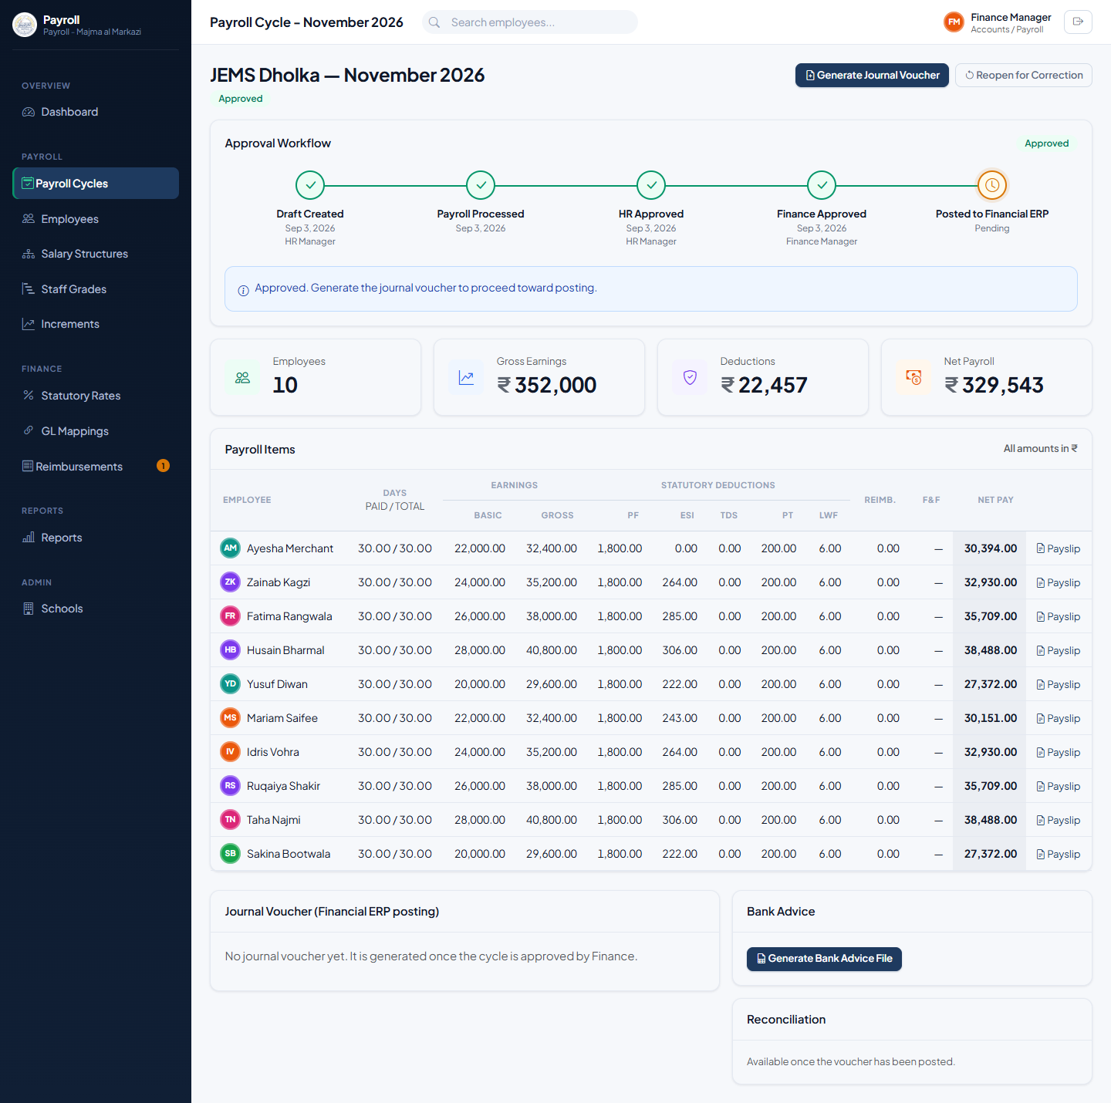
Figure 5.4 — An approved cycle, ready for its journal voucher.
- Click Generate Journal Voucher. The system builds a balanced voucher — salary expense, employer statutory contributions and reimbursements on the debit side; statutory liabilities and net pay payable on the credit side — mapped to the GL accounts configured in Chapter 3.
- Review the voucher’s lines and totals.
- Click Post to Financial ERP to finalize it. The cycle status becomes Posted.
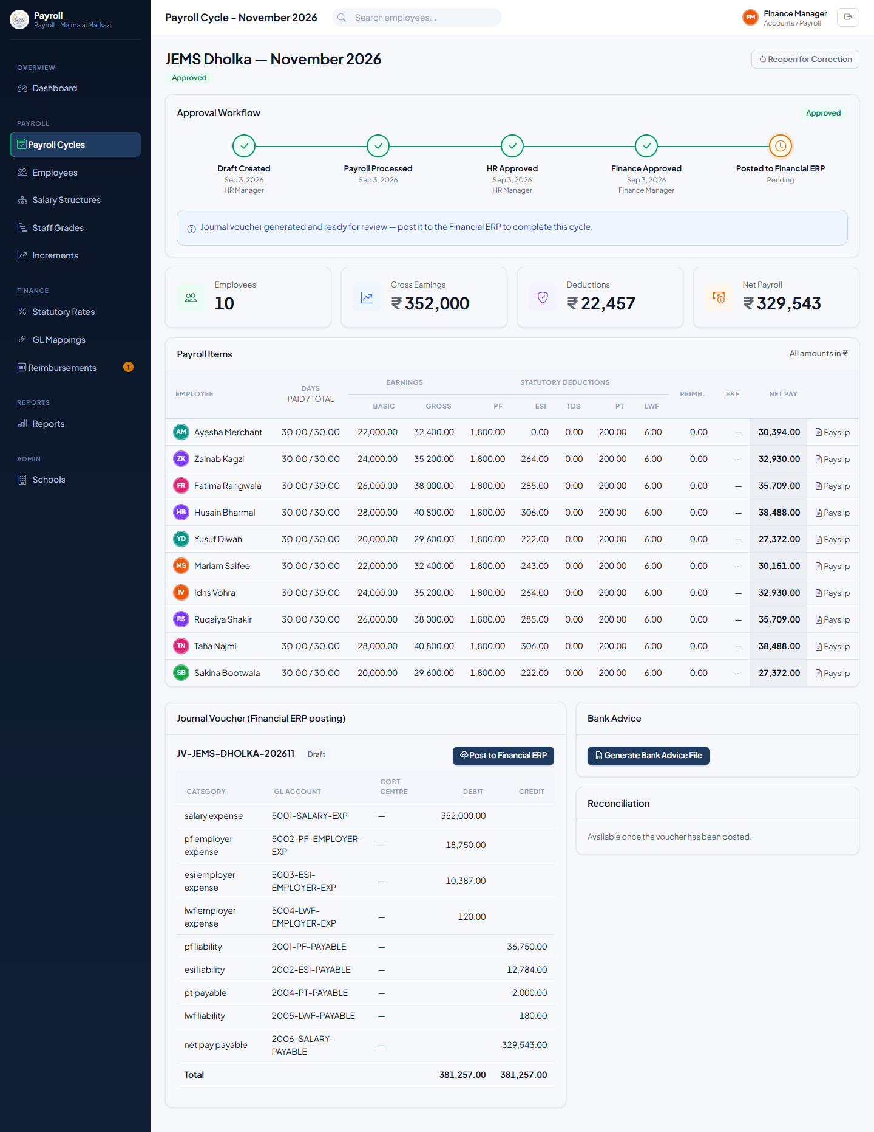
Figure 5.5 — A generated journal voucher, ready to post.
Note: If a payroll cycle has already been approved but its voucher hasn’t been posted yet, Finance can still Reopen for Correction to pull it back to Draft. Once a voucher is actually posted, use Reverse on the voucher instead — which creates an offsetting reversal voucher rather than editing history.

5.4 Reconciliation
After posting, generate a reconciliation report to confirm the amount posted to the Financial ERP matches the payroll register.
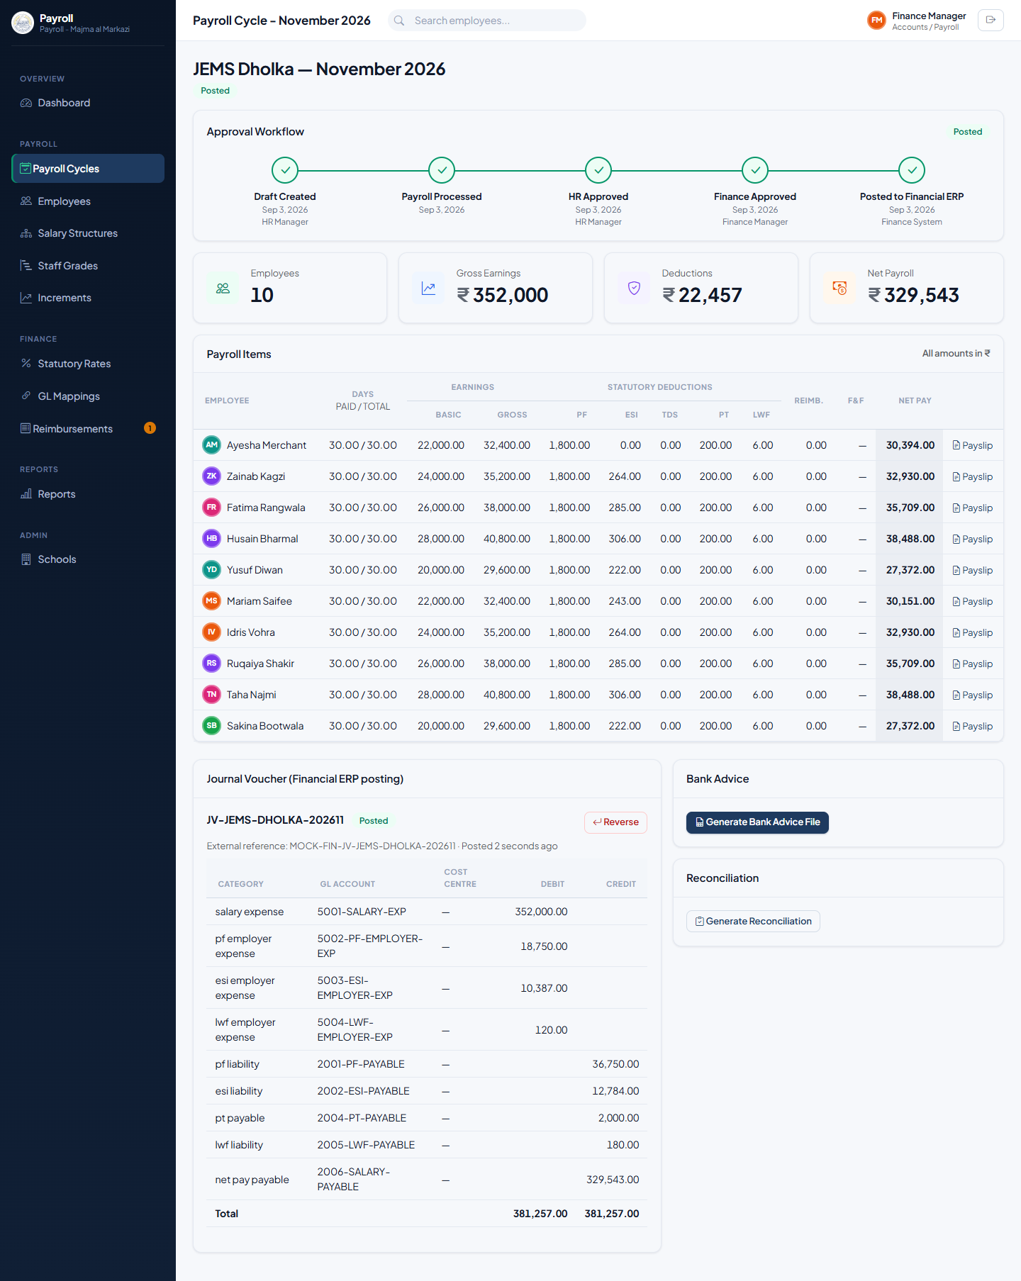
Figure 5.6 — A posted cycle, with Bank Advice and Reconciliation now available.
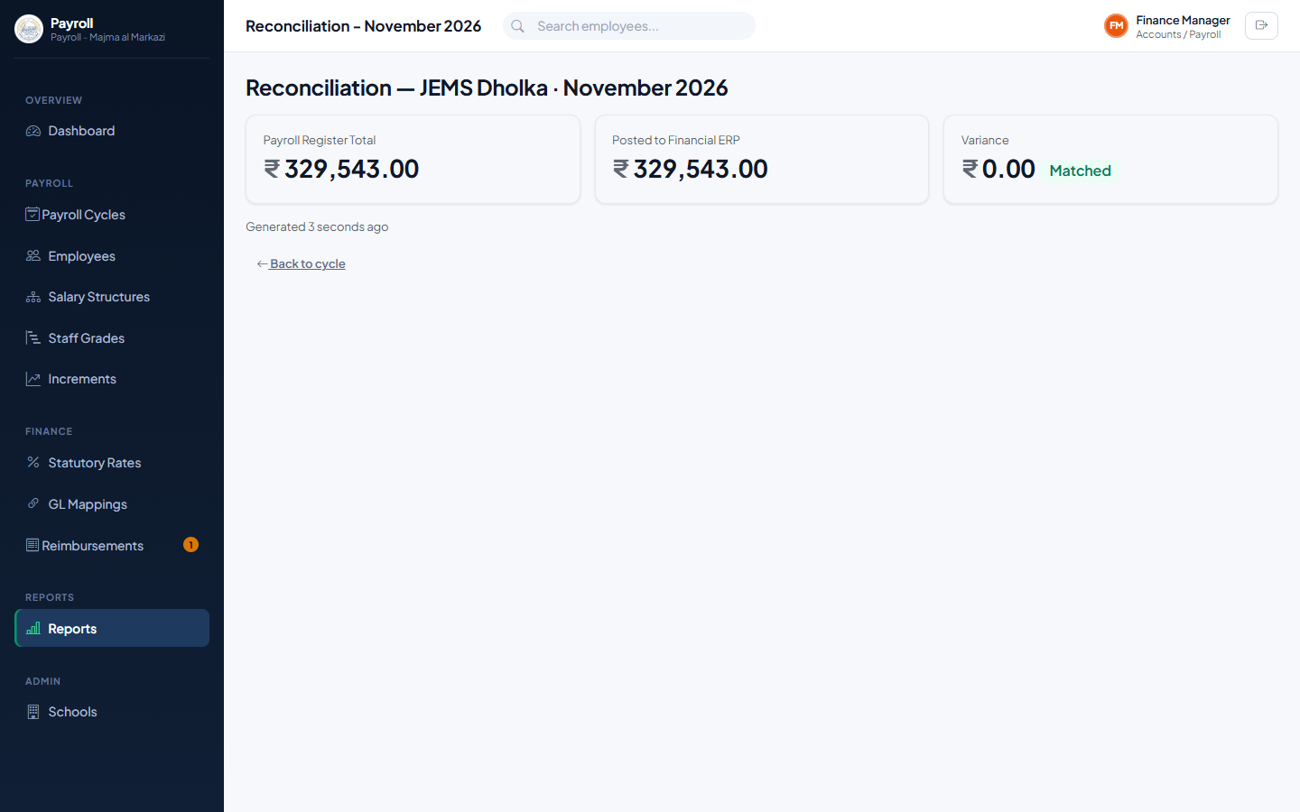
Figure 5.7 — Reconciliation report showing a matched (zero-variance) result.

5.5 Bank Payment Advice
Generate the bank payment file once a cycle is approved (or posted) to hand to your bank for salary disbursement — an Excel file listing each employee’s bank account, IFSC and net payable amount.
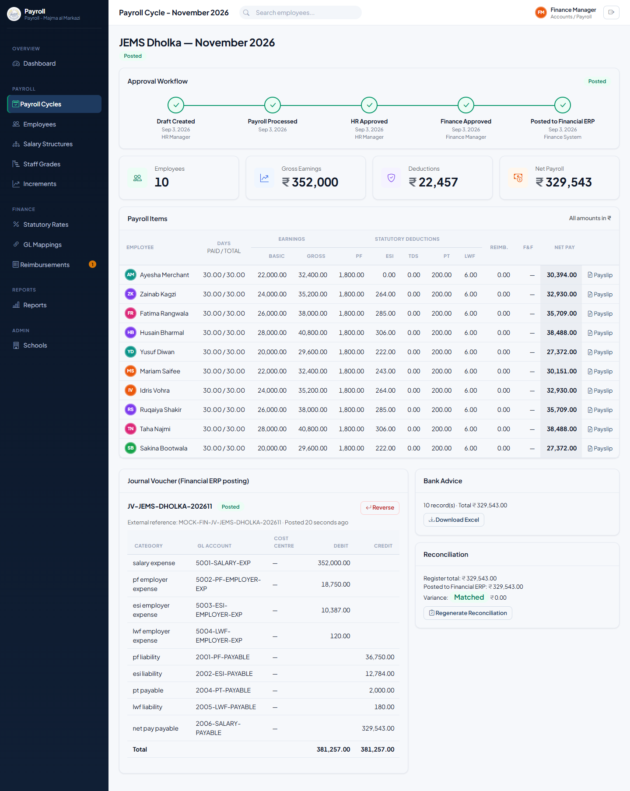
Figure 5.8 — A generated bank advice file, ready to download.

5.6 GL Mappings, Schools and Compensation Compliance
GL Account Mappings and School setup are shared with the Super Admin role and covered in Chapter 3 (§§3.1–3.2) — Finance Managers have the same access to both. The Compensation Compliance report (Chapter 6, §6.3) is also available under Reports, useful when reviewing whether any employee’s pay has drifted outside their grade’s policy band.

5.7 Monthly Checklist
- Confirm statutory rates are current for every school before the first cycle of the month is approved.
- Review and approve each cycle HR has submitted.
- Generate and post the journal voucher for each approved cycle.
- Generate the bank payment file and hand it to the bank.
- Generate the reconciliation report and confirm it shows zero variance.

6. Management
The Management role is read-only: it gives school and trust leadership full visibility into payroll cost, status, trends and compensation-policy compliance, without the ability to create, edit, or approve anything. Nothing in this chapter has action buttons — that’s intentional.

6.1 The Dashboard
The Dashboard (see §2.2) is Management’s primary tool — an at-a-glance view of gross and net payroll cost, pending approvals, department cost breakdown, and the 12-month cost trend, without needing to open any individual cycle. The Filter by School control lets you narrow every figure on the page down to one or several schools.
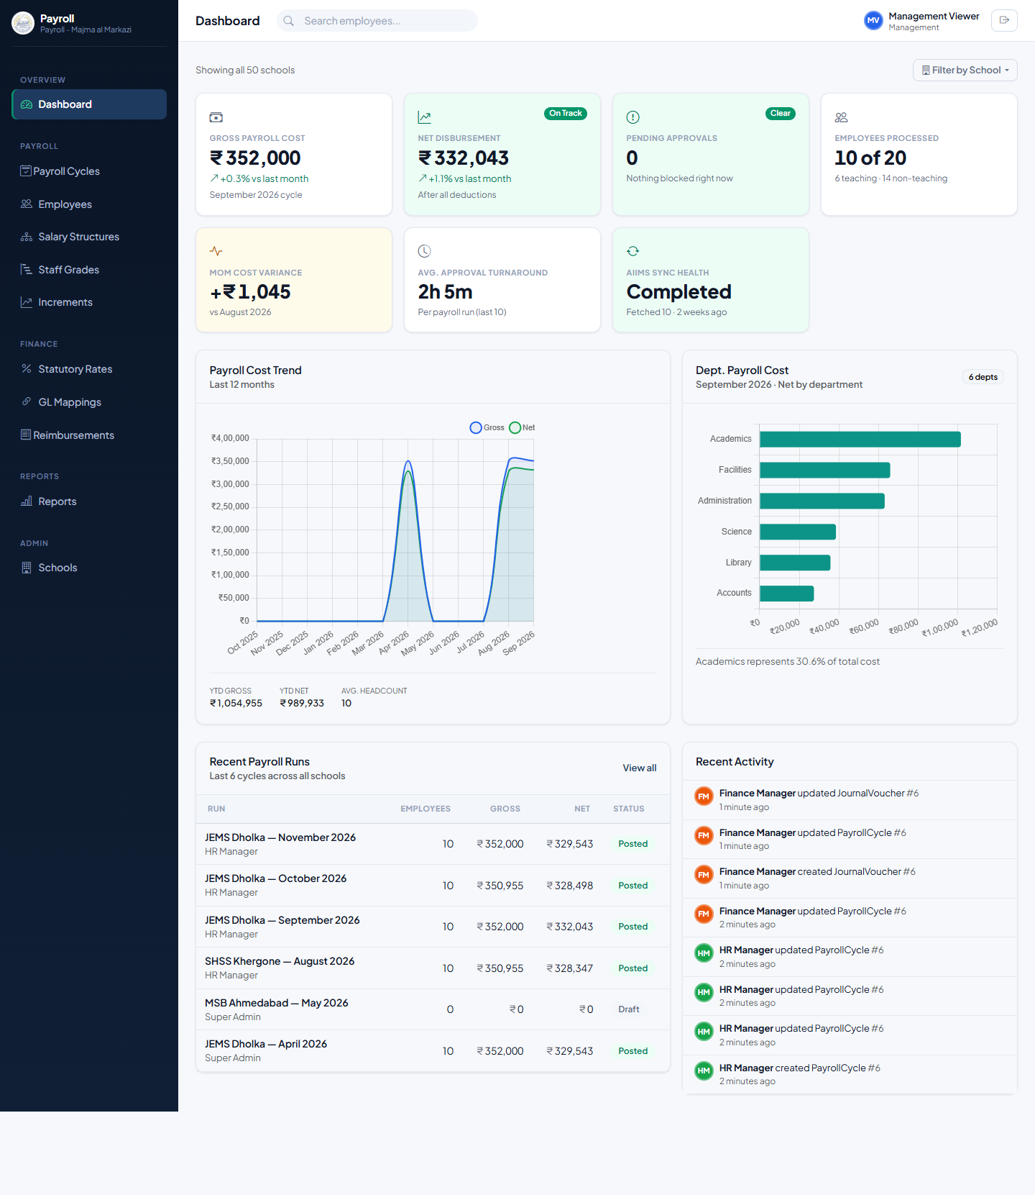
Figure 6.1 — The Dashboard as seen by Management.

6.2 Payroll Cycles
The Payroll Cycles list (Payroll → Payroll Cycles) shows every cycle across every school with its status. Note there is no + New Cycle button — Management can view but not initiate a cycle.
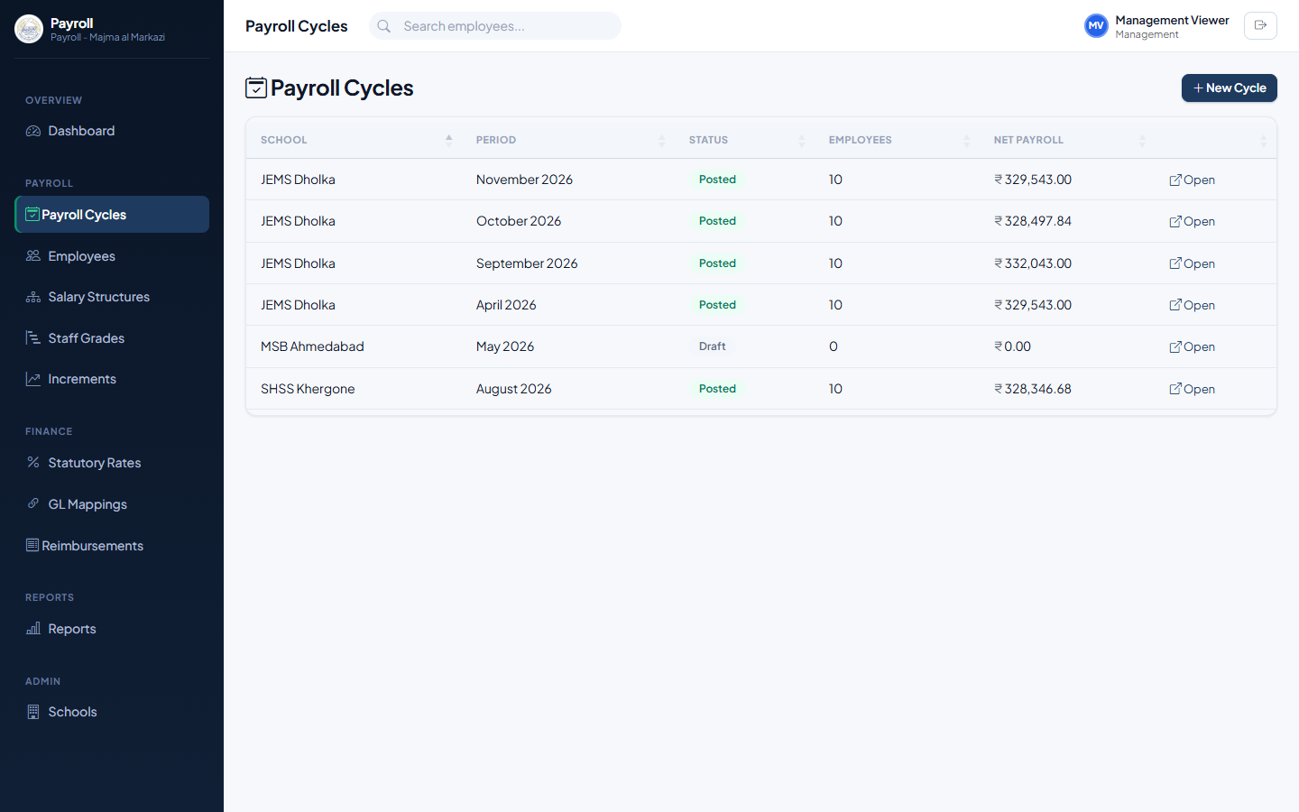
Figure 6.2 — Payroll Cycles list (view-only).
Opening a cycle shows the same approval-workflow stepper, KPI cards and payroll items table that HR and Finance see — just without any action buttons.
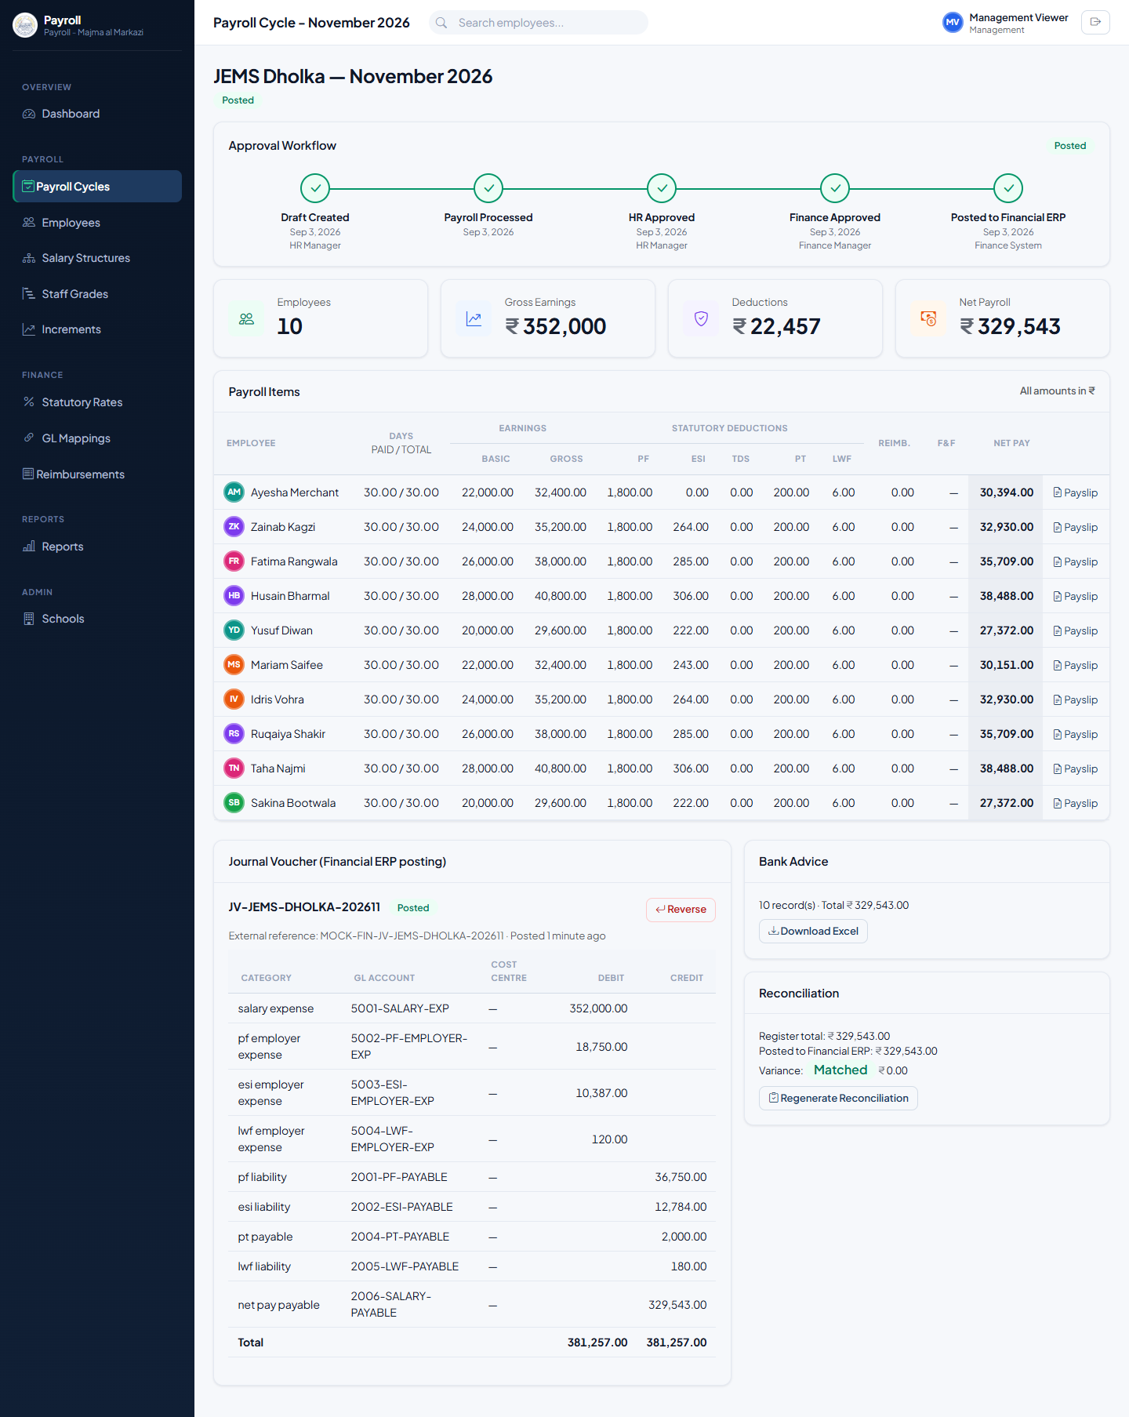
Figure 6.3 — A payroll cycle opened by Management — fully visible, no actions available.

6.3 Reports
The Reports section provides the Salary Register, department-wise and statutory (PF/ESI/TDS/PT/LWF) exports, the reconciliation report, the AIIMS sync log, and the Compensation Compliance report — the same reports Finance uses, available here for review and download.
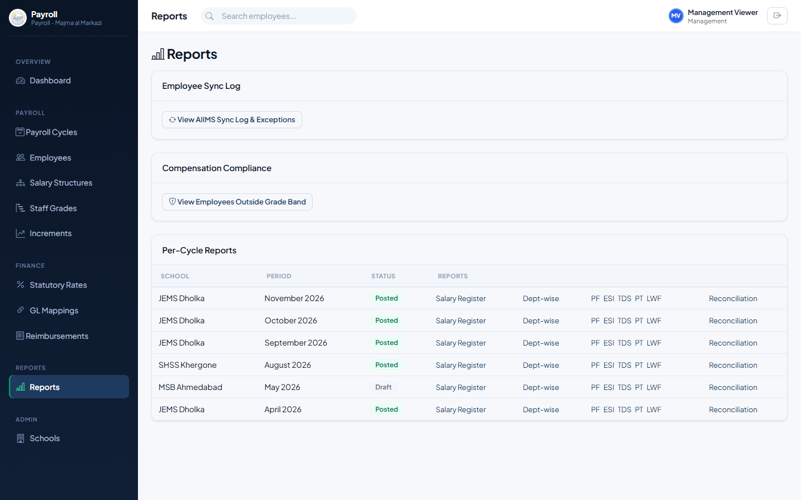
Figure 6.4 — Reports index.
Compensation Compliance lists every graded employee whose current basic salary falls outside their grade’s policy band — exactly the employees policy §10 requires action on, in one place, without having to check each profile individually.
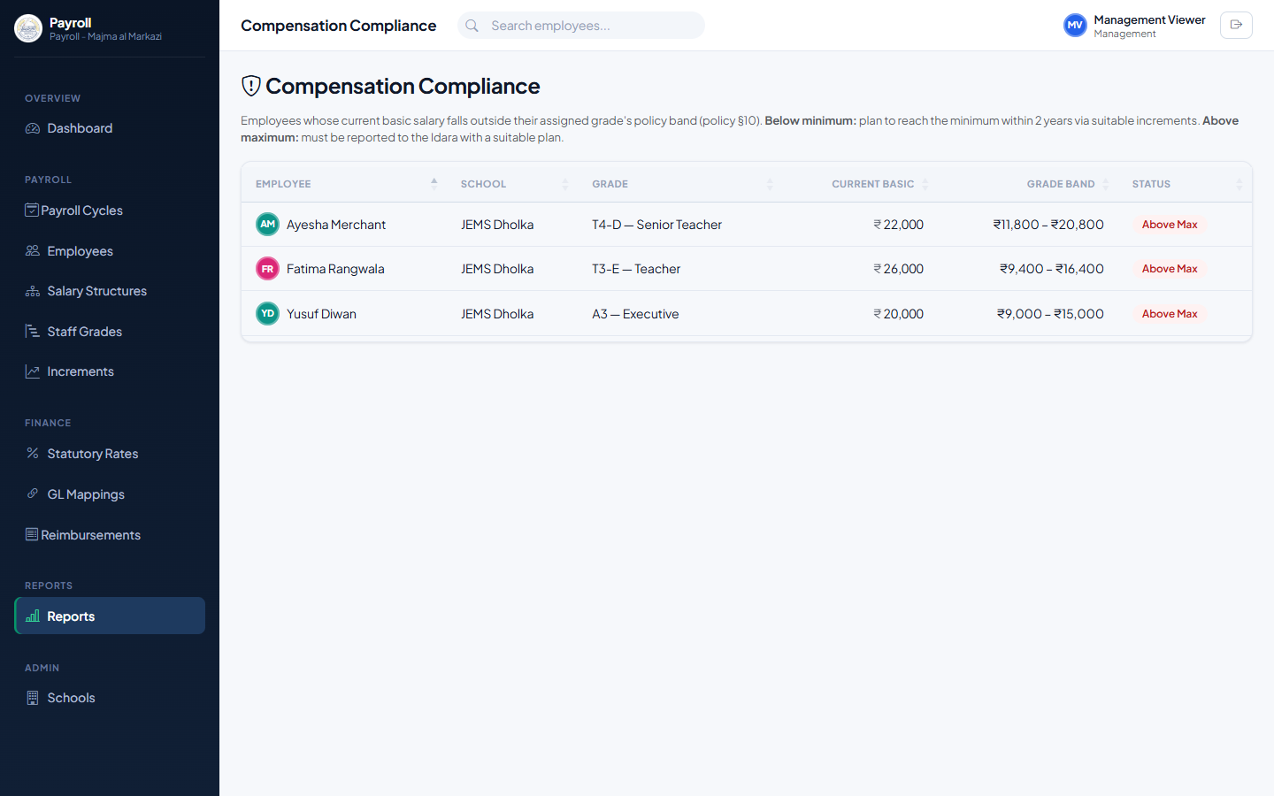
Figure 6.5 — Compensation Compliance report.

7. School Admin
The School Admin role is intended for a school-level administrator who needs visibility into their own school’s employees and payroll.
Note: At present, School Admin has the same system-wide, read-only permissions as Management (Chapter 6) — the system does not yet restrict a School Admin’s view to only their own school’s data. This is flagged here deliberately rather than glossed over; if school-scoped access is required, it should be raised as a follow-up enhancement.

7.1 Viewing Employees
Employees → the same list HR uses, without the AIIMS sync panel or any Add/Edit actions.
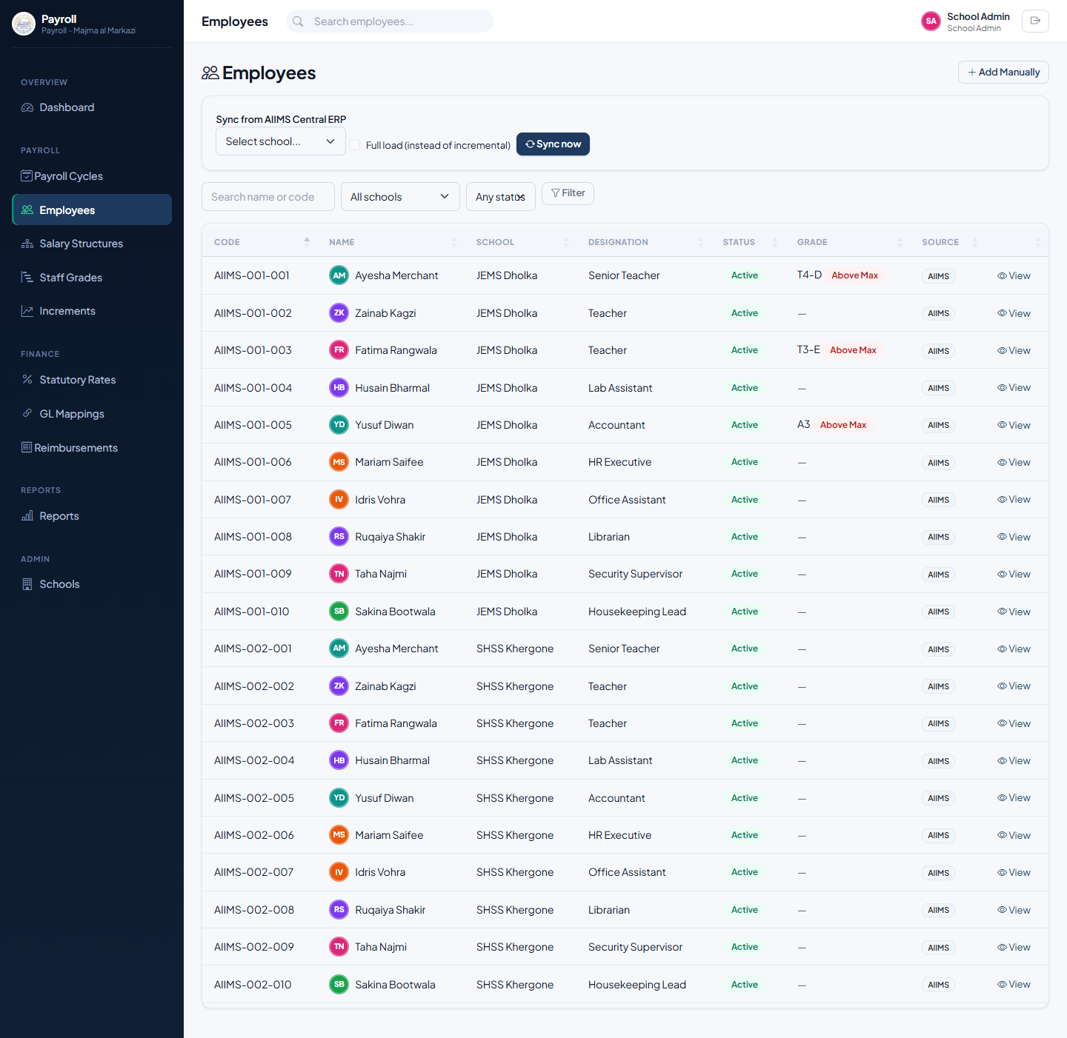
Figure 7.1 — Employees list as seen by School Admin (view-only).

7.2 Viewing Payslips
From any payroll cycle’s item list, or an employee’s profile, click Payslip to view and download that employee’s payslip as a PDF — school letterhead, earnings and deductions breakdown, and net pay.
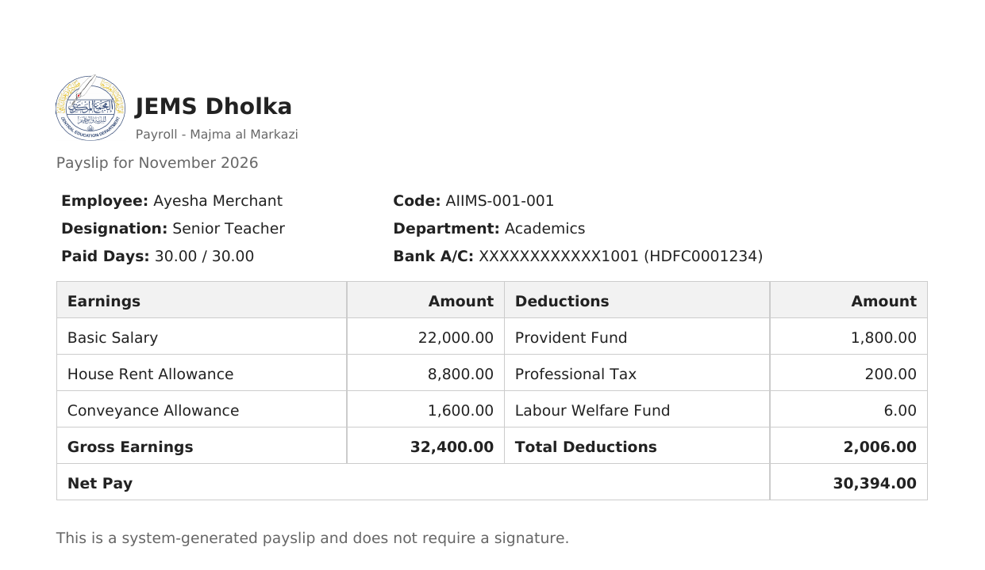
Figure 7.2 — A generated payslip PDF.

Appendix A: Permission Matrix
A quick reference for exactly which actions each role can perform. “✓” means the role can perform that action; “—” means the action is not available to that role (Super Admin can always perform every action).
Action | Super  Admin | HR | Finance | Mgmt | School  Admin
View Dashboard & Reports | ✓ | ✓ | ✓ | ✓ | ✓
View Employees & Payslips | ✓ | ✓ | ✓ | ✓ | ✓
Add / Edit Employees, Sync from AIIMS | ✓ | ✓ | — | — | —
Assign Staff Grade to an Employee | ✓ | ✓ | — | — | —
Manage Salary Structures | ✓ | ✓ | — | — | —
Give Increments (single & bulk) | ✓ | ✓ | — | — | —
Manage Staff Grades | ✓ | ✓ | — | — | —
Create Payroll Cycle & Compute Payroll | ✓ | ✓ | — | — | —
Submit for / Approve HR Review | ✓ | ✓ | — | — | —
Approve Finance Review, Reopen Cycle | ✓ | — | ✓ | — | —
Generate / Post / Reverse Journal Voucher | ✓ | — | ✓ | — | —
Generate Bank Advice & Reconciliation | ✓ | — | ✓ | — | —
Manage Statutory Rates (global & per-school) | ✓ | — | ✓ | — | —
Manage GL Mappings | ✓ | — | ✓ | — | —
Manage Schools & Location Tiers | ✓ | — | ✓ | — | —
Submit Reimbursement Claim | ✓ | ✓ | ✓ | ✓ | ✓
Approve / Reject Reimbursement Claim | ✓ | ✓ | ✓ | — | —

Appendix B: The Payroll Cycle Lifecycle
Every payroll cycle moves through the same five stages, shown as the Approval Workflow stepper on the cycle page:
- Draft — created by HR; payroll can be computed and recomputed freely.
- HR Review — HR has submitted the cycle; HR approval hands it to Finance.
- Finance Review — awaiting Finance’s financial approval.
- Approved — signed off by both HR and Finance; a journal voucher can now be generated.
- Posted — the journal voucher has been posted to the Financial ERP; bank advice and reconciliation are now available.
At the HR Review or Finance Review stage, either reviewer can Reject a cycle, sending it back to Draft with a recorded reason and clearing both sign-offs so it must be resubmitted. An Approved cycle without a posted voucher can still be pulled back to Draft via Reopen for Correction; once a voucher is actually posted, corrections go through Reverse on the voucher instead, which creates an offsetting entry rather than rewriting history.

Appendix C: Support
For new user accounts, role changes, password resets, or any access issues, contact your Super Admin or IT administrator.

