

**DEPARTMENT OF ELECTRICAL ENGINEERING**

**(COMPUTER SYSTEM)**

**ENGINEERING DRAWING (EL225)**

**GROUP MEMBERS:**

**Report by:**

M. Waleed Waseen (17B-024-CE)

**Project By:**

Tuba Siddiqui (17B-042-CE)

S.M Murtaza Ali Zaidi (17B-044-CE)

**SUBMITED TO:**

ENGR. SHAHEER AHMED

* We starts make a Mosque by using the very basic command of AutoCAD known as “line command” we simple make a square or a box by using line command we started off my making a 100 foot line in x and y axis direction and make a replica in front of these lines so we get a square or a box and also we also draw the two diagonals in order to get intersection points. So our box looking like the box which we providing below.

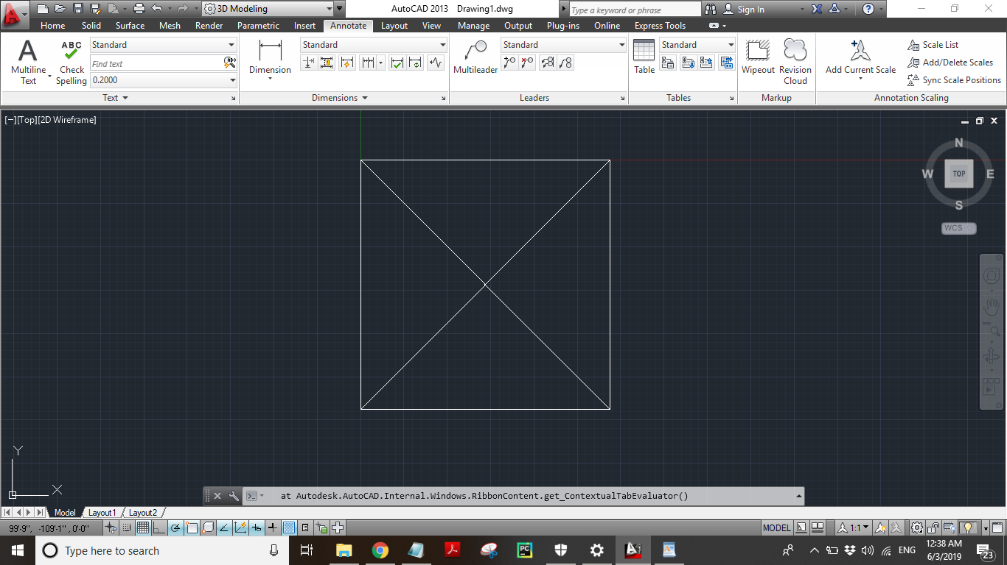

* Now, in the second step we just made a line of height 40 foot on the centre of the box or the point of intersection which we get by making two diagonals previously and also made a 30 foot line on the mid of the four lines of the box or a square so now the box which we previously drawn looking like the picture which we are providing you below.

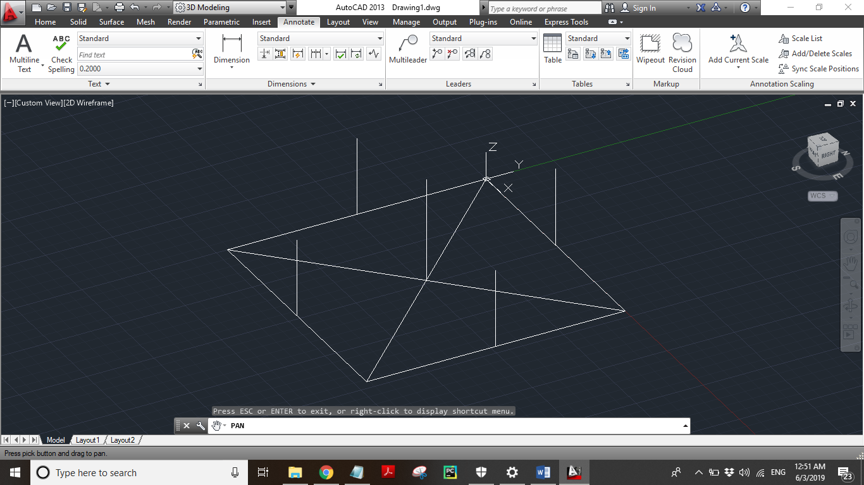

* Now, we are using a new command in AutoCAD known as “3D Face” command what this command does it simply, creates a three-sided or four-sided surface in 3D space. So we just joint all the points, from center one to the mid one, back to the center and then to the corner of the box. This is how the upper surface of the Mosque was formed. So the upper surface of the Mosque look like the picture we are providing you below.

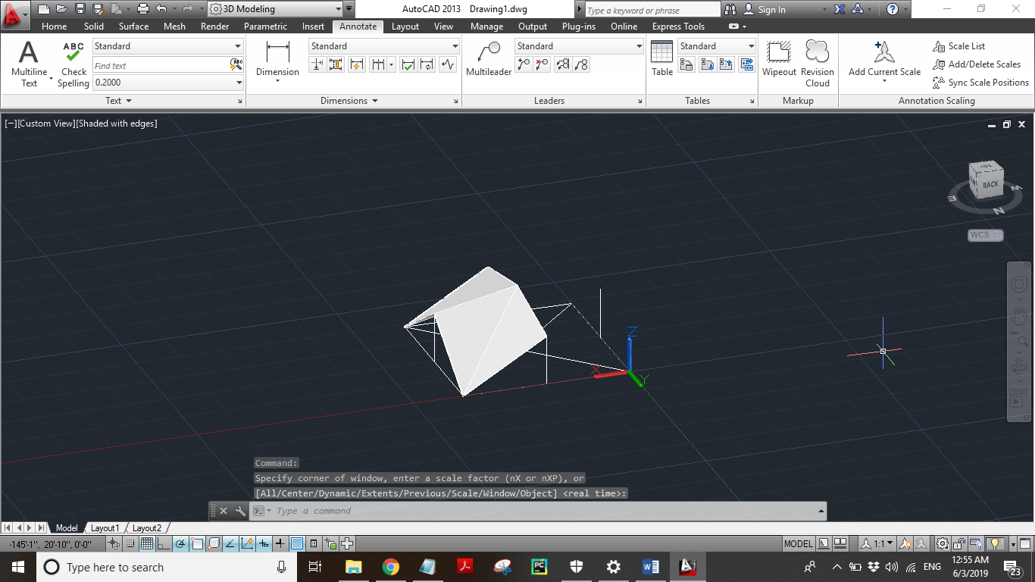

* We, using this command around the 360 degree upper surface of the mosque so finally the upper surface of the Mosque look like the picture giving below.

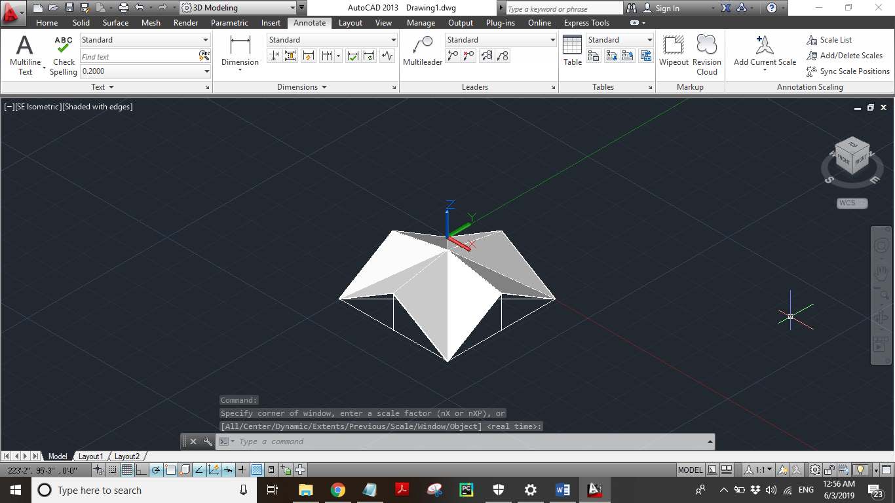

* Now, we just copied front lines of the mosque upper surface by using copy selection tool and place it in front of the upper surface of the mosque we are doing this for another reason and will explain this in next step.

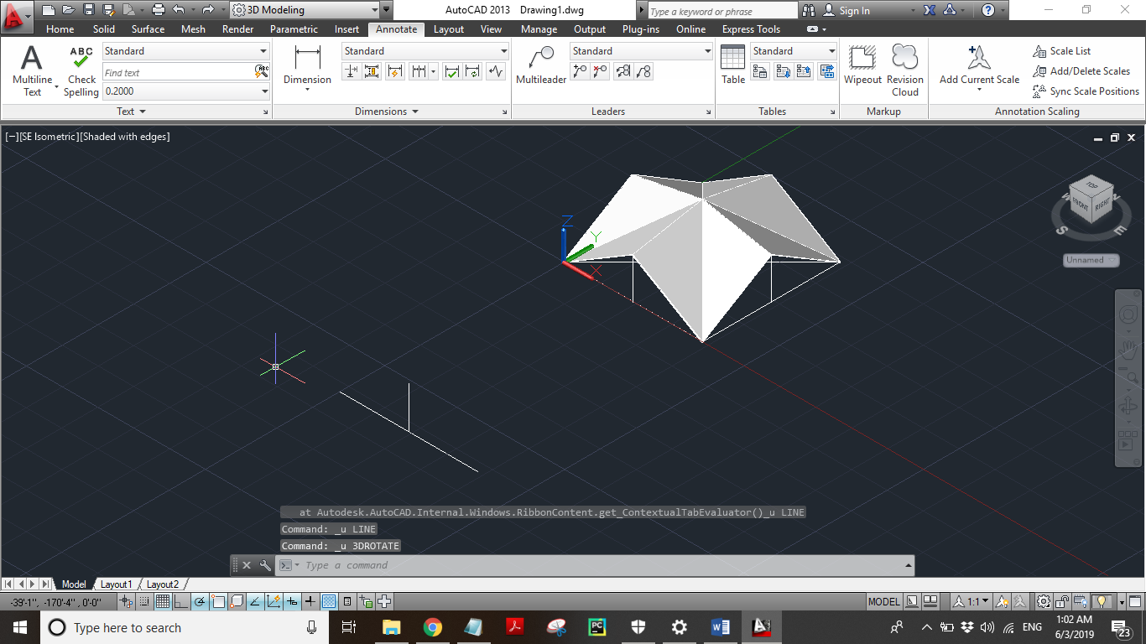

* Now, the lines which were copied from the mosque’s upper surface we made a triangle by using this lines we just rotate the triangle and took offset of 3 foot of the centre lines, throughout the triangle on the center of the triangle we made a small triangle and took its offset of 3 inches as its width. Then we rotated it 180° and attached its pointy edge to each line’s endpoint by copying it. Before copying, we used JOIN command to make it a proper one unit.

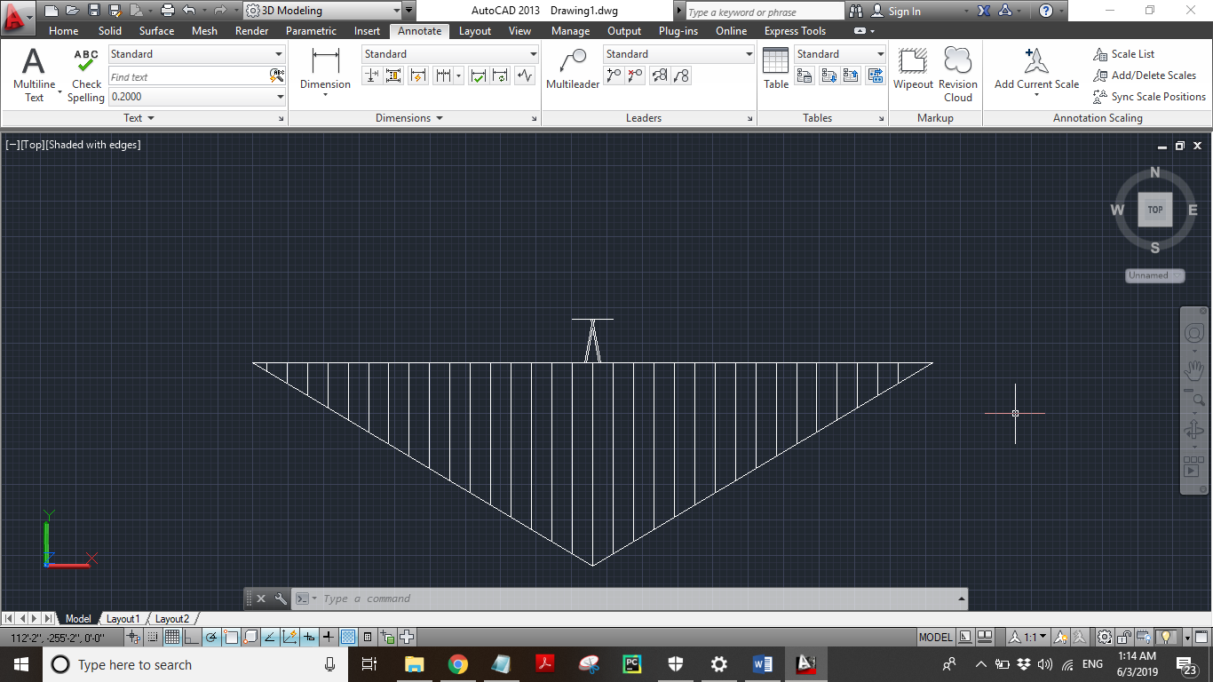

* Now, we rotated the triangle 180° and attached its pointy edge to each line’s endpoint by copying it. Before copying, we used JOIN command to make it a proper one unit.

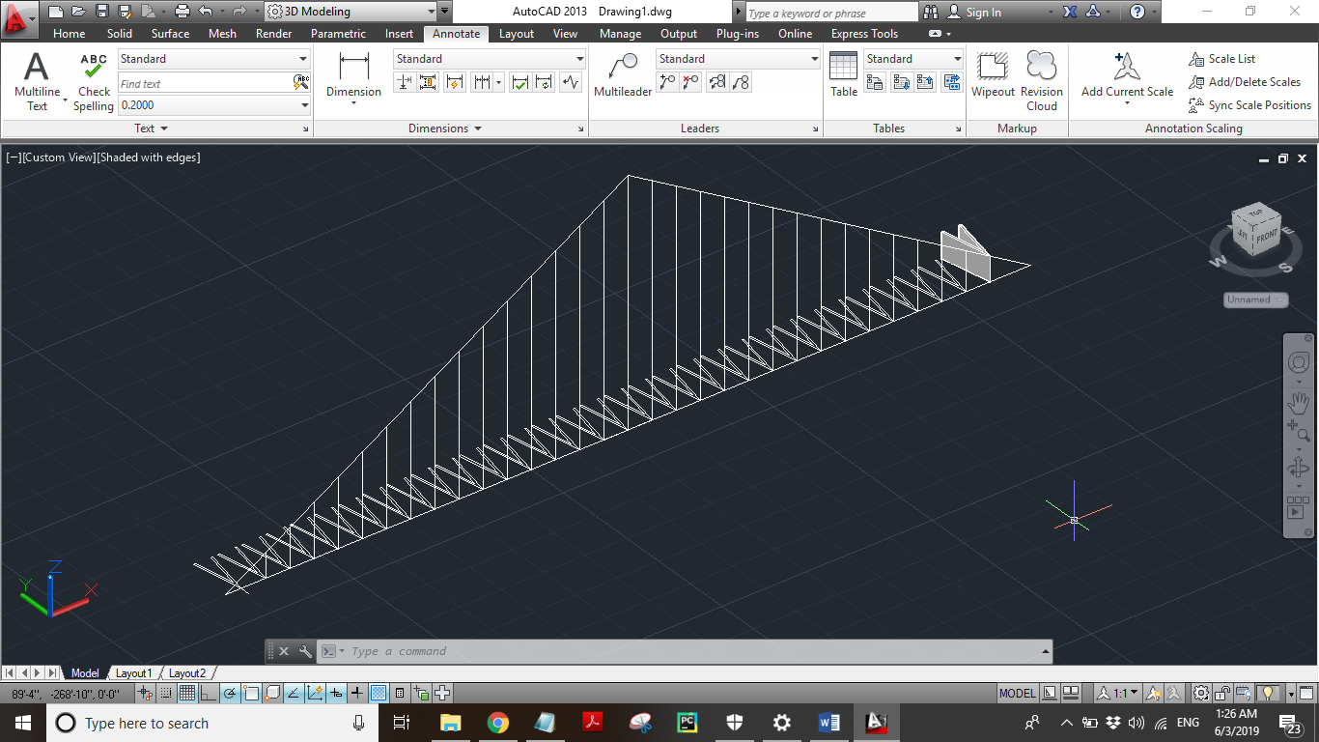

* We 3DROTATE-d the bigger triangle and the lines to -90° and by using TABSURF command, we made the triangular 3d structure, each of its corresponding line’s height. Now, the final structure look like the structure we are providing below.

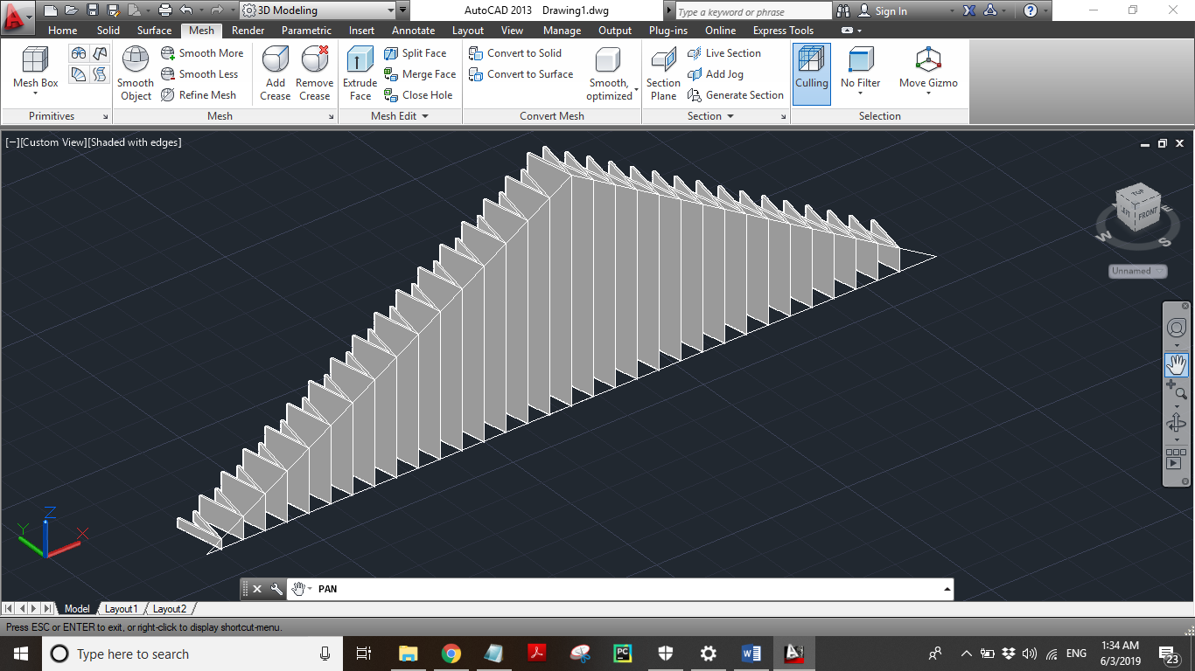

* Finally, we copied the above structure by using copy selection tool and paste the triangular structure on each side of the upper surface of the mosque now we are done with the upper surface of the mosque now we have to make a minar of the mosque.

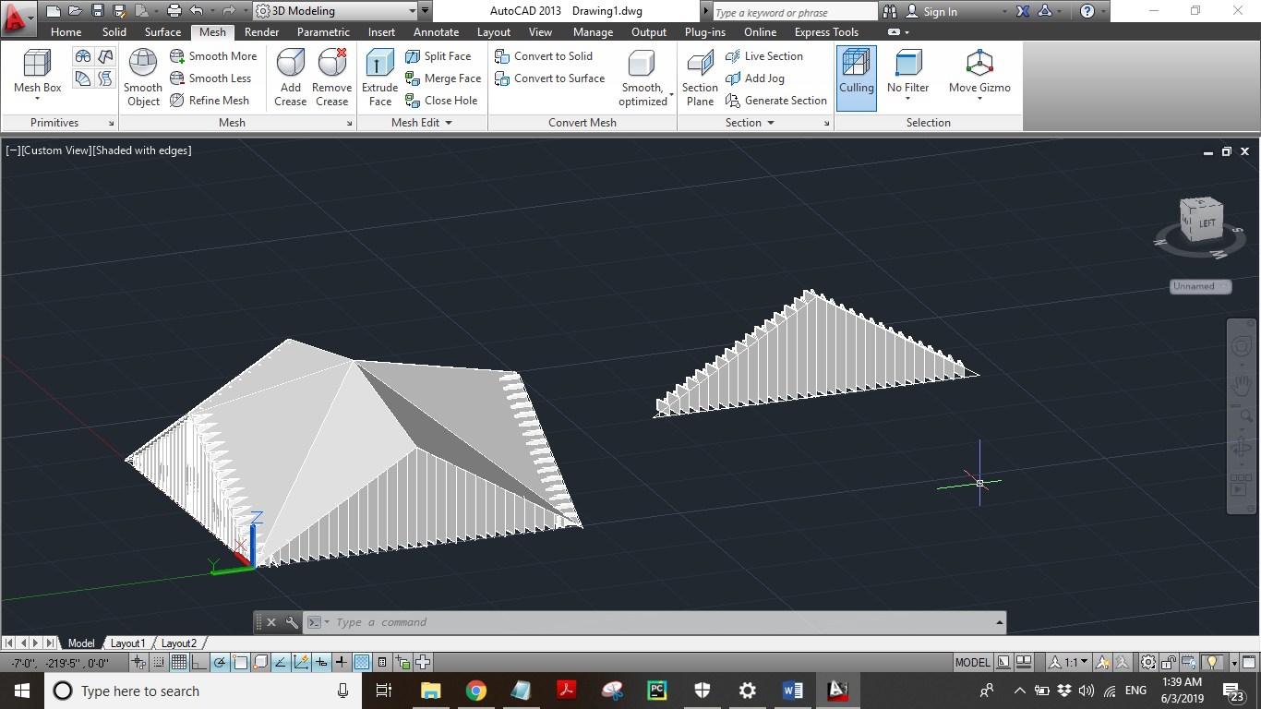

* Now, come towards the making of minar we started making minar by the two rectangles by starting from the same point 0,0 the size of the first rectangle is 23,23 and the size of the second rectangle is 17,17. And take the 17,17 box on the height of 20 by using LOFT command.

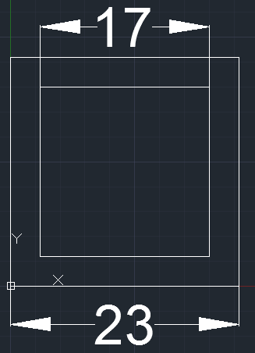

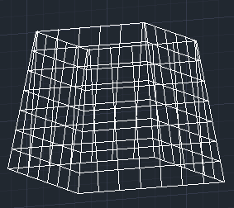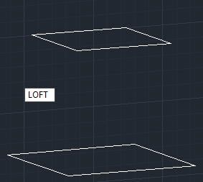

* After using loft command we draw and rectangle on the upper square and extrude it on 60units.

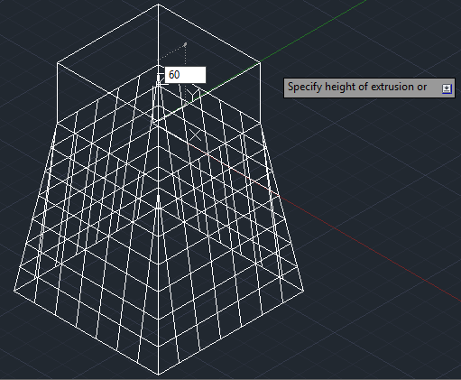

* After extruding the rectangle we have to draw another rectangle and also extrude it by using “TAPER COMMAND” at the angle and height of 10,10 units respectively.

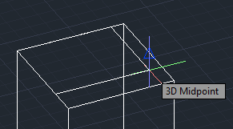

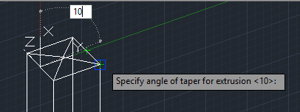

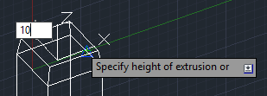

* We draw another rectangle and use “TAPER COMMAND” again and again we do this procedure almost 4 times at the same height and angle of 10,10 respectively,

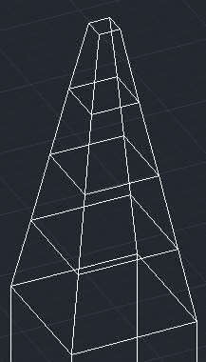

* Now, make a box of dimensions (23,23,20). Now placed the whole minar over this box.

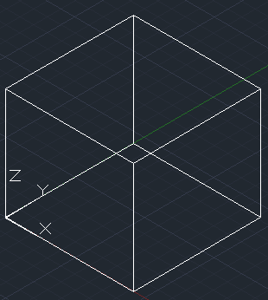

* After placing the minar our minar will be look like the picture we are providing you below now the structure of the minar is complete only the upper part and inner part of the minar are left lets go towards the making of inner and upper part of the minar.

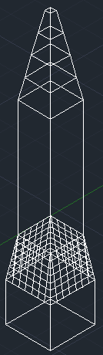

* Now, construct two hollow cubic frames by joining 4 rectangles on each frame.

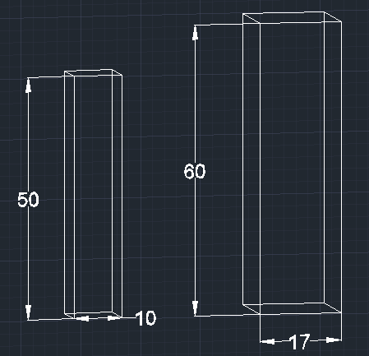

* After that draw two lines in between each of the frames in order to obtain the mid points of both the hollow cubic frames.

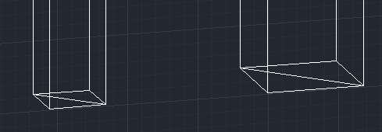

* 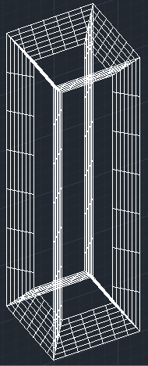Now placed the smaller frame in between the larger hollow cubic frame and lifted it up by using the “LOFT COMMAND” up to the height of 5 units.

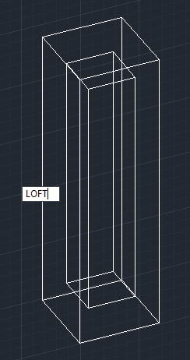

* Now, create a box with dimension 10 on x-axis, 2 on y-axis and 10 on z-axis or simply type (10,2,10).

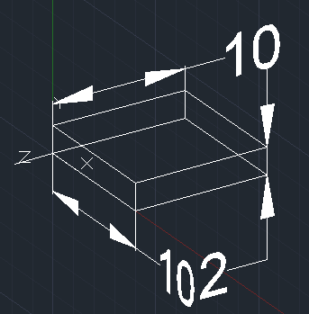

* Now, placed the small box on the midpoint of the two hollow cubic frame which we previously made.

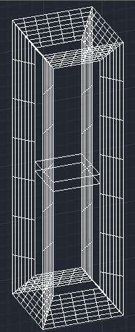

* Now, by using “COPY SELECTION” make a copies with the distance of 5 units inside the two hollow frame after copy it your shape will be look the picture we are given you the below.

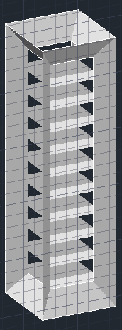

* So, we finally done with the making of minar the thing we have to draw is moon which we have to place top of the minar.

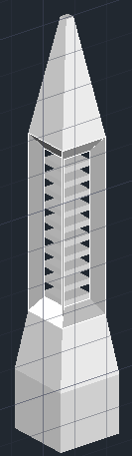

* Now, make a rectangle with the dimension of 1 and the height of 20.

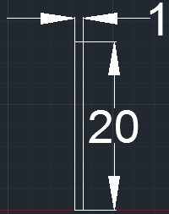

* Now, create a circle of radius 3 at origin, and placed its midpoint of the circle on a height of 10 units made 2 copies of it and placed them at a distance of 5.5units from midpoint. Then changed the radius of upper and lower circle to 1.5 units.

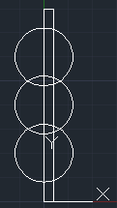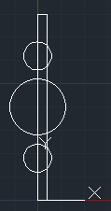

* Now, trim the right part of the circle after trimming finally you got the image we are given you below.

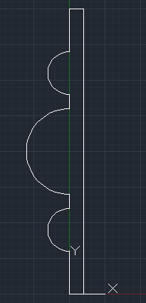

* By, using “REVOLVE COMMAND” we revolve the image by 360 degree for making 3D object. So we finally done with the making of the part which will be placed on the top of the minar in picture # 02.

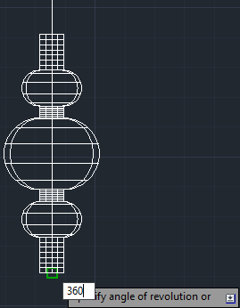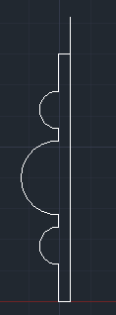 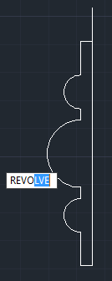

* Now, for the shape of moon we have to draw two circles of radius 5 units overlap two circles and trim it so we have to trim the upper part of the circle so we get the shape of the moon.

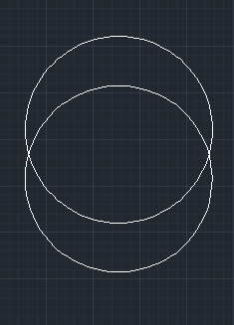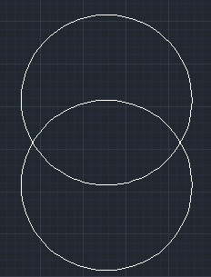

* After trimming the upper part of the circle we get the moon and the shape will be look like which we are giving you below.

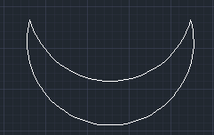

* Now, use extrude command to extrude the moon by 2units and then place the moon on the surface of the part which we are made previously, so our final image of the moon or the image which we draw previously is looking below.

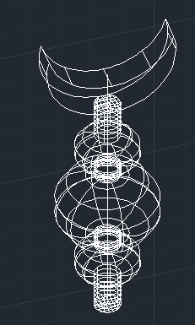

* Now, placed the revolved figure with moon over the tower and joined both with the help of “LOFT COMMAND” So, the final picture of the upper part of the minar will be look like the picture we are given you below.

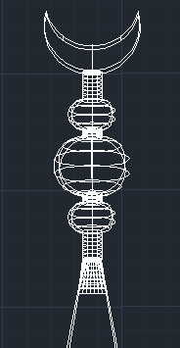

* Finally, we are done with the making of minar but last thing which we do in it is we convert whole minar from centimeters to feet now, the final image will be look like the picture we are given you below.

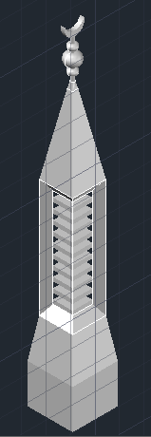

* We almost done with making of the mosque the two finals things are left one is stair and the other one is grills now lets start with making the stairs for stair we made 1 box of 200 foot length and 160 foot width and 20 foot height. And array it .

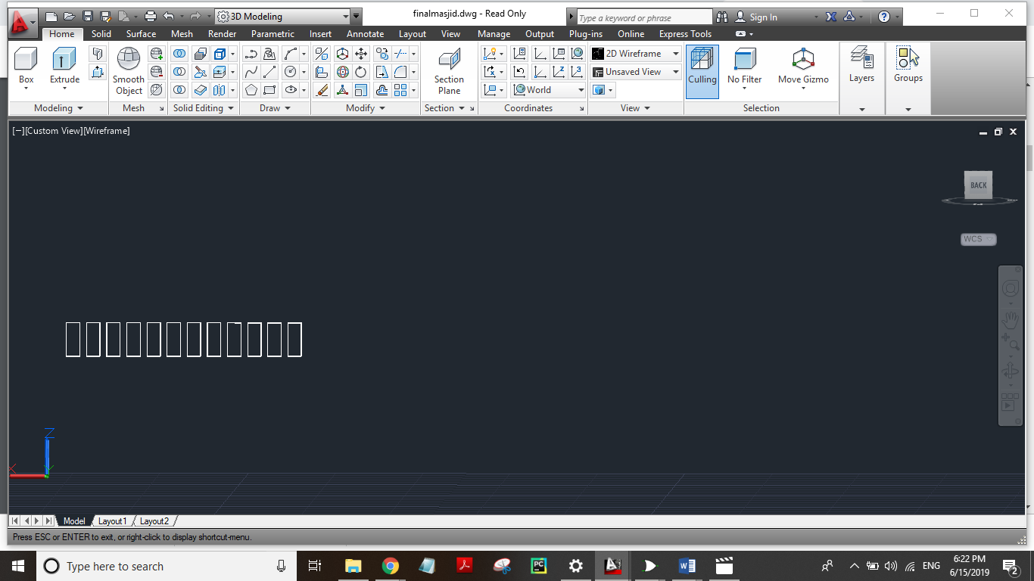

* Now the last thing is left which are grills, we made a rectangle of length and width 4 foot and height 10 foot, and then used array command to make them in a line and also Then made a plane of 70 foot length and 13 foot width to put it above grills. So the grills look like in the picture which we are providing below.

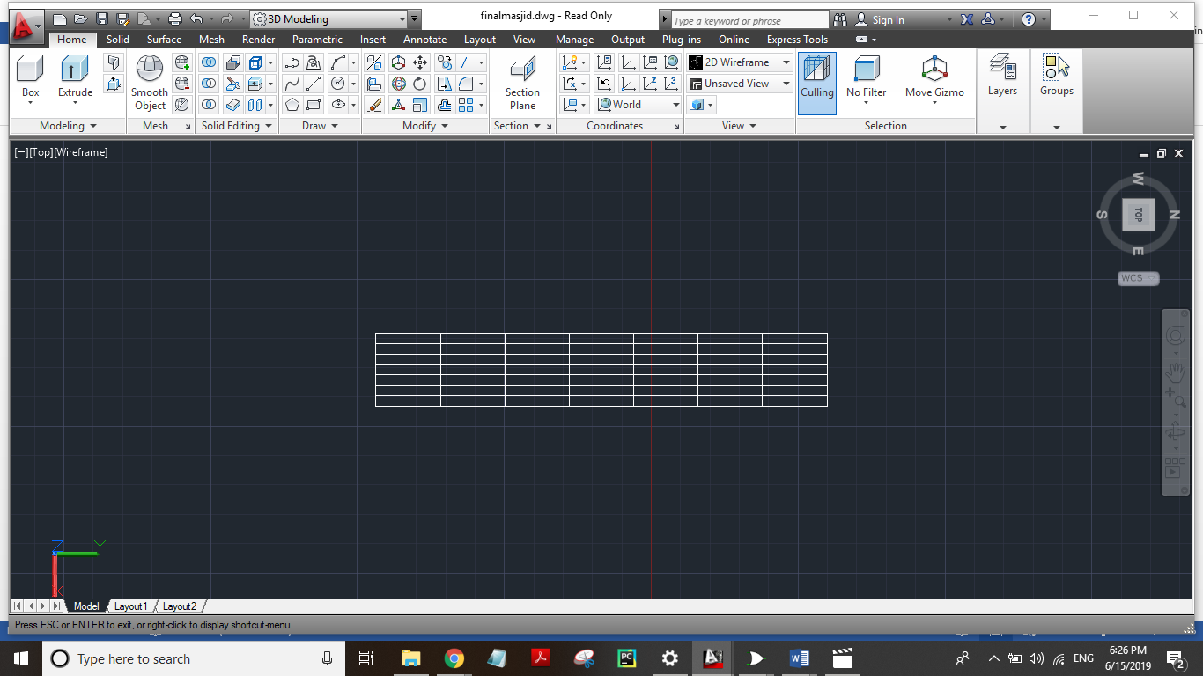

* Finally, we made a small square by using line command, of 3 foot and a big square of 6 foot, used loft command to turn it into similar to triangle to put it above grills on the front side.

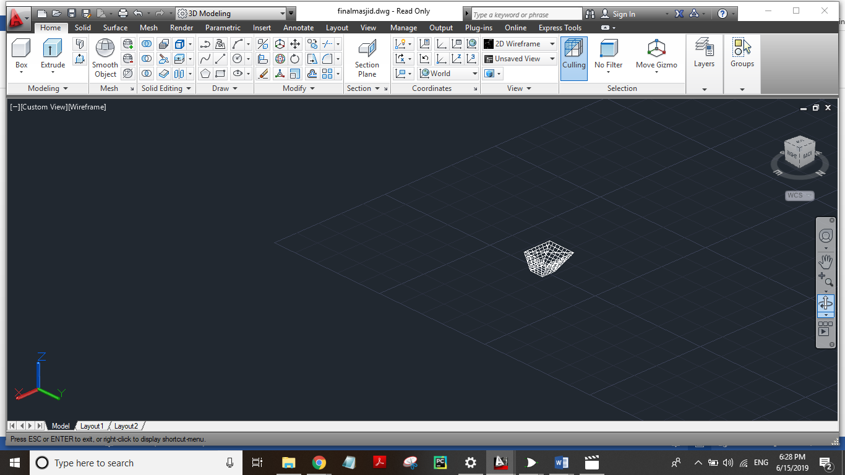

* Finally, we are done with the making of Faisal Mosque located in Islamabad, Pakistan here is the complete AutoCAD picture and SE Isometric view of the mosque.

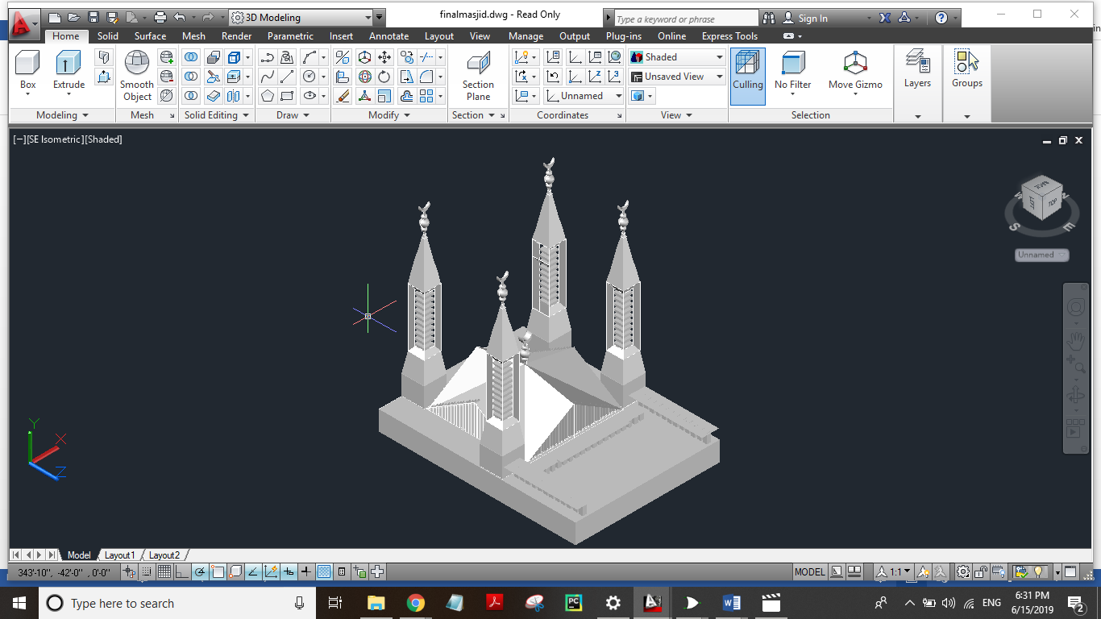

Here, is the custom view of the mosque.

