Project Documentation

# Laptop Request Catalog Item

# 1. INTRODUCTION

## Project Overview

Managing laptop requests manually often causes inefficiency, delays, and miscommunication. This project creates an automated Laptop Request Catalog Item in ServiceNow, with features like dynamic fields, reset button, visibility conditions, and portability using update sets.

## Purpose

The solution replaces outdated manual workflows with a digital catalog form in ServiceNow, ensuring: - Faster request processing - Standardized data input - Improved user experience - Easy deployment across instances via update sets

# 2. IDEATION PHASE

## Problem Statement

Laptop requests through email/verbal communication cause incomplete data, tracking issues, and burden on IT teams. A centralized catalog item in ServiceNow resolves these challenges.

## Empathy Map (Users: Employees)

- Think/Feel: Delays, unclear process - See: No request visibility - Say/Do: Follow-ups with IT teams - Hear: Complaints from colleagues - Pain: Miscommunication, missed deadlines - Gain: Transparent and smooth request process

## Brainstorming Options

1. Manual emails (inefficient) 2. Spreadsheets/third-party tools (limited integration) 3. ServiceNow Catalog Item (chosen) → Scalable, integrated, user-friendly

# 3. REQUIREMENT ANALYSIS

## Customer Journey

User logs into ServiceNow → Opens Service Catalog → Laptop Request → Completes dynamic form → Request routed automatically.

## Solution Requirements

- Single catalog item for all laptop requests - Fields: Laptop model, justification, accessories - Conditional display for accessories details - Reset button to clear form - Update set support for migration

## Data Flow Diagram

User → Catalog Form → UI Policies → Submission ↓ Update Set ↓ Export/Import XML ↓ Target Instance Execution

## Technology Stack

- Platform: ServiceNow (Orlando or higher) - Scripting: JavaScript (GlideForm APIs), XML - Modules: Service Catalog, UI Policy, UI Action, Update Sets - Testing: Manual validation

# 4. PROJECT DESIGN

## Problem-Solution Fit

Manual → digital form. Ensures complete data with dynamic fields. Reduces IT workload and improves satisfaction.

## Proposed Solution

- Catalog item: Laptop Request under Hardware category - Dynamic form with conditional visibility - Reset button for usability - Portability via update sets

## Solution Architecture

- Frontend: Catalog form with dynamic behavior - Logic Layer: JavaScript (UI Policies, UI Actions) - Persistence Layer: Data stored in ServiceNow tables - Deployment Layer: XML update set import/export

# 5. PROJECT PLANNING

## Steps followed

1. Create Update Set 2. Build Catalog Item 3. Add Variables 4. Configure UI Policies 5. Create Reset Button 6. Test catalog item 7. Export/Import Update Set

# 6. IMPLEMENTATION WORKFLOW

## 6.1 Create Update Set

Navigate: All → Update Sets → Local Update Sets Click New → Name: Laptop Request Save → Make Current

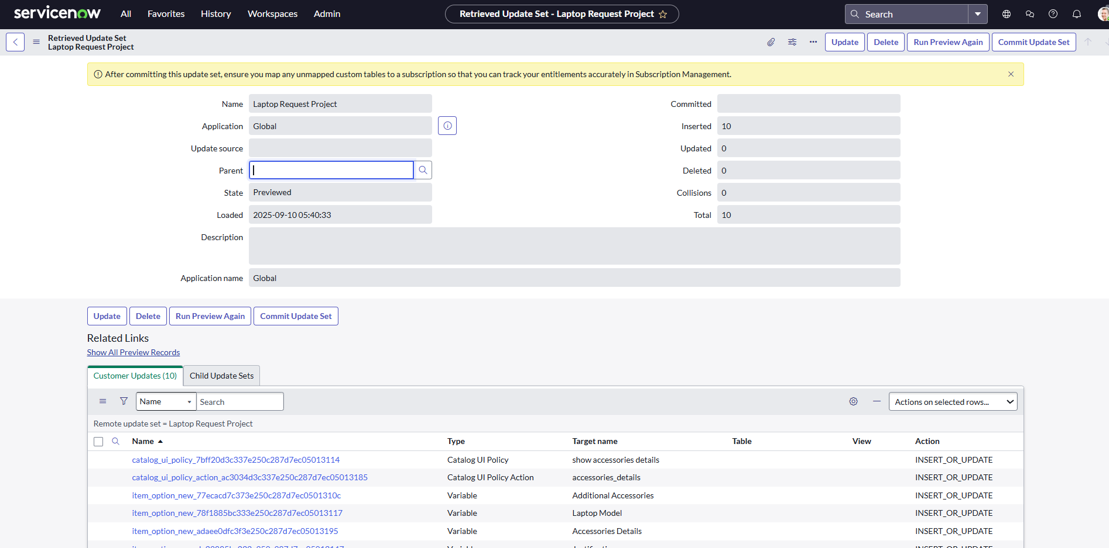

## 6.2 Create Catalog Item

Navigate: All → Service Catalog → Maintain Items Click New → Name: Laptop Request, Catalog: Service Catalog, Category: Hardware Save

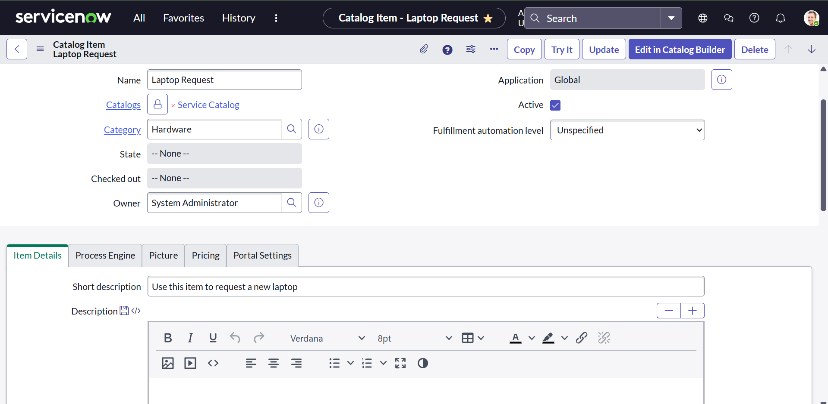

## 6.3 Add Variables

Add variables: Model, Justification, Accessories, Accessories Details Save

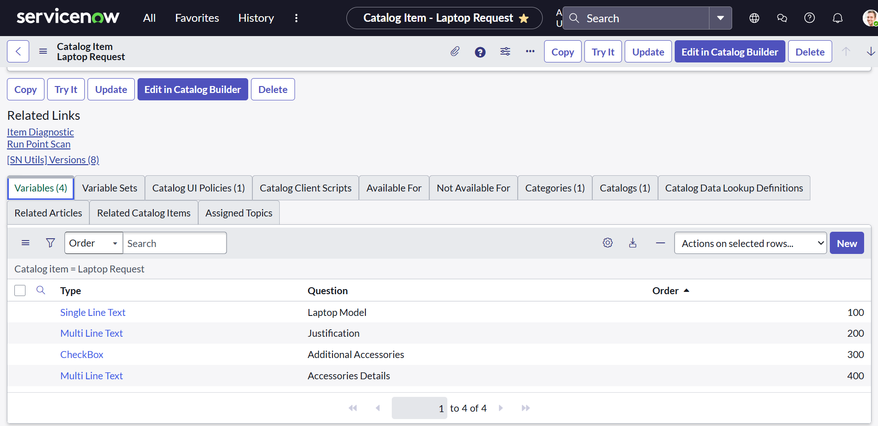

## 6.4 Configure UI Policy

Condition: If Additional Accessories = True → Show Accessories Details (mandatory)

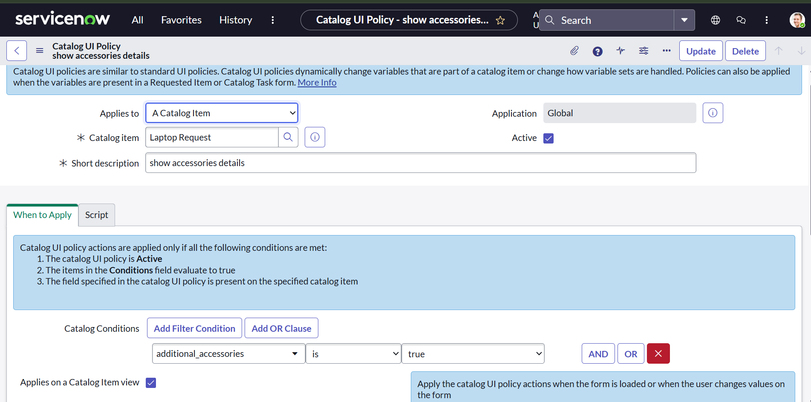 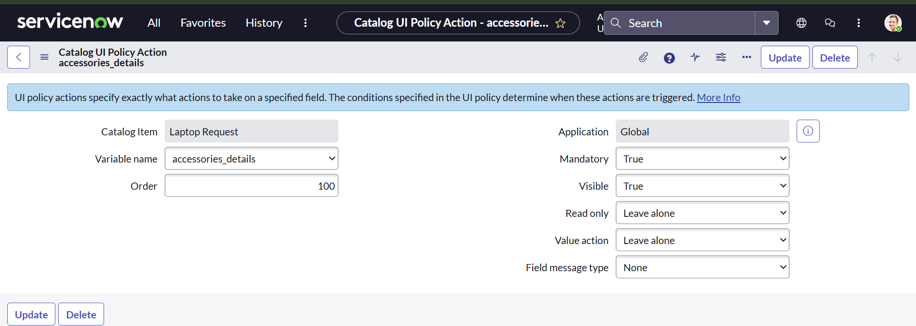

## 6.5 Create Reset Button (UI Action)

Navigate: System Definition → UI Actions → New Table: sc_cart, Action: Reset form, Client: Checked Script: function resetForm() { g_form.clearForm(); alert("The form has been reset."); }

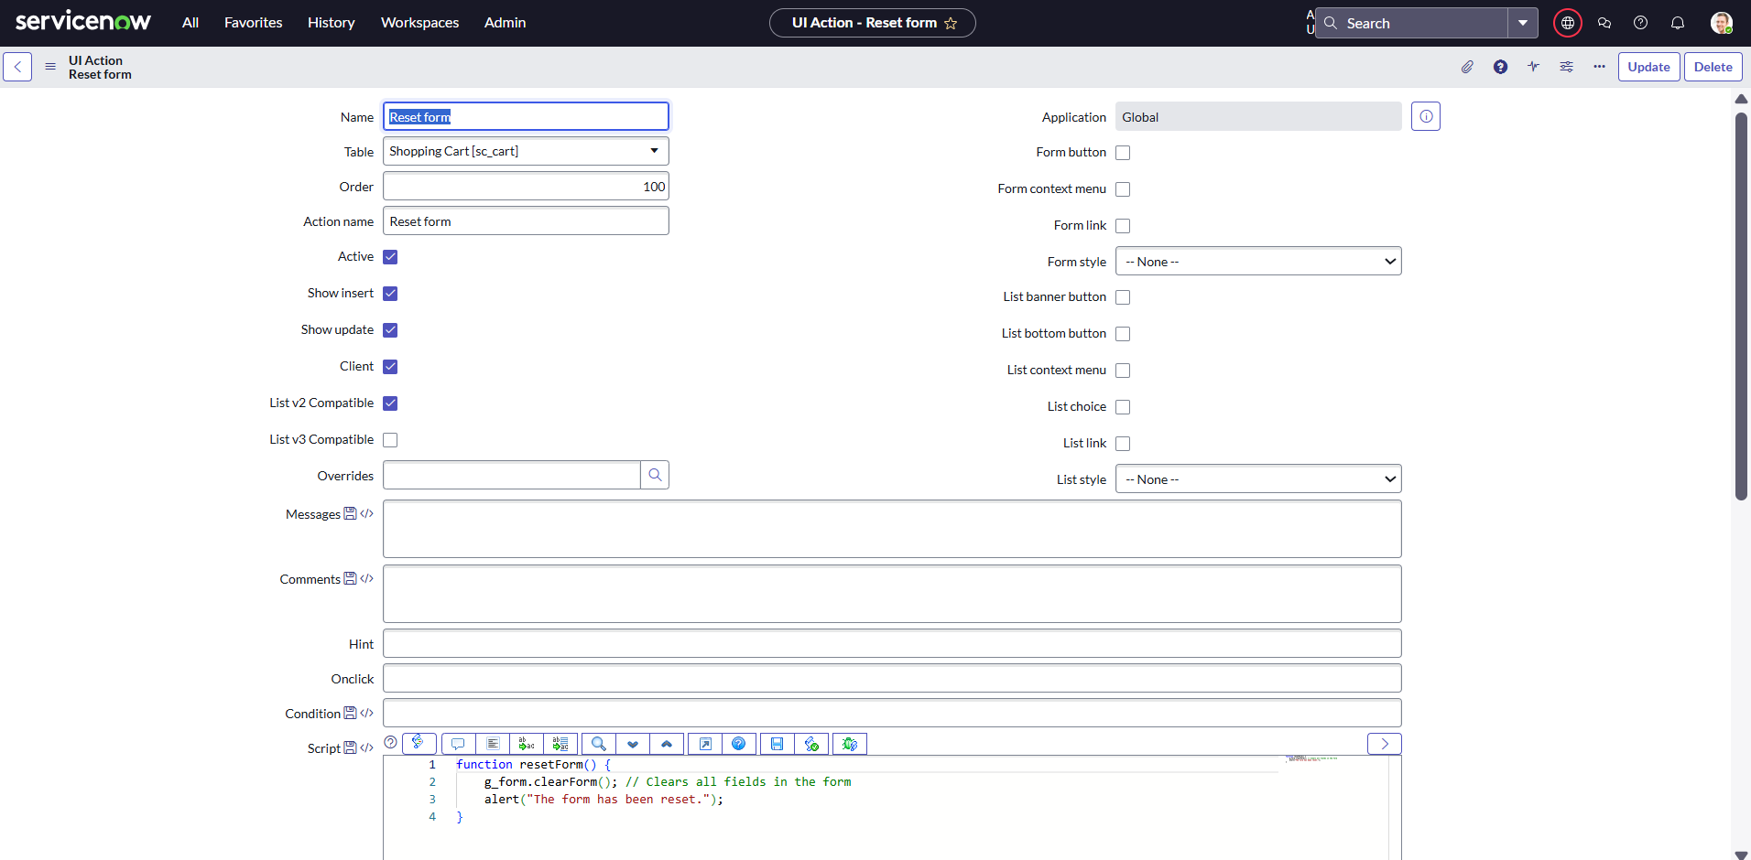

## 6.6 Export Update Set

Navigate: Update Sets → Local Update Sets → Laptop Request Set state: Complete Export XML

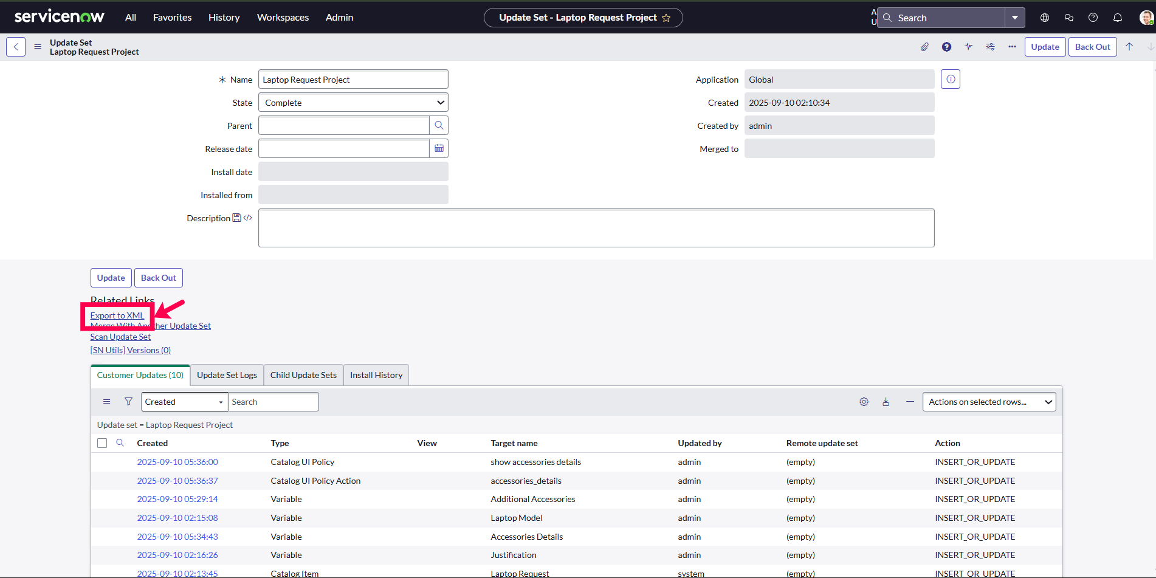

## 6.7 Import Update Set

Navigate: System Update Sets → Retrieved Update Sets Import XML → Preview → Commit

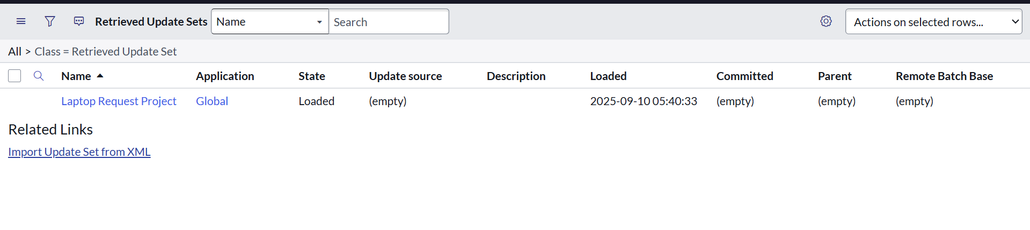 

## 6.8 Testing

- Initial fields only visible - Accessories Details field appears if checkbox selected - Form submission blocked if empty - Reset clears all fields

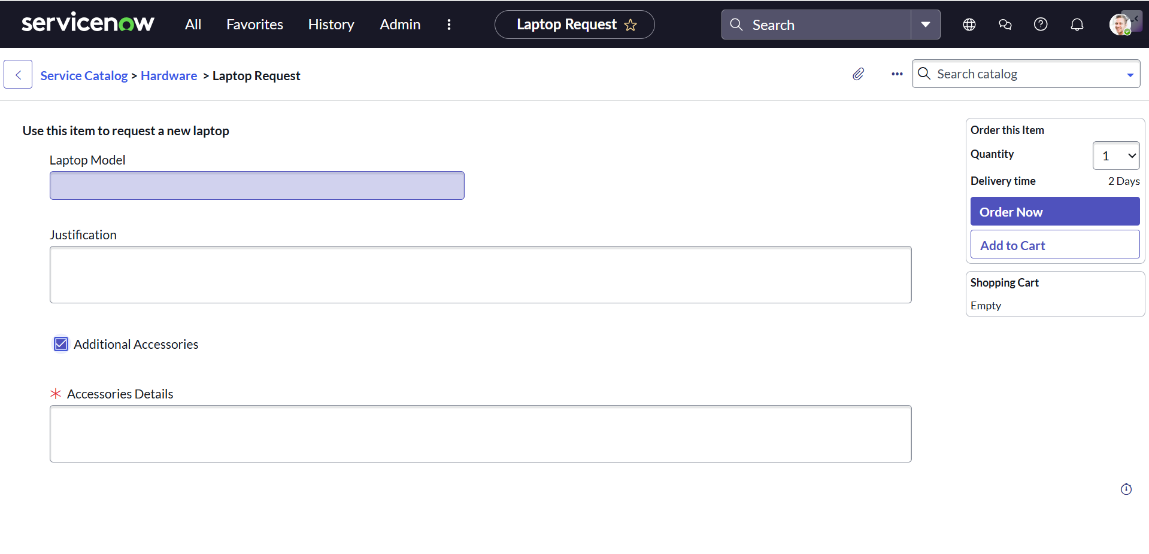

# 7. FUNCTIONAL & PERFORMANCE TESTING

Verified dynamic behavior, mandatory field validation, reset button functionality, and update set migration.

# 8. ADVANTAGES & DISADVANTAGES

## Advantages

- Faster submission & processing - No manual errors - Easy customization - Portable across instances - User-friendly interface

## Disadvantages

- Requires ServiceNow knowledge - Admin access needed for deployment

# 9. CONCLUSION

The Laptop Request Catalog Item in ServiceNow streamlines laptop requests with dynamic forms, validations, and easy deployment, improving IT efficiency and user experience.

# 10. FUTURE SCOPE

- Add approval workflows - Send automated notifications - Integrate dashboards - Extend to mobile devices and other hardware

# 11. APPENDIX

## UI Action Script

function resetForm() { g_form.clearForm(); alert("The form has been reset."); }

BY D.S.V.Krishna Murthy

Mail:22331a4720@mvgrce.edu.in