**PORTFOLIO**

**PROJECT BASED LEARNING REPORT**

Submitted in partial fulfilment of the requirements for the award of the degree of

**BACHELOR OF TECHNOLOGY**

**IN**

**COMPUTER SCIENCE AND ENGINEERING (INTERNET OF**

**THINGS AND CYBERSECURITY INCLUDING BLOCK CHAIN**

**TECHNOLOGY)**

**BY**

**DASARI S V KRISHNA MURTHY**

**(22331A4720)**

**Under The Supervision**

### Mr. Vella Manikanta

(**Assistant Professor)**



DEPARTMENT OF DATA ENGINEERING

MVGR COLLEGE OF ENGINEERING(Autonomous)

VIZIANAGARAM- 535005, AP (INDIA)

(Accredited by NBA, NAAC, and Permanently Affiliated to Jawaharlal Nehru

Technological University Vizianagaram)

**CERTIFICATE**



This is to certify that the project report entitled “**Portfolio**” being submitted by

**D. S. V . Krishna Murthy** bearing registered numbers **22331A4720** respectively, in partial fulfilment for the award of the degree of “**Bachelor of Technology” in Computer Science with IOT and Cybersecurity** is a record of bonafide work done by them under my supervision during the academic year 2022-2026.

**Mr. Vella Manikanta Dr P. Satheesh**

**Assistant Professor** **Head of the Department**

**Dept. of Data Engineering Dept. of Data Engineering**

ACKNOWLEDGEMENTS

We place on record and warmly acknowledge the continuous encouragement, invaluable supervision, timely suggestions and inspired guidance offered by our guide and our coordinator **Mr. V. Manikanta** Assistant Professor Department of Computer Science with IOT and Cybersecurity MVGR College of Engineering in bringing this report to a successful completion.

We consider it out privilege to express our deepest gratitude to **Dr. P. Satheesh**, Head of the Department for his valuable suggestions and constant motivation that greatly helped the project work to get successfully completed.

**INDEX CONTENTS**

I. ABSTRACT

2. INTRODUCTION

3. OBJECTIVE

4.FLOWCHART

5. IMPLEMENTATION

6. RESULT

7. CONCLUSION

8. REFERENCES

**ABSTRACT**

This project aims to design and develop a personal portfolio website using core web development technologies: **HTML**, **CSS**, and **JavaScript**. A portfolio website is an essential tool in today’s professional landscape as it serves as a central hub where individuals can present their skills, projects, education, and contact details. The portfolio is fully responsive, adapting to different screen sizes and devices, and incorporates interactive features for enhanced user experience. This project not only helps in creating a professional online presence but also demonstrates a practical understanding of front-end development concepts.

**INTRODUCTION**

In the modern digital era, having an online presence is crucial for professionals, especially those in tech and creative fields. A personal portfolio serves multiple purposes:

* It acts as an online resume.
* It allows for showcasing personal and professional projects.
* It provides a platform for employers or clients to easily get in touch.

This project is focused on developing a personal portfolio website using **HTML** for structure, **CSS** for styling, and **JavaScript** for adding interactivity. The website includes sections like Home, About, Skills, Projects, Resume, and Contact. It’s designed with user experience in mind, ensuring ease of navigation, mobile responsiveness, and visually appealing elements. The development process enhances knowledge in layout design, responsive frameworks, DOM manipulation, and basic client-side scripting.

**OBJECTIVE**

The main objectives of this project include:

* Designing a modern and user-friendly portfolio interface.
* Building a responsive layout that adapts to desktops, tablets, and mobile phones.
* Showcasing skills, projects, and personal information effectively.
* Incorporating visual elements such as animations and hover effects using CSS.
* Adding JavaScript features to improve interactivity (e.g., smooth scrolling, responsive navbar, form validation).
* Creating a professional and aesthetically pleasing platform to demonstrate web development capabilities.

**FLOWCHART**

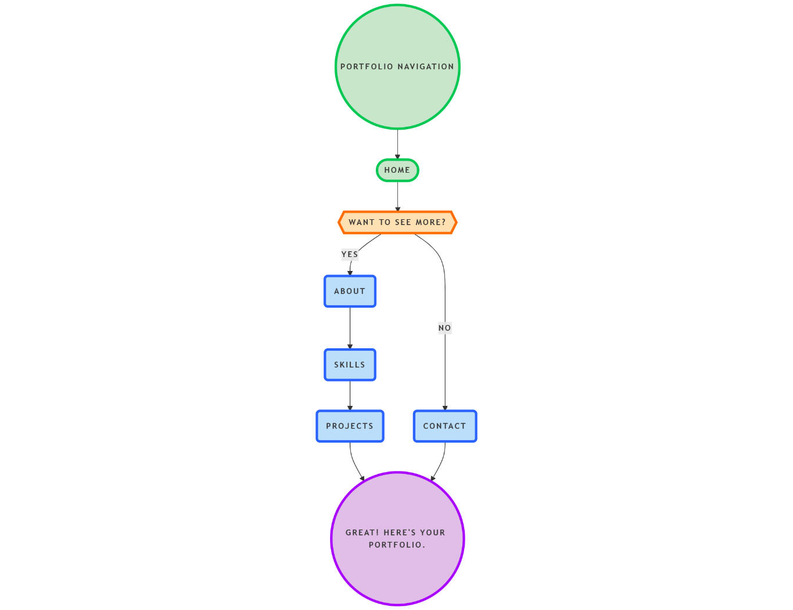

**IMPLEMENTATION**

**HTML – Structure**

* Semantic HTML5 tags used: <header>, <nav>, <main>, <section>, <footer>, etc.
* Navigation bar includes links to internal sections using anchor tags.
* Each section (Home, About, Skills, Projects, Contact) is clearly separated for modular design.

**CSS – Styling**

* External CSS file for styling and modularity.
* Modern layout techniques like **Flexbox** and **CSS Grid**.
* Use of variables for colors and fonts to maintain design consistency.
* Implemented **hover effects**, **transitions**, **media queries**, and **animations**.
* Design inspired by minimalist principles with emphasis on readability and usability.

**JavaScript – Interactivity**

* Responsive hamburger menu for mobile navigation.
* Scroll-to-section functionality.
* Scroll-triggered animations for content appearance.
* Dynamic date updates (e.g., footer copyright).
* Form validation to ensure proper input before submission.

**SOURCE CODE**

Index.html

<!DOCTYPE html>

<html lang="en">

    <head>

        <meta charset="UTF-8">

        <meta name="viewport" content="width=device-width, initial-scale=1.0">

        <link rel="stylesheet" href="assets/css/styles.css">

        <link href='https://cdn.jsdelivr.net/npm/boxicons@2.0.5/css/boxicons.min.css' rel='stylesheet'>

        <link rel="stylesheet" href="https://cdnjs.cloudflare.com/ajax/libs/font-awesome/6.4.0/css/all.min.css">

        <title>Portfolio website complete</title>

    </head>

    <body>

\        <header class="l-header">

            <nav class="nav bd-grid">

                <div>

                    <a href="#" class="nav__logo">Krishna Murthy</a>

                </div>

                <div class="nav__menu" id="nav-menu">

                    <ul class="nav__list">

                        <li class="nav__item"><a href="#home" class="nav__link active-link">Home</a></li>

                        <li class="nav__item"><a href="#about" class="nav__link">About</a></li>

                        <li class="nav__item"><a href="#skills" class="nav__link">Skills</a></li>

                        <li class="nav__item"><a href="#project" class="nav__link">Work</a></li>

                        <li class="nav__item"><a href="#contact" class="nav__link">Contact</a></li>

                    </ul>

                </div>

                <div class="nav__toggle" id="nav-toggle">

                    <i class='bx bx-menu'></i>

                </div>

            </nav>

        </header>

        <main class="l-main">

            <!--===== HOME =====-->

            <section class="home bd-grid" id="home">

                <div class="home__data">

                    <h1 class="home__title">Hi,<br>I'am <br><span class="home__title-color">Krishna Murthy</span></h1>

                    <a href="#contact" class="button">Contact</a>

                    <div class="home__social">

                        &nbsp; &nbsp; &nbsp; &nbsp; &nbsp;

                        <a href="https://www.linkedin.com/in/murthy-dasari-32b807259/" class="home__social-icon"><i class='bx bxl-linkedin'></i></a>

                        <a href="https://github.com/murthy1601" class="home__social-icon"><i class='bx bxl-github' ></i></a>

                    </div>

                </div>

                <div class="home__img">

                    <svg class="home__blob" viewBox="0 0 479 467" xmlns="http://www.w3.org/2000/svg" xmlns:xlink="http://www.w3.org/1999/xlink">

                        <mask id="mask0" mask-type="alpha">

                            <path d="M9.19024 145.964C34.0253 76.5814 114.865 54.7299 184.111 29.4823C245.804 6.98884 311.86 -14.9503 370.735 14.143C431.207 44.026 467.948 107.508 477.191 174.311C485.897 237.229 454.931 294.377 416.506 344.954C373.74 401.245 326.068 462.801 255.442 466.189C179.416 469.835 111.552 422.137 65.1576 361.805C17.4835 299.81 -17.1617 219.583 9.19024 145.964Z"/>

                        </mask>

                        <g mask="url(#mask0)">

                            <path d="M9.19024 145.964C34.0253 76.5814 114.865 54.7299 184.111 29.4823C245.804 6.98884 311.86 -14.9503 370.735 14.143C431.207 44.026 467.948 107.508 477.191 174.311C485.897 237.229 454.931 294.377 416.506 344.954C373.74 401.245 326.068 462.801 255.442 466.189C179.416 469.835 111.552 422.137 65.1576 361.805C17.4835 299.81 -17.1617 219.583 9.19024 145.964Z"/>

                            <image class="home__blob-img" x="50" y="60" href="assets/img/profile.png"/>

                        </g>

                    </svg>

                </div>

            </section>

            <!--===== ABOUT =====-->

            <section class="about section " id="about">

                <h2 class="section-title">About</h2>

                <div class="about__container bd-grid">

                    <div class="about__img">

                        <img src="assets/img/about.jpg" alt="">

                    </div>

                    <div>

                        <h2 class="about__subtitle">I'am Krishna Murthy</h2>

                        <p class="about__text"> a passionate Computer Science and Engineering graduate with a strong interest in web development,Python programming and bug hunting. I enjoy creating responsive, user-friendly websites using HTML, CSS, JavaScript, and exploring new technologies to sharpen my skills. My curiosity for cybersecurity drives me to find and report vulnerabilities in web applications, helping improve their security while deepening my understanding of how the web works. I'm always eager to learn, take on new challenges, and contribute to real-world projects.</p>

                    </div>

                </div>

            </section>

            <!--===== SKILLS =====-->

            <section class="skills section" id="skills">

                <h2 class="section-title">Skills</h2>

                <div class="skills__container bd-grid">

                    <div class="skills__wrapper">

                        <div class="skills__data">

                            <div class="skills__names">

                                <i class='bx bxl-html5 skills__icon'></i>

                                <span class="skills__name">HTML5</span>

                            </div>

                        </div>

                        <div class="skills__data">

                            <div class="skills__names">

                                <i class='bx bxl-css3 skills__icon'></i>

                                <span class="skills__name">CSS3</span>

                            </div>

                        </div>

                        <div class="skills__data">

                            <div class="skills__names">

                                <i class='bx bxl-javascript skills__icon'></i>

                                <span class="skills__name">JAVASCRIPT</span>

                            </div>

                        </div>

                        <div class="skills__data">

                            <div class="skills__names">

                                <i class='fab fa-python skills__icon'></i>

                                <span class="skills__name">PYTHON</span>

                            </div>

                        </div>

                        <div class="skills__data">

                            <div class="skills__names">

                                <i class='bx bxs-data skills__icon'></i>

                                <span class="skills__name">MySQL</span>

                            </div>

                        </div>

                        <div class="skills__data">

                            <div class="skills__names">

                                <i class='fas fa-leaf skills__icon'></i>

                                <span class="skills__name">Django</span>

                            </div>

                        </div>

                    </div>

                </div>

            </section>

            <!--===== project =====-->

            <section class="project section" id="project">

                <h2 class="section-title">Project</h2>

                <div class="project__container">

                    <div class="project_content">

                        <div class="project_grids">

                            <h3>QR-Based Visitor Gatepass Management System</h3>

                            <p>Implemented a QR code-based access control system, streamlining visitor registration and reducing average wait time by 2 minutes. Laborsaving visitor registration and entry/exit tracking through QR codes, improving efficiency and record keeping.</p>

                        </div>

                        <div class="project_grids">

                            <h3>Weather Forecasting</h3>

                            <p>Developed a weather forecasting application utilizing an API key for real-time data retrieval and a Python Tkinter-based user interface. Enhanced usability and accuracy in weather predictions, allowing for efficient planning and resource management.</p>

                        </div>

                    </div>

                </div>

            </section>

            <!--===== CONTACT =====-->

            <section class="contact section" id="contact">

                <div class="contact__container ">

                <h2 class="section-title">Contact</h2>

                <div class="contact-info">

                    <p>Email: murthy.dasari878@gmail.com</p>

                    <p>Phone: +91 9399965636</p>

                    <p>Contact me for any inquiries or collaborations.</p>

                </div>

                <div class="contact_social">

                    <h2 class="section-title">Social contacts</h2>

                    <a href="https://www.linkedin.com/in/murthy-dasari-32b807259/" class="footer__icon"><i class='bx bxl-linkedin'></i></a>

                    <a href="https://www.instagram.com/krishna__dasari_/" class="footer__icon"><i class='bx bxl-instagram'></i></a>

                    <a href="https://github.com/murthy1601" class="footer__icon"><i class='bx bxl-github'></i></a>

                </div>

                </div>

            </section>

        </main>

        <!--===== FOOTER =====-->

        <footer class="footer">

            <p class="footer__copy">&#169;2026 Krishna Murthy Dasari. All rigths reserved</p>

        </footer>

        <!--===== SCROLL REVEAL =====-->

        <script src="https://unpkg.com/scrollreveal"></script>

        <!--===== MAIN JS =====-->

        <script src="assets/js/main.js"></script>

    </body>

</html>

Styles.css(Sample code)

/*===== HOME =====*/

.home {

  position: relative;

  row-gap: 5rem;

  padding: 4rem 0 5rem;

}

.home__data {

  align-self: center;

}

.home__title {

  font-size: var(--big-font-size);

  margin-bottom: var(--mb-5);

}

.home__title-color {

  color: var(--first-color);

  font-size: 3rem;

}

.home__social {

  display: flex;

  flex-direction: column;

}

.home__social-icon {

  width: max-content;

  margin-bottom: var(--mb-2);

  font-size: 1.5rem;

  color: var(--second-color);

}

.home__social-icon:hover {

  color: var(--first-color);

}

.home__img {

  position: absolute;

  right: 0;

  bottom: 0;

  width: 280px;

}

.home__blob {

  fill: var(--first-color);

}

.home__blob-img {

  width: 418px;

}

/*BUTTONS*/

.button {

  display: inline-block;

  background-color: var(--first-color);

  color: #fff;

  padding: 0.75rem 2.5rem;

  font-weight: var(--font-semi);

  border-radius: 0.5rem;

  transition: 0.3s;

}

.button:hover {

  box-shadow: 0px 10px 36px rgba(0, 0, 0, 0.15);

}

/* ===== ABOUT =====*/

.about__container {

  row-gap: 2rem;

  text-align: center;

}

.about__subtitle {

  margin-bottom: var(--mb-2);

}

.about__img {

  justify-self: center;

}

.about__img img {

  width: 200px;

  border-radius: 0.5rem;

}

/* ===== SKILLS =====*/

.skills.section {

  padding-bottom: 0;

}

.skills__container {

  row-gap: 0;

  text-align: center;

  align-content: center;

  justify-content: center;

  margin: 0;

  padding: 0;

}

.skills__wrapper {

  display: flex;

  flex-wrap: wrap;

  justify-content: center;

  gap: 1.5rem;

  padding: 0;

  margin: 0 0 2rem 0;

}

.skills__data {

  min-width: 150px;

  padding: 0.8rem 1.2rem;

  border-radius: 10px;

  box-shadow: 0 4px 25px rgba(14, 36, 49, 0.15);

  background-color: #fff;

}

.skills__names {

  display: flex;

  align-items: center;

  gap: 10px;

}

.skills__icon {

  font-size: 2rem;

  margin-right: var(--mb-2);

  color: var(--first-color);

}

/* ===== PROJECT ===== */

.project.section {

  padding-top: 0;

}

.project__container {

  margin-top: 0;

  padding-top: 0;

}

.project_content {

  display: flex;

  flex-direction: column;

  gap: 1.5rem;

}

.project_grids {

  background-color: #fff;

  padding: 1.5rem;

  margin-bottom: var(--mb-4);

  border-radius: 0.5rem;

  box-shadow: 0px 4px 25px rgba(14, 36, 49, 0.15);

  text-align: left;

  transition: transform 0.3s ease, box-shadow 0.3s ease;

  margin-left: 9%;

  margin-right: 10%;

}

.project_grids h3 {

  font-size: var(--h2-font-size);

  color: var(--first-color);

  margin-bottom: var(--mb-2);

}

.project_grids p {

  font-size: var(--normal-font-size);

  color: var(--second-color);

  line-height: 1.6;

}

.project_grids:hover {

  box-shadow: 0px 6px 30px rgba(14, 36, 49, 0.5); /* Enhanced shadow on hover */

}

/* ===== CONTACT =====*/

.contact-info {

  background-color: #fff;

  padding: 1.5rem;

  margin-bottom: var(--mb-4);

  border-radius: 0.5rem;

  box-shadow: 0px 4px 25px rgba(14, 36, 49, 0.15);

  text-align: left;

  transition: transform 0.3s ease, box-shadow 0.3s ease;

  margin-left: 9%;

  margin-right: 10%;

}

.contact-info:hover {

  box-shadow: 0px 6px 30px rgba(14, 36, 49, 0.5); /* Enhanced shadow on hover */

}

.contact-info p {

  font-size: var(--normal-font-size);

  color: var(--second-color);

  line-height: 1.6;

  margin-bottom: var(--mb-2);

}

/* Center the social icons under the title */

.contact_social {

  text-align: center;

  margin-top: var(--mb-4);

}

.contact_social .footer__icon {

  font-size: 2rem;

  color: var(--second-color);

  margin: 0 var(--mb-2);

  transition: color 0.3s ease, transform 0.3s ease;

}

.contact_social .footer__icon:hover {

  color: var(--first-color);

  transform: scale(1.2); /* Slight zoom effect on hover */

}

/* ===== FOOTER =====*/

.footer {

  background-color: var(--second-color);

  color: #fff;

  text-align: center;

  font-weight: var(--font-semi);

  padding: 2rem 0;

}

.footer__copy {

  font-size: var(--smaller-font-size);

}

Main.js

/*===== MENU SHOW =====*/

const showMenu = (toggleId, navId) =>{

    const toggle = document.getElementById(toggleId),

    nav = document.getElementById(navId)

    if(toggle && nav){

        toggle.addEventListener('click', ()=>{

            nav.classList.toggle('show')

        })

    }

}

showMenu('nav-toggle','nav-menu')

/*==================== REMOVE MENU MOBILE ====================*/

const navLink = document.querySelectorAll('.nav__link')

function linkAction(){

    const navMenu = document.getElementById('nav-menu')

    // When we click on each nav__link, we remove the show-menu class

    navMenu.classList.remove('show')

}

navLink.forEach(n => n.addEventListener('click', linkAction))

/*==================== SCROLL SECTIONS ACTIVE LINK ====================*/

const sections = document.querySelectorAll('section[id]')

const scrollActive = () =>{

    const scrollDown = window.scrollY

  sections.forEach(current =>{

        const sectionHeight = current.offsetHeight,

              sectionTop = current.offsetTop - 58,

              sectionId = current.getAttribute('id'),

              sectionsClass = document.querySelector('.nav__menu a[href*=' + sectionId + ']')

        if(scrollDown > sectionTop && scrollDown <= sectionTop + sectionHeight){

            sectionsClass.classList.add('active-link')

        }else{

            sectionsClass.classList.remove('active-link')

        }

    })

}

window.addEventListener('scroll', scrollActive)

/*===== SCROLL REVEAL ANIMATION =====*/

const sr = ScrollReveal({

    origin: 'top',

    distance: '60px',

    duration: 2000,

    delay: 200,

//     reset: true

});

sr.reveal('.home__data, .about__img, .skills__subtitle, .skills__text,.project section',{});

sr.reveal('.home__img, .about__subtitle, .about__text, .skills__img,.section-title,.project_grids,.contact-info,.contact_social',{delay: 400});

sr.reveal('.home__social-icon',{ interval: 200});

sr.reveal('.skills__data, .work__img, .contact__input',{interval: 200});

**OUTPUT**

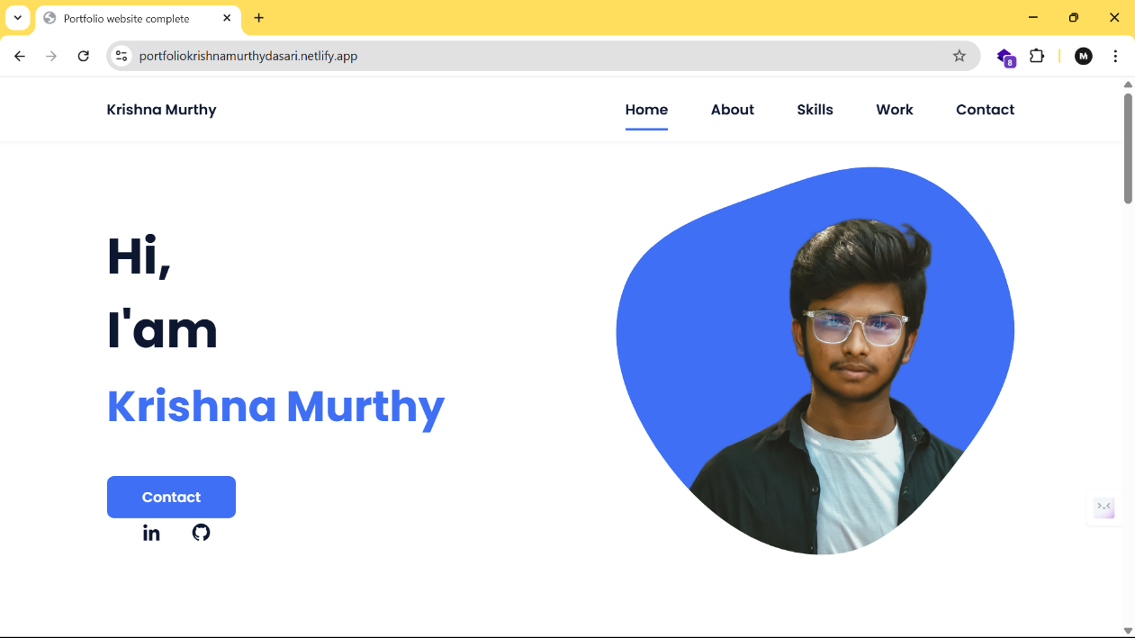[**https://portfoliokrishnamurthydasari.netlify.app/**](https://portfoliokrishnamurthydasari.netlify.app/)

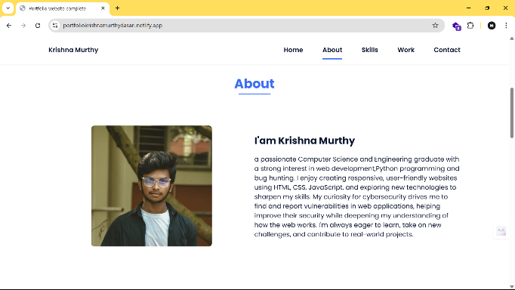 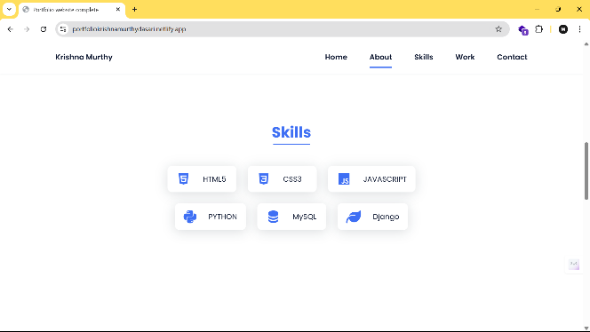

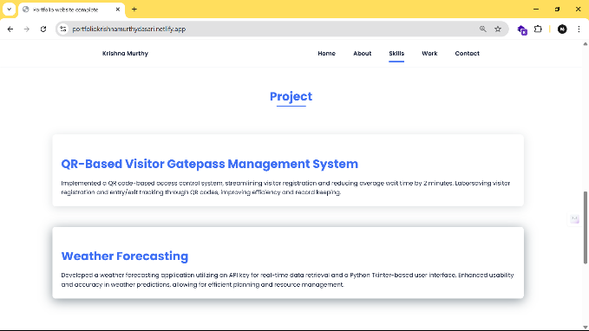 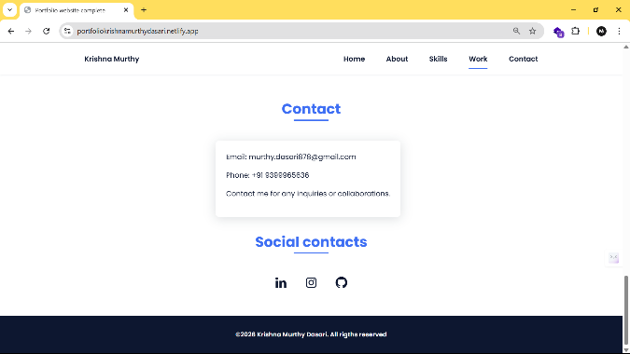

**RESULT**

The outcome of this project is a fully functional, visually engaging, and mobile-responsive personal portfolio website. Key results include:

* A clean and professional interface that reflects the developer’s personality and skills.
* Smooth navigation with animated transitions enhancing user interaction.
* Responsiveness across various screen sizes (mobile, tablet, desktop).
* A contact form that validates inputs and can be integrated with backend services or tools like EmailJS or Formspree (optional).
* Code quality maintained through consistent naming conventions and organized structure.

Screenshots of the final product (add if needed):

* Home Page View
* Projects Section
* Contact Form Validation
* Mobile Navigation Menu

**CONCLUSION**

The personal portfolio website project effectively showcases the practical use of HTML, CSS, and JavaScript in building a real-world application. It reinforces the understanding of:

* Structuring web pages using semantic HTML.
* Designing attractive and responsive layouts using CSS techniques.
* Enhancing user experience with JavaScript-driven interactivity.

Additionally, this project encourages good coding practices such as separation of concerns (HTML/CSS/JS), responsive design strategies, and attention to user experience. It serves as a strong foundation for future web development work and can be extended with features such as blog integration, dark mode, or CMS integration.

**REFERENCES**

* Mozilla Developer Network (MDN)  
  [https://developer.mozilla.org](https://developer.mozilla.org/)
* W3Schools  
  [https://www.w3schools.com](https://www.w3schools.com/)
* CSS Tricks  
  [https://css-tricks.com](https://css-tricks.com/)
* FreeCodeCamp  
  [https://www.freecodecamp.org](https://www.freecodecamp.org/)
* Stack Overflow  
  [https://stackoverflow.com](https://stackoverflow.com/)
* GitHub Pages Documentation  
  [https://pages.github.com](https://pages.github.com/)