For EPAM Interview do prepare on
javaScript:
Array and its methods
Object and its methods
organizing the different ways of Objects in javascript(accessing)
Callback functions
Event Handling in javascript
Event Loop & Asynchronous JavaScript
setTimeOut, setInterval,
Closures,Hoisting
this, Bind, Call, Apply
Prototypes & Inheritance
Functional Programming Concepts
Deep vs Shallow Copy
Module Systems
Memory Leaks and Garbage Collection
Event delegation
Web APIs integration (e.g. Fetch, IndexedDB)
React:
State Management (Local, Global, Derived)
Component Lifecycle (including Hooks)
Reconciliation & React Rendering Behavior
Prop Drilling vs Context API
Custom Hooks
Code Splitting & Lazy Loading
Java:
Exception Handling
OOP Principles (Inheritance, Encapsulation, Abstraction, Polymorphism)
Memory Management & Garbage Collection
Collections Framework
Multithreading & Concurrency
Java 8+ Features
Streams API and functional programming concepts.
Lambdas and method references.
Optional<T> to handle nulls safely.
CompletableFuture for async programming.
Git:
Git & GitOps
Linux Commands for command line interaction
CI/CD Pipelines
Docker (and Containers)

Concept – 1
JavaScript: Arrays & Objects - Interview Prep and Project Scenarios

🎯 Conceptual Deep Dives
1. map()
- Purpose: Transforms each element in an array without changing the original array.
- Syntax: array.map(callback(currentValue, index, array))
- Returns: A new array of the same length.
2. filter()
- Purpose: Filters elements that pass a condition.
- Syntax: array.filter(callback(currentValue, index, array))
- Returns: A new array with only elements that return true from the callback.
3. reduce()
- Purpose: Reduces array to a single value (sum, product, object).
- Syntax: array.reduce(callback(accumulator, currentValue, index, array), initialValue)
- Returns: A single value (can be number, string, array, or object).
4. Object.keys() / Object.values()
- Purpose: Convert objects into arrays of keys or values respectively.
- Syntax:
  - Object.keys(obj) returns an array of keys.
  - Object.values(obj) returns an array of values.

💡 Scenario-Based Questions (with Answers)
Q1: You receive a list of products. Each has a price and category. Create a list of product names under 'Electronics' only.
const products = [
{ name: 'Laptop', price: 50000, category: 'Electronics' },
{ name: 'Shirt', price: 1500, category: 'Apparel' },
{ name: 'Phone', price: 20000, category: 'Electronics' }
];

const electronicsNames = products
.filter(p => p.category === 'Electronics')
.map(p => p.name);
// Output: ['Laptop', 'Phone']
Q2: You're building a leaderboard. Convert an array of scores to a ranked string.
const scores = ["Alice", "Bob", "Charlie"];
const ranks = scores.map((name, index) => `#${index + 1} - ${name}`);
// Output: ['#1 - Alice', '#2 - Bob', '#3 - Charlie']
Q3: Given an object with employee salaries, compute the average salary.
const salaries = {
John: 30000,
Alice: 40000,
Bob: 50000
};

const values = Object.values(salaries);
const avgSalary = values.reduce((sum, curr) => sum + curr, 0) / values.length;
// Output: 40000
Q4: From an array of transactions, compute total deposits.
const transactions = [
{ type: 'deposit', amount: 1000 },
{ type: 'withdrawal', amount: 500 },
{ type: 'deposit', amount: 700 }
];

const totalDeposits = transactions
.filter(t => t.type === 'deposit')
.reduce((sum, t) => sum + t.amount, 0);
// Output: 1700
Q5: Convert an object of user info to an array of strings.
const user = { name: "Alice", age: 25, role: "admin" };
const userInfo = Object.entries(user).map(([key, value]) => `${key}: ${value}`);
// Output: ['name: Alice', 'age: 25', 'role: admin']

🎓 Project-Level Scenario
Project Context: E-commerce dashboard to manage inventory and sales.
Use Case: Generate a sales summary by category.
const orders = [
{ item: 'Laptop', category: 'Electronics', price: 50000 },
{ item: 'Shirt', category: 'Apparel', price: 1500 },
{ item: 'Phone', category: 'Electronics', price: 20000 },
{ item: 'Jeans', category: 'Apparel', price: 2000 }
];

const summary = orders.reduce((acc, order) => {
acc[order.category] = (acc[order.category] || 0) + order.price;
return acc;
}, {});

// Output: { Electronics: 70000, Apparel: 3500 }

forEach()
- What it does: Executes a function for each array element (like map, but doesn't return anything).
- Common use: Logging, side-effects.
[1, 2, 3].forEach((num) => console.log(num * 2));
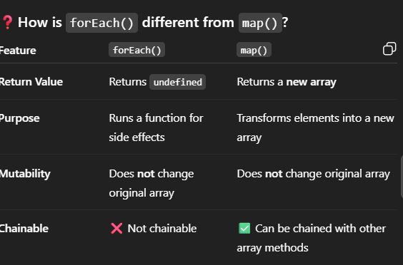
Conclusion:
Use map() when you want a transformed array. Use forEach() for logging, side effects, or mutations (though mutation is generally discouraged).
🔹 find()
- What it does: Returns first element that matches a condition.
- Use case: Fetching one item (e.g. a user by ID).
const users = [{id: 1}, {id: 2}];
const user = users.find(u => u.id === 2); // {id: 2}
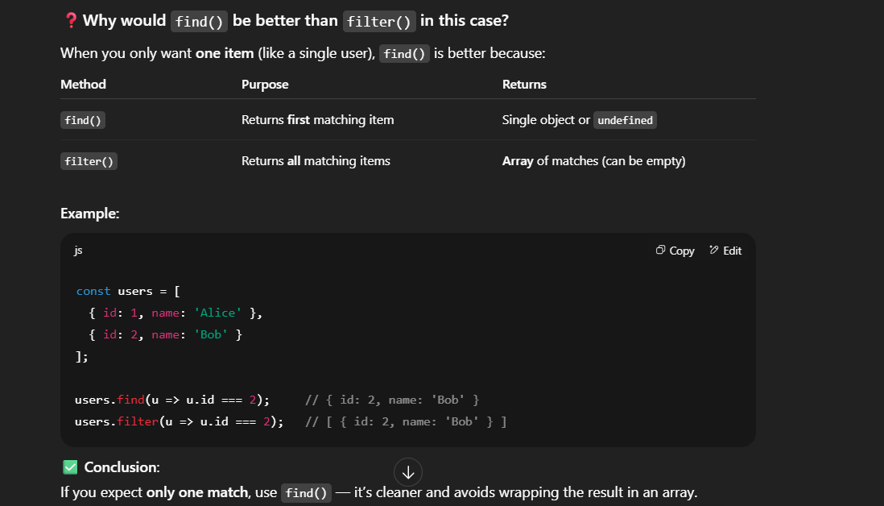🔹 some() / every()
- some(): Returns true if any element passes a test.
- every(): Returns true only if all elements pass a test.
const marks = [80, 70, 90];
marks.every(score => score > 60); // true
marks.some(score => score > 85); // true
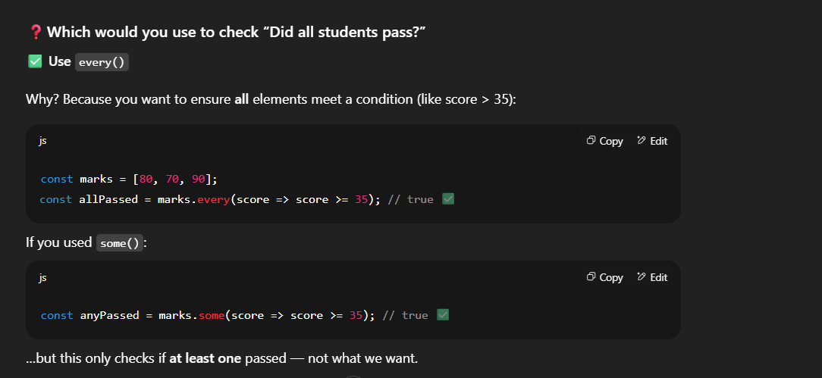
FUNCTIONS are first class Citizens in JAVASCRIPT

Closure
Function along with lexical scope, bundled together is called closure
Function x(){
Var a = 7;
Function y(){
Console.log(a);
}
Return y;
}
Var z = x();
Console.log(z); //print 7
//……..
Z()
The function doesn’t print value that you initialized previously, it prints the reference values (if you change a = 7 to 100 before it returns it prints 100 because it points to its reference)
Uses:
  - module Design Pattern
  - currying
  - functions (it runs only once)
  - memorize
  - maintaining state in async world
  - setTimeouts
  - iterators

Call Back Functions:-
A callback function is a function that is passed as an argument to another function and executed later.
  - As JS executes sync, as we need delay execution. Callbacks help achieve this by passing a function that is execute later

Uses:
  - Async operations: api req, reading files, event listeners, db queries
  - Function handling operations
  - Event listeners
  - Api calls
Cons:
  - Nested callbacks (hell) (promise is alternative)
  - Error handling may difficult
Async/ Awat (cleaner alternative)
When to Use and Avoid Callbacks?
Use callbacks when
Handling asynchronous tasks (API calls, file reading).
Implementing event-driven programming.
Creating higher-order functions.
Avoid callbacks when
Code becomes nested and unreadable (use Promises or async/await).
You need error handling in asynchronous operations (Promises are better).
Function x(…y){
We will pass y function to x, its upto x function when it can call y
}
X(function y(){

})
Garbage collection & removeEventListeners : event listeners are heavy means it takes memory
Asynchronous JS & Event Loop
- JS is a synchronous one threaded language
- all the code of JS will execute in a call Stack
When any js code is run a GEC – Global Execute Context is created
GEC

4
Console
--
a
End

a()

Function a(){
a is stored in the memory
Console.log(“a”)
}
In function invocation- executive context is created and pushed in call stack
a();
console.log(“end”)

micro task queue : all the call back functions which go through promises and mutation observers will be under this micro task queue,
  - Mutation observer: keeps on checking is there mutation in dom tree or not
No matter how many tasks in micro task queue , callback/Task Queue doesn’t get chance to execute until micro task is empty
Event loop: a bridge between microtask/task queue to make call backs in those queues gets executed
Starvation: The tasks in the micro Task Queue keep on getting added
https://g.co/gemini/share/c575242b9a2d -exception handling

React js
HOOKS
  - useState : why use, when
  - useEffect : Dependency array works , if it empty what happens, if a value present what happens
  - useContext
  - useReducer
  - useMemo
  - useCallBack
  - useRef
Higher Order Components:
  - what, when, why, how
life cycle methods of components
  - Cals components
  - Mounting, updating, unmounting phases (there are 9-10.. order is important)
State management
  - State / props
  - Props drilling (need able to write code)
  - Context
Redux—how, why, when (--redux toolkit--)
Custom Hooks:
  - When, why, how
Lazy Loading
  - Code splitting
  - Chunking
  - Suspense
Virtual DOM
  - Reconciliation
  - React fiber
  - Renders
  - Diffing algo
  - Render works
Routing (role based access control)
  - React router
  - Protected routes
  - Handle query params
Testing
  - React testing library (say I can write some easy test cases for this) – unit testing
Async tasks
  - Api calls
  - Events
  - Promises
  - setTimeouts, setIntervals
Coding practises
  - use these words, reusability, modularity, testability
  - {only 200 lines are allowed in a component if we are writing more than that we can modularize into components}
  - When to use, custom hook, high order function, break down component into smaller, pass props into it, how to manage state of whole application
Performance
  - No loading bar
  - Shiner ui
  - Lazy loading
  - Asset optimization
  - Bundler lever optimization
  - CDN server level
Styling: tailwind, styleX, bootstrap, ant ui, (pros and cons)
Four pillars: Accessibility, security, performance, testing

Queries
Select upper(first_name) as student_name from student;
Select distinct major from student
Select major from student group by (major);
Select substring(first_name,1,3) from Student;
Select instr(lower(first_name),’a’) from student where first_name = ‘Shivansh’;
Select distinct major, length(major) as length from student;
Select Replace (first_name, ‘a’, ‘A’) from student;
Select concat(first_name+’ ’+last_name) as Complete_name from student;
Select * from student order by first_name, major desc;
Select * from student where first_name in (‘prem’ , ‘shivansh’)
Select * from students where first_name like ‘%a’;
Select * from students where first_name like ‘-----a’;
Select * from students where gpa between 9.00 and 9.99;
Select major, count(*) as total_count from student where major = ‘computer science’;
Select concat(first_name+’ ’+last_name) as Complete_name from student where gpa between 8.5 and 9.5
Select major, count(major) from student group by major order by count(major) desc;
Select st.name, sh.scholorship_amount from students st inner join scholarship on st.sid = sh.sid;
Select * from student where student_id %2 !=0
Select all from student s left join scholarship on s.sid = sh.sid;
Select * from student order by gpa desc limit 5;
Select * from student order by gpa desc limit 4,1;
Select * from student s1 where 4 = (
Select count(distinct(s2.gpa))
From student s2
Where s2.gpa>= s1.gpa;
)
Select s1.* from student s1, student s2 where s1.gpa = s2.gpa and s1.student_id!= s2.student_id;
Select max(gpa) from student where gpa not in(select max(gpa) from student);
Select * from student union all select * from student order by sid;
Select s.sid from student where s.sid not in (select sh.sid from scholarship);
Select * from student limit (select floor(count (*)/2) from student);
Select major, count(major) from student group by major having count(major) < 4;
Select * from student where sid = (select max(sid) from student);
Select * from (select * from student order by sid desc limit 5) as subquery order by sid;
Select distinct gpa from student s1 where 3>=(select count(Distinct gpa) from student s2 where s2.gpa>=s1.gpa) order by s1.gpa desc;
Select major,max( gpa) from students group by major;
Select fn, gpa from student where gpa = (select max(gpa) from student);
Select curdate()
Select now()
Create table ct as select * from student;
Update student set gpa = 7.5 where major = ‘cse’
Select major, avg(gpa) as avg from student group by major;
Select * from student s1 where 3< = (
Select count(distinct(s2.gpa))
From student s2
Where s2.gpa>= s1.gpa;
)

Select * from student order by gpa desc limit 3;
Select major, count(sid) as highgpa from student where gpa>7.5 group by major;
Select * from student where gpa = (select gpa from student where sname = ‘mahajan’);

