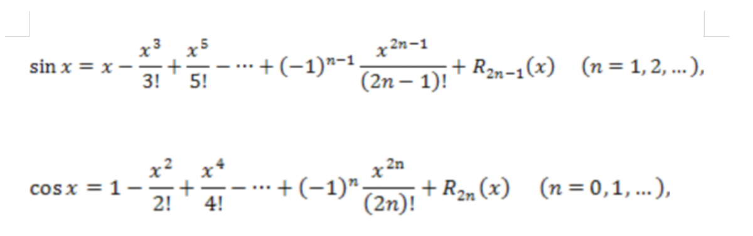

Write a program that calculates and prints the average of several integers. Assume that the last readable value is the 9999 label. A typical input sequence may look like

10 8 11 7 9 9999

showing that the average value of the numbers preceding 9999 should be calculated.

The company pays its employees either as managers (who receive a fixed weekly salary), or as hourly workers (who receive a fixed hourly wage for the first 40 working hours and an hourly rate of one and a half for over 40 hours of work), or as commission workers (who receive $250 plus 5.7% of the weekly amount sales), or as pieceworkers (who receive a fixed amount from each unit of production they produce - each pieceworker in this company produces only one type of product).

Write a program for calculating the weekly payment of each employee. You don't know the number of employees in advance. Each type of employee has its own payment code: managers have code 1, hourly workers have code 2, commission workers have code 3, piecework workers have code 4. Use a switch based on these payment codes to calculate payments to each employee. In the switch structure, ask the user (the clerk who makes up the payroll) to enter the relevant data necessary to calculate the payment to the employee in accordance with his payment code.