LasPay Card Management System

Business & Operations Guide
Document Title | LasPay Card Management System — Business & Operations Guide
Document ID | LasPay-CMS-001
Version | 1.0
Status | Client Ready
Classification | Confidential
Prepared For | LasPay
Prepared By | Karsaaz — CMS Delivery Team
Last Updated | August 2026

Document control
Version | Date | Author | Description
1.0 | Aug 2026 | CMS Team | Initial client business guide with deployed UI screenshots

Role | Name | Signature | Date
Project Manager
Business Lead
Client Representative

Table of contents
- Introduction
- Executive summary
- System overview
- User roles & access
- Business flows
  - 5.1 Sign in & dashboard
  - 5.2 New card request
  - 5.3 Card request approval (checker)
  - 5.4 Card generation
  - 5.5 Card search & operations
  - 5.6 Change card status
  - 5.7 Replacement request
  - 5.8 Change card type
  - 5.9 Cards by expiry date
  - 5.10 Card export to bureau
  - 5.11 Master data setup (housekeeping)
  - 5.12 Security & access control
- Module reference
- Appendix A — API summary
- Appendix B — Glossary
- Appendix C — Screenshot index
- Appendix D — Word document design

1. Introduction

1.1 Purpose
This document describes the LasPay Card Management System (CMS) from a business and operations perspective. It is intended for senior management and business teams who need to understand:
- What the system does
- How day-to-day card operations work
- Which screens users interact with at each step
- Which backend APIs support each business process
This guide complements the technical specification (Technical.md) and live Swagger documentation at /swagger-ui.html.

1.2 Scope
In scope | Out of scope
LasPay web CMS (admin portal) | Mobile app channel (separate guide)
Card production, operations, housekeeping | Core banking host internals
Security (users, roles, permissions) | Network / infrastructure design
Screenshots from deployed LasPay environment | Full API request/response schemas

1.3 Audience
Audience | How to use this document
Senior management | Sections 2–3 and flow diagrams in Section 5
Business / operations | Section 5 (step-by-step flows with screenshots)
QA / UAT | Flows + Appendix A (API mapping)
IT / integration | Appendix A + Swagger for full contracts

2. Executive summary
LasPay CMS is a secure web platform for managing the full card lifecycle — from new card requests and dual-control approval through card generation, day-to-day operations, and bureau export.

2.1 Key capabilities
Capability | Business value
Card production | Controlled issuance with maker/checker approval before generation
Operations | Search, status changes, replacements, type changes, expiry management
Housekeeping | Configure products, card types, limits, branches, and reference data
Security | Role-based access, permission control, encrypted sessions
Dashboard | Real-time view of pending approvals, open requests, and operational KPIs

2.2 Platform modules
The LasPay CMS is organised into five functional areas accessible from the main navigation menu:
flowchart LR
subgraph LasPay CMS
A[Dashboard]
B[Security]
C[Operations]
D[Card Production]
E[Housekeeping]
end
A --> F[Daily KPIs & queues]
B --> G[Users Roles Permissions]
C --> H[Cards Status Replace Export]
D --> I[Request Approve Generate]
E --> J[Products Types Limits]
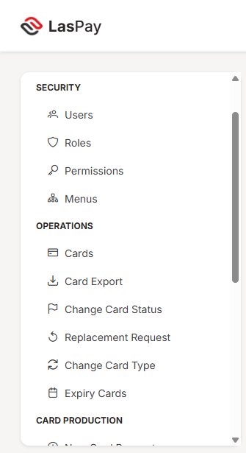
Figure 2.1 — LasPay navigation (Security & Operations)
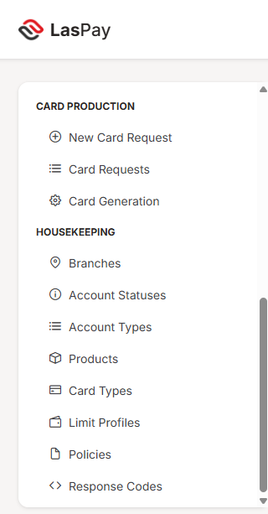
Figure 2.2 — LasPay navigation (Card Production & Housekeeping)

2.3 Flagship flow — new card issuance
flowchart TB
A[Maker: New Card Request] --> B[Customer lookup]
B --> C[Select product type branch]
C --> D[Submit request]
D --> E[Checker: Review queue]
E -->|Reject| F[Request rejected]
E -->|Approve| G[Card generation]
G --> H[Card issued & encrypted]
H --> I[Optional bureau export]
This end-to-end flow is documented in detail in Section 5.2 through Section 5.4.

3. System overview

3.1 High-level architecture
┌─────────────────────┐ ┌─────────────────────┐ ┌─────────────┐
│ LasPay Web UI │ HTTPS │ CMS REST API │ │ Oracle DB │
│ (Next.js portal) │ ──────► │ (core-service) │ ──────► │ (19c) │
└─────────────────────┘ └─────────────────────┘ └─────────────┘
Component | Role
LasPay Web UI | Browser-based portal for all CMS functions
CMS REST API | Business logic, validation, security, card processing
Oracle database | Persistent storage; card data encrypted at rest

3.2 Security highlights
- Encrypted session — JWT-based authentication on every API call
- Role-based access — Users see only menus and actions permitted by their role
- Dual control — Card requests require checker approval before generation
- PAN protection — Card numbers displayed masked (e.g. 222333******5352) in all list views
- Audit trail — System actions are logged for compliance (administrative review available to authorised users)

3.3 Sign-in screen
All users begin at the LasPay sign-in page. Access is restricted to authorised personnel.
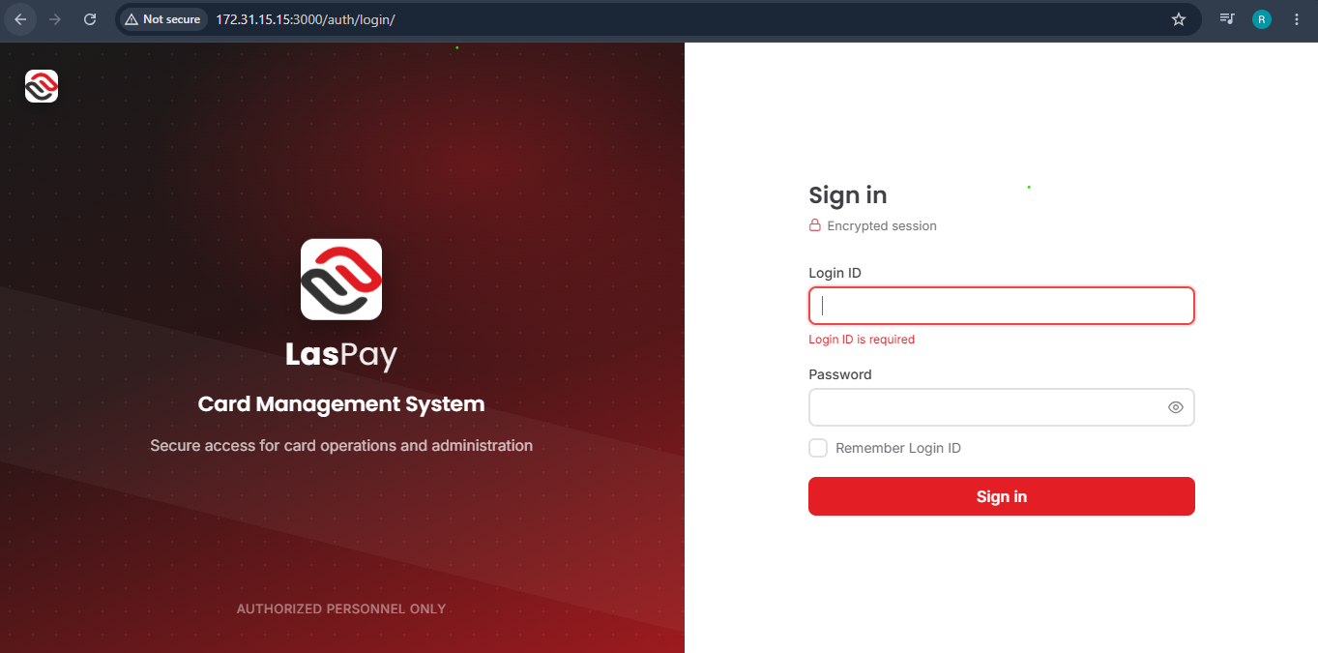
Figure 3.1 — LasPay sign-in
Step | Action | API
1 | User enters Login ID and password | —
2 | System validates credentials and issues session token | POST /api/auth/login
3 | User lands on Operations Dashboard | GET /api/dashboard/summary

4. User roles & access
LasPay CMS uses role-based access control (RBAC). Each user is assigned one or more roles that determine which menus and actions are available.

4.1 Typical roles
Role | Typical user | Primary activities
Administrator | IT / system admin | Users, roles, permissions, all modules
Maker | Branch operations staff | Create and edit card requests
Checker | Supervisor / authoriser | Approve or reject card requests
Card Operator | Card operations team | Card search, status, replacement, export
Card Viewer | Read-only users | View cards and reports

4.2 Access model
flowchart LR
U[User] --> R[Roles]
R --> P[Permissions]
P --> M[Menus & actions]
M --> S[Screens in LasPay CMS]
Permissions such as CREATE_CARD_REQUEST, APPROVE_CARD, and EXPORT_CARD gate specific business operations. See Section 5.12.

5. Business flows
Each flow below follows the same structure:
- Purpose — why the business uses this process
- Steps — what the user does
- Flow diagram — visual overview
- Screenshots — from deployed LasPay environment
- APIs — backend endpoints that power the screen
- Business rules — key controls and outcomes

5.1 Sign in & dashboard
Purpose: Provide a landing page after login with operational KPIs and quick access to pending work.
Who: All authenticated users

Steps
- User signs in at the LasPay login page
- System loads the Operations Dashboard
- Dashboard shows: pending approvals, open requests, cards issued today, expiring cards, hot cards, and request status chart
- User navigates to any module from the left menu

Screenshot
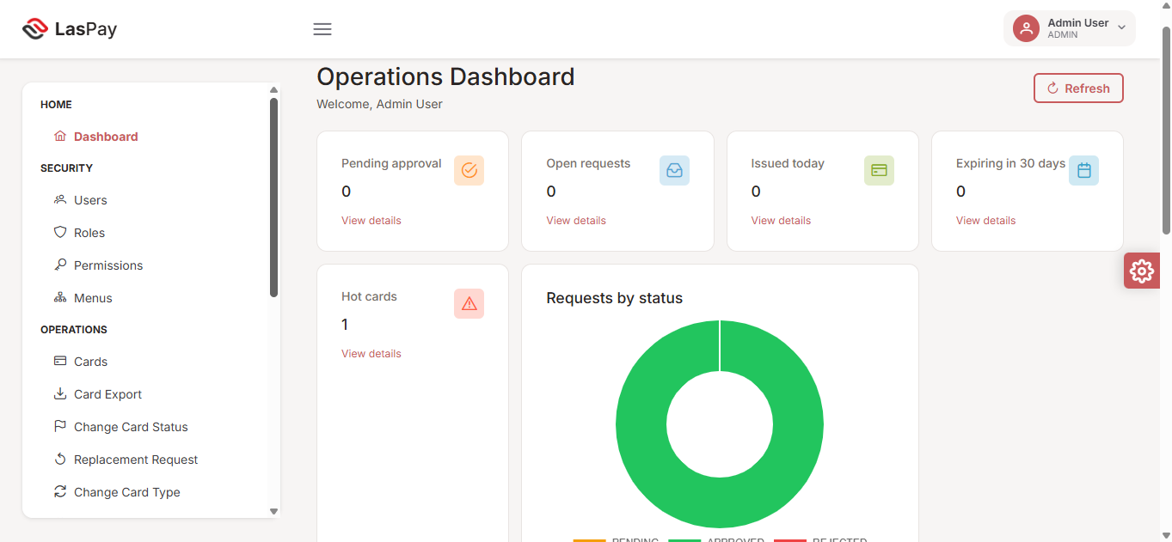
Figure 5.1 — Operations Dashboard

APIs
Function | Method | Endpoint | Purpose
Sign in | POST | /api/auth/login | Authenticate user
Dashboard KPIs | GET | /api/dashboard/summary | Load queues, counts, charts
User menus | GET | /api/my-menus | Build navigation for current user

Business rules
- Dashboard counts refresh on page load; user can click Refresh for latest data
- KPI cards link to relevant detail screens (e.g. pending approval → card requests)

5.2 New card request
Purpose: Allow a maker to submit a new card request for an existing or new customer account.
Who: Maker (or Admin with maker permissions)

Steps
- Navigate to Card Production → New Card Request
- Enter relationship number — system loads customer and account options
- Select existing account or choose new account
- Complete card details: card title, product, card type, branch, supplementary count
- Submit the request — it enters the maker/checker workflow

Flow diagram
flowchart LR
A[Open New Card Request] --> B[Enter relationship #]
B --> C[Load customer & accounts]
C --> D[Fill card details]
D --> E[Submit request]
E --> F[Request pending in queue]

Screenshots
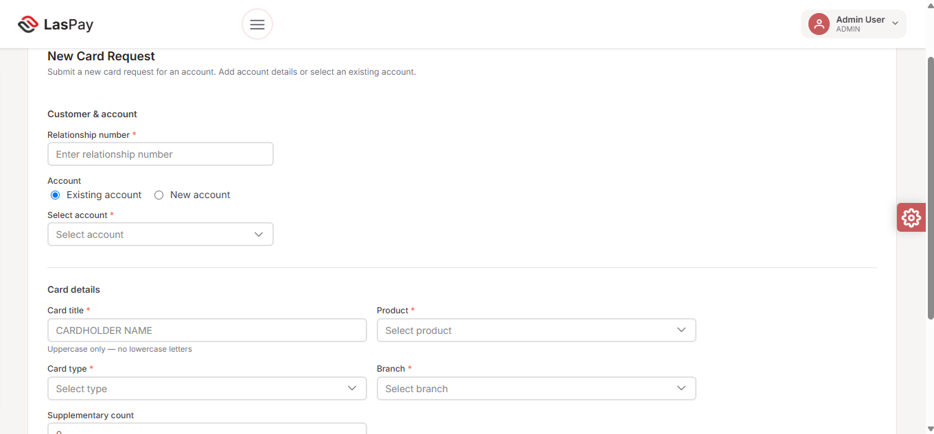
Figure 5.2.1 — New card request (empty form)
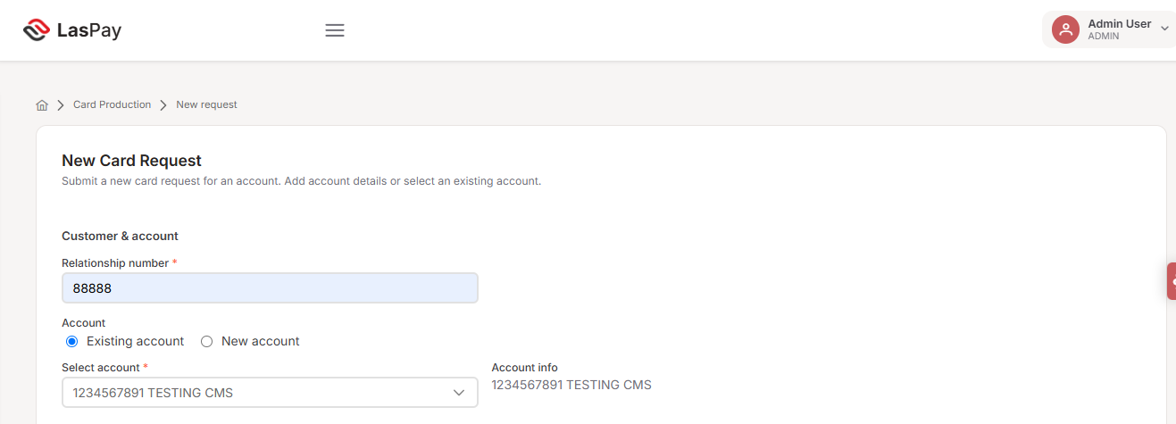
Figure 5.2.2 — Customer lookup — account selected
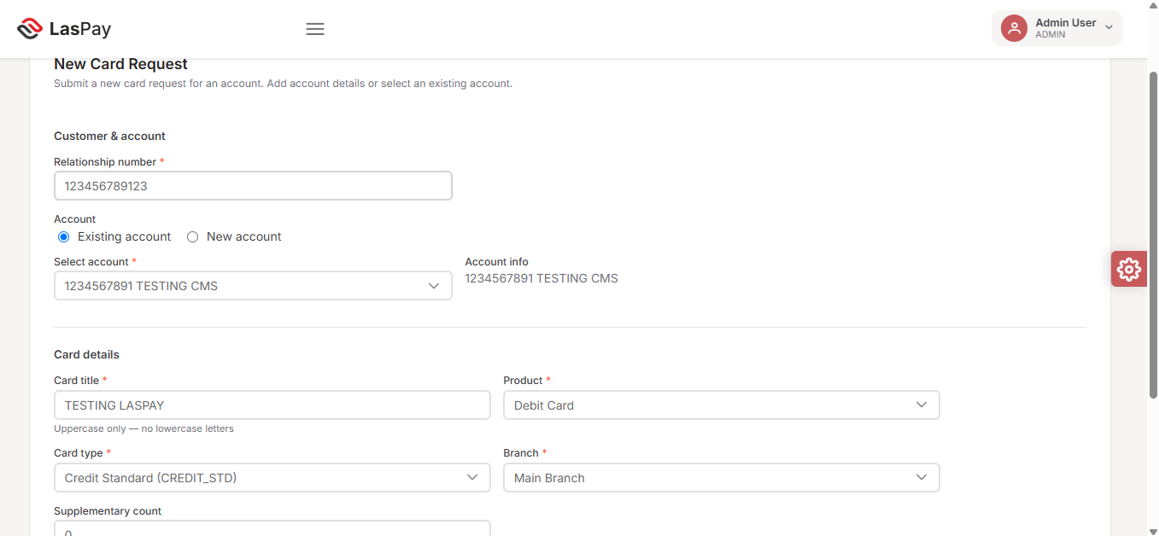
Figure 5.2.3 — Form completed — ready to submit

APIs
Step | Method | Endpoint | Purpose
Customer lookup | GET | /api/card-requests/customer-info?relationshipNum= | Load customer and accounts
Create request | POST | /api/card-requests | Submit new card request
Update request | PUT | /api/card-requests/{id} | Edit before approval
Dropdowns | GET | /api/products, /api/card-types, /api/branches | Product, type, branch lists

Business rules
- Card title must be uppercase (no lowercase letters)
- All fields marked with * are mandatory
- Request appears in checker queue after submission
- Maker cannot approve their own request (dual control)

Outcome
Result | Description
Success | Request created with status Pending; visible in Card Requests queue
Validation error | Missing or invalid fields highlighted on form

5.3 Card request approval (checker)
Purpose: Authorised checker reviews pending card requests and approves or rejects them.
Who: Checker (or Admin with approve permissions)

Steps
- Navigate to Card Production → Card Requests
- View Checker queue — lists pending requests with customer, product, branch details
- Review request details (relationship, account, title, type, product)
- Click Approve to proceed to generation, or Reject to decline with audit record
- Approved requests move to card generation

Flow diagram
flowchart TB
A[Checker opens Card Requests] --> B[Review pending item]
B --> C{Decision}
C -->|Approve| D[Request approved]
C -->|Reject| E[Request rejected]
D --> F[Proceed to Card Generation]

Screenshot
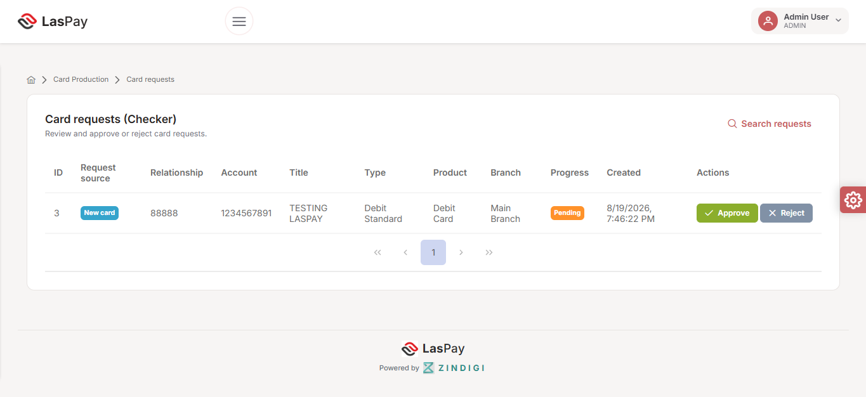
Figure 5.3 — Card requests checker queue

APIs
Step | Method | Endpoint | Purpose
Checker queue | GET | /api/card-requests/checker | List requests awaiting approval
Maker queue | GET | /api/card-requests/maker | List maker’s requests
Reject | POST | /api/card-requests/reject | Reject with reason
Approve & generate | POST | /api/card-generation/request/{id}/approve-and-generate | Approve and create card
Search | GET | /api/card-requests/search | Find historical requests

Business rules
- Only users with APPROVE_CARD permission can approve
- Rejected requests remain searchable for audit
- Progress shown as Pending until checker action

Outcome
Result | Description
Approved | Request proceeds to card generation
Rejected | Request marked rejected; no card created

5.4 Card generation
Purpose: Generate the physical/logical card record after checker approval.
Who: Card operations / generation operator

Steps
- Navigate to Card Production → Card Generation
- Enter relationship number and account number
- Click Load requests — system shows approved requests for that account
- Process generation — card record created, PAN encrypted, optional bureau file prepared
- Processed column shows Yes when complete

Flow diagram
flowchart LR
A[Approved request] --> B[Load by relationship & account]
B --> C[Process generation]
C --> D[Card record created]
D --> E[Marked processed]

Screenshot
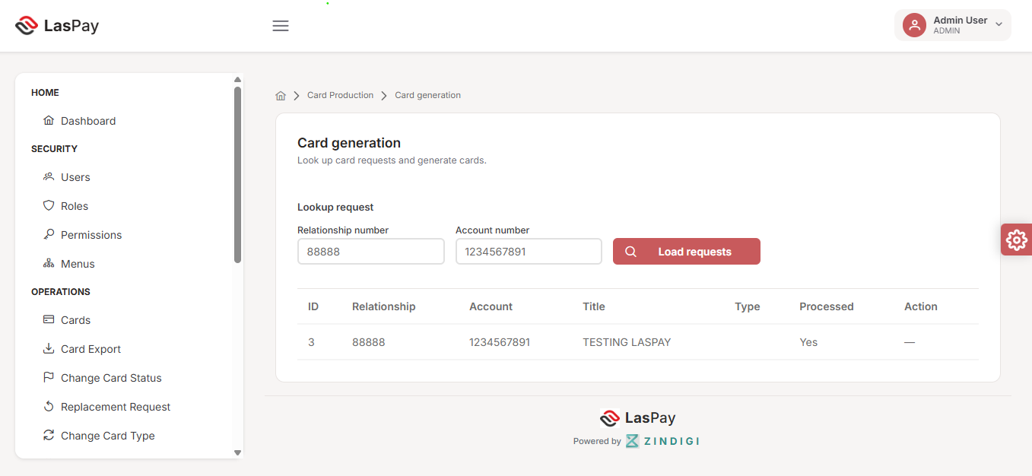
Figure 5.4 — Card generation

APIs
Step | Method | Endpoint | Purpose
Load requests | POST | /api/card-generation/request-by-code | Find requests by relationship & account
Approve & generate | POST | /api/card-generation/request/{id}/approve-and-generate | Generate card from approved request
Process | POST | /api/card-generation/process | Process generation for request ID
Update progress | PUT | /api/card-generation/request/{id}/progress | Update workflow progress flag

Business rules
- Only approved requests appear for generation
- Generated cards stored with encrypted PAN
- Limit profile from product/card type applied on generation

Outcome
Result | Description
Success | Card issued; processed flag = Yes; card visible in Operations → Cards
Already processed | Request shown as processed; no duplicate generation

5.5 Card search & operations
Purpose: Search and manage existing cards across all operational functions.
Who: Card Operator, Admin

Overview
The Operations module provides unified card search used by multiple processes:
Screen | Business use
Cards | Primary card search and detail view
Change card status | Move card between Cold / Warm / Hot states
Replacement request | Request replacement card for lost/damaged cards
Change card type | Upgrade or change card product type
Expiry Cards | Find cards expiring in a date range; bulk renew or replace
Card Export | Export issued cards to bureau production file
All operational search screens share common filters: PAN, relationship number, date range, card type.

APIs (shared)
Function | Method | Endpoint | Purpose
Search cards | POST | /api/cards/search | Filter cards by criteria
Get card detail | GET | /api/cards/{id} | Full card information
Get dropdowns | GET | /api/cards/dropdowns | Filter options (types, statuses)
Customer lookup | GET | /api/cards/customer-by-relation | Customer info by relationship #

5.6 Change card status
Purpose: Update a card’s operational status (e.g. Cold → Warm → Hot) for fraud or lifecycle management.
Who: Card Operator

Steps
- Navigate to Operations → Change Card Status
- Apply search filters (PAN, relationship, date range, card type)
- Click Search — results show current status per card
- Click Change Status on the target row
- Select new status and confirm

Screenshot
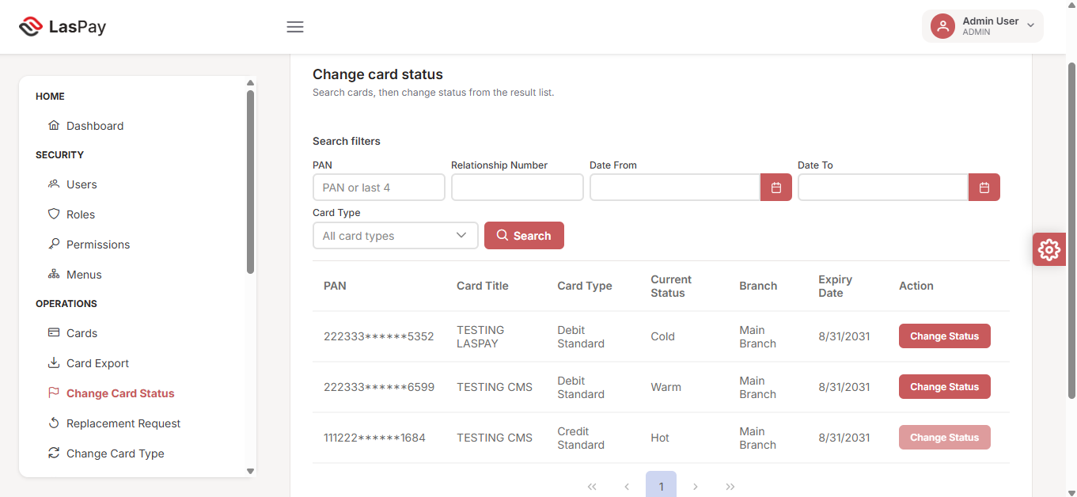
Figure 5.6 — Change card status

APIs
Step | Method | Endpoint | Purpose
Search | POST | /api/cards/search | Find cards matching filters
Update status | PUT | /api/cards/{id} | Apply new card status

Business rules
- Status values configured in housekeeping (Cold, Warm, Hot)
- Hot cards flagged on dashboard for immediate attention
- All status changes logged for audit

5.7 Replacement request
Purpose: Initiate a replacement card when the existing card is lost, stolen, or damaged.
Who: Card Operator

Steps
- Navigate to Operations → Replacement Request
- Search for the card by PAN, relationship, or date range
- Review card details (type, branch, status, expiry)
- Click Request Replacement on the selected card
- System marks card inactive and creates a new card request in the production queue

Screenshot
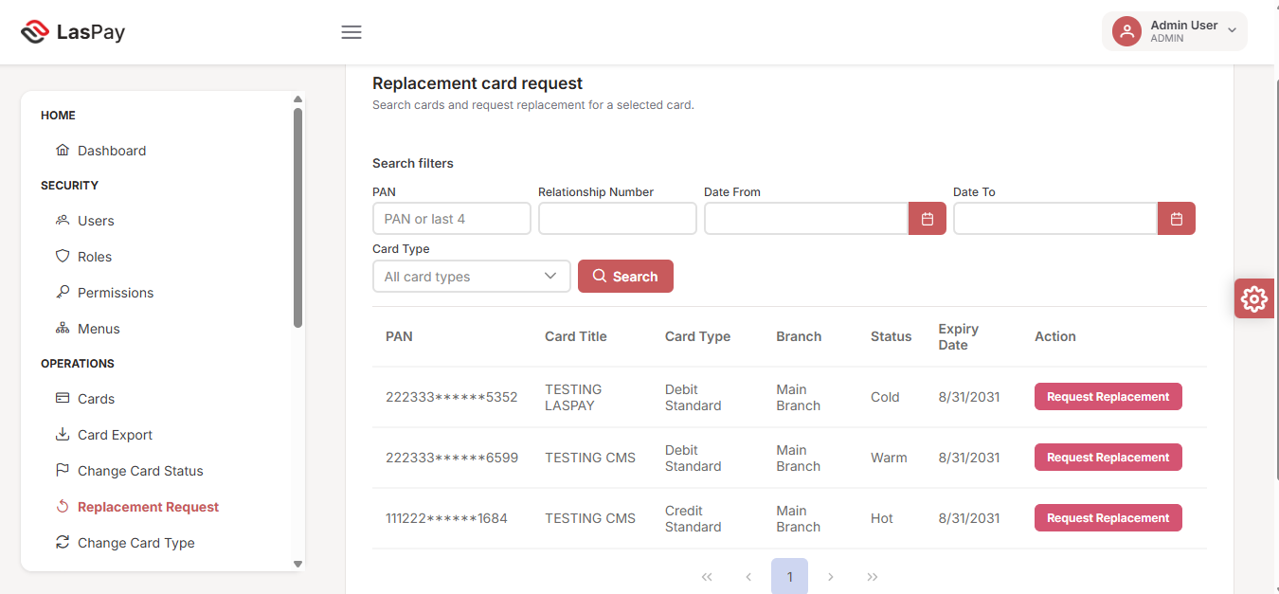
Figure 5.7 — Replacement card request

APIs
Step | Method | Endpoint | Purpose
Search | POST | /api/cards/search | Find target card
Create replacement | POST | /api/cards/{id}/replacement-request | Mark inactive & create new request

Business rules
- Original card deactivated upon replacement request
- New request follows standard maker/checker/generation flow
- Replacement source tagged in request queue

5.8 Change card type
Purpose: Change an existing card from one type to another (e.g. Debit Standard → Credit Standard).
Who: Card Operator

Steps
- Navigate to Operations → Change Card Type
- Search for the card
- Review current card type in results
- Click Change Type and select the new card type
- System creates a card type change request for processing

Screenshot
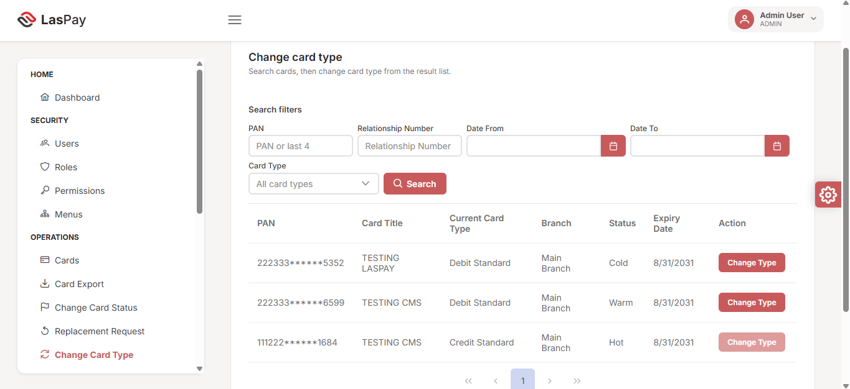
Figure 5.8 — Change card type

APIs
Step | Method | Endpoint | Purpose
Search | POST | /api/cards/search | Find target card
Change type | POST | /api/cards/{id}/change-card-type | Create type change request

Business rules
- New card type must be compatible with the card’s product
- Change request enters production workflow for approval if required

5.9 Cards by expiry date
Purpose: Identify cards approaching expiry and perform bulk renewal or replacement.
Who: Card Operator

Steps
- Navigate to Operations → Expiry Cards
- Set date range (from / to) and optional PAN filter
- Click Search — cards with expiry in range are listed
- Select cards via checkbox
- Click Renew selected (extend expiry) or Replace selected (create replacement requests)
- Use View on individual rows for card detail

Screenshot
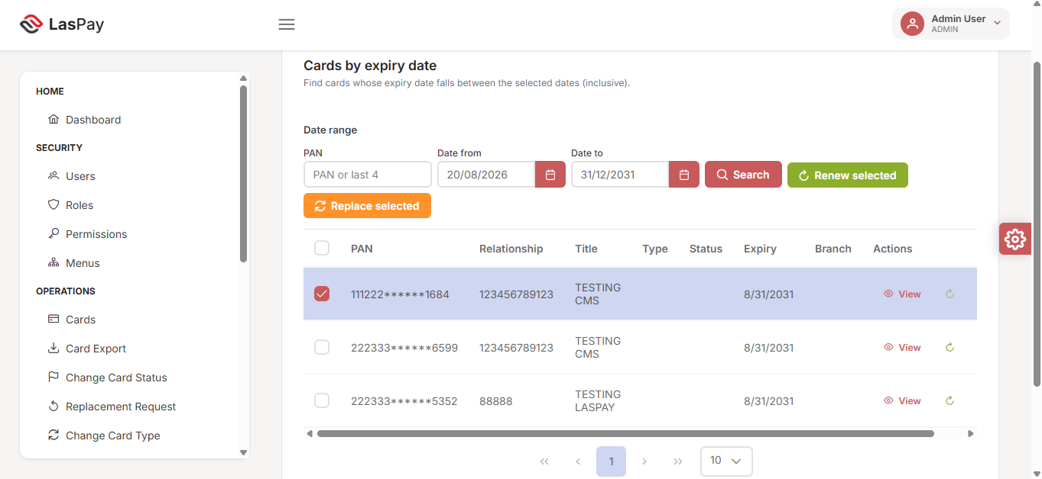
Figure 5.9 — Cards by expiry date

APIs
Step | Method | Endpoint | Purpose
Expiry search | POST | /api/cards/expiry-search | Find cards in date range
Bulk renew | POST | /api/cards/bulk-renew | Extend expiry on selected cards
Replacement | POST | /api/cards/{id}/replacement-request | Replace selected cards

Business rules
- Dashboard shows count of cards expiring in 30 days
- Bulk actions require at least one selected card
- Renew extends expiry; replace creates new card request

5.10 Card export to bureau
Purpose: Export issued cards ready for physical card bureau production.
Who: Card Operator with export permission

Steps
- Navigate to Operations → Card Export
- Select card type filter
- Click Search — system finds cards with production status Issued
- Success message confirms count (e.g. “2 export-ready card(s) found”)
- Select cards and export to bureau file

Screenshot
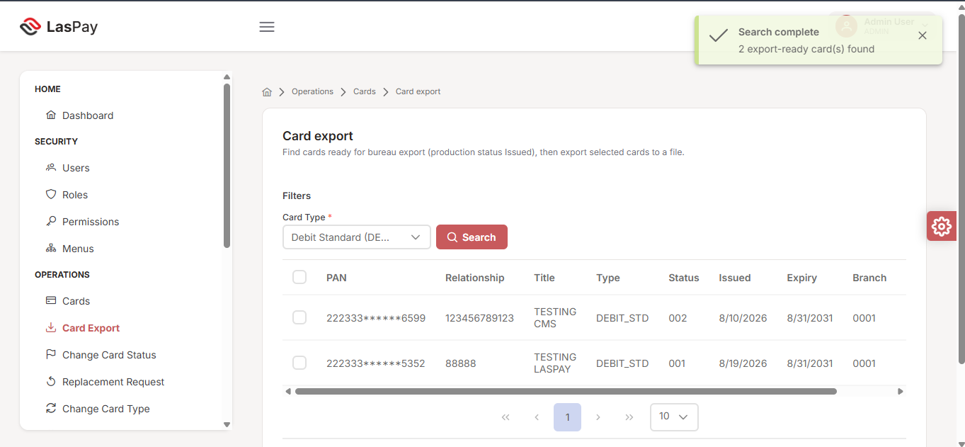
Figure 5.10 — Card export

APIs
Step | Method | Endpoint | Purpose
Find export-ready | POST | /api/cards/export-ready | List cards ready for bureau
Bulk export | POST | /api/cards/bulk-export | Generate bureau export file
Download file | GET | /api/cards/{id}/export-file | Download generated export file

Business rules
- Only cards with status Issued appear in export search
- Requires EXPORT_CARD permission
- Export file generated to secured output directory

5.11 Master data setup (housekeeping)
Purpose: Configure reference data required before card production and operations can run.
Who: Administrator

Setup order (recommended)
flowchart LR
A[Branches] --> B[Products]
B --> C[Card Types]
C --> D[Limit Profiles]
D --> E[Account Types & Statuses]
E --> F[Ready for card production]

Screenshots
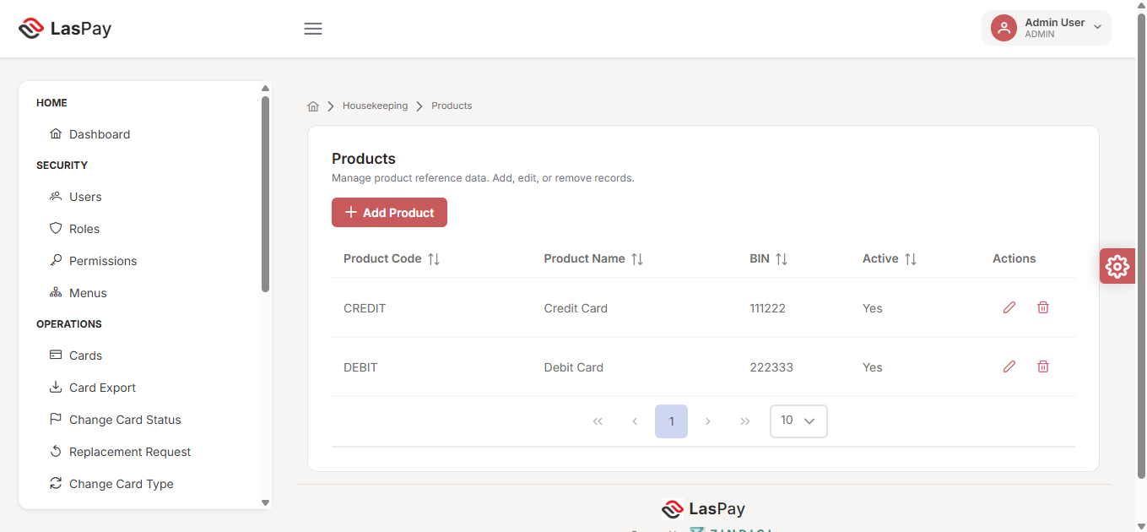
Figure 5.11.1 — Products
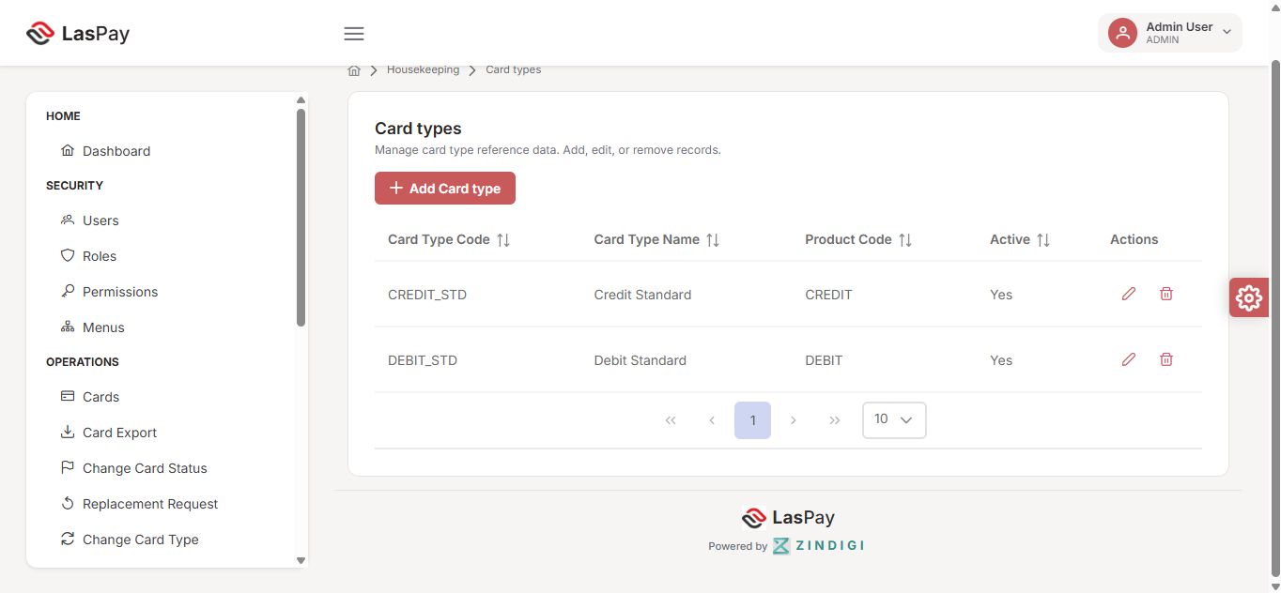
Figure 5.11.2 — Card types
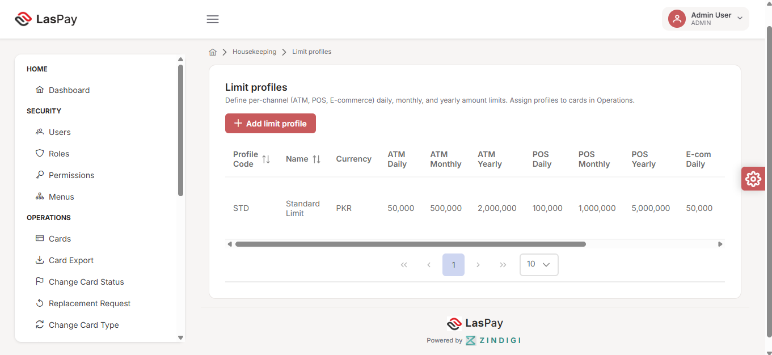
Figure 5.11.3 — Limit profiles

Key entities
Entity | Example values | Used in
Products | Credit Card (BIN 111222), Debit Card (BIN 222333) | New card request product selection
Card types | Credit Standard, Debit Standard | Card type selection, export filter
Limit profiles | Standard Limit — ATM/POS/E-com daily/monthly/yearly | Applied on card generation

APIs
Entity | Base endpoint | Operations
Branches | /api/branches | CRUD
Products | /api/products | CRUD
Card types | /api/card-types | CRUD
Limit profiles | /api/limit-profiles | CRUD
Account types | /api/account-types | CRUD
Account statuses | /api/account-statuses | CRUD
Response codes | /api/response-codes | CRUD
Policies | /api/policies | CRUD

Business rules
- Products and card types must be Active to appear in card request dropdowns
- Each card type links to a product code
- Limit profiles define per-channel caps (ATM, POS, E-commerce) in PKR

5.12 Security & access control
Purpose: Manage who can access LasPay CMS and what actions they can perform.
Who: Administrator

Components
Component | Function
Roles | Define access groups (Admin, Card Operator, Card Viewer)
Permissions | Granular action rights (view, create, approve, export)
Menus | Control which navigation items each role sees

Screenshots
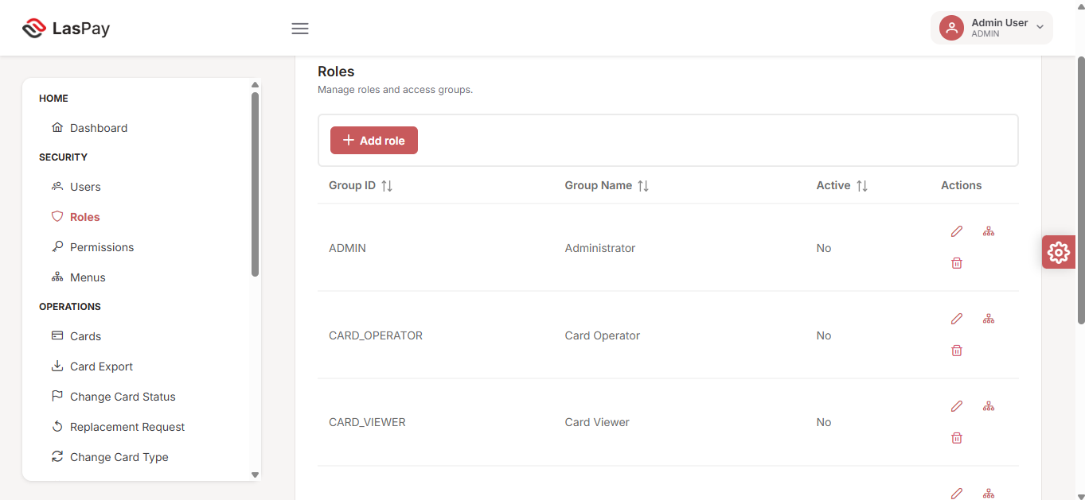
Figure 5.12.1 — Roles
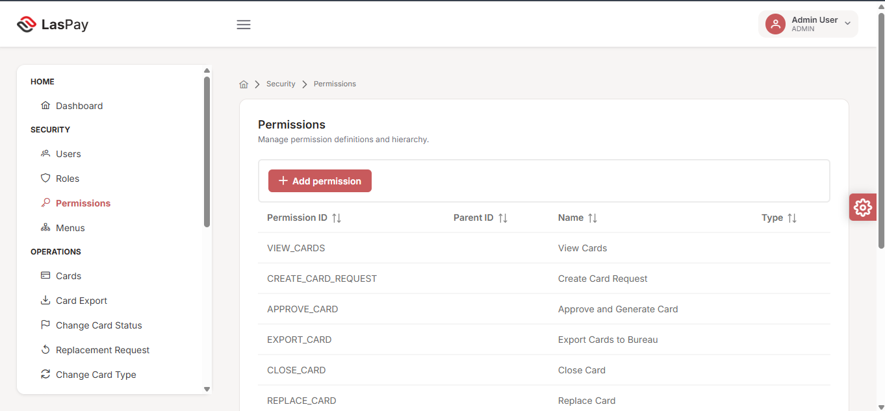
Figure 5.12.2 — Permissions
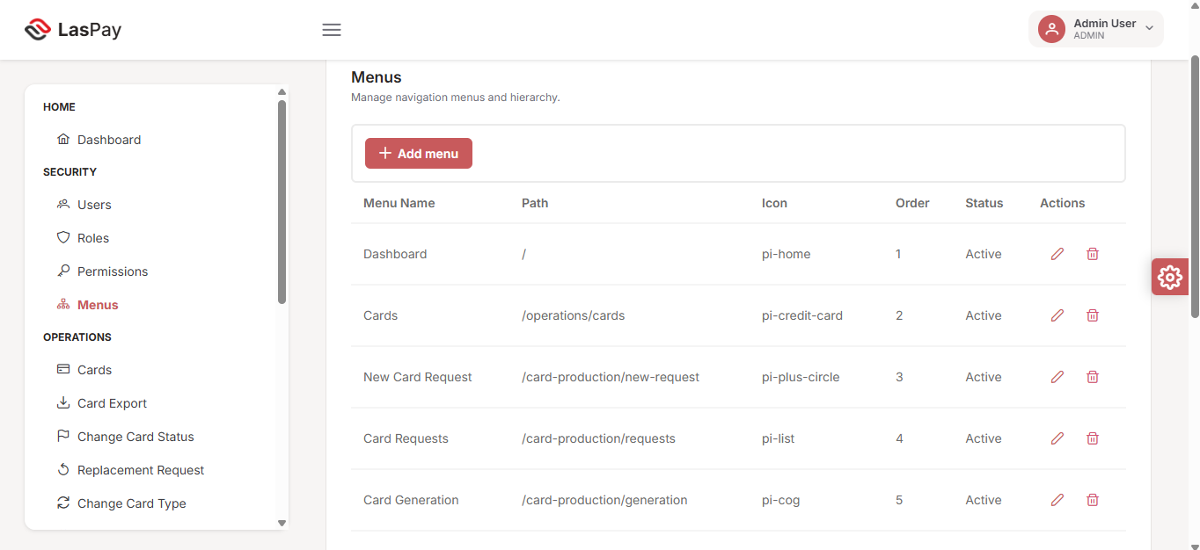
Figure 5.12.3 — Menu configuration

Key permissions (card operations)
Permission ID | Name | Gates
VIEW_CARDS | View Cards | Card search and detail screens
CREATE_CARD_REQUEST | Create Card Request | New card request form
APPROVE_CARD | Approve and Generate Card | Checker approval and generation
EXPORT_CARD | Export Cards to Bureau | Card export screen
CLOSE_CARD | Close Card | Card closure action
REPLACE_CARD | Replace Card | Replacement request action

APIs
Function | Method | Endpoint
Users | CRUD | /api/users
Roles | CRUD | /api/roles
Permissions | CRUD | /api/permissions
Menus | CRUD | /api/menus
Assign roles | POST | /api/users/{id}/roles

Business rules
- Users must have at least one active role to sign in
- Menu visibility driven by role–menu mapping
- Permission checks enforced on API for every protected action

6. Module reference
Quick reference for all LasPay CMS menu items.

6.1 Home
Screen | Route | Description
Dashboard | / | Operations KPIs, queues, charts

6.2 Security
Screen | Route | Description
Users | /security/users | Create and manage CMS users
Roles | /security/roles | Define access groups
Permissions | /security/permissions | Action-level permission definitions
Menus | /security/menus | Navigation menu configuration

6.3 Operations
Screen | Route | Description
Cards | /operations/cards | Search and view cards
Card Export | /operations/cards/export | Bureau export for issued cards
Change Card Status | /operations/cards/change-status | Update card status
Replacement Request | /operations/cards/replacement | Request card replacement
Change Card Type | /operations/cards/change-type | Change card type
Expiry Cards | /operations/cards/expiry | Expiry search and bulk actions

6.4 Card Production
Screen | Route | Description
New Card Request | /card-production/new-request | Submit new card request
Card Requests | /card-production/requests | Maker and checker queues
Search Requests | /card-production/requests/search | Search historical requests
Card Generation | /card-production/generation | Generate approved cards

6.5 Housekeeping
Screen | Route | Description
Branches | /housekeeping/branches | Branch reference data
Account Statuses | /housekeeping/account-statuses | Account status codes
Account Types | /housekeeping/account-types | Account type codes
Products | /housekeeping/products | Card products and BINs
Card Types | /housekeeping/card-types | Card type definitions
Limit Profiles | /housekeeping/limit-profiles | Transaction limit templates
Policies | /housekeeping/policies | Business policy rules
Response Codes | /housekeeping/response-codes | System response codes

Appendix A — API summary
Base URL: CMS REST API (core-service). All endpoints prefixed with /api/. Authentication: JWT Bearer token.

Authentication
Method | Endpoint | Purpose
POST | /api/auth/login | Sign in
POST | /api/auth/refresh | Refresh token
POST | /api/auth/change-password | Change password

Dashboard
Method | Endpoint | Purpose
GET | /api/dashboard/summary | Dashboard KPIs and charts

Card requests
Method | Endpoint | Purpose
POST | /api/card-requests | Create request
GET | /api/card-requests/maker | Maker queue
GET | /api/card-requests/checker | Checker queue
POST | /api/card-requests/reject | Reject request
PUT | /api/card-requests/{id} | Update request
GET | /api/card-requests/search | Search requests
GET | /api/card-requests/customer-info | Customer lookup
GET | /api/card-requests/{id} | Get by ID

Card generation
Method | Endpoint | Purpose
POST | /api/card-generation/request-by-code | Load requests
POST | /api/card-generation/request/{id}/approve-and-generate | Approve & generate
POST | /api/card-generation/process | Process generation
PUT | /api/card-generation/request/{id}/progress | Update progress

Cards (operations)
Method | Endpoint | Purpose
POST | /api/cards/search | Search cards
GET | /api/cards/{id} | Card detail
PUT | /api/cards/{id} | Update card / status
POST | /api/cards/{id}/replacement-request | Replacement
POST | /api/cards/{id}/change-card-type | Type change
POST | /api/cards/expiry-search | Expiry search
POST | /api/cards/bulk-renew | Bulk renew
POST | /api/cards/export-ready | Export-ready search
POST | /api/cards/bulk-export | Bureau export
POST | /api/cards/{id}/close | Close card

Housekeeping
Method | Endpoint | Purpose
CRUD | /api/branches | Branches
CRUD | /api/products | Products
CRUD | /api/card-types | Card types
CRUD | /api/limit-profiles | Limit profiles
CRUD | /api/account-types | Account types
CRUD | /api/account-statuses | Account statuses
CRUD | /api/response-codes | Response codes
CRUD | /api/policies | Policies

Security
Method | Endpoint | Purpose
CRUD | /api/users | Users
CRUD | /api/roles | Roles
CRUD | /api/permissions | Permissions
CRUD | /api/menus | Menus
GET | /api/my-menus | Current user menus
Full API detail: Live Swagger UI at /swagger-ui.html when core-service is running.

Appendix B — Glossary
Term | Definition
BIN | Bank Identification Number — first 6 digits identifying the card product
Bureau | External card personalisation / printing vendor
Checker | Authorised user who approves or rejects card requests (dual control)
CMS | Card Management System
Cold / Warm / Hot | Card status levels indicating activation and risk state
Housekeeping | Reference data configuration (products, types, branches, limits)
Maker | User who creates card requests
PAN | Primary Account Number — the card number (always masked in UI)
Relationship number | Customer identifier linking accounts and cards
Dual control | Two-person rule: maker creates, checker approves

Appendix C — Screenshot index
All screenshots captured from the deployed LasPay CMS environment.
Figure | File | Screen | Section
3.1 | 1.png | Sign in | 3.3
5.1 | 02-Dashboard.png | Operations Dashboard | 5.1
2.1 | 03-menu.png | Navigation — Security & Operations | 2.2
2.2 | 04-menus.png | Navigation — Production & Housekeeping | 2.2
5.2.1 | 05-new-card-request.png | New card request (empty) | 5.2
5.2.2 | 06-Existing customer .png | Customer lookup | 5.2
5.2.3 | 07-Submit new card request.png | Form completed | 5.2
5.3 | 08-Approve card.png | Checker queue | 5.3
5.4 | 09-Card Generation.png | Card generation | 5.4
5.11.1 | 10-Product.png | Products | 5.11
5.11.2 | 11-Card Type.png | Card types | 5.11
5.11.3 | 12-Card-limit-profile.png | Limit profiles | 5.11
5.8 | 13-change card type.png | Change card type | 5.8
5.7 | 14-request replacment.png | Replacement request | 5.7
5.6 | 15-change card status.png | Change card status | 5.6
5.9 | 16-card expiry.png | Expiry cards | 5.9
5.10 | 17-card export.png | Card export | 5.10
5.12.1 | 18-Roles.png | Roles | 5.12
5.12.2 | 19-Permissions.png | Permissions | 5.12
5.12.3 | 20-Menus.png | Menu configuration | 5.12
Screenshot folder: Laspay_Client_Screenshots/ (project root)

Appendix D — Word document design
Use the following instructions when converting this guide to a client-ready Microsoft Word (.docx) presentation.

Brand palette
Use | Color | Hex
Primary accent | LasPay red | #E31E24
Secondary accent | Soft red | #C85A5C
Dark headers | Brand black | #1A1A1A
Body text | Charcoal | #3F3F46
Captions | Muted grey | #71717A
Table header fill | Light grey | #F4F2F1
Page background | Warm surface | #F7F5F4

Typography
Element | Font | Size
Cover title | Poppins SemiBold | 28 pt
Heading 1 (chapters) | Poppins SemiBold | 18 pt
Heading 2 (sections) | Poppins Medium | 14 pt, color #C85A5C
Body | Inter Regular | 11 pt
Figure captions | Inter Italic | 9 pt, color #71717A
Footer | Inter | 8 pt

Page setup
- A4, margins 2.5 cm
- Cover: black band with LasPay logo, title in white
- Header: thin #E31E24 rule + “LasPay Card Management System”
- Footer: LasPay-CMS-001 | Confidential | Page X of Y

Images
- Insert all screenshots from Laspay_Client_Screenshots/
- Center images; max width 16 cm; keep aspect ratio
- Caption format: Figure X.Y — Description (italic, 9 pt)
- Crop or blur any sensitive test data if needed

Diagrams
- Render Mermaid flowcharts as crisp PNG images (red/black palette)
- Place diagrams before screenshot sections in each flow

Callout boxes
Use left-border callouts (4 px #E31E24, background #FAF9F8) for:
- Business rules in each flow
- Security notes (PAN masking, dual control)

Do not include
- Third-party partner branding visible in screenshot footers — crop footers if present
- Audit log screens or sections
- Real customer PANs or live credentials

Conversion prompt
Copy this guide (LasPay-CMS-Business-Guide.md) together with the Laspay_Client_Screenshots/ folder into Word/Pandoc/Claude and apply the design rules above to produce LasPay-CMS-001 v1.0.docx.

© Karsaaz — LasPay Card Management System. Confidential. All rights reserved.

