TECHNICAL ARCHITECTURE & BUILD PREREQUISITES
Online Exam-Prep Platform — v3: technology decisions locked (v2) + Requirements Baseline v1.0 changes
Prepared by Murtaza · 14 September 2026 · updated 21 September 2026 for Requirements Baseline v1.0 · Internal
v2 (14 Sep 2026) recorded the 13 locked technology decisions. v3 (21 Sep 2026) keeps all 13 unchanged and adds the architecture consequences of the requirements lock: a new AI Gateway that keeps personal data away from every AI vendor, an exception-based marking model for GCSE/iGCSE, automated question QC, and an AI Operations & Quality layer. These are summarised in Section 10 and folded into Sections 1, 4, 5, 6 and 9. Where anything conflicts, Section 10 and Requirements_Baseline_v1.0_LOCKED.docx win.

1. Locked Requirements Baseline
Updated for Requirements Baseline v1.0 (21 Sep 2026) — see Requirements_Baseline_v1.0_LOCKED.docx and the Decision Log sheet in Project_Open_Items_Tracker.xlsx:
- Content: 5 GCSE boards (AQA, Edexcel, OCR, Eduqas, WJEC) + BOTH iGCSE boards (Edexcel Intl 4CH1, Cambridge 0620/0971) = 7 board-tracks. Official board sites only, no PMT. AI-rewritten revision notes.
- Platform: Web app AND native mobile app, both in MVP.
- Marking: Objective questions fully automated. GCSE/iGCSE AI marks are instant and final; people only handle exceptions (low confidence, two passes disagree, or a student dispute). A-Level long answers: AI marks shown as provisional, then every one is confirmed by a human reviewer (client Round 1). Target: ≥95% accuracy against an examiner-marked gold set.
- Voice: Live spoken AI tutor from day 1, not Phase 3.
- Channels: Direct-to-consumer AND schools (B2B) launch in parallel.
- Excluded: Webcam/biometric sensing. Gamification (badges, streaks, XP) held back to Phase 2 per client Round 1. Tutor marketplace not in MVP.
- AI data boundary: no personal data (name, DOB, email, school, stable user ID) is ever sent to an AI vendor. Voice audio to Google Cloud Speech is the one consented exception.
- Commercial: Same pricing tier across GCSE/iGCSE/A-Level. Stripe for payments.

2. Locked Technology Decisions
Made this session, in order of how much they gate everything else:
# | Decision | Choice | Why
1 | Primary LLM vendor | Anthropic Claude, direct API | Strongest reasoning/rubric-following for the >95% marking-accuracy KPI and the most safety-conscious behaviour for the safeguarding/disclosure-detection work. Trade-off accepted: no native realtime voice, so voice needed its own decision (#5).
2 | Hosting | Self-hosted Docker (Hetzner-style) | Matches how VycePay and PayBridge already run. Lowest cost, full control. Means the team owns provisioning, backups, patching and uptime directly — no managed-cloud safety net (see Section 8).
3 | Database | PostgreSQL for everything | pgvector (needed for the RAG vector store) only runs on Postgres, so this also decides the relational engine — one DB to operate instead of two. content_model_schema.sql gets ported from its Oracle dialect to Postgres syntax.
4 | Vector store | pgvector, same Postgres instance | Resolved by #3 — no separate vector-DB vendor or instance to run.
5 | Voice (STT/TTS) | Google Cloud Speech (STT + TTS) | Bundled pair from one vendor rather than stitching two specialists. Because it's not a single realtime voice API (unlike an OpenAI/Gemini-native option), the team owns the STT → Claude → TTS orchestration and turn-taking logic directly — flagged as real build effort in Section 8.
6 | Vision / handwriting marking | Claude vision — no new vendor | Claude already does the reasoning/marking; its vision input reads handwritten working directly. Keeps every marking tier on one model family for consistent rubric-following.
7 | Mobile app | Native — Swift (iOS) + Kotlin (Android) | Best platform performance and full API access, including for voice audio handling. Trade-off accepted: two more specialist skillsets to staff, on top of the existing Java + React team (see Section 8).
8 | Safety / moderation classifier | Secondary Claude call, independent classifier | No new vendor — a separate, independently-prompted Claude call reviews every exchange for safety concerns and welfare-disclosure signals, so it doesn't inherit the tutor persona's own blind spots.
9 | Age assurance (OSA) | Lightweight in-house, built swappable | Self-declared age + parental consent for under-13s now, architected behind an interface so a full vendor (Yoti/Persona-style) can be swapped in without a redesign if the pending legal OSA opinion requires stronger verification.
10 | DBS check provider | uCheck | API-first UK DBS umbrella body built for onboarding many individual applicants — fits vetting many tutors/reviewers over time rather than a one-off HR check.
11 | Push notifications | OneSignal | One push layer over FCM/APNs shared across the two separate native codebases (#7), avoiding duplicate push-integration work.
12 | Transactional email | Postmark | Strong transactional deliverability, simple API, no AWS account needed — consistent with the self-hosted (#2), not-AWS direction.
13 | Event streaming | Deferred — Redis Streams / DB writes for the pilot | Pilot-stage telemetry volume (1-2 subjects) doesn't justify a Kafka cluster to operate on self-hosted infra. Revisit once real volume demands it.

3. Architecture Overview
Same core principle as the original sketch: keep the transactional 90% (accounts, billing, content catalogue, pricing) on a Java/Spring Boot core, and isolate the genuinely AI-native work as separately scalable services — now fully self-hosted on Docker rather than a managed cloud, with PostgreSQL as the single database engine and Anthropic Claude as the sole primary AI vendor (voice is the only piece stitched to a second vendor, Google Cloud Speech).
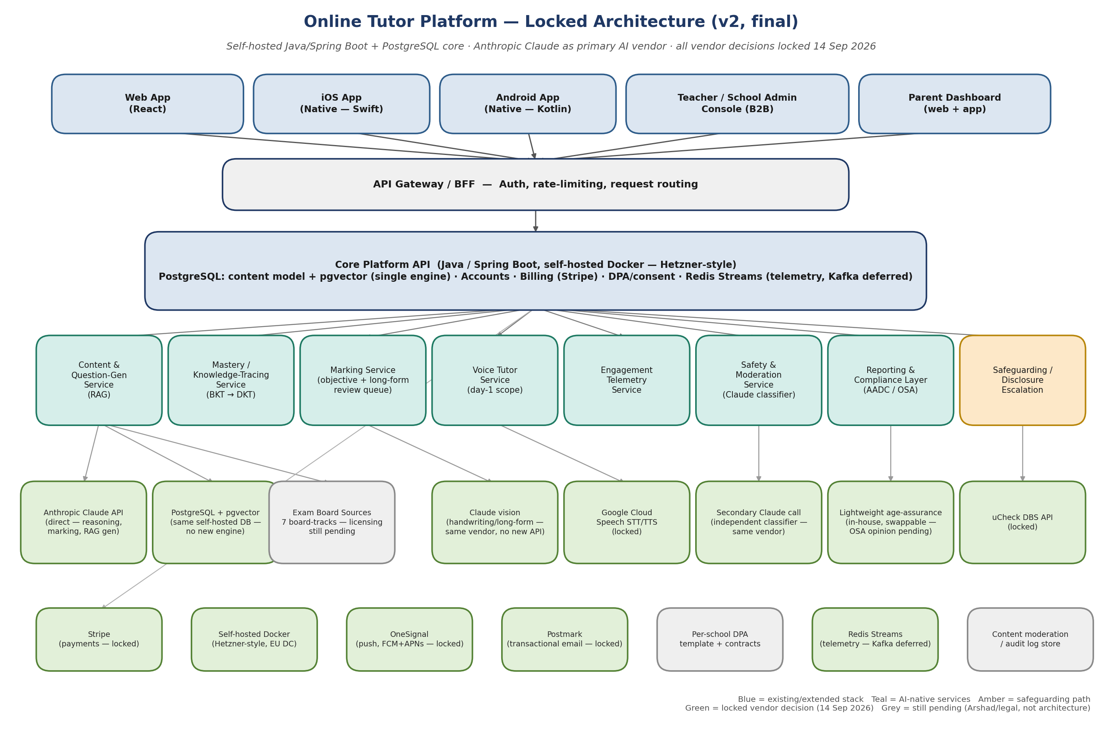
Colour key: blue = existing/extended stack; teal = AI-native services; amber = the safeguarding/disclosure path; green = a locked vendor decision from Section 2; grey = still pending, but on Arshad's or legal's desk, not an architecture call.

4. Service Breakdown
Service | Owns | Locked tech
Core Platform API | Accounts, billing, multi-child/parent profiles, content catalogue, pricing, DPA/consent records | Java/Spring Boot on self-hosted Docker; PostgreSQL. Add school + school_dpa_status and staff_vetting_record tables.
Content & Question-Gen Service | RAG over past papers/mark schemes; questions and mock papers for all 7 board-tracks | Claude API via the AI Gateway + pgvector (same Postgres instance). Automated 5-check QC; only failures reach E-01.
Mastery / Knowledge-Tracing Service | BKT → DKT mastery models, IRT ability estimates | Java/Spring, unchanged by this round.
Marking Service (tiered) | Objective auto-marking; GCSE/iGCSE instant final marking with exceptions routing; A-Level provisional marking into the review workbench; handwriting/photo marking | Objective tier stays deterministic Java. Written/handwritten answers: Claude (incl. vision) via the AI Gateway, two independent passes + confidence score. Queues: marking_exception (GCSE/iGCSE), marking_review_queue (A-Level).
Voice Tutor Service | STT → tutor dialogue → TTS; Socratic scaffolding tied to the mastery layer | Google Cloud Speech (STT+TTS) + Claude for dialogue reasoning — three-way orchestration the team builds and owns, since it isn't one integrated realtime API.
Engagement Telemetry Service | Interaction events → rolling engagement score → confusion-rescue triggers | Redis Streams / direct DB writes for the pilot; Kafka deferred.
Safety & Moderation Service | Secondary monitoring, off-topic/concerning-content flagging, disclosure detection, audit log | Independent secondary Claude call, own prompt/context — no new vendor.
Reporting & Compliance Layer | Parent/student reports, consent management, age-band gating, AADC + OSA record-keeping | Java service over the same Postgres store; owns the lightweight age-assurance record (swappable interface).
Teacher / School Admin Console (Phase 1) | Class-level mastery/engagement view, DPA status, safeguarding contact | Phase 1 — B2B launches alongside consumer.
Safeguarding / Disclosure Escalation (Phase 1) | Routes a welfare disclosure to a named human, logs it, tracks resolution | New service; consumes flags from the Safety & Moderation Service's Claude classifier.
AI Gateway (NEW v3) | Single exit point for every Claude and Google Cloud Speech call: per-request random tokens, free-text and image redaction, logging, vendor fail-over behaviour | Java/Spring service in front of all AI calls. Owns ai_gateway_log and redaction_event. Screen Q-02.
AI Ops & Quality (NEW v3) | Gold-set accuracy evaluation, prompt/model versioning and promotion, AI cost per active student, safety-flag triage | Java/Spring + Postgres. Screens Q-01 to Q-05. Prompt promotion gated on the gold set (≥95%).
Support & Audit (NEW v3) | Support console without learning-content access; append-only audit of every privileged action | Postgres append-only audit_log, 7-year retention. Screens P-03, P-04.

5. Data Architecture
content_model_schema.sql's structure carries over — qualification, exam_board, subject, specification, spec_unit, spec_topic, board_style_profile, question, mark_scheme, question_generation_log, plus the learner-side tables — but is now ported to PostgreSQL syntax rather than Oracle, and the pgvector extension lives in the same database rather than a separate vector store. exam_board already being a proper dimension means the second iGCSE board needs new rows, not new tables.
New tables the locked requirements and this session's decisions require:
- school and school_dpa_status — B2B tenant record and DPA state, linked to student_enrolment.
- staff_vetting_record — uCheck DBS/Barred-List status per tutor/marking-reviewer, with expiry tracking.
- voice_session_transcript and safeguarding_disclosure_log — required now that voice mode and the Claude-classifier disclosure path both exist.
- marking_review_queue — now A-Level only (every long answer, anonymised, 48h SLA). GCSE/iGCSE exceptions use the new marking_exception table (Section 10.6).
- age_assurance_record — method used (currently: self-declared + parental consent) and outcome, kept swappable per decision #9.

6. AI Integration — Final Shape
6.1 Question-generation & marking-grounding pipeline (RAG)
Claude API (direct) + pgvector on the same self-hosted Postgres instance, over ingested past papers and mark schemes for all 7 board-tracks. Every generated question passes five automated checks before it publishes — see 10.4. Only failures reach a person (E-01). All calls go through the AI Gateway (10.1). Still gated by the exam-board licensing question (P-3).
6.2 Tiered marking
Objective tier: deterministic, rule-based, in the Java service. GCSE/iGCSE written answers: Claude marks instantly and the mark is final; two independent marking passes plus a confidence score decide whether an answer goes to the exceptions queue. A-Level long answers: Claude marks as a provisional first reader and every answer goes to the A-Level review workbench. Full model in 10.3; the ≥95% KPI is measured as described in 10.5.
6.3 Voice Tutor
Google Cloud Speech-to-Text → Claude (dialogue + Socratic scaffolding, tied to the mastery/pedagogy layer) → Google Cloud Text-to-Speech. Because this is three services stitched together rather than one integrated realtime API, latency and turn-taking (knowing when the student has finished speaking, handling interruptions) is engineering work the team owns directly — budget a dedicated performance-testing pass before the pilot includes voice, not just a feature checklist.
6.4 Handwriting / photo marking
Same Claude vision call reads handwritten working directly — no separate OCR vendor. Before upload, the paper's header area (name, candidate number) is masked and the student is prompted to crop (10.2).
6.5 Safety, moderation & disclosure detection
A second, independently-prompted Claude call reviews every tutor/voice exchange — flagging off-topic content, refusing to become a homework-answering shortcut, and specifically watching for welfare disclosures that must route to a human via the Safeguarding/Disclosure Escalation service.

7. Build Sequencing
When | What
Now — before dev starts | Sign Anthropic's enterprise DPA (decision #1); provision the self-hosted Docker environment — server, backups, security hardening (#2); stand up PostgreSQL + pgvector (#3/#4); confirm Google Cloud Speech account + quota (#5); get the exam-board licensing answer in writing (still pending, not an architecture item); start hiring/contracting the two native mobile specialists (#7).
Parallel to pilot build | uCheck-based DBS vetting process (#10); per-school DPA template (legal, pending); KCSIE-aligned policy pack; content sourcing/tagging across all 7 board-tracks; OneSignal + Postmark account setup (#11/#12) — low effort, do early.
Phase 1 — pilot (Chemistry, both iGCSE boards + 5 GCSE boards) | Core Platform API on self-hosted infra; Content & Question-Gen Service (Claude + pgvector); objective-tier marking; Voice Tutor Service (basic scope, with the STT→Claude→TTS orchestration built and latency-tested); Teacher/School Admin Console (basic B2B view); Safeguarding/Disclosure Escalation (must exist before schools onboard).
Phase 2 — post-pilot widen | Long-form marking human-review queue at full scale with defined QA sampling; Safety & Moderation Service hardening; remaining subjects (Maths, English, Physics, Biology).
Phase 3 | DKT upgrade from BKT; cohort/anonymised benchmarking; gamification, once the compliance-aware design pass is done; revisit Kafka if telemetry volume justifies it.

8. Staffing & Operational Implications of These Decisions
Worth surfacing explicitly, since a few of today's choices trade lower cost/higher control for more the team has to own directly:
- Self-hosted infra (#2): no managed database, no managed Kubernetes, no automatic failover — provisioning, backups, security patching and uptime monitoring are now the team's job, not a cloud vendor's. Budget real DevOps time, not just app-development time.
- Native mobile (#7): two more specialist skillsets to staff or contract (Swift/iOS, Kotlin/Android) beyond the existing Java + React depth — a real hiring/contracting item, not just a technical choice.
- Voice orchestration (#5): stitching Google Speech and Claude yourself means the team owns turn-taking, interruption handling and latency tuning that a single integrated realtime API would otherwise absorb — worth a short technical spike before committing to the day-1 voice timeline.
- Two-vendor AI story (#1 + #5): Anthropic and Google both need their own DPAs and compliance review — slightly more legal overhead than a single-vendor route, but each vendor is doing the job it's strongest at.

9. Still Pending — Not Architecture, Needs Arshad or Legal
- Exam-board licensing — confirmation in writing from each board that AI-generation use at scale is covered.
- Per-school DPA contracts — legal drafting, not a technology decision.
- Marking-review staffing (P-1) — now A-Level only, plus a small GCSE/iGCSE exceptions role. Arshad to confirm who, how many, cost.
- Final OSA legal opinion — determines whether decision #9's lightweight age-assurance approach is sufficient or needs the vendor swap-in.
- UK-only hosting (P-9) — if pilot schools require UK hosting, Hetzner (EU) needs a UK alternative for school tenants.
- Gold set (P-2) — owner and budget for ≥2,000 examiner-marked answers; needed before pilot build starts.

10. Requirements Baseline v1.0 — Architecture Changes (21 Sep 2026)
None of the 13 technology decisions change. What changes is how the AI is used: it only ever sees education content, humans only handle exceptions (except A-Level, where the client asked for full review), and quality is measured continuously against a gold set.
10.1 AI Gateway — the data boundary
Every call to Claude and Google Cloud Speech goes through one internal service. No other service may hold vendor API keys. The gateway replaces identity with a random token that changes on every request; the mapping stays only in our database.
Model-agnostic by design (D-28): the gateway routes each task (marking, question generation, spec tagging, QC checks, tutor dialogue, safety classification) to a configurable model per prompt_version. The pilot runs every task on Claude. Later, a self-hosted open-weight model on our own GPU servers can take over a task only after it passes the same gold-set gate as any prompt change: beat the live version and stay at or above 95%. Likely order: batch generation, tagging and QC first; tutor and safety next; marking last. Because no service calls a vendor directly, a switch is a configuration change, not a rebuild.
Sent to the AI | Never sent to the AI
Question text and mark scheme | Name, date of birth, email
The learner's answer (after redaction) | School, class or teacher
Board and spec-point tag | Any stable user or account ID
A random per-request token | Parent or payment details
10.2 Controls by route
Route | Risk | Control
Typed answers and chat | Learner writes their name, school or personal details | Redaction against our own name/school lists plus pattern matching; flagged items map back to the learner only inside our database; every redaction logged (Q-02).
Photos of work (D-06, F-08) | Name or candidate number on the paper; faces | Header area masked and crop prompt before upload; image never leaves the gateway unmasked.
Voice (J-01) | Audio itself is personal data | The one exception: audio goes to Google Cloud Speech. Separate parent consent (J-06); transcripts kept 30 days and visible to parents (H-09).
10.3 Marking model
Level | Flow
GCSE / iGCSE | Instant, final mark. Answer goes to the exceptions queue (F-10) only if confidence is low, two independent marking passes disagree, or the student disputes (F-04). Every resolved exception joins the gold set.
A-Level | AI mark shown immediately as provisional (F-09). Every answer enters the anonymised review workbench (F-05) with the AI marking trail; reviewer confirms or adjusts within 48h. Only then does it count toward progress. Adjusted marks join the gold set.
10.4 Automated question QC
Each generated question must pass five checks before publishing: (1) grounding in a real past-paper source, (2) spec-point tag, (3) mark-scheme consistency with the mark allocation, (4) duplicate detection, (5) answerability by the marking model. Failures go to E-01; nothing else needs a person.
10.5 Evaluation and prompt promotion
Accuracy = agreement between AI marks and an examiner-marked gold set, measured per marking point and reported by board and question type (Q-01), plus exact-total agreement and over-marking rate. A prompt or model change goes live only if it beats the current version on the gold set and stays ≥95% (Q-03). The gold set's owner and budget are pending (P-2).
10.6 New data tables
- ai_gateway_log / redaction_event — every AI call (token, route, vendor, model, prompt version, latency, cost) and every redaction, with no identity fields.
- marking_exception — GCSE/iGCSE exception queue: trigger (low confidence / pass disagreement / dispute), resolution, reviewer.
- gold_set_item / eval_run — examiner-marked answers and per-run accuracy results by board, question type and prompt version.
- prompt_version — versioned prompts/models per task with promotion history.
- ai_usage_cost — cost per task per day, rolled up to cost per active student (Q-04).
- audit_log — append-only log of privileged actions, 7-year retention (P-04).
- parent_ai_controls / voice_consent — voice/chat toggles, time limits, quiet hours, separate voice consent (H-09, J-06).
- school_roster_import / sso_connection / school_invoice — MIS/CSV rostering, Google/Microsoft SSO, invoice + PO billing (O-06, O-07).
10.7 Impact on build sequencing (Section 7)
- Before dev starts: build the AI Gateway first — no service calls Claude or Google directly, from day one. Start collecting the gold set (P-2).
- Pilot: GCSE/iGCSE exception marking (F-10), automated QC (E-01), Q-01 to Q-03 and Q-05, P-03/P-04, all B2B additions (O-04 to O-07), billing screens (C-08 to C-10), Chemistry answer input (D-12).
- A-Level go-live: A-Level review workbench (F-05) and provisional marks (F-09), once reviewer staffing (P-1) is settled.
- Phase 2: gamification (K-01) per client Round 1.
All 13 technology decisions in Section 2 remain locked. Section 10 records the v1.0 requirements-lock changes (21 Sep 2026). The items in Section 9 are the only things still blocking a full green light, and none of them are architectural.

