DESIGN DOCUMENT
Designing a Multi-Agent
Research System
Collaborative intelligence for comprehensive market analysis
Five specialized agents. One evolving shared understanding.
System | Multi-Agent Market Research Assistant
Domain | Consulting and Market Intelligence
Design Focus | State, coordination, adaptive workflow, synthesis
Output | Evidence-based market analysis report

Prepared from the original Problem 3 assignment brief

Executive Summary
This design proposes a coordinated multi-agent research system for producing comprehensive market analysis reports. A research coordinator interprets the client question, activates the right specialist agents, manages dependencies, and decides when the evidence is mature enough for synthesis.
The design does not treat the agents as isolated report writers. Every agent reads from and contributes to a structured collaborative state. Findings can therefore be challenged, extended, connected, or converted into new research tasks. The final report is built from synthesis threads that preserve the relationships among evidence, quantitative analysis, market trends, and competitor behavior.
Core design principle The system creates value when one agent's work changes what another agent investigates or concludes.

Design Goals
- Create shared understanding instead of merely collecting separate agent outputs.
- Make dependencies and handoffs explicit so agents receive the context they need.
- Adapt the workflow to the question rather than running every agent in the same order.
- Support investigation loops when evidence is incomplete, contradictory, or low confidence.
- Begin synthesis only after coverage and quality conditions are satisfied.

1. System Architecture
The architecture uses a coordinator pattern around a collaborative state. The coordinator has visibility into all specialists and the shared state, while specialists communicate through structured contributions and events. This reduces uncontrolled agent-to-agent links and makes the research process observable.
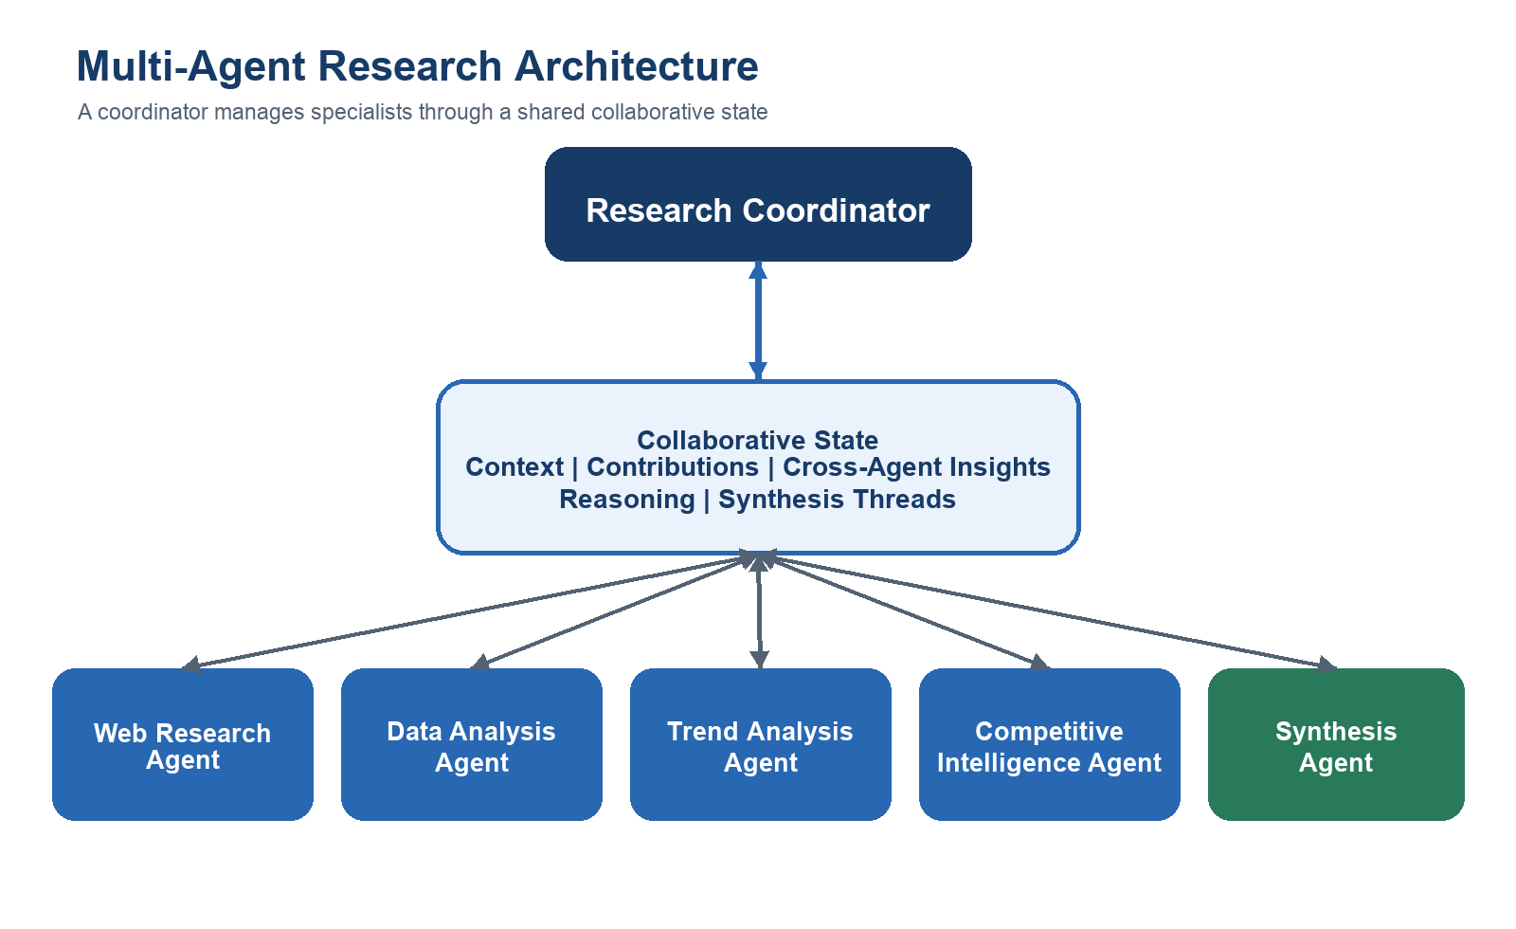
Figure 1. The coordinator selects and sequences specialists; the collaborative state carries shared knowledge.

Architectural Responsibilities
Component | Responsibility
Research Coordinator | Interprets the request, creates the plan, activates agents, resolves dependencies, and applies readiness gates.
Specialist Agents | Perform bounded research or analysis using the context and evidence relevant to their expertise.
Collaborative State | Stores research context, evidence, reasoning, links, unresolved questions, and synthesis threads.
Synthesis Agent | Builds an integrated report from validated threads rather than concatenating agent summaries.

2. Collaborative State Architecture
The shared state is organized into five layers. Each layer has a distinct purpose, owner expectations, and quality rules. This prevents the state from becoming a single unstructured container that every agent edits differently.
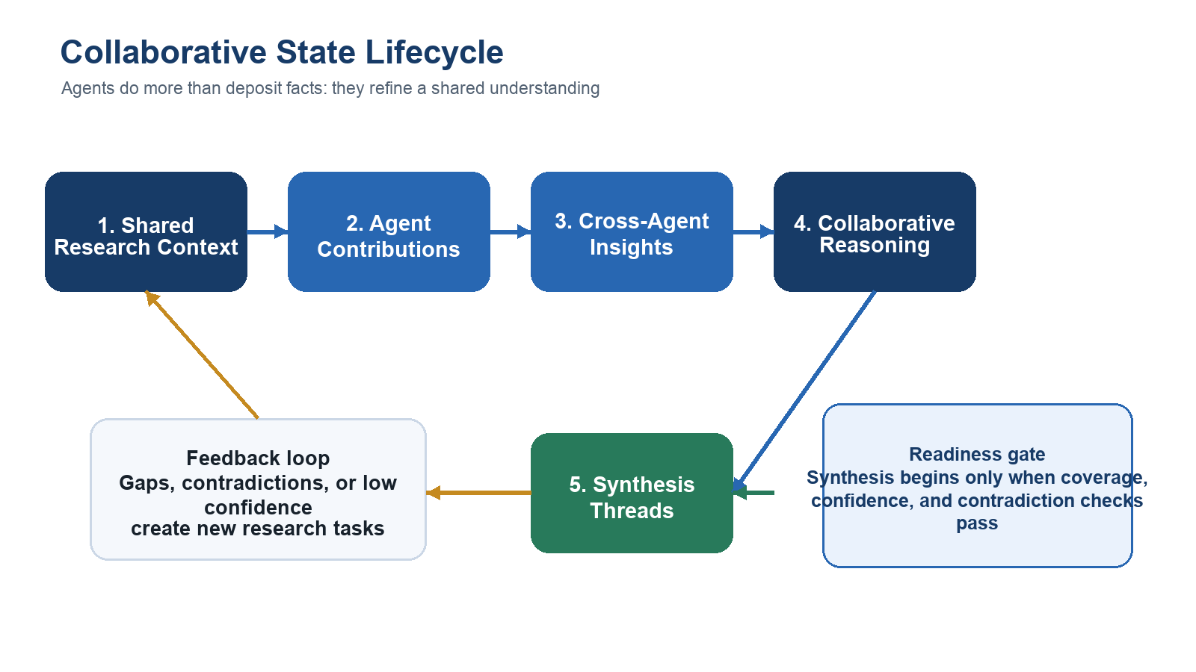
Figure 2. Contributions are converted into connected reasoning and synthesis threads, with feedback when gaps remain.

State Schema
State Layer | Representative Fields | Primary Writer | Purpose
Shared Research Context | research_question, client_objective, scope, geography, time_horizon, definitions, constraints, success_criteria | Coordinator | Stable framing used by every agent
Agent Contributions | agent_id, finding, evidence, source, confidence, assumptions, timestamp, related_question | Specialist agents | Traceable domain findings
Cross-Agent Insights | linked_findings, relationship_type, explanation, supporting_agents, confidence | Any agent or coordinator | Connections across domains
Collaborative Reasoning | hypotheses, confirmations, contradictions, open_questions, agreed_interpretations | Coordinator and specialists | Evolving shared understanding
Synthesis Threads | thread_title, claim, supporting_evidence, implications, risks, unresolved_items | Synthesis agent | Report-ready narratives

State Update Rules
- Append evidence rather than silently replacing another agent's finding.
- Attach a source and confidence level to every material claim.
- Represent disagreement explicitly as a contradiction or competing hypothesis.
- Link new insights to the findings that support them.
- Promote content into synthesis threads only after evidence and dependency checks.

3. Agent Coordination Matrix
Each agent has a bounded role, but its work is intentionally connected to the others. The matrix below defines what each agent needs, contributes, responds to, and signals.
Agent | Needs | Contributes | Responds To | Signals
Web Research | Question, scope, keywords, unresolved evidence gaps | Articles, reports, facts, citations, source quality | New task; missing evidence; claim needing verification | Source found; weak source; conflicting external evidence
Data Analysis | Datasets, definitions, web findings, metrics to test | Calculations, comparisons, charts, anomalies, confidence | New dataset; quantitative claim; regional or temporal gap | Statistical pattern; outlier; insufficient data
Trend Analysis | Research evidence, data results, time horizon | Drivers, trajectories, scenarios, projections, uncertainty | Stable baseline evidence; material change signal | Emerging trend; turning point; projection risk
Competitive Intelligence | Market trends, company evidence, market metrics | Competitor moves, positioning, capability gaps, implications | Competitor event; trend with strategic impact | Strategic shift; market response; competitor contradiction
Synthesis | Validated findings, cross-agent insights, open issues, threads | Integrated narrative, implications, recommendations, report | Coverage threshold met; major contradictions resolved | Draft ready; evidence gap; final review required

Coordination Pattern
- The coordinator creates tasks with explicit inputs, expected outputs, and dependencies.
- Agents publish structured contributions to the shared state rather than sending informal messages.
- Important findings generate events that can activate another specialist.
- The coordinator tracks open questions, coverage, confidence, and contradictions.
- The synthesis agent remains downstream of evidence maturity, not simply elapsed time.

4. Dynamic Workflow Logic
The system first classifies the research request, then chooses an execution pattern. A narrow request can use a targeted path; independent evidence gathering can run in parallel; dependent reasoning is sequenced so later agents inherit validated context.
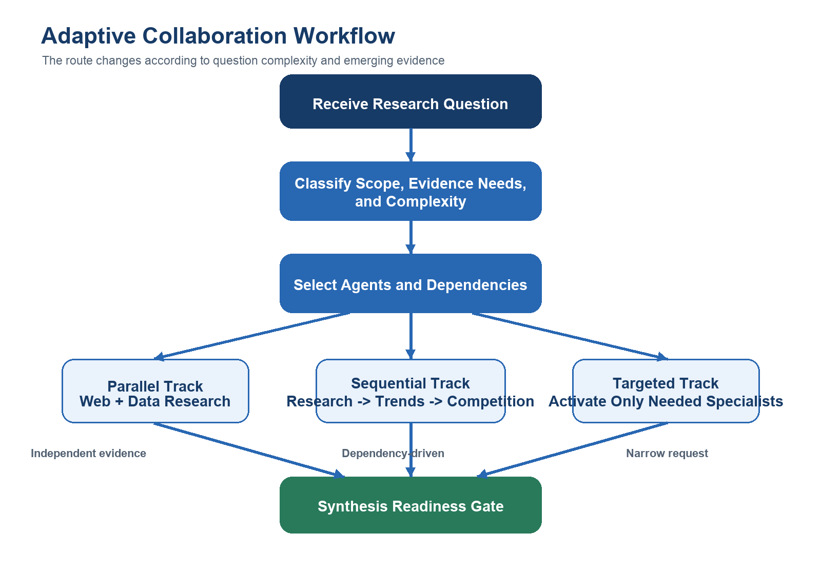
Figure 3. The coordinator selects parallel, sequential, or targeted collaboration and converges at a synthesis gate.

Agent Activation Framework
Question Type | Initial Activation | Dependency Logic
Factual or source-led question | Web Research | Data Analysis if quantitative validation is required
Market size or performance question | Web Research + Data Analysis in parallel | Trend Analysis after baseline validation
Future outlook question | Web Research + Data Analysis | Trend Analysis, then Competitive Intelligence
Competitor strategy question | Web Research + Competitive Intelligence | Data and Trend agents when market context is needed
Comprehensive market report | All evidence agents | Trend and Competitive agents build on research/data; Synthesis runs last

Parallel vs. Sequential Decision
- Run in parallel when agents can collect independent evidence from the same stable research context.
- Run sequentially when an agent's task definition depends on another agent's result.
- Use a hybrid workflow when broad evidence collection is parallel but interpretation requires ordered handoffs.
- Pause or backtrack when a critical input is absent, confidence is low, or findings materially conflict.

Synthesis Readiness Conditions
Readiness gate Begin synthesis when required domains are covered, major claims have evidence, confidence is acceptable, critical contradictions are resolved or disclosed, and no blocking research task remains.

5. Investigation, Backtracking, and Quality Control
Collaboration is not complete after the first pass. Agents may discover evidence gaps or contradictions that require additional work. The coordinator turns these discoveries into explicit follow-up tasks and preserves both the original finding and the resolution.
Condition | Detection | Backtracking Action
Missing evidence | A material claim has no reliable source | Web Research receives a targeted verification task
Quantitative inconsistency | Reported figures disagree across sources | Data Analysis reconciles definitions, dates, and units
Low-confidence projection | Trend conclusion depends on weak assumptions | Trend Analysis creates scenarios and records uncertainty
Competitive contradiction | Observed company action conflicts with stated strategy | Competitive Intelligence investigates behavior and timing
Narrative gap | A report thread lacks evidence or implication | Synthesis returns the thread to the relevant specialist

Completion Controls
- Coverage: every required report domain has at least one validated contribution.
- Traceability: important claims link to sources and originating agent contributions.
- Consistency: contradictions are resolved, bounded, or transparently reported.
- Confidence: uncertainty is recorded and reflected in conclusions.
- Coherence: synthesis threads connect evidence to implications rather than listing facts.

6. Worked Collaboration Example
Consider the research question: “How will the electric vehicle market evolve over the next three years, and where should a charging-network provider invest?” The example below shows how an isolated observation becomes a stronger strategic insight through collaboration.
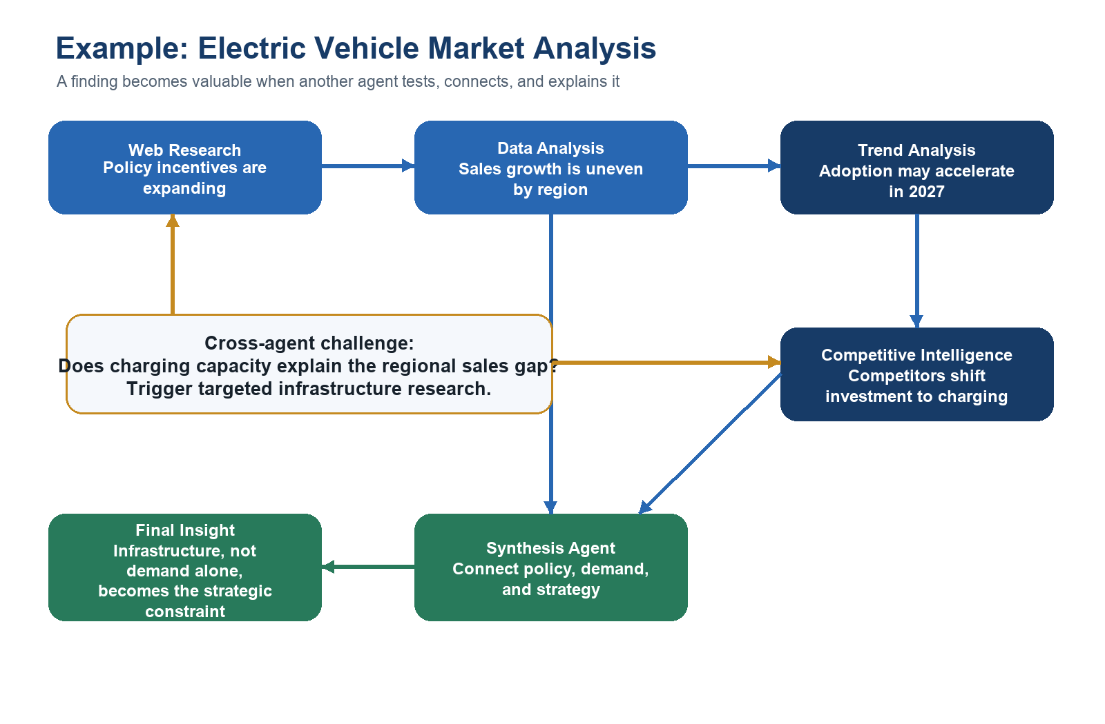
Figure 4. Cross-agent reasoning converts separate findings into a defensible strategic conclusion.

Example Reasoning Trace
- Web Research identifies new incentives and infrastructure policy.
- Data Analysis finds that sales growth varies sharply across regions.
- Trend Analysis proposes that adoption will accelerate but records infrastructure as a limiting assumption.
- Competitive Intelligence observes competitors redirecting investment toward charging capacity.
- The coordinator creates a targeted question linking charging coverage to regional sales performance.
- The synthesis agent forms a report thread: infrastructure availability may be the strategic constraint that determines where demand converts into adoption.

Why This Is Collaborative Intelligence
No single agent produced the final conclusion. Web evidence supplied policy context, quantitative analysis exposed regional variation, trend reasoning framed the future trajectory, and competitive analysis revealed how firms were responding. The shared state made these relationships visible, and the feedback loop prompted a new investigation. The final insight therefore emerged from connected reasoning rather than aggregation.

7. Report Assembly
The synthesis agent assembles the final deliverable from validated synthesis threads. Each section should preserve the relationship between evidence, interpretation, business implication, and uncertainty.
Report Section | Content
Executive Summary | Most important conclusions, implications, and recommended actions
Market Overview | Scope, size, segments, definitions, and baseline conditions
Data Insights | Quantitative findings, comparisons, anomalies, and limitations
Trends and Projections | Drivers, scenarios, time horizon, and uncertainty
Competitive Landscape | Competitor moves, positioning, responses, and strategic gaps
Integrated Implications | Cross-agent synthesis threads connecting market evidence to decisions
Conclusion | Priorities, risks, open questions, and next research steps

8. Collaboration Rationale
The proposed design satisfies the assignment's requirement for true collaborative intelligence in four ways.
Shared context creates alignment. All agents interpret the same objective, scope, definitions, and constraints.
Structured contributions create traceability. Findings retain evidence, confidence, assumptions, and ownership.
Cross-agent insights create new knowledge. The system records relationships that are not present in any isolated contribution.
Adaptive coordination improves relevance. Agents are activated, sequenced, or re-engaged according to the question and emerging findings.
Final design outcome The system produces a report whose conclusions are supported by connected evidence and collective reasoning, not a bundle of independent summaries.

9. Completion Criteria Mapping
Assignment Criterion | Where Addressed
Collaborative state enables intelligence beyond data sharing | Five-layer state architecture with explicit reasoning and synthesis layers
Coordination patterns show agents building on each other | Coordination matrix, dependencies, triggers, and event signals
Workflow adapts to research complexity | Parallel, sequential, targeted, and hybrid activation framework
Rationale explains emergent intelligence | Worked example and collaboration rationale

