**Mongodb_day2_task**

**Create Zen class database:**

Use zenclass

**Createcollections and Insert Data:**

**1.Users:**

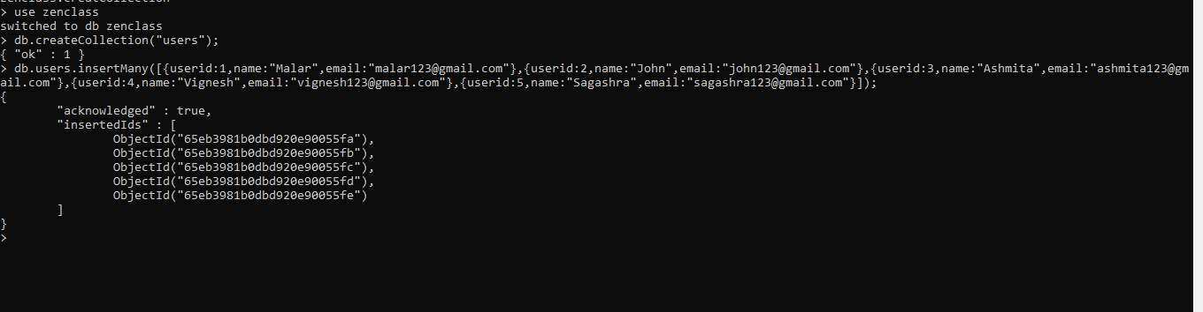

use zenclass

switched to db zenclass

> db.createCollection("users");

{ "ok" : 1 }

> db.users.insertMany([{userid:1,name:"Malar",email:"malar123@gmail.com"},{userid:2,name:"John",email:"john123@gmail.com"},{userid:3,name:"Ashmita",email:"ashmita123@gmail.com"},{userid:4,name:"Vignesh",email:"vignesh123@gmail.com"},{userid:5,name:"Sagashra",email:"sagashra123@gmail.com"}]);

{

"acknowledged" : true,

"insertedIds" : [

ObjectId("65eb3981b0dbd920e90055fa"),

ObjectId("65eb3981b0dbd920e90055fb"),

ObjectId("65eb3981b0dbd920e90055fc"),

ObjectId("65eb3981b0dbd920e90055fd"),

ObjectId("65eb3981b0dbd920e90055fe")

]

}

**2.codeKata:**

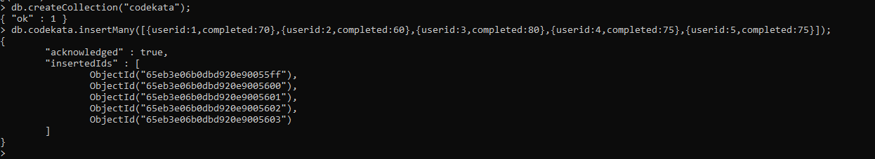

> db.createCollection("codekata");

{ "ok" : 1 }

> db.codekata.insertMany([{userid:1,completed:70},{userid:2,completed:60},{userid:3,completed:80},{userid:4,completed:75},{userid:5,completed:75}]);

{

"acknowledged" : true,

"insertedIds" : [

ObjectId("65eb3e06b0dbd920e90055ff"),

ObjectId("65eb3e06b0dbd920e9005600"),

ObjectId("65eb3e06b0dbd920e9005601"),

ObjectId("65eb3e06b0dbd920e9005602"),

ObjectId("65eb3e06b0dbd920e9005603")

]

}

**3.Attendence:**

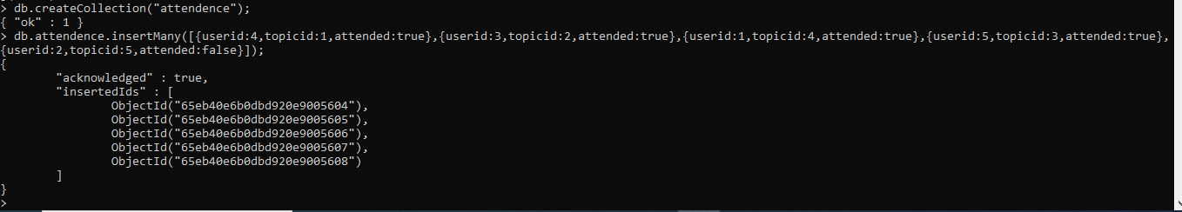

> db.createCollection("attendence");

{ "ok" : 1 }

> db.attendence.insertMany([{userid:4,topicid:1,attended:true},{userid:3,topicid:2,attended:true},{userid:1,topicid:4,attended:true},{userid:5,topicid:3,attended:true},{userid:2,topicid:5,attended:false}]);

{

"acknowledged" : true,

"insertedIds" : [

ObjectId("65eb40e6b0dbd920e9005604"),

ObjectId("65eb40e6b0dbd920e9005605"),

ObjectId("65eb40e6b0dbd920e9005606"),

ObjectId("65eb40e6b0dbd920e9005607"),

ObjectId("65eb40e6b0dbd920e9005608")

]

}

**4.topics:**

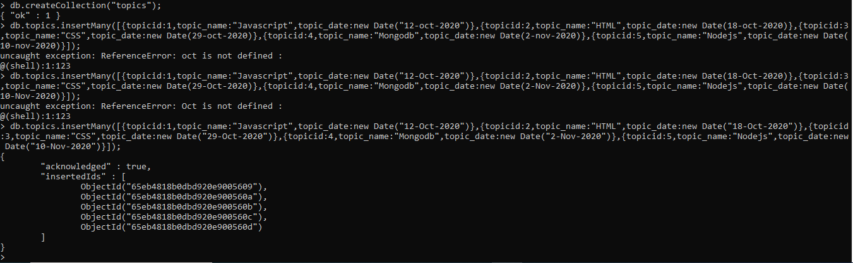

> db.createCollection("topics");

{ "ok" : 1 }

> db.topics.insertMany([{topicid:1,topic_name:"Javascript",topic_date:new Date("12-Oct-2020")},{topicid:2,topic_name:"HTML",topic_date:new Date("18-Oct-2020")},{topicid:3,topic_name:"CSS",topic_date:new Date("29-Oct-2020")},{topicid:4,topic_name:"Mongodb",topic_date:new Date("2-Nov-2020")},{topicid:5,topic_name:"Nodejs",topic_date:new Date("10-Nov-2020")}]);

{

"acknowledged" : true,

"insertedIds" : [

ObjectId("65eb4818b0dbd920e9005609"),

ObjectId("65eb4818b0dbd920e900560a"),

ObjectId("65eb4818b0dbd920e900560b"),

ObjectId("65eb4818b0dbd920e900560c"),

ObjectId("65eb4818b0dbd920e900560d")

]

}

**5.tasks:**

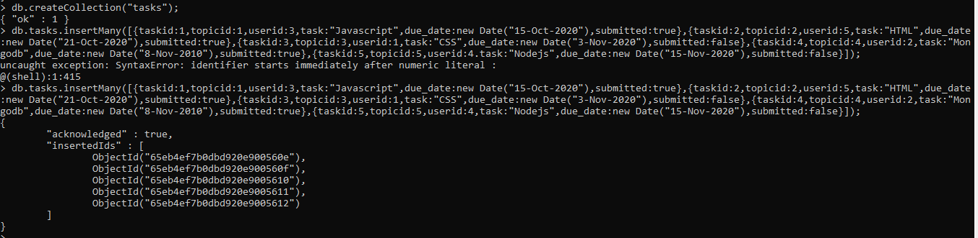

}

> db.createCollection("tasks");

{ "ok" : 1 }

> db.tasks.insertMany([{taskid:1,topicid:1,userid:3,task:"Javascript",due_date:new Date("15-Oct-2020"),submitted:true},{taskid:2,topicid:2,userid:5,task:"HTML",due_date:new Date("21-Oct-2020"),submitted:true},{taskid:3,topicid:3,userid:1,task:"CSS",due_date:new Date("3-Nov-2020"),submitted:false},{taskid:4,topicid:4,userid:2,task:"Mongodb",due_date:new Date("8-Nov-2010"),submitted:true},{taskid:5,topicid:5,userid:4,task:"Nodejs",due_date:new Date("15-Nov-2020"),submitted:false}]);

{

"acknowledged" : true,

"insertedIds" : [

ObjectId("65eb4ef7b0dbd920e900560e"),

ObjectId("65eb4ef7b0dbd920e900560f"),

ObjectId("65eb4ef7b0dbd920e9005610"),

ObjectId("65eb4ef7b0dbd920e9005611"),

ObjectId("65eb4ef7b0dbd920e9005612")

]

}

**6.Companydrives:**

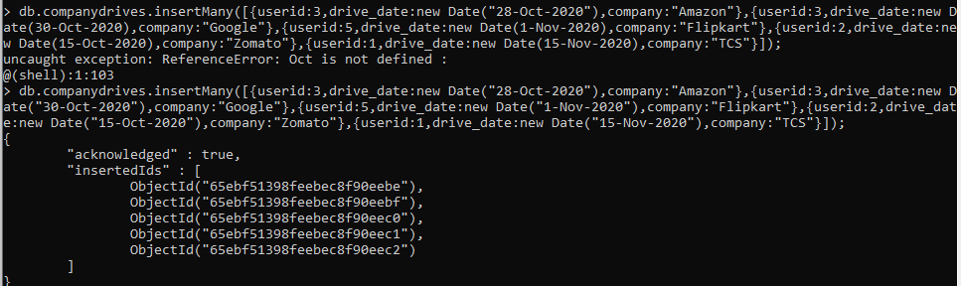

>db.createCollection(“companydrives”);

> db.companydrives.insertMany([{userid:3,drive_date:new Date("28-Oct-2020"),company:"Amazon"},{userid:3,drive_date:new Date("30-Oct-2020"),company:"Google"},{userid:5,drive_date:new Date("1-Nov-2020"),company:"Flipkart"},{userid:2,drive_date:new Date("15-Oct-2020"),company:"Zomato"},{userid:1,drive_date:new Date("15-Nov-2020"),company:"TCS"}]);

{

"acknowledged" : true,

"insertedIds" : [

ObjectId("65ebf51398feebec8f90eebe"),

ObjectId("65ebf51398feebec8f90eebf"),

ObjectId("65ebf51398feebec8f90eec0"),

ObjectId("65ebf51398feebec8f90eec1"),

ObjectId("65ebf51398feebec8f90eec2")

]

}

**7.mentors**

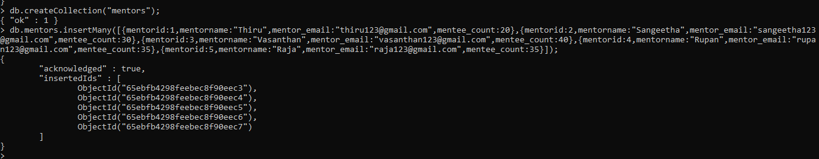

> db.createCollection("mentors");

{ "ok" : 1 }

> db.mentors.insertMany([{mentorid:1,mentorname:"Thiru",mentor_email:"thiru123@gmail.com",mentee_count:20},{mentorid:2,mentorname:"Sangeetha",mentor_email:"sangeetha123@gmail.com",mentee_count:30},{mentorid:3,mentorname:"Vasanthan",mentor_email:"vasanthan123@gmail.com",mentee_count:40},{mentorid:4,mentorname:"Rupan",mentor_email:"rupan123@gmail.com",mentee_count:35},{mentorid:5,mentorname:"Raja",mentor_email:"raja123@gmail.com",mentee_count:35}]);

{

"acknowledged" : true,

"insertedIds" : [

ObjectId("65ebfb4298feebec8f90eec3"),

ObjectId("65ebfb4298feebec8f90eec4"),

ObjectId("65ebfb4298feebec8f90eec5"),

ObjectId("65ebfb4298feebec8f90eec6"),

ObjectId("65ebfb4298feebec8f90eec7")

]

}

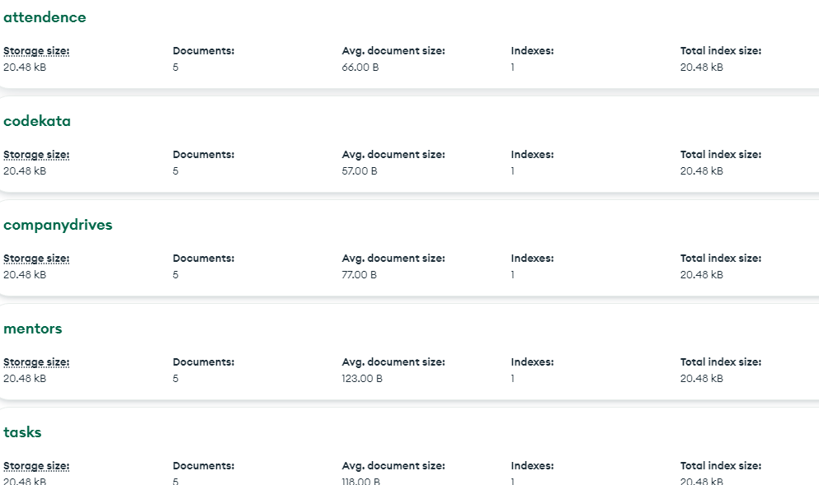

**1.Find all the topics and tasks which are thought in the month of October :**

**db.topics.aggregate({$lookup:{from:"tasks",localField:"topicid",foreignField:"topicid",as:"taskinfo"}},{$match:{$and:[{topic_date:{$gte:new Date("2020-10-01"),$lt:new Date("2020-11-01")}},{$or:[{"taskinfo.due_date":{$gte:new Date("2020-10-01"),$lt:new Date("2020-11-01")}},{"taskinfo.due_date":{$exists:false}}]}]}},{$project:{_id:0,topicid:1,topic_name:1,topic_date:1,tasks:{$arrayElemAt:["$taskinfo.task",0]},due_dates:{$arrayElemAt:["$taskinfo.due_date",0]}}});**

{ "topicid" : 1, "topic_name" : "Javascript", "topic_date" : ISODate("2020-10-12T00:00:00Z"), "tasks" : "Javascript", "due_dates" : ISODate("2020-10-15T00:00:00Z") }

{ "topicid" : 2, "topic_name" : "HTML", "topic_date" : ISODate("2020-10-18T00:00:00Z"), "tasks" : "HTML", "due_dates" : ISODate("2020-10-21T00:00:00Z") }

**2.Find all the company drives which appeared between 15 oct-2020 and 31-oct-2020**

**db.companydrives.find({drive_date:{$gte:new Date("2020-10-15"),$lte:new Date("2020-10-31")}}).pretty();**

{

"_id" : ObjectId("65ee4e615c34bc732968c9bf"),

"userid" : 3,

"drive_date" : ISODate("2020-10-28T00:00:00Z"),

"company" : "Amazon"

}

{

"_id" : ObjectId("65ee4e615c34bc732968c9c0"),

"userid" : 3,

"drive_date" : ISODate("2020-10-30T00:00:00Z"),

"company" : "Google"

}

{

"_id" : ObjectId("65ee4e615c34bc732968c9c2"),

"userid" : 2,

"drive_date" : ISODate("2020-10-15T00:00:00Z"),

"company" : "Zomato"

}

**3.Find all the company drives and students who are appeared for the placement.**

**db.companydrives.aggregate([{$lookup:{from:"users",localField:"userid",foreignField:"userid",as:"students"}},{$project:{_id:0,drive_date:1,company:1,students:{userid:1,name:1,email:1}}}]).pretty();**

{

"drive_date" : ISODate("2020-10-28T00:00:00Z"),

"company" : "Amazon",

"students" : [

{

"userid" : 3,

"name" : "Ashmita",

"email" : "ashmita123@gmail.com"

}

]

}

{

"drive_date" : ISODate("2020-10-30T00:00:00Z"),

"company" : "Google",

"students" : [

{

"userid" : 3,

"name" : "Ashmita",

"email" : "ashmita123@gmail.com"

}

]

}

{

"drive_date" : ISODate("2020-11-03T00:00:00Z"),

"company" : "Flipkart",

"students" : [

{

"userid" : 5,

"name" : "Sagashra",

"email" : "sagashra123@gmail.com"

}

]

}

{

"drive_date" : ISODate("2020-10-15T00:00:00Z"),

"company" : "Zomato",

"students" : [

{

"userid" : 2,

"name" : "John",

"email" : "john123@gmail.com"

}

]

}

{

"drive_date" : ISODate("2020-11-15T00:00:00Z"),

"company" : "TCS",

"students" : [

{

"userid" : 1,

"name" : "Malar",

"email" : "malar123@gmail.com"

}

]

}

**4.Find the number of problems solved by the user in codekata**

**db.codekata.find().pretty();**

{

"_id" : ObjectId("65ee53cc67c15fb14e34a132"),

"userid" : 1,

"completed" : 70

}

{

"_id" : ObjectId("65ee53cc67c15fb14e34a133"),

"userid" : 2,

"completed" : 60

}

{

"_id" : ObjectId("65ee53cc67c15fb14e34a134"),

"userid" : 3,

"completed" : 80

}

{

"_id" : ObjectId("65ee53cc67c15fb14e34a135"),

"userid" : 4,

"completed" : 75

}

{

"_id" : ObjectId("65ee53cc67c15fb14e34a136"),

"userid" : 5,

"completed" : 75

}

**5.Find all the mentors with who has the mentee's count more than 15**

**db.mentors.find({"mentee_count":{$gt:15}}).pretty();**

{

"_id" : ObjectId("65ee55d16e7d309016ea3dcd"),

"mentorid" : 1,

"mentorname" : "Thiru",

"mentor_email" : "thiru123@gmail.com",

"mentee_count" : 20

}

{

"_id" : ObjectId("65ee55d16e7d309016ea3dcf"),

"mentorid" : 3,

"mentorname" : "Vasanthan",

"mentor_email" : "vasanthan123@gmail.com",

"mentee_count" : 16

}

{

"_id" : ObjectId("65ee55d16e7d309016ea3dd1"),

"mentorid" : 5,

"mentorname" : "Raja",

"mentor_email" : "raja123@gmail.com",

"mentee_count" : 18

}

**6.Find the number of users who are absent and task is not submitted  between 15 oct-2020 and 31-oct-2020**

**>db.users.aggregate([{$lookup:{from:"attendance",localField:"userid",foreignField:"userid",as:"user_attendance"}},{$lookup:{from:"tasks",localField:"userid",foreignField:"userid",as:"user_tasks"}},{$lookup:{from:"topics",localField:"user_tasks.topicid",foreignField:"topicid",as:"topic_info"}},{$match:{$and:[{"topic_info.topic_date":{$gte:ISODate("2020-10-5"),$lte:ISODate("2020-10-31")}},{"user_attendance":{$elemMatch:{"attended":"false"}}},{$or:[{"user_tasks":{$exists:"false"}},{"user_tasks":{$eq:[]}}]}]}},{$group:{"_id":null,"num_users":{$sum:1}}}]);**

{ "_id": null, "num_users": 3 }