**RESUME**

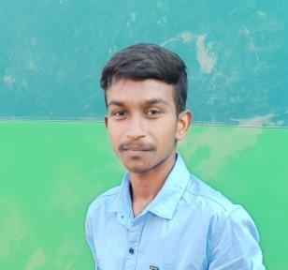**ABOUT**

**Name** : Murugan.M s/o Magesh

**Phone** : 8270462759

**Email ID** : [murugan.m3562@gmail.com](mailto:murugan.m3562@gmail.com)

LinkedIn : <https://www.linkedin.com/in/murugan-m-> bb4489244

**OBJECTIVES**

Seeking a challenging position in a reputed organisation where I can learn new skills, expand my knowledge, and leverage my learning. Dream becomes a Full Stack Developer in reputed organisation.

**EDUCATION QUALIFICATION**

|  |  |  |  |
| --- | --- | --- | --- |
| **Education** | **School/University** | **Percentage/CGPA** | **Year of Passing** |
| B.E - CSE | P.S.V College of Engineering and Technology, Krishnagiri. | 7.89 CGPA (upto 6th sem) | 2024  (expected) |
| HSC | I.V.N Government Boys Hr. Sec School, Gajalnaicken Patti. | 55 % | 2020 |
| SSLC | I.V.N Government Boys Hr. Sec School, Gajalnaicken Patti. | 74.2 % | 2018 |

**SKILLS**

* + HTML 5
  + CSS 3
  + JavaScript
  + PHP
  + MySQL
  + Python
  + C Programming
  + Typist

**WORKSHOP ATTENDED**

**CLOUD COMPUTING TOOLS**

This workshop I learn how to buy a amazon Virtual Machine and what are the major role of cloud services.

**WEB APPLICATION DEVELOPMENT**

This workshop I learn how to create a web application, what are the major uses and skills are need for web application development.

**PROJECTS**

**ONLINE BLOOD BANK SYSTEM**

In this project I develop a web site for emergency required blood situation and easily find the rare blood in nearby cities.

**COLLEGE GATE PASS SYSTEM**

This project I develop a web application for college Gate Pass and store the gate pass details without any note book. Only the authorized persons can view the gate pass details. College watch man only enter the gate pass data’s.

**ACHIEVEMENTS**

**2023 -** Won 2nd place in Project Expo at Technical Symposium in P.S.V College of Engineering and Technology, Krishnagiri.

**PERSONAL DETAILS**

**Name : M.**Murugan.

**Gender :** Male.

**Father’s Name : R.**Magesh.

**Address :** 2/269, Mamarathu kottai**(**vill**),** Batlapalli(psot),Bargur(tk),Krishnagiri(dt) – 635104.

**Date of Birth :** 26/07/2003.

**Languages Known :** English, Tamil.

**DECLARATION**

The information stated above is true to the best of my knowledge and belief.

Thank You

|  |  |
| --- | --- |
| Place : Krishnagiri | Yours faithfully, |
| Date : | Murugan.M |