 ***Crown Solutions India Private Limited (Crown)***

**Statement of Contract Fee Payment**

**Please find enclosed the full and final settlement payable for which details are as follows:**

|  |  |
| --- | --- |
| Name | : R.Murugan |
| Client | : Tata Consultancy Services |
| Contract Start Date | : 25 Mar 2022 |
| Contract End Date | : 31 Jul 2023 |
| Monthly Contract Fee    Total Contract Fee Payable for | : Rs. 36,050 |
| whole contract period | : Rs. 5,44,199 |

Total deductions for the whole contract period : Rs. 35,197

Total amount payable less deductions : Rs. 5,09,002

**Thanking you,**

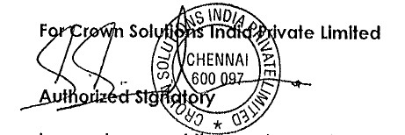

**I Confirm I have no claims from the company.”**

**Signature** 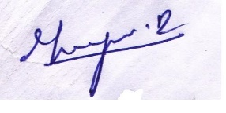

**Date: 31/07/2023**

**Pan Number : BNEPM8872N**

**www.crownsolution.com**