MicroGoals
1.Introduction:

Project title : Microgoals :secure goal managaement backend API
Team ID : SWTID-2026-4895
Team Size : 4
Team Leader : M.Harini muruganharini.9710@gmail.com

Team Member :

Name &email:
U.Jackline zandous jackline2611@gmail.com
Name &email:
C.Harshini charhini097@gmail.com
Name &email:
K.Gopika gopikakrishnank123@gmail.com

2. Project Overview:
MicroGoals is a secure backend RESTful API developed using Node.js, Express.js, and MongoDB. It enables users to register, log in, and manage their personal goals through CRUD operations. The system uses JWT authentication and middleware to ensure data security and user-specific access control.
The system includes:
- User Registration & Login
- JWT-based Authentication
- CRUD Operations for Goals
- Protected Routes
- Centralized Error Handling
The main objective is to provide a secure and scalable backend system for digital goal management.

3. Project Instruction:
- The project follows REST API principles.
- Authentication is handled using JWT.
- MongoDB is used as the database.
- APIs are tested using Thunder Client.
- The project follows MVC architecture.

4. Pre-requisites:
Before running the project, the following tools are required:
- Node.js (v18 or higher)
- Express.js
- MongoDB (Local / Atlas)
- VS Code
- Thunder Client (Extension)
- Basic knowledge of JavaScript & REST APIs

5. Project Architecture Image:
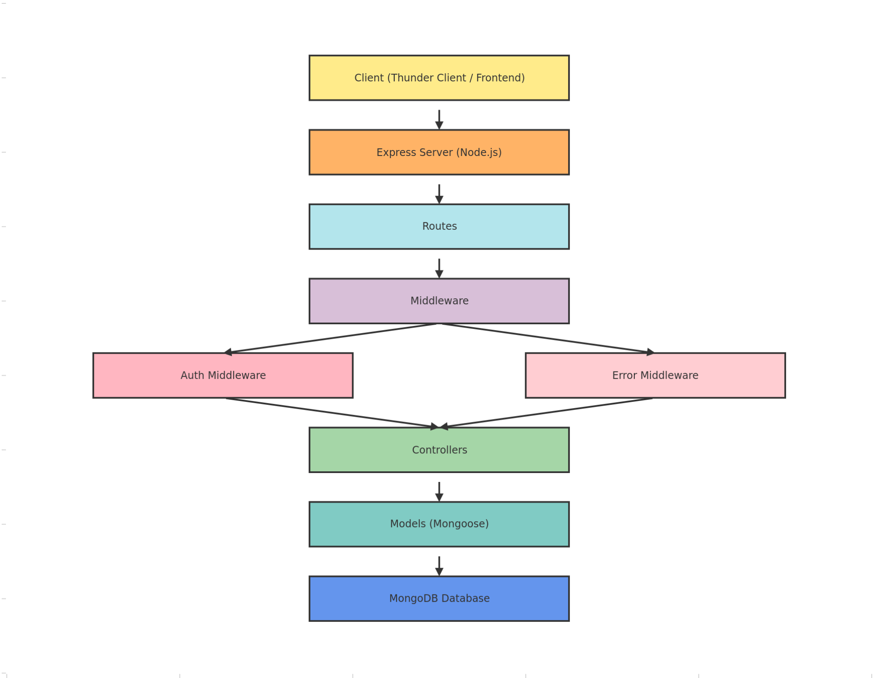

6.PROJECT ARCHITECTURE:

TECHNICAL ARCHITECTURE
- Runtime: Node.js
- Framework: Express.js
- Database: MongoDB
- Authentication: JWT
- Architecture Pattern: MVC

Relationship:
One User → Many Goals
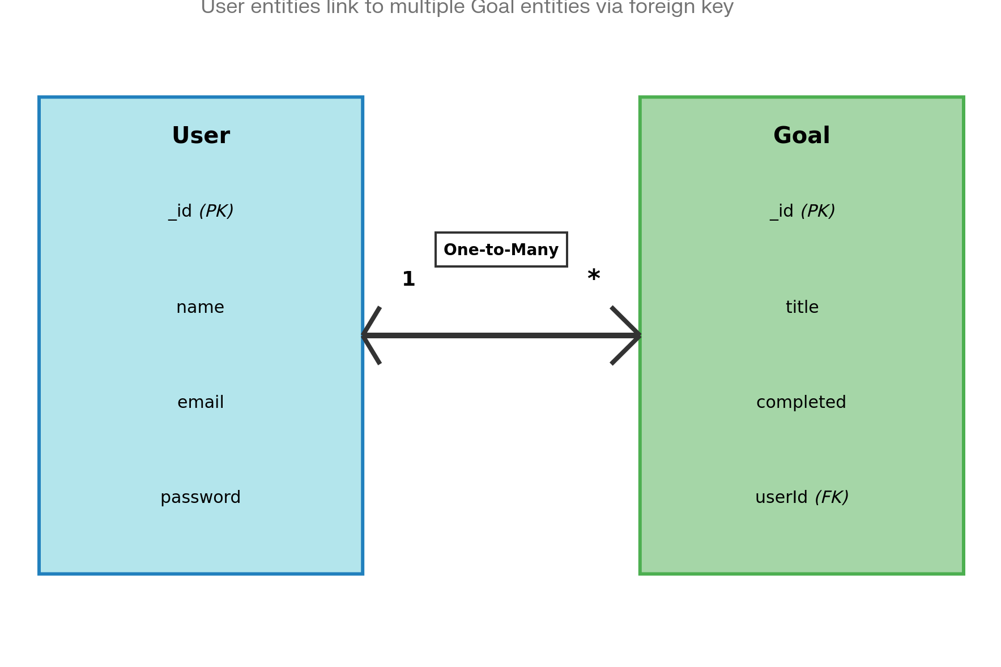

7. FEATURES:
- User Registration
- Secure Login with JWT
- Create Goal
- Update Goal
- Delete Goal
- View User-specific Goals
- Protected Routes
- Centralized Error Handling

8. ROLES AND RESPONSIBILITIES:
:Role | Responsibility
User | Register, Login, Manage Goals
Developer | API Development & Testing

9. USERS FLOW:
- User registers
- User logs in
- JWT token generated
- User sends token in header
- Access protected routes
- Perform CRUD operations
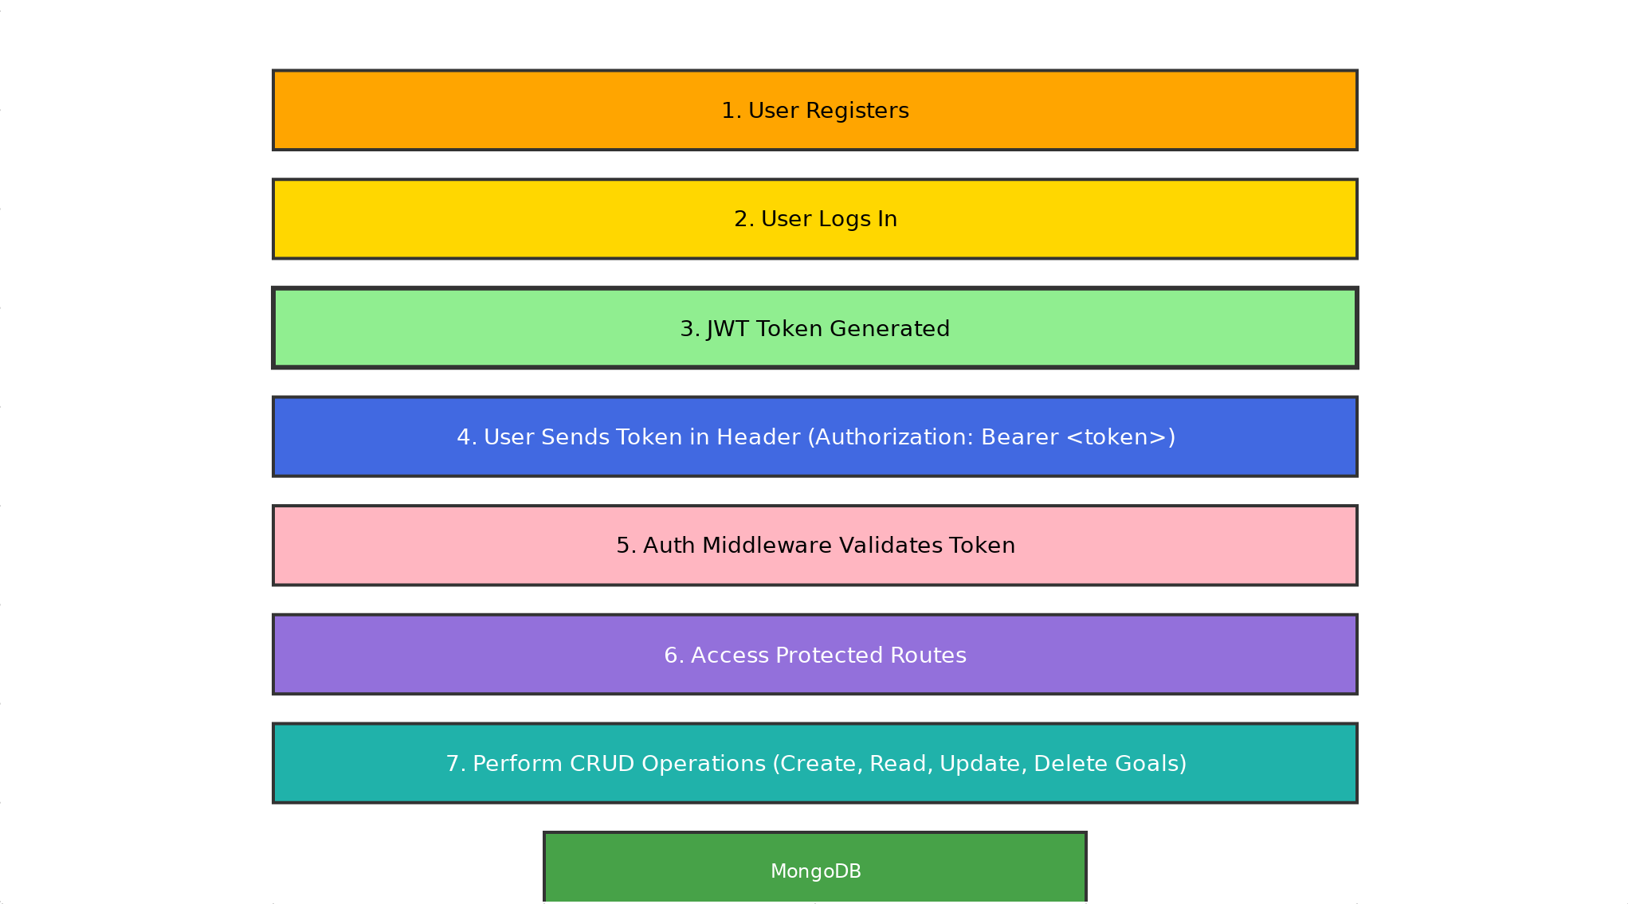

10. PROJECT SETUP AND CONFIGURATION:

Folder Structure
MicroGoals/
├── middleware/
│ ├── authMiddleware.js
│ └── errorMiddleware.js
├──Schema/
├──User.js
├──GoalSchema.js
├── models/
│ ├── userModel.js
│ └── goalModel.js
│
├── routes/
│ ├── authRoutes.js
│ └── goalRoutes.js
│
├── .env
├── Index.js
└── package.json
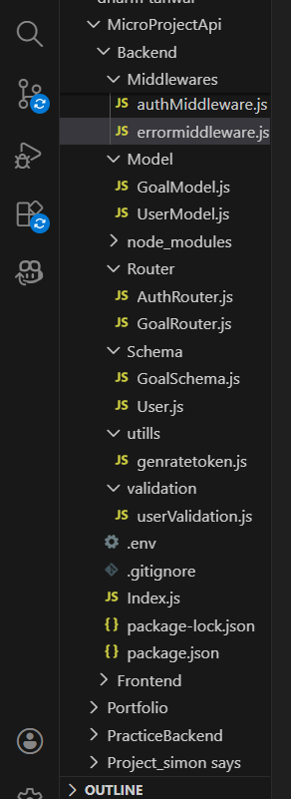

11. Project Setup:
- npm init -y
- Install dependencies:
npm install express mongoose jsonwebtoken bcryptjs dotenv

- Start server:
node server.js

12. BACKEND DEVELOPMENT:
- Created Express Server
An Express server was set up to handle API requests, connect routes, and enable JSON parsing for backend operations
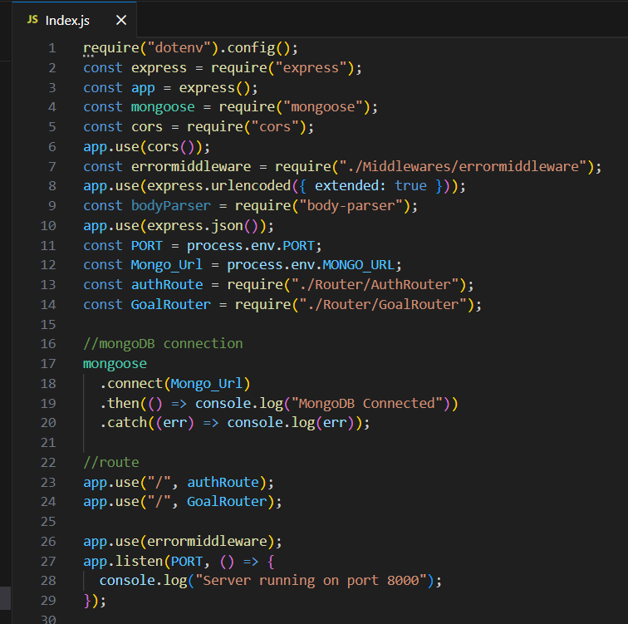
- Connected MongoDB
For Connection with MongoDB:-
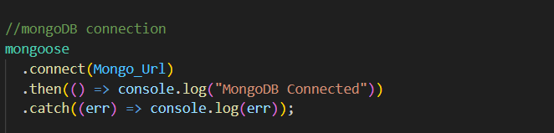
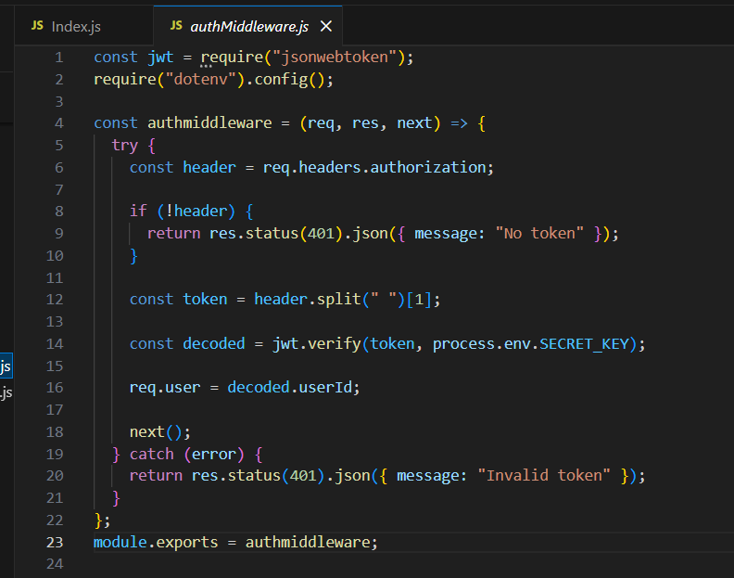

- Added Error Middleware
An error middleware was added to handle application errors centrally and return proper status codes and messages. 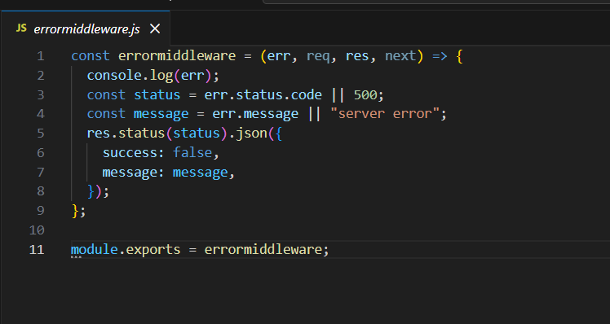

13.DATABASE DEVELOPMENT:

CONFIGURE MongoDB
- Use MongoDB Atlas or Local MongoDB
- Store connection string in .env
CREATE DATABASE CONNECTION
Index.js file:
- Use mongoose.connect()


- Handle connection errors

14. CREATE SCHEMA AND MODELS:
User Schema
The User Schema defines the user data structure with name, email (unique), and hashed password fields.
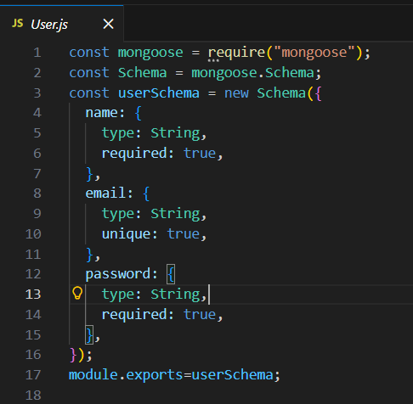
Goal Schema (with userId reference)
The Goal Schema stores goal details and includes a userId reference to associate each goal with a specific user.
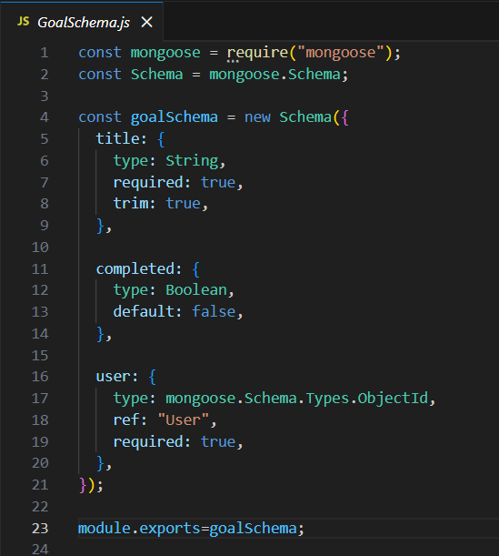

15.PROJECT EXECUTION:

Project Execution Steps
- Start MongoDB
- Run server
- Test APIs in Thunder Client
- Register User
- Login and get JWT
- Perform CRUD operations

16. Project Output Screenshots:
- Successful User Registration(Signup/Login)
- In this Api call the user register or login and token was genrated
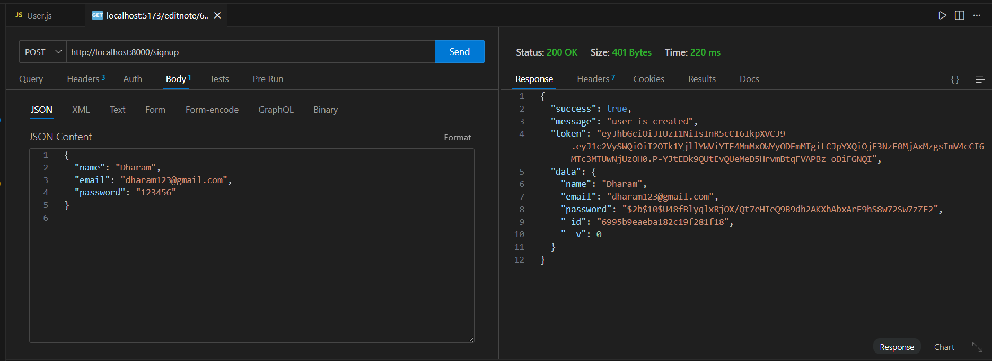
- JWT Token Response
After successful login user the api generate the token and these token was sent with every request to every api

- Goal Created Successfully
- After the login and token is generated the user give post request to api for creating there goals and goal was save in MongoDB which was the database
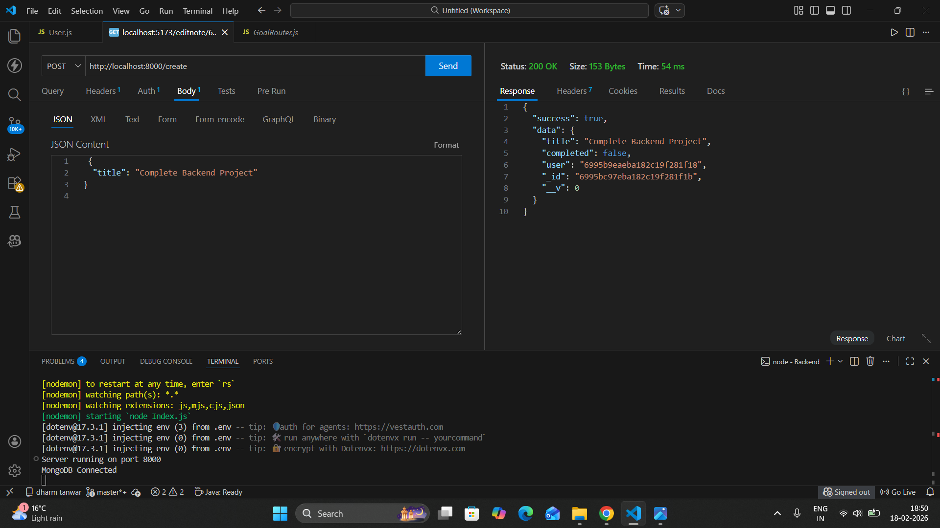
- Protected Route Working
- If the user does not have token which was generated by backend api then he cannot access the api so Route are protectedZ
