DEFECT REPORT
Field | Description
Defect ID | DEF-1
Title / Summary | Login allows users to log in with an invalid email format
Description | The application allows users to log in even when an invalid email format is entered. The system does not display any validation message and accepts the invalid email.
Steps to Reproduce | 1. Open the Login page.  2. Enter an invalid email (e.g., user232gmail.com).  3. Enter any valid password (e.g., Test@123).  4. Click Login.
Expected Result | The application should display an "Invalid email format" validation message and should not allow the user to log in.
Actual Result | The application allows the user to log in with an invalid email format without displaying any validation message.
Environment Details | Device: Windows PC  OS: Windows 11  Browser: Google Chrome  Application: Tichi Web App (Stage)
Severity | High
Priority | High
Module / Feature Affected | Login / Authentication
Reported By | Murugavel V
Reported On | 02 July 2026
Status | New
Assigned To | Development Team
Comments / Notes | Email format validation should be added before authentication.

Field | Description
Defect ID | DEF-2
Title / Summary | Verify Account screen keeps loading continuously without timeout
Description | After successful signup, the Verify Account screen keeps loading continuously when the user does not click the email verification link. The application does not display any waiting message, timeout, or guidance to the user.
Steps to Reproduce | 1. Complete the Signup process.  2. Open the Verify Account screen.  3. Do not click the email verification link.  4. Wait for 5 minutes.
Expected Result | The application should display a proper waiting message or timeout instead of loading continuously.
Actual Result | The Verify Account screen kept loading for more than 5 minutes without displaying any message or timeout.
Environment Details | Device: Windows PC  OS: Windows 11  Browser: Google Chrome  Application: Tichi Web App (Stage)
Severity | Medium
Priority | Medium
Module / Feature Affected | Signup / Account Verification
Reported By | Murugavel V
Reported On | 02 July 2026
Status | New
Assigned To | Development Team
Comments / Notes | The Verify Account page should display a loading indicator with a timeout or provide instructions such as "Please verify your email" or an option to resend the verification email instead of loading indefinitely.

Field | Description
Defect ID | DEF-3
Title / Summary | Login accepts an email address exceeding the maximum allowed length
Description | The application allows users to continue to the next page even when the entered email address exceeds the maximum allowed length of 254 characters.
Steps to Reproduce | 1. Open the Login page.  2. Enter an email address longer than 254 characters.  3. Enter any valid password.  4. Click Login.
Expected Result | The application should display a validation message such as "Email address cannot exceed 254 characters" and should not allow login.
Actual Result | The application allowed the user to continue to the next page without displaying any validation message.
Environment Details | Device: Windows PC  OS: Windows 11  Browser: Google Chrome  Application: Tichi Web App (Stage)
Severity | Medium
Priority | Medium
Module / Feature Affected | Login / Email Validation
Reported By | Murugavel V
Reported On | 02 July 2026
Status | New
Assigned To | Development Team
Comments / Notes | The application should enforce the maximum email length before processing the login request.

Field | Description
Defect ID | DEF-4
Title / Summary | Login accepts an email address that does not meet the minimum length requirement
Description | The application allows users to continue to the next page even when the entered email address does not meet the minimum length requirement.
Steps to Reproduce | 1. Open the Login page.  2. Enter an email address shorter than the minimum allowed length.  3. Enter any valid password.  4. Click Login.
Expected Result | The application should display a validation message and should not allow login with an email that does not meet the minimum length requirement
Actual Result | The application allowed the user to continue to the next page without displaying any validation message.
Environment Details | Device: Windows PC  OS: Windows 11  Browser: Google Chrome  Application: Tichi Web App (Stage)
Severity | Medium
Priority | Medium
Module / Feature Affected | Login / Email Validation
Reported By | Murugavel V
Reported On | 02 July 2026
Status | New
Assigned To | Development Team
Comments / Notes | The application should validate the minimum email length before allowing the login process to continue.

DEF-3:
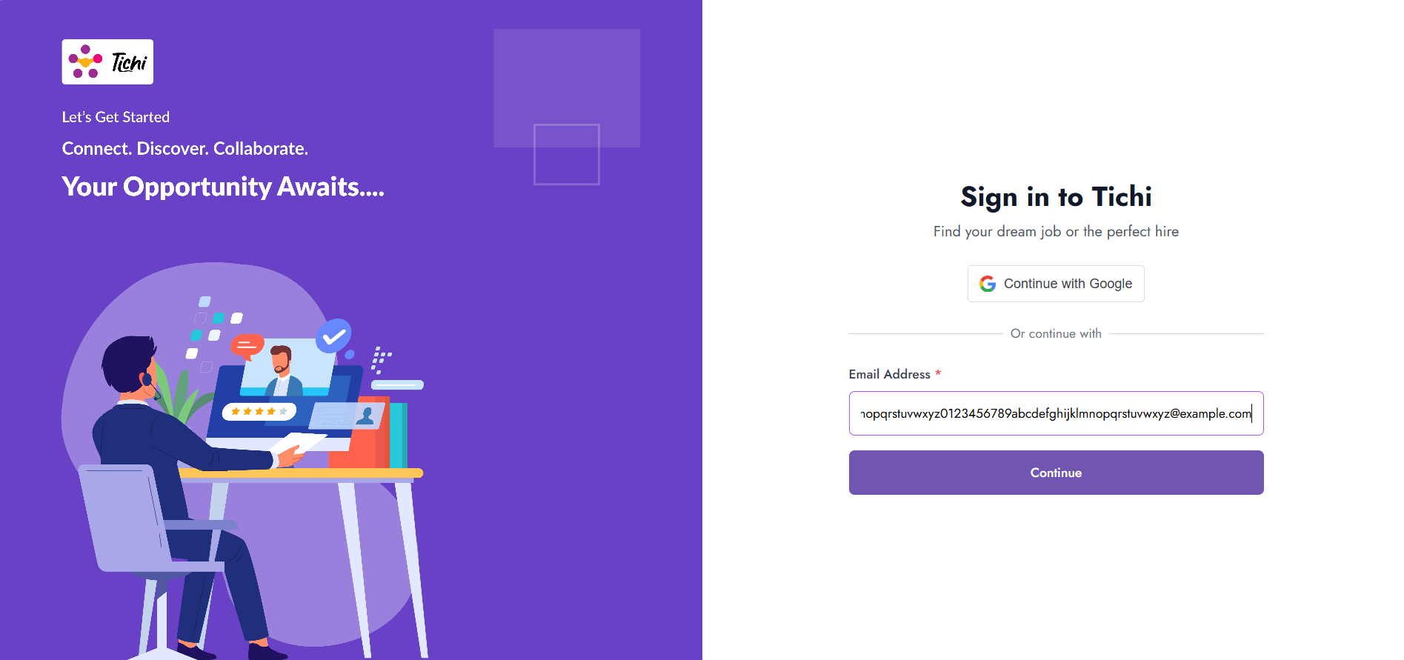
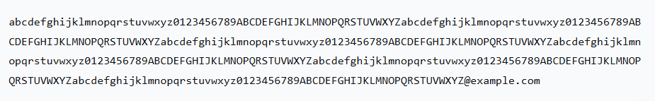
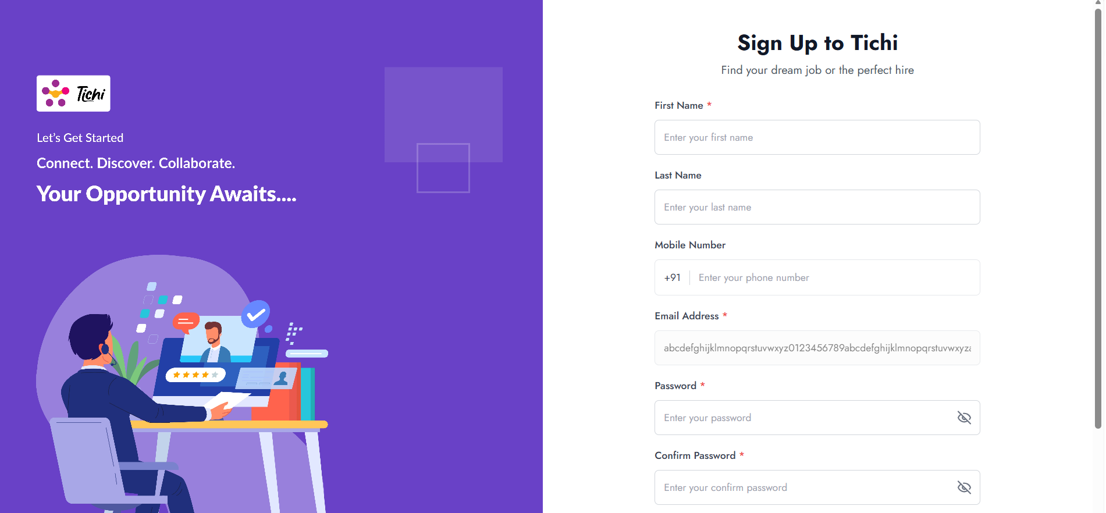

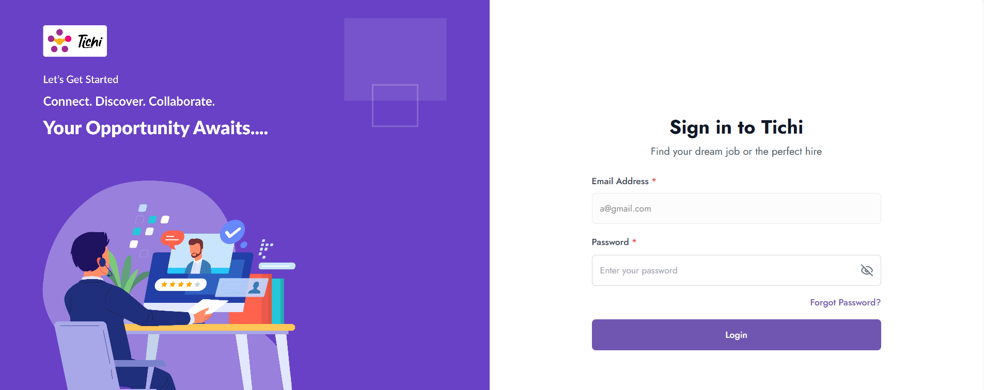
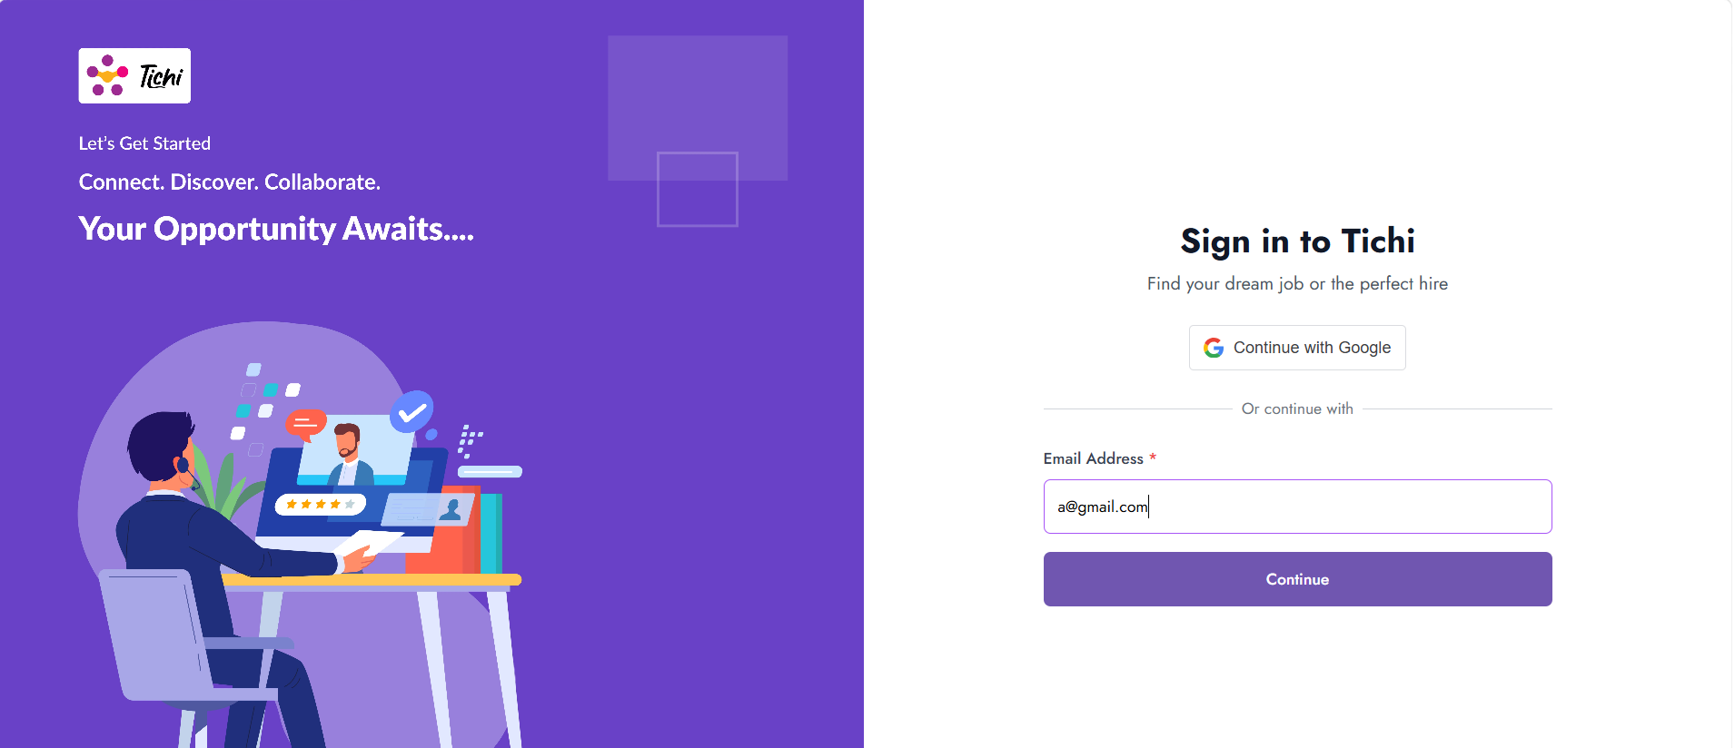
DEF-4:

