**Python Assignment 1 Screenshot**

Objective:

The objective of this assignment is to enhance Python programming skills by implementing loops,

conditional statements, functions, and exception handling. These exercises will strengthen

participants' ability to write efficient, error-free, and user-friendly scripts, which are essential for

automation, infrastructure scripting, and application development.

**1. Factorial Calculation Using a For Loop**

Write a Python program that calculates the factorial of a given number using a for loop.

Requirements:

• Prompt the user to enter a non-negative integer.

• Calculate the factorial using a for loop.

• Display the result with a clear output message.

Sample Output:

Enter a number: 5

Factorial of 5 is 120

**Screenshot:**

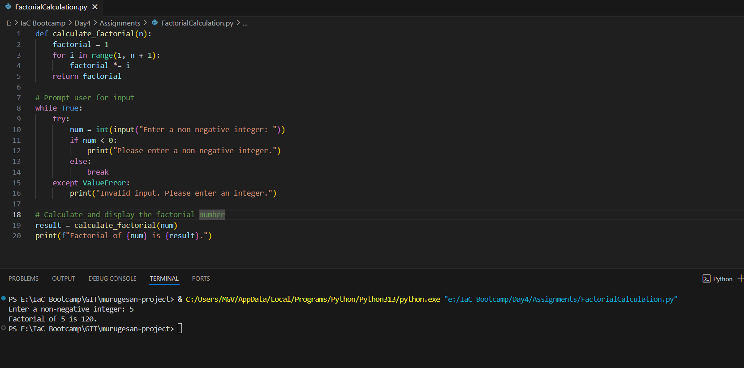

**2. Basic Calculator Program**

Implement a Python calculator that performs addition, subtraction, multiplication, and division based

on user input.

Requirements:

• Prompt the user for two numbers.

• Ask the user to select an operation (+, -, *, /).

• Perform the chosen operation and display the result.

• Ensure proper handling of division by zero.

Sample Output:

Enter first number: 10

Enter second number: 5

Choose operation (+, -, *, /): *

Result: 10 * 5 = 50

**Screenshot:**

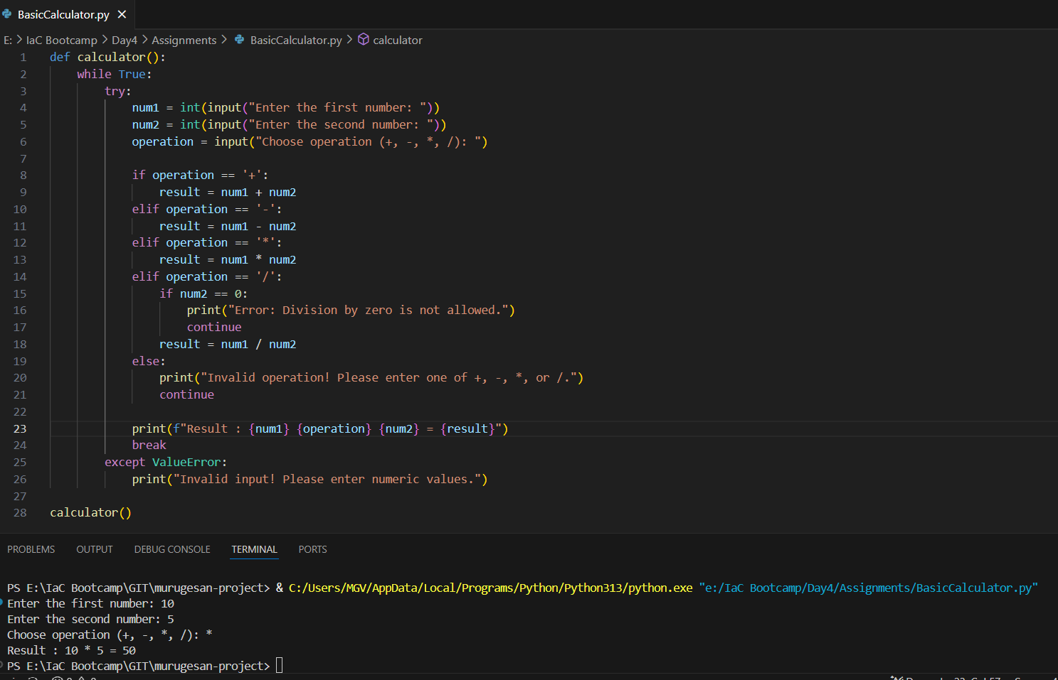

**3. Filter Even Numbers from a List**

Write a Python program that accepts a list of numbers from the user and prints only the even

numbers.

Requirements:

• Prompt the user to enter multiple numbers (comma-separated).

• Convert the input into a list of integers.

• Identify and print only the even numbers from the list.

Sample Output:

Enter numbers: 12, 7, 8, 3, 10

Even numbers: 12, 8, 10

**Screenshot:**

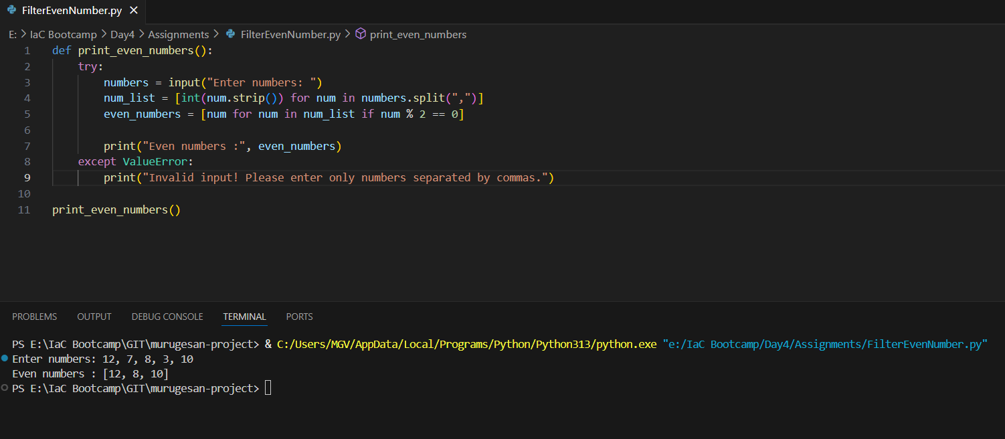

**4. Handling Input Errors with Exception Handling**

Modify the previous program to handle invalid inputs using exception handling.

Requirements:

• Implement a try-except block to catch non-numeric inputs.

• Ensure the program does not crash if the user enters invalid data.

• Provide a clear error message and prompt the user to re-enter the input.

Sample Output:

Enter numbers: 12, 7, a, 8

Invalid input detected! Please enter only numbers.

Enter numbers: 12, 7, 8, 3, 10

Even numbers: 12, 8, 10

**Screenshot**

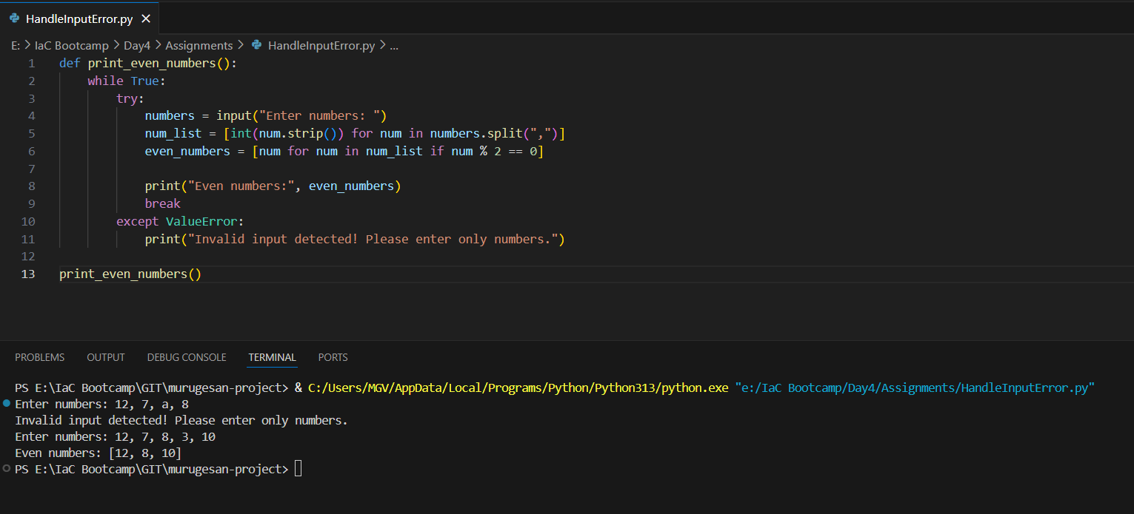

**Evaluation Criteria:**

• Ensure code readability by using comments and proper formatting.

• Validate user input to prevent unexpected errors

• Test each script to confirm its correctness and robustness.

• Maintain consistent and meaningful output messages.