Conceptual framework
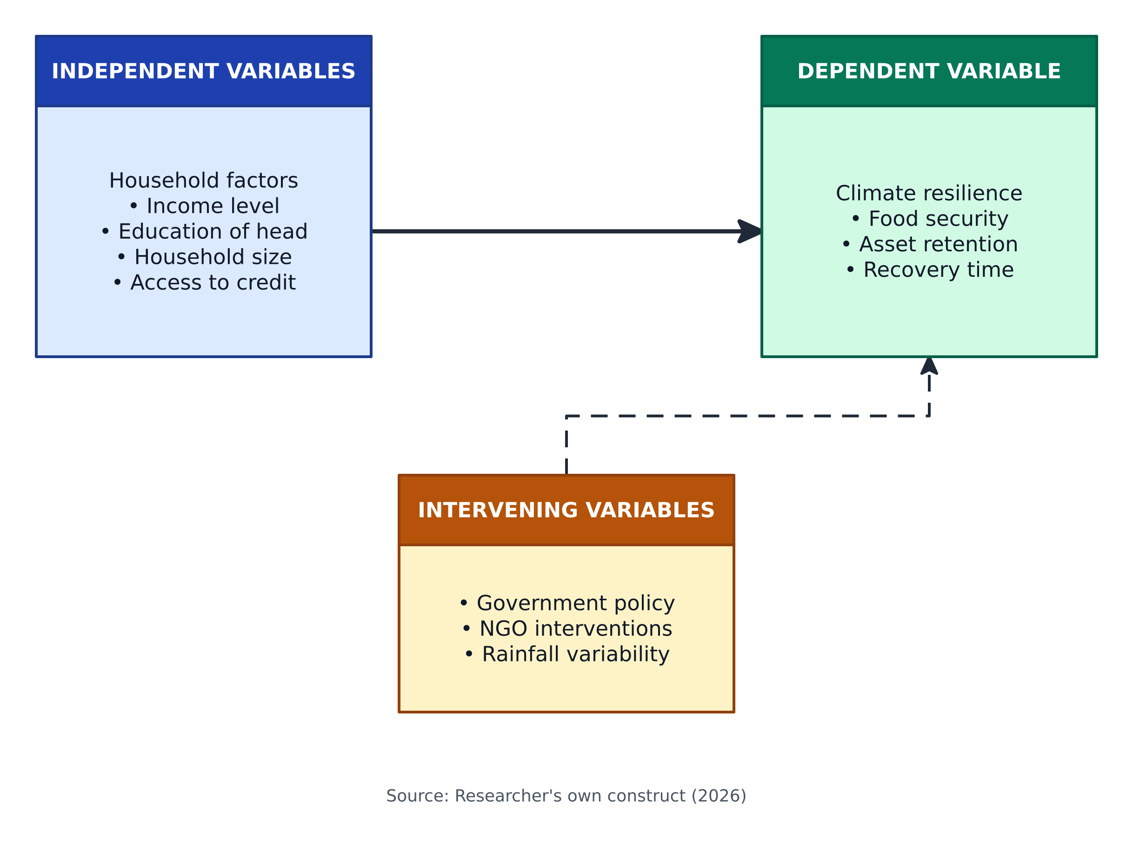
Figure 1: Conceptual framework

