1. **INTRODUCTION**

InBloom is a mobile application that endeavours to assist female users in their menstrual cycles. It provides a systematic tracking of dates, bodily and emotional changes. Based on the data entry it can also be used to predict periods and locate most fertile/least fertile days on the calendar.

The application should provide a calendar obviously with settings where you can enter how many days your cycle is, for instance a typical cycle is 34 days, so the application automatically calculates when period is due. Each woman will set how many days her periods will last.

There is also a luteal phase. Most women will have 14 days luteal phase that must be manually set. Intimate days can also be set to keep track. Based on the last period and luteal phase dates the app should calculate fertile and safe days.

Girly themes that can be set and customized. E.g. A heart as icon for intimate days, a flower or simply highlighted pink for fertile days and red drops for period icon. If you really want it to be a top application then moods, emotion symbols, and optional diary for dates should be included.

A forum where ladies discuss about related topics such as pregnancy and cycles.

Optional password to access the application,

1. **OVERALL FEATURES**
   1. **Product Perspective**

InBloom.

* 1. **Product features**
* Allow user to enter her menstrual cycle signs such as initial spotting days and period days on a calendar or any logical entry form.
* Allow user to enter her menstruation details such as cycle length and luteal days so that the fertile and safe days can be calculated.
* Offer the user the ability to over ride cycles and period length and recalculate predictions.
* View graphs of weight, temperature and emotional moods against time.
* Allow user to add indicators along with the recording of those dates. Notes can be in the form of basal temperature, weight, mood, cramps, bloating, food cravings, flow, amorousness and other text notes.
* Alongside the indicators the user should be able to indicate spotting and intimate days.
* Provide predictions of the most fertile and least fertile days.
* Allow user to choose from a set of themes for the whole application. E.g. Pink backgrounds, lavender and other light coloured themes. Buttons and labels also change to match the theme.
* Provide a means to view forum threads and participate on forum conversations from the application itself.
* Allow user to enter general settings information such as average cycle time, average luteal times, average period times, units for weight and temperature.
* Allow user to toggle to pregnancy mode when she discovers it. Cycles will then be halted.
* Allow user to have a personal profile with attributes such as name and profile picture.
* Allow user to quickly see a preview of the most fertile/ least fertile days from the home screen.
* Allow user to password protect the application.
  1. **Operating Environment**

The target environment is the Nokia’s S40 OS. The platform is MIDP 2.0 and CLDC 1.1.

1. **ANALYSIS**

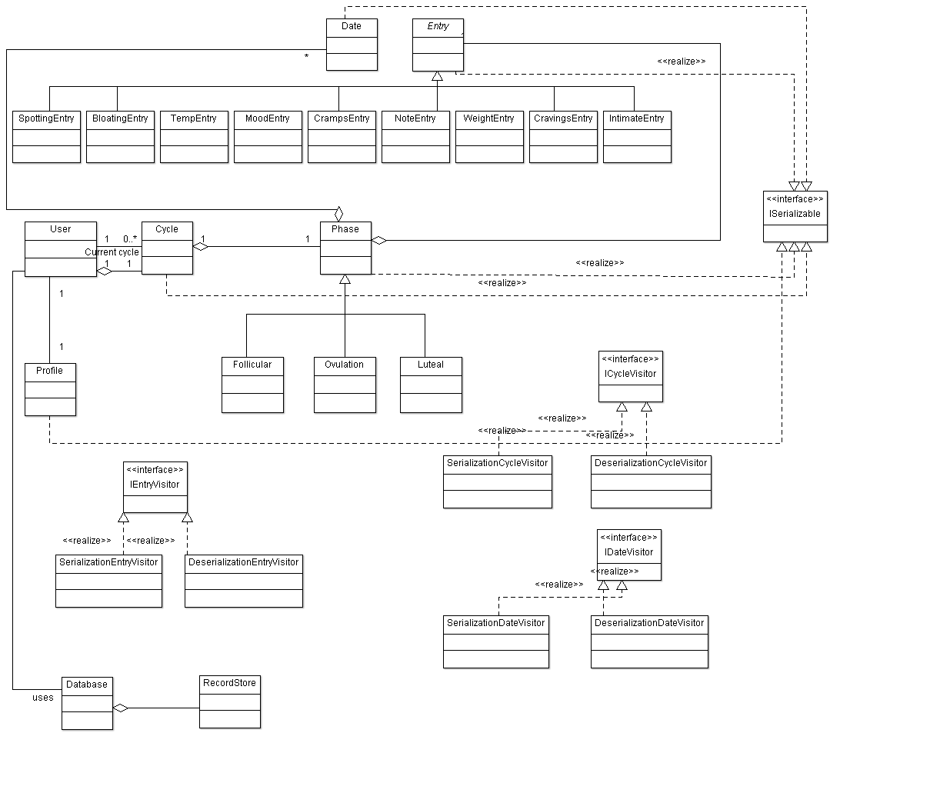**3.1 Initial model classes.**

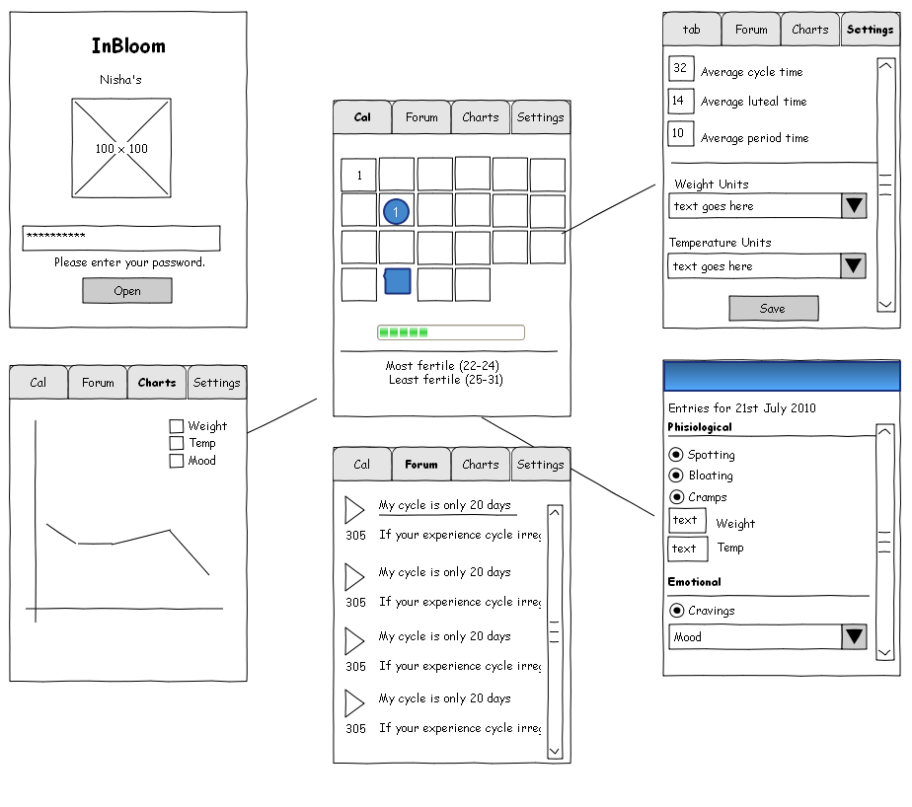**3.2 UI sketch**

**3.3 UI classes**

