|  |  |
| --- | --- |
| Internship Project Title | TCS iON RIO-45: Customer Satisfaction Survey Dashboard |
| Name of the Company | TCS iON |
| Name of the Industry Mentor | Prepinsta |
| Name of the Institute | PrepInsta Technologies Pvt. Ltd. |

|  |  |  |  |  |
| --- | --- | --- | --- | --- |
| Start Date | End Date | Total Effort (hrs.) | Project Environment | Tools used |
| 09 -02- 2023 | 06-04-2023 | 45 | Windows 11 , Eclipse | Eclipse, Apache Tomcat, PostgreSQL |

|  |
| --- |
| **Acknowledgements**  I am highly indebted to TCS iON for their guidance and constant supervision, for providing necessary information regarding the project & also for their support in completing the project.  I would like to express my gratitude towards my parents and academic mentor, for their kind co-operation and encouragement which help me complete this project.  I would like to express my special gratitude and thanks to my industry mentor for giving me such attention and time. |
| **Objective**  The objective is to develop a web UI-based customer feedback monitoring and satisfaction survey system with dynamic dashboard powered with java. |
| **Introduction**  Customer satisfaction is an essential aspect of any business. In today's highly competitive market, understanding the needs and preferences of customers is critical to the success of any organization. To achieve this, companies often conduct customer satisfaction surveys to measure how satisfied their customers are with the products or services they provide. The data collected from these surveys can be used to create a customer satisfaction survey dashboard that provides valuable insights into customer satisfaction levels. |
| **Approach**   1. First created a login page using java servlet and PostgreSQL database. 2. After that It has two options if a user will give his username and password it will redirect him/her to the feedback page where he can give feedback about the products. 3. If the admin will log in it will redirect him/her to the admin page where he can add products or assign roles to the user. 4. After all this our main task is to connect the servlet code with the database where we can store our data. 5. Lastly the dashboard, we have created the dashboard on the admin page only where he will be able to see the metrics, KPI and feedback of the products by the customer. |

**Outcome**

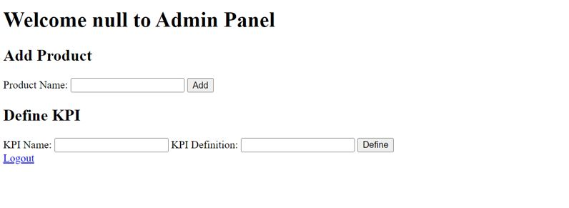

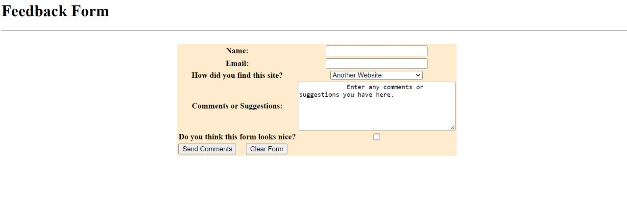

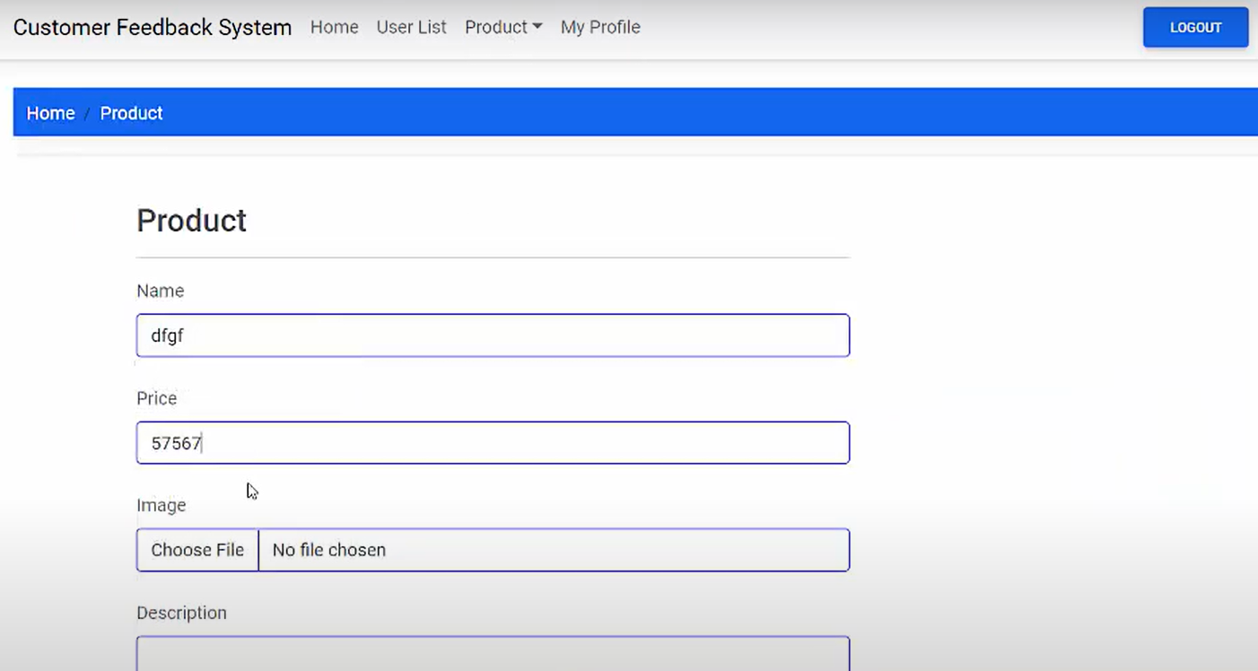

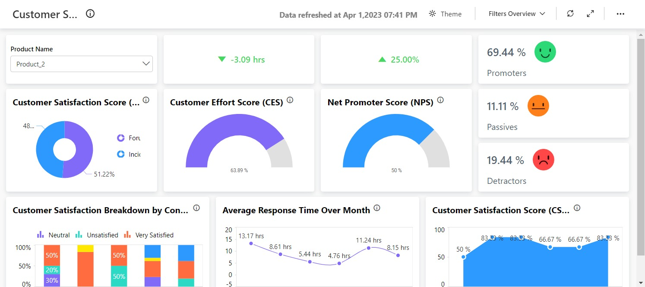

**Link**

[http://localhost:8444](http://localhost:8444%20%20(My) (My Local Host Link)

**Executable file:-**

[**https://drive.google.com/file/d/1sfcSpf5Bq9EgdXc-NgVjtq5Z2pU-J1H2/view?usp=share_link**](https://drive.google.com/file/d/1sfcSpf5Bq9EgdXc-NgVjtq5Z2pU-J1H2/view?usp=share_link)

**https://github.com/mus-BYTE/Customer-Satisfaction-Survey-Dashboard/tree/main/Customer%20Satisfaction%20Survey%20Dashboard**