# Data Base connection

Connect to express and run the **bootstrap.sql** found on the documents folder under the scripts folder

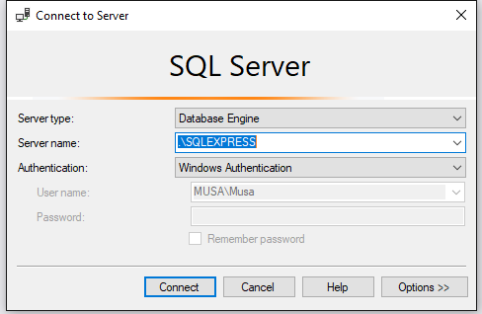

Get SQLEXPRESS FROM HERE: <https://www.microsoft.com/en-us/download/details.aspx?id=55994>

After installation you should see this screen.

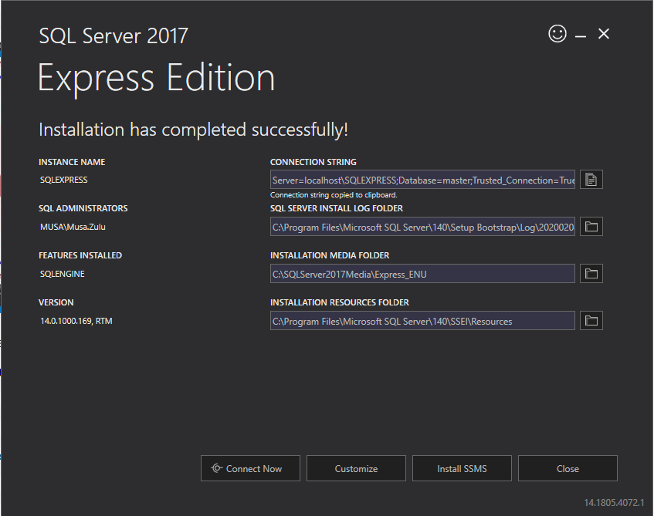

If you don’t have sqlexpress installed (which I recommend that you do install)

Please connect to your local instance e.g my computer name is MUSA and my local instance is MUSA

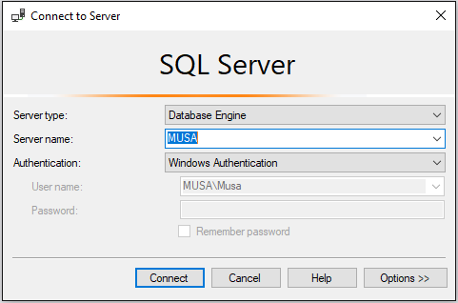

Run the **bootstrap.sql** script found under Documents folder in the project

You have to modify **appsettings.json found under the ProductsInventory.Server project**

**Change the DefaultConnection**

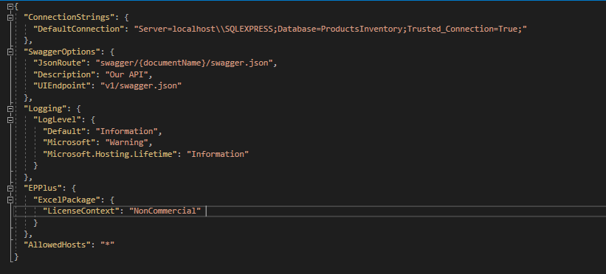

# API

Set the CustomerListing.Server as a startup project and run the project.

If for any reason you don’t get the swagger screen please right-click on your **CustomerListing.Server** project and make sure your Debug settings looks like the following.

# Run the project

## If you get this error.

Open Sql Server Configuration manager (you can search for this on the start menu on windows)

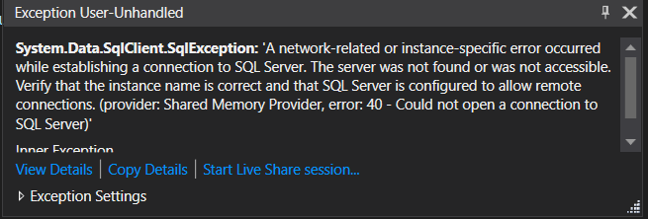

Make sure the SQL Server(SQLEXPRESS) is running and restart your application.

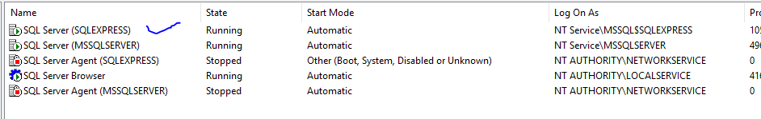

# Navigating around the project

## Manage Customers

This page has a list of customers that have been added to the system. This page allows the user to perform the following functions

* Create or add a customer
* Edit an existing customer
* Delete a customer

## New Customer

This dialog box allows a user to add a new record to the system

## Update Customer

# Validation

Please note that the system handles validation and shows correct messages but the user has to close these messages by clicking the “X” button

Success message

# Unit Testing

You can run the tests by clicking **Test** on VS and “**Run All Tests”**



