# Data Base connection

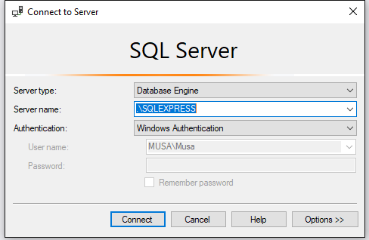

Get SQLEXPRESS FROM HERE: <https://www.microsoft.com/en-us/download/details.aspx?id=55994>

After installation you should see this screen.

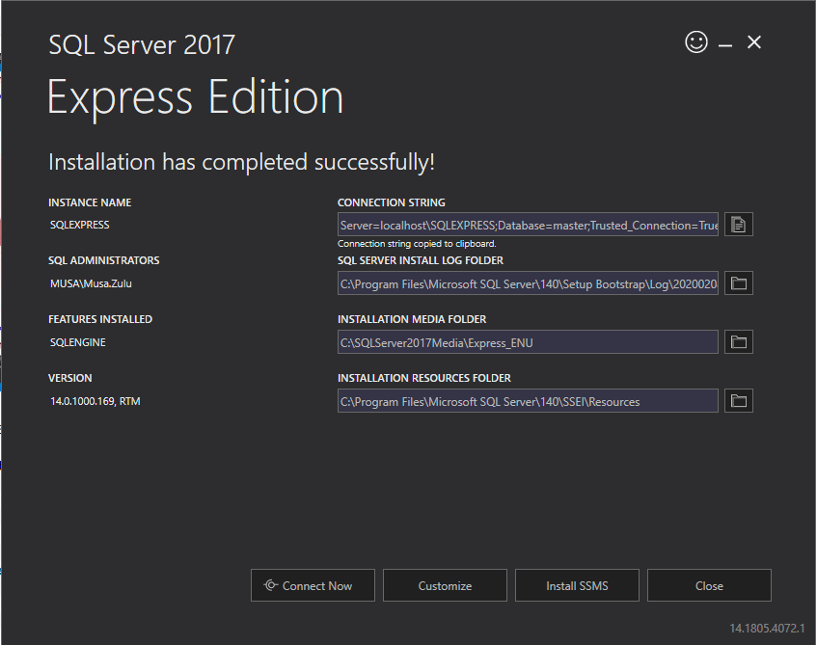

If you don’t have sqlexpress installed (which I recommend that you do install)

Please connect to your local instance.

# API

Set the Nologo web project as a startup project and run the project.

If for any reason you don’t get the swagger screen please right-click on your **Nologo** project and make sure your Debug settings looks like the following.

# Run the project

## If you get this error.

Open Sql Server Configuration manager (you can search for this on the start menu on windows)

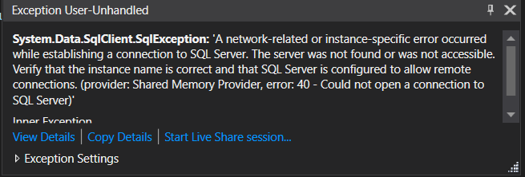

Make sure the SQL Server(SQLEXPRESS) is running and restart your application.

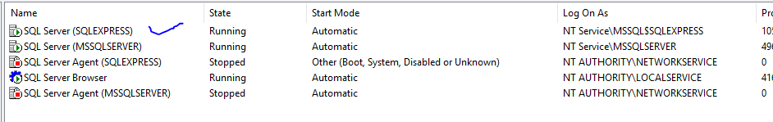

# Navigating around the project

## Dashboard

This is the landing page it has 2 links on the navigation

* **Recipe Book** which redirects the user to the dashboard
  + Shows list of Recipes
* **Admin Panel** which redirects the user to manage recipes page
  + Allows a user to add, edit and delete recipes
* **Register** which redirects the user registration page
  + Shows Registration form that allows the user to register
* **Login** which redirects the user login page
  + Shows Registration form that allows the user to login to the system
  + Only loggedin admin users can add edit or remove items

## Manage Recipes

This page has a list of recipes that have been add to the system. This page allows the user to perform the following functions

* Create or add a recipe
* Edit an existing recipe
* Delete a recipe

# Dashboard

# Home Page

# Add Recipe

# Edit Recipe Page

# Details Page

# Delete Recipe

# Validation

Please note that the system handles validation and shows correct messages

## Error message

