# API

The following screen is what you should see when you the PhoneBook API 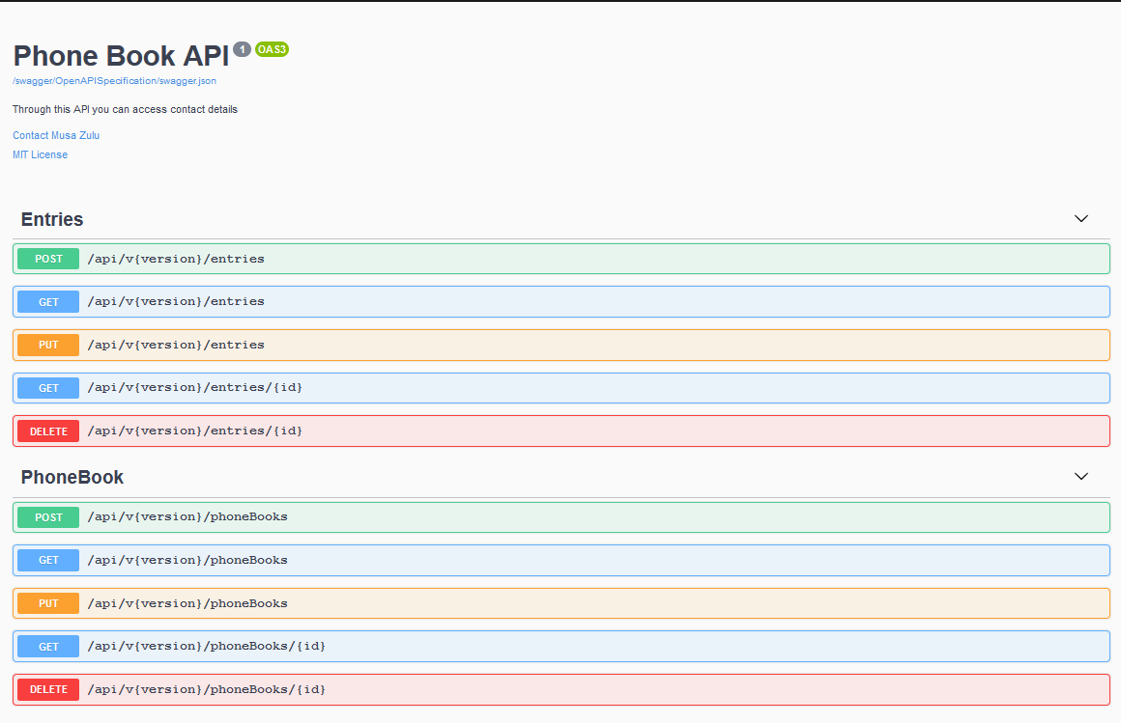

If for any reason you don’t get the swagger screen please right-click on your **PhoneBook web** project and make sure your Debug settings looks like the following.

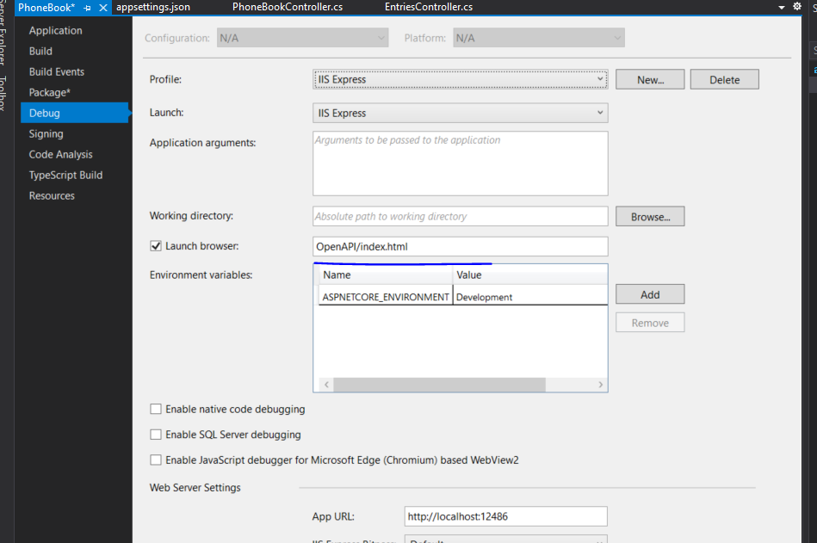

# Run the project

## If you get this error.

Open Sql Server Configuration manager (you can search for this on the start menu on windows)

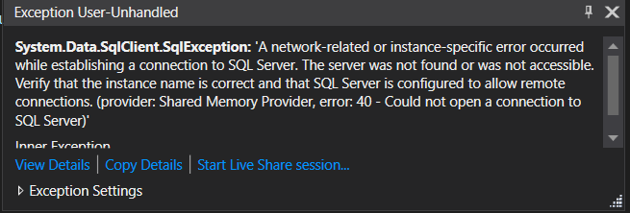

Make sure the SQL Server(SQLEXPRESS) is running and restart your application.

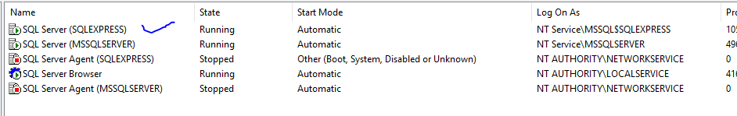

# Navigating around the project

## Manage Phone Books

This page has a list of phone books that have been add to the system. This page allows the user to perform the following functions

* Create or add a phone book
* Edit an existing phone book
* Delete a phone book

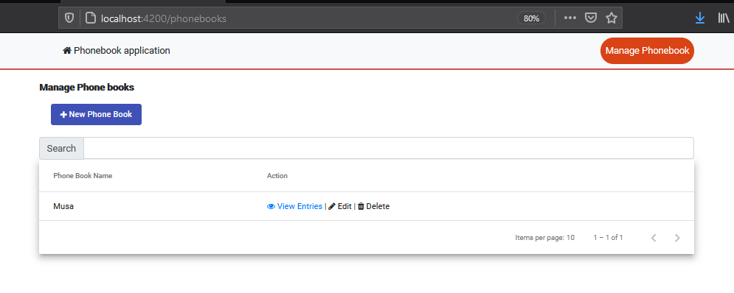

## New Phone Book

This dialog box allows a user to add a new record to the system

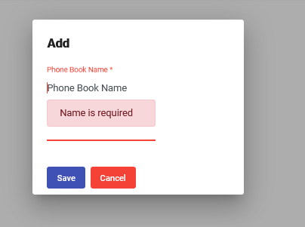

## Entries

This page has a list of entries that have been add to the system. This page allows the user to perform the following functions

* Create or add an entry
* Edit an entry
* Delete an entry

To get to this page a user must click on “View Entries” from the Manage Phone Books screen see the image below.

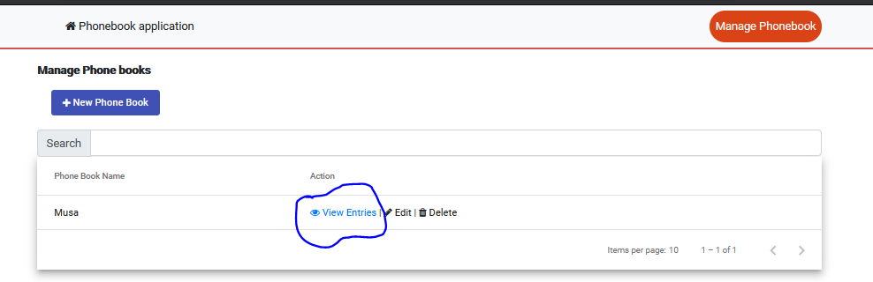

# Manage Phone book entries

Upon clicking the “View Entries” as shown above the user will be redirected to the following screen

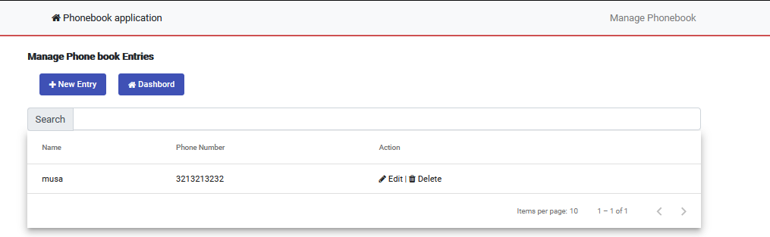

# New Entry

This button allows a user to add a new entry to the system

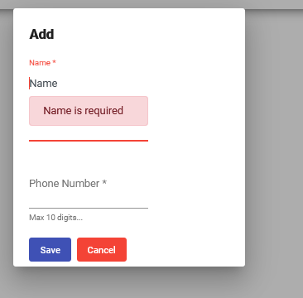

A user can also edit and delete entries for a phone book.

# Validation

Please note that the system handles validation and shows correct messages but the user has to close these messages by clicking the “X” button

**Error message**

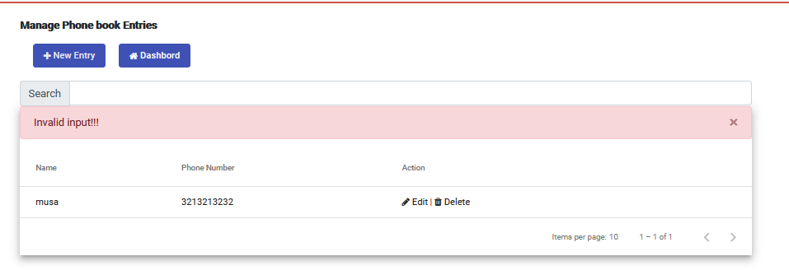

**Successful message**

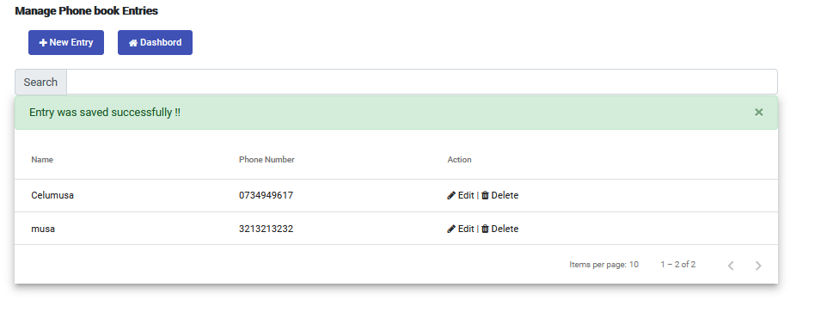

# Validation

The system allows the user to dynamically filter by name as shown on the picture below.

