# Data Base connection

Connect to express and run the **bootstrap.sql** found on the documents folder under the scripts folder

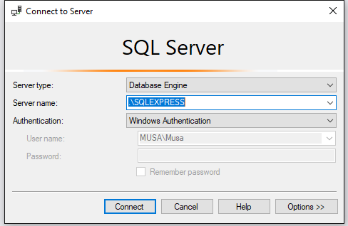

Get SQLEXPRESS FROM HERE: <https://www.microsoft.com/en-us/download/details.aspx?id=55994>

After installation you should see this screen.

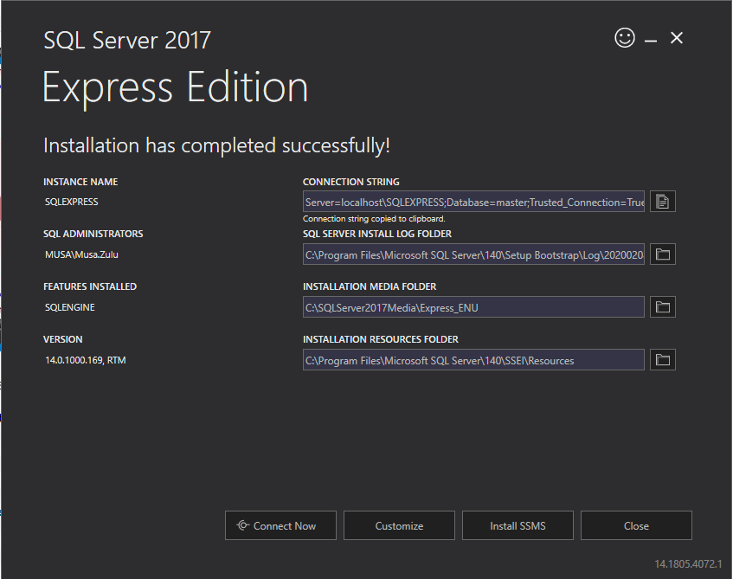

If you don’t have sqlexpress installed (which I recommend that you do install)

Please connect to your local instance e.g my computer name is MUSA and my local instance is MUSA

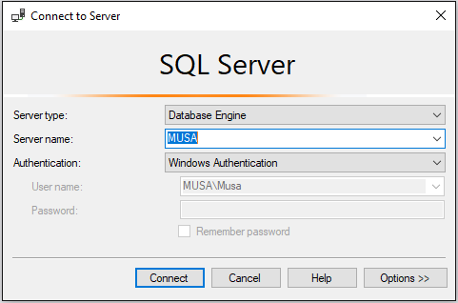

Run the **bootstrap.sql** script found under Documents folder in the project

You have to modify **appsettings.json found under the ProductsInventory.Server project**

**Change the DefaultConnection**

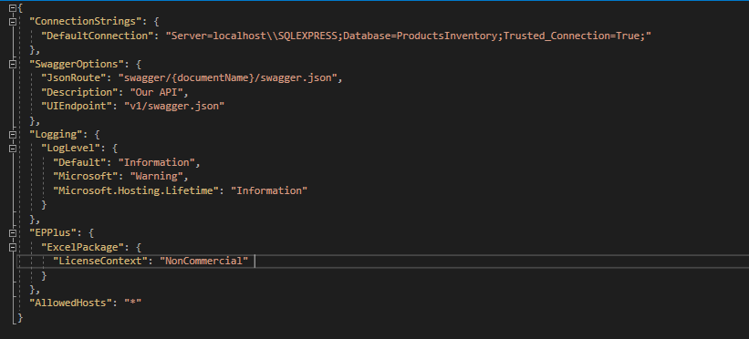

# API

Set the ProductsInventory.Server as a startup project and run the project. You should see the following screen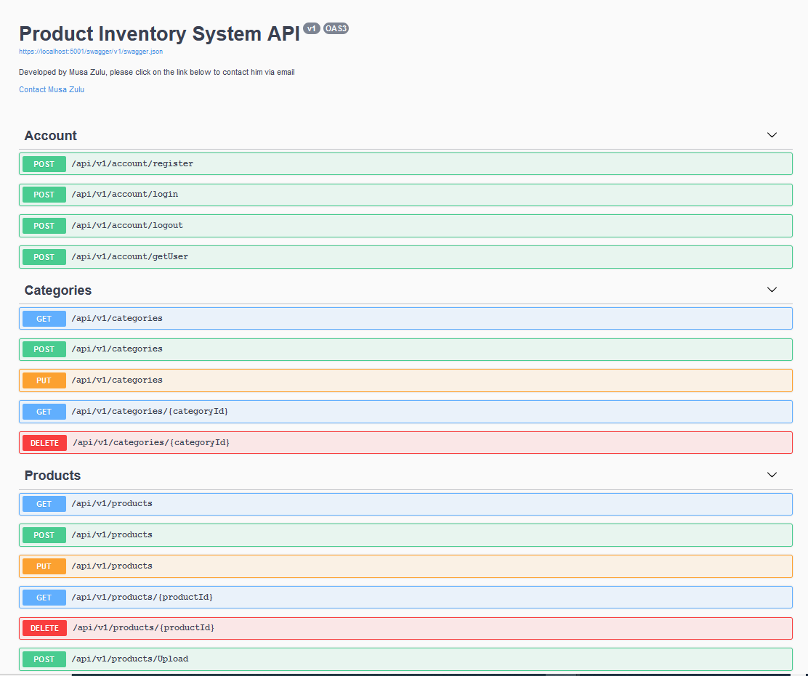

If for any reason you don’t get the swagger screen please right-click on your **ProductsInventory.Server** project and make sure your Debug settings looks like the following.

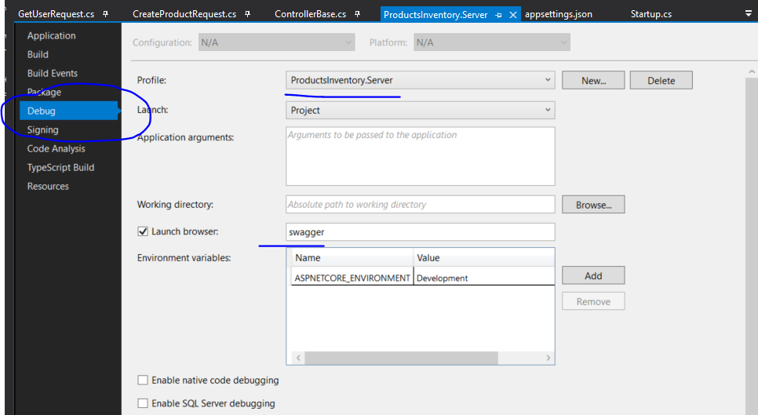

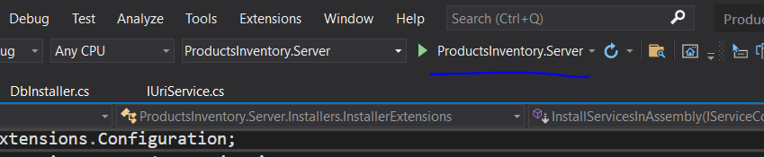

# Run the project

## If you get this error.

Open Sql Server Configuration manager (you can search for this on the start menu on windows)

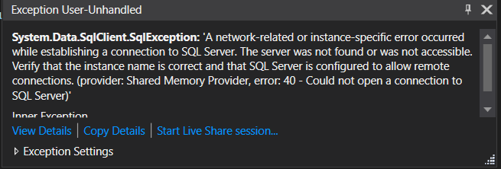

Make sure the SQL Server(SQLEXPRESS) is running and restart your application.

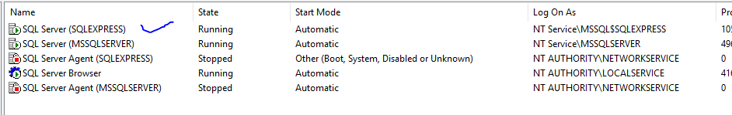

# Navigating around the project

## Dashboard

This is the landing page it has 5 links on the navigation

* **Dashboard** which redirects the user to the dashboard
  + Shows list of categories
  + Products can be filtered by category on the left filtered by category
* **Manage Categories** which redirects the user to manage categories page
  + Allows a user to add, edit and delete categories
* **Manage Products** which redirects the user to manage products page
  + Allows a user to add, edit and delete a product.
* **Register** which redirects the user registration page
  + Shows Registration form that allows the user to register
* **Login** which redirects the user login page
  + Shows Registration form that allows the user to login to the system

## Manage Categories

This page has a list of categories that have been add to the system. This page allows the user to perform the following functions

* Create or add a category
* Edit an existing category
* Delete a category

## New Category

This dialog box allows a user to add a new record to the system

## Manage Products

This page has a list of products that have been add to the system. This page allows the user to perform the following functions

* Create or add a product
* Delete a product

# New Product

This page allows a user to add a new product

# Validation

Please note that the system handles validation and shows correct messages but the user has to close these messages by clicking the “X” button

Error message

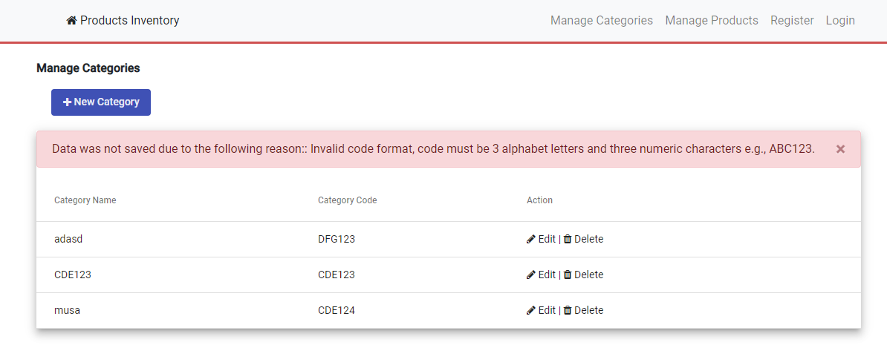

Success message

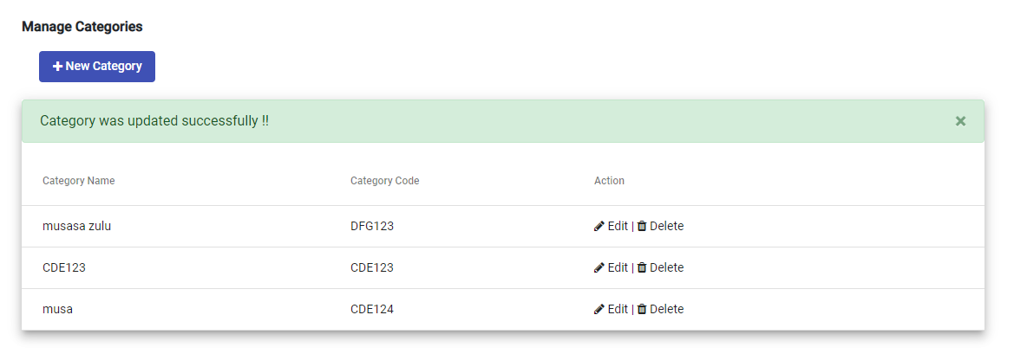

Not LoggedIn users won’t be able to perform any operation on the system

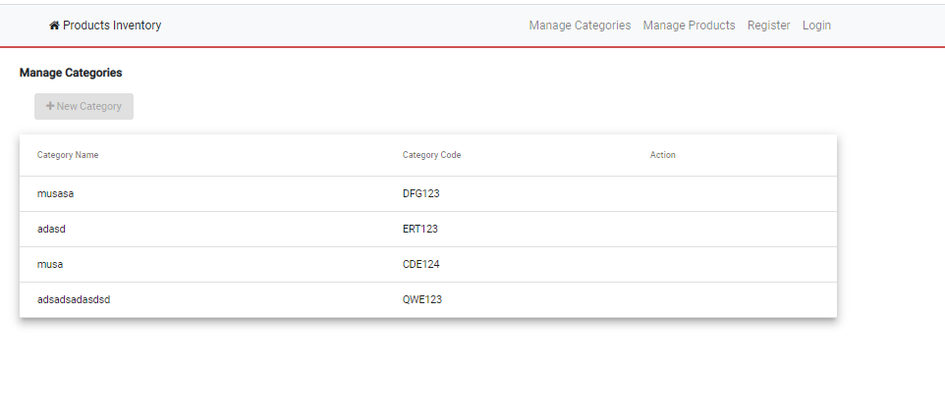

# Unit Testing

You can run the tests by clicking **Test** on VS and “**Run All Tests”**

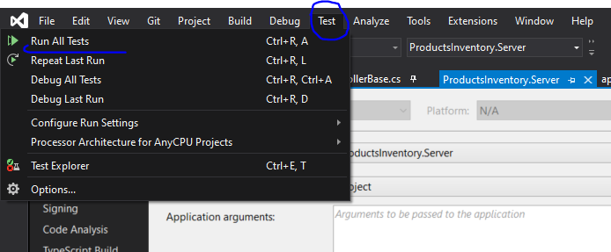

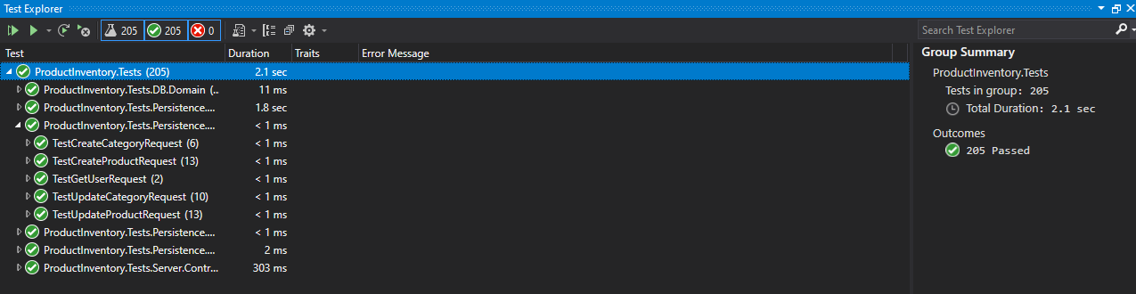

Download Excel file end point – allows a user to download an excel file FE functionality was not covered

